Comparative analysis of vertically mass irregular RC frame structure

Sumit Sunil Pandit¹, Prof. Ishant Dahat²
P.G. Student, Department of Civil Engineering, G. H. Raisoni University, Amravati, Maharashtra, India¹
Assistant Professor, Department of Civil Engineering, G. H. Raisoni University, Amravati, Maharashtra, India²

ABSTRACT: It would be ideal if all buildings had their own elements that resisted the side load, symmetrically located, and the ground movements of the earthquake would strike in known directions. Due to the lack of land in large cities, architects often offer irregular buildings in order to use the most accessible land and provide adequate ventilation and light in various building components. However, quite often structural inequality is the result of a combination of both types. Most buildings have a degree of unevenness in the geometric configuration or distribution of mass, rigidity and / or strength. This work consists of a comparative analysis of the vertically mass irregular structure of the frame RC.

Keywords: response, Irregular structures, Asymmetric structures and seismic

- INTRODUCTION:
An asymmetric building (touringly unbalanced) can be defined as one in which, for a purely translational movement, the result of resistance forces does not pass through the center of mass (Humar and Kumar, 1999) [12]. At stress in the inelastic range, torsional movements in such structures will lead to movements and plasticity requirements much larger than in symmetrical buildings (including torsion), which have similar characteristics. In general, torsion resulting from the eccentric distribution of mass and rigidity can be taken into account when describing the moment of gradual torsion (T) in each floor, equal shift (B) on this floor multiplied by the eccentricity (e) measured perpendicular to the direction of the applied movement of the earth. The exact assessment of the torsion response is quite complex, as the associated lateral vibration modes of the entire structure should be considered by performing the calculation of the reaction of two or three sizes.
- REVIEW OF LITERATURE
S.Varadharajan et al. (2013) reviewed existing work on plan violations and justified the advantage of multi-storey building models over single-storey building models.
Aijay and Rahman (2013) tried to analyze the proportional distribution of the lateral forces involved in the earthquake for individual floors due to changes in the rigidity of the vertically incorrect structure.
Poncet, L. And Tremblay (2004) suggested the influence and effect of mass irregularity, given the case of an eight-storey concentrically fixed steel frame structure with different configurations. The methods used in this paper are equivalent to the static load method and the response spectrum analysis method.
Deves P. Sony (2006) considered several vertical irregular buildings for analysis. Various criteria and codes were discussed and revised in this paper. Vertical indicators of incorrect structure and response are reviewed and presented. Studies have suggested that large seismic requirements are found for combined rigidity and strength inequality.

- MODELING
Following models of building with vertical mass irregularity are prepared using STAAD software:
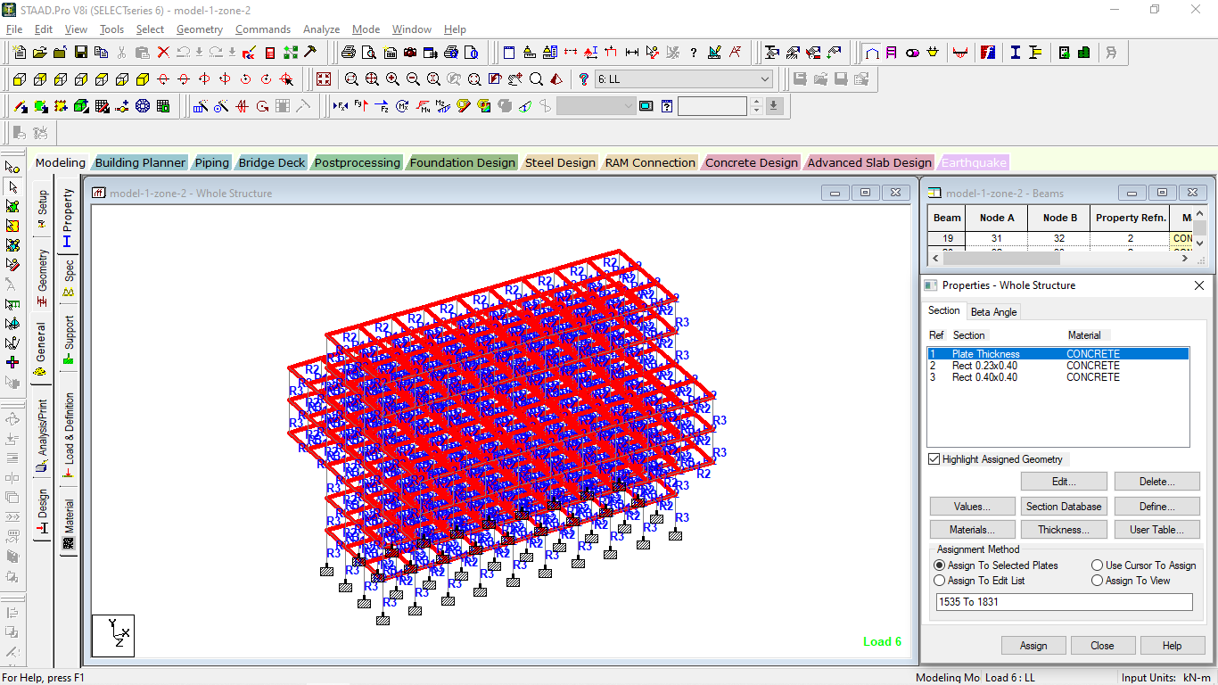
Figure 1:Property assignment of model-IV
The above figure shows the Property assignment of model-IV giving the details of property assigned in the model.
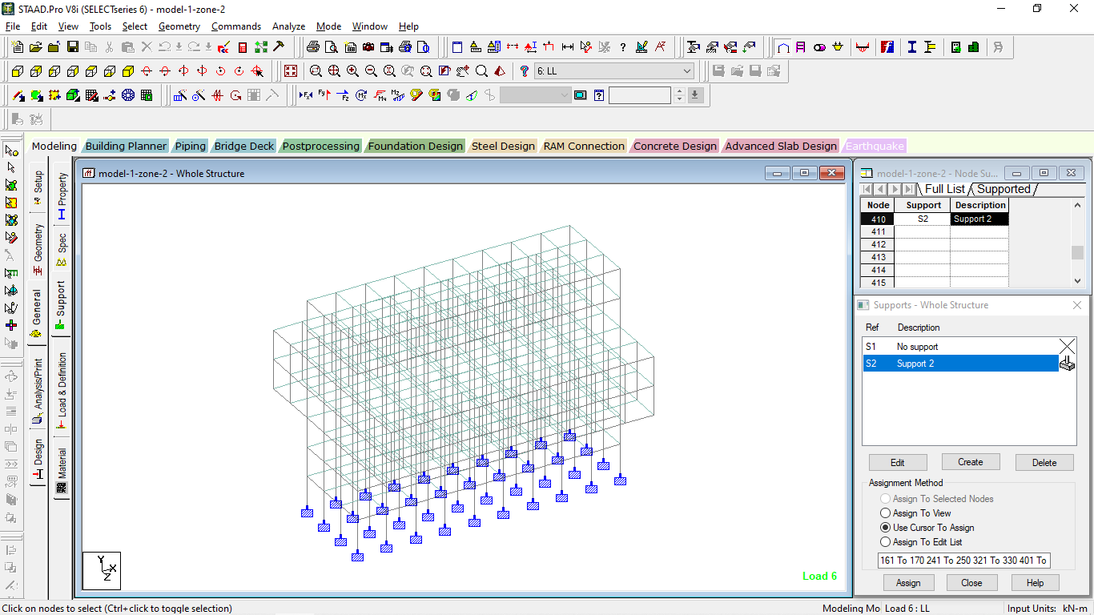
Figure 2:Support assignment to model-IV
The above figure shows the Support assignment to model-IV giving the details of property assigned in the model.

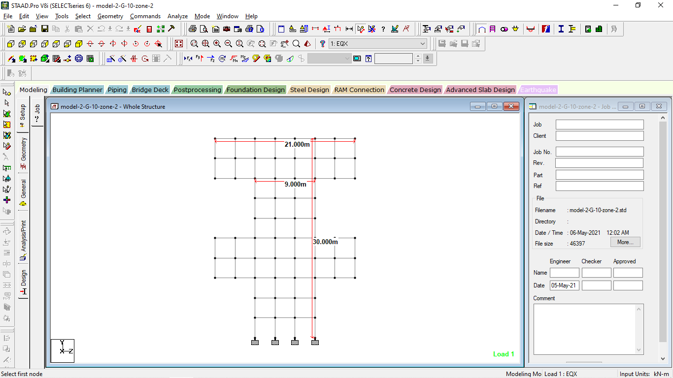
Figure 3:Elevation of model-V
The above figure shows the Elevation of model-V giving the details of dimensions used in the model.

- RESULTS
The analysis is carried out in STAAD-PRO software and the results in terms of shear force, bending moment and other parameter is obtained as follows.

Figure 4:Comparison of displacement (X) for all the models
The above figure shows the Comparison of displacement (X) for all the models and it is observed that the displacement (X) is maximum in the model-10 having the maximum value of 150 mm.
Figure 5:Comparison of displacement (Y) for all the models
The above figure shows the Comparison of displacement (Y) for all the models and it is observed that the displacement (Y) is maximum in the model-10 having the maximum value of 27 mm.
Figure 6:Comparison of displacement (Z) for all the models
The above figure shows the Comparison of displacement (Z) for all the models and it is observed that the displacement (Z) is maximum in the model-10 having the maximum value of 190 mm.
Figure 7:Comparison of displacement (resultant) for all the models
The above figure shows the Comparison of displacement (resultant) for all the models and it is observed that the displacement (resultant) is maximum in the model-10 having the maximum value of 190 mm.
Figure 8:Comparison of Horizontal reaction (Fx) for all models
The above figure shows the Comparison of Horizontal reaction (Fx) for all models and it is observed that the Horizontal reaction (Fx) is maximum in the model-10 having the maximum value of 170 kN.
Figure 9:Comparison of Vertical reaction (Fy) for all models
The above figure shows the Comparison of Vertical reaction (Fy) for all models and it is observed that the Vertical reaction (Fy) is maximum in the model-10 having the maximum value of 3800 kN.

- CONCLUSION:

The conclusions from the above study are as follows:
- The above results shows the Comparison of beam moment (My) for all models and it is observed that the beam moment (My) is maximum in the model-10 having the maximum value of 420 kNm. Also it shows the Comparison of beam moment (Mz) for all models and it is observed that the beam moment (Mz) is maximum in the model-8 having the maximum value of 300 kNm.
- The above results shows the Comparison of Plate shear stresses (SQX-local) for all models and it is observed that the Plate shear stresses (SQX-local) is maximum in the model-10 having the maximum value of 0.35 N/mm2. Also it shows the Comparison of Plate shear stresses (SQY-local) for all models and it is observed that the Plate shear stresses (SQY-local) is maximum in the model-8 having the maximum value of 0.54 N/mm2.
- The above results shows the Comparison of Plate shear stresses (SXY-local) for all models and it is observed that the Plate shear stresses (SXY-local) is maximum in the model-10 having the maximum value of 0.11 N/mm2. Also it shows the Comparison of Plate shear stresses (SX-local) for all models and it is observed that the Plate shear stresses (SX-local) is maximum in the model-10 having the maximum value of 0.11 N/mm2.
- The above results shows the Comparison of Plate shear stresses (SY-local) for all models and it is observed that the Plate shear stresses (SY-local) is maximum in the model-10 having the maximum value of 1.15 N/mm2. Also it shows the Comparison of Plate shear stresses (SXY-local) for all models and it is observed that the Plate shear stresses (SXY-local) is maximum in the model-8 having the maximum value of 0.45 N/mm2.
- The above results shows the Comparison of Plate bending moment (Mx) for all models and it is observed that the bending moment (Mx) is maximum in the model-10 having the maximum value of 3kNm/m. Also it shows the Comparison of Plate bending moment (My) for all models and it is observed that the bending moment (My) is maximum in the model-10 having the maximum value of 8.6 kNm/m.

REFERENCE:
- U RakshithGowda. K. R, Bhavani Shankar (2014).”Seismic Analysis Comparison of Regular And Vertically irregular RC Building with soft storey at different level”.(IJETE) International journal of emerging Technologies and Engineering. Volume 1 issue 6.
- HimanshuGaur, R.K. Goliya, Krishna Murari, Dr.A.K.Mullikh. “A Parametric Study of Multi-storey R\C Buildings with Horizontal Irregularity’’. IJRET Volume: 03. Issue: 04|April 2014.
- Anil Chopra (2004). “Seismic Response of Vertical irregular Frames: Response History and Modal Pushover Analysis”. Journal of Structural Engineering, Vol. 130(8).
- Anvesh (2015). “Effect of Mass Irregularity on Reinforced Concrete Structures using Etabs”. International Journal of Innovative Research in Science, Engineering andTechnology, Vol. 4(10).
- Devesh Soni, P. and Bharat Mistry, B., (2006). “Qualitative review of seismic response of vertically irregular building frames”. ISET Journal of Earthquake Technology, Vol. 43 (4), Pp. 121-132.
- Gowthami, V., Satheesh, V.S. and Suresh Babu, S., (2016). “An Epitome on 3D Plan Irregularities of RC Buildings with Seismic Analysis”. International Journal forScientific Research & Development, Vol. 4(1).
- Gunay Ozmen, Konuralp Girgin and Durgun, (2014). “Torsional Irregularity in Multi-Story Structures”. International Journalof Advanced Structural Engineering(IJASE), Vol.6(4), Pp. 121–131.
- Gupta and Pajagade, P.S., (2012). “Torsional behaviour of multi-storey buildings with plan as well as vertical irregularities”. International Journal for Scientific Research &Development, Vol. 7(3).
- Han Seon Lee and Dong Woo Co, (2002).“Seismic response of high-rise RC bearing-wall structures with irregularities at bottom stories”. 13th World Conference onEarthquake Engineering Vancouver.
- IS: 1893-2002. "Criteria for Earthquake resistant design of structures", Part-1 General provisions and buildings (Sixth revision), Bureau of Indian Standards, New Delhi, India.
- IS 456:2000. Indian standard Plain and reinforced concrete – Code of Practice, Bureau ofIndian standard, New Delhi.
- Kusuma, B., (2017). “Seismic Analysis of a High-rise RC Framed Structure with Irregularities”. International Research Journal of Engineering and Technology (IRJET),Vol.4(7).
- Lakshmi Subash, (2017). “Seismic Behaviour of Vertically Irregular Reinforced Concrete Buildings with P-Delta Effect”. International Research Journal of Engineering andTechnology, Vol. 4(4).
- Moehle, (1984). “Seismic Response of Vertically Irregular Structures”. Journal ofStructural Engineering, Vol. 110(9).
- Neha Modakwar, P., Sangita Meshram, S. and Dinesh Gawatre, W., (2014). “Seismic Analysis of Structures with Irregularities”. Journal of Mechanical and Civil Engineering, Pp. 63-66.

