# Abstract

Neuropathic pain and seizure disorders are the two main conditions for which carbamazepine is prescribed. it is used to treat bipolar disorder as a second-line medication and, in certain situations, to treat schizophrenia when standard antipsychotic therapy has not worked. Evidence, however, opposes using it to treat schizophrenia. Myoclonic and absence seizures cannot be treated with it.

When compared to phenytoin and valproate, carbamazepine may be equally effective (measured by patients continuing to take the medication) and efficacious (measured by the medication reducing seizure recurrence and improving remission). However, the choice of medication should be assessed individually, as more research is required to determine which medication is most helpful for people with newly-onset seizures. It selectively binds to voltage-gated sodium channels in their inactive conformation, preventing the action potential from firing again and continuously.

Carbamazepine is an anticonvulsant drug used to treat neuropathic pain and epilepsy.

**Keywords:-** Carbamazepine, Anticonvulsant, Epilepsy, Neuropathic Pain.

# Introduction

The most prevalent neurological conditions is epilepsy diseases, impacting over 50 million individuals globally. Introduced in 1912, phenobarbital was one of the first drugs used to treat epilepsy. Since then, a number of antiepileptic medications (AEDs) have been created, yet just a handful of them establish oneself. According to estimates, the majority of epileptic individuals are managed with a mere four medications valproic acid, carbamazepine (CBZ), phenobarbital, and phenytoin (1).

Epilepsy is a common neurological disorder. The probability of an individual developing the disorder during a lifetime is between 3% and 5%. Newborn, children, and the elderly have the highest risk of developing epilepsy. An epileptic seizure is defined as a paroxysmal discharge of cerebral neurons, followed by obvious clinical phenomena: motor, sensory, and autonomic, with impairment or complete loss of consciousness. Epilepsy is defined as a condition characterized by repeating seizures (colloquially named “fits”). A patient should not be diagnosed with epilepsy until two such non-febrile seizures occur (2). The original purpose of carbamazepine development was as a possible antidepressant. It is a popular mood stabilizer that can be used to treat bipolar disorder as well as mania. Currently, most guidelines acknowledge it as a useful second-line mood stabilizer for treating and preventing bipolar affective disorder at both stages. Neuropathic pain and epilepsy are the two main conditions for which carbamazepine (CBZ) is used (3).

# Chemical Nature Carbamazepine-

## Carbamazepine -

Carbamazepine is a common neurological disorder. The original purpose of carbamazepine development was as a possible antidepressant. It is a popular mood stabilizer that can be used to treat bipolar disorder as well as mania.

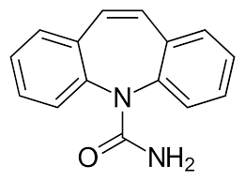

|  |  |  |
| --- | --- | --- |
| **Sr.no** | **Properties** | **Range / Value** |
| **1** | **IUPAC Name** | 5H-dibenzo[b,f]azepine-5- carboxamide |
| **2** | **Form of Carbamazepine** | Crystallized Form |
| **3** | **Molecular Formula** | C15H12N2O |
| **4** | **Molecular Weight** | 236.274 g·mol−1 |
| **5** | **Melting Point** | 204-206°C |
| **6** | **Boling Point** | 191-192 °C |
| **7** | **UV Absorption Wavalength** | 246 nm |
| **8** | **PH** | 7.4 |
| **9** | **Solubility** | Poor water Solubility |

## Pharmacology of Carbamazepine :- Pharmacokinetics :-

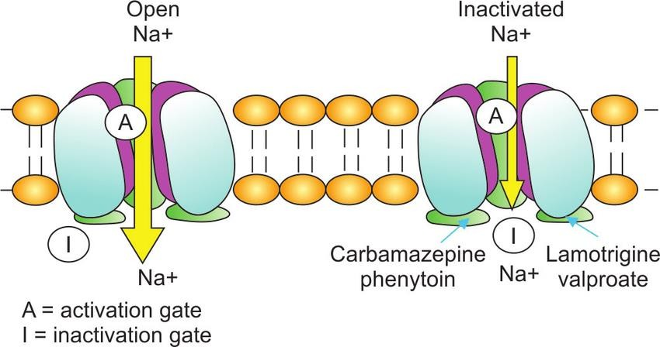

Carbamazepine has complicated pharmacokinetics. They are affected by its restricted solubility in water and by the fact that several anti-seizure medications, such as carbamazepine, can enhance the liver's oxidative enzymes' conversion of the drug to an active metabolite (4).

## Pharmacodynamic :-

By inhibiting sodium channels, carbamazepine stabilizes the neuronal membrane and prevents both depolarization and hyperpolarization, therefore raising excitability and convulsive threshold. Additionally, it restricts cell depolarization inside the epileptic center and lessens the discharge of pathologically altered neurons (5).

It seems that a slowdown in the pace at which voltage-activated sodium channels recover from inactivation is responsible for this impact. When carbamazepine is present in the human CSF at levels within the therapeutic medication range, its effects become noticeable. At these dosages, carbamazepine's effects are selective in that they don't affect spontaneous activity or reactions to GABA or glutamate delivered iontophoretically. 10,11-epoxycarbamazepine, a metabolite of carbamazepine, likewise inhibits prolonged repetitive firing at therapeutically relevant concentrations, indicating that it may play a role in the anti-seizure action of the drug (4).

## Mechanism of Action :-

The sodium channel blocker carbamazepine.It inhibits the repeated and prolonged firing of an action potential by preferentially binding to voltage-gated sodium channels in their inactive state. Although carbamazepine affects serotonin systems, it is unclear how these actions relate to its anti-seizure properties. It may potentially be a serotonin reuptake inhibitor, based on the research suggesting it is a serotonin releasing agent.

## Side effect :-

Atypical thinking, vertigo, fatigue, and challenges Talking, Shaking a portion of the body uncontrollably, bowel obstruction, issues with coordination, walking, and dry mouth

# Uses of Carbamazepine :-

* Used to treat epilepsy
* Used to mange trigeminal neuralgia
* Useful in some patient with mania
* It is not sedative in usual therapeutic range
* Also used to treat neuropathic pain
* Mood stabilizer

# Conclusion

Antiepileptic drugs With a broad spectrum of effectiveness, carbamazepine is a well-known and often used medicine. It works well for treating neuropathic pain, acute manic and mixed episodes of bipolar I illness, epilepsy, and trigeminal neuralgia. The medication works by inhibiting sodium channels and controlling synaptic transmission. Carbamazepine's complex pharmacokinetics include high protein binding, great bioavailability, and self-metabolism. It interacts pharmacodynamically with other ADEs, hence caution should be used when taking certain drugs at the same time.

# References

1. Sindrup, S. H. and Jensen, T. S. 1999. Efficacy of pharmacological treatments of neuropathic pain: un update and effect related to mechanism of drug action. Pain 83:389–400.
2. Kang JQ. Defects at the crossroads of GABAergic signaling in generalized genetic epilepsies. Epilepsy Res. 2017; 137: 9-18. PMID: 28865303, DOI: 10.1016/j.eplepsyres.2017.08.013.
3. Gierbolini J, Giarratano M, BenbadisSR. Carbamazepine-related antiepileptic drugs for the treatment of epilepsy - a comparative review. Ther Adv Chronic Dis. 2016 Apr 21;7(4):173- 176. doi: 10.1517/14656566.2016.1168399.
4. Pohlmann-Eden B, Marson AG, Noack-Rink M, Ramirez F, Tofighy A, Werhahn KJ, Wild I, Trinka E. Comparative effectiveness of levetiracetam, valproate and carbamazepine among elderly patients with newly diagnosed epilepsy: subgroup analysis of the randomized, unblinded KOMET study. BMC Neurol. 2016; 16(1): 149. PMID: 27552848, DOI: 10.1186/s12883-016-0663-7.
5. Pozzi M, Pineschi R, Bonanni P, Pellegri A, Clementi E. Precipitation of CarbamazepineControlled Seizures Due to Low-Dose Risperidone in a Child: A Conspiracy to Unbalance Blood Electrolytes. J Clin Psychopharmacol. 2016; 36(6): 729-30. PMID: 27680767.
6. Pohlmann-Eden B, Marson AG, Noack-Rink M, Ramirez F, Tofighy A, Werhahn KJ, Wild I, Trinka E. Comparative effectiveness of levetiracetam, valproate and carbamazepine among elderly patients with newly diagnosed epilepsy: subgroup analysis of the randomized, unblinded KOMET study. BMC Neurol. 2016; 16(1): 149. PMID: 27552848, DOI: 10.1186/s12883-016-0663-7.