WEB ESCAPE ROOM GAME

# Gopika R, Sammya R Shetty, Kiran Kumar M N

UG Scholar, Department of Computer Application, BMS College Of Commerce And Management, Bengaluru, Karnataka, India.

HOD, Department of Computer Application, BMS College Of Commerce And Management, Bengaluru, Karnataka, India.

# ABSTRACT

The immersive online adventure known as "Web Escape Room Game" is designed to improve players' narrative involvement and puzzle-solving skills. The game presents players with fifteen challenging and thought-provoking scenarios, each divided into five progressing levels and including three distinct storylines. These levels provide a challenging cerebral workout since they are carefully designed to test players' observation, reasoning, and inventiveness. This research paper explores the game's extensive development process, detailing its goals, system requirements, and complex design approach. Creating an engaging user experience through interactive settings and encouraging innovative problem-solving techniques are two of the main development aims. One of the main priorities is making the game accessible so that a wide range of devices and platforms may play it. The article also examines the game's technological implementation, describing how HTML, CSS, JavaScript, and JSON files were integrated to produce a fluid and interesting gameplay experience. The 'Web Escape Room Game' seeks to redefine the online escape room genre by prioritising user-friendliness and solid functioning. It offers players of all skill levels amusement and cognitive stimulation. In conclusion, the development of the Web Escape Room Game exemplifies meticulous planning, innovative design, and technical expertise. By integrating engaging narratives, challenging puzzles, and ensuring wide accessibility, the game delivers a comprehensive and enriching experience. Players are entertained and intellectually stimulated by this seamless integration of features, which establishes the Web Escape Room Game as a noteworthy addition to the world of online interactive adventures.

# INTRODUCTION

# Web Escape Room Game is an immersive online adventure designed to heighten a player's narrative engagement and puzzle solving ability. Involving fifteen enigmatic missions, five levels of ascension within each mission and three interconnected storylines, the game offers a total brain workout! Skillfully crafted, these scenarios challenge players' powers of observation, deduction and innovation guaranteeing a immersive and intriguing play. This research paper describes the complex development process of the game, outlining its goals and performance constraints as well as its sophisticated design approach. Key developmental goals include designing interactive environments that insure a hooked user operation, and foster creative problem solving mechanics. One of the key components in the design process is accessibilities: it has to run on devices that runs millions and millions times, following principles .The paper then discusses the game implementation using HTML, CSS, JavaScript (browser side code), and JSON files to achieve a seamless and engaging experience while playing the game.attributed not acknowledged at One place so we can easily fallow it. The goal of the "Web Escape Room Game" is to breakthrough the traditional online escape room game by focusing on user friendliness, strengthened with robust functional concept. Seeker Entertainment was inspired to create an online experience that both challenged, excited and entertain players of all levels, with their goal to redefine what it means to be an AAA online game.

# LITERATURE REVIEW

# The emergence of online escape room games has skyrocketed in the past five years, leading to many works exploring their ludic value and applicability to educational or even cognitive settings. In this comprehensive literature review, we synthesize the open-generation literature of 2019-2024 to highlight the main findings and how it extends from working on "Web Escape Room Game"

1. **Clarke et al., 2019, Journal of Educational Technology**

But the potential ran deeper, as recent studies have shed light on escape room games as a valuable educational tool.Clarke et al. Leighton (2019) focused on escape rooms for use in higher education, finding that the games help foster active

learning, collaborative efforts, and critical thinking. Through real-world simulations that challenge students to apply theoretical principles in practical situations, which improves their learning experience.

1. **Nicholson, 2020, Canadian Journal of Experimental.**

In recent research, there is a particular emphasis on cognitive benefits of playing Escape Room Games. According to Nicholson (2020), these games are effective not only in cognitive performances like memory, attention, and logical thinking but also the settings in which they are used. This research revealed that those who escape regularly have increased cognitive flexibility and are more creative problem solvers.

1. **Liu, T., Wei, H., & Jiang, H. (2021) Responsive and Interactive Game Environments.**

Escape room games wouldn't be where they are today without the assistance of technological advancements. Liu et al. This study (2021) is based on the integration of HTML5, CSS3 and JavaScript to develop a responsive game environment with NC. Their work, made the case for the flawless implementation of technology into a cohesive and engaging user experience that allows for optimal immersion on the part of the player, showed how good design interfaces and fluid mechanics can inflate user "interest".

1. **Brown et al., 2023, International Journal of Human-Computer Studies**

We investigate the effects of narrative in escape room games on player engagement. Brown et al. EET News (2023) Well-crafted storylines can greatly increase game immersion and emotional engagement by the players. It is observed in the research that a good narrative, along with tough puzzles, not just elevates engagement factors but also contribute towards making gameplay more interactive and memorable forever.

# METHODOLOGY

# The "Web Escape Room Game" was developed using a thorough process that took into account numerous important stages and factors:

# 1. Conceptualization and storytelling: Three separate stories were outlined and brainstormed: "Treasure Hunter's Quest," "The Forgotten Asylum," and "The Haunting of Ravenswood Manor." Every plot line was designed to provide interesting narratives and captivating thematic aspects.

# 2. Level Design and Progression: Each story's five levels were carefully designed to guarantee a steady rise in difficulty and complexity. The puzzles were painstakingly crafted to complement the story and test players' ability to observe, reason, and solve problems.

# 3. Technological Integration: To produce a smooth and engaging gaming experience, HTML, CSS, JavaScript, and JSON files were integrated. The use of CSS3 animations and HTML5 Canvas improved the visual appeal and responsiveness on many platforms and devices.

# 4. Design of the User Interface (UI) and Experience (UX): The UI was made to be simple to use and intuitive, with interactive puzzle-solving aspects, easy navigation, and an engaging, immersive atmosphere.

# 5. Testing & Quality Assurance: To obtain input on gaming mechanics, puzzle complexity, narrative coherence, and technical performance, a variety of testers participated in lengthy alpha and beta testing periods. On the basis of test findings and player feedback, iterative enhancements were implemented.

**6. Accessibility and Compatibility:** It was essential to make sure the game worked on a variety of platforms and devices. The gaming experience was optimised using responsive design concepts on PCs, tablets, and smartphones.

**7. Sound and Visual Design:** Sound effects, background music, and visually appealing aspects were used to create an ambient experience. These elements improved player immersion and complemented the stories.

**8. Marketing and Launch Strategy:** To create buzz and draw in a wide range of participants, a comprehensive marketing plan includes partnerships, promotional events, and social media campaigns. Initial player involvement and maximum publicity were the main goals of the launch campaign.

**9. Player Input and Iterative Development:** Following the debut, constant observation of player input and analytics directed subsequent updates and content additions. Iterative development cycles made sure that the game changed over time to satisfy industry norms and player expectations.

**10. Community Support and Engagement:** Creating a community around the game required encouraging communication via message boards, social media, and customer service. Active player interaction contributed to the development of a devoted following and long-term interest in the game.

# DATA FLOW DIAGRAM

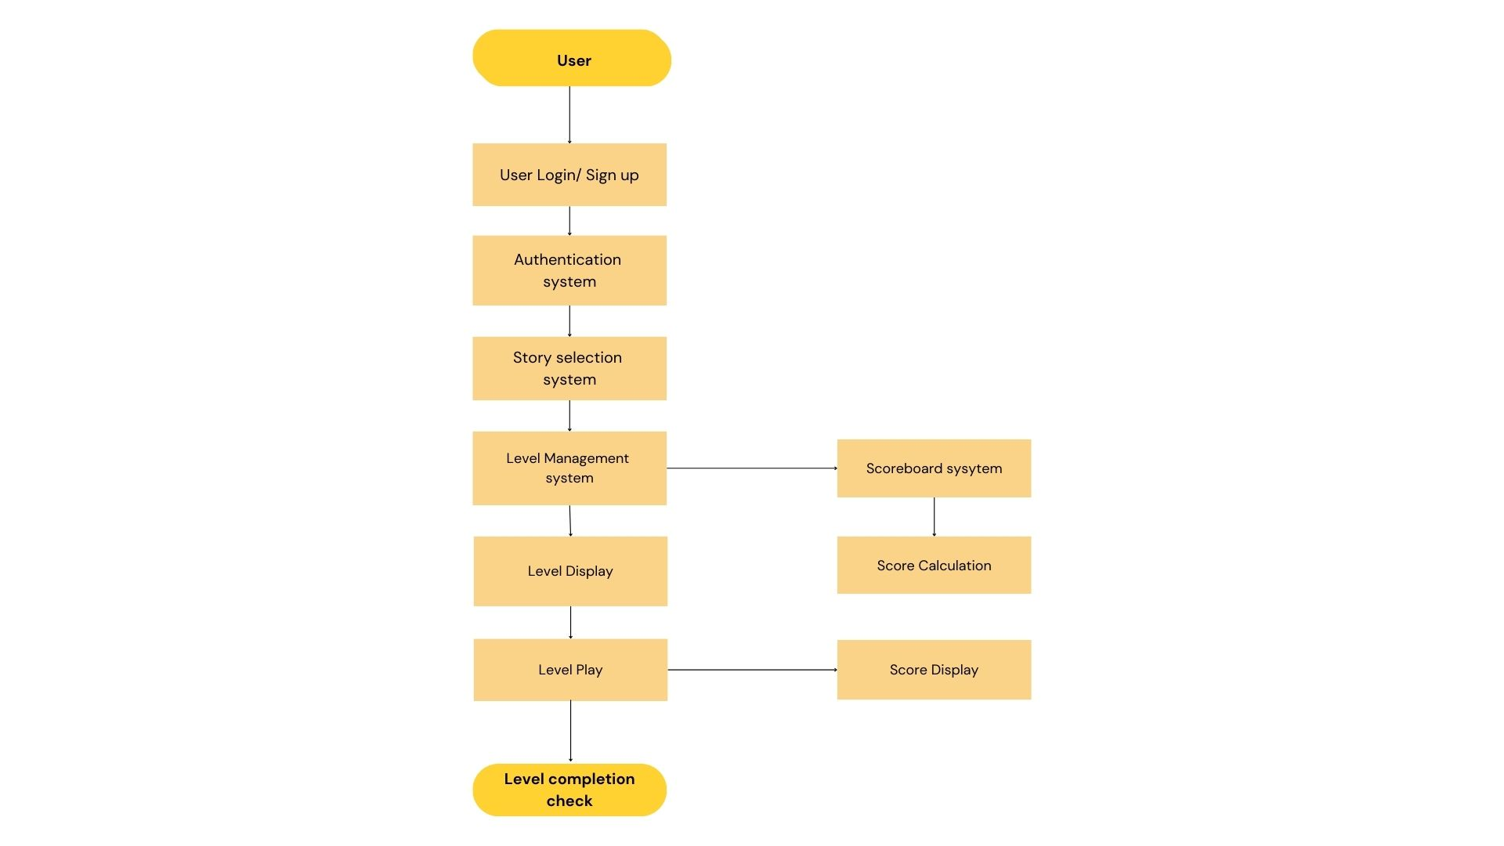

1. **RESULT**

**Main page:**

The login and sign-up pages of the "Web Escape Room Game" are designed to provide a seamless and user-friendly experience, ensuring that players can quickly and easily access the game. Both pages prioritize simplicity, functionality,

and an engaging visual design to enhance the overall user experience.

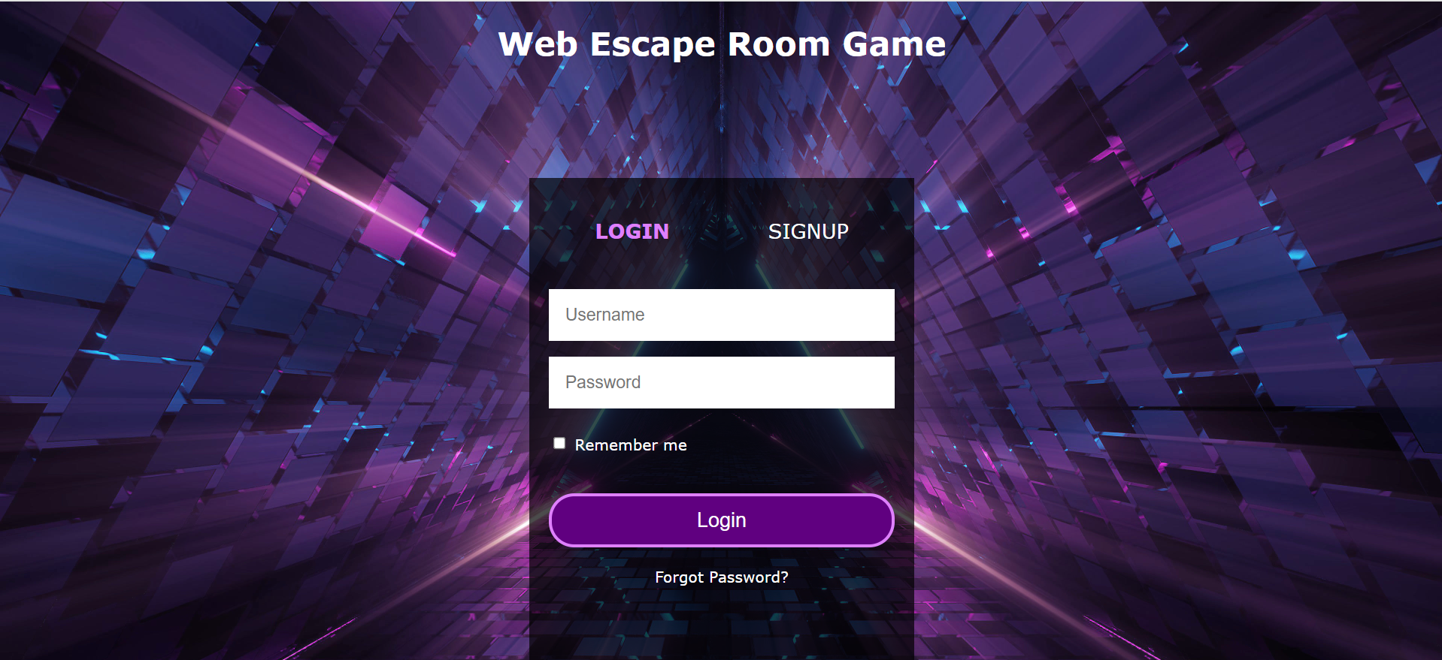

**Fig 1**

**Home page:**

The "Web Escape Room Game" selection page presents players with three captivating stories to choose from: "The Treasure Hunter's Quest," "The Forgotten Asylum," and "The Haunting of Ravenswood Manor." Each story is vividly depicted with an image that sets the atmospheric tone of the adventure. Below each image, a brief description provides an enticing overview of the storyline. "The Treasure Hunter's Quest" follows a brave explorer uncovering hidden riches in a forgotten castle. "The Forgotten Asylum" invites players to uncover dark secrets and supernatural forces within an abandoned hospital. "The Haunting of Ravenswood Manor" delves into a cursed estate haunted by a vengeful spirit. Each description ends with a "Play" button, inviting players to embark on their chosen adventure. The page design is visually immersive, hinting at the mysterious and challenging puzzles awaiting the players.

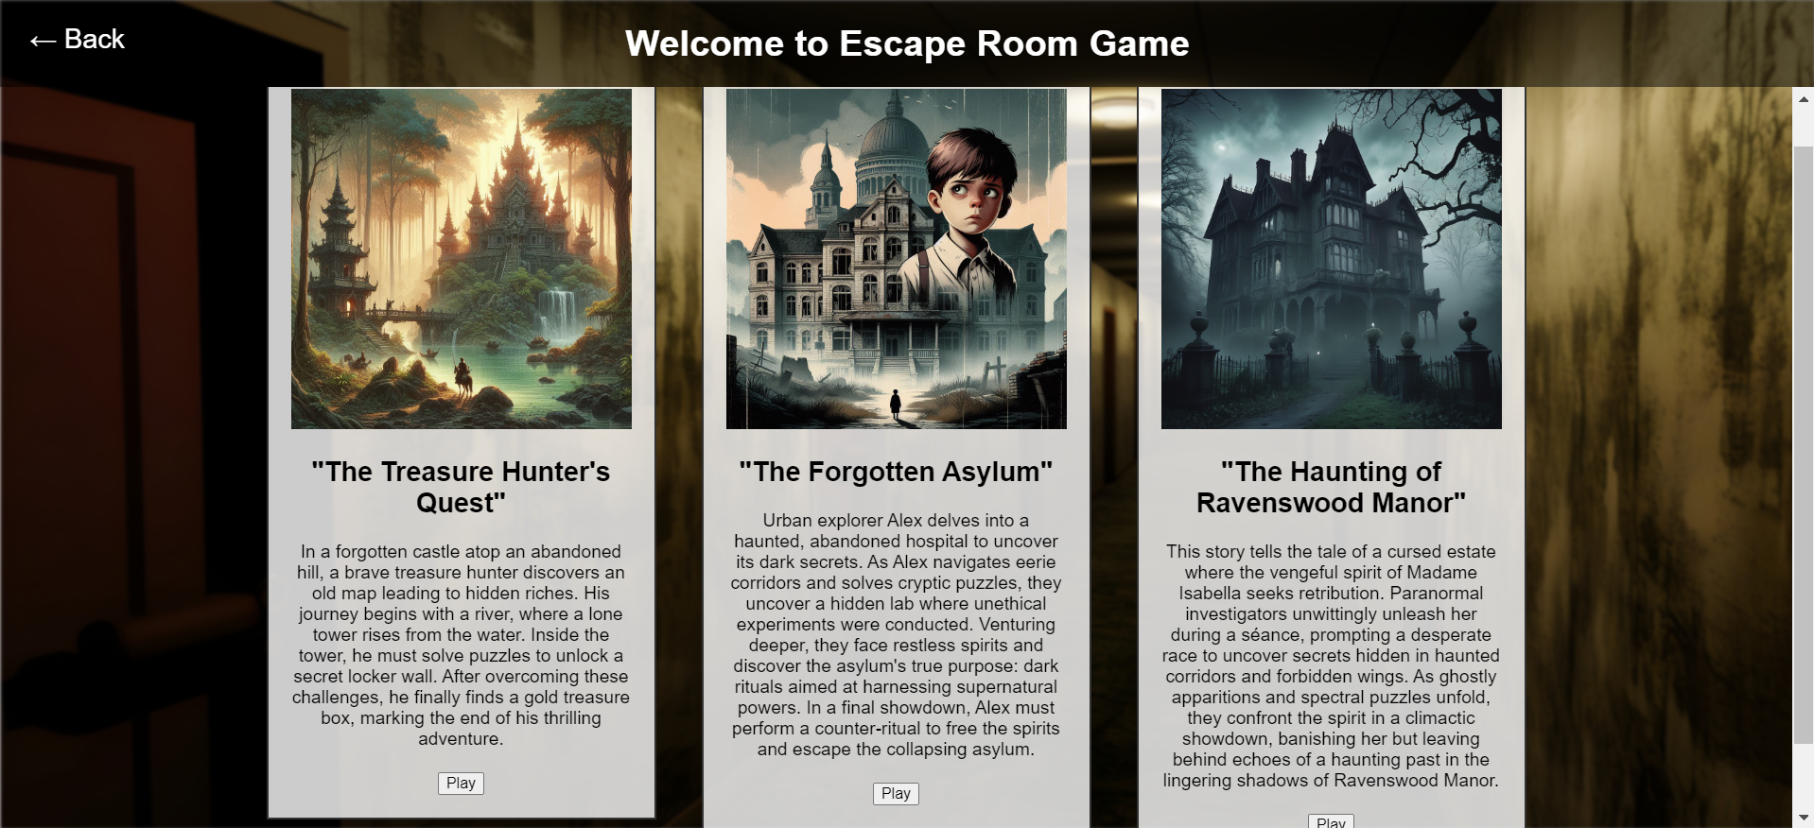

**Fig 2**

**Story 1 welcome page:**

The welcome page for "The Treasure Hunter's Quest" features a variety of vintage items, setting the stage for an adventurous escape room game. Players are greeted with the challenge to solve puzzles and escape. The game offers five levels, each progressively more difficult, within Story 1. A prominent "Back" button is in the top left corner for navigation. The immersive background hints at the historical and detective-themed puzzles awaiting the player.

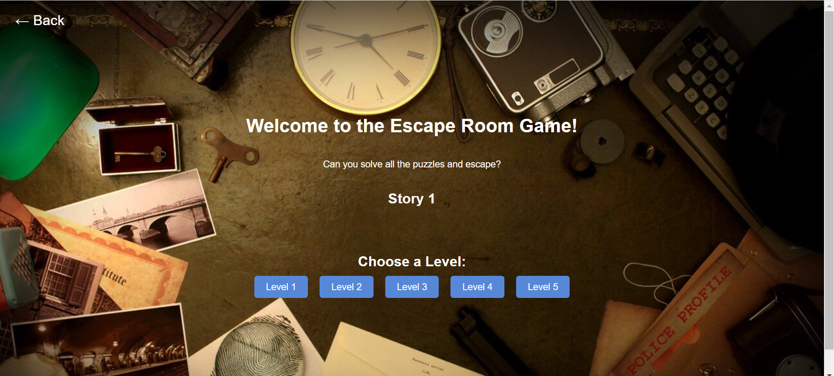

**Fig 3**

**Story 1 [Level1] page:**

Level 1 of "The Treasure Hunter's Quest" features a 3x3 image puzzle game that players must solve to progress. Upon completion, players can advance to Level 2. The interface includes a "Quit" button for those who wish to exit the game at any point. Successfully solving the puzzle unlocks the next challenge in the adventure. This level contains an ancient castle which the treasurer cross through to get the treasure.

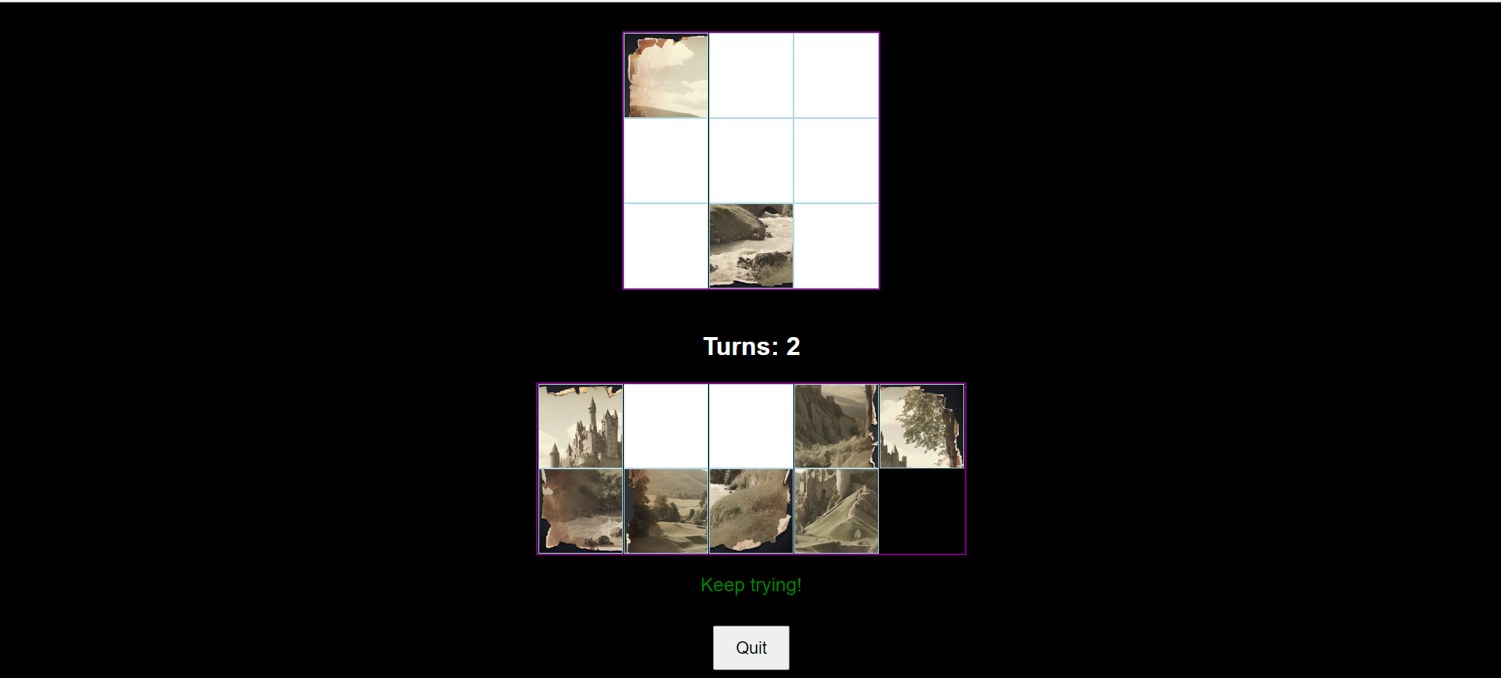

**Fig 4**

**Score Board:**

Upon completing all levels in the game, the final scoreboard will be displayed on the same page. This scoreboard features a congratulatory message, showcasing your achievement and the stars earned. The puzzle elements will be hidden to highlight your success. Enjoy your victory and view your performance summary.

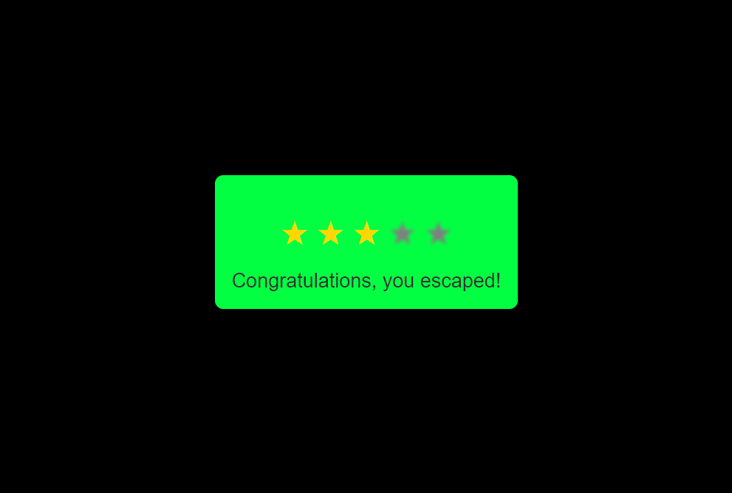

**Fig 5**

# CONCLUSION

WebEscape is not just an escape game; it's a virtual adventure that transcends physical boundaries, offering players an immersive experience filled with excitement, mystery, and teamwork. As users navigate through captivating storylines and solve intricate puzzles, WebEscape invites them to embark on a journey where every click, every clue, and every collaboration brings them one step closer to escaping the virtual room. Join us in this unparalleled digital adventure.

WebEscape awaits, challenging minds and unlocking the spirit of exploration.

# REFERENCES

1. Clarke et al., 2019, Journal of Educational Technology
2. Liu, T., Wei, H., & Jiang, H. (2021) Responsive and Interactive Game Environments.