**COLLEGE MANAGEMENT SYSTEM USING DJANGO**

**Chaithanya S1, Naina Agarwal2, Mr. Kiran Kumar M N3**

1Student, Department of BCA, BMS College of Commerce and Management, Bangalore, Karnataka, India

2 Student, Department of BCA, BMS College of Commerce and Management, Bangalore, Karnataka, India

3 Head of Department, Department of BCA, BMS College of Commerce and Management,

Bangalore, Karnataka, India

1. **ABSTRACT**

This report provides a detailed overview of the methods and strategies used in the requirement gathering, design, implementation, and testing phases of the college management system project. The existing system's shortcomings were identified and documented, with the goal of this project being to address and improve these areas. The project was developed as a website using Django (Python), and additional features were incorporated into the college ERP system to resolve existing issues, such as the ability to modify attendance and grades before they are finalized. The primary objective of this project is to demonstrate the requirements of the College Information Management System and assist organizations in effectively maintaining and managing personal data. This comprehensive project was built from scratch to meet the needs of educational institutions in guiding their students. It encompasses various aspects of college operations, including attendance and leave management, and provides feedback, thereby reducing data errors and ensuring that information throughout the college is up-to-date.

**Keywords:** college ERP, college management, student management, Django-website, teacher-management, feedback, leave-management, result.

1. **INTRODUCTION**

College Management System deals with all kind of student details, academic related reports, college details, course details, curriculum, batch details and other resource related details too. It tracks all the details of a student from the day one to the end of his course which can be used for all reporting purpose, tracking of attendance, progress in the course, completed semesters years, coming semester year curriculum details, exam details, project or any other assignment details, final exam result; and all these will be available for future references too. Our program will have the databases of teacher or faculty's details, batch execution details, students' details in all aspects. The main purpose of this project is to illustrate the requirements of the project College Information Management System and is intended to help any organization to maintain and manage personal data.

1. **LITERATURE REVIEW**

Over the years, CMS has gained significant attention in the field of education, and a considerable amount of research has been conducted to explore its potential benefits. According to the literature, the primary objective of CMS is to improve the efficiency of college operations and provide better services to students, teachers, and administrative staff. One of the primary benefits of CMS is that it simplifies complex administrative tasks such as admission, enrolment, attendance, scheduling, and examination management. A study by Ahmed and Omar (2018) revealed that CMS significantly reduces the time and effort required for these activities, thereby enabling administrators to focus on more important tasks such as improving the quality of education.

CMS also provides a platform for effective communication between students, teachers, and administrative staff. According to Khan et al. (2019), CMS facilitates online discussion forums, feedback mechanisms, and messaging systems that improve communication between stakeholders, leading to better collaboration and greater transparency. Another significant benefit of CMS is its ability to improve the quality of education. CMS provides teachers with tools for managing courses, creating and sharing course materials, and monitoring student progress. A study by Al-Dabbagh et al. (2020) found that CMS enhanced the quality of education by providing teachers with a comprehensive view of student performance, which allowed them to identify areas for improvement and provide targeted feedback to students.

However, despite the potential benefits of CMS, several challenges have been identified in its implementation. One of the primary challenges is the resistance to change from teachers and staff who are accustomed to traditional methods of administration. Teachers and staff who are used to conventional systems of administration sometimes demonstrate reluctance to change, which presents a substantial obstacle when implementing a College Management System (CMS). This resistance frequently has several causes. They can worry that using new technologies would reduce their independence or change their positions within the company. Furthermore, there's a chance that some employees are reluctant to deploy the CMS because they lack the digital literacy or training needed to use it properly.

1. **SCOPE**

This software is designed to suit all colleges, featuring separate divisions for managing student and teacher records, notifications, and discussions. As a public college portal, it promotes transparency and inclusivity, ensuring accessibility without a steep learning curve. With asynchronous communication capabilities to accommodate global users, it supports multiple participants for collaboration and diverse input. Archived discussions preserve community sentiment and decisions over time, while robust search and filtering functionalities facilitate efficient information retrieval. Customizable notifications keep users informed, and analytics provide insights for platform improvement. A structured feedback mechanism ensures continuous academic performance enhancement, aiming to be accessible and inclusive for all community members, present and future.

1. **REQUIREMENT ANALYSIS**

**Processor:** Multi-core processor (e.g., Intel Core i5 or Ryzen 3 and above)

**Memory (RAM):** Minimum 4GB RAM

**Storage:** SSD storage for faster data access and improved performance

**Network:** Stable internet connection

**Operating System:** Windows (Windows 10 or Server editions), macOS, and Linux

**Text Editor**: Visual Studio Code, or PyCharm

**Frontend Technologies:** HTML, CSS, JS

**Backend Technologies:** Python- Version 3.x, Django 3.x

**Database:** SQLite-Lightweight SQL database

**Web Server:** Gunicorn (Green Unicorn)- A Python WSGI HTTP Server

1. **MODULES DESCRIPTION**

The college ERP system caters to three primary user classes: Students, Staff, and Administrators, each with distinct roles and functionalities tailored to their specific needs within the academic institution.

**ADMIN PANEL:** The Administrator (HOD) panel manages student, teacher, and course records, ensures effective communication, coordinates subject and session allocation, oversees leave requests, and manages feedback.

**STAFF PANEL:** The Staff panel enables academic staff to manage student attendance, academic results, leave requests and provide feedback.

**STUDENT PANEL:** The Student panel enables students to monitor attendance, track academic results, communicate with teachers, provide feedback and request for leaves.

1. **DATA FLOW DIAGRAM**

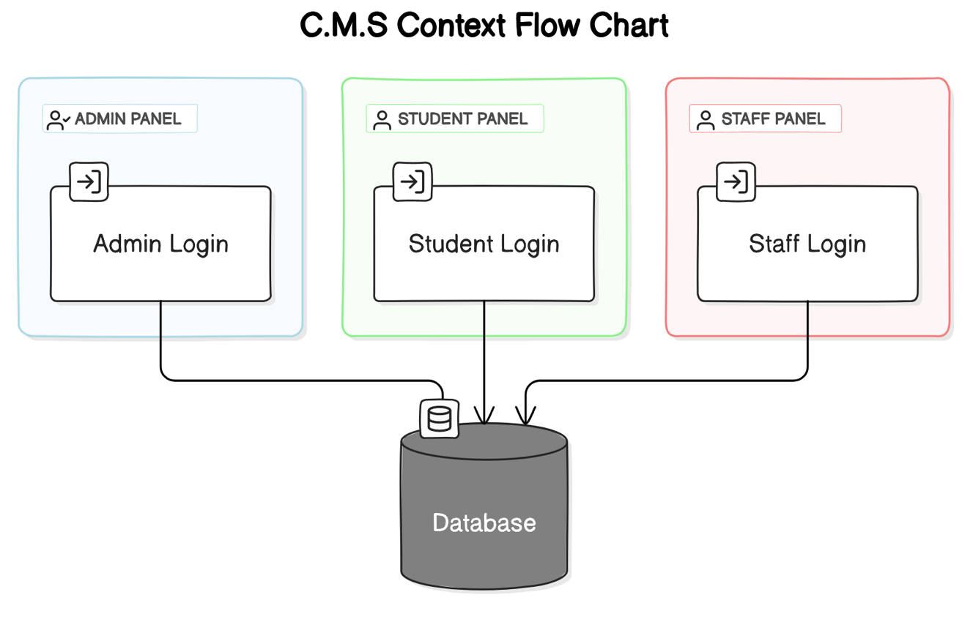

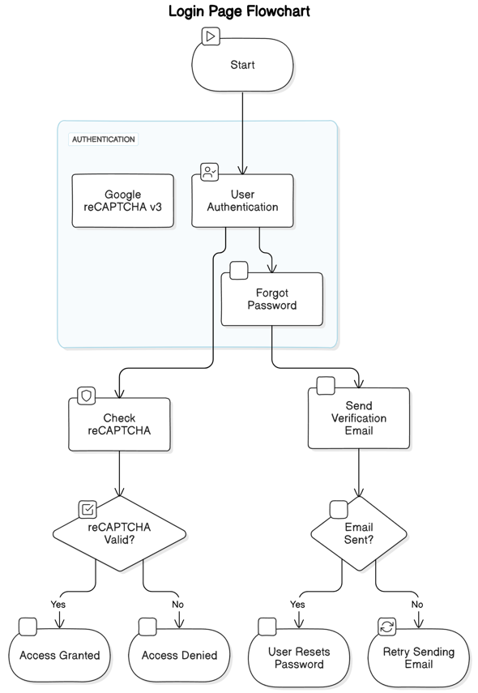

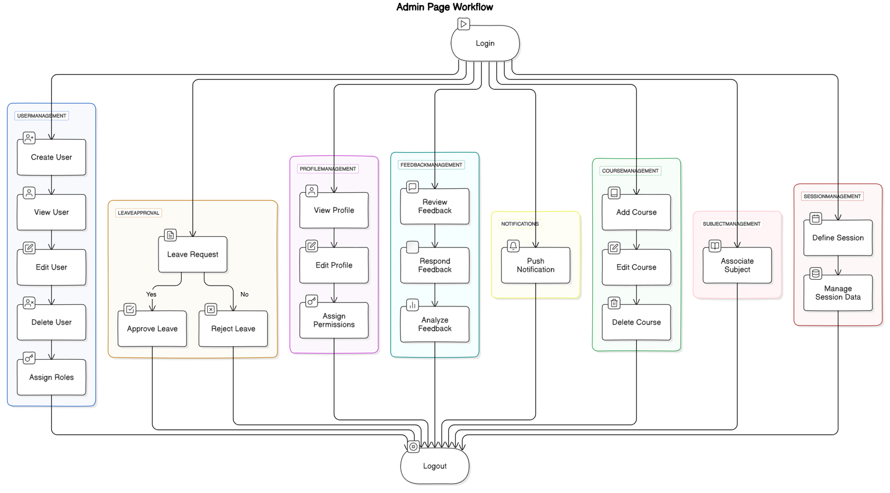

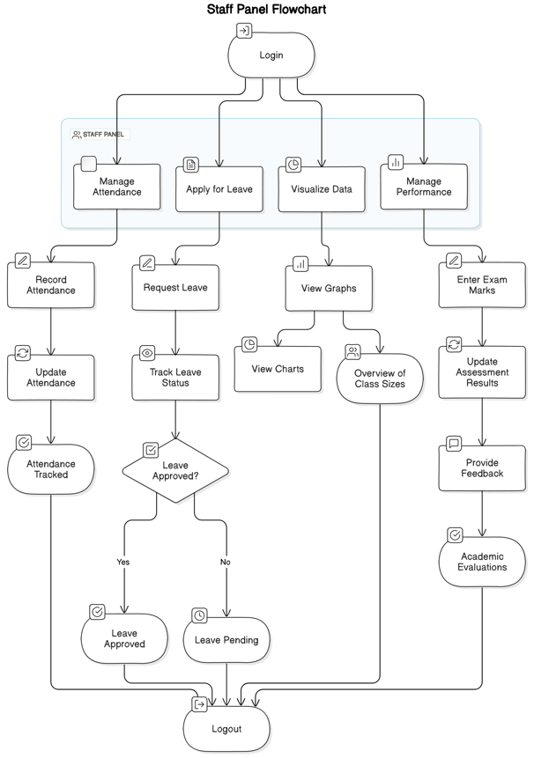

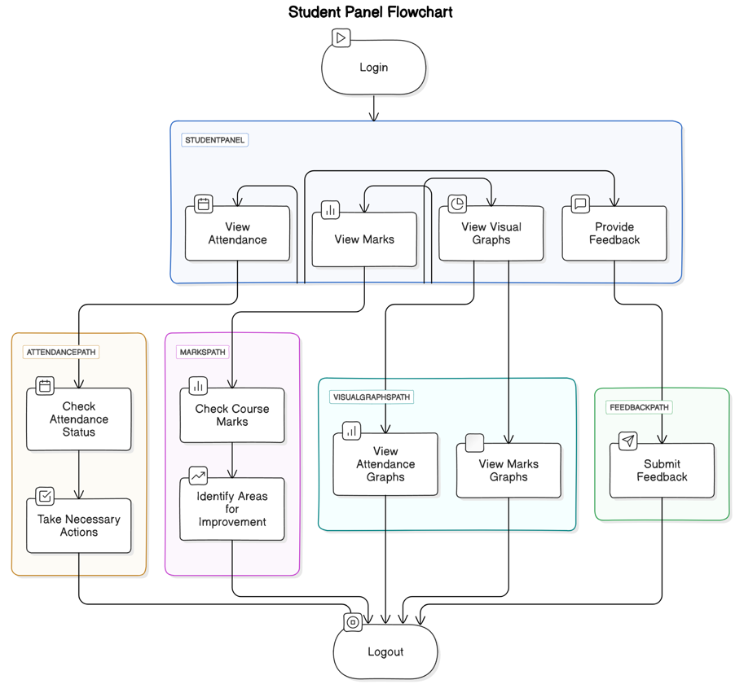

1. **RESULTS**

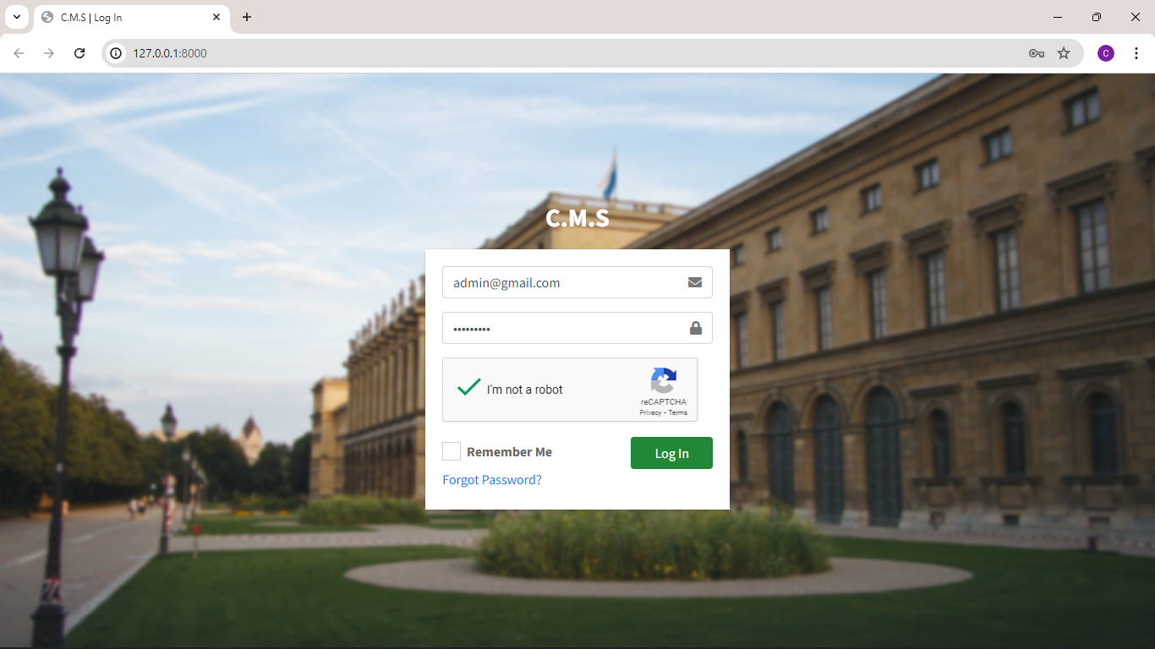

**LOGIN PAGE**

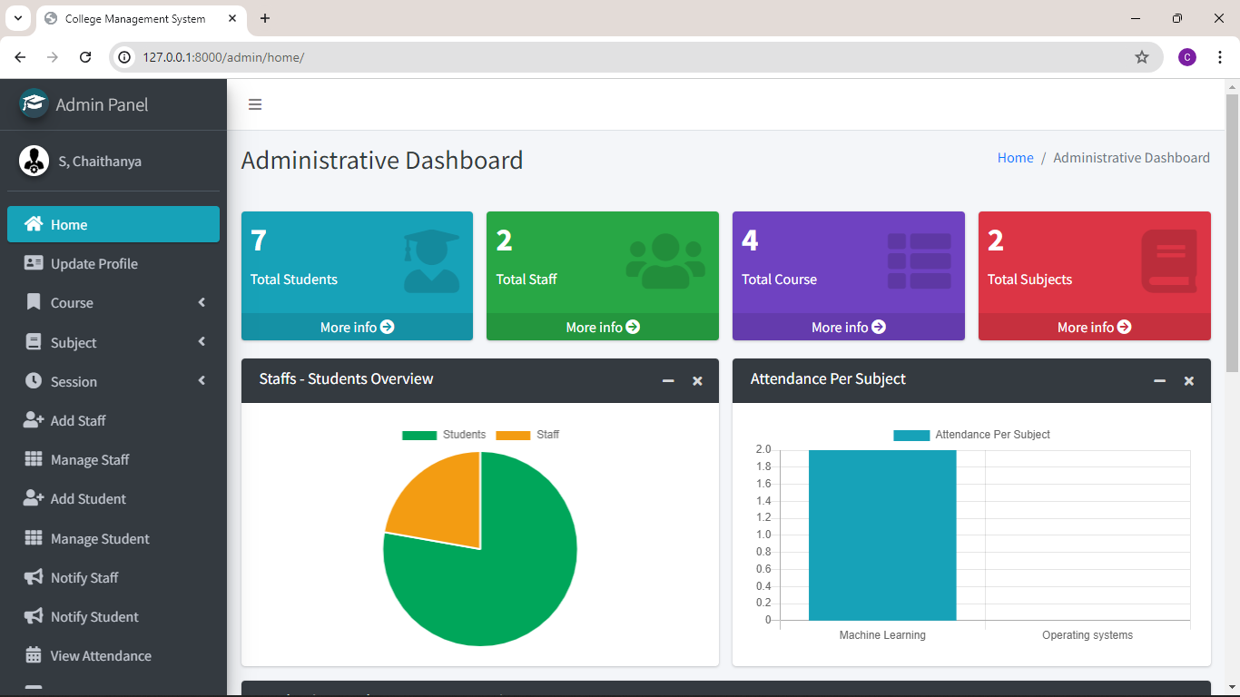

**ADMIN PANEL DASHBOARD**

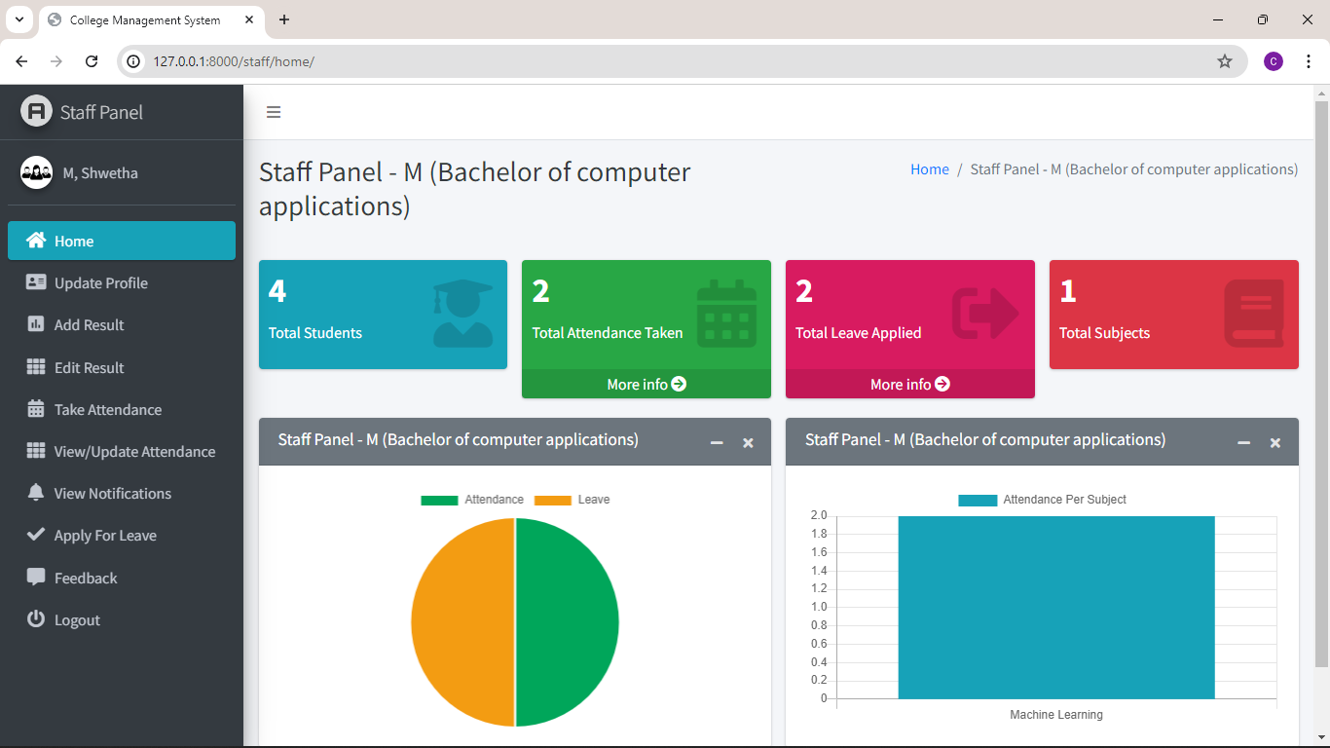

**STAFF PANEL DASHBOARD**

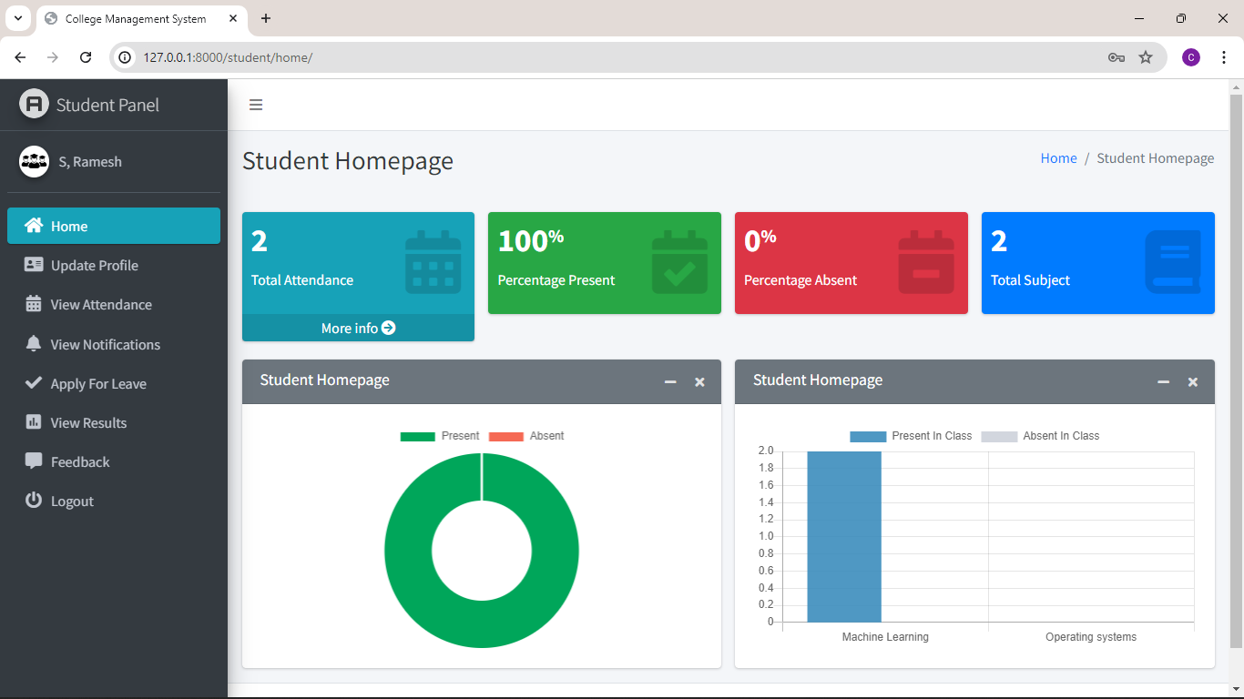

**STUDENT PANEL DASHBOARD**

1. **CONCLUSION**

The current system makes accessing information from files difficult and lacks automation, resulting in a heavy workload for staff. Our College ERP System aims to streamline processes and save time for both students and staff. This system addresses specific issues within the institution, providing easy access to information for users based on their profiles. By automating admissions and eliminating manual processes, this paperless system reduces manpower and ensures accurate information is always available. With features designed to simplify tasks and provide accurate results, this project successfully meets the requirements of a college management system.

1. **REFERENCES**

[1] Ganesh Kumar and P.Vasanth Sena, [“Novel Artificial Neural Networks and Logistic Approach for Detecting Credit Card Deceit,” International Journal of Computer Science and Network Security, Vol. 15, issue 9, Sep. 2015, pp. 222-234](https://research.ijcaonline.org/volume122/number11/pxc3905003.pdf)

[2] Gyusoo Kim and Seulgi Lee, [“2014 Payment Research”, Bank of Korea, Vol. 2015, No. 1, Jan. 2015.](https://ijrpr.com/uploads/V4ISSUE4/IJRPR11875.pdf)

[3] Chengwei Liu, Yixiang Chan, Syed Hasnain Alam Kazmi, Hao Fu, [“Financial Fraud Detection Model: Based on Random Forest,” International Journal of Economics and Finance, Vol. 7, Issue. 7, pp. 178-188, 2015.](https://www.ijcseonline.org/pub_paper/12-IJCSE-08046.pdf)

[4] Hitesh D. Bambhava, Prof. Jayeshkumar Pitroda, Prof. Jaydev J. Bhavsar (2013), [“A Comparative Study on Bamboo Scaffolding And Metal Scaffolding in Construction Industry Using Statistical Methods”, International Journal of Engineering Trends and Technology (IJETT) – Volume 4, Issue 6, June 2013, Pg.2330-2337.](https://www.ijcseonline.org/pub_paper/12-IJCSE-08046.pdf)

[5] P. Ganesh Prabhu, D. Ambika, [“Study on Behaviour of Workers in Construction Industry to Improve Production Efficiency”, International Journal of Civil, Structural, Environmental and Infrastructure Engineering Research and Development (IJCSEIERD), Vol. 3, Issue 1, Mar 2013, 59-66](https://www.jetir.org/papers/JETIR2305C77.pdf)