## A REVIEW ON DIAGNOSIS, CAUSES AND TREATMENT ON HAIR LOSS

**Ms. Anuradha S. Godage , Mr. Sandip V. Jadhav, Dr. Vijaysinh U. Sable,**

**Dr. Rani M. Mhetre.**

**Author, Assistant Professor, Associate Professor, Associate Professor.**

**Department Of Pharmacology, Lokmangal College Of Pharmacy, Wadala, Solapur, Maharashtra, India.**

**ABSTRACT:-**

Hair loss is a common issue that can stem from various congenital or acquired disorders. Physicians’ understanding of the causes and distinctions between these conditions is crucial for accurate diagnosis and treatment. A through clinical evaluation is essential to diagnose individuals experiencing hair fall. It’s important for doctors to stay updated on advancements in therapy. This review article focuses on the common acquired causes of hair loss, providing general practitioners with essential knowledge and management strategies for addressing hair loss and common baldness. Hair loss can be emotionally challenging and profoundly impact the patient’s wellbeing. Patients often initially consult their primary care physician due to widespread or localized hair loss. Dermatologists are best suited to assess scarring alopecia. Non-scarring types can typically be diagnosed and managed directly by family physicians. Hair loss is widely discussed and understanding the causes and treatments of different types of hair loss can significantly improve patients' lives. Exploring conditions like alopecia not only benefits clinical understanding but also offers insights into fundamental biological processes.

**KEYWORDS :-** **Alopecia ,Hair loss causes, Diagnosis of hair loss, scalp examination , Hair transplant .**

**INTRODUCTION:-**

Hair loss, also known as alopecia, is a significant concern affecting both adults and children due to societal emphasis on appearance. Addressing the patient's cosmetic worries is crucial. Alopecia can stem from various causes, some requiring reassurance and education, while others demand medical assessment and treatment. This review focuses on common types such as androgenetic alopecia, telogen effluvium, alopecia areata, and traction alopecia. Hair loss in children covers a range of conditions, both inherited and acquired, stemming from issues with the hair shaft, follicles, or infections.[3,4] Hair loss, known medically as alopecia, represents a common and often distressing condition affecting individuals globally. It encompasses a spectrum of manifestations from localized bald patches to diffuse thinning, impacting both physical appearance and emotional well-being. Current diagnostic strategies for scarring alopecia rely on clinical assessment, supplemented by histopathological examination of scalp biopsies to evaluate the extent of follicular destruction and inflammatory infiltrates. However, challenges persist in accurately distinguishing between different subtypes of scarring alopecia and predicting disease progression. Hair loss, or alopecia, is a common dermatological condition that can significantly impact patients' quality of life and psychological well-being.[2,7,8]

**SIGNS AND SYMPTOMS OF HAIR LOSS:-**

**Thinning Hair:** As hair follicles miniaturize due to dermal papilla cell senescence, affected individuals may experience overall thinning of hair on the scalp.

**Gradual Hair Loss:** Over time, the miniaturization and eventual loss of hair follicles lead to the gradual onset of hair thinning and balding patterns characteristic of androgenetic alopecia.[9]

**Bald Patches:** Areas of the scalp or other body parts where hair completely falls out, leaving smooth, round patches.

**Receding Hairline:** A receding hairline, particularly common in men, where hair starts to thin and recede from the forehead.[10]

**Circular or Patchy Bald Spots:** Areas on the scalp where hair is lost in circular or patchy patterns, characteristic of conditions like alopecia aerate.

**Sudden Hair Loss:** Rapid shedding of hair, often resulting in handfuls of hair coming out when brushing or washing, indicative of conditions like telogen effluvium.[11]

**Increased Hair Shedding:** Telogen effluvium is characterized by a noticeable increase in hair shedding from the scalp. This shedding can occur throughout the day and may be particularly evident during activities like washing or brushing hair.

**Widening of the Hair Part:** In women, telogen effluvium may cause a widening of the hair part due to decreased hair density across the scalp.[12]

**CAUSES OF HAIR LOSS:-**

**Genetics:** Inherited genes play a significant role in male pattern baldness (androgenetic alopecia), leading to progressive hair thinning and eventual baldness. It is the most usual cause of hair loss.

**Hormonal Factors**: Androgens (male hormones) can affect hair growth cycles, leading to shorter growth phases and miniaturization of hair follicles.[13]

**Medical Conditions:**

Scalp infections (e.g., fungal infections like ringworm), chronic illnesses (e.g., lupus), and certain medical treatments (e.g., chemotherapy, radiation therapy) can lead to hair loss as a side effect.

**Nutritional Deficiencies:**

Inadequate intake of essential nutrients, such as iron, protein, vitamins (especially B vitamins), and minerals (like zinc), can affect hair growth and contribute to hair loss.[14]

Tight braids, ponytails, elastic hair bands, rollers, and similar styling methods can cause significant stress on the scalp hair.

Often, an event triggers the process 3 to 6 months before the shedding begins. Acute shedding was initially described after febrile diseases, childbirth, chronic systemic diseases, use of heparin, and emotional distress.3 Other factors identified as both acute and chronic causes of telogen effluvium include numerous drugs, endocrine disorders, severely restrictive diets, surgical procedures, and anaesthesia.[15]

The hair growth cycle is a continuous process consisting of four main phases: anagen, catagen, telogen, and exogeny. Each phase plays a crucial role in the growth, shedding, and renewal of hair follicles.

Hair loss can occur at different stages of this cycle due to various reasons: Androgen and Stress-related Causes, Systemic Causes, Environmental Factors and Aging and Genetic Factors.[16]

sebaceous gland loss and inflammation may play a role in the pathogenesis of scarring alopecia, which is a type of hair loss. Therefore, according to this study, the cause of hair loss in scarring alopecia could be attributed to sebaceous gland loss and inflammation.[17]

### **Androgenetic alopecia:**

Androgenetic alopecia is a genetic condition where males typically experience hair loss from the temples and crown, while females tend to have overall thinning hair. It often manifests more prominently with age, though it can begin post-puberty and may worsen after menopause in women, influenced by hormonal changes. Treatment options like minoxidil (Rogaine, Loniten) can promote hair growth, with visible results typically appearing within 6 to 12 months consistent use.

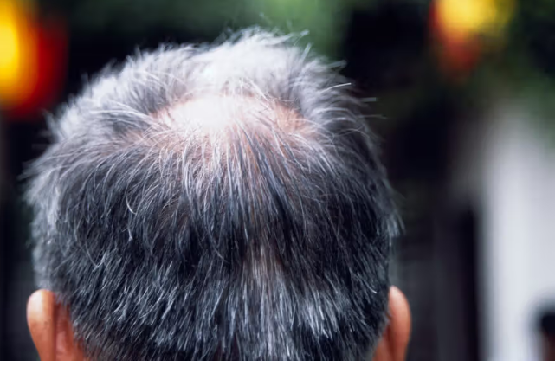

Androgenetic alopecia (Fig 1)

### **Pregnancy:**

Experiencing excessive hair loss after giving birth, known as postpartum hair shedding or telogen effluvium, is quite common and typically occurs due to hormonal changes. During pregnancy, elevated estrogen levels prolong the anagen (growth) phase of the hair cycle, resulting in thicker hair. However, after childbirth, estrogen levels drop, causing more hair follicles to enter the telogen (resting) phase and eventually shed. This shedding usually peaks around three to six months postpartum but tends to resolve within a year as hormone levels stabilize.

**Telogen effluvium:**

Healthy hair follicles progress through four growth phases. During the anagen phase, follicles produce hair, promoting growth. Subsequently, growth slows in the catagen phase, followed by natural shedding in the telogen phase, where hair loss increases in the exogen phase.

Telogen effluvium occurs when hair follicles remain in the telogen phase longer than usual, leading to excessive hair shedding, often noticeable as significant hair loss.

Several factors can trigger telogen effluvium, including childbirth, surgery, severe stress, rapid weight loss, thyroid disorders, and specific medications.[18]

**TREATMENT:-**

Telogen effluvium is a common cause of hair loss characterized by increased hair shedding and diffuse thinning, typically occurring 1 to 6 months after a triggering event. The scalp appears normal without signs of inflammation or scarring, and pulling on the hair easily removes more telogen hairs than usual. This condition results from a higher proportion of hairs entering the telogen (resting) phase prematurely before they are shed.

Common triggers for telogen effluvium include acute or chronic illness, surgery, changes in medication, thyroid problems, nutritional deficiencies, and severe stress. A thorough history is necessary to identify potential triggers or underlying conditions. If no clear cause is evident, screening blood tests are often performed to uncover any hidden disorders.

Once the underlying cause is identified and addressed, hair regrowth typically resumes within about 6 months.

**Androgenetic Alopecia**:

Treatment options for thinning hair vary depending on the underlying cause. FDA-approved medications such as minoxidil and finasteride are commonly used to address androgenetic alopecia, also known as male and female pattern baldness.

Minoxidil is available in 2% or 5% strengths and is applied directly to areas of thinning hair. It typically takes 6–12 months to see improved hair growth, but discontinuing the treatment can lead to hair loss recurrence. Potential side effects include contact dermatitis, skin irritation, and excessive hair growth on the face and other body areas.

Finasteride, also known as Propecia, is an oral medication taken daily at a 1 milligram dose. It is prescribed for males and females from puberty to menopause who have not responded well to minoxidil treatment. Potential side effects include erectile dysfunction, decreased libido, and gynecomastia (growth of breast tissue).

### **Pregnancy:**

Hair loss during and after pregnancy often resolves without specific treatment, typically improving over time on its own.

In cases where hair growth does not return to previous levels, doctors may consider prescribing minoxidil (Rogaine). However, it's important to note that minoxidil is not recommended for use during pregnancy due to safety concerns.

In the case of conditions Such as hypothyroidism or iron deficiency anemia, working with your doctor to find medication or vitamin supplements that will return your levels to normal should help start the regrowth cycle with time.

The majority of treatments for other conditions, such as androgenic alopecia, are also not recommended during pregnancy. Your doctor may suggest to try low-level laser treatment (LLLT), which uses red light waves to stimulate hair growth, instead of medications.[19]

**DIAGNOSIS:-**

A general practitioner, internist, or gynecologist can conduct initial health screenings. Dermatologists specialize in skin, hair, and nail issues and can offer advanced diagnoses and treatments for hair thinning and loss, sometimes requiring a scalp biopsy.[22]

Increased hair shedding often occurs early in female pattern hair loss (FPHL). When women experience this shedding but do not see a noticeable decrease in hair volume over the middle-front scalp, various potential diagnoses should be considered, particularly acute and chronic telogen effluvium. Acute telogen effluvium typically resolves on its own and can be triggered by physical illness, surgery, blood loss, or rapid weight loss. Chronic telogen effluvium (CTE) may result from conditions such as thyroid disease, systemic lupus, certain medications, or iron deficiency anemia.[23]

**Trichotillomania:**

Trichotillomania can be distinguished by the presence of hairs of varying lengths within the balding areas.[24]

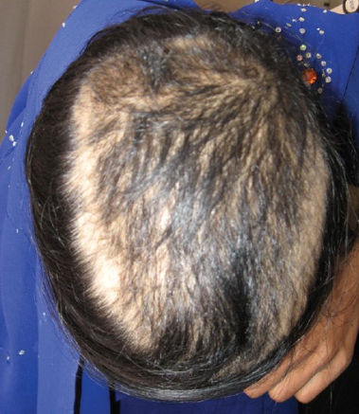

Trichotillomania: (Fig 2)

Young girl with trichotillomania. Note terminal hairs of variable lengths

**Tests that can be conducted at the bedside to assess hair loss:**

**1.Card Test:**

The card test is employed to distinguish between newly growing hairs, broken hairs, and miniaturized hairs. It involves using an 8 × 12 cm card with contrasting white and black colors on one side to provide contrast against the hair shafts. By placing the card on the affected area of the scalp, differences in hair characteristics such as tapered ends for newly growing hairs, blunt ends for broken hairs, and smaller caliber for miniaturized hairs can be identified.

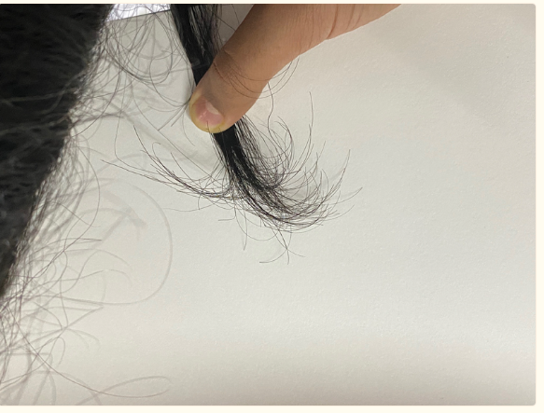

Card Test ( Fig 3)

**2.Hair Pull Test:**

The hair pull test is a straightforward bedside examination used to evaluate ongoing hair loss. Approximately 50 to 60 hairs are gently grasped between the thumb, index, and middle fingers. By pulling along the hair shaft from the scalp towards the ends, the ease of hair extraction is noted. A positive result, indicating active hair loss, is defined by the extraction of more than 5 to 6 hairs. This test should be performed across all scalp regions, and patients are advised to avoid washing their hair for at least 24 hours prior to the examination.

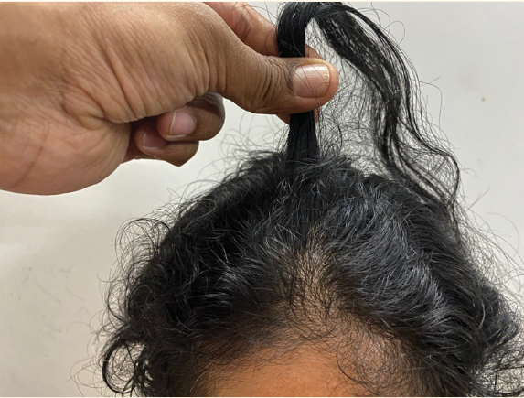

(Fig 4) Hair Pull Test

**3.Tug Test:**

The tug test evaluates hair fragility by grasping a group of hairs midway along the shaft length and gently pulling from the ends, as demonstrated in Fig. 5. If the hair shaft breaks during this test, it indicates fragility and possible abnormalities in the hair shaft structure.[25]

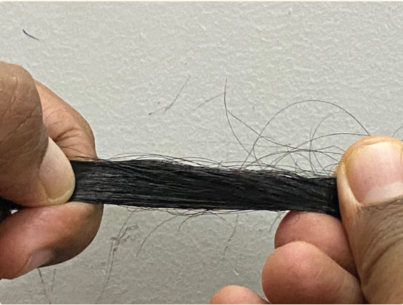

(Fig. 5) Tug Test

**RESULT:-**

Diagnosing the causes of hair loss involves a comprehensive evaluation that includes a detailed medical history, physical examination, and often additional tests such as blood work or scalp biopsy. The primary types of hair loss include androgenetic alopecia, which is hereditary and hormone-related, resulting in gradual hair thinning; telogen effluvium, typically triggered by stress, illness, medications, or hormonal changes, causing sudden hair shedding; alopecia areata, an autoimmune condition leading to patchy hair loss due to immune system attacks on hair follicles; and traction alopecia, caused by repeated tension on hair follicles from hairstyles like tight braids or ponytails. Treatment approaches vary depending on the underlying cause. For androgenetic alopecia, options include medications like minoxidil and finasteride, as well as surgical procedures such as hair transplant.

**CONCLUSION:-**

In conclusion, diagnosing the underlying causes of hair loss involves a thorough assessment encompassing medical history, physical examination, and potentially additional tests to pinpoint the specific type and triggers. From androgenetic alopecia to telogen effluvium, alopecia areata, and traction alopecia, each condition requires tailored treatment strategies. Whether through medications like minoxidil and finasteride, corticosteroid injections, or changes in hair care practices, addressing hair loss necessitates a multifaceted approach aimed at both treating the condition and managing cosmetic concerns. Collaboration with healthcare professionals, particularly dermatologists, ensures individualized care to achieve optimal outcomes for patients dealing with hair loss.

## REFERENCES:-

1.**Dawber R** (1995). Hair and scalp disorders, common presenting signs, differential diagnosis and treatment. 1st edition, Martin Dunitz. London, .

2. **Smith, A.B., Jones**, C.D. (2023). Diagnosis, Causes, and Treatment of Hair Loss: A Comprehensive Review. Journal of Dermatological Science

3**.Liwen Xu,Kevin X Liu and Maryanne M. Senna (24 July 2017)** Harvard Medical School, Boston, MA, United States, Department of Dermatology, Massachusetts General Hospital, Boston, MA, United States

4**. Fabiane Mulinari** Brenner Universidade **Federal do Paraná Wilma F Bergfeld** Cleveland Clinic (September 2001) Dermatology nursing / Dermatology Nurses' Association

# 5.**Ibrahim K AL Aradi(**12 June 2004)As'ad Al Hamad Dermatology Center , Sabah Hospital, Kuwait · Dermatologic Surgery Unit MBBS FRCPC FAAD

# Hair Fall: Common Causes and Treatment Modalities

6**.** [**Ji Qi**](https://pubmed.ncbi.nlm.nih.gov/?term=Qi%20J%5BAuthor%5D) **and**[**Luis A. Garza**](https://pubmed.ncbi.nlm.nih.gov/?term=Garza%20LA%5BAuthor%5D)(2014 Mar) An Overview of Alopecias

7. **Al-Zaid T, Vanderweil S, Zembowicz** A, Lyle S 2011. Sebaceous gland loss and inflammation in scarring alopecia: A potential role in pathogenesis. *J Am Acad Dermatol*

8. **Baibergenova** A, Walsh S. Use of pioglitazone in patients with lichen **planopilaris. J Cutan Med** Surg. 2012;16

9. **Bahta AW, Farjo N, Farjo B, Philpott MP** 2008. Premature senescence of balding dermal papilla cells in vitro is associated with pp16INK4a expression. J Invest Dermatol

10. ***J Cutan Med Surg***  Baibergenova A, Walsh S 2012. Use of pioglitazone in patients with lichen planopilaris.

11. **Betz RC, Pforr J, Flaquer A, Redler S, Hanneken S, Eigelshoven S, Kortüm AK, Tüting T, Lambert J, De Weert J,** et al. 2007. Loss-of-function mutations in the filaggrin gene and alopecia areata: Strong risk factor for a severe course of disease in patients comorbid for atopic disease. *J Invest Dermatol*

12. **Bleiker TO, Nicolaou N, Traulsen J, Hutchinson** PE 2005. “Atrophic telogen effluvium” from cytotoxic drugs and a randomized controlled trial to investigate the possible protective effect of pretreatment with a topical vitamin D analogue in humans.

13. **Callahan CA, Oro AE** 2001. Monstrous attempts at adnexogenesis: Regulating hair follicle progenitors through Sonic hedgehog signaling. *Curr Opin Genet Dev*

14. **Rushton DH** (1993). Management of hair loss in women. Dermatol Therapy

# 15. [**Fabiane Mulinari-Brenner**](https://pubmed.ncbi.nlm.nih.gov/?term=Mulinari-Brenner+F&cauthor_id=12959397)[**Wilma F Bergfeld**](https://pubmed.ncbi.nlm.nih.gov/?term=Bergfeld+WF&cauthor_id=12959397) **September 2003 Cleveland** Clinic Journal of Medicine September Hair loss: Diagnosis and management

# 16. [**J Prev Med Hyg.**](https://www.ncbi.nlm.nih.gov/pmc/articles/PMC9710406/) An overview of the genetic aspects of hair loss and its connection with nutrition

[NURIYE GOKCE](https://pubmed.ncbi.nlm.nih.gov/?term=GOKCE%20N%5BAuthor%5D),[NESLIHAN BASGOZ](https://pubmed.ncbi.nlm.nih.gov/?term=BASGOZ%20N%5BAuthor%5D),[SERCAN KENANOGLU](https://pubmed.ncbi.nlm.nih.gov/?term=KENANOGLU%20S%5BAuthor%5D),[HILAL AKALIN](https://pubmed.ncbi.nlm.nih.gov/?term=AKALIN%20H%5BAuthor%5D),[YUSUF OZKUL](https://pubmed.ncbi.nlm.nih.gov/?term=OZKUL%20Y%5BAuthor%5D),[MAHMUT CERKEZ ERGOREN](https://pubmed.ncbi.nlm.nih.gov/?term=ERGOREN%20MC%5BAuthor%5D),,[TOMMASO BECCARI](https://pubmed.ncbi.nlm.nih.gov/?term=BECCARI%20T%5BAuthor%5D),[MATTEO BERTELLI](https://pubmed.ncbi.nlm.nih.gov/?term=BERTELLI%20M%5BAuthor%5D),and [MUNIS DUNDAR](https://pubmed.ncbi.nlm.nih.gov/?term=DUNDAR%20M%5BAuthor%5D)corresponding author 2022 Jun

17. **)Al-Zaid T, Vanderweil S, Zembowicz A**, Lyle S 2011. Sebaceous gland loss and inflammation in scarring alopecia: A potential role in pathogenesis. J Am Acad Dermatol

18. Medically reviewed by **Reema Patel**, MPA, PA-C — Written by Beth Sissons — Updated on December 6, 2023

19**.** [**Rajani Nalluri**](https://pubmed.ncbi.nlm.nih.gov/?term=Nalluri%20R%5BAuthor%5D), specialist trainee in dermatologyand [**Matthew Harries**](https://pubmed.ncbi.nlm.nih.gov/?term=Harries%20M%5BAuthor%5D), consultant dermatologist and honorary senior lecturer [Clin Med (Lond).](https://www.ncbi.nlm.nih.gov/pmc/articles/PMC4954340/) 2016 Feb

20. Medically reviewed by **Sharleen St. Surin-Lord, MD** — Written by **Adrienne Stinson** — Updated on January 23, 2024

21. Medically reviewed by **Holly Ernst**, PA-C — Written by Ashley Marcin on September 17,2018

22.[**Gary W. Cole, MD, FAAD**](https://www.medicinenet.com/script/main/art.asp?articlekey=149323)**(**12/14/2023) BA degree in bacteriology, his MA degree in microbiology, and his MD at the University of California, Los Angeles.

23**.** [**Clin Interv Aging.**](https://www.ncbi.nlm.nih.gov/pmc/articles/PMC2684510/) 2007 Jun **Female pattern hair loss: Current treatment concepts** Quan Q Dinh and [Rodney Sinclair](https://pubmed.ncbi.nlm.nih.gov/?term=Sinclair%20R%5BAuthor%5D)

24. **Archana Singal, Sidharth Sonthalia, Prashant Verma** Department of Dermatology

University College of Medical Sciences and GTB Hospital, University of Delhi

Symposium-Hair Disorders 2013

25. **Sukhbir Singh** and **Kumaresan Muthuvel** Practical Approach to Hair Loss

[Indian **J Plast Surg**.](https://www.ncbi.nlm.nih.gov/pmc/articles/PMC8719967/) 2021 Oct Published online 2021 Dec 27