**PETZEE- Analyzing the dynamics of a pet shop ecommerce platform**

**Dhanya Manjunath hegde *1, Keerthana N*2,**

**Ms. Keerthana H.R*3**

*1UG Scholar, Department of Computer Application, BMS College of commerce and management, Bangalore, Karnataka, India

*2UG Scholar, Department of Computer Application, BMS College of commerce and management, Bangalore, Karnataka, India

*3Assistant professor, Department of Computer Application, BMS College of commerce and management, Bangalore, Karnataka, India

**ABSTRACT**

Having a pet not just helps people emotionally, but it also helps them physically. It decreases stress, lowers blood pressure and keeps an individual more active. Evidently more people are realizing this, and adding a new member to their family. Our Petzee is a website where one can purchase food, accessories and also book an appointment with the best Vernerian near your location for your pet. To meet the needs of different pet owners, our platform provides a wide variety of toys, accessories, and pet food goods. In addition to this, the website also incorporates a tool that allows them to schedule veterinary appointments. This is an online store dedicated to the pet owners and lovers which will help them get all the things related to pet at one place. The objective of this project is to provide one stop shop for pet products and enable online transaction.

**Keywords:** Analysis, Ecommerce, Internet, Technology, Pets, Shopping

1. **INTRODUCTION**

This Petzee is an ecommerce platform designed to cater the diverse needs of pet owners and enthusiasts. In the past few years, we can notice a rapid change in technology. Technological changes in every industry have contributed a significant amount of difference, which result in customer advancement towards the services. And this platform leverages this trend by offering a comprehensive range of products and services tailored specifically for pets. Our Petzee is a website where one can purchase food, accessories and also book an appointment with the best Vernerian near your location for your pet. The primary objective of this platform is to create a one – stop shop for the pet lovers where they can purchase food, accessories, and other essential product for their beloved pets, as well as book an appointment for the veterinary services from their home.

Our platform provides wide variety of high-quality pet food and accessories to different categories of pets that includes cats, dogs, birds, and other animals. By collaborating with trusted brands and suppliers, we ensure that our customers have access to premium products that meet the nutritional and lifestyle needs of their pets. The user-friendly interface and seamless navigation of our website enable customers to browse through categories, compare products, read reviews, and make informed purchasing decisions with ease.

In addition to retail offerings, our eCommerce platform also integrates veterinary services, bridging the gap between pet owners and healthcare professionals. Customers can book appointments with certified veterinarians for regular check-ups, vaccinations, and emergency consultations. This service not only provides convenience but also ensures that pets receive timely and professional medical care. The inclusion of veterinary services within the platform underscores our commitment to the holistic well-being of pets, extending beyond mere commerce to fostering a supportive community for pet owners. The objective of this project is to provide one stop shop for pet products and enable online transaction.

1. **LITERATURE REVIEW**

The evolution of Ecommerce had a huge impact on various industries including pet care sector. There is a growing demand for convenient solution for pet care.

**1.Gurpreet Singh et, al in the paper titled “A Research paper on Gmart-The Ecommerce website”[2021]:**

E-commerce provides an easy way to sell products to a large customer base. However, there is a lot of competition among multiple e-commerce sites. When users land on an e-commerce site, they expect to find what they are looking for quickly and easily. Also, users are not sure about the brands or the actual products they want to purchase. They have a very broad idea about what they want to buy. Many customers nowadays search for their products on Google rather than visiting specific e-commerce sites. They believe that Google will take them to the e-commerce sites that have their product. The purpose of any e-commerce website is to help customers narrow down their broad ideas and enable them to finalize the products they want to purchase

**2.Shahid Amin et, al in paper titled “A Review Paper on E-Commerce” [2016]:**

E-commerce is a boom in the modern business. E-commerce means electronic commerce. Ecommerce (Electronic commerce) involves buying and selling of goods and services, or the transmitting of funds or data, over an electronic network, predominantly the Internet. E-commerce (Electronic commerce) is a paradigm shift influencing both marketers and the customers. Rather e-commerce is more than just another way to boost the existing business practices. It is leading a complete change in traditional way of doing business.

**3. Abhay P N et, al in paper titled “unique E-commerce for artwork” [2023]:**

In this raising economy, Artists fail at making living by selling art. Many artists with huge talent and stunning art works are left unsold. This project has two types of users one is the creator(seller) and the other is the customer(buyer). The creator uses website to sell his/her work and customer uses the website to buy the work of the creator. A creator can also be a customer without any additional process. But the customer needs a creator account to sell any work. And for surfing through products user does not need either of the accounts.

**4. Yidan Wang** **et, al in paper titled “Research on E-commerce Platform of Online Shopping Consumers” [2021]:**

In recent years, e-commerce platforms have emerged in an endless stream, including Amazon and eBay in the high-end international market, Tmall and JD.com in the high-end Chinese market, Pendulous and Taobao in the low-end market. It is not so difficult for many companies to share a piece of the online shopping business. However, due to the serious homogeneity of online shopping platforms, it is difficult for users with special purchasing needs to find suitable e-commerce platforms. At the same time, different e-commerce platforms have different user stickiness for different products. Therefore, understanding users' preferences and reasons for purchasing on the platform can help enterprises improve the efficiency and accuracy of marketing. For example, after big data analysis, companies can push different products to different groups of people with more accurately and more appropriate prices.

1. **METHEDOLOGY**

**1. Define Project Objectives:** The aims and objectives of E-commerce project is clearly stated. The issue it seeks to address, the audience its eeks to reach, and the expected results are identified.

**2. Conduct Market Research**: Perform market research to gain insights into the e-commerce landscape. Competitors and understand user needs and preferences are identified. This research will help to refine the project concept and differentiate it in the market.

**3. Design User Interface (UI):** Creating wireframes and planning a user-friendly interface. Put an emphasis on usefulness, aesthetics, and simplicity. Made sure both project developers and users have a seamless experience.

**4. Implement Front-End Development:** Developing the front-end of our e-commerce web application Petzee using web technologies like HTML, CSS, and JavaScript. Integrate the UI design with various functionalities to provide a cohesive user experience.

**5. Integration of the database:** Creating the database for storing the details of different users. Integrating the database with the user interface, allowing customers, shop owners and veterinary service providers have a seamless experience.

**8. Platform for shop owners:** A separate interface is provided for shop owners to add new products or to update the existing product details. He/she will have to register as shop owner and then can login anytime using the same data and have an access to their products.

**9. Professional medical** **care**: Evaluate Care from professional team combined with heartfelt care to prioritize pet’s health. Customers can book appointments with certified veterinarians for regular check-ups, vaccinations, and emergency consultations. The inclusion of veterinary services within the platform underscores our commitment to the holistic well-being of pets.

1. **DATA FLOW DIAGRAM**

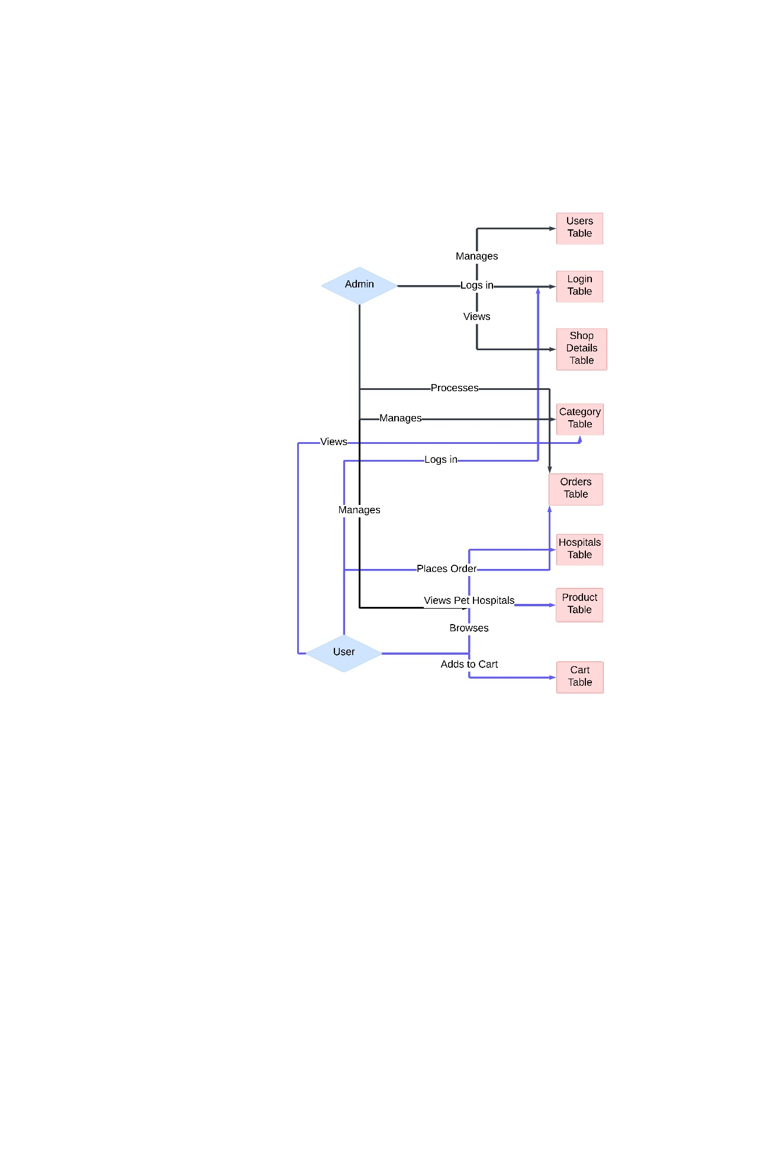

**Figure 1:** User and Admin interactions.

1. **RESULT**



**Figure 1:** Home page

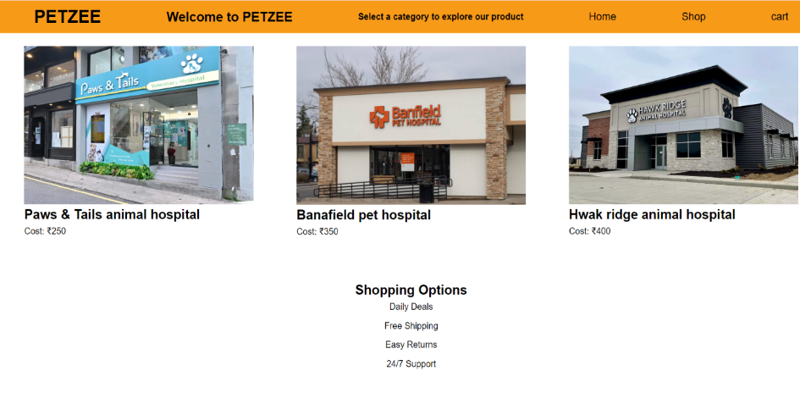

**Figure 2:** Veterinary service category page.

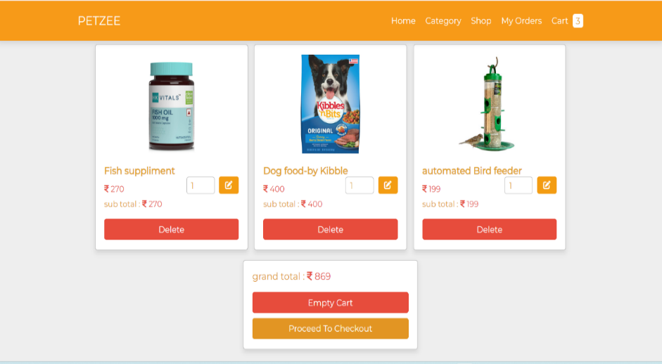

**Figure 3:** Shopping cart page.

1. **CONCLUSION**

This project deals with developing a product catalogue website related to pets. It provides user with catalogue of different categories available for purchase in the store. The user will be able to view different products, get introduces to new accessories, can purchase quality food from well-known brands, can book an appointment with the best veterinarian near to them, and as a whole they can get everything related to pets at one place. This project has effectively combined user-friendly design, robust backend infrastructure, and comprehensive product offerings to create a seamless and enjoyable shopping experience for pet owners. The project has established a strong foundation for future growth and scalability. This project not only demonstrates technical proficiency and strategic planning but also reinforces the commitment to delivering high-quality service to pet lovers everywhere.

1. **REFERENCES**
2. Ozok, A.A., Oldenburger, K., and Salvendy, G. (2007), “Impact of Consistency in Customer Relationship Management on E Commerce Shopper Preferences” Journal of organizational computing and electronic commerce” 17.4, pp.283–309.
3. S. G. E Garrett, P.J. Skevington, “An Introduction to ECommerce,” BT Technology Journal, 1999.
4. Kalakota, Ravi and Andrew B. Whinston, “Electronic Commerce: A manager’s Guide,” Addison Wesley Longman, Inc, 1997.
5. Abhay P N, “unique E-commerce for artwork”, international Research journal of Modernization in Engineering, Technology and Science,2023
6. Gurpreet Singh, Jayesh Bankhede, Kishan Murari Barnwal, Jayesh Verma, Juhi Shrivastava, Shivshankar Rajput, International Journal for Research in Applied Science & Engineering Technology (IJRASET), 2021.