## FABRICATION AND MECHANICAL CHARACTERIZATION OF GLASS FIBER REINFORCED EPOXY COMPOSITE

## Sandeep Kumar1, Vardanshi Varma 2, Shubham Kumar3, Ankit Kumar4

1*Asst Prof. Department of Mechanical Engineering, MIT Moradabad. UP-244001*

*2,3 & 4UG Student, Department of Mechanical Engineering, MIT Moradabad. UP-244001*

[sandeep.sun.varshney@gmail.com,](mailto:sandeep.sun.varshney@gmail.com,%20)  [verma24122004@gmail.com](mailto:verma24122004@gmail.com),

**Abstract:** Glass fiber reinforced epoxy composites are extensively utilized in various engineering applications due to their superior mechanical properties and versatility. This research investigates the fabrication process and mechanical characterization of glass fiber reinforced epoxy composites with a focus on understanding their structural integrity and performance under different loading conditions. The fabrication involved the preparation of composite specimens using a hand lay-up technique followed by curing under controlled conditions. Mechanical characterization included testing the composites for impact resistance, and hardness according to ASTM standards. The results demonstrated that the incorporation of glass fibers significantly enhanced the mechanical properties of the epoxy matrix, with improvements observed in strength, stiffness, and toughness. This study contributes valuable data to the understanding of composite materials, particularly in optimizing their performance for practical engineering applications where lightweight, durable materials are essential.

**Keywords:**Epoxy, E-300 MAT form , Glass fibers , GFRP:- Glass fibers reinforced polymer.

# Introduction

Composite materials consist of two phases: a continuous phase that holds the second phase, known as the reinforcement. These phases are not soluble in each other but are combined at the macroscopic level (Sanjay M R, 2015). Glass fiber reinforced epoxy composites have gained significant attention in the realm of advanced materials due to their exceptional mechanical properties and versatility in engineering applications. These composites combine the high strength and stiffness of glass fibers with the excellent corrosion resistance and dimensional stability of epoxy resins, making them suitable for a wide range of industries including aerospace, automotive, marine, and construction.

Epoxy composites have numerous applications in structural industry as well as automobiles and aircraft. (J. L. Massingill, 2000). The motivation behind this research stems from the continuous quest for lightweight materials that offer superior mechanical performance compared to traditional metals. Epoxy resins are chosen as the matrix material due to their ability to form strong bonds with fibers, thereby enhancing load transfer capabilities and overall composite strength. Glass fibers, renowned for their high tensile strength and modulus, are preferred reinforcement materials in this study for their compatibility with epoxy and cost-effectiveness.

The fabrication process of glass fiber reinforced epoxy composites plays a crucial role in determining their final mechanical properties. Techniques such as hand lay-up, vacuum infusion, and filament winding are commonly employed to achieve desired fiber orientations and resin impregnation levels, influencing the composite's structural integrity and performance under various loading conditions.

Glass Fiber–Reinforced Polymer (GFRP) is known for its high resistance to corrosion, impressive strength, and relatively low modulus of elasticity (Saafi, 2000). Glass and other synthetic fibers possess high stiffness and specific strength, but their application is still limited due to the high production costs (Sanjay M R, 2015). These fibers are widely utilized in mechanical joints because of their unique physical and mechanical properties (J. Paulo Davim, 2004). Recently, natural fibers such as jute, vegetable waste, and cotton are increasingly being used as alternatives to glass and carbon fibers (Fairbairn, 2009). Glass fibers form the structural foundation of composite materials, while fly ash improves their mechanical and physical properties (Jina, 2020). Currently, the use of glass fibers is prevalent in the manufacture of composites (Liem Thanh Nguyen, 2018)..

By comprehensively studying the fabrication techniques and mechanical behaviors of glass fiber reinforced epoxy composites, this research aims to contribute valuable data to the ongoing development and optimization of composite materials. The findings are expected to inform engineers and researchers seeking to enhance the performance and reliability of structural components in diverse industrial applications.

# Material Used and fabrication of composite specimen

In the fabrication of the reinforced composite, E-glass fibers in mat form serve as the reinforcement. The bonding between the glass fibers is facilitated by "ARALDITE LY556," an industrial epoxy resin tailored for industrial applications. Epoxy resins like ARALDITE LY556 typically achieve optimal physical properties when cured with stoichiometric or nearly stoichiometric amounts of a curative agent.

To solidify the epoxy resin and the glass fiber mat structure, "HY951," an epoxy curing agent from Araldite, was employed. Curing involves the hardening and toughening of polymers through the cross-linking of chemical chains, ensuring robust bonding between the components. The efficacy of curing depends significantly on the proper selection and application of the hardener, including its distribution, curing time, and the ratio used. Maintaining uniform resin distribution and controlling temperature and pressure are critical parameters during the curing process (SPRINGER, 1983).In this study, the epoxy resin and hardener were mixed in a ratio of 10:1 to ensure optimal curing conditions. This precise formulation and controlled curing process are essential for achieving the desired mechanical properties and structural integrity of the composite material.

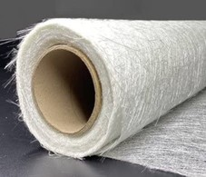

**Figure 1 Fiber Glass Matt form**

Mat-form glass fiber reinforced polymers comprise glass fibers arranged in a random pattern and held together by binders. The fabrication process involves the hand lay-up method, where layers of material sheets are positioned and coated with resin. The binder within the material dissolves in the resin, allowing it to uniformly wet out and conform to various shapes easily. Once the resins cure, the hardened product is demolded from the form.

Chopped strand mat enables fiberglass to possess uniform material properties in all directions. Glass fibers exhibit weakness under shear loading, and their long aspect ratio makes fiberglass susceptible to compression and buckling (Czarnecki, 1980).GFRP laminates were fabricated using the hand lay-up technique, followed by curing at approximately 25°C for a duration of 48 hours.

The fiberglass in mat form was laid out along the mold surface. Subsequently, a precise quantity of epoxy resin was dispensed into a container, mixed with a 1:10 ratio of hardener. Once thoroughly blended, the epoxy resin and hardener mixture was evenly spread across the surface of the glass fiber.

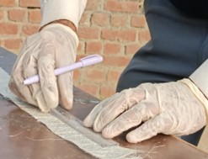

**Figure 2 Fabrication of GFRP**

To ensure even distribution, the material is carefully rolled onto a mat. This meticulous rolling process aims to prevent the formation of voids and the trapping of air bubbles. After rolling, the mat is left to sit for a few minutes to allow exothermic chemical reactions to take place. The mould is then covered with a peel ply film and placed on the mould base, with weights totaling approximately 20 kilograms added for curing. Following a 24-hour period, the laminate is carefully examined for any voids or extra edges before being removed from the mold using ejector pins. The following curing stage involves varying the weight ratios of fly ash and epoxy. This mixture is given time to solidify and acquire a texture. To make the epoxy composite, the slurry and fiberglass are subsequently put through a manual lay-up procedure. When the mold is prepared for use, the fiberglass sheet is placed on it, and the glass fiber's surface is coated with the appropriate quantity of epoxy resin.

. A hand roller is used to evenly spread the epoxy mixture, as illustrated in the accompanying image. Another layer of fiberglass sheet is then laid down, and the epoxy mixture is rolled over it once more. This procedure is repeated until the desired thickness is reached.

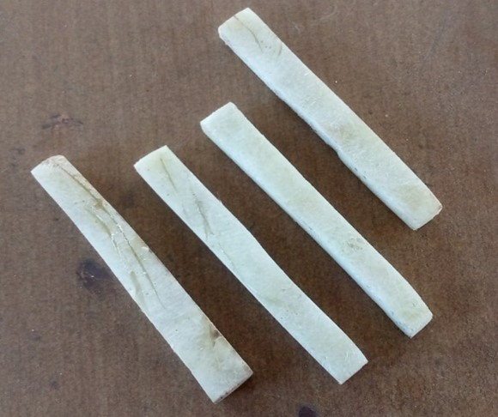Subsequent to this procedure, a load of 33 kilograms is applied to the stacked pile, which is then left undisturbed to allow for solidification. After an adequate period for the setting process has elapsed, the cast is carefully extracted from the mould.

Small sections are cut off from the casting and subsequently processed to prepare them for the specified tests.

Initially, the pieces are cut and filed to eliminate rough surfaces, ensuring consistent surface properties. Certain specimens (as depicted in Fig. 3) undergo further filing and machining to attain the specific shapes required

for testing.

**Fig. 3 Prepared Specimen**

# Mechanical Test

The newly developed composites underwent various mechanical tests to evaluate their strengths and weaknesses. Research indicates that varying concentrations have a significant impact on mechanical properties such as strength, corrosion resistance, and hardness (Caifen Wang, 2012; Pradeep Sambyal, 2015).

In this work, we primarily concentrate on the synthesis and analysis of the deformation behavior of syntactic foams based on epoxy resin microspheres and reinforced with natural glass fiber. The composite, which consists of glass fibers and epoxy resins, is next assessed for its mechanical qualities.

Mechanical properties such as hardness and impact strength are measured using the laboratory's experimental setups.

## 2.1 Vicker Hardness Test

Hardness refers to a material's capacity to withstand indentation, abrasion, and scratching on its surface. The hardness of samples with different fly ash concentrations was measured using the Vickers hardness test. The Rockwell hardness tester, featuring a load capacity between 10 and 100 kg and a 1.58 mm diameter ball indenter, was employed to obtain these hardness measurements.

## 2.2 Impact Test

The impact test evaluates a material's ability to absorb energy during plastic deformation. The outcome of this test is influenced by the specimen's geometry, as it does not isolate specific material properties (P.V. Vasconcelos, 2005).

To measure impact strength, an ASTM standard method, specifically the IZOD impact testing machine, is used. In this test, an arm falls suddenly and strikes a notched specimen, causing it to break. The energy absorbed by the specimen is calculated based on the arm's swing height. For this purpose, a V-notch impact test machine with an applied impact weight of 33 kg was employed.

# Result and discussion

As previously discussed, mechanical testing was conducted on specimens with varying concentrations of fly ash, revealing distinct trends in the results.

Table 1 presents the hardness results for the different specimens tested.

The composite material is tested on the specific hardness testing method name as Vickers hardness test.

**Table 1**. Hardness values of composite material

|  |  |  |  |
| --- | --- | --- | --- |
| Sample Id | Composition | Hardness | Avg |
| Sample 1 | Part 1 | 15.4 HV 1 |  |
| Sample 2 | Part 2 | 16.9 HV 1 | 15.7 |
| Sample 3 | Part 3 | 15.7 HV 1 |  |

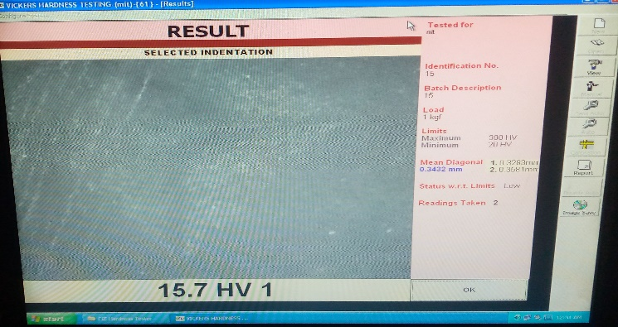

From the result , it is evident that the composite material composed of enough hardness value this shows that it bear a significant hardness compared to other constituent materials. The Vicker Hardness No of the given specimen = 15.7 HV 1

The same composite material is also tested for the toughness test which is done by using impact testing machine, the results are presented in table.

|  |  |  |  |
| --- | --- | --- | --- |
| Sample Id | Composition | Toughness | Avg |
| Sample 1 | Part 1 | 8 |  |
| Sample 2 | Part 2 | 6 | 8 |
| Sample 3 | Part 3 | 8 |  |

The toughness result indicate that composite material ( part1 and part 2) has maximum value. This result also shows that it has too much value to energy absorption and resistance to crack propagation compared to other composite material . Entire energy required to facture the given specimen is = 8 joule

# Conclusions

The findings from the hardness and toughness tests reveal important insights into the performance characteristics of the composite materials. The composite material [sample 3], which showed the between hardness, may be suitable for applications requiring high wear resistance. In contrast, the composite [sample 1\ sample 3] demonstrated excellent toughness, making it ideal for applications where impact resistance is crucial.

Further testing can be conducted to explore different mechanical properties by varying the types of epoxy resins, aiming for improved results in future studies.

# References

1. CaifenWang, J. H. (2012). Effect of fly ash cenospheres on the microstructure and properties of silica-based composites. *Ceramics International*, 4395-4400.
2. Fairbairn. (2009). Physical and mechanical properties of durable sisal fiber–cement composites. Construction and Building Materials.
3. Hoi-yan Cheung, M.-p. K.-t. (2009). Natural fibre-reinforced composites for bioengineering and environmental engineering applications. *Composites Part B: Engineering*, 655-663.
4. J. L. Massingill, J. a. (2000). Epoxy Resins. *Applied Polymer Science 21 Century*, 393-424.
5. J.Paulo Davim, P. R. (2004). Experimental study of drilling glass fiber reinforced plastics (GFRP) manufactured by hand lay-up. *Composites Science and Technology*, 289-297.
6. jina, S. p. (2020). preparation of epoxy-glass composite with graphene and fly ash filler. *Materials today: Proceddings.* Elsevier.
7. kacemQaiss, A. l. (29-49). Investigation of the deformation behavior of epoxy-based composite materials. *Woodhead Publishing Series in Composites Science and Engineering*, 2019.
8. Kishore, S. M. (2002). Effect of filler–fiber interactions on compressive strength of fly ash and short‐fiber epoxy composites. *journal of applied polymer science*, 836-841.
9. lech Czarnecki, J. L. (1980). Shear flow rheological properties, fiber damage, and mastication characteristics of aramid-, glass-, and cellulose-fiber-reinforced polystyrene melts. *Journal of Applied Polymer Science*, 1217-1244.
10. Liem Thanh Nguyen, 1. C. (2018). Simultaneous Effects of Silanized Coal Fly Ash and Nano/Micro Glass Fiber on Fracture Toughness and Mechanical Properties of Carbon Fiber-Reinforced Vinyl Ester Resin Composites. *Polymer Engineering and science*.
11. lPradeep Sambyal, G. R. (2015). Advanced anti corrosive properties of poly(aniline-co-o-toluidine)/flyash composite coatings. *Surface and Coatings Technology*, 129-140.
12. M Singla, V. C. (2010). Mechanical properties of epoxy resin–fly ash composite. *Journal of Minerals & Materials Characterization and Engineering*.
13. P.V. Vasconcelos a, F. L. (2005). Impact fracture study of epoxy-based composites with aluminium particles and milled fibres. *Journal of Materials Processing Technology*, 277-283.
14. Saafi, H. A. (2000). Flexural Behavior of Concrete Beams Reinforced with Glass Fiber-Reinforced Polymer (GFRP) Bars. *ACI STRUCTURAL JOURNAL*, 97- S72.
15. Sanjay M R, A. G. (2015). Study on Mechanical Properties of Natural - Glass Fibre Reinforced Polymer Hybrid Composites: A Review. *4th International conference on Materials Processing and Characterization. Materials Today proceedings* (pp. 2959-2967). Elsevier.
16. SPRINGER, A. C. (1983). Curing of Epoxy Matrix. *Journal OfCOMPOSITE MATERIALS,*, vol 17.

# 