**A Review on Anticancer potential of Natural and Herbal origin Drugs.**

**Ms. Mamata A. Pavale*1, Dr. H.V.Kambale 2, Mr. Ghodke S.R 3, Mr. Mahesh Thakare4.**

1Department of Pharmacology, LSDP College of Pharmacy, Mandavgan Pharata, 412211, Tal-Shirur, Dist-Pune.

2,Department of Pharmacology, Principal at LSDP College of Pharmacy, Mandavgan Pharata, 412211, Tal-Shirur, Dist-Pune.

3,Department of Pharmacology, Asst. Prof at LSDP College of Pharmacy, Mandavgan Pharata, 412211, Tal-Shirur, Dist-Pune.

4,Department of Pharmaceutics, Asst. Prof at Bhalchandra College of Pharmacy, Khanapur 411025, Tal-Haveli, Dist-Pune.

**Corresponding author: Ms. Mamata Ankush Pavale**

LSDP College of Pharmacy, Mandavgan Pharata, 412211, Tal- Shirur Dist-Pune, MS.

Email Id: mamatapatil1010@gmail.com

Contact No. 9284653937

**Abstract**

This article has been made to review some medicinal plants used for the treating cancer disease, the plant sources of India are likely to provide effective anticancer agents. Herbs have a vital role in the prevention and treatment of cancer. Every year millions of people die because of various types of cancers. Many aspects relate to the cause of disease besides heredity, food habits, smoking, nutritional behaviours, radiation etc. The successful cancer therapy till now has been under research, only chemotherapy and radiation treatments are at times successful and much times toxic and lethal. Alternative and less toxic medication is very much in need towards the disease, the use of concepts of herbal medicine with knowledge of Ayurveda could present better drug leads towards the inhibitory treatment of Cancer. Nature shows plethora of medicinal plants with anticancer and antioxidant activities which may suppress the disease completely. The search for cancer drugs from natural sources started in late 1960s, lead to discoveries of vincristine, vinblastine, campthothecin and taxol. This review certainly focuses on the herbal medicine from natural products for the discovery of new drug leads towards the cancer treatment.

**Keywords:** Ayurveda, Medicinal plants, Anti-cancer activity.

**1. Introduction:**

Cancer has been a constant battle globally with a lot of development in cures and preventative therapies. The disease is characterised by cells in the human body continually multiplying with the inability to be controlled or stopped. Consequently, forming tumours of malignant cells with the potential to be metastatic.[1] Current treatments include chemotherapy, radiotherapy and chemically derived drugs. Treatments such as chemotherapy can put patients under a lot of strain and further damage their health. Therefore, there is a focus on using alternative treatments and therapies against cancer.[2] For many years herbal medicines have been used and are still used in developing countries as the primary source of medical treatment. Plants have been used in medicine for their natural antiseptic properties. Thus, research has developed into investigating the potential properties and uses of terrestrial plants extracts for the preparation of potential nanomaterial based drugs for diseases including cancer.[3] Many plant species are already being used to treat or prevent development of cancer. Multiple researchers have identified species of plants that have demonstrated anticancer properties with a lot of focus on those that have been used in herbal medicine in developing countries.[4,5] In the present review we are discussing some plants which are used for their anticancer and antitumor activity. Plants having anticancer activity are growing popularly now a day because they contain several anticancer phytochemicals.

**Examples of Herbal drugs as anticancer agents:**

1. **Turmeric (*Curcuma longa*) [6]**

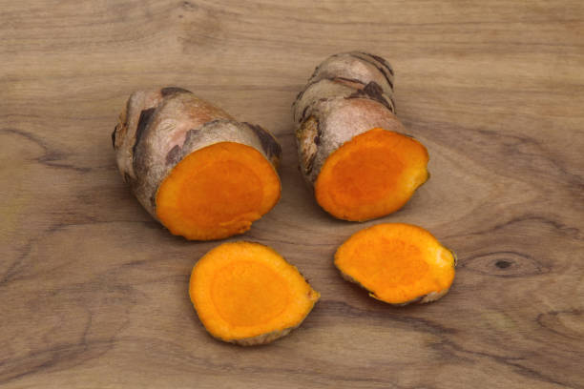

Turmeric consists of dried as well as fresh rhizomes of the plant known as *Curcuma longa* Linn. (*C. domestica*), belonging to the family Zingiberaceae. Curcumin, a common dietary pigment possesses a wide range of therapeutic utilities in traditional Indian medicine. Curcumin (difeuryloyl-methane) is a polyphenolic phytochemical has been currently accepted as a potent anticancer agent. The tumoricidal effect of curcumin has been studied on a wide range of cell lines like mouse sarcoma (S 180), human colon cancer cells (HT-29), human kidney cell line 293 and hepatocellular carcinoma (Hep G2 cells). Curcumin also showed antiproliferative activity on human breast tumor MCF-7 cells. The tumoricidal action of curcumin is due to the inhibition of protein tyrosine kinase activity, protein kinase activity and arachidonic acid metabolism. Curcumin causes growth arrest and apoptosis of B cell lymphoma. [7, 8, 9, 10, 11, 12].

1. **Vinca rosea (*Catharanthus roseus*) [13]**

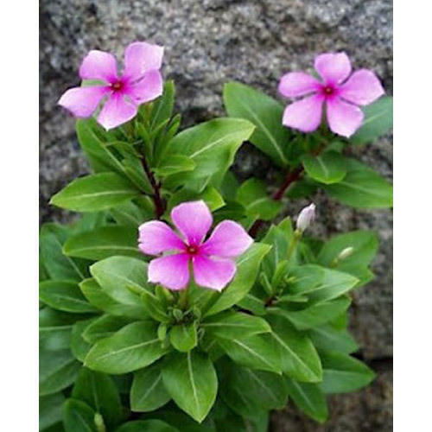

*Catharanthus roseus* is a perennial tropical plant belonging to the family Apocynaceae that produces more than 100 monoterpenoid indoles including two commercially important cytotoxic dimeric alkaloids used in cancer chemotherapy. These two bis-indole alkaloids, vinblastin and vincristine, accumulates in trace amounts in leaves and are formed from the oxidative coupling of catharanthine and vindoline. Vinblastine kills actively dividing cells in G1 and M phase and vincristine in the M phase only [14].

1. **Taxus (*Taxus baccata*) [15]**

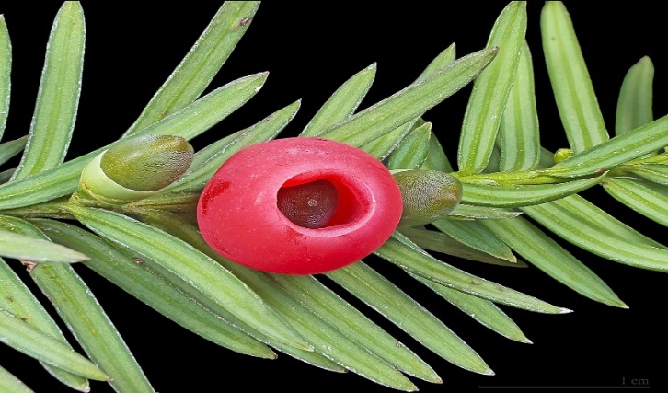

Taxus is a naturally occuring diterpenoid belonging to taxane group of compounds present in genus Taxus under family Taxaceae. Taxol is a valuable plant-derived drug showing activity against various cancer types. Paclitaxel is a very important anticancer drug commonly called Taxol. Another taxane used as anticancer drug is docetaxel, commonly called Taxotere. The active ingredients in taxol and taxotere are mainly derived via chemical semisynthesis from advanced taxoid 10-deacetyl baccatin III. It has been found that the enzyme activity of secondary metabolic pathways was stimulated, which was particularly responsible for enhanced Paclitaxel production. Toxoids are complex molecules that are chemically similar to paclitaxel. Paclitaxel enhances polymerization of tubulin: a mechanism opposite to that of the vinca alkaloids. The microtubules are stabilized and their depolymerization is prevented [13].

1. **Bitter gourd (*Momordica charantia*) [16]**

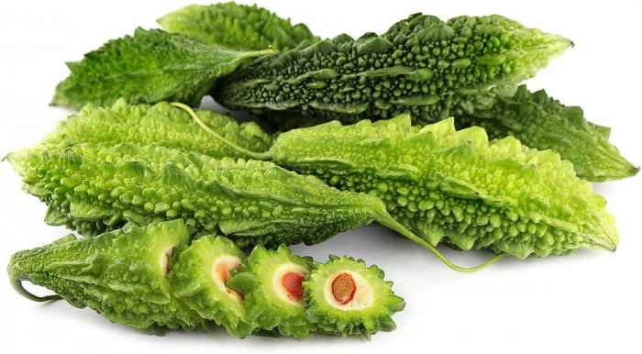

*Momordica charantia* (MC), a climber belonging to the family Cucurbitaceae, is commonly known as bitter gourd or bitter melon in English and karela in Hindi. Momordica means, “to bite”-reffering to the jagged edges of the leaf, which appears as if bitten [17]. *Momordica charantia* contains biologically active chemicals that include glycosides, saponins, alkaloids, fixed oils, triterpenes, proteins and steroids. Several phytochemicals such as α & β-momorcharins, momordenol, charantin, charine, cryptoxanthine, cucurbitins, cucurbitacins, cycloartenols and diosgenin etc. have been isolated. α-momorcharin was found to have tumor suppressive properties [18, 19]. Various preliminary studies (*in-vitro* as well as *in-vivo*) with crude MC extract and its various purified fraction-including MAP 30 (Mitogen activating protein 30) have shown anticancer activity against lymphoid leukemia, choriocarcinoma, melanoma, breast cancer, squamous carcinoma of tongue and larynx, human bladder carcinomas and Hodgkins disease [20, 21, 22].

1. **Gripe weed (*Phyllanthus urinaria*) [23]**

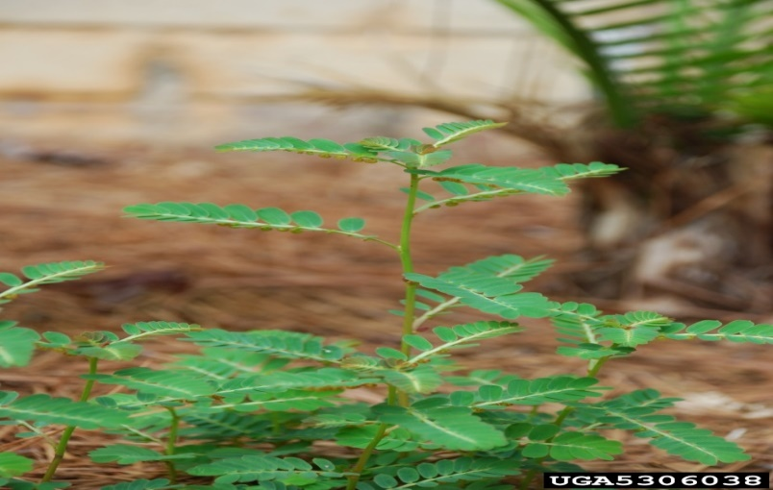

*Phyllanthus urinaria* is a herbal plant belonging to the genus phyllanthus (Euphorbiaceae), is widely distributed in China, Southern India and Southern America. It was tested for its antitumor effect *in-vivo* for the first time. The antitumor activity in *P.urinaria* extract was evaluated by its effect on tumor developed in C57BL/6J mice implantation of Lewis lung carcinoma cells. The oral administration of *P.urinaria* to mice caused significant inhibition of tumor development with lower occurence rate and markedly reduced tumor size. *Phyllanthus amarus* protected the liver from hepatocarcinogenesis induced by N-nitrosodiethylamine in animal models. Roots of *Phyllanthus acuminatus* also has been shown to inhibit the growth of murine P-388 lymphocytic leukemia and B-16 melanoma cell lines. Recently, 7' hydroxy 3',4',5,9,9'-Pentamethoxy-3,4-methylene dioxy lignan isolated from the ethyl acetate extract of *P.urinaria* was shown to exhibit anticancer activity by inducing apoptosis through the inhibition of telomererase activity and Bcl-2 expression. Since the inhibiton of angiogenesis could result in a suppression of tumor growth. It was also investigated in the potential anti-angiogenic effect of *P. urinaria* by examining the neovascularization of the tumor developed in C57BL/6J mice with the implantation of Lewis lung carcinoma cells [24, 25, 26, 27, 28].

1. **Liquorice (*Glycyrrhiza glabra*) [29]**

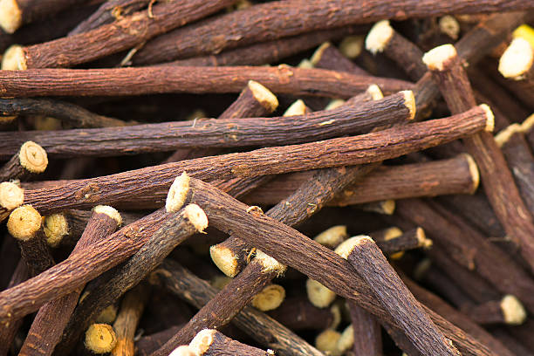

Glycyrrhiza (Liquorice) consists of dried, peeled and unpeeled, roots and stolon of *Glycyrrhiza glabra* Linn., belonging to the family Leguminosae. The liquorice plant is a legume (related to beans and peas), native to southern Europe and parts of Asia. Sophora flavescens, a perennial herb, is a species of plant in the genus Sophora belongs to the family papilionaceous. It is a traditional Chinese medicine. Matrine (Mat), a component extract from Sophora flavescens A, it has a wide spectrum of pharmacological activities. Glycyrrhizin (Gly), a major active constituent of liquorice (*Glycyrrhiza glabra*) root has various pharmacological effects. Glycyrrhizinic acid is a glycoside and on hydrolysis yields glycyrrhetinic acid, which has a triterpenoid structure. Gly and Mat is ancillary drug used clinically in china for protection of liver function and treatment of tumors. Combined use of Gly and Mat could offer better liver protection and antihepatocarcinogenic effects than Gly or Mat alone, and whether it could reduce the adverse effects of Gly alone by acetaminophen induced heoatotoxicity, diethylnitrosamine –induced hepatocarcinogenesis [30, 31, 32]. Glycyrrhizin (Gly) molecular formula: (C42H24N2O), a triterpene glycoside and a conjugative compound of enoxolone and glucuronic acid as an active component of liquorice has been used in preventation of liver cancer [33, 34, 35, 36, 37].

1. **Ginger (*Zingiber officinalis*) [38]**

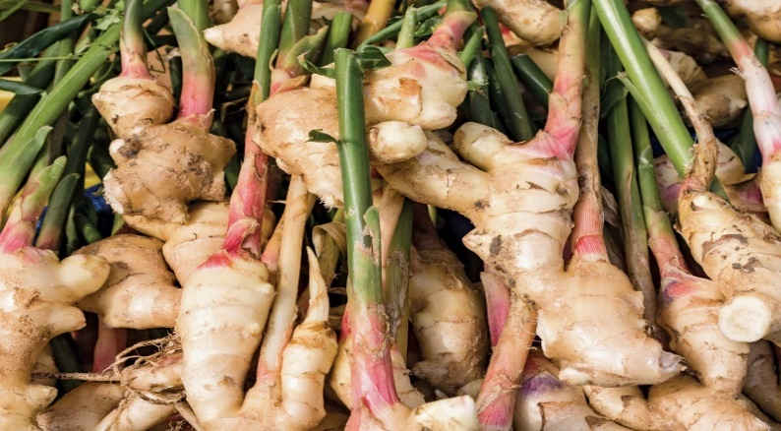

Zinger consists of rhizomes of *Zingiber officinalis* Roscoe, belongs to a tropical and sub-tropical family - Zingiberaceae, originating in South-East Asia and introduced to many parts of the globe, has been cultivated for thousands of years as a spice and for medicinal purposes [39]. The non-volatile pungent principles are gingerols, shogales, paradols and zingerone that produce a “hot” sensation in the mouth. The gingeroles, a series of chemical homologs differentiated by the length of their unbranched alkyl chains, were identified as the major active components in the fresh rhizome [40]. The anticancer properties of ginger are attributed due to the presence of certain pungent vallinoids viz. 6-gingerol and 6-paradol, as well as some other constituents like 6-shagaol, zingerone etc. [41]. The alcoholic extract of the ginger inhibited cell growth at concentration of 0.2-1mg/ml *in-vitro* and 0.12-0.3mg/ml in tissue culture as well as inhibited thymidine uptake into DNA. *Helicobator pylori* is the primary etiological agent associated with peptic ulcer disease and development of gastric and colon cancer. The anti-H pylori effects of ginger and its constituents were tested *in-vitro* [42]. 6-Gingerol inhibited angiogenesis of human endothelial cells and caused cell cycle arrest in the G1 phase through the down-regulation of the cyclin D1 [43].

1. **Ashwagandha (*Withania somnifera*)**

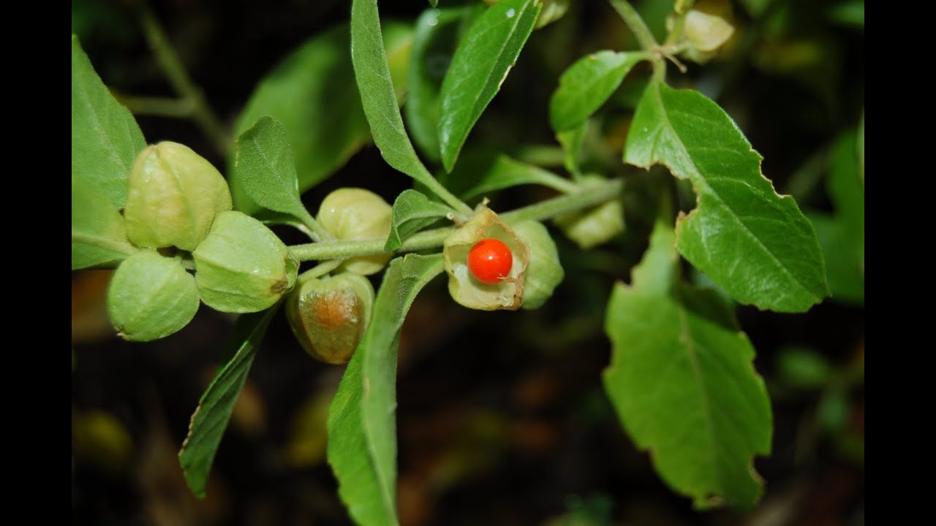

It is also know as the Indian ginseng, it has been used to help the body deal with stress in Ayurveda. Its anti-cancer value was realized about 40 years ago when researchers isolated a crystalline steroidal compound (withaferin A) from this herb. Further research on these extracts which were taken from the leaf of ashwagandha showed that they were able to kill activity in human cervical and prostate cancerous cells.[44]

1. **Jaiphala (*Myristica fragrans*)**

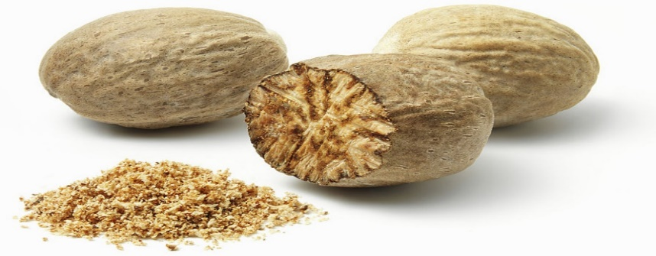

It is used for various medicinal properties. The fruit and seed extracts show various activities like hepatoprotective activity, anti-oxidant activity, memory enhancing activity, anti-cancer activity, aphrodisiac activity, antidiabetic activity, anti-depressant activity, hypolipidaemic and hypocholesterolemic effect, anti-microbial activity, anti-bacterial, anti-inflammatory and anti-carcinogenic activity.[45]

1. **Neem (*Azadirachta indica*)**

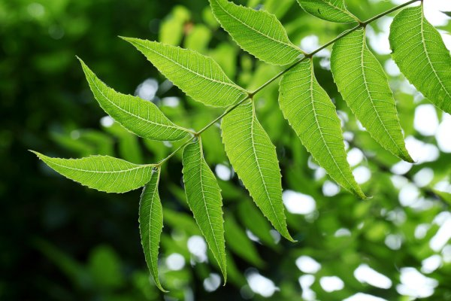

It shows therapeutics role in health management due to rich source of various types of ingredients. Neem extracts have been shown to possess anti-bacterial, anti-fungal, potent antiviral and anticancerous. The Active principles in form of various compounds present in bark, leaves, seeds and seed oil reduces tumors and cancers very efficiently without producing side effects. Nimbolide, a limonoid present in leaves and flowers of the neem tree, have apoptosis-inducing property, thus beneficial in human breast cancer. [46]

1. **Amla (*Emblica officinalis*)**

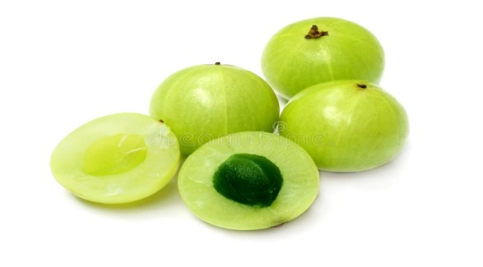

It is one of the richest sources of Vitamin C and also contains quercetin, phyllaemblic compounds, gallic acid, tannins, flavonoids, pectin and various polyphenolic compounds, making it the king of rejuvenation. Scientific research of three decades has proven the traditional use of amla to be correct. Research found that amla is beneficial to treat different types of cancers.

**Conclusion**

Herbal drugs can cure cancer or not still debatable, but a combination of Ayurveda and Chemopathy is considered to be the best, since the side effects are reduced or eradicated by Ayurveda. The anticancer property of medicinal plants used in the traditional Indian medicine System and further evaluation of the selected medicinal plants for an effective anticancer drug with minimal side effects. Our herbs can be used for therapeutic purposes with some advancement and research, therefore additive a balanced diet may have beneficial effect. While scientific research continues to discover deeper into the prevention and cure of cancer given its growing hazard, People should take all precautions to safeguard our self. The healthier you live, the less risk you are at. If you have a positive family history, Should go for regular checks-up. Earlier detection of cancer makes it easier to treat.

**References:**

1. Ochwang’I DO, Kimwele CN, Oduma JA, Gathumbi PK, Mbaria JM, Kiama SG. Medicinal plants used in treatment and management of cancer in Kakamega County Kenya. Journal of Ethnopharmacology. 2014;151:1040–1055. [[PubMed](https://www.ncbi.nlm.nih.gov/pubmed/24362078)] [[Google Scholar](https://scholar.google.com/scholar_lookup?journal=Journal+of+Ethnopharmacology&title=Medicinal+plants+used+in+treatment+and+management+of+cancer+in+Kakamega+County+Kenya&author=DO+Ochwang%E2%80%99I&author=CN+Kimwele&author=JA+Oduma&author=PK+Gathumbi&author=JM+Mbaria&volume=151&publication_year=2014&pages=1040-1055&pmid=24362078&)]
2. Cancer Research UK [Accessed 23 January 2015];What is cancer? 2014 Available at: <http://www.cancerresearchuk.org/about-cancer/what-is-cancer>.
3. Sivaraj R, Rahman PKSM, Rajiv P, Vanathi P, Venckatesh R. Biosynthesis and characterization of *Acalypha indica* mediated copper oxide nanoparticles and evaluation of its antimicrobial and anticancer activity. Spectrochimica Acta Part A: Molecular and Biomolecular Spectroscopy. 2014;129:255–258. [[PubMed](https://www.ncbi.nlm.nih.gov/pubmed/24747845)] [[Google Scholar](https://scholar.google.com/scholar_lookup?journal=Spectrochimica+Acta+Part+A:+Molecular+and+Biomolecular+Spectroscopy&title=Biosynthesis+and+characterization+of+Acalypha+indica+mediated+copper+oxide+nanoparticles+and+evaluation+of+its+antimicrobial+and+anticancer+activity&author=R+Sivaraj&author=PKSM+Rahman&author=P+Rajiv&author=P+Vanathi&author=R+Venckatesh&volume=129&publication_year=2014&pages=255-258&)]
4. Freiburghaus F, Kaminsky R, Nkunya MHH, Brun R. Evaluation of African plants for their *in vitro* trypanocidal activity. Journal of Ethnopharmacology. 1996;55:1–11. [[PubMed](https://www.ncbi.nlm.nih.gov/pubmed/9121161)] [[Google Scholar](https://scholar.google.com/scholar_lookup?journal=Journal+of+Ethnopharmacology&title=Evaluation+of+African+plants+for+their+in+vitro+trypanocidal+activity&author=F+Freiburghaus&author=R+Kaminsky&author=MHH+Nkunya&author=R+Brun&volume=55&publication_year=1996&pages=1-11&pmid=9121161&)]
5. Kamatou GPP, Van Zyl RL, Davids H, Van Heerden FR, Lourens ACU, Viljoen AM. Antimalarial and anticancer activities of selected South African *Salvia* species and isolated compounds from *S. radula*. South African Journal of Botany. 2008;74:238–243. [[Google Scholar](https://scholar.google.com/scholar_lookup?journal=South+African+Journal+of+Botany&title=Antimalarial+and+anticancer+activities+of+selected+South+African+Salvia+species+and+isolated+compounds+from+S.+radula&author=GPP+Kamatou&author=RL+Van+Zyl&author=H+Davids&author=FR+Van+Heerden&author=ACU+Lourens&volume=74&publication_year=2008&pages=238-243&)]
6. <http://en.wikipedia.org/wiki/Turmeric>
7. Mehta K, Pantazis P, McQueen T, Aggarwal BB. Antiproliferative effect of Anticancer Drugs. Anticancer Drugs 1997; 8:470-81.
8. Hanif R, Qiao L, Shiff SJ, Rigas BJ. Curcumin, a natural plant phenolic food. J. Lab. Clin. Med. 1997; 130:576584.
9. Jiang MC, Yang-Yen HF, Yen JJ, Lin JK. Curcumin induces apoptosis in immortalized NIH3T3 and malignant cancer cell lines. Nutr Cancer 1996; 26:111-120.
10. Miquel J, Bernd A, Sempere JM, et al. The curcuma antioxidants: pharmacological effects and prospects for future clinical use. Archives of Gerontology and Geriatrics 2002; 34:37–46.
11. Chen HW, Huang HC. Effect of Curcumin on cell cycle progression and apoptosis in vascular smooth muscle cells. Br. J. Pharmacol. 1998; 124:1029–1040.
12. Han SS, Chung ST, Robertson DA, Ranjan D, Bondada S. Lymphoma by down regulation of egr-l, c-myc, bel-XL, NF-kappa B, and p53. Clin lmmunol 1999; 93:52-161.
13. Frense D. Taxanes: Perspectives for biotechnological Production. Appl Microbiol. Biotechnol. 2007; 73: 12331240
14. Magnotta M, Murata J, Chen J, Luca De V. Identification of a low vindoline accumulating cultivar of Catharanthus roseus (L.) G. Don by alkaloid and enzymatic profiling. Phytochemistry 2007; 67:1758-1764.
15. <http://en.wikipedia.org/wiki/Taxus>.
16. <http://jaimelivi.files.wordpress.com/2009/10/karela.jpg>
17. Yesilada E, Gurbuz I, Shibata H. Screening of Turkish antiulcerogenic folk remedies for anti-Helicobacter pylori activity. J. Ethnopharmacol. 1999; 66:289–293.
18. Husain J, Tickle IJ, Wood SP, Crystal structure of momordin, a type I ribosome inactivating protein from the seeds of Momordica charantia. FEBS Letters 1994; 342:154–158.
19. Ng TB, Chan, WY, Yeung HW. Proteins with abortifacient, ribosome inactivating, immunomodulatory,
20. Licastro F, Franceschi C, Barbieri L, Stirpe F. Toxicity of Momordica charantia lectin and inhibitor for human normal and leukaemiclymphocytes. Virchows Archives of B Cell Pathology Including Molecular Pathology 1980; 33:257–265
21. Ng TB, Liu WK, Sze SF, Yeung HW. Action of alphamomorcharin, a ribosome inactivating protein, on cultured tumor cell lines. General Pharmacology 1994; 25: 75–77
22. Battelli MG, Polito L, Bolognesi A et al. Toxicity of ribosome-inactivating Protein containing immunotoxins to a human bladder carcinoma cell line. International Journal of Cancer1996; 68:485–490.
23. <http://www.tropilab.com/shatterst.html>
24. Sheng-Teng Huang, Rong-Chi Yang, Pei-Nir Lee et al. Anti-tumor and anti-angiogenic effects of Phyllanthus urinaria in mice bearing Lewis lung carcinoma. International Immunopharmacology 2006; 6:870-879.
25. Jeena KJ, Joy KL, Kuttan R. Effects of Emblica officinalis, Phyllanthus amarus and Picrorrhiza Kurroa on N-nitrosodi-ethylamine induced hepatocarcinogenesis. Cancer Lett 1999; 136:11-6.
26. Powis G, Moore DJ. High –performance liquid chromatographic assay for the antitumor glycoside phllanthoside and its stability in plama of several species. J Chromator 1985; 342:129-34.
27. Pettit GR, Schaufelberger DE, Nieman RA, Dugresne C, Saenz-Renauld JA. Antineoplastic agents, 177. isolation and structure of phyllanthostatin 6. J Nat Prod 1990; 53:1406-1413.
28. Giridharan P, Somasundaram ST, Perumal K et al. Novel Substituted methylenedioxy lignan suppresses proliferation of cancer cells by inhibiting telomerase and activation of c-myc and caspases leading to apoptosis. Br. J Cancer 2002; 87:98-105. 28.
29. <http://en.wikipedia.org/wiki/liquorice>
30. Wan Xu-Ying, Luo Ming, Li Xiao-dong, He Ping, Hepatoprotective and antihepatocarcinogenic effects of glycyrrhizin and matrine. Chemico-Biological Intercactions 2009; 181:15-19.
31. L. Ma, S. Wen Y, Zhan, et. al. Anticancer effects of the Chinese medicine Mat on murine hepatocellular carcinoma cells. Planta Med. 2008; 74:245-251.
32. Shen XD, Song GB, Yan RB et al. Research progress of mat and oxymatirne in the anti-tumor mechanism. J. Chongqing Univ. (Natural Science Edition) 2005; 28:125128.
33. Isbrucker RA, Burdock GA. Risk and safety assessment on the consumption of Licorice root (Glycyrrhiza sp.), its extract and powder as a food ingredient, with emphasis on the pharmacology and toxicology of Gly. Regul. Toxicol. Pharmacol. 2006; 46:167-192.
34. Kurisu S, Inoue I, Kawagoe T, et al. Clinical profile of patients with symptomatic Gly-induced hypokalemia. J. Am. Geriatr. Soc. 2008; 56:1579-1581.
35. Bing L, Yun Q. The pharmacology research progression of Gly acid and gly-cyrrhetic acid, foreign medicine. Planta Med. 2006; 21:100-104.
36. Kimura M, Moro T, Motegi H. In vivo Gly accelerates liver regeneration and rapidly lowers serum transaminase activities in 70% partially hepatectomized rats. Eur. J. Pharmacol. 2008; 579:357-364.
37. Wen Y, L, Han QL. The pharmacology research progression of the Sophora flavescens base. Chin. J. Pract. Chin. Modern Med. 2006; 19:473-475.
38. <http://en.wikipedia.org/wiki/Ginger>
39. Park EJ, Pizzuto JM. Botanicals in cancer chemo- prevention. Cancer Metastasis Review 2002; 21:231-255.
40. Govindarajan V. Ginger-chemistry technology and quality evaluation:Part-I CRC. Critical Reviews in Food Science and Nutrition. 1982;17:1–96.
41. Shukla Y, Singh M. Cancer preventive properties of ginger: A brief review, food and chemical toxicology 2007; 45: 683- 690.
42. Mahady GB, Pendland SL, Yun GS, Lu ZZ, Stoia A. Ginger (Zingiber officinale Roscoe) and the gingerols inhibit the growth of Cag A+ strains of Helicobacter pylori. Anticancer Research 2003; 23:3699–3702.
43. Ippoushi K, Azuma K, Ito H, Horie H, Higashio H. [6] Gingerol Inhibits nitric oxide synthesis in activated J774.1 mouse macrophages and prevents peroxynitrite induced oxidation and nitration reactions. Life Sciences 2003; 73: 3427–3437.
44. <https://en.wikipedia.org/wiki/Withaferin>
45. Prakash E, Gupta DK. Cytotoxic activity of ethanolic extract of Myristica fragrans (Houtt) Against seven human cancer cell lines. Universal J Food Nutrition Sci 2013; 1:1-3.
46. https://scialert.net/fulltextmobile/?doi=jbs.2014.110.1 23&org=11