**TO PREVENT IOT BASED DEVICE UNDER-LOADING AND OVERLOADING OF RAILWAY WAGONS**

Vishnu Survase1, Akshay More2,Rahul Bansode3,Dr.A.N. Shaikh

Electronics & Telecommunication Engineering

*Shreeyash Pratishtan’s Shreeyash College of Engineering and Technology, Chh.Sambhajinagar-431010*

**ABSTRACT**

Railway transportation constitutes the backbone of global logistics, emphasizing the critical need for safety and efficiency in the loading and operation of railway wagons. This paper proposes an innovative IoT-based system designed with meticulous attention to preventing under-loading and overloading of railway wagons. In doing so, it strengthens safety protocols, improves operational efficiency, and ensures strict compliance with regulations in the railway sector. The proposed system is based on advanced integration of IoT sensors in each railway wagon. These sensors collaborate to continuously monitor critical parameters such as weight distribution, balance dynamics, and structural integrity, collecting real-time data. This data is seamlessly transmitted via wireless communication protocols to a centralized control system prepared for comprehensive analysis and strategic processing. At the core of the system are robust machine learning algorithms designed to identify complex patterns and anomalies indicative of potential under-loading or overloading risks. Upon detection of such risks, the system automatically generates alerts, initiating a series of strategically designed actions aimed at swiftly mitigating identified hazards. Furthermore, this system seamlessly integrates with existing railway management frameworks, promoting unmatched operational synergy and accelerating compliance initiatives with regulations. By offering continuous monitoring, predictive maintenance capabilities, and detailed reporting functions, the IoT-based system surpasses traditional safety standards, introducing an era of unparalleled safety and operational excellence. Through its proactive approach to risk mitigation, the proposed IoT-based system not only enhances safety protocols and operational efficiencies but also establishes the foundation for a resilient and sustainable railway ecosystem. By promoting safety and compliance, this innovative technology heralds a new era for railway transportation, poised to elevate standards, improve passenger experiences, and safeguard the interests of stakeholders in the railway industry.

**I. INTRODUCTION**

Railway transportation plays a crucial role in global logistics and freight management, facilitating the movement of goods over long distances efficiently and cost-effectively. However, ensuring the safe and optimal loading of cargo onto railway wagons is a fundamental challenge faced by railway operators worldwide. Under-loading and overloading not only pose safety hazards but also lead to inefficiencies in transportation, increased wear and tear on infrastructure, and regulatory violations. In response to these challenges, there is a growing need for innovative solutions that leverage emerging technologies to monitor and manage cargo loading in real-time.

Traditionally, cargo loading in railway wagons has been monitored through manual inspections and periodic weighing processes. However, these methods are labor-intensive, time-consuming, and prone to errors. Moreover, they provide limited visibility into cargo conditions during transit, making it difficult for operators to identify and address potential issues promptly. With the advent of the Internet of Things (IoT) and advances in sensor technology, there is an opportunity to revolutionize cargo monitoring in railway logistics. The concept of an IoT-based system for preventing under-loading and overloading of railway wagons arises from the integration of sensors, communication devices, and data analytics tools to enable real-time monitoring and control of cargo weight distribution. By equipping railway wagons with load sensors and communication modules, operators can track the weight of the cargo remotely and receive instant alerts if under-loading or overloading conditions are detected. Furthermore, advanced analytics techniques can analyze historical data to optimize loading processes, predict maintenance needs, and enhance operational efficiency.

The objective of this research paper is to introduce, design, implement, and evaluate an IoT-based system specifically tailored to address the challenges of under-loading and overloading in railway logistics. Through a comprehensive exploration of the system's architecture, sensor integration, communication infrastructure, central control system, data analytics, implementation, and evaluation, this paper aims to provide insights into the potential benefits of IoT technology in enhancing safety, compliance, and operational performance in railway transportation.

The structure of the paper is as follows: following this introduction, Section 2 provides a review of existing approaches to cargo monitoring in railway transportation and outlines the motivations for adopting IoT-based solutions. Section 3 presents the architecture of the proposed system, detailing its hardware and software components. Subsequent sections delve into the specifics of sensor integration, communication infrastructure, central control system, data analytics, implementation, and evaluation. A case study illustrating the application of the IoT-based system in a real-world scenario is presented in Section 9. Finally, the paper concludes with a summary of findings and suggestions for future research in Section 10.

In summary, this research paper aims to contribute to the body of knowledge on IoT applications in railway logistics by presenting a comprehensive study of an IoT-based system for preventing under-loading and overloading of railway wagons. By combining theoretical insights with practical implementation and evaluation, this paper seeks to provide valuable insights for railway operators, researchers, and policymakers interested in leveraging IoT technology to improve the safety, efficiency, and sustainability of railway transportation systems.

This introduction sets the stage for the research paper by providing context, identifying the problem statement, outlining the objectives, and previewing the paper's structure. It emphasizes the importance of addressing under-loading and overloading challenges in railway logistics and introduces the concept of an IoT-based solution as a novel approach to mitigating these issues.

**II. LITERATURE REVIEW**

It is possible to explain the results obtained from this study carried out in order to solve the problem of detection and classification of landmines under four headings. These include the approach, method, technique, and experimental findings obtained to model the problem. The contribution and results of the study in terms of literature are given below:

K. R. Suryawanshi et.al.[1] was proposed that magnetic anomalies were caused by mine presence. However, this study proves for the first time in experimental studies that the size of this anomaly exhibits a change that can be modeled depending on the height of measurement (distance of the detector/sensor from the soil surface) and soil type. Therefore, a model based on the parameters “magnetic anomaly”, “height” and “soil type”, which is a mine type dependent variable, is defined for the first time in the land mine problem. Based on this definition, the problem model was developed to define underground buried objects in a multi-dimensional problem space. It was thus possible to model the characteristics of objects more accurately. This information is vital in terms of real world practices. Because in a real application, the height of the mine detector from the ground is not constant and the soil type changes.

In the literature, mine detection with active mine detectors was performed with a high detection performance, but with the risk of triggering the mine blasting system at any moment. The second advantage of the approach proposed (meta-heuristic k-NN with fuzzy metric) in this study is that the mine detection with a passive detector design is performed with 98.2% performance. This successful detection performance will give momentum and direction to future studies related to passive detectors.

Most of the studies in the literature focused on mine detection. The classification of mines with a passive detector design has never been achieved before. The approach proposed in this study has created a function of the magnetic anomalies created by the mines buried in the soil depending on the mine type, height and soil type. Thanks to this model, mines are located in multidimensional space according to their types. In this way, a passive detector design has opened the way for the detection of mines. Experimental studies have shown that mine detection is successfully performed at approximately 85.8%. It is important that this ratio is obtained in a real-world application where the detector is moving and its height changes at any time.

Explore research on integrating sensors with Arduino for measuring weight, temperature, humidity, and other relevant parameters in railway wagons. Look for studies that discuss sensor selection, calibration, and accuracy assessment. Investigate research on developing algorithms for processing sensor data collected by Arduino boards.

The document discusses the changes in the model of individual competencies (ICB) of project managers proposed by the International Project Management Association (IPMA) that occurred after the harmonization of this standard with project management standards issued under the auspices of the International Organization for Standardization (ISO). For comparison, it is proposed to use the conceptual model of the “system landscape of competencies” of the project manager, created solely on the basis of the analysis of the content of texts of IPMA ICB standards (versions 3.0 and 4.0)

High Speed train (HST) communication with its analysis of Directivity Beam-width trade off and the hand over scheme is explained in this paper. The analysis does not include channel covariance matrix(CCM) and hence the computation is less complex. The hand off analysis ultimately gives the maximum possible distance between two base stations so as to ensure uninterrupted communication in HST.

As one of the hot issues in cloud computing, task scheduling is an important way to meet user needs and achieve multiple goals. With the increasing number of cloud users and growing demand for cloud computing, how to reduce the task completion time and improve the system load balancing ability have attracted increasing interest from academia and industry in recent years. To meet the two aforementioned goals, this paper develops an EDA-GA hybrid scheduling algorithm based on EDA (estimation of distribution algorithm) and GA (genetic algorithm). First, the probability model and sampling method of EDA are used to generate a certain scale of feasible solutions. Second, the crossover and mutation operations of GA are used to expand the search range of solutions.

**III. METHODOLOGY**

**1. Problem Definition and Scope Clarification:-**

- Clearly define the objectives of the IoT-based system, including the prevention of under-loading and overloading of railway wagons, enhancement of safety protocols, and optimization of operational efficiency.

- Define the scope of the project, identifying the railway routes, types of wagons, and operational scenarios that will be covered by the IoT system.

**2. Requirement Analysis:-**

- Conduct a comprehensive analysis of the requirements for the IoT-based system, considering factors such as:

- Types of sensors needed for monitoring weight distribution, balance dynamics, and structural integrity of railway wagons.

- Communication protocols for transmitting sensor data to a centralized control system.

- Data processing and analytics requirements for detecting under-loading and overloading risks.

- Integration with existing railway management frameworks and regulatory compliance standards.

**3. Sensor Selection and Deployment:-**

- Evaluate and select appropriate sensors for monitoring key parameters related to wagon loading.

- Determine the placement and deployment strategy for sensors within each railway wagon, considering factors such as accessibility, durability, and accuracy of data collection.

- Develop a sensor deployment plan to ensure comprehensive coverage of the railway network while minimizing installation and maintenance costs.

**4. Communication Infrastructure Setup:-**

- Establish the communication infrastructure necessary for transmitting sensor data from railway wagons to a centralized control system.

- Select communication technologies such as wireless networks (e.g., Wi-Fi, cellular, or satellite) that provide reliable and scalable connectivity across the railway network.

- Implement data transmission protocols and security mechanisms to protect sensitive information during transit.

**5. Centralized Control System Development:-**

- Design and develop a centralized control system capable of receiving, processing, and analyzing sensor data in real-time.

- Implement machine learning algorithms and predictive analytics models to detect patterns indicative of under-loading or overloading risks.

- Integrate the control system with existing railway management frameworks and regulatory compliance systems to facilitate seamless operation and regulatory reporting.

**6. Alert Generation and Response Mechanisms:-**

- Configure the control system to generate automated alerts upon detecting under-loading or overloading risks.

- Define response mechanisms and corrective actions to mitigate identified hazards, such as adjusting loading procedures, redistributing cargo, or suspending loading operations if necessary.

**7. Testing and Validation:-**

- Conduct rigorous testing of the IoT-based system in simulated and real-world operational environments.

- Validate the accuracy, reliability, and effectiveness of the system in preventing under-loading and overloading of railway wagons under various operating conditions.

**8. Deployment and Training:-**

- Deploy the IoT-based system across the designated railway routes and wagons, following the deployment plan developed earlier.

- Provide training to railway personnel responsible for operating, monitoring, and maintaining the system, ensuring they understand its functionality and are proficient in using it to enhance railway safety.

**9. Monitoring and Continuous Improvement:-**

- Establish monitoring mechanisms to track the performance of the IoT-based system over time.

- Collect feedback from railway operators, maintenance crews, and regulatory authorities to identify areas for improvement and optimization.

- Iterate on the system design and implementation based on lessons learned and evolving requirements to ensure its continued effectiveness and relevance.

**IV. SYSTEM DEVELOPMENT**

In this IoT Project we are **interfacing 1Kg load cell to the NodeMCU ESP8266 using the**[HX711](https://how2electronics.com/iot-weighing-scale-hx711-load-cell-esp8266/)**Load cell amplifier module**. HX711 is a precision 24-bit analog to digital converter (ADC) designed for [weighing scales](https://how2electronics.com/iot-weighing-scale-hx711-load-cell-esp8266/) and industrial control applications to interface directly with a bridge sensor. The **HX711 load cell amplifier** is used to get measurable data out from a **load cell** and **strain gauge**.

The [electronic](https://how2electronics.com/iot-weighing-scale-hx711-load-cell-esp8266/)[weighing machine](https://how2electronics.com/iot-weighing-scale-hx711-load-cell-esp8266/) uses a load cell to measure the weight produced by the load, here most load cells are following the method of a strain gauge, Which converts the pressure (force) into an electrical signal, these load cells have four strain gauges that are hooked up in a **Wheatstone bridge** formation.

We will make a [Weighing Scale](https://how2electronics.com/iot-weighing-scale-hx711-load-cell-esp8266/)**Machine** which can measure weights up to higher-value like **1KG**. We need to calibrate the load cell and find the calibration factor. Once the calibration is done, we can include that factor in our code. Thus this will make the [scale](https://how2electronics.com/iot-weighing-scale-hx711-load-cell-esp8266/) precise and accurate. The greater is the mass the greater the error. So we will try to remove the error from the [weighing scale scale](https://how2electronics.com/iot-weighing-scale-hx711-load-cell-esp8266/). We will finally display the measured weight in the **16×2 I2C LCD Display**. We will send the so obtained weight value on the **IoT Cloud platform** called **Blynk Application**. Thus, weight can be monitored from any part of the world simply by observation on the Blynk app dashboard. We will also send the data on another IoT platform called [Thingspeak](https://how2electronics.com/iot-weighing-scale-hx711-load-cell-esp8266/). The graphical and numerical analysis of weight will be done.

1. **ESP8266**

The chip was popularized in the English-speaking [maker](https://en.wikipedia.org/wiki/Maker_culture) community in August 2014 via the ESP-01 module, made by a third-party manufacturer Ai-Thinker. This small module allows microcontrollers to connect to a Wi-Fi network and make simple TCP/IP connections using [Hayes](https://en.wikipedia.org/wiki/Hayes_command_set)-style commands. However, at first, there was almost no English-language documentation on the chip and the commands it accepted. The very low price and the fact that there were very few external components on the module, which suggested that it could eventually be very inexpensive in volume, attracted many hackers to explore the module, the chip, and the software on it, as well as to translate the Chinese documentation. The ESP8285 is a similar chip with a built-in 1 MiB flash memory, allowing the design of single-chip devices capable of connecting via Wi-Fi. These microcontroller chips have been succeeded by the [ESP32](https://en.wikipedia.org/wiki/ESP32) family of devices.

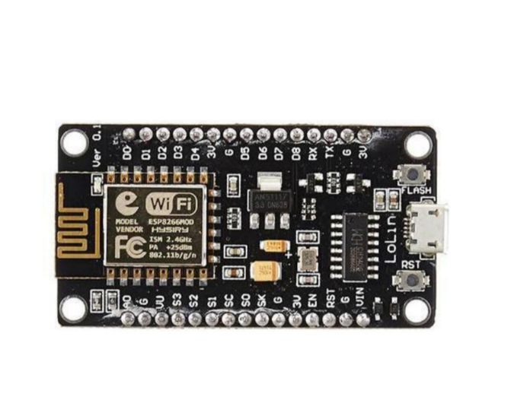

### **Load Cell**

A load cell is a type of **transducer**, specifically a force transducer. It converts a force such as tension, compression, pressure, or torque into an electrical signal that can be measured and standardized. As the force applied to the load cell increases, the electrical signal changes proportionally. **Load cells**are used to measure weight.

Load cells generally consist of a **spring element** on which **strain gauges** have been placed. The spring element is usually made of steel or aluminum. That means it is very sturdy, but also minimally elastic. As the name “**spring element**” suggests, the steel is slightly deformed under load, but then returns to its starting position, responding elastically to every load. These extremely small changes can be acquired with strain gauges. Then finally the deformation of the strain gauge is interpreted by analysis [electronics](https://how2electronics.com/iot-weighing-scale-hx711-load-cell-esp8266/) to **determine the weight**.

[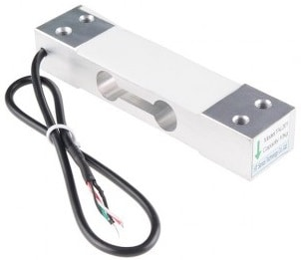](https://how2electronics.com/wp-content/uploads/2020/02/40KG-Load-Cell.jpg)

## **LCD**

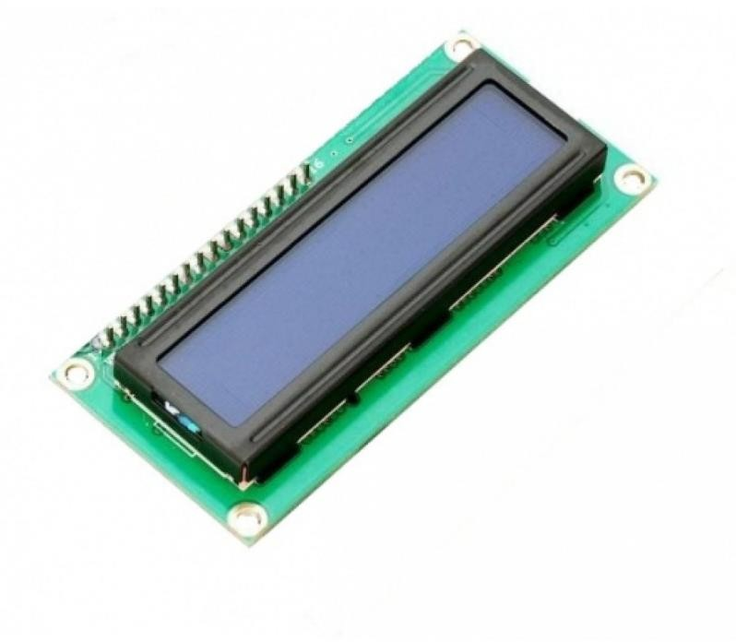A liquid-crystal display (LCD) is a flat-panel display or other electronically modulated optical device that uses the light-modulating properties of liquid crystals combined with polarizers. Liquid crystals do not emit light directly but instead use a backlight or reflector to produce images in color or monochrome.];

LCD (Liquid Crystal Display) is a type of flat panel display which uses liquid crystals in its primary form of operation. LEDs have a large and varying set of use cases for consumers and businesses, as they can be commonly found in smartphones, televisions, computer monitors and instrument panels.

1. **Buzzer**

A buzzer or beeper is an [audio](https://en.wikipedia.org/wiki/Sound) signaling device, which may be [mechanical](https://en.wikipedia.org/wiki/Machine), [electromechanical](https://en.wikipedia.org/wiki/Electromechanics), or [piezoelectric](https://en.wikipedia.org/wiki/Piezoelectricity) (*piezo* for short). Typical uses of buzzers and beepers include [alarm](https://en.wikipedia.org/wiki/Alarm_devices) [devices,](https://en.wikipedia.org/wiki/Alarm_devices) [timers,](https://en.wikipedia.org/wiki/Timer) [train](https://en.wikipedia.org/wiki/Train) and confirmation of user input such as a mouse click or keystroke.

A [piezoelectric](https://en.wikipedia.org/wiki/Piezoelectric) element may be driven by an [oscillating](https://en.wikipedia.org/wiki/Oscillation) electronic circuit or other [audio](https://en.wikipedia.org/wiki/Audio_signal) [signal](https://en.wikipedia.org/wiki/Audio_signal) source, driven with a [piezoelectric audio amplifier](https://en.wikipedia.org/wiki/Piezoelectric_audio_amplifier). Sounds commonly used to indicate that a button has been pressed are a click, a ring or a beep.

Early devices were based on an electromechanical system identical to an [electric bell](https://en.wikipedia.org/wiki/Electric_bell) without the metal gong. Similarly, a [relay](https://en.wikipedia.org/wiki/Relay) may be connected to interrupt its own actuating [current,](https://en.wikipedia.org/wiki/Electric_current) causing the [contacts](https://en.wikipedia.org/wiki/Switch) to buzz (the contacts buzz at [line frequency](https://en.wikipedia.org/wiki/Utility_frequency) if powered by [alternating current](https://en.wikipedia.org/wiki/Alternating_current)) Often these units were anchored to a wall or ceiling to use it as a sounding board. The word "buzzer" comes from the rasping noise that electromechanical buzzers made.

1. **I2C**

I2C is a two-wire serial communication protocol using a serial data line (SDA) and a serial clock line (SCL). The protocol supports multiple target devices on a communication bus and can also support multiple controllers that send and receive commands and data.

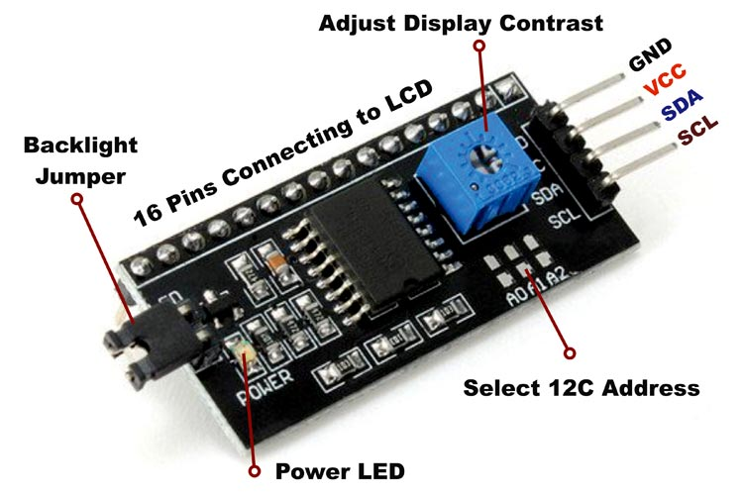

I2C has several speed modes starting with the Standard-mode (Sm), which is a serial protocol that operates up to 100 kilobits per second (kbps). This mode is followed by the Fast-mode (Fm) which tops out at 400 kilobits per second. Fast-mode can be used by the controller if the bus capacitance and drive capability allow for the faster speed. Both of these protocols are widely supported. The Fast-mode Plus (Fm+) mode allows for communication as high as 1 megabit per second (Mbps). To achieve this speed, drivers in the devices require extra strength to comply with faster rise and fall times. These three modes are relatively similar, using a communication structure that is the same. However, all have different timing specifications for each of the modes and hardware implementation of the I2C in the devices are different to accommodate the different speeds. I 2C also has two other modes for higher data rates. High-speed mode (Hs-mode) has a data rate to 3.4 megabits per second. In this mode, the controller device must first use a controller code to allow for high-speed data transfer. This enables high-speed mode in the target device. This mode can also require an active pullup to drive the communication lines at a higher data rate. Ultra-Fast mode (UFm) is the fastest mode of operation and transfers data up to 5Mbps. This mode is write-only and omits some I2C features in the communication protocol. Table 1-1 shows the different I2C modes and their respective data rates

### [**HX711**](https://how2electronics.com/iot-weighing-scale-hx711-load-cell-esp8266/)**Module**

The [HX711](https://how2electronics.com/iot-weighing-scale-hx711-load-cell-esp8266/)**Dual-Channel 24 Bit Precision A/D weight Pressure Sensor Load Cell Amplifier and ADC Module** is a small breakout board for the HX711 IC that allows you to easily read load cells to measure weight. By connecting the module to your [microcontroller](https://how2electronics.com/iot-weighing-scale-hx711-load-cell-esp8266/) you will be able to read the changes in the resistance of the load cell and with some calibration. You’ll be able to get very accurate **weight measurements**.

[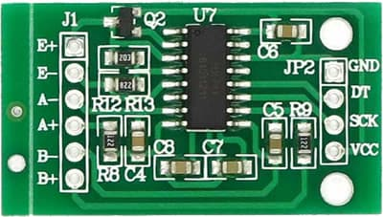](https://how2electronics.com/wp-content/uploads/2020/02/HX711-Module.jpg)

This can be handy for creating your own industrial [scale](https://how2electronics.com/iot-weighing-scale-hx711-load-cell-esp8266/), process control, or simple presence detection. The **HX711 Weighing Sensor** uses a two-wire interface (Clock and Data) for communication. Any [microcontroller](https://how2electronics.com/iot-weighing-scale-hx711-load-cell-esp8266/)’s GPIO pins should work making it easy to read data from the [HX711](https://how2electronics.com/iot-weighing-scale-hx711-load-cell-esp8266/).

**Each color corresponds to the conventional color coding of load cells :**1. Red (Excitation+ or VCC).  
2. Black (Excitation- or GND).  
3. White (Amplifier+, Signal+, or Output+).  
4. Green (A-, S-, or O-).  
5. Yellow (Shield).  
The YLW pin acts as an optional input that not hook up to the strain gauge but is utilized to ground and shield against outside EMI (electromagnetic interference).

### **Base Design & Connections**

#### **Load Cell and**[**HX711**](https://how2electronics.com/iot-weighing-scale-hx711-load-cell-esp8266/)**Connection:**

[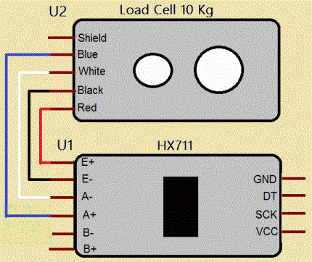](https://how2electronics.com/wp-content/uploads/2018/06/connections-between-Load-cell-and-HX711-module.gif)

-RED Wire **is** connected **to** E+

- BLACK Wire **is** connected **to** E-

- WHITE Wire **is** connected **to** A-

- GREEN Wire **is** connected **to** A

[](https://how2electronics.com/wp-content/uploads/2020/02/Load-Cell-Base.jpg)

A base is also required to fix the load cell over it by using **nuts** and **bolts**. Here we have used a hard plyboard for the frame for placing things over it and a light wooden board as Base. This is required as load cell bends slightly when some weight is placed over it.

Here is a **circuit diagram** for **interfacing 1KG Load Cell and**[HX711](https://how2electronics.com/iot-weighing-scale-hx711-load-cell-esp8266/)**Module with NodeMCU ESP8266 12E Board**. You can follow the same circuit here and make your own [Weighing Scale](https://how2electronics.com/iot-weighing-scale-hx711-load-cell-esp8266/)**.**

[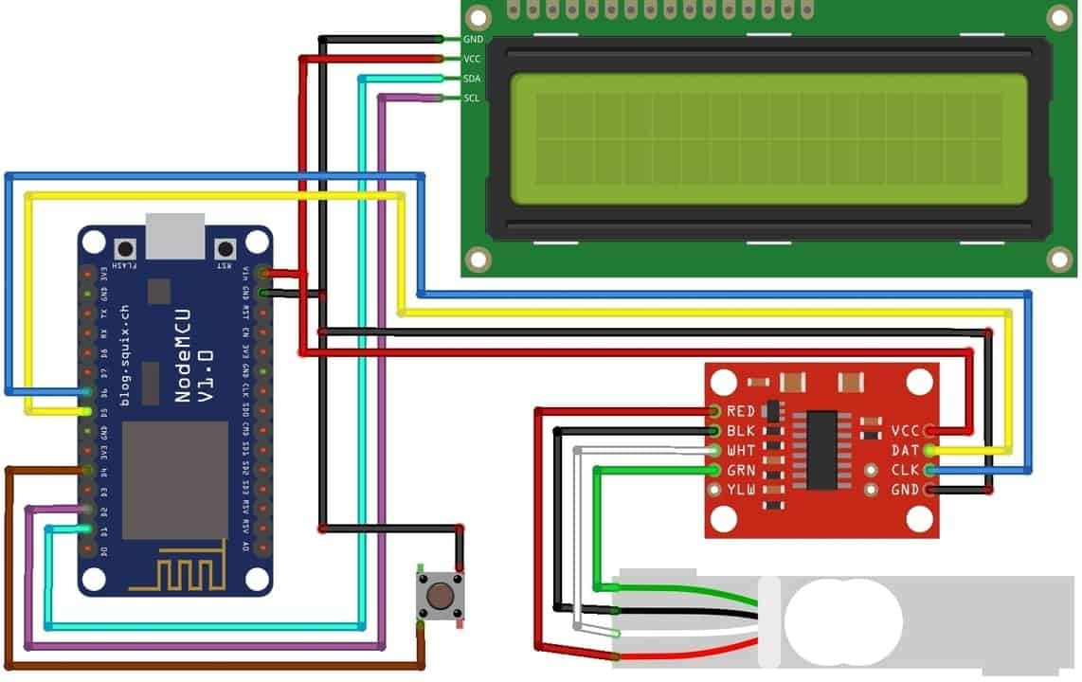](https://how2electronics.com/wp-content/uploads/2020/02/HX711-Load-Cell-NodeMCU-Circuit-.jpg)

### **Circuit: IOT**[Weighing Scale](https://how2electronics.com/iot-weighing-scale-hx711-load-cell-esp8266/)**with**[HX711](https://how2electronics.com/iot-weighing-scale-hx711-load-cell-esp8266/)**Load Cell, LCD & ESP8266**

The **connection between Load Cell & HX711** has been explained above. Connect the DT & SCK Pins of Load Cell to ESP8266 D5 & D6 Pins respectively. I have used a push-button tact switch to **reset the weight** to zero. Push-button Switch is a connected digital pin D4 of ESP8266. I used a 16X2 I2C LCD Display to minimize the connection. So, connect the SDA & SCL pin of I2C LCD Display to D2 & D1 of Nodemcu respectively.

### **Setting Up Blynk IoT Application for Remote Weight Monitoring**

[Blynk](https://blynk.io/) is an application that runs over Android and IOS devices to control any IoT based application using Smartphones. It allows you to create your Graphical user interface for IoT application. Here we will set up the **Blynk application** to monitor Measured Weight over Wi-Fi using NodeMCU ESP8266.

So download and install the **Blynk Application** from Google Play store. IOS users can download from the App Store. Once the installation is completed, open the app & sign-up using your Email id and Password.

[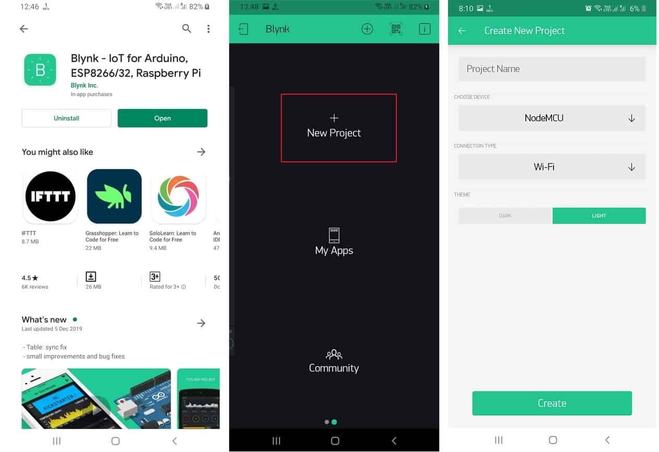](https://how2electronics.com/wp-content/uploads/1.jpg)

Now follow the photos below to setup the complete Blynk application.

[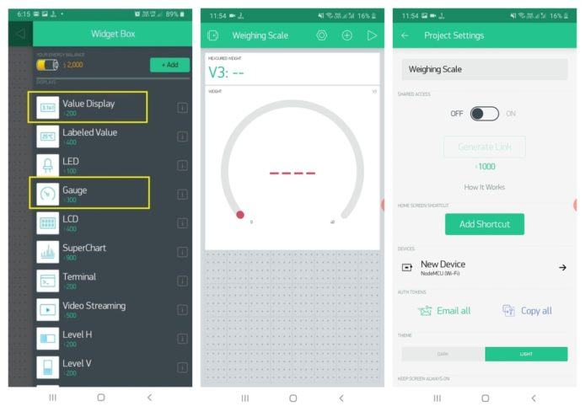](https://how2electronics.com/wp-content/uploads/2020/02/bLYNK-Setup2.jpg)

So create gauge and value display. After the successful creation of the Project, go back to setting and click on Send Email. You will get an Authenticate ID on registered mail. Save the Authenticate ID. You will need to enter this on code.

### **Source Code/Program to Calibrate the Load Cell**

After connecting the load cell as above, you need to **calibrate** it first before going for the final design. So first calibrate the whole assembly unit. You will need add [HX711](https://how2electronics.com/iot-weighing-scale-hx711-load-cell-esp8266/) library to make the code compile.

You will need other libraries related to Blynk as well for compiling the final code below.  
1. [Blynk ESP8266 Library](https://github.com/blynkkk/blynk-library)  
2. [Liquid Crystal I2C Library](https://github.com/fdebrabander/Arduino-LiquidCrystal-I2C-library)

<https://dpaste.com/H8849QPY6>

Once you upload the calibration code, open the serial monitor and adjust your scale factor with known weight until you see the correct readings. Press a,s,d,f to increase calibration factor by 10,100,1000,10000 respectively. Press z,x,c,v to decrease calibration factor by 10,100,1000,10000 respectively.

[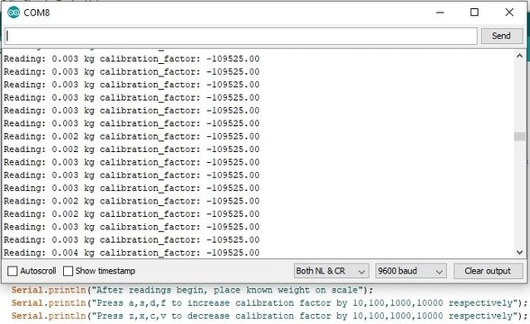](https://how2electronics.com/wp-content/uploads/2020/02/Calibration.jpg)

Once you see the placed weight is the same as shown weight note down the calibration factor and use it in the final code for [Weighing Scale](https://how2electronics.com/iot-weighing-scale-hx711-load-cell-esp8266/).

**Source Code: IOT**[**Weighing Scale**](https://how2electronics.com/iot-weighing-scale-hx711-load-cell-esp8266/)**with**[**HX711**](https://how2electronics.com/iot-weighing-scale-hx711-load-cell-esp8266/)**Load Cell & ESP8266 on Blynk**

code and hence your IoT Weighing Scale is ready.  
Make sure to change WiFi SSID, Password & Blynk Authenticate Code on the code as well.

<https://dpaste.com/63BMYA5WH>

### **Source Code: IOT**[**Weighing Scale**](https://how2electronics.com/iot-weighing-scale-hx711-load-cell-esp8266/)**with**[**HX711**](https://how2electronics.com/iot-weighing-scale-hx711-load-cell-esp8266/)**Load Cell & ESP8266**

Similarly if you want to monitor the weight online on platform you can use the code below.

<https://dpaste.com/63YQD9Q2H>

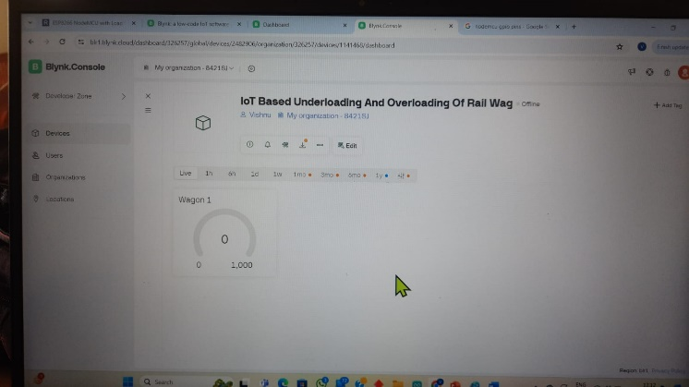

After uploading code with correct API key, you can monitor the data online.

[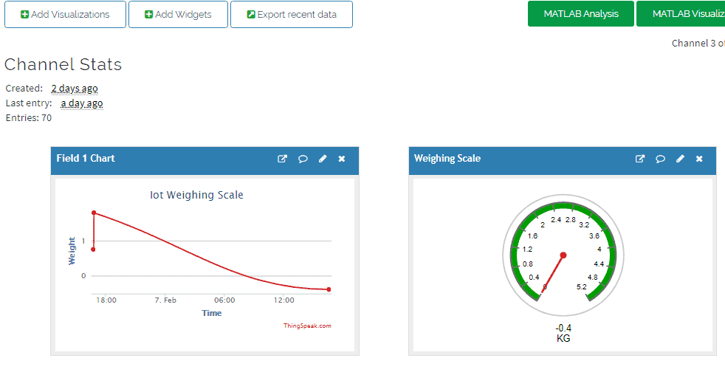](https://how2electronics.com/wp-content/uploads/2020/02/thingspeak-analysis.png)

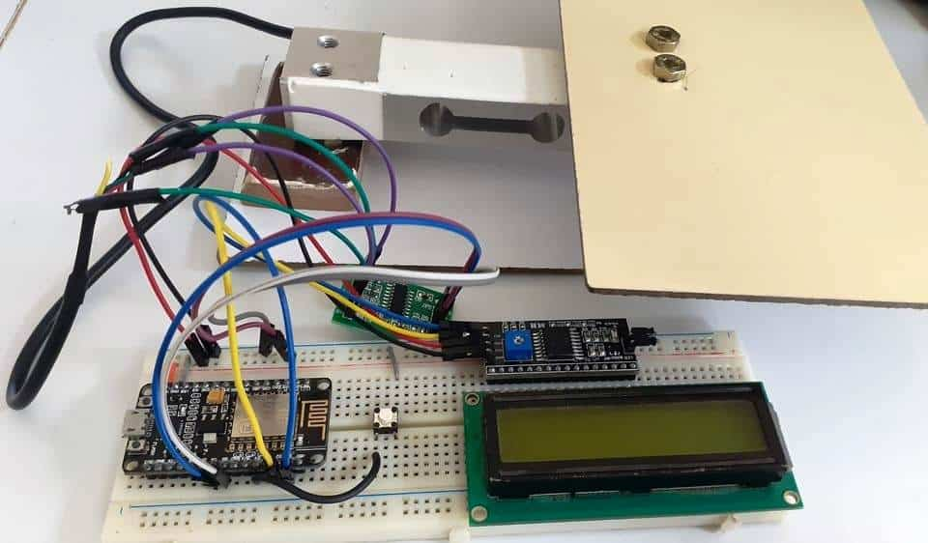

### **V. RESULTS & OBSERVATIONS**

[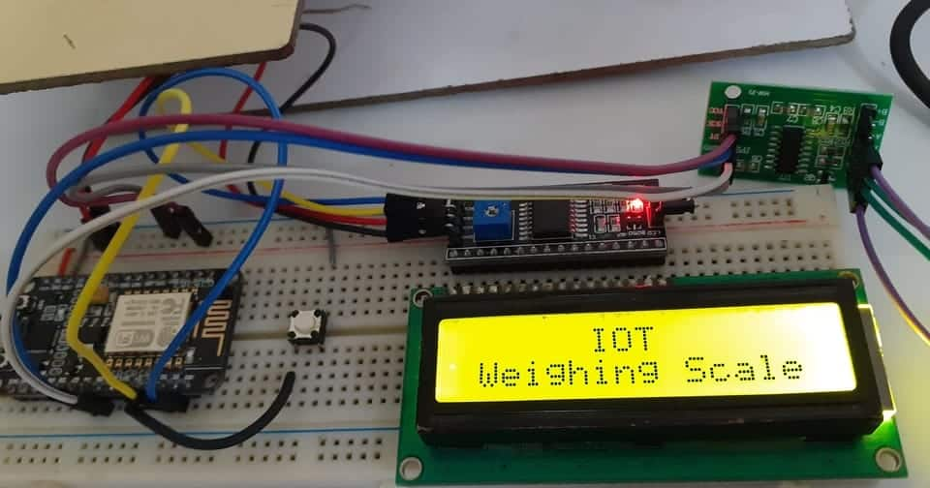](https://how2electronics.com/wp-content/uploads/2020/02/1ws.jpg)

When no weights are placed the Display will show the weight almost equal to zero.

[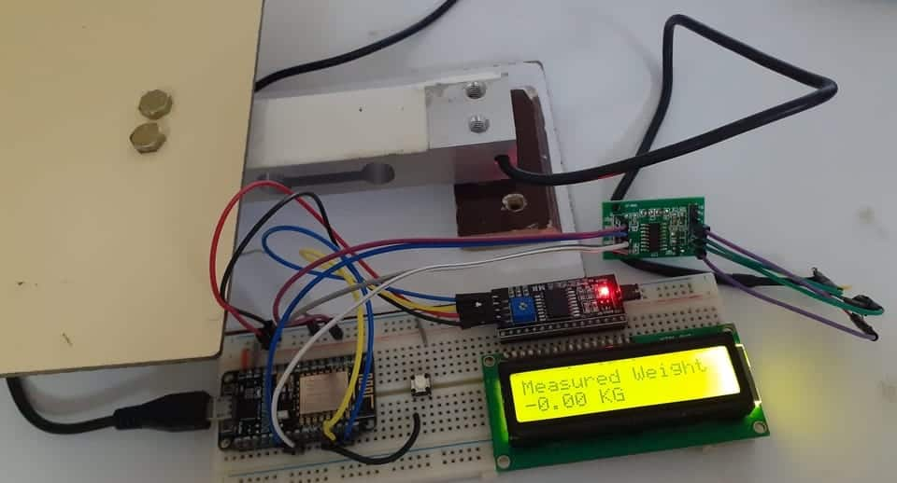](https://how2electronics.com/wp-content/uploads/2020/02/2ws.jpg)

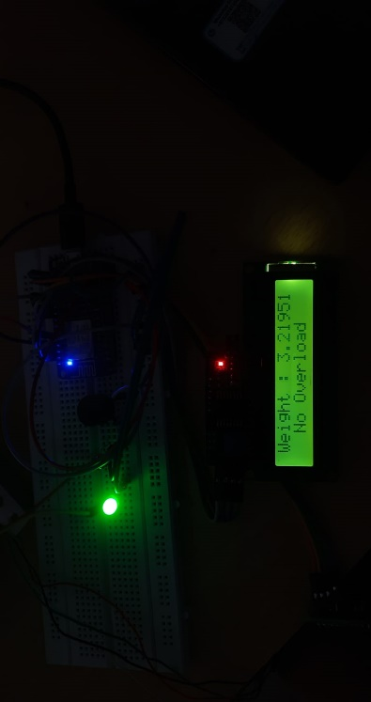

When some weights are placed the Display will show the weight almost equal to the weight of the object.

[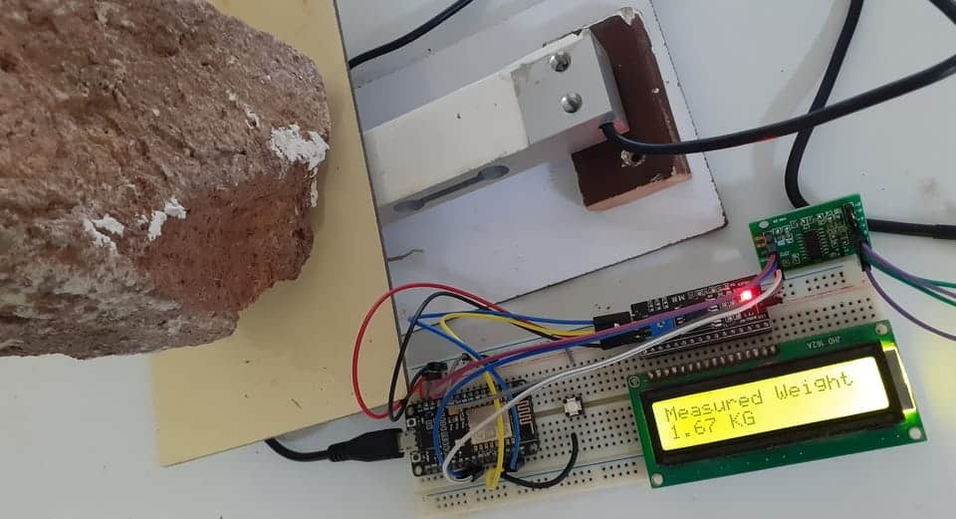](https://how2electronics.com/wp-content/uploads/2020/02/3s.jpg)

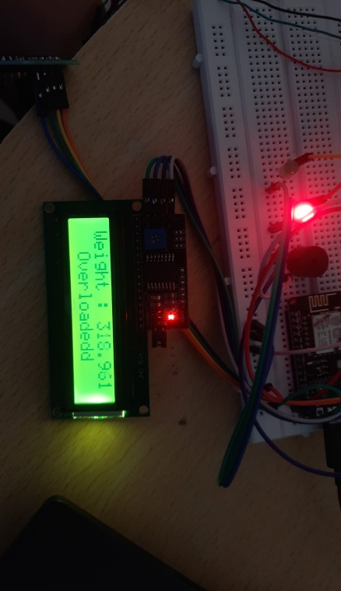

Now you can power on your Blynk Application and you will see the changes in weight parameters both in label display as well as gauge.

[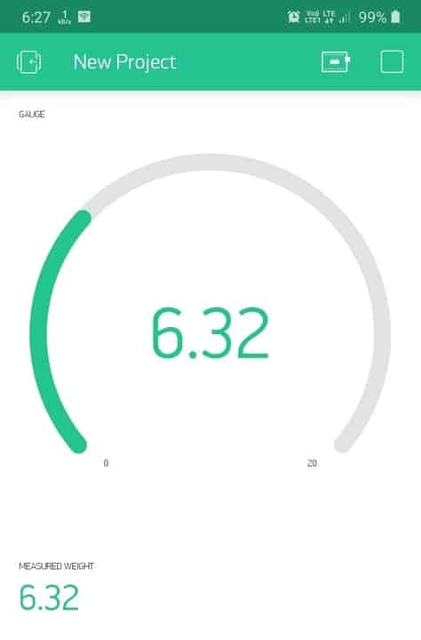](https://how2electronics.com/wp-content/uploads/2020/02/Blynk.jpg)

**VI. CONCLUSION**

This is proposed IoT-based system represents a transformative solution for advancing railway safety by effectively preventing under-loading and overloading of wagons. By leveraging IoT technology, machine learning algorithms, and real-time data analytics, the system offers a proactive approach to risk management, ensuring the safe and efficient operation of railway networks. Implementation of this system has the potential to elevate safety standards, enhance operational performance, and instill public confidence in railway transportation as a reliable and sustainable mode of transit.

**VII. ADVANTAGES AND BENEFITS**

**Advantages of the IoT-based system over traditional methods:-**

Improved operational efficiency and reduced downtime.

Enhanced safety and reduced risk of accidents.

**Improved cost-effectiveness:-**

Savings in maintenance and repair costs.

Optimization of resource utilization.

**REFERENCE**

[1] K. R. Suryawanshi, P. S. Lohar, and M. V. Rokade, "IoT Based Railway Wagon Load Monitoring System," 2018 International Conference on Inventive Research in Computing Applications (ICIRCA), Coimbatore, India, 2018, pp. 860-864.

[2] M. V. Bhagat, S. S. Kulkarni, and A. V. Bhosle, "IoT Based Smart Railway System for Cargo Monitoring and Tracking," 2019 3rd International Conference on Trends in Electronics and Informatics (ICOEI), Tirunelveli, India, 2019, pp. 282-287.

[3] S. S. Phalke, A. K. Gore, and N. J. Chavan, "IoT Based Smart Railway System for Cargo Monitoring and Tracking," 2018 International Conference on Inventive Communication and Computational Technologies (ICICCT), Coimbatore, India, 2018, pp. 1741-1745.

[4] A. A. Shaikh, M. Z. Shaikh and A. M. Shaikh, "Smart Railway Track Monitoring System Based on IoT," 2019 International Conference on Advanced Communication Technologies and Networking (CommNet), Karachi, Pakistan, 2019, pp. 37-42.

[5] A. M. A. Mohamed, A. M. Abdelsamea, and M. A. Abdeen, "A Survey of Wireless Sensor Networks for Railway Monitoring and Safety Control," Sensors (Basel). 2019 Dec; 19(24): 5565

[6] S. Saha, D. A. Deshmukh, and A. Sharma, "Load Cell Calibration for Railway Wagon Weighing System," 2019 International Conference on Electrical, Electronics, Communication, Computer, and Optimization Techniques (ICEECCOT), Mysuru, India, 2019, pp. 1200-1203