**Pole Zero Plot Analysis**

**Mandar D. Sontakke1, Saurabh R Prasad2\***

mandarrkkop@gmail.com saurabhprasad21@gmail.com

*1KIT’s College of Engineering, Kolhapur, India*

*2DKTE Society’s Textile and Engineering Institute, Ichalkaranji, India*

**\*Corresponding Author:**

**Abstract:** In control systems, poles and zeros is one of important concept. Using poles and zeros, we are able to understand the behaviour of the system. The most difficult part in the analysis is to find the angle between poles and zeros. To overcome this difficulty, I developed some rules using which we easily able to calculate the angle.

***Index Terms****:* Introductio*n,* Rules, different examples.

**Introduction:** Poles and zeros are commonly employed by analog designers to characterize the linear behavior of analog integrated circuits [1].A system is an arrangement of or combination of different physical components connected or related in such a manner so as to form an entire unit to attain a certain objective. Control system is an arrangement of different physical elements connected in such a manner so as to regulate, director command itself to achieve a certain objective. Requirements of a good control system are accuracy, sensitivity, noise, stability, bandwidth, Speed and oscillations. , the calculation of poles and zeros also inherits the exponential growth of the network function complexities with the circuit size [2], even worse, as operations between a number of network function coefficients have to be performed.

Previous approaches to symbolic pole/zero extraction, reported in [3–8], incorporate some type of approximation in the calculation of the network functions.

The following rules are used to find angle from Pole – Zero Diagram:

1) Moving towards origin: Angle is Zero degree.

2) Moving away from origin: Angle is 1800

3) Moving from Imaginary Pole to Real Pole: Angle is directly calculated angle.

4) Moving from Imaginary Zero to Real Pole: Angle is directly calculated angle.

5) Moving from Real Pole to Imaginary Pole 1800 - Angle is directly calculated angle.

6) Moving from Real zero to Imaginary Pole: 900 + Angle is directly calculated angle.

7) Moving from +jω to –jω: Angle is +900

8) Moving from -jω to +jω: Angle is -900

Their no case like, moving from Imaginary Pole to Real Zero.

For Example:

Ex.1) For a given function, draw Pole-Zero Diagram and find i(t). I(s) = S/(S+1) (S+2)

Solution:

We observe that there is one Zero at zero location and there are 2 poles at S= -1 and S= -2 position.

Pole Zero Plot is as follows,

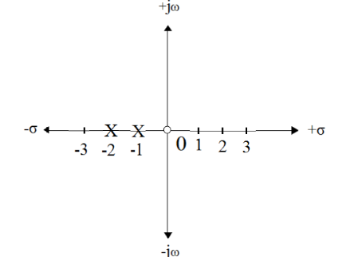

Using partial fraction expansion method:

|  |  |  |
| --- | --- | --- |
|  | I(S) = A/(S+1) + B/(S+2) | (1) |

To find A: Keep S = -1 fixed.

A= (Magnitude and angle from Zero to Pole)/ (Magnitude and angle from Pole to Pole)

A= (Magnitude and angle from S = 0 to S = -1)/ (Magnitude and angle from S = -2 to S = -1)

A= (1 ∠1800)/(1Ɩ00) = 1 ∠1800

Numerator: We are moving from 0 to - 1: See Rule 2, we are moving away from origin.

So angle = 1800.

Denominator: We are moving from - 2 to - 1: See Rule 2, we are moving towards origin. So angle = 00

B= (Magnitude and angle from Zero to Pole)/ (Magnitude and angle from Pole to Pole)

B= (Magnitude and angle from S = 0 to S = - 2)/ (Magnitude and angle from S = - 1 to S = - 2)

B= (2 ∠1800)/ (1 ∠1800) = 2

Numerator: We are moving from 0 to - 2: See Rule 2, we are moving away from origin.

So angle = 1800.

Denominator: We are moving from - 1 to - 2: See Rule 2, we are moving away from origin.

So angle =1800

Put A & B in equation 1)

We get the transform of I(s) as,

|  |  |  |
| --- | --- | --- |
|  | T[I(S)] = (1∠ 800)/(S+1) + (2)/(S+2) | (2) |

Taking Inverse Laplace of equation (2),

We get, i(t) = [(1 ∠1800) e-t + (2) e-2t] Amp.

Ex.2) I(S) = (S+1)/(S+2) (S+3) (S+4)

Draw Pole-Zero Diagram and find i(t).

Answer: We observe that there is one Zero at location S = - 1 & there are 3 poles at S = - 2, S = -3

and S = - 4 position.

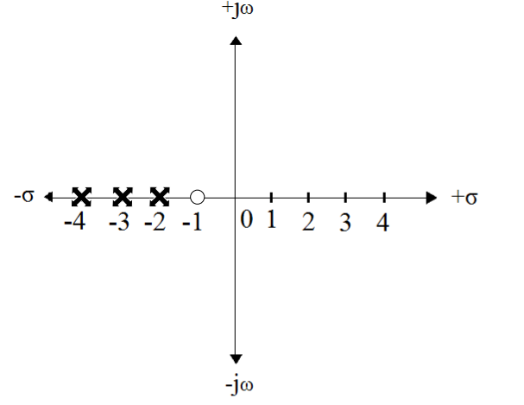

Using partial fraction expansion method:

|  |  |  |
| --- | --- | --- |
|  | I(S) = A/(S+2) + B/(S+3) +C/(S+4) | (3) |

To find A: Keep S = -2 as fixed.

A= (Magnitude and angle from Zero to Pole)/ (Magnitude and angle from Pole to Pole)

A= (Magnitude and angle from S = - 1 to S = - 2)/ (Magnitude and angle from S = - 3 to S = - 2) * (Magnitude and angle from S = - 4 to S = - 3

A= (1 ∠1800)/ (1∠00) * (2 ∠00) = (1/2) ∠1800

Numerator: We are moving from - 1 to - 2: See Rule 2, we are moving away from origin.

So angle = 1800.

Denominator: We are moving from -3 to -2: See Rule 2, we are moving towards origin. So angle = 00

Denominator: We are moving from -4 to - 3: See Rule 2, we are moving towards origin. So angle = 00

B= (Magnitude and angle from Zero to Pole) / (Magnitude and angle from Pole to Pole)

B= (Magnitude and angle from S = 1 to S = - 3) / (Magnitude and angle from S = - 2 to S = - 3) * (Magnitude and angle from S = - 4 to S = - 3)

B= (2 ∠1800)/(1∠1800) * (1Ɩ00) = 2

Numerator: We are moving from -1 to -3: See Rule 2, we are moving away from origin.

So angle = 1800.

Denominator: We are moving from -2 to - 3: See Rule 2, we are moving away from origin.

So angle = 1800

Denominator: We are moving from -4 to -3: See Rule 2, we are moving towards origin. So angle = 00

C = (Magnitude and angle from S = 1 to S = - 4) / (Magnitude and angle from S=-2 to S=-4) * (Magnitude and angle from S = - 3 to S = - 4)

C = (3 ∠1800)/ (1∠1800) * (1∠1800) = (3/2) ∠-1800

Numerator: We are moving from -1 to - 4: See Rule 2, we are moving away from origin.

So angle = 1800.

Denominator: We are moving from -2 to -4: See Rule 2, we are moving away from origin.

So angle = 1800

Denominator: We are moving from -3 to -4: See Rule 2, we are moving away from origin.

So angle = 1800

Put A, B & C in equation 1), We get,

|  |  |  |
| --- | --- | --- |
|  | T [I(S)] = ((1/2) ∠1800)/(S+2) + (2)/(S+3) + ((3/2) ∠-1800)/(S+4) | (4) |

Taking Inverse Laplace of equation (2), we get,

i (t) = [((1/2) Ɩ1800) e-2t + (2) e-3t] + (3/2) ∠

1800 e-4t] Amp.

Ex.3) Using Pole-Zero Plot, find i(t).

I(S) = S*(S+1)/ (S2 + 4)

Answer:

There are 2 Zeros at S = 0 and S = -1. Also there are 2 Poles at S = + 2j and S = - 2j.

Pole-Zero Plot is as follows,

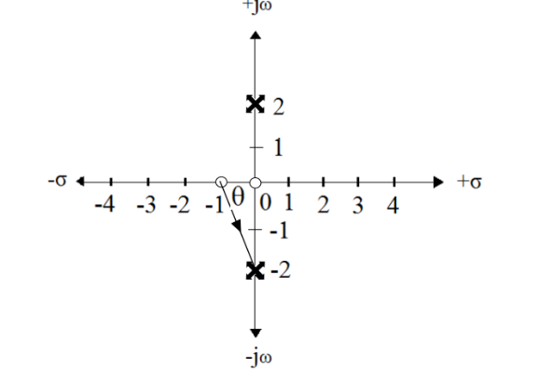

I(S) = S*(S+1)/(S+2j) (S-2j)

Using partial fraction expansion method:

|  |  |  |
| --- | --- | --- |
|  | I(S) = A/(S+2j) + B/(S-2j) | (5) |

To find A: Keep S = -2j, fixed.

Calculation of A:

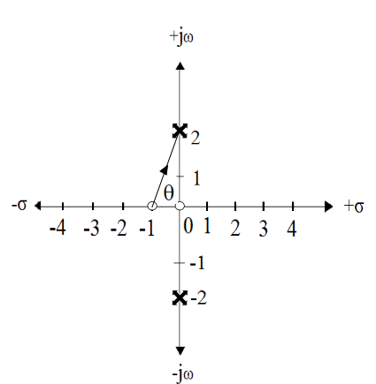

θ = sinˉ¹ (2/√5)

θ =63.43 ͦ =directly calculated angle.

As we are moving from real zero to imaginary pole, according to rule no.6

Angle = 90 ͦ +directly calculated angle= 90+63.43=153.43 ͦ

A= (Magnitude and angle from Zero to Pole) / (Magnitude and angle from Pole to Pole)

A= (Magnitude and angle from S=0 to S= -2j) * (Magnitude and angle from S=-1 to S=-2j)/ (Magnitude and angle from S=+2j to S=-2j)

A = (2∠900) * (√5) ∠900 + directly calculated angle i.e. 63.430)/ (4∠900)

A = (root 5/2) ∠153.430

Numerator: We are moving from 0 to -2j: See Rule 7, we are moving 0 to –jω axis. So angle = 900

Numerator: We are moving from -1 to -2j: See Rule 6, we are moving real zero to imaginary pole.

So angle = 900 + directly calculated angle=153.430

Denominator: We are moving from +2j to -2j: See Rule 7, we are moving from +jω to –jω. So angle = +900

To find B: Keep S = +2j, fixed.

Calculation of B:

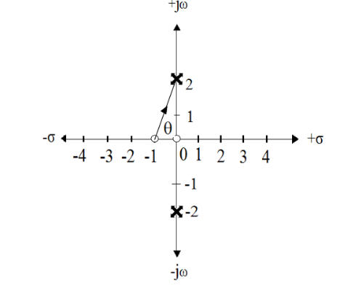

θ = sinˉ¹ (2/√5)

θ =63.43 ͦ =directly calculated angle.

As we are moving from real zero to imaginary pole, according to rule no.6

Angle = 90 ͦ +directly calculated angle= 90+63.43=153.43 ͦ

As it is exactly opposite of A: Angle= -153.43 ͦ

A= (Magnitude and angle from Zero to Pole)/ (Magnitude and angle from Pole to Pole)

A= (Magnitude and angle from S=0 to S=+2j) *(Magnitude and angle from S=-1 to S=+2j)/ (Magnitude

and angle from S=-2j to S=+2j)

B = (2∠-900) * (√5) ∠ 900 + directly calculated angle i.e. 63.430=153.430)/ (4∠-900)

B = (√5/2) ∠-153.430

Numerator: We are moving from 0 to +2j: See Rule 7, we are moving 0 to +jω axis. So angle = -900

Numerator: We are moving from -1 to +2j: See Rule 6, we are moving real zero to imaginary pole.

So angle = 900 + directly calculated angle= -153.430

Denominator: We are moving from -2j to +2j: See Rule 8, we are moving from - jω to + jω.

So angle = - 900

Put A & B in equation (1), we get,

|  |  |  |
| --- | --- | --- |
|  | T[I(S)] = (√5/2 ∠153.430) / (S+2j) + (√5/2∠-153.430)/(S-2j) | (5) |

Taking Inverse Laplace of equation (2), we get,

i(t) = [((√ 5/2∠153.430) e-2jt + (√5/2∠-153.430) e+2j] Amp.

Ex.4) Using Pole-Zero Plot, find i(t), if

I(S) = (S+1) / (S+3) *(S2 + 1)

Answer: There is one Zero at S = -1 and there are 3 Poles at S = -3, S = + j and S = - j.

Pole-Zero Plot is as shown below,

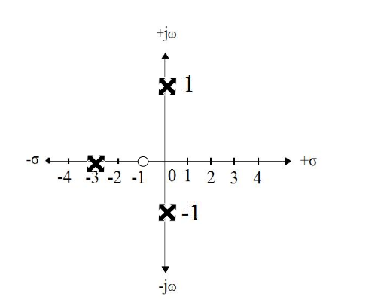

Calculation of A:

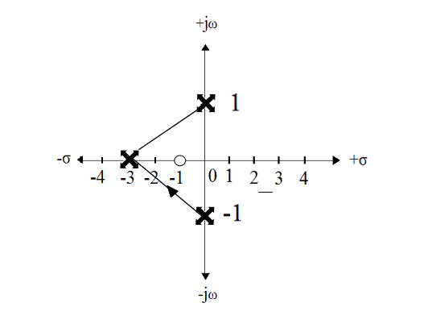

I(S) = (S+1) / (S+3) *(S2 + 1)

Using partial fraction expansion method:

|  |  |  |
| --- | --- | --- |
|  | I(S) = A/(S+3) + B/(S + j ) + C/ ( S - j ) | (6) |

To find A: Keep S = -3 as fixed.

A= (Magnitude and angle from Zero to Pole) / (Magnitude and angle from Pole to Pole)

A= (Magnitude and angle from S= - 1 to S = - 3) / (Magnitude and angle from S = - j to S = -3) * (Magnitude and angle from S = +j to S = - 3)

A = [(2∠1800)] / [(√ 10 ∠18.430) * (√ 10 ∠-18.430)]

A = (1/5) Ɩ800

Numerator: We are moving from -1 to -3: See Rule 2, we are moving away from origin. So angle = 1800

Denominator: We are moving from -j to -3: See Rule 3, we are moving from imaginary pole to real pole. So angle = Directly calculated angle i.e. 18.430

Denominator: We are moving from +j to -3: See Rule 3, we are moving from imaginary pole to real pole.So angle = directly calculated angle i.e. - 18.430

To find B: Keep S = - j, fix.

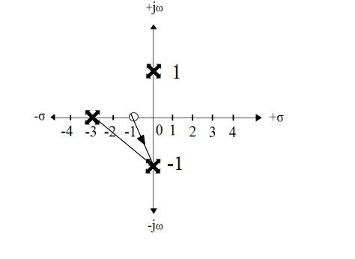

B= (Magnitude and angle from Zero to Pole)/ (Magnitude and angle from Pole to Pole)

B= (Magnitude and angle from S= - 1 to S = - j) / (Magnitude and angle from S = - 3 to S = - j)*(Magnitude and angle from S = + j to S = -j)

B = [(√ 2∠1350)] / [(√ 10 ∠161.570) * (2 ∠ 900)

B = (1/√20) ∠-116.570

Numerator: We are moving from -1to -j: See Rule 6, we are moving from real zero to imaginary pole So angle = 900 + directly calculated angle =900 + 450

Denominator: We are moving from -3 to - j: See Rule 5, we are moving from real pole to imaginary pole. So angle = 1800 - directly calculated angle i.e. 1800 – 18.430 = 161.57

Denominator: We are moving from +j to - j: See Rule 7, we are moving from+ jω to - jω.

So angle = + 900

To find C, it is complex conjugate of B. As (S + j) and (s – j) are complex conjugate pair.

C = [(√ 2∠ - 1350) / [(√10 ∠ - 161.570) * (2∠ - 900)

C = (√ 5/ √20) ∠16.570

Put A, B & C in equation (1), we get,

|  |  |  |
| --- | --- | --- |
|  | T[I(S)] = ((1/5) ∠1800)/(S+3) + (1/ √20∠  – 116.570)/(S+ j) + ( (1/ √20∠  + 116.570)/(S - j) | (7) |

Equation 2)

Taking Inverse Laplace of equation (2)

We get,

i(t) = [(1/5) ∠1800) e-3t) + (1/√ 20) ∠- 116.570) e-jt + ( (1/√ 20) ∠+ 116.570) e+jt] Amp.

Ex. No. 5)

Using Pole Zero diagram, find i(t).

Given: I(S) = [(S)/(S+1) * (S2 + 4*S + 8)]

Answer:

From given equation, we observe that there is only one Zero at location S = 0 & there are 2 conjugate Poles at location S = - 2 - 2j and at S = + 2 + 2j

Solving given equation, we get

I(S) = [(S)/(S+1) * (S+2+2j) * (S+2-2j)]

Using partial fraction expansion, we get

|  |  |  |
| --- | --- | --- |
|  | I(S) = [A/(S+1) + B/(S+2+2j) + C/(S+2+2j)] | (7) |

From Pole Zer Plot, we observe that, there is only one Zero at S = 0 location and there are two Poles at

S = -2-2j and S = -2+2j locations:

To find A: Keep S = - 1 as fixed.

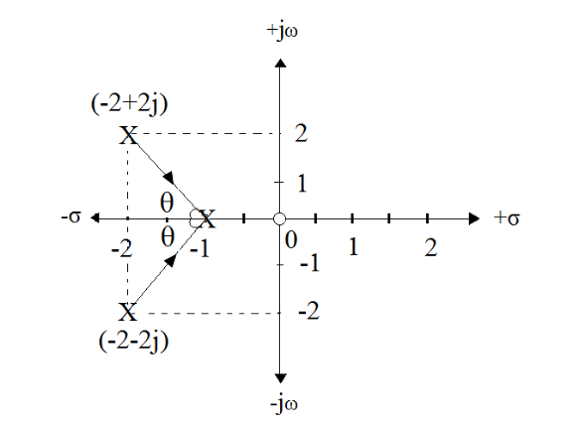

Calculation of A:

θ = sinˉ¹ (2/√5) = 63.43 ͦ

As we are moving from imaginary pole to real pole, so angle is directly calculated angle= θ =63.43 ͦ =directly calculated angle.

A= Magnitude and angle from Zero to Pole/ Magnitude and angle from Pole to Pole

A= (Magnitude and angle from S= 0 to S = - 1) / (Magnitude and angle from S = -2 -2 j to S = - 1) * (Magnitude and angle from S = -2 + 2j to S = - 1)

A = [(1Ɩ1800)] / [(√ 5 Ɩ +63.430) * (√ 5 Ɩ - 63.430)]

A = (1/5) Ɩ800

Numerator: We are moving from 0 to -1: See Rule 2, we are moving away from origin. So angle = 1800

Denominator: We are moving from -2-2j to - 1: See Rule 3, we are moving from imaginary pole to real pole. So angle = Directly calculated angle i.e. 63.430

Denominator: We are moving from 2+2j to - 1 : See Rule 3, we are moving from imaginary pole to real pole. So angle = Directly calculated angle i.e. - 63.430

To find B: Keep S = - 2- 2j, fix.

Calculation of B:

As we are moving from real pole to imaginary pole, so angle is =180-directly calculated angle.

B= Magnitude and angle from Zero to Pole/ Magnitude and angle from Pole to Pole

B= (Magnitude and angle from S= 0 to S = -2-2 j) / (Magnitude and angle from S = - 1 to S = -2-2 j)*(Magnitude and angle from S = -2+2j to S = -2-2 j)

B = [(√ 8∠1350)] / [(5 ∠116.570) * (4 ∠ 900)

B = (4√40) ∠-71.560

Numerator: We are moving from 0 to -2-2 j: See Rule 6, we are moving from real zero to imaginary pole so angle = 900+ directly calculated angle =900 + 450

Denominator: We are moving from - 1 to -2-2 j: See Rule 5, we are moving from real pole to imaginary pole. So angle = 1800 - directly calculated angle i.e. 1800 – 63.430 = 116.570

Denominator: We are moving from -2+2j to -2-2j: See Rule 7, we are moving from+ jω to - jω.

So angle = + 900

To find C, it is complex conjugate of B. As (S +2+2 j) and (S+2-2j) are complex conjugate pair.

C = [(√8∠ -1350)] / [(√5 ∠ -116.570) * (4 ∠ - 900)

C = (4√40) ∠ +71.560

Put A, B & C in equation 1)

We get, I(S) Transform

= ((1/5) ∠1800)/(S+3) + 4√40– 71.560)/(S+2+2 j) + ( (4√40∠ + 71.560)/(S+2-2j) ----------------- Equation 2)

Taking Inverse Laplace of equation 2), We get,

i(t) = [(1/5) ∠1800) e-3t) + (4√40) ∠ – 71.560) e(-2-2j)tt + ( (4√40) ∠ + 71.560).e(-2+2j)t] Amp.

Location of Poles and Stability:

|  |  |  |  |
| --- | --- | --- | --- |
| Sr. No. | Location of poles | Root in s-plane | Corresponding impulse response |
| 1 | LHP real axis single pole |  |  |
| 2 | LHP real axis repeated pole |  |  |
| 3 | LHP complex conjugate pole |  |  |
| 4 | Jω axis single pole |  |  |
| 5 | Jω axis repeated pole |  |  |
| 6 | Origin Single Pole |  |  |
| 7 | Origin repeated pole |  |  |
| 8 | RHP real axis single pole |  |  |
| 9 | RHP real axis repeated pole |  |  |
| 10 | RHP complex conjugate pole |  |  |

Conclusion: In this paper, we are able to solve different examples by considering some rules.These rules are best suited or any type of control system equation.

References:

1. Gregorian, R. and Temes, G. C., Analog MOS Integrated Circuits for Signal Processing. John Wiley & Sons, 1986.

2. Fernandez, F. V., Rodr ´ ´ıguez-Vazquez, A., Huertas, J. L. and ´ Gielen, G. (eds.), Symbolic Analysis Techniques. Applications to Analog Design Automation. IEEE Press, 1998.

3. Fernandez, F. V., Rodr ´ ´ıguez-Vazquez, A. and Huertas, J. L., ´ “A tool for symbolic analysis of analog integrated circuits including pole/zero extraction,” in Proc. 10th European Conf. on Circuit Theory and Design 2, pp. 752–761, September 1991.

4. Fernandez, F. V., Rodr ´ ´ıguez-Vazquez, A. and Huertas, J. L., ´ “Interactive AC modelling and characterization of analog circuits via symbolic analysis.” Analog Integrated Circuits and Signal Processing 1(3), pp. 183–208, November 1991.

5. Nebel, G., Kleine, U. and Pfleiderer, H., “Symbolic pole/zero calculation using SANTAFE,” IEEE J. Solid-State Circuits 30(7), pp. 752–761, July 1995.

6. Hsu, J. and Sechen, C., “Accurate extraction of simplified symbolic pole/zero expressions for large analog IC’s,” in Proc. IEEE Int. Symp. Circuits and Systems, pp. 2083–2087, 1995.

7. Droge, G. and Horneber, E. H., ¨ “Symbolic calculation of poles and zeros,” in Proc. 4th Int. Workshop on Symbolic Methods and Applications in Circuit Design, October 1996.

8. Constantinescu, F. and Nitescu, M., “Computation of symbolic pole/zero expressions for analog circuit design,” in Proc. 4th Int. Workshop on Symbolic Methods and Applications in Circuit Design, October 1996