Jaundice : A comprehensive Study

Abstract:

The disease jaundice is complicated. The body's elevated bilirubin level is what causes jaundice. Skin, mucous membranes, and skin discoloration are typical signs of jaundice. Pre-hepatic jaundice, which results from hemolysis of red blood cells, hepatic jaundice, which results from a failure in the liver's ability to catch, conjugate, and excrete bilirubin, and post-hepatic jaundice, which results from obstruction of the extra-hepatobiliary system, are some of the variations of jaundice. Both acquired and congenital factors might contribute to different forms of jaundice. A high amount of plasma bilirubin can have a variety of symptoms, including weight loss, anaemia, edoema, gastrointestinal bleeding, diarrhoea, and satiety. It can also be lethal since it can result in psychosis, lethargy, convulsions, coma, or even death.An elevated bilirubin level may aid in the identification of jaundice. Utilising radiological tools such as ultrasound and bilirubin level (conjugated and unconjugated), different types of jaundice can be differentiated. A low-fat diet and increased water consumption are the best ways to treat jaundice. Phototherapy is the main effective treatment for both neonatal physiological jaundice and pre-hepatic jaundice. Immunoglobulin infusion is another treatment for pre-hepatic jaundice. Hepatic jaundice is treated with immunosuppressive drugs, steroids, and a healthy diet. Post-hepatic jaundice is treated with surgery and decompression(4)

Keywords: Bilirubin, chlongitis, Heamolysis, Gallstone disease.

Introduction:

Elevated serum bilirubin can present as a clinical symptom of jaundice. Jaundice, also known as icterus, is the yellow colouring of the skin, sclera, and other mucous membranes caused by an accumulation of high serum bilirubin. A clinically noticeable level of jaundice is reached when the blood bilirubin level surpasses 3 mg/dL. From the perspective of general practitioners (GPs), it is critical to evaluate a patient with jaundice as soon as possible and appropriately. When treating a patient who exhibits jaundice, a comprehensive medical history, a meticulous clinical examination, and the use of the proper laboratory and imaging methods should all be included. According to epidemiology data, jaundice is more common in some age groups and varies in occurrence depending on the underlying reason. Specifically, 6 out of 10 apparently healthy babies suffer from jaundice, mostly as a result of According to epidemiology data, jaundice is more common in some age groups and varies in occurrence depending on the underlying reason. Specifically, 6 out of 10 otherwise healthy neonates experience jaundice, which is mostly caused by immature hepatic conjugation and absorption. Primary biliary cholangitis is the predominant underlying cause of jaundice in women, whereas jaundice resulting from alcoholic and nonalcoholic liver diseases is more frequent in males.When the serum bilirubin level rises above 3 mg/dL (51.3 μmol/L), jaundice develops. It can be challenging to identify only by physical examination. Acute jaundice can result from both intra- and extrahepatic aetiologies and is frequently an indication of a serious underlying illness. The majority of instances (55%) of acute jaundice in adults are brought on by intrahepatic illnesses, such as drug-induced liver injury, alcoholic liver disease, and viral hepatitis, according to a retrospective research involving over 700 individuals. The remaining 45% of cases of acute jaundice are extrahepatic, involving hemolysis, gallstone disease, and cancer.(9)(8)

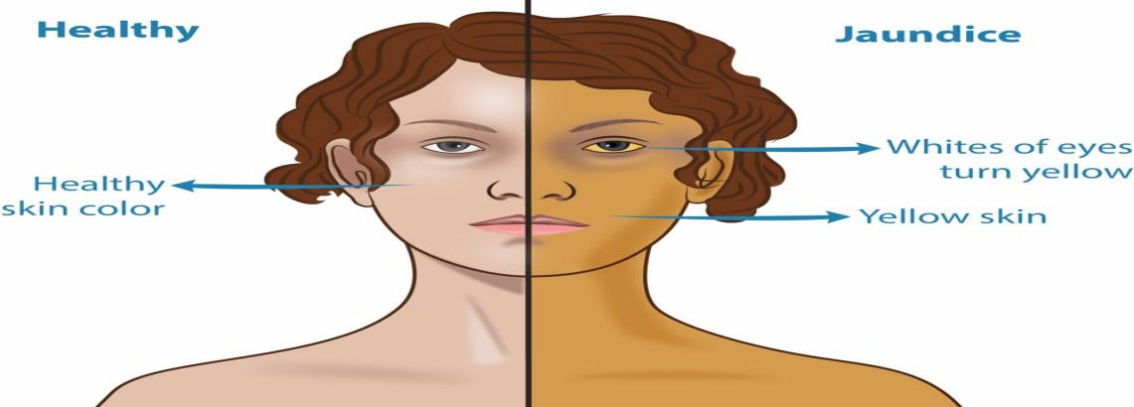

(figure No. 1 normal person versus jaundice affected)

The Pathophysiology and Metabolism of Bilirubin in Jaundice :

Bilirubin is formed as a result of heme degradation. The majority of hem is derived from erythrocyte haemoglobin, whereas smaller amounts are caused by inefficient erythropoiesis and the breakdown of other hem-containing proteins, including myoglobin, catalases, and isoenzymes of cytochrome P450. The process of bilirubin synthesis occurs in two stages: heme is converted to biliverdin in the first phase, and biliverdin is then converted to unconjugated bilirubin in the second phase by reductase Since unconjugated bilirubin is insoluble in water, it is carried to the liver along with albumin, where conjugation takes place. In the liver, uridine diphosphate (UDP)-glucuronyltransferases mediate the conjugation process. Once in the biliary system, conjugated bilirubin from liver cells travels through bile to the intestines. The majority of conjugated bilirubin is absorbed by intestinal cells and is subsequently excreted as urobilinogen in urine, while the unabsorbed portion is expelled as stercobilinogen in stool. Jaundice is caused by an increase in either conjugated or unconjugated bilirubin as a result of a change in bilirubin metabolism. The pathophysiological mechanism of bilirubin allows for the division of the aetiology of jaundice into three categories: prehepatic, hepatic, and posthepatic.(10)

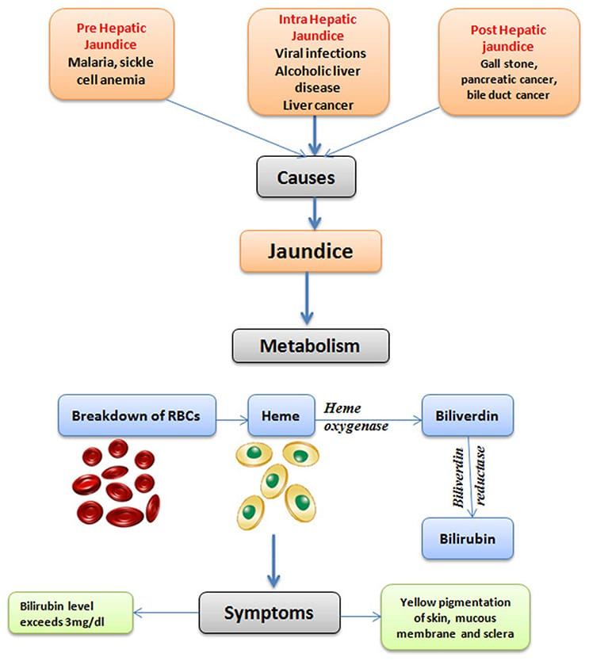

Figure No. 2 Pathophysiology of Jaundice)

History and physical Examination:

To help clarify the diagnosis, the history and physical examination should be the main emphasis of the initial workup for jaundice. Identification of intrahepatic illnesses, such as alcoholic liver disease, viral hepatitis, chronic liver disease, or drug-induced liver injury, might be aided by a thorough history of alcohol and drug use. It's crucial to review systems with emphasis. As an illustration, fever and prodromal viral symptoms may occur before acute viral hepatitis, fever and underlying sepsis may be linked, and weight loss may be linked to an underlying cancer. Evaluation of signs of chronic liver disease, such as bruising, spider angiomas, palmar erythema, and gynecomastia; evaluation of underlying encephalopathy by testing for asterixis and mental status changes; and a comprehensive abdominal examination to assess for hepatomegaly, splenomegaly, and right upper quadrant tenderness and ascites.(3)

Medical History:

When addressing a patient who exhibits jaundice, a thorough medical history is required. Establishing the differential diagnosis of jaundice can be greatly aided by association with other symptoms. Specifically, concomitant fever may signal the existence of bacterial or parasitic diseases in addition to viral hepatitis. Furthermore, there is a growing clinical suspicion of viral hepatitis if the patient reports symptoms including lethargy, muscle aches, and appetite loss. Furthermore, a complete medical history of potential risk factors for viral hepatitis is highly helpful in the diagnosing process. Additionally, prolonged nausea and vomiting may indicate chronic hepatitis or biliary obstruction, whereas previous jaundice may also indicate viral hepatitis or acute gallstone biliary obstruction.Additionally, chills may suggest a potential biliary blockage if they coexist with a fever. Loss of appetite and significant weight loss may indicate an underlying cancer. When pruritus persists over an extended period of time, it may indicate primary biliary cholangitis or biliary blockage. Information on the beginning of the symptoms in the medical histories of patients with jaundice may also point to the cause of the condition. In particular, sudden onset may indicate hepatitis and an infectious or drug-related condition, whereas jaundice that gradually manifests over weeks may represent chronic hepatitis or a biliary drainage obstruction.Furthermore, bilirubin metabolism disorders or liver cirrhosis are known to be associated with jaundice episodes in the past. It is important to record information about past operations, illnesses, and any alcohol or drug use. A family history is necessary to assess potential familial and inborn disorders.(11)(12)

References:

1. 7 Chen HL, Wu SH, Hsu SH, Liou BY, Chen HL, Chang MH. Jaundice revisited: recent advances in the diagnosis and treatment of inherited cholestatic liver diseases. J Biomed Sci. 2018 Oct;25(1):75
2. Tátrai P, Krajcsi P. Prediction of drug-induced hyperbilirubinemia by in vitro testing. Pharmaceutics. 2020 Aug;12(8):755.
3. Tong DP, Wu LQ, Chen XP, Li Y. Post-operative care of interventional therapy for 40 liver cancer patients with obstructive jaundice. Eur J Cancer Care. 2018 Jul;27(4):e12858.
4. RocheSP,KobosR.Jaundiceintheadultpatient.AmFamPhysician.2004;69(2):299304.
5. Winger J, Michelfelder A. Diagnostic approach to the patient with jaundice. *Prim Care.*2011;38(3):469-482:, viii
6. Vuppalanchi R, Liangpunsakul S, Chalasani N. Etiology of new-onset jaundice: how often is it caused by idiosyncratic drug-induced liver injury in the United States?. *Am J Gastroenterol.*2007;102(3):558-562.
7. Erlinger S, Arias IM, Dhumeaux D. Inherited disorders of bilirubin transport and conjugation: new insights into molecular mechanisms and consequences. *Gastroenterology.*2014;146(7):1625-1638.
8. Porter ML, Dennis BL. Hyperbilirubinemia in the term newborn. Am Fam Physician. 2002 Feb;65(4):599.
9. Purohit T, Cappell MS. Primary biliary cirrhosis: pathophysiology, clinical presentation and therapy. World J Hepatol. 2015 May;7(7): 926–41
10. Fevery J. Bilirubin in clinical practice: a review. Liver Int. 2008 May;28(5):592–605
11. Gadia CLB, Manirakiza A, Tekpa G, Konamna X, Vickos U, Nakoune E. Identification of pathogens for differential diagnosis of fever with jaundice in the Central African Republic: a retrospective assessment, 2008–2010. BMC Infect Dis. 2017 Nov;17(1):735.
12. Bassari R, Koea JB. Jaundice associated pruritis: a review of pathophysiology and treatment. World J Gastroenterol. 2015 Feb;21(5): 1404–13