Revolutionizing Disease Diagnosis The Role of Machine Learning in Biomedical Imaging
Dr. R. GURUNADHA* Dr.M.Hema**
*Associate Professor, Department of Electronics and Communication Engineering, JNTU-GV College of Engineering
**Assistant Professor, Department of Electronics and Communication Engineering, JNTU-GV College of Engineering

ABSTRACT
Biomedical imaging has not been exempt from the revolutionary changes brought about by machine learning (ML) development. This study investigates how machine learning can revolutionize the classification of disease using biomedical imaging. In many cases, machine learning algorithms especially deep learning techniques have outperformed conventional methods by diseases from medical images. Better medical results for patients, tailored treatment regimens, and early detection are made possible by applying machine learning to biomedical imaging. This study examines the most recent developments, difficulties, and potential uses of machine learning in different kinds of imaging like MRIs, CT scans, and X-rays. Large datasets and complex algorithms combined with machine learning (ML) have the potential to completely change diagnostic paradigms and open the door to more accurate, dependable, and affordable healthcare solutions.
Key Words : Machine Learning, BioMedical Imaging,X-rays, CT,MRI.

INTRODUCTION
The nexus between biomedical imaging and machine learning (ML) is one of the most exciting areas in contemporary healthcare. The use of biomedical imaging methods, such as computed tomography (CT), magnetic resonance imaging (MRI), and X-rays, has proved essential in the diagnosis and follow-up of numerous illnesses. Nevertheless, human error, unpredictability, and the long processing times associated with older methods of image interpretation frequently pose limitations. By automating and improving picture processing, machine learning, especially deep learning offers a revolutionary solution that overcomes these drawbacks and achieves previously unheard-of levels of efficiency and accuracy in illness diagnosis.

Large volumes of imaging data might potentially be analyzed by machine learning algorithms at speeds and precision far faster than by humans. Using large datasets, these mathematical models can be further trained to identify trends and abnormalities that can point to the existence of disease. One sort of deep learning model that has demonstrated success in image identification tasks is convolutional neural networks (CNNs). CNNs are useful in medical imaging because they can spot minute features and fluctuations that the ordinary eye can miss. This allows for the early diagnosis of problems including cancer, neurological disorders, including cardiovascular ailments. Early detection is important because it frequently results in improved medical results and more efficient treatment regimens.

Incorporating machine learning into medical image processing not only increases diagnostic precision but also dramatically boosts process efficiency. Radiologists and other experts typically take a long time to analyze pictures and write findings. Medical practitioners can concentrate their knowledge on essential cases and decision-making by using machine learning to flag areas of concern and provide early analysis, thereby streamlining this workflow. By augmenting human capabilities with machine learning-driven technologies, especially in underprivileged areas with a scarcity of specialists, one might lessen the strain on healthcare systems, speed up diagnosis, and increase access to high-quality care.

The use of statistical learning beyond biomedical imaging has made significant strides, but there are still several obstacles to overcome. One major obstacle is the requirement for massive annotated datasets to train machine learning models. Another is making sure that these models are durable and generalizable across a range of imaging equipment and population types. Furthermore, as physicians need to be able to be confident and comprehend the decisions produced by these systems, the interpretability of algorithms using machine learning continues to be a crucial concern. We also need to pay close attention to ethical issues, like the safety of patients and the possibility of bias in training data. It will need a revolutionized approach to illness diagnosis if machine learning is successfully integrated into biomedical imaging, which will require addressing these issues to continue its development.

METHODOLOGY
Since it can manage intricate linkages and irregular interactions in the data, Random Forest is an effective machine-learning technique for processing medical health information. Large and varied data sources from genetic testing, medical records, and diagnostic tests can be easily analyzed by Random Forest models in biomedical applications. Using Random Forest, it is possible to efficiently classify diseases, forecast the results of patients, and find biomarkers linked to certain disorders by combining predictions from many different decision trees, each trained upon a subset of attributes and samples. The clinical data analysis setting, where data quality and thoroughness are subject to variation, is a good fit for its versatility and resilience against overfitting. The random forest approach models are used in practice to forecast the likelihood of disease, improve treatment plans, and provide

As a result, it is easy to understand, straightforward, and useful for modeling binary outcomes, logistic regression is still a mainstay in the analysis of biomedical clinical data. It is frequently used to forecast the likelihood of an occurrence, such as the existence of a disease or the response to treatment, based on patient features and biomarkers. Logistic regression models play a crucial role in clinical settings for assessing risk, evaluating screening tests, and predicting outcomes. Logistic regression gives information on how particular variables affect health outcomes by calculating the probability of occurrences using a linear array of predictors reduced by coefficients. Logistic regression is the method of choice for analyzing epidemiological data, studies involving humans, and observational research because of its versatility in handling both discrete and categorical predictors, as well as its simple interpretation of coefficients. All things considered, logistic regression is essential.

Leveraging the massive volumes of data created with biomedical imaging and hospital procedures is made possible in large part by machine learning (ML). Machine learning algorithms can examine intricate datasets, gleaning patterns and connections that conventional methods can miss. Machine learning (ML) improves diagnostic precision in biomedical imaging by automating the analysis of images and identifying minute abnormalities that human observers would miss. Deep learning algorithms, for instance, have been created to help radiologists identify and categorize lesions in tumors and accurately detect retinopathy caused by diabetes in retinal pictures. In addition to imaging, machine learning (ML) models evaluate clinical data from electronic health records, also known as EHRs, to forecast the course of an illness, suggest individualized care, and improve the delivery of healthcare. Healthcare practitioners can make better decisions by combining machine learning with biological data.

LITERATURE SURVEY
By improving the precision, effectiveness, and breadth of diagnostic techniques, machine learning (ML) approaches have completely changed the field of biomedical imaging[1,2]. Large volumes of imaging data may be analyzed quickly and precisely by these algorithms, which are capable of identifying minute patterns and abnormalities faster than humans. Convolutional neural networks (CNNs), for example, are best suited for analyzing medical pictures like MRIs, CT scans, and histopathology slides because of their superior performance in image identification tasks. Machine learning algorithms can accurately discover intricate patterns that may be suggestive of a wide range of diseases, including neurological disorders and malignancies, by learning from vast datasets[3,4,5]. Healthcare personnel may now concentrate more on providing care to patients and difficult diagnostic decisions thanks to machine learning (ML), which also makes it easier to automate repetitive image analysis duties. In biomedical imaging, machine learning methods generally enhance not only diagnostic but also support the technicians.A wide range of tools and methods are used in biomedical imaging to view and examine biological processes in the human body[6]. These imaging techniques, which range from conventional X-rays to more sophisticated modalities like MRIs, CT scans, and PET scans, offer vital information on anatomical structures, physiological processes, and disease states. Every imaging modality has certain benefits[7]. For example, MRI is an excellent tool for evaluating soft tissue contrast while participating and is used extensively in the diagnosis of musculoskeletal injuries and neurological problems. Conversely, CT scans offer finely detailed three-dimensional images that are critical for identifying anomalies in organs such as the abdomen and lungs[8,9]. Biomedical imaging is essential to modern healthcare since it not only helps with the identification of illnesses early but also directs therapeutic approaches and actions[10]. As a result, it is easy to understand, straightforward, and useful for modeling binary outcomes, logistic regression is still a mainstay in the analysis of biomedical clinical data. It is frequently used to forecast the likelihood of an occurrence, such as the existence of a disease or the response to treatment, based on patient features and biomarkers[11,12]. Logistic regression models play a crucial role in clinical settings for assessing risk, evaluating screening tests, and predicting outcomes[13]. Logistic regression gives information on how particular variables affect health outcomes by calculating the probability of occurrences using a linear array of predictors weighted by coefficients. Logistic regression is the method of choice for analyzing epidemiological data, studies involving humans, and observational research because of its versatility in handling both discrete and categorical predictors, as well as its simple interpretation of coefficients. All things considered, logistic regression is essential[14,15].

RESULTS & DISCUSSION
The resulting three-dimensional scatter as well as surface plots are useful visual aids for analyzing the correlations between lesion size, age, and the likelihood of malignancy. The fact that all of the patients show the same trend indicates that abscess size is a reliable indicator of malignancy. On the other hand, in this small sample, age does not show a consistent correlation with malignancy probability. A smooth, interpolated visualization that emphasizes this link is provided by the 3D surface plot, which emphasizes a rising pattern of malignancy likelihood with higher lesion sizes. The significance of lesion size in determining the likelihood of cancer is highlighted by these visualizations collectively, and they also highlight the necessity for a more comprehensive data set to completely comprehend age-related trends.

Applied Algorithms
SNO | ALGORITHM | ACCURACY
1 | LOGISTIC REGRESSION | 0.86%
2 | RANDOM FOREST | 0.83%

Statistical Analysis for the Biomedical Clinical Data
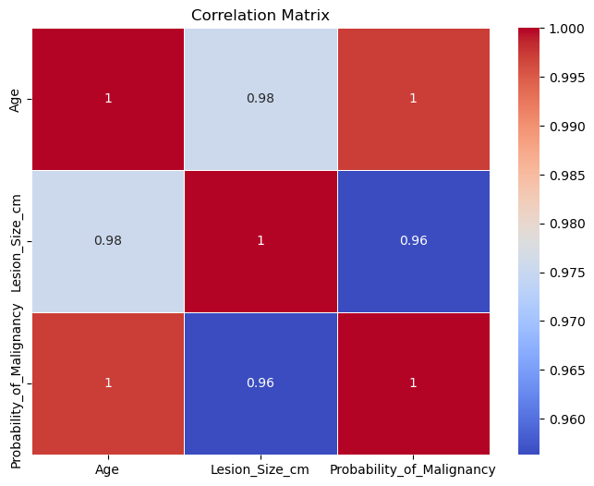 | 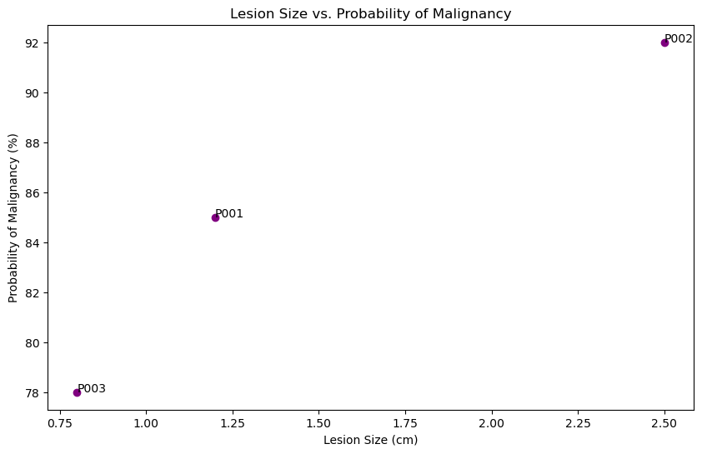

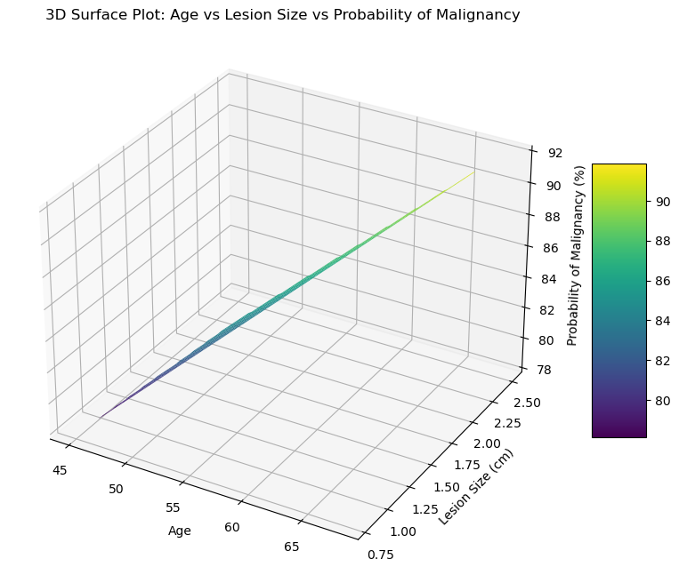 | 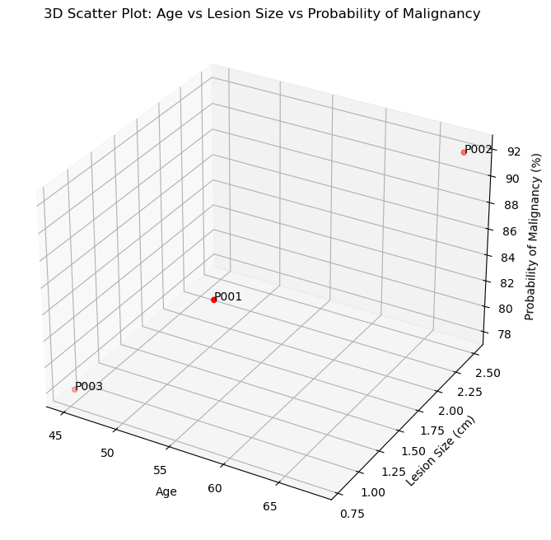

CONCLUSION
REFERENCES
- Esteva, A., Kuprel, B., Novoa, R. A., Ko, J., Swetter, S. M., Blau, H. M., & Thrun, S. (2017). Dermatologist-level classification of skin cancer with deep neural networks. Nature, 542(7639), 115-118.
- Litjens, G., Kooi, T., Bejnordi, B. E., Setio, A. A. A., Ciompi, F., Ghafoorian, M., ... & Sánchez, C. I. (2017). A survey on deep learning in medical image analysis. Medical Image Analysis, 42, 60-88.
- Gulshan, V., Peng, L., Coram, M., Stumpe, M. C., Wu, D., Narayanaswamy, A., ... & Webster, D. R. (2016). Development and validation of a deep learning algorithm for detection of diabetic retinopathy in retinal fundus photographs. JAMA, 316(22), 2402-2410.
- Hosny, A., Parmar, C., Quackenbush, J., Schwartz, L. H., & Aerts, H. J. W. L. (2018). Artificial intelligence in radiology. Nature Reviews Cancer, 18(8), 500-510.
- Litjens, G., Ciompi, F., Wolterink, J. M., de Vos, B. D., Leiner, T., Teuwen, J., ... & Sánchez, C. I. (2017). State-of-the-art deep learning in cardiovascular image analysis. Journal of Cardiovascular Magnetic Resonance, 19(1), 1-15.
- Shen, D., Wu, G., & Suk, H. I. (2017). Deep learning in medical image analysis. Annual Review of Biomedical Engineering, 19, 221-248.
- Routhu Shanmukh, Lakshmana Rao Rowthu,CH Nooka Raju,” Analysis of fundus images using conventional edge detection techniques”, pp. 206-217 2022.
- Erickson, B. J., Korfiatis, P., Akkus, Z., & Kline, T. L. (2017). Machine learning for medical imaging. Radiographics, 37(2), 505-515.
- Litjens, G., Sánchez, C. I., Timofeeva, N., Hermsen, M., Nagtegaal, I., Kovacs, I., ... & Ciompi, F. (2016). Deep learning as a tool for increased accuracy and efficiency of histopathological diagnosis. Scientific Reports, 6, 26286.
- Routhu Shanmukh, Nooka Raju Chintala, Naveen K Challa, C H Mukesh, A Comparative Analysis of CNN Techniques on Application to Fundus Images, Journal Of Chemical Health Risks, January 2024.
- Kooi, T., Litjens, G., van Ginneken, B., Gubern-Mérida, A., Sánchez, C. I., Mann, R., ... & Karssemeijer, N. (2017). Large scale deep learning for computer aided detection of mammographic lesions. Medical Image Analysis, 35, 303-312.
- Lee, J. G., Jun, S., Cho, Y. W., Lee, H., Kim, G. B., & Seo, J. B. (2017). Deep learning in medical imaging: General overview. Korean Journal of Radiology, 18(4), 570-584.
- Ch Nooka Raju, G.S.N Raju , Sunil Tej Boppudi,”Applications Of Fuzzy Two And Four Rules For Segmentation Of Blood Cells”, Vol 7, Issue 18, 2020,Pp 2856-2863.
- Ch Nooka Raju, G.S.N Raju , Sunil Tej Boppudi,”Applications Of Fuzzy Two And Four Rules For Segmentation Of Blood Cells”, Vol 7, Issue 18, 2020,Pp 2856-2863.
- Routhu Shanmukh, CH Nooka Raju, Syed Raashid Andrabi, “Analysis Of intensity variations in applications of edge detection techniques to fundus images, GRADIVA REVIEW JOURNAL, VOLUME 9, ISSUE 1 Jan-2023.

