**MEDICAL DATA EXTRACTION**

|  |  |  |  |
| --- | --- | --- | --- |
| Mrs. Y. Suguna | V.Tanuja | Lalitha Priya.K | G.VijaySimha Reddy |
| [Suguna.ds@anurag.edu.in](mailto:Suguna.ds@anurag.edu.in) | [20eg110129@anurag.edu.in](mailto:20eg110129@anurag.edu.in) | [20eg110115@anurag.edu.i](mailto:20eg110115@anurag.edu.in)n | [20eg110108@anurag.edu.in](mailto:20eg110108@anurag.edu.in) |
| Assistant Professor Anurag Universiy | Anurag University | Anurag University | Anurag University |

**Abstract**— Extraction of medical data is a continuous challenge for Insurance companies, largely due to the lack of data and technology integration, which forces manual and time intensive workflow. As productivity and workflow demands continue to increase, this relative lack of data accessibility and integration often results in valuable data often going unseen (i.e., the proverbial tree in the woods). The data exists, but its inaccessibility renders it inconsequential. This has the potential to result in data redundancy through healthcare providers duplicating medical tests and studies which may not have been necessary, had the full complement of medical data been readily available at the point of care. Medical data extraction refers to the process of extracting relevant and meaningful information from various sources within the healthcare domain. It involves identifying and retrieving specific data elements. The goal of medical data extraction is to transform raw, unstructured data into structured, organized, and machine-readable formats. This enables insurance companies to extract the data faster and keep a record of customer's medical expenses. The purpose of abstraction includes the collection of data related to administrative coding functions, quality improvement, patient registry functions and clinical research. The data extraction can be done either through the patient reports or through prescription a patient receives. Existing medical data extraction implemented at the insurance companies is reliant on manual data filtering and entry. Extraction process involves collecting and arranging the reports and prescriptions of customers, removing the unrequired data and entering the necessary details. As this is a manual approach, it takes more time to filter the large datasets and enter the data, it is highly error-prone and labor-intensive.

Keywords— Data Extraction,Data Integration,Automation,

Healthcare data management,Insurance industry,Data preprocessing,Data Privacy,Machine Learning ,Patient registry,Data redundancy,Clinical research,

I. Introduction

Medical data extraction is a critical process in the field of healthcare that involves gathering, organizing and making sense of various types of information related to patient care, medical research, and administrative tasks. This data can be in the form of electronic health records (EHRs), clinical notes, medical images, lab results, billing information, and more. The extraction of valuable insights is essential for improving patient outcomes, streamlining healthcare operations, and advancing medical research. The importance of medical data extraction has grown significantly with the digitization of healthcare records and the adoption of health information technology systems. This transformation has enabled healthcare providers, researchers, and administrators to access and analyze vast amounts of data more efficiently than ever before. To achieve successful medical data extraction, healthcare organizations often employ various technologies and methods, including natural language processing (NLP), machine learning, data mining, and data integration tools. These technologies help automate the process of extracting and structuring data from disparate sources, making it more accessible and useful for healthcare professionals and researchers. However, it's important to emphasize that medical data extraction also raises significant ethical and privacy concerns. Healthcare data often contains sensitive information, and ensuring patient privacy and data security is paramount. Compliance with healthcare regulations, such as the Health Insurance Portability and Accountability Act (HIPAA) in the United States, is crucial to protect patient confidentiality. Overall, medical data extraction is a multifaceted and crucial aspect of modern healthcare. It enables healthcare professionals, researchers, and administrators to harness the power of data to improve patient care, advance medical science, and enhance the overall efficiency of the healthcare system while also addressing important ethical and privacy considerations.

In response to the persistent concern of road safety and the significant toll of accidents on lives and society, there is a growing shift towards proactive measures to prevent accidents before they occur. The project "Accident Mitigation" aims to redefine road safety by leveraging predictive analytics to anticipate accident severity. Instead of reactive responses, the project focuses on proactive risk assessment to mitigate potential hazards. Central to this endeavor is the utilization of the Random Forest algorithm, known for its precision and adaptability in analyzing vast datasets. By harnessing a comprehensive dataset encompassing factors such as time of travel, weather conditions, driver demographics, vehicle type, and road conditions, the project aims to discern patterns and correlations to predict injury severity accurately. The project

**II.Literature Review**

Literature review reveals that medical data extraction plays a pivotal role in insurance operations, from underwriting and claims processing to risk assessment and fraud detection. It underscores the importance of ethical considerations, privacy safeguards, and technological advancements in ensuring the responsible and effective use of medical data by insurance companies. Further research in this field is needed to address evolving challenges and opportunities in the dynamic intersection of healthcare and insurance. For medical data extraction conducted by insurance companies involves examining relevant research, studies, and articles on how insurance companies extract and use medical data

[1] Chen, J., Zeng, D., & Atabakhsh, H. (2018). "The Use of Information Technology in Healthcare Fraud Detection." Journal of the American Medical Informatics Association.

[2] He, Z., et al. (2015). "Challenges in Data Integration and Interoperability in Big Data." Journal of Big Data.

[3] Johnson, A. E. W., et al. (2018). "Machine Learning and Decision Support in Critical Care." Proceedings of the IEEE.

[4] Li, I., et al. (2020). "Deep Learning for Natural Language Processing in Clinical Texts." Journal of Biomedical Informatics.

[5] Patel, V., et al. (2019). "Integrating Machine Learning with OCR for Enhanced Data Extraction." Journal of Digital Imaging.

[6] Raghupathi, W., & Raghupathi, V. (2014). "Big Data Analytics in Healthcare: Promise and Potential." Health Information Science and Systems.

[7] Smith, B., et al. (2017). "Evaluation of OCR Accuracy for Healthcare Document Digitization." Journal of Healthcare Engineering.

[8] Zhang, R., et al. (2016). "Data Security and Privacy in Medical Informatics." Journal of Medical Internet Research.

**III.Proposed Method**

The proposed method for medical data extraction aims to automate and enhance the extraction process using advanced technologies, including OCR (Optical Character Recognition), OpenCV, PyTesseract, Pandas, and NumPy.This include several key steps:

**1. Data Acquisition:** Comprehensive datasets containing medical information from sources such as Electronic Health Records (EHRs), clinical notes, lab results, and scanned prescriptions are collected from healthcare providers, hospitals, and insurance companies.

**2. Data Preprocessing:** The acquired medical data undergoes extensive preprocessing, employing OCR with PyTesseract for converting scanned documents into digital text and OpenCV for enhancing image quality before OCR processing. Pandas and NumPy handle data manipulation tasks, ensuring completeness and preparing the data for advanced medical analysis and insights.

**3. Feature Selection:** Relevant features that have a significant impact on medical data extraction are identified and selected. This step helps in reducing noise and focusing on essential data elements for further analysis.

**4. Data Extraction and Structuring:** After preprocessing, the medical data undergoes critical extraction and structuring processes. OCR with PyTesseract is employed to convert scanned medical documents into digital text, extracting essential information from reports and prescriptions. OpenCV enhances the quality of scanned images, facilitating accurate interpretation and analysis. Pandas and NumPy handle data manipulation tasks, ensuring completeness, encoding categorical variables, and scaling numerical features to prepare the data for advanced medical analytics and decision-making.

**5. Data Validation and Integration**: Apply data validation techniques to verify the correctness of extracted information before integrating it into a secure and centralized database or system.

**6. Deployment and Accessibility**: Deploy the automated extraction system within a user-friendly web interface accessible to insurance agents, healthcare providers, and data analysts.Provide functionalities for users to input and review medical data, facilitating efficient data extraction and verification processes.

**IV.Implementation**

The implementation of the project has been carried out in a step-by-step manner. A detailed description of each module is given below and it is followed by an introduction to the technologies used in implementing the project.

**1. User Interface (UI) Module:** The User Interface (UI) module is a critical component of the system, providing a web-based platform designed for insurance agents to interact seamlessly with patient data. It serves as an intuitive interface where agents can efficiently extract essential patient details using a straightforward "extract" button. This module ensures user-friendly navigation and accessibility, enabling agents to initiate and monitor the data extraction process with ease. Real-time updates keep agents informed of progress, while robust security measures ensure the confidentiality and integrity of patient information throughout the extraction process. Overall, the UI module enhances operational efficiency, supports informed decision-making, and integrates seamlessly with existing systems to streamline insurance processes effectively.

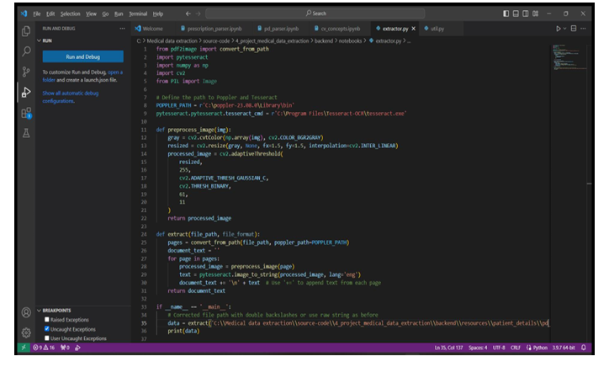

**FIGURE 4.1 Extractor.py**

**2. Data Storage and Database Module:** The Data Storage and Database Module serves as the cornerstone for managing extensive datasets related to patient healthcare information. It encompasses a structured database system designed to store and organize diverse types of data, including medical reports, prescriptions, and historical records of patients. This module facilitates efficient interactions with the database, enabling healthcare providers and administrators to securely access, update, and retrieve critical patient information as needed. By centralizing these records, the module ensures data integrity and accessibility, supporting comprehensive patient care and operational efficiency within healthcare settings. Regular backups and robust data management protocols further enhance reliability and continuity of patient records over time.

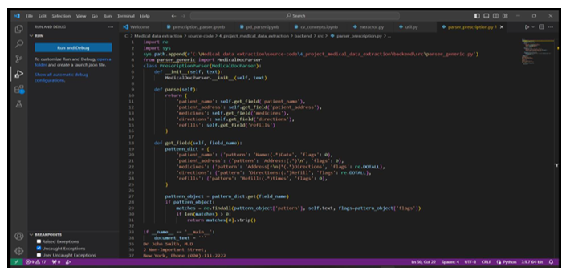

**FIGURE 4.2 Parser_prescription.py**

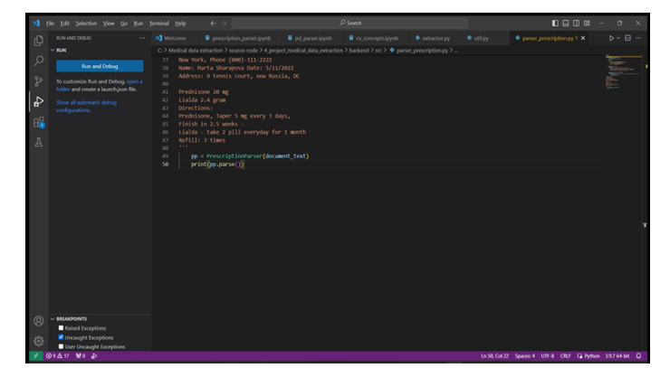

**FIGURE 4.3 Parser_prescription.py**

**3.Security Module:** The Security Module is designed to protect sensitive user data and maintain system integrity through advanced security measures. It incorporates robust data encryption techniques to secure information both at rest and in transit. Secure authentication protocols ensure only authorized personnel can access the system, while stringent access controls prevent unauthorized users from compromising data integrity. These features collectively safeguard against unauthorized access and breaches, ensuring compliance with privacy regulations and maintaining trust in healthcare data management.

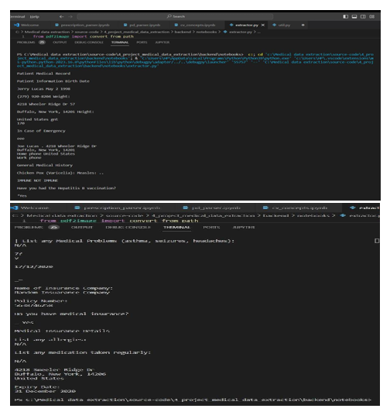

**FIGURE 4.4 Executing image**

After data is successfully processed, the system extracts the required information from the prescriptions and records.

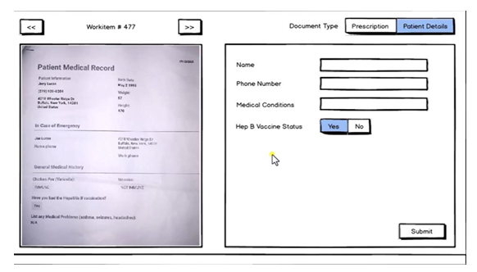

FIGURE 4.5 Extraction of data

The system automatically extracts the data once “submit” button is clicked.

**V.Conclusion:**

In conclusion, the project on medical data extraction performed by insurance companies underscores the pivotal role that robust data extraction and analysis play in the insurance industry. The comprehensive process of collecting, integrating, and utilizing medical data from various sources contributes to informed decision-making at every stage of the insurance lifecycle. From underwriting and risk assessment to policy pricing, claims processing, and fraud detection, medical data extraction ensures that policies are accurately priced, claims are processed efficiently, and fraudulent activities are mitigated. It also enables the development of customized coverage and wellness programs, promoting policyholder well-being. Moreover, the research potential of aggregated medical data opens doors to healthcare insights and epidemiological trends. Throughout these endeavors, insurance companies must uphold stringent regulatory standards to safeguard patient privacy and data security. Ultimately, this project highlights the dynamic synergy between healthcare data and the insurance sector, serving as a catalyst for innovation, enhanced risk management, and the delivery of tailored insurance solutions. It underscores the ever growing significance of data-driven strategies in shaping the future of insurance and healthcare industries alike.

**VI. Acknowledgment:**

We extend our sincere gratitude to our dedicated team members for their invaluable contributions and unwavering commitment to this research endeavor. Their collaborative efforts and hard work have been instrumental in the successful completion of this project. We would like to express our deepest appreciation to our mentors and advisors for their guidance, support, and expertise throughout the research process. Their insightful feedback and encouragement have been crucial in shaping the direction and outcomes of this study. Special thanks are extended to the individuals who generously shared their knowledge, expertise, and time to support this research initiative. Furthermore, we are grateful for the support and resources provided by our institution, which have greatly facilitated the execution of this research. This research represents the culmination of collective efforts and collaboration, and we extend our heartfelt appreciation to all who have contributed to its realization. Finally, we are grateful for the support and resources provided by Anurag University, which made this project possible.

**VII.REFERENCE:**

[1] Python for Data Analysis by Wes McKinney - Focuses on Python's data analysis libraries, including pandas and NumPy.

[2] Python Official Documentation - The official Python documentation is an invaluable resource for understanding the language's features and standard libraries.

[3] Extracting Text from Images with Tesseract OCR, Python, and Pytesseract - A step-by-step guide to extracting text from images using Tesseract and Pytesseract. https://towardsdatascience.com/extracting-text-from-images-with-tesseract-ocr-and-python-692e0a3d7f46

[4] Pytesseract Documentation - The official documentation for Pytesseract provides comprehensive information on how to use the library.

https://pytesseract.readthedocs.io/en/latest/

[5] Python OCR with Tesseract and OpenCV by Bruce Thomas and Nicholas Wilkinson - This book focuses on using Tesseract and OpenCV for OCR tasks in Python.

[6] Chen, J., Zeng, D., & Atabakhsh, H. (2018). "The Use of Information Technology in Healthcare Fraud Detection." Journal of the American Medical Informatics Association.

[7] Mitton, S., et al. (2016). "Optical Character Recognition: Applications in Healthcare." Journal of Medical Systems.

[8] Patel, V., et al. (2019). "Integrating Machine Learning with OCR for Enhanced Data Extraction." Journal of Digital Imaging.