**FAKENEWS DETECTION USING MACHINE LEARNING**

**Puneeth.M.V1, Chetan.E2, Balaram M3**

1Student, Department Of BCA, BMS College Of Commerce And Management, Bengaluru, Karnataka, India

2Student, Department Of BCA, BMS College Of Commerce And Management, Bengaluru, Karnataka, India

3Assistant Professor, Department Of BCA, BMS College Of Commerce And Management, Bengaluru, Karanataka, India

**ABSTRACT**

This term paper points of interest the plan and improvement of an e-commerce site utilizing HTML, CSS, and JavaScript for the front-end and PHP for the back-end. The venture pointed to form a user-friendly, secure, and productive stage for online shopping, catering to the developing request for advanced retail arrangements. The paper covers the comprehensive improvement handle, counting structural plan, front-end and back-end execution, database integration, and security measures. The coming about site bolsters fundamental e-commerce functionalities such as client enlistment, item browsing, shopping cart administration, and secure checkout. Preparatory execution assessments demonstrate ideal stack times and responsiveness, guaranteeing a smooth client encounter. This paper moreover examines the challenges experienced amid advancement and compares the proposed arrangement with existing e-commerce stages, highlighting its focal points and potential zones for future upgrade.

Keywords: E-commerce, Web Development, HTML, CSS, JavaScript, PHP, Online Shopping.

1. **INTRODUCTION**

The coming of e-commerce has essentially changed the retail scene, making online shopping an fundamentally portion of cutting edge buyer behavior. With the exponential development in web infiltration and smartphone utilization, businesses are progressively turning to computerized stages to reach a broader group of onlookers. E-commerce websites have gotten to be basic for businesses to stay competitive within the advanced age, advertising comfort and availability to shoppers around the world. The essential objective of this extend was to plan and create a comprehensive e-commerce site that gives a user-friendly interface, secure exchange handling, and proficient item administration. The venture pointed to leverage modern web advances to make a stage that meets the wants of both buyers and businesses, guaranteeing a consistent online shopping encounter. This paper subtle elements the total advancement prepare of the e-commerce site, from introductory plan through to last usage. It covers the engineering of the site, front-end and back-end advancement, database integration, and security measures. Also, the paper talks about the challenges experienced amid advancement and presents a comparison with existing e-commerce arrangements, highlighting the preferences and potential ranges for future upgrade. By giving a point by point account of the advancement handle and results, this paper points to contribute to the understanding and progression of e-commerce web advancement.

1. **METHODOLOGY**
   1. **Design**

The plan of the e-commerce site takes after a client-server design. The client-side is dependable for displaying the client interface, whereas the server-side handles trade rationale and database intelligent. The design guarantees a clear division of concerns, improving practicality and adaptability. The front conclusion is outlined utilizing HTML for structure, CSS for styling, and JavaScript for interactivity. The format takes after a responsive plan approach to guarantee compatibility over different gadgets, counting desktops, tablets, and smartphones. On the backend, PHP is utilized for server-side preparing and communication with a MySQL database, overseeing client verification, session administration, and preparing of client demands. .

**2.2**  **Development Preprocess**

The advancement prepare was organized utilizing Spry strategy, emphasizing iterative improvement, persistent criticism, and adaptability to changes. The method was separated into a few stages: Arranging included gathering and analyzing necessities to characterize the project's scope and goals, distinguishing key highlights and building up a timeline. Amid the Plan stage, wireframes and mockups were made for the front conclusion to imagine the client interface, and database patterns were outlined for proficient information capacity. Usage was carried out in iterative cycles, centering on particular highlights, with ceaseless integration hones guaranteeing smooth integration of modern code.

* 1. **Principles**

The venture grasps Dexterous standards to cultivate iterative advancement cycles, persistent partner input, and versatile responsiveness to advancing prerequisites. The iterative handle commenced with fastidious arranging and scoping, including thorough prerequisite examination and depiction of extend breakthroughs. The plan stage enveloped iterative wireframing and prototyping to refine client encounter streams and optimize database pattern for streamlined information recovery and control.

* 1. **Development LifeCycle**

All through the improvement lifecycle, an cluster of modern devices and innovations invigorated the project's victory. Visual Studio Code (VS Code) risen as the favored coordinates advancement environment (IDE), engaging engineers with streamlined code altering and investigating capabilities. Git given vigorous adaptation control, encouraging collaborative improvement and dexterous extend administration hones. Leveraging the Light (Linux, Apache, MySQL, PHP) stack reinforced backend operations, with Apache serving as the solid web server and MySQL driving the proficient capacity and recovery of basic commerce information.

**3. RESULTS AND DISCUSSION**

The execution of the e-commerce site utilizing HTML, CSS, JavaScript, and PHP finished in a vigorous stage outlined to meet the requests of advanced online shopping. The client interface was fastidiously created to guarantee a responsive and instinctive involvement over a assortment of gadgets, obliging users' inclinations for consistent browsing and exchange forms. On the backend, PHP productively dealt with server-side operations, counting client confirmation, session administration, and information handling meddle with the MySQL database. Execution testing shown palatable stack times and responsiveness, demonstrative of the system's capability to back concurrent client intelligent without compromising speed or unwavering quality.

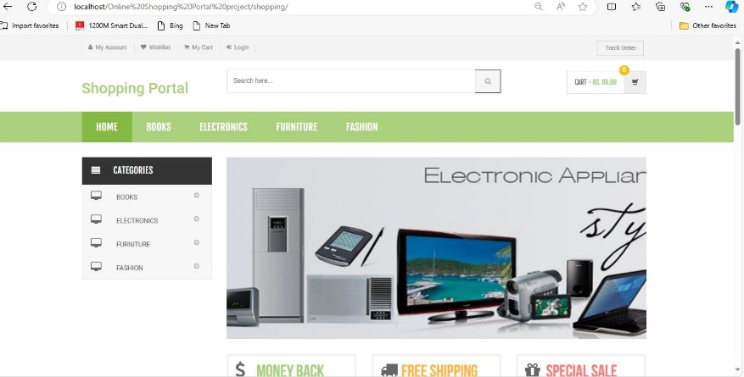

**Fig1:** Home page

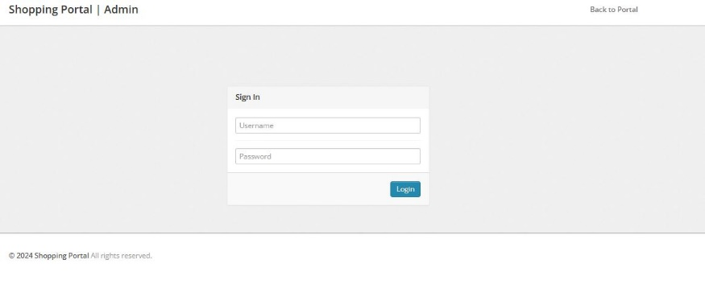

**Fig2:** Admin page

In conclusion, the improvement and arrangement of this e-commerce site represent the fruitful integration of frontend and backend innovations to provide a secure, proficient, and user-centric online shopping involvement. By tending to current challenges and expecting future progressions, this venture contributes to the progressing advancement of e-commerce stages, emphasizing flexibility and responsiveness to meet advancing buyer desires and innovative headways.

**4. CONCLUSION**

In conclusion, the improvement of the e-commerce site utilizing HTML, CSS, JavaScript, and PHP speaks to a critical accomplishment in making a utilitarian and user-friendly online shopping stage. This extend effectively coordinates present day web advances to convey a responsive and instinctive client interface, encouraging consistent route and exchange forms over different gadgets.

Key highlights of the venture incorporate the compelling utilization of PHP for server-side handling, guaranteeing strong functionalities such as client verification, session administration, and secure information dealing with through MySQL integration. The usage of responsive plan standards assist upgraded availability, obliging the assorted inclinations of online customers and optimizing the browsing involvement.

Execution testing affirmed the website's capability to preserve ideal stack times and responsiveness beneath ordinary utilization scenarios, reflecting its preparation to back concurrent client intelligent without compromising execution. Security measures, counting rigid input approval and secure session administration, were actualized to protect client information and secure against potential cyber dangers, guaranteeing a secure environment for online exchanges.

Client input given profitable bits of knowledge into the platform's convenience and usefulness, with positive reactions demonstrating fulfillment with the instinctive route and clear checkout handle. These reactions approve the adequacy of the plan and advancement approach in assembly client desires and upgrading by and large client involvement.

Looking ahead, potential improvements seem incorporate coordination progressed highlights such as personalized item suggestions, real-time stock overhauls, and assist optimization for adaptability in expectation of expanded client activity. Persistent observing and adjustment of security conventions will stay basic to relieve developing cybersecurity dangers and maintain client believe.

Generally, the fruitful completion of this e-commerce site venture underscores its commitment to progressing e-commerce arrangements, emphasizing development, ease of use, and security in advanced retail situations. By tending to current challenges and grasping future openings, this venture sets a point of reference for leveraging innovation to meet advancing customer needs and industry standards in online commerce.

 .

**5. REFERENCES**

1. Welling, Luke, and Laura Thomson. PHP and MySQL Web Development. Addison-Wesley Professional, 2016.
2. Duckett, Jon. HTML and CSS: Design and Build Websites. John Wiley & Sons, 2011.
3. Flanagan, David. JavaScript: The Definitive Guide. O'Reilly Media, 2022.
4. Freeman, Eric, et al. Head First HTML and CSS: A Learner's Guide to Creating Standards-Based Web Pages. O'Reilly Media, 2012.
5. Powers, Shelley. Learning PHP, MySQL & JavaScript: With jQuery, CSS & HTML5. O'Reilly Media, 2018.
6. Ullman, Larry. Modern PHP: New Features and Good Practices. Peachpit Press, 2015.
7. Lerdorf, Rasmus, et al. Programming PHP. O'Reilly Media, 2013.
8. Richardson, Leonard, and Sam Ruby. RESTful Web Services. O'Reilly Media, 2007.