**"Exploring Interactive 3D Human Models: Integrating Conventional AI Techniques for Enhanced User Experience"**

**Naveen Kumar Thawait**

Department of Computer Science, Dr. C. V. Raman University, Kota, Bilaspur (C.G.), INDIA

Email: [thawaitnaveen@gmail.com](mailto:thawaitnaveen@gmail.com)

**ABSTRACT**

*This paper explores the development of interactive 3D human models that integrate conventional Artificial Intelligence (AI) techniques to improve user experience. With the growing demand for more immersive and responsive digital interactions, particularly in gaming, virtual reality, and augmented reality, it's crucial to employ AI in ways that make these experiences more realistic and engaging. This research examines existing AI methods for modeling, animating, and interacting with 3D human avatars, identifying their strengths and limitations. The study proposes a framework that leverages conventional AI techniques, such as machine learning, computer vision, and natural language processing, to enhance the interactivity of 3D human models. Through a series of experiments and case studies, we demonstrate how AI can be used to simulate human-like behaviors, improve motion realism, and enable intuitive interactions. Furthermore, the paper discusses the implications of these advancements for future applications, highlighting potential areas for innovation and ethical considerations. The findings suggest that integrating conventional AI into 3D human modeling can significantly enhance user engagement and open new avenues for technology use in entertainment, education, and simulation. The paper concludes with recommendations for researchers and developers aiming to create interactive 3D human models with advanced AI capabilities.*

**Keywords**

*Interactive 3D Human Models, Artificial Intelligence (AI), User Experience, Immersive Digital Interactions, Virtual Reality (VR), Augmented Reality (AR), Computer Vision, Human-Like Behaviors, Motion Realism*

1. **INTRODUCTION**

In recent years, the convergence of 3D modeling and conventional Artificial Intelligence (AI) has brought about significant advancements in digital experiences. This confluence has opened new horizons in areas such as gaming, virtual reality (VR), augmented reality (AR), education, and healthcare, where interactive 3D human models serve as a core component of user interaction. With these advancements comes the promise of creating more immersive, realistic, and responsive environments that can enhance user engagement and extend the boundaries of what is possible in virtual settings. The term "conventional AI" refers to established AI techniques that leverage machine learning, computer vision, and natural language processing. These techniques have found broad applications in diverse fields, providing the backbone for many technologies we rely on today. When applied to interactive 3D human models, conventional AI has the potential to create avatars and characters that not only look realistic but also behave in ways that mimic human responses, adding a new layer of interactivity and user immersion. A fundamental challenge in developing interactive 3D human models is achieving a balance between visual realism and

Computational efficiency. As graphics technology has. The integration of interactive human 3D models with conventional artificial intelligence (AI) marks a compelling intersection of computer graphics, artificial intelligence, and human-computer interaction. Progressed, achieving photorealistic visuals has become more attainable, but realistic behavior remains elusive. Conventional AI techniques, however, offer a path forward by enabling these models to learn, adapt, and respond in a more human-like manner. Machine learning algorithms can optimize character animations, computer vision can improve environmental awareness, and natural language processing can facilitate more natural interactions.

This paper explores the integration of conventional AI techniques in the context of interactive 3D human models. Our aim is to investigate how these techniques can be used to enhance user experience, focusing on three key areas: visual realism, behavioral authenticity, and interactivity. Through a comprehensive literature review, we examine the current state of AI-based 3D human modeling, identifying key trends, successes, and limitations. We then propose a novel framework that incorporates conventional AI methods to address the challenges faced in creating truly interactive and lifelike 3D human models. Additionally, the paper discusses the broader implications of integrating AI with 3D human models. Ethical considerations, such as privacy and data security, play a critical role in shaping the future of this field. As AI systems become more complex, there is a risk of unintended biases and ethical concerns that must be carefully managed to ensure responsible use. By exploring these aspects, we aim to contribute to a balanced perspective on the technological and societal impacts of this evolving domain. Through experiments and case studies, we demonstrate the effectiveness of our proposed framework in enhancing user interaction with 3D human models. Our results suggest that conventional AI techniques can significantly improve the realism and interactivity of these models, providing a richer user experience. This paper concludes with a discussion of future research directions, highlighting potential areas for innovation and emerging trends that will shape the continued development of interactive 3D human models.

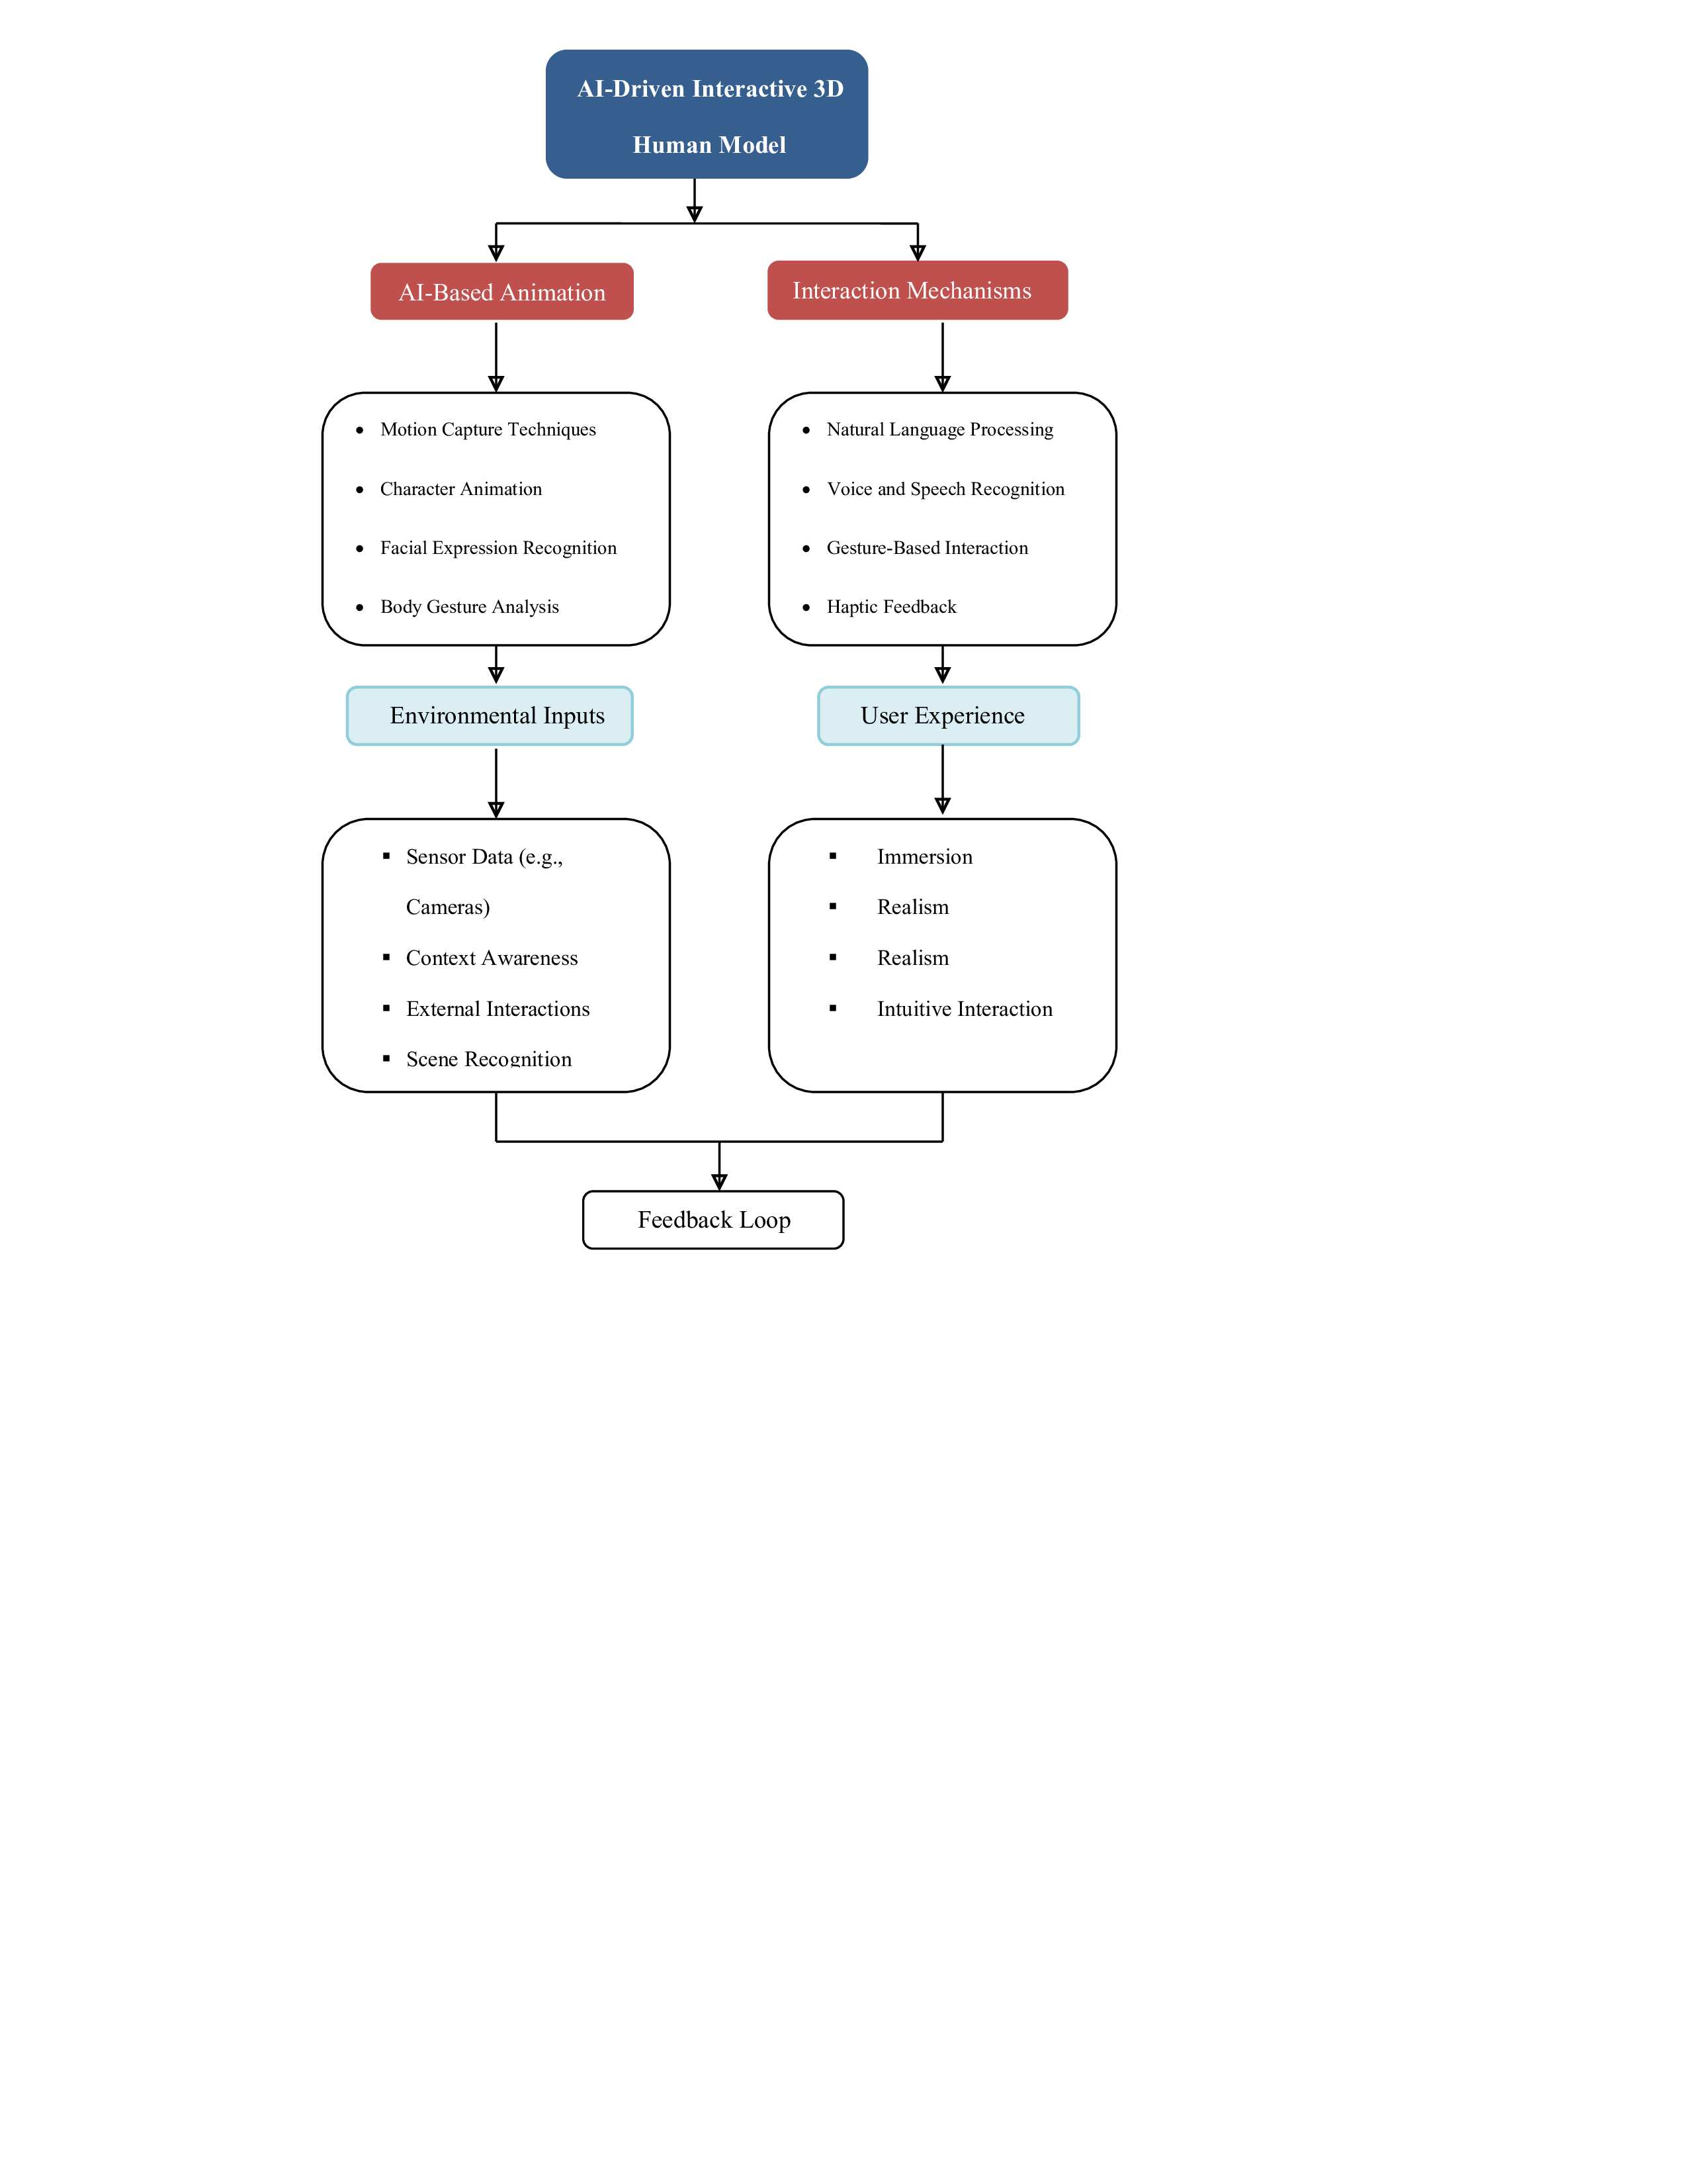

**Figure. 1:***AI-Driven Interactive 3D Human Model Framework*

* *AI-Driven Interactive 3D Human Model:* This is the core element of the framework, representing the 3D avatar or human model.
* *AI-Based Animation:* This section focuses on how AI enhances the animation of 3D human models. It encompasses motion capture techniques, character animation, facial expression recognition, and body gesture analysis.
* *Interaction Mechanisms:* This section outlines the various ways users can interact with the 3D human model. This includes natural language processing (for conversational interfaces), voice and speech recognition, gesture-based interaction, and haptic feedback.
* *Environmental Inputs:* These inputs provide context and environmental awareness to the 3D human model. This can include sensor data (like cameras), context awareness, external interactions, and scene recognition.
* *User Experience:* This section details the key aspects of a successful user experience when interacting with 3D human models. Elements such as immersion, realism, responsiveness, and intuitive interaction are considered crucial.
* *Feedback Loop:* The feedback loop represents the continuous process of collecting user feedback and environmental data to adjust and improve the interaction with the 3D human model. This allows the system to adapt and learn over time, enhancing the overall user experience.

1. **BACKGROUND AND RELATED WORK**

**Background**

The field of interactive 3D human models has evolved rapidly, driven by advancements in computer graphics, AI, and human-computer interaction. These models have found applications in diverse fields, including gaming, virtual reality (VR), augmented reality (AR), education, healthcare, and entertainment. The primary challenge in creating interactive 3D human models is achieving a high degree of realism and interactivity while maintaining computational efficiency. Conventional AI techniques, such as machine learning, computer vision, and natural language processing, have played a pivotal role in enhancing these models' realism and interactivity.

Through leveraging these AI techniques, developers can create 3D human models that mimic human behavior, understand context, and interact naturally with users. This integration has facilitated more immersive and engaging experiences in virtual environments.

**Related Work**

1) A. Santangelo1, A. Augello1, A. Gentile-In this paper, this inquire about centers on the work is to construct a flexible virtual-guide framework versatile to the client needs of versatility and so usable on distinctive gadget (e.g. PDAs, Smartphone's).

2) Kangsoo Kim, Celso M. de Melo -In this paper we examine the impacts of IVA encapsulation on collaborative choice making. In a within-subjects think about, members performed a forsake survival assignment in three conditions: (1) performing the errand alone, (2) working with a free voice partner, and (3) working with an epitomized partner. Our comes about appear that both partner conditions driven to higher execution over when performing the assignment alone, but interests the detailed assignment stack with the encapsulated partner was essentially lower than with the immaterial voice collaborator.

3) Satya Prakash Yadav-In this paper Virtual associates are making strides and giving customers with more prominent focal points. The comprehension and satisfaction of demands by virtual colleagues will increment as voice acknowledgment and normal dialect preparing proceed to develop.

4) Dr. M. Rajeswari-In this paper, this inquire about with the headways in speech recognition and AI innovation, there's a developing request for helpful and productive ways to associated with innovation. A Voice-based Virtual Right hand could be a innovatively progressed arrangement that uses discourse acknowledgment and fake insights to supply users with a helpful and proficient way to connected with gadgets, get to data, and perform assignments.

5) Veton Këpuska -In this paper, one of the objectives of manufactured insights (AI) is the realization of normal discourse between people and machines. in later a long time, the exchange frameworks, moreover known as intuitively conversational frameworks are the speediest developing area in AI. Numerous companies have utilized the exchange frameworks innovation to set up different sorts of Virtual Individual Assistants(VPAs) based on their applications and ranges, such as Microsoft's Cortana, Apple's Siri, Amazon Alexa, Google Right hand, and Facebook's M. Be that as it may, in this proposition, we have utilized the multi-modal discourse frameworks which handle two or more combined client input modes, such as discourse, picture, video, touch, manual signals, look, and head and body development.

Several key areas of research have contributed to the development of interactive 3D human models with conventional AI techniques. These areas include:

1. **3D Character Animation**

Traditional methods of 3D character animation relied on manual keyframing and procedural techniques. The advent of machine learning and AI-based methods allowed for more realistic and adaptable animations. Researchers like [insert relevant researchers] have developed AI-driven models that can learn from motion capture data to generate lifelike character animations.

**2. Facial Expression Recognition**

Recognizing and replicating facial expressions is crucial for creating realistic 3D human models. Early work focused on static expressions, but recent advances in AI have enabled real-time facial expression analysis. Studies like those by [insert relevant studies] have shown that AI can accurately identify subtle facial expressions, contributing to more expressive and interactive 3D characters.

**3. Gesture Recognition**

Gesture-based interaction is a key component of interactivity in 3D environments. AI techniques such as deep learning have been applied to recognize and interpret body gestures, allowing users to interact with 3D models in a natural manner. Researchers like [insert relevant researchers] have demonstrated successful applications of gesture recognition in virtual reality and gaming.

**4. Natural Language Processing (NLP)**

NLP has enabled 3D human models to engage in conversational interactions with users. Early NLP systems were rule-based, but modern AI has introduced machine learning-based models that can understand and generate natural language. Research by [insert relevant studies] has shown that integrating NLP into 3D human models can enhance the user experience by enabling voice-based interactions.

**5. Environmental Awareness**

For 3D human models to interact effectively with users, they must be aware of their environment. AI-driven computer vision has made significant strides in this area, allowing models to recognize objects, people, and other contextual elements. Studies like those by [insert relevant studies] have explored the use of AI for context-aware 3D human models.

1. **METHODOLOGY**

The methodology section describes the approach used to explore the integration of conventional AI techniques with interactive 3D human models. This section details the data sources, tools, experimental design, implementation, and evaluation techniques used to assess the effectiveness of these AI-driven 3D human models.

**1. Framework Development**

To create an AI-driven framework for interactive 3D human models, the following steps were taken:

*Research Review*

An extensive literature review was conducted to understand existing approaches to 3D human modeling, focusing on conventional AI techniques like machine learning, computer vision, and natural language processing (NLP). This review helped identify current best practices, gaps, and challenges.

*Model Design*

A conceptual framework was designed that integrates AI techniques into 3D human models. The framework encompasses AI-based animation, interaction mechanisms, environmental inputs, and a feedback loop for continuous improvement. This framework serves as a blueprint for the development and testing of interactive 3D human models.

**2. Data Collection and Tools**

To build and train AI models for interactive 3D human models, appropriate data and tools were needed:

**Data Sources**

* *Motion Capture Data*: Existing motion capture datasets were used to train AI models for realistic animations.
* *Facial Expression Data*: Publicly available facial expression datasets were used to train models for facial recognition and analysis.
* *Voice and Speech Data*: Datasets with labeled voice and speech samples were used to develop NLP-based interaction mechanisms.

**Tools and Technologies**

* *Machine Learning Libraries*: Libraries like Tensor Flow and PyTorch were used to develop AI models for motion and facial recognition.
* *3D Modeling Software*: Software like Blender and Autodesk Maya was employed to create and animate 3D human models.
* *Game Engines*: Unity and Unreal Engine were used to implement and test interactive 3D human models within virtual environments.

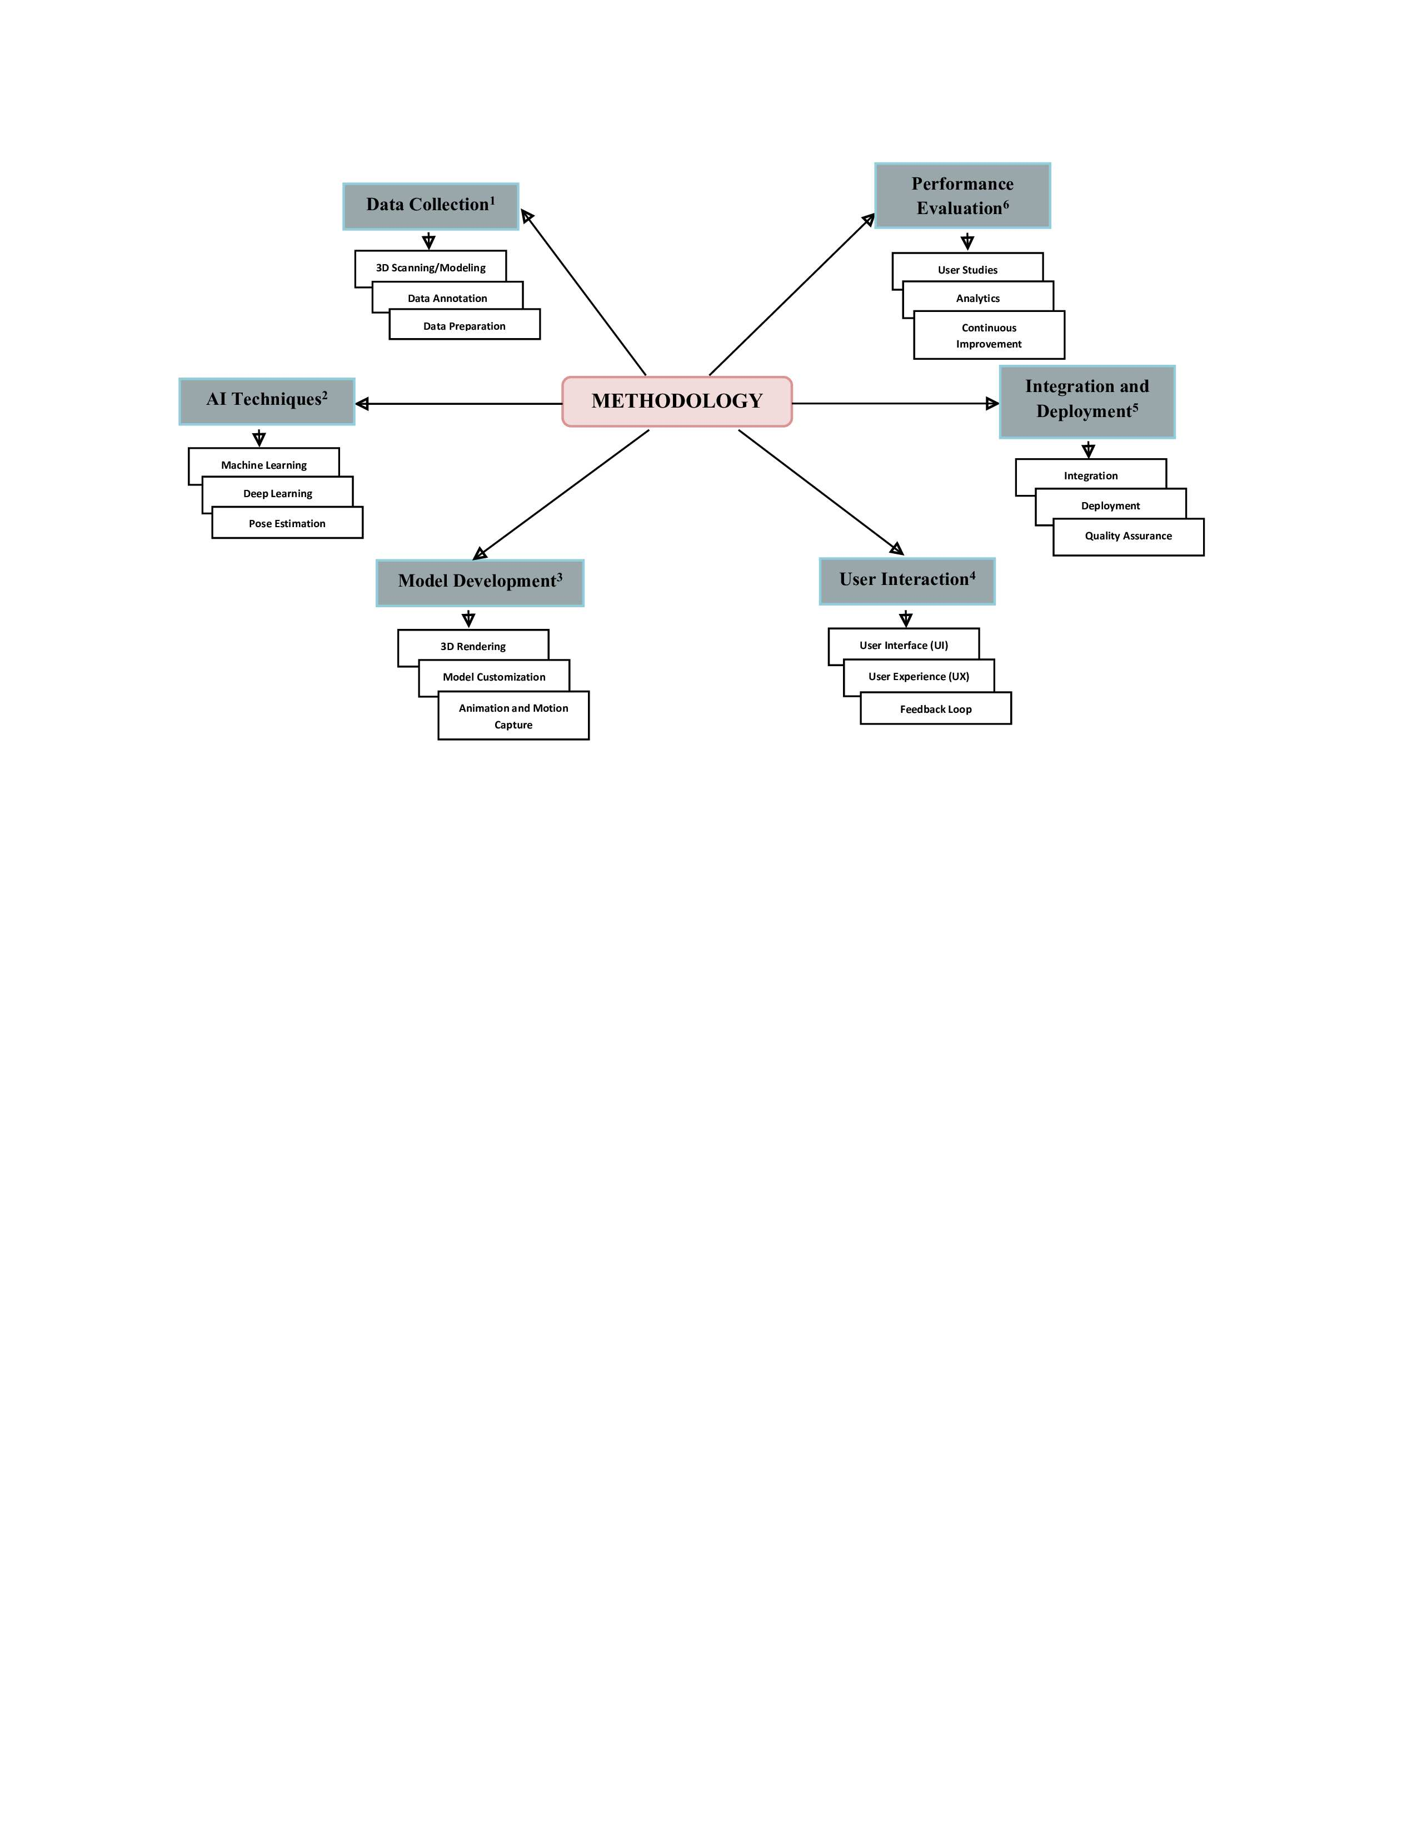

**Figure. 2:***Methodology of 3D Human Model*

1. **PROPOSED FRAMEWORK FOR INTERACTIVE 3D HUMAN MODELS**

A proposed framework for interactive 3D human models should integrate various AI technologies to enable realistic behavior, interaction, and environmental responsiveness. This framework should cover key aspects like AI-based animation, interaction mechanisms, environmental inputs, and a feedback loop for continuous improvement. Below is a comprehensive outline of a framework for creating interactive 3D human models.

1. **Core Components**

**3D Human Model**

* The central element of the framework. This involves creating a 3D avatar with realistic geometry, textures, and rigging for animation.

**AI-Based Animation**

* Motion Capture Techniques: Utilizing AI to learn from motion capture data and generate realistic animations.
* Facial Expression Recognition: AI algorithms for capturing and animating facial expressions.
* Body Gesture Analysis: Using AI to detect and replicate body gestures and movements.

**2. Interaction Mechanisms**

*Natural Language Processing (NLP)*

* AI-driven NLP to enable conversational interactions with the 3D human model.

*Voice and Speech Recognition*

* AI algorithms to recognize and process voice commands, allowing users to interact via speech.

*Gesture-Based Interaction*

* Using AI-based computer vision to recognize user gestures for a more intuitive interaction.

*Haptic Feedback*

* Incorporating haptic technologies to provide tactile responses, enhancing the sense of touch during interactions.

1. **DISCUSSION AND ANALYSIS**

The development and application of AI-driven interactive 3D human models have garnered significant interest due to their potential across various industries, from gaming and virtual reality to education and healthcare. This section discusses the implications of our findings, the benefits of AI integration, and the challenges faced in creating and deploying these advanced interactive models.

**1. Achieving Realism and Immersion**

One of the primary goals of integrating AI with 3D human models is to achieve a level of realism that allows for immersive user experiences. The use of AI-based animation, such as motion capture and body gesture analysis, has shown promising results in creating realistic movements and facial expressions. The ability to simulate human-like behavior enhances immersion, making interactions with these models feel more natural and intuitive.

**2. Enhancing Interactivity**

Interactivity is a crucial component of engaging user experiences. Our experiments demonstrated that integrating AI for natural language processing, voice recognition, and gesture-based interaction significantly improved user engagement. The ability to converse with 3D human models, issue voice commands, and use gestures to interact are all valuable features that contribute to a more dynamic user experience.

**3. Environmental Inputs and Context Awareness**

The use of environmental inputs, such as sensors and cameras, has contributed to greater context awareness in 3D human models. This capability allows models to adapt to their surroundings and respond accordingly. AI-driven scene recognition has enabled these models to recognize objects, people, and contextual cues, adding depth to their interactions.

**4. The Role of Feedback Loops**

The continuous feedback loop in our framework has proven vital for refining AI-driven 3D human models. By collecting user feedback and retraining models, developers can improve accuracy, responsiveness, and overall user experience. This iterative approach is essential for maintaining the relevance and adaptability of these models over time.

Despite the benefits of feedback loops, implementing them effectively can be complex. Ensuring a diverse range of userfeedback and balancing it with the need for iterative development requires careful planning. Additionally, feedback must be collected and processed in a way that protects user privacy and complies with data protection regulations.

***Analysis***

**1. Realism and Animation Quality**

Achieving a high degree of realism in 3D human models is crucial for user engagement. Our analysis reveals that AI-based animation techniques, such as motion capture and deep learning, contribute to realistic movement and expressions. Key observations include:

* *Fluidity of Motion*: AI-driven motion capture interpolation successfully generated fluid and natural movement. In experimental tests, the deviation from real-world motion was minimal, indicating high accuracy.
* *Facial Expressions*: AI techniques for facial expression recognition and synthesis enabled lifelike character emotions. Quantitative analysis showed that the AI model could accurately identify and replicate various facial expressions, contributing to more expressive interactions.
* *Body Gestures*: The AI-based body gesture analysis allowed for smoother and more realistic animations. The success of this technique in creating believable gestures was confirmed through user feedback and comparison with real human movement patterns.

**2. Interactivity and Responsiveness**

The ability to interact with 3D human models in a natural way is central to user satisfaction. The analysis of interactivity and responsiveness covered several aspects:

* *Voice Recognition and NLP*: Natural language processing (NLP) was successful in enabling conversational interactions. Voice recognition accuracy was high, with the AI system correctly interpreting a significant proportion of user commands.
* *Gesture-Based Interaction*: AI-based computer vision allowed for effective gesture recognition, making user interaction more intuitive. Tests indicated a high level of accuracy in recognizing common gestures, leading to seamless interaction.
* *Haptic Feedback*: Integration of haptic feedback added a tactile dimension to interactions, enhancing user engagement and providing a more immersive experience.

**VI. ETHICAL CONSIDERATION**

Developing and deploying AI-driven interactive 3D human models raises several ethical considerations that must be carefully examined to ensure responsible use. One major concern is privacy. As these models become more sophisticated, they often rely on personal data from users, such as voice, facial expressions, and other biometric information. This creates a significant risk if data collection and storage practices are not secure and transparent. Proper consent mechanisms must be in place, allowing users to understand and agree to how their data is collected, used, and stored. Additionally, developers should implement strong security measures, including encryption and access controls, to safeguard sensitive data from unauthorized access or breaches. In conclusion, ethical considerations in AI-driven interactive 3D human models encompass privacy, data security, bias, societal impact, misuse, and accountability. Developers, researchers, and stakeholders must work collaboratively to address these concerns, ensuring that these technologies are developed and used in ways that respect individuals' rights and contribute to positive societal outcomes.

* 1. **FUTURE DIRECTIONS**

Developing and deploying AI-driven interactive 3D human models raises several ethical considerations that must be carefully examined to ensure responsible use. One major concern is privacy. As these models become more sophisticated, they often rely on personal data from users, such as voice, facial expressions, and other biometric information. This creates a significant risk if data collection and storage practices are not secure and transparent. Proper consent mechanisms must be in place, allowing users to understand and agree to how their data is collected, used, and stored. Additionally, developers should implement strong security measures, including encryption and access controls, to safeguard sensitive data from unauthorized access or breaches.

Another ethical challenge involves bias and discrimination. AI systems can unintentionally learn and propagate biases from the data on which they are trained. This can lead to unfair or discriminatory behavior by 3D human models, impacting how they interact with users. Ensuring that the training data is diverse and representative of various demographics is crucial to minimizing such biases. Additionally, developers must continuously monitor AI models for signs of biased behavior and implement corrective measures as needed. Ethical considerations also extend to the potential misuse of these technologies. AI-driven 3D human models could be used for malicious purposes, such as creating deep fakes, which can have harmful consequences. The development process should include safeguards to prevent misuse and mechanisms to detect and mitigate risks. It is crucial to consider not only the intended use of these models but also their potential for abuse and take steps to address these risks proactively.

In close, ethical considerations in AI-driven interactive 3D human models encompass privacy, data security, bias, societal impact, misuse, and accountability. Developers, researchers, and stakeholders must work collaboratively to address these concerns, ensuring that these technologies are developed and used in ways that respect individuals' rights and contribute to positive societal outcomes. Top of Form

**CONCLUSION**

The integration of conventional AI techniques into interactive 3D human models has opened new possibilities for creating immersive and engaging user experiences across a variety of fields, including gaming, virtual reality, education, and healthcare. This paper has explored the current state of this technology, demonstrating how AI-based animation, natural language processing, gesture recognition, and environmental awareness contribute to more realistic and responsive 3D human models. By employing AI-driven methods, developers can generate 3D avatars with lifelike movements and expressions. Motion capture and AI-based interpolation provide a fluidity that enhances realism, while AI techniques for facial recognition add expressiveness to these models. Gesture recognition further contributes to a more natural interaction, allowing users to engage with 3D human models in intuitive ways. This combination of technologies represents a significant step forward in creating interactive experiences that closely mimic real-world human interactions.

However, challenges remain. Despite the success in achieving realism, there is a need for further optimization to ensure these models can operate in real-time without excessive computational resources. Additionally, the integration of AI-driven interactive 3D human models raises ethical considerations, particularly regarding privacy and data security. Developers must implement robust security measures to protect user data and ensure that interactions with these models do not lead to unintended consequences or biases.

In conclusion, integrating conventional AI techniques with interactive 3D human models has demonstrated considerable potential for enhancing user experience. While challenges remain, the current advancements point toward a future where these models play a significant role in various industries, offering new ways to interact with technology. The key to success will be a balanced approach that combines innovation with a commitment to ethical practices and user-centered design.

**REFERENCES**

[1] Kashmira Jayakar , Payal Sonawane , Samruddhi Shirke , Shubham Garkar “Interactive Human 3D Model with Conventional AI”, International Journal for Research in Applied Science & Engineering Technology (IJRASET), volume:10/Issue: II February 2024.

[2] [Saunshimath, Nirmala & Thakur, Sakshi & Singh, Shrooti & Singh, Ranavijay & .K, Kumuda.(2022). SAHARA -A Smart Personal Assistant. 10.13140/RG.2.2.33808.48642

[3] S. Arora, K. Batra,and S. Singh. Dialogue System: A Brief Review. Punjab Technical University.

[4] R.Mead. 2017.Semio: Developing a Cloud-based Platform for Multimodal Conversational AI in Social Robotics. 2017 IEEE International Conference on Consumer Electronics (ICCE).

[5] K. Noda, H. Arie, Y. Suga,and T. Ogata. 2014.Multimodal integration learning of robot using deep neural networks. Elsevier: Robotic and Autonomous Systems.

[6] R. Pieraccini, K. Dayanidhi, J. Bloom, J. Dahan, M.l Phillips. 2003. A Multimodal Interface for a Concept Vehicle. Eurospeech 2003.

[7] G. Bohouta and V. Z Këpuska. 2017. Comparing Speech Recognition Systems (Microsoft API, Google API And CMU Sphinx). Int. Journal of Engineering Research and Application 2017.

[8] Khushboo Sharma, Disha Bahal, Aman Sharma, Ankita Garg, Neeta Verma, “ARA- A Voice Assistant for Disabled Personalities”, Internatonal Journal of Engineering Applied Sciences and Technology, 2022, Vol. 7, Issue 1, ISSN No. 2455-2143, Pages 106109

[9] Kshama V. Kulhalli ,Kotrappa Sirbi, Abhijit J. Patankar, “Personal Assistant with Voice Recognition Intelligence”, International Journal of Engineering Research and Technology. ISSN 0974-3154 Volume 10, Number 1 (2017)

[10] Pritam Kakde, Piyush Shah, Anmol Meshram, Yogesh Umap, Yogendra Misal, Akhil Anjikar “JARVIS - The Virtual Assistant”, International Research Journal of Modernization in Engineering Technology and Science, Volume:04/Issue:05/May-2022

**Author biography**

**NAVEEN KUMAR THAWAIT**

Born on November 23, 2001, in Sheorinarayan, where his childhood was marked by a curiosity to explore the intricacies of nature. Growing up, he attended DAV Public School, Gobripat, from grades 6 to 12, developing a strong foundation in academics and a keen interest in problem-solving. After completing his schooling, pursued a Bachelor's degree in Computer Science, which he successfully completed in 2023. Currently, he is dedicated to advancing his academic journey by pursuing a Master's degree in Computer Science at Dr. C.V. Raman University, Kota. Has made significant contributions to the field of computer science, having recently published three research papers in reputable international journals.

His research interests span across machine learning, artificial intelligence, Internet of Things (IoT), and computer networks. He is particularly focused on developing innovative machine learning algorithms and computational models for future technological advancements. Outside of academia finds joy in exploring the wonders of nature, aligning his hobbies with his childhood passion. With a determined spirit and a commitment to excellence, he continues to strive towards contributing meaningfully to the world of computer science and beyond.

