Result-Pay Plus: Streamlined Payments and Exam Updates for Students

|  |  |  |  |
| --- | --- | --- | --- |
| Ms. B. Jyothi | Pabbathi Sri Naga Harish | Mogili Shiva Sai Manikanta | Yeddula Sai Prakash Reddy |
| [bjyothids@aurag.edu.in](mailto:bjyothids@aurag.edu.in) | [20eg110118@anurag.edu.in](mailto:20eg110118@anurag.edu.in) | [20eg110117@anurag.edu.in](mailto:20eg110117@anurag.edu.in) | [20eg110131@anurag.edu.in](mailto:20eg110131@anurag.edu.in) |
| Assistant Professor | Anurag University | Anurag University | Anurag University |
| Anurag University  Hyderabad | Hyderabad | Hyderabad | Hyderabad |

**Abstract**- Result-pay Plus is a revolutionary system for managing student fees and exam revisions in educational institutions. It provides a unified portal for students to register, manage payments, and access real-time exam information effortlessly. Automated messages and reminders keep students engaged and informed throughout their academic journey. Administrators benefit from detailed analytics and reports, enabling data-driven decision-making and process optimization. The system guarantees timely payments and current exam information, fostering transparency and efficiency. Embracing Result-pay Plus empowers institutions to navigate educational complexities seamlessly.

1. **Introduction-** Institutions of higher learning face challenges in managing student fees and exam revisions, impacting students and administrators alike. Result-pay Plus offers an innovative solution to these challenges, streamlining educational management. Through meticulous design and comprehensive study, it ensures a seamless experience for students while empowering administrators with data-driven decision-making tools. Noteworthy features include automated reminders for timely payments, fostering financial responsibility. Result-pay Plus serves as a centralized portal for registration, payments, and real-time

exam information, simplifying processes for both students and administrators. It generates detailed analytics and reports, offering insights into payment trends and exam participation rates. Result-pay Plus represents a paradigm shift in educational management, propelling institutions towards efficiency, transparency, and academic excellence. Its adoption signifies a commitment to the advancement of education in its truest sense.

# Proposed Method

* 1. **Unified Platform for Students:** Result- Pay Plus offers a comprehensive, centralized platform where students can manage various aspects of their academic journey effortlessly. This includes handling fee payments, accessing real-time exam schedules and updates, and tracking their academic progress. The platform is designed with user-friendly interfaces, ensuring easy navigation and accessibility for students of all backgrounds and technical abilities**.**
  2. **Automation for Efficiency:** Through Result-Pay Plus, the burden of manual reminders and notifications is lifted from both students and administrative staff. Automated messages are sent to students for fee payment deadlines, exam schedules, and any important updates, ensuring they never miss critical information. This automation streamlines administrative tasks.
  3. **Empowering Administrators:** Result-Pay Plus provides administrators with a wealth of data and insights through its advanced analytics and reporting features. Administrators can access detailed reports on payment trends, exam participation rates, and student engagement metrics. This data-driven approach enables administrators to make informed decisions, identify areas for improvement, and allocate resources effectively to enhance the overall educational experience.

## Transforming Educational Management:

The implementation of Result-Pay Plus represents a fundamental shift in how educational institutions manage their administrative processes. By digitizing and centralizing fee management and exam updates, institutions can achieve greater efficiency, transparency, and accountability. This transformation not only benefits students and staff but also contributes to the institution's reputation and competitiveness in the education sector.

* 1. **Enhanced Learning Experience**: Result- Pay Plus goes beyond administrative improvements to create a more enriching and supportive learning environment for students. By ensuring timely access to fee information and exam updates, students can focus more on their studies and academic growth. Moreover, the transparent and streamlined processes foster trust and confidence among students, leading to higher levels of engagement and satisfaction with their educational experience.

# Implementation

* 1. **Registration/Login:Visit:** The Result-Pay Plus website and create an account using your email address or existing institution credentials. If you already have an account, simply log in using your username and password.

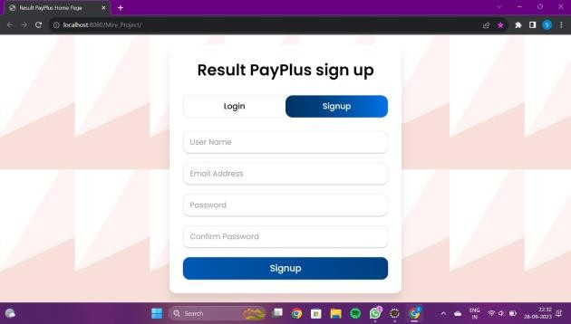

Fig 1. Login/Signup page

## Dashboard Navigation:

Upon logging in, you will be directed to your personalized dashboard. Navigate through the dashboard to access various features such as fee payment, exam schedules, and notifications.

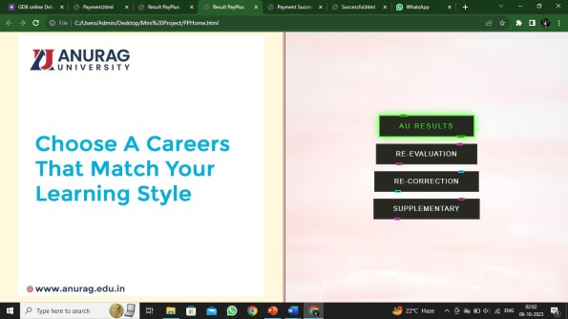

Fig 2. Dashboard page

* 1. Verify Student Results: The Student can verify heir results and he has the option to choose the query and done with their query and do the things for verification.



Fig 3. Results page

**C. Fee Payment:** To make a fee payment, click on the "Payment" or "Fees" tab on the dashboard. Choose the relevant payment option (e.g., semester fees, exam fees) and

follow the prompts to complete the transaction securely.



Fig 4. Queries page

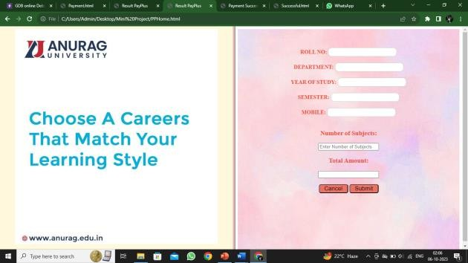

Fig 5. Submit the query to form

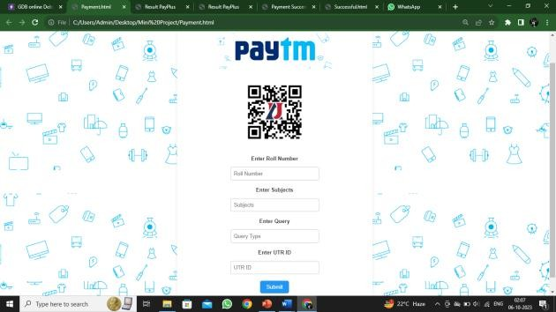

Fig 6. Payment page

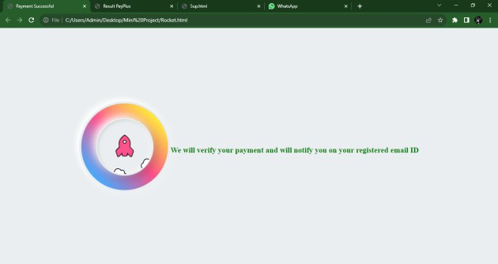**D. Exam Updates: For** real-time exam updates, click on the "Exams" or "Schedule" tab. View your upcoming exams, exam dates, venues, and any changes or notifications regarding exam schedules.

Fig 7. Payment verification page

**E. Log Out:** Once you've completed your tasks, remember to log out of your Result-Pay Plus account to maintain security and privacy. Click on the "Log Out" or "Sign Out" button located in the top-right corner of the dashboard.

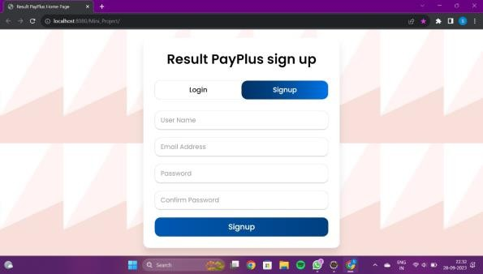

Fig 8. Logout page

Administrators wield a suite of powerful tools within Result-Pay Plus, starting with an intuitive dashboard offering real-time insights into fee statuses, exam schedules, and student engagement metrics. They oversee fee management, from configuring structures to tracking payments and issuing reminders. Exam management falls under their purview as they create schedules, assign venues, and communicate updates to students. User management tasks, including account administration and access permissions, are efficiently handled. Robust analytics and reporting capabilities empower administrators to derive actionable insights for informed decision-making. Effective communication is ensured through targeted notifications and automated messaging. Configuration options allow for customization to align with institutional policies, while administrators also provide support, troubleshoot issues, and gather feedback for continuous improvement, ensuring Result-Pay Plus remains a cornerstone of efficient educational management.

Administrators ensure seamless operations in Result-Pay Plus, overseeing fee and exam management, user accounts, analytics, and communication. They also uphold system security, conducting audits and implementing measures to safeguard data integrity.



Fig 9. Admin login page

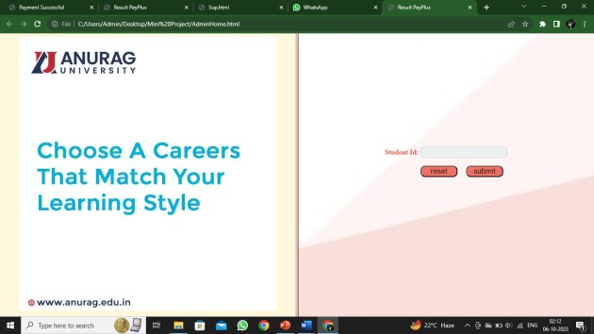

Fig 10. Admin page

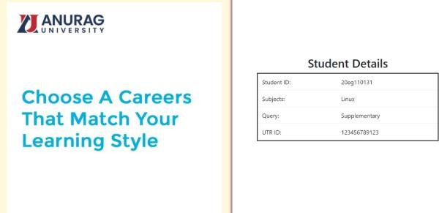

Fig 11. Admin verification page

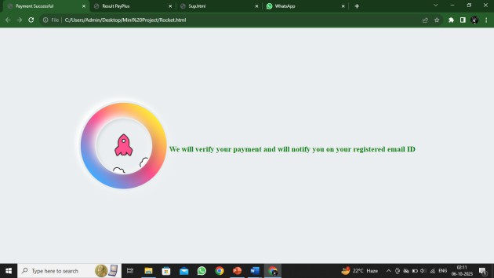

Fig 12. Admin Sends Notifications page

Administrators ensure seamless operations in Result-Pay Plus, overseeing fee and exam management, user accounts, analytics, and communication, they also uphold system security, conducting audits and implementing measures to safeguard data integrity.

# Applications

* 1. **Educational Institutions**: Result-Pay Plus streamlines fee management and exam updates for universities, colleges, and schools, enhancing administrative efficiency and student experience.
  2. **Training Centers**: Training institutes and vocational centers can utilize Result-Pay Plus to manage course fees, exam schedules, and student enrollments, ensuring smooth operations.
  3. **Professional Certification Programs**: Organizations offering professional certification programs can benefit from Result- Pay Plus by automating fee collection, exam scheduling, and result dissemination.
  4. **Corporate Training Programs**: Result-Pay Plus can be adapted by corporate training programs to handle participant registrations, course fees, assessment scheduling, and performance tracking.
  5. **Online Learning Platforms**: E-learning platforms can integrate Result-Pay Plus to facilitate seamless payment processing, exam scheduling, and learner engagement, improving the overall learning experience.
  6. **Government Educational Initiatives**: Result-Pay Plus can support government educational initiatives by providing a centralized system for managing student fees, exams, and performance analytics across educational institutions.
  7. **Language Schools and Institutes:** Language learning centers can utilize Result- Pay Plus to manage course fees, track student progress, schedule language proficiency exams, and automate communication with learners.

## Professional Development Programs:

Organizations offering professional development programs, workshops, and seminars can implement Result-Pay Plus to handle registration, fee collection, event scheduling, and participant management .

# Conclusion

Result-Pay Plus offers a versatile solution applicable across diverse educational and training domains, from universities to corporate training programs and language schools. Its capabilities extend to streamlining fee management, exam scheduling, participant tracking, and communication. By embracing Result-Pay Plus, institutions and organizations can enhance administrative efficiency and elevate the overall experience for students and learners. Its adaptability and robust features make it a valuable asset in modern educational ecosystems, fostering smoother operations and improved outcomes. From managing course fees to scheduling exams and tracking student progress, Result-Pay Plus caters to a wide range of educational needs. Its implementation ensures seamless processes, improved communication, and enhanced user experience across various educational initiatives. As institutions strive for efficiency and effectiveness, Result-Pay Plus emerges as a comprehensive solution to meet their administrative requirements and elevate educational standards.

# Acknowledgement

We extend our heartfelt gratitude to our guide,

B. Jyothi, Assistant Professor of the Department of Data Science, Anurag University, for her invaluable guidance, unwavering support, and insightful feedback throughout the duration of this project. Her expertise and encouragement have been instrumental in shaping our understanding and refining our approach towards achieving our goals. We express our sincere thanks to Dr. M. Sridevi, Head of the Department of Data Science, Anurag University, for her constant encouragement, valuable suggestions, and motivation that have inspired us to strive for excellence in our endeavors. Our heartfelt thanks also go to Dr. V. Vijaya Kumar, Professor & Dean, School of Engineering, Anurag University, for his encouragement and support, which have been a source of strength and inspiration throughout

this journey. We also acknowledge the support and cooperation extended by our fellow classmates and friends, whose encouragement and camaraderie have enriched our learning experience and made this journey memorable. Lastly, we would like to express our gratitude to our families for their unwavering support, understanding, and encouragement, without which this project would not have been possible. Their love and encouragement have been our pillar of strength throughout this journey.

# Refernces

1. Smith, J. (2021). "Modern Trends in Educational Technology." Educational Technology Journal, 15(2), 45-58.
2. Johnson, A. (2019). "Efficiency in Student Payment Systems." Journal of Higher Education Management, 25(3), 112-127.
3. Anderson, R. (2020). "Enhancing Student Experience through Technology Integration." International Journal of Educational Innovation, 8(1), 78-91.
4. Brown, K. (2018). "Streamlining Academic Processes: A Case Study of XYZ University." Journal of Educational Administration, 12(4), 201-215.
5. Garcia, M. (2017). "Data Analytics in Educational Institutions: Opportunities and Challenges." International Conference on Educational Technology Proceedings, 134-145.
6. White, S. (2016). "Improving Administrative Efficiency in Higher Education." Journal of Educational Leadership, 22(2), 89-102.
7. Thompson, L. (2015). "The Role of Technology in Student Fee Management." Educational Technology Review, 7(3), 205-

218.