**DustGuard: Rapid Image Enhancement and License Plate Recognition in Sandy Conditions**

**Alby Binoy**1

1Mangalam College of Engineering, Kottayam, India, [albyjob1234@gmail.com](mailto:albybinoy98@gmail.com)

1. **ABSTRACT**

The color variations and limited visibility of photos taken under sandy conditions have a significant negative impact on computer vision systems. I propose a fast and efficient method to improve qualities of photos taken in sand-dusty environment to address the issues explained. First, compensate for the loss of the blue channel. The color of the image damaged by the sand dust is then corrected using white balance technology. To improve the image contrast and edge accuracy, guided image filtering is applied, and an adaptive approach is used to determine the magnification factor of the detail plane to improve the detail information of the image. Also added an additional feature to detect license plates in the sandy images. The goal of this task is to develop an automated system that can accurately and efficiently recognize license plates on sandy images taken with a camera. To identify the license plate, uses the MobileNetV2 method to isolate the license plate from the sand image. If MobileNetV2 fails, Haar Cascade can be used to recognize the license plate. This technology is applied in various fields, such as traffic control systems, toll collection, parking management and law enforcement. The experimental results show that the approach can successfully recover the fading characteristics of a large number of photos damaged by the presence of sand or dust.

**Key words:** Blue Channel, MobileNetV2, Haar Cascade

1. **INTRODUCTION**

Low contrast, color deviations and blurring are main challenges of photos taken in sandy environment, which has a negative effect on the clarity of the image. The main cause of this phenomenon is, light absorbed by sand/dust particles and it gets scattered. As a result, the processing performance of surveillance systems, automatic driving systems and remote sensing systems is directly reduced by the photos damaged by sand dust.

Although there are already approaches to improve images affected by sand dust that eliminate color inconsistencies, increase contrast, and improve clarity, there are still certain problems. First, presence of blue color appears in the photos and reduce the photos quality. When the sand-dust damaged photos are processed with the current color restoration technique. Second, the current methods for enhancing sand-dust damaged images have significant time complexity.

There are still certain problems with sand-dust damaged images, although modern techniques can correct some of them. When applying current color restoration techniques to photographs damaged by sand dust, initial observations show the appearance of blue artifacts that degrade overall image quality. In addition, the existing methods for enhancing images damaged by sand dust exhibit a certain degree of temporal complication. In this paper, a quick and efficient technique is suggested that allows to improve the contrast and color tone of photos damaged by sand and dust. The main steps of the proposed method are described below.

The blue factors can be retrieved by restoring the lost value using the first proposed blue channel recovery algorithm. An adaptive method is used to obtain the magnification coefficient for the detail plane to improve the detail information of the image, and guided image filtering is used to improve the image contrast and edge accuracy.

License Plate Recognition is a technology for automatically detecting and recognizing license plates from dusty images. As the count of vehicles on the roads increases, automatic license plate recognition systems offer a way to increase safety, reduce traffic congestion and enhance security measures. The main goal of license plate recognition is to accurately and efficiently distinguish the license plate area from the background and recognize the characters on the license plate. To recognize the license plate, used the MobileNetV2 method to isolate the license plate from the sand image. If MobileNetV2 fails, Haar Cascade is useful to recognize the license plate. Recent advances in computer vision and machine learning have led to significant improvements in license plate identification.

The experimental results, obtained via qualitative and quantitative evaluations, show that this method can quickly and effectively improvise photos taken in sand-dust environment and eliminate existing approaches.

1. **LITERATURE SURVEY**

In Sand-dust image enhancement using successive color balance with coincident chromatic histogram (2021)- a brand-new color balancing algorithm for enhancing sand dust images is presented. The goal of the proposed enhancement approach is to obtain a matching chromatic histogram. First, using the mean and standard deviation of the chromatic histograms, a pixel adaptive color correction technique has been developed. The statistical properties of the green component are used to modify the pixels of each color component. Secondly, a color normalization method that maintains the green mean value is provided. However, since the red or blue components of many sand dust photos have a narrow histogram with a high peak, using the mean value of the red and blue components as the mean value of the green may lead to an unacceptable result. To solve this problem, an algorithm for shifting the histogram that maximizes the overlap between the red, blue and green histogram is presented here. This algorithm can be used to reduce bluish or reddish artifacts in the enhanced image. The brightness of the sand dust image is improved by image correction, which is the final step. Here, extensive tests were carried out on a large number of sand-dust photos and the performance of the proposed method was compared with that of state-of-the-art enhancement techniques. According to the simulation results, the proposed enhancement system performs better than the current methods in both subjective and objective terms.

In 2022, the solve the problem by developing a unique enhancement method based on the fusion strategy is proposed to solve these problems. It consists of two parts: the extended color correction technique based on a Gaussian model to remove sand and the residual-based CNN to remove dust. The advanced color correction technique based on the Gaussian model removes the visual degradation caused by sand. To further increase the clarity of the input photos, convert the dust removal task into a haze removal task. The proposed fusion strategy can successfully correct the yellowed hue and remove the distracting dust haze. The theoretical analysis and experimental results provide a useful idea for the future development of sand dust image enhancement.

In Blue channel and fusion for sandstorm image enhancement (2020)- propose a new technique for enhancing images captured during a sandstorm. The technique starts by blending two photos taken directly from the damaged original image. Next, enhance the image details using a multi-layer decomposition technology and restore the image contrast and color intensity using blue channel and white balancing techniques. Thirdly, to improve the contrast of the image edges, weight maps associated. Finally, the fusion results of the color-corrected image without sandstorm are obtained using the Laplacian pyramid fusion method. The test results show that the proposed strategy can successfully restore the fading features of sandstorm-damaged photos while improving their clarity. The proposed method can significantly improve photos taken during a sandstorm and the results are better than those of previous methods, as shown by the experimental results through subjective and objective evaluations.

In 2018, Structure-revealing low-light image enhancement via robust retinex model- To improve the performance in enhancing low-light and high-noise photos, here introducing the elastic retinex model in this study, which considers a noise map in addition to the usual retinex model. Here, an optimization function is provided using brand new regularization terms for illumination and reflectance based on the reliable Retinex model. In particular, a fidelity term for reflectance gradients is used in this work to reveal the structural details in dimly illuminated images. Here, an improved Lagrange multiplier based alternating direction minimization approach without logarithmic transformation is offered to successfully solve the optimization problem. Experimental results show the effectiveness of the proposed strategy in enhancing low-light images. Furthermore, this approach can be extended to various related challenges, such as enhancing images for remote sensing or underwater applications, as well as in environments affected by fog or dust.

In Multinational license plate recognition using generalized character sequence detection (2020)- Datasets from different nations that have the same LP layout are used to test previous studies on global LP recognition. This study provides a deep ALPR solution that can be used by multinational LPs to solve this problem. The proposed method includes three basic steps: LP layout recognition, uniform character recognition, and LP detection. YOLO networks form the basis of the system to a large extent. In particular, the small YOLOv3 was used for the first step, while YOLOv3-SPP, a variant of YOLOv3 that includes the SPP block, was used for the second step. For character recognition, YOLOv3-SPP receives the localized LP. The bounding boxes of the expected characters are returned by the character recognition network, but the order of the LP number is not disclosed. A wrong order is considered as a wrong LP number. Therefore, propose a layout recognition technique that can extract the correct order of LP numbers from multinational LPs to obtain the correct order. Here they collected their own dataset of Korean license plates and made them accessible to the public. LP datasets from five different countries — South Korea, Taiwan, Greece, the United States and Croatia —were used to evaluate the proposed approach. A small dataset of license plates from 17 different countries was also collected to test the effectiveness of the global license plate layout recognition system. The proposed ALPR system requires an average of 42 ms per image to extract the LP number. The results of the experiments show how successful our ALPR technology is.

1. **PROPOSED SYSTEM**

## A visibility restoration technique based on guided image filtering and blue channel correction, which is used to improve damaged photos taken in sand-dust weather. The proposed technique consists of two steps:

## Guided image filtering

## White balancing based on blue channel compensation.

## First, we compensate the lost blue value and apply white balancing to the compensated image to effectively remove the blue artifacts and recover the fading characteristics of the damaged photos.

## Secondly, guided image filtering is applied to improve the contrast and edge accuracy of the image contaminated by sand dust.

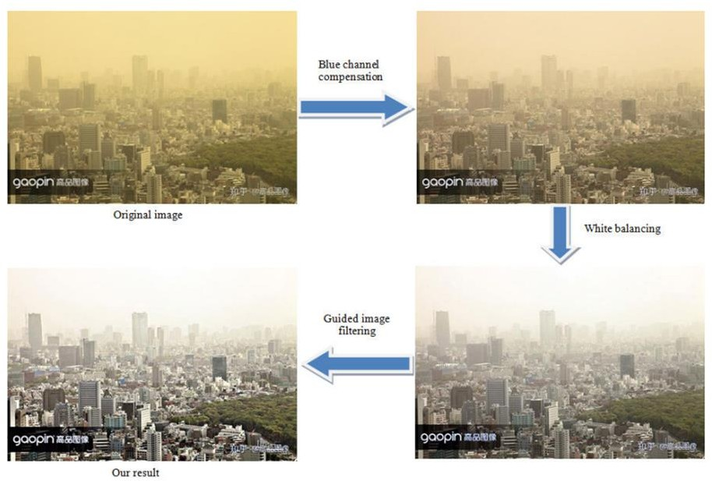

Figure 1: Framework proposed algorithm

**Blue Channel Compensation:**

In dusty environments, majority of blue light is scattered and absorbed, leading to images appearing yellowish and distorted in color. To address this issue, several image processing techniques are employed:

* Blue Channel Compensation: Initially, the blue channel is adjusted to recover its lost information in images affected by sand dust.
* White Balancing: This technique corrects the overall yellowish appearance of the images. It ensures that the colors appear more natural by adjusting the white point.
* Gray Scale: Converting the image to grayscale can sometimes help in simplifying the correction process by focusing on luminance values.
* OCM (Optical Compensation Method): This likely involves methods to ensure consistent color appearance across different parts of the image, despite the yellowish hue caused by dust.
* Color Balance: Adjustments are made to the color channels to achieve a more balanced and accurate representation of colors in the image.

The approach leverages several principles:

Scattering and Absorption of Blue Light: Explains why images appear yellowish in such conditions, motivating the need to restore blue components.

Gray World Assumption: Assumes that in natural scenes, the average reflectance of light is uniform across all channels. This is used to restore the blue channel by compensating for its absence.

Channel Mean Values: Assumes that in degraded images affected by sand dust, the mean values of green and red channels can be used to estimate and recover the blue channel.

Overall, these methods aim to improve the quality of images taken in dusty environments by addressing color distortions caused by the absence of blue light.

**White Balancing**

The "Robust-AWB" technique corrects color deviations in low-quality, sand-affected images. It estimates the light source's color temperature using gray color points from the images, comparing differences at various temperatures. After determining the correct temperature, the algorithm restores lost blue components with blue channel compensation and improves overall color balance through white balancing, enhancing image quality.

**Guided Image Filtering**

After adjusting the blue channel and applying white balancing, the process continues with guided image filtering. This method focuses on preserving edges while smoothing the image, using a guide image that emphasizes structures from the original. In the context of sand dust images, this technique specifically aids in detecting license plates.

**Mobile Net V2**

MobileNetV2 is an optimized neural network architecture designed for efficiency, particularly well-suited for mobile and embedded devices. It improves upon the original MobileNet by enhancing performance while maintaining computational effectiveness.

Implementation Summary of MobileNetV2:

Set up the environment:

* Prepare necessary dependencies and libraries for model training and inference.

Load the pre-trained model:

* Download pre-trained weights from an official source or repository.
* Use deep learning framework APIs to load the model, specifying input size and classes if needed.

Pre-process the input data:

* Prepare input data as required by MobileNetV2.
* Convert input images to the model's expected format and size through appropriate pre-processing.

Perform inference:

* Utilize the loaded MobileNetV2 model to make predictions on pre-processed input data.
* Pass inputs through the model's forward pass to generate predictions.
* Process output predictions based on task-specific requirements.

Fine-tuning or transfer learning:

* Optionally fine-tune the MobileNetV2 model on specific datasets or tasks.
* Adjust parameters to optimize performance for the intended application.

Evaluation and testing:

* Assess model performance by evaluating on validation or test datasets.
* Calculate metrics like accuracy, precision, and recall to measure model effectiveness.

In conclusion, MobileNetV2 facilitates efficient deployment of deep learning models on mobile and embedded platforms with its improved architecture and performance optimizations. Implementation involves environment setup, loading pre-trained models, data pre-processing, inference execution, potential fine-tuning, and rigorous performance evaluation.

If the implementation of MobileNetV2 has failed, the Haar Cascade algorithm is used.

**Haarcascade**

The Haar cascade algorithm is a popular object detection technique used to identify objects or patterns in digital images or videos. The Haar cascade algorithm is based on a cascade of simple classifiers trained with a machine learning technique called AdaBoost (Adaptive Boosting).

1. **RESULT**

The user interface consists of mainly two options, option 1 is for sand dust removal and option 2 is for number plate detection after sand dust removal. In the sand dust removal page, there will be option to select a file from our system and then it displays the intermediate images and the final image. In number plate detection there will be option to select the image and then it will display the enhanced image, cropped image of the number plate and the license plate number.

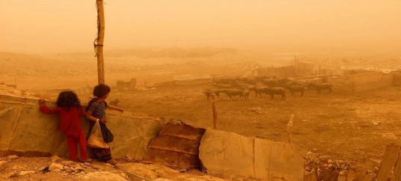

Figure 2: Input image

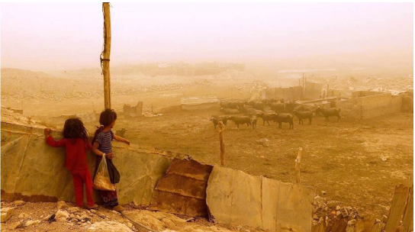

Figure 3: Post blue channel compensation

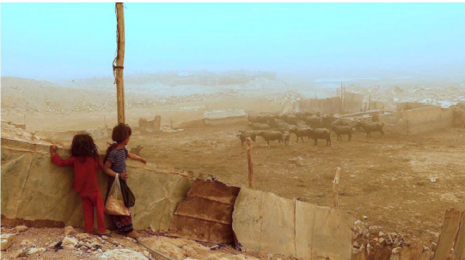

Figure 4: Post guided image filtering

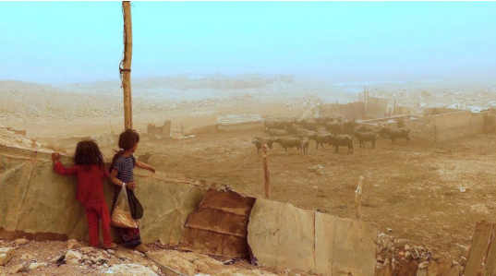

Figure 5: Output image



Figure 6: After executing number plate detection.

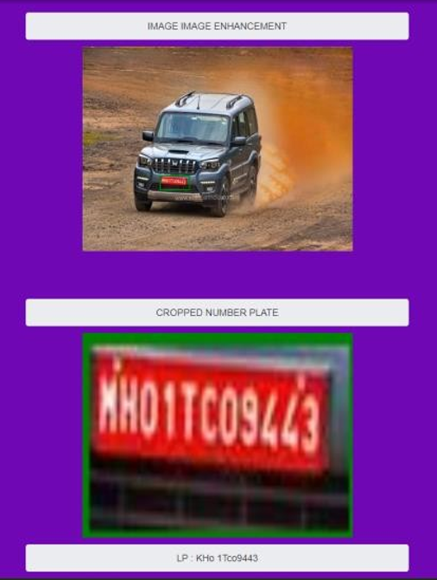

Figure 6: Number plate detection.

1. **CONCLUSION**

Learned about improving sand-dust images by adjusting the blue channel and using guided image filtering. Many current methods struggle with this task, so here suggested a cost-effective and easy-to-use system. Our new way of restoring visibility, which involves adjusting the blue channel and using guided image filtering, effectively improves sand-dust-damaged images. Initially, we fix missing information in the blue channel, then deal with color inconsistencies and blue issues. Guided image filtering boosts contrast and sharpness. This method enhances the appearance of images, making them suitable for surveillance, remote sensing, and environmental monitoring. Additionally, here incorporated a number plate detection system using MobileNetV2 and Haar cascade. MobileNetV2 is designed for mobile devices and provides precise detection. Haar cascade offers quick and simple detection, complementing the accuracy of MobileNetV2. A user-friendly interface makes it easy to upload images, view them, enhance them, and detect number plates. In summary, our project demonstrates the effectiveness of adjusting the blue channel and using guided image filtering to enhance sand-dust images, along with an efficient method for number plate detection.

**REFERENCES**

1. Tae Hee Park and Kyu Eom, ‘Sand-Dust Image Enhancement Using Successive Color Balance with Coincident Chromatic Histogram ,’’ IEEE Access, vol. 8,pp. 66931– 66940,2021.
2. Yazhong Si,Fan Yang, ‘‘Sand dust image visibility enhancement algorithm via fusion Strategy,’’ Int. J. Intell. Syst. Appl., vol. 8, no. 8, pp. 10–17, 2022
3. Y. Cheng, Z. Jia, H. Lai, J. Yang, and N. K. Kasabov, ‘‘Blue channel and fusion for sandstorm image enhancement,’’ IEEE Access, vol. 8, pp. 66931–66940, 2020
4. M. Li, J. Liu, W. Yang, X. Sun, and Z. Guo, ‘‘Structure-revealing low light image enhancement via robust Retinex model,’’ IEEE Trans. Image Process., vol. 27, no. 6, pp. 2828–2841, Jun. 2018.
5. Chris Henry,Sung Yoon Ahn,”Multinational License Plate Recognition Using Generalized Character Sequence Detection”vol. 35, no. 6, pp. 1397–1409, Jun. 2020