Comparing the structural efficiency of floating columns in composite & RCC structure
¹Faique Ahmad Ziya Ahmad & ²Dr. S.D. Ambadkar
¹PG Scholar, Department of Civil Engineering, G H Raisoni University, Amravati
²Assistant Professor, Department of Civil Engineering, G H Raisoni University, Amravati
Abstract This study compares the structural efficiency of floating columns in composite and reinforced concrete (RCC) structures. Key findings reveal that Model-5, a composite building with three floating columns, exhibits the highest displacement among all analyzed models. This suggests that multiple floating columns in composite structures can lead to increased overall displacement under applied loads, necessitating mitigation strategies to control displacements and ensure structural integrity. Conversely, Model-10, an RCC building with four floating columns, shows the highest reactions, beam forces, and plate stresses, indicating significant impacts on force and stress distribution within the structure. The elevated reactions highlight the increased support demands and foundation requirements for RCC buildings with multiple floating columns. These insights are crucial for engineers and designers in optimizing the design and ensuring the safety of buildings with floating columns.
Keywords: floating columns, structural efficiency, composite structures, RCC structures, displacement, reactions, beam forces
1. Introduction
India is a developing nation experiencing rapid urbanization, leading to significant advancements in building construction methods over the past few decades. As part of this urbanization process, multi-storey buildings with complex architectural features, such as soft storeys, floating columns, heavy loads, and reduced stiffness, are being constructed. An increasingly common feature in urban multi-storey buildings is the open first storey, primarily used for parking or reception lobbies. Traditional civil engineering designs focus on strength and stiffness criteria, often leaving the ground floor open except for the columns that support the building and distribute its weight to the ground.
This study explores the architectural complexity of multi-storey buildings, particularly those with "floating columns," and examines their behavior in high seismic zones, offering specific recommendations based on the findings. While architectural innovation is essential to avoid monotonous structures, it should not compromise seismic safety. Architectural elements that adversely affect a building's earthquake resilience should be minimized or eliminated.
Buildings with irregular features, like floating columns, require more extensive engineering efforts to ensure structural integrity, and they may not perform as well as simpler designs. Consequently, structures with these discontinuous components in seismic zones are at risk. Instead of demolishing such buildings, research can be conducted to reinforce them or propose corrective measures. Strengthening first storey columns by enhancing their stiffness or adding bracing to reduce lateral deformation are potential solutions to improve the seismic performance of these structures.
To ensure the safety and durability of these complex buildings, it is crucial to adopt advanced engineering practices and continuous monitoring. Retrofitting existing structures with modern technologies can significantly enhance their resilience to seismic activities. Additionally, implementing stricter building codes and regulations that address these architectural complexities will contribute to safer urban environments. Public awareness and education about the potential risks and necessary precautions can also play a vital role in mitigating the impact of earthquakes on such buildings. By combining innovative design with robust engineering solutions, the construction industry can achieve both aesthetic appeal and structural safety in the rapidly urbanizing regions of India.

2. REVIEW OF LITERATURE
A.M.K Srikanth et al. (2014) present a simplified probabilistic risk analysis (PRA) for the seismic reliability of a G+7 storey RCC building, comparing models with and without floating columns. The moment about X and Z axes are analyzed using the equivalent static method with STAAD Pro 8Vi [1]. Poonam, A. K., et al. (2012) focus on recognizing the presence of floating columns in multistoried buildings and reducing earthquake risks by strengthening with bracings. Four G+9 models are analyzed using equivalent static and response spectrum methods in zones III and V, highlighting the effectiveness of Model 4 with central bracings [2]. Patel, T., et al (2017) conduct seismic analyses on four G+9 building models with and without floating columns, comparing storey shears, drifts, displacement, time period, and base shear using ETABS and IS:1893-2002. Model 4 shows superior performance in pushover analysis [3]. P. Mundada and S.G. Sawdatkar (2023) compare seismic responses of a G+7 residential building with and without floating columns. The 3D models include all structural components influencing mass, strength, stiffness, and deformability, and are analyzed using STAAD Pro [4]. Mandwale, S., et al. (2020) examine the strengthening of floating column buildings with bracings, noting increased moments, storey drifts, and shears in floating column structures, highlighting their potential risks in seismically active areas [5]. Arpit Shrivastav and Aditi Patidar (2014) analyze 8, 12, and 16-storey buildings with floating columns, with and without shear walls, across seismic zones III, IV, and V using STAAD Pro. Shear walls significantly reduce storey drift and displacement values, especially in higher seismic zones [6]. Deekshitha R. and Dr. H.S. Sureshchandra (2014) study the seismic safety and economy of G+5 buildings with floating columns using ETABS-2015, assessing their performance in seismically active areas and determining if such structures are safe and economical [7]. Patel, T., et al. (2017) analyze a 10-storey building with floating columns and shear walls in different locations using ETABS-2015. The study examines the effects of shear wall placement on displacement, time period, and base shear, identifying the optimal shear wall locations for seismic resistance [8]. Bhensdadia, H., & Shah, S. (2015) compare G+20 buildings with and without floating columns and shear walls. They evaluate storey displacement, drift, shear, and time period, finding that the inclusion of shear walls and floating columns affects the building's seismic response [9]. Rohilla, I., et al. (2010) explore the seismic performance of multistory buildings with floating columns, analyzing various configurations using SAP2000. The study highlights the increased vulnerability of floating column structures in high seismic zones [10]. Nayel, I. H., et al (2018) provide a comprehensive review of seismic design principles, including the effects of floating columns on building dynamics. They emphasize the need for rigorous analysis and design modifications to ensure structural integrity during earthquakes [11]. Patel, T, et al (2017) investigate the impact of floating columns on the seismic performance of high-rise buildings. Using ANSYS software, they simulate different scenarios to identify critical weaknesses and suggest reinforcement strategies [12]. Balsamo, A., et al (2005) states that columns typically transfer loads from the foundation to the ground, but floating columns start from a lower story and do not reach the foundation. This causes a vertical load path discontinuity, increasing the building's vulnerability to lateral loads and risking collapse if fewer columns or walls are present in a story [13]. Gupta, A., et al. (2020) analyzed the seismic response of a 16.8 m high building with various configurations of floating columns. The study modeled four cases: a normal RC building, a building with external floating columns, internal floating columns, and both internal and external floating columns. The authors concluded that external floating columns increase node displacements, while internal and combined floating columns raise axial force, shear, and moment values, making the structure more susceptible to seismic forces [14]. Pawar, N., et al. (2021) highlighted that multistory buildings, whether residential, commercial, or industrial, often feature an open ground storey for parking, with only columns supporting the upper floors. This design, providing large, uninterrupted spaces for banquet halls, lobbies, or parking, uses floating columns to avoid closely spaced columns on lower floors [15]. Chand D, et al. (2021) analyzed the seismic response of a normal G+5 storey building and a G+5 storey floating column building using SAP2000. Their study compared the time history values of both buildings under past earthquake ground motions [16].

METHODOLOGY
These are different structural models that have been analyzed using STAAD-PRO software, which is a widely used structural analysis and design software in civil engineering. Each model represents a different configuration or scenario of a building, and they are labeled as follows:
- Model-1: Composite building without floating column
  - This model likely represents a composite structure where different materials like steel and concrete are used together, but there are no floating columns included in the design.
- Model-2: RCC building without floating column
  - This model represents a reinforced concrete (RCC) building without any floating columns. RCC is a common material used in construction due to its strength and durability.
- Model-3: Composite building with one floating column
- Model-4: Composite building with two floating columns
- Model-5: Composite building with three floating columns
- Model-6: Composite building with four floating columns
  - These models depict composite buildings where the structural system includes floating columns. Floating columns are structural elements that do not have direct support from the foundation and are typically used in seismic-prone areas to allow for better flexibility and movement during earthquakes.
- Model-7: RCC building with one floating column
- Model-8: RCC building with two floating columns
- Model-9: RCC building with three floating columns
- Model-10: RCC building with four floating columns
- Similarly, these models represent RCC buildings with varying numbers of floating columns included in their design.
The analysis of these models using STAAD-PRO software involves subjecting them to different load conditions, such as dead loads, live loads, wind loads, and seismic loads. The software then calculates and analyzes the structural response of each model, including stress distribution, deflections, stability, and overall performance under the specified loads.
The modeling takes into account the following material properties and loading conditions:
- Material Properties:
  - The specific weight of Reinforced Cement Concrete (RCC) is considered to be 25 kN/m³.
  - Columns are uniformly sized at 500×500 mm.
  - Beams maintain a consistent size of 300×400 mm.
- Loading Conditions:
  - Dead Load: This includes the self-weight of the slab, calculated at 3 kN/m².
  - Live Loads: As per IS 875 (Part 2):1987, Loading Class III is assumed. For typical floors, the live load is estimated at 3 kN/m².
Seismic load:
These parameters relate to seismic design considerations for structures:
- Zone Factor (Z): A factor used in seismic design to quantify the level of seismic hazard in a specific geographic zone. A zone factor of 0.1 typically indicates a low to moderate seismic hazard.
- Response Reduction Factor (R): Also known as the seismic reduction factor or behavior factor, R accounts for the ability of a structure to dissipate seismic energy without experiencing significant damage. A factor of 5 indicates a moderate level of ductility and energy dissipation capability in the structure.
- Importance Factor (I): This factor reflects the importance of the structure in terms of its function or occupancy. An importance factor of 1 suggests that the structure has a standard importance level.
- Rock and Soil Site Factor (S): This factor accounts for the site conditions, specifically the type of soil or rock upon which the structure is built. A factor of 2 typically indicates that the site is on soft soil or rock.
- Damping Ratio (ξ): The damping ratio represents the energy dissipation capacity of the structure during seismic events. A damping ratio of 0.05 indicates low damping, implying that the structure has limited ability to dissipate seismic energy.
These parameters are essential in seismic design and analysis to ensure that structures can withstand earthquake forces according to specified safety and performance criteria.

Table 1: parameters for the analysis of building
Sr. No. | Parameter | Dimension
1 | Plan of the building | 15 m X 15 m
2 | Height of the building | 22.5 m
3 | Floor height | 3.0 m
4 | Steel Column | ISMB 600
5 | Steel beam | ISMB 500
6 | RCC beam | 300 X 400 mm
7 | RCC Column | 500 X 500 mm
8 | RCC slab | 150 mm

Engineers use such software simulations to optimize the design, ensure structural integrity, and assess the safety and stability of buildings before actual construction begins. The results obtained from these analyses help in making informed decisions regarding the structural design and construction methods to be employed for each specific building configuration.
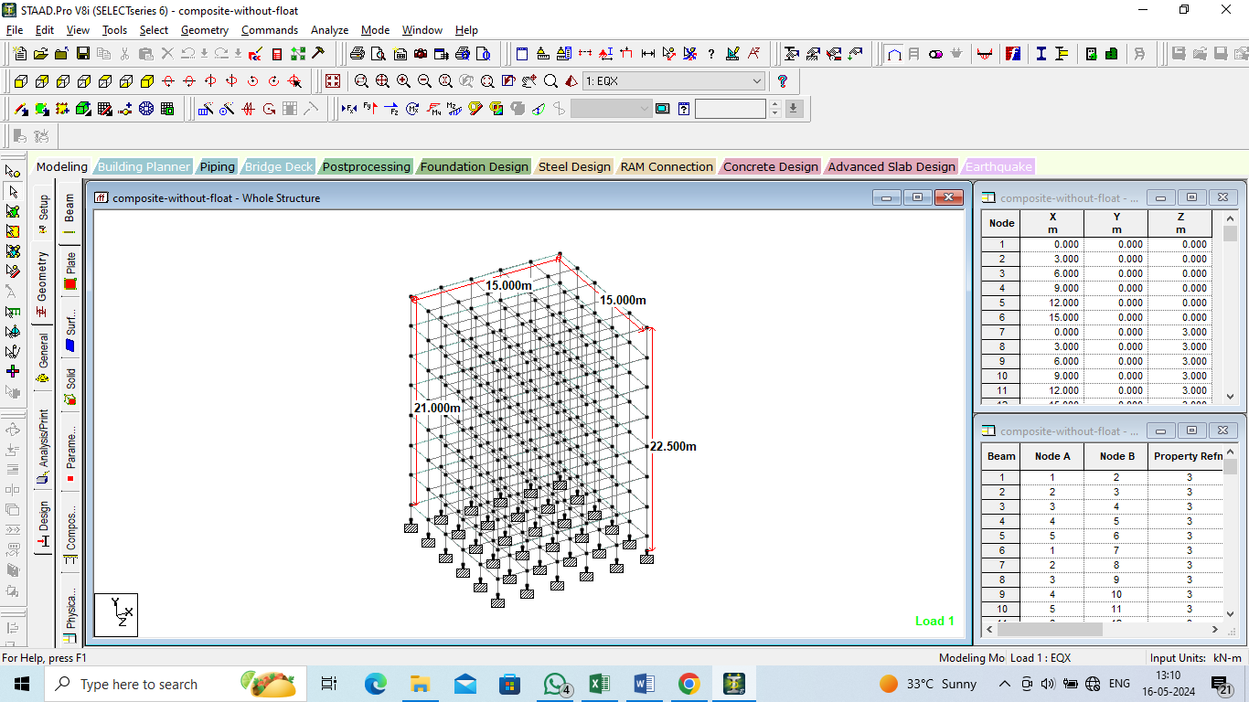
Figure 1:Geometry of the building
Figure 1 illustrates the geometry of a composite building featuring a floating column. This structural design integrates a floating column, which is a vertical element that is not directly supported by the foundation but rather rests on a beam or a slab. The figure provides a visual representation of the building's overall layout, including the placement of the floating column within the composite framework. This configuration is often employed to achieve specific architectural or functional requirements, allowing for open spaces or unique structural arrangements in the building design.
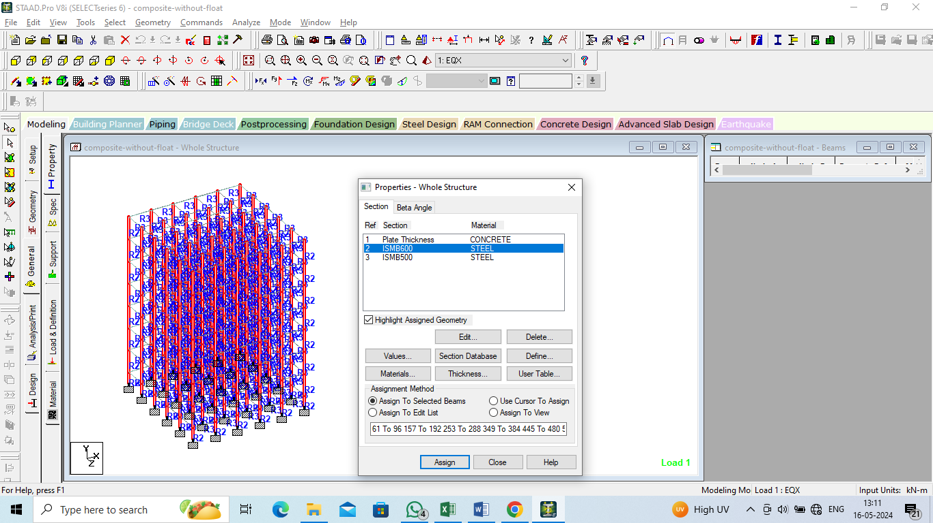
Figure 2:Properties assigned to the building
Figure 2 illustrates the properties assigned to the composite building structure featuring floating columns. The composite building integrates both steel and concrete elements, combining their strengths to enhance overall performance. The figure details specific material properties such as the modulus of elasticity, yield strength, and density for both the steel and concrete components. Additionally, it highlights the geometric parameters of the floating columns, including dimensions and placement within the building. These properties are crucial for accurately modeling and analyzing the building's structural behavior under various load conditions, ensuring safety and stability.
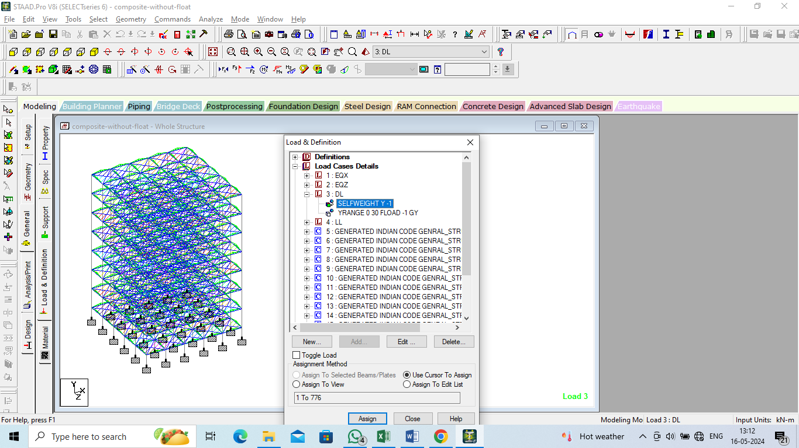
Figure 3:Loads assigned to the building

Figure 3 illustrates the loads assigned to a composite building featuring a floating column. The diagram details the various forces and stresses acting on the structure, including dead loads, live loads, wind loads, and seismic loads. These loads are critical for analyzing the building's performance under different conditions, ensuring that the design accommodates the additional complexities introduced by the floating column. Proper load assignment is essential for maintaining structural integrity, stability, and safety in composite buildings with unconventional design elements.
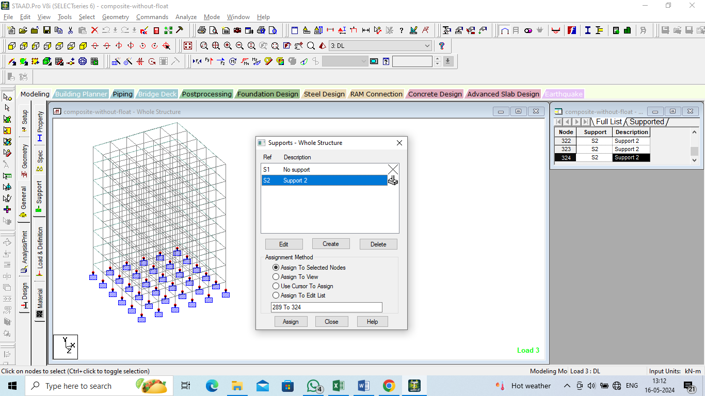
Figure 4:Supports assigned to the building

Figure 4 illustrates the supports assigned to a composite building featuring floating columns. These supports are critical components designed to bear the loads transferred from the floating columns, ensuring structural stability and integrity. The diagram highlights the specific placement and types of supports used, showcasing how they distribute the loads to the foundation. This arrangement is essential for managing the unique challenges posed by floating columns, which require precise support configurations to maintain the building's overall balance and performance under various load conditions.

RESULTS
The study compares the structural performance of ten different building models, categorized into composite and reinforced concrete (RCC) structures with varying numbers of floating columns.
Figure 5:Displacement (Horizontal-X) for all the models
The analysis of various building models reveals significant insights into the impact of floating columns on structural displacement. Model-1, a composite building without floating columns, exhibits the minimum horizontal displacement (X-direction), indicating its inherent structural stability. In contrast, Model-8, an RCC building with two floating columns, shows the maximum horizontal displacement, highlighting the increased flexibility and movement associated with the presence of floating columns. These findings suggest that while floating columns can enhance flexibility, especially in seismic-prone areas, they also lead to greater overall displacement under applied loads. This necessitates careful consideration and design strategies to manage and mitigate such displacements to maintain structural integrity.
Figure 6:Displacement (Vertical-Y) for all the models

The analysis of various structural models reveals distinct behaviors in terms of vertical displacement (Y-axis). Model-1, representing a composite building without floating columns, exhibits the maximum vertical displacement among all the models analyzed. This suggests that the absence of floating columns in a composite structure might lead to greater overall vertical movement under applied loads. Conversely, Model-2, which is an RCC building without floating columns, shows the minimum vertical displacement. This indicates that reinforced concrete structures, when designed without floating columns, tend to exhibit superior resistance to vertical displacement compared to their composite counterparts. The findings highlight the importance of material choice and structural configuration in influencing vertical displacement behavior in buildings.
Figure 7:Reactions (Horizontal-Fx) for all the models
The provided models represent various structural configurations of composite and reinforced concrete (RCC) buildings, both with and without floating columns. Models 1 and 2 serve as baselines, depicting composite and RCC buildings without floating columns, respectively. Models 3 to 6 illustrate composite buildings incorporating one to four floating columns, while Models 7 to 10 depict RCC buildings with a similar progression of floating columns. Floating columns, which do not extend to the foundation and are often utilized in seismic-prone regions, offer enhanced flexibility and movement during earthquakes. Notably, the analysis indicates that Model-3, a composite building with one floating column, experiences the highest horizontal reaction force (Fx), whereas Model-2, an RCC building without floating columns, exhibits the lowest horizontal reaction force. This observation highlights the significant impact that the inclusion and number of floating columns have on the structural reactions of buildings.
Figure 8:Reactions (Vertical-Fy) for all the models
The study involves ten models to compare the structural efficiency of composite and reinforced concrete (RCC) buildings with varying numbers of floating columns. Model-1 is a composite building without floating columns, while Model-2 is an RCC building without floating columns. Models 3 to 6 represent composite buildings with one to four floating columns, respectively. Models 7 to 10 are RCC buildings with one to four floating columns. Notably, the analysis indicates that Model-10, an RCC building with four floating columns, experiences the maximum vertical reaction force (Fy), suggesting significant support demands and foundation requirements. In contrast, Model-1, a composite building without floating columns, exhibits the minimum vertical reaction force, highlighting the impact of floating columns on the structural load distribution.

Figure 9:Plate stresses (Principal-Bottom) for all the models

Among the various models analyzed, Models 5 and 6 of the composite buildings with three and four floating columns, respectively, exhibit the highest plate stresses at the bottom principal level. This indicates significant stress concentrations in these structural configurations. In contrast, Model 10, which represents an RCC building with four floating columns, shows the lowest plate stresses among all the models studied. The variation in plate stresses underscores the influence of floating columns on the structural behavior, particularly highlighting how the number and arrangement of floating columns impact stress distribution within the building's components. These findings are crucial for engineers and designers aiming to optimize structural designs for resilience and performance under varying load conditions and seismic activity.

CONCLUSIONS
The following conclusions are obtained
• The analysis reveals that Model-5, which is the composite building with three floating columns, experiences the maximum displacement among all analyzed models. This finding suggests that the addition of multiple floating columns in composite buildings can lead to increased overall displacement under applied loads. Engineers and designers should consider this factor when designing such structures, implementing mitigation strategies to control displacements and ensure structural integrity.
• Model-10, representing an RCC building with four floating columns, exhibits the highest reactions, beam forces, and plate stresses compared to other models in the study. This indicates that the presence of multiple floating columns in RCC buildings can significantly impact the distribution of forces and stresses within the structure.
• The elevated reactions suggest higher support demands and foundation requirements for buildings with multiple floating columns.

REFERENCES
    - A.M.K srikanth, Y.R holebagilu (2017). Effect of floating column on RCC building with and without infill wall subjected seismic force. International Journal of Engineering Trends and Technology, 47, 206-212.
    - Poonam, A. K., & Gupta, A. K. (2012). Study of response of structurally irregular building frames to seismic excitations. International Journal of Civil, Structural, Environmental and Infrastructure Engineering Research and Development, 2(2), 25-31.
    - Patel, T., Gadhiya, J., & Bhatt, A. (2017). Effect of floating column on RCC building with and without infill wall subjected seismic force. International Journal of Engineering Trends and Technology, 47, 206-212.
    - A.P. Mundada, S.G. Sawdatkar, (2023). Comparative study on seismic analysis of a multi-storied building with and without floating column. In AIP Conference Proceedings (Vol. 2713, No. 1). AIP Publishing.
    - Mandwale, S., & Pitale, N. (2020). Review on Analysis of Multi-storey Building with and without Floating Columns. International Journal for Research in Applied Science & Engineering Technology, 8, 1395-1398.
    - Arpit Shrivastav, Aditi Patidar (2014). Seismic Analysis of Multistorey Building with Floating Column. International Journal of Civil and Structural Engineering Research, 2(2), 12-23.
    - Deekshitha.R, Dr.H.S.Sureshchandra, (2014). Comparative Seismic Analysis of Multistorey Building with and without Floating Column. International Journal of Current Engineering and Technology, 4(5), 3395-3400.
    - Patel, T., Gadhiya, J., & Bhatt, A. (2017). Effect of floating column on RCC building with and without infill wall subjected seismic force. International Journal of Engineering Trends and Technology, 47, 206-212.
    - Bhensdadia, H., & Shah, S. (2015). Pushover analysis of rc frame structure with floating column and soft story in different earthquake zones. International Journal of Research in engineering and Technology, 4(04), 114-121.
    - Rohilla, I., Gupta, S. M., & Saini, B. (2015). Seismic response of multi-storey irregular building with floating column. International Journal of Research in Engineering and Technology, 4(3), 506-518.
    - Nayel, I. H., Abdulridha, S. Q., & Kadhum, Z. M. (2018). The effect of shear wall locations in rc multistorey building with floating column subjected to seismic load. International Journal of Civil Engineering and Technology, 9(7), 642-651.
    - Patel, T., Gadhiya, J., & Bhatt, A. (2017). Effect of floating column on RCC building with and without infill wall subjected seismic force. International Journal of Engineering Trends and Technology, 47, 206-212.
    - Balsamo, A., Colombo, A., Manfredi, G., Negro, P., & Prota, A. (2005). Seismic behavior of a full-scale RC frame repaired using CFRP laminates. Engineering Structures, 27(5), 769-780.
    - Gupta, A., & Pendharkar, U. (2020). Multi storey building with and without floating column. International Journal of Innovative Technology and Exploring Engineering, 4(7), 16-19.
    - Pawar, N., Dabhekar, K., Patil, P. B., & Khedikar, I. (2021, July). Review on “Effect of Floating Columns on Building subjected to seismic Forces”. In IOP Conference Series: Earth and Environmental Science (Vol. 822, No. 1, p. 012045). IOP Publishing.
    - Chand D, Sakalle R Januay (2021). Review on “Effect of Floating Columns on Building subjected to seismic Forces”. In IOP Conference Series: Earth and Environmental Science (Vol. 822, No. 1, p. 012045). IOP Publishing.

