A STUDY ON EVALUATION OF BALANCED FUNDS
¹M. Nagaraju, Assistant Professor, Dept. of MBA, Santhiram Engineering College(A), Nandyal,A.P., India
²Y.Siva Kumar, Student, Dept. of MBA, Santhiram Engineering College(A), Nandyal,A.P., India

ABSTRACT:
A mutual fund is simply a financial intermediary that allows a group of investors to pool their money together with a predetermined investment objective. The mutual fund will have a fund manager who is responsible for investing the pooled money into specific securities (usually stocks or bonds). When you invest in a mutual fund, you are buying shares (or portions) of the mutual fund and become a shareholder of the fund. By pooling money together in a mutual fund, investors can purchase stocks or bonds with much lower trading costs than if they tried to do it on their own. But the biggest advantage to mutual funds is diversification. Diversification is the idea of spreading out your money across many different types of investments. When one investment is down another might be up. Choosing to diversify your investment holdings reduces your risk tremendously
Index terms: Mutual Funds, growth of company, AMC. NAV
1. INTRODUCTION :
The most basic level of diversification is to buy many stocks (even hundreds or thousands). Beyond that, you can diversify even more by purchasing different kinds of stocks, then adding bonds, the international, and so on. It could take you weeks to buy all these investments, but if you purchased a few mutual funds you could be done in a few hours because mutual funds automatically diversify in a predetermined category of investments (i.e.- growth companies, low-grade corporate bonds, international small companies[1].
Appreciation or reduction in value of investments is reflected in net asset value (NAV) of the concerned scheme, which is declared by the fund management from time to time. Respective Asset Management Companies (AMC) manages mutual fund schemes. Different business groups/financial institutions/banks sponsor these AMCs, either alone or in collaboration with well-known international firms.

  - ORGANIZATION OF A MUTUAL FUND
The following diagram shows the structure of Mutual Fund. Since for setting up a mutual fund, first a trust has to be set upon, a trust deed needs to be executed. This trust deed makes sure that the investors are indemnified for any negligence on the part of the mutual fund[2]. The mutual fund takes full responsibility for any damages caused due to negligence of the mutual fund.

Unit Holders

Sponsors
SEBI

Trustees
Custodian

The Mutual Fund
Transfer Agent
AMC

As far as the appointment of trustees is concerned, SEBI has laid the following rules that are as under:
- He/She must be capable to act as trustee of a mutual fund and should not have any conviction against him/her for moral turpitude or any economic offences whatsoever[3].
- He/She must not be a trustee of another mutual fund unless he/she is an independent trustee or has sought a prior approval from the mutual fund for such appointment.
- Also, at least two-thirds of directors of the Trust must be independent, i.e. they should not be associated with sponsors.
After the trust has been set up, the mutual fund needs to be constituted. For this, the mutual fund needs to be registered. The application has to be made in the prescribed application form with Rs.25000 as fees that are non-refundable[4]. The registration is granted by SEBI if and only if the following conditions are met.
1.2.Fund Sponsor: The Sponsor is the main body that establishes the Mutual fund. The Sponsor can be compared to a promoter of a company. The responsibility of the sponsor includes appointing the trustees with the approval of SEBI and setting up an AMC under the Companies act 1956 while getting the trust registered with SEBI. Since the Sponsors play the most important role in the functioning of a mutual fund, SEBI has a set of strict guidelines for the eligibility of a sponsor[5]. Some of them are as follows: the sponsor should have a sound track record of carrying out business in the financial services space for not less than five years. A Sponsor also needs to have made profits in at least three of the five years including the latest year. During the same period, it is also important that the sponsor has had a positive net worth. It should be contributing a minimum of 40 per cent net worth of the AMC. it is also important that the sponsor has a good track record of fairness and integrity in all its transactions. For example ICICI Bank and Purdential Plc are sponsors for ICICI Mutual Fund. For Birla Sun Life Mutual Fund, Aditya Birla Financial Services and Sun Life (India) AMC Investments Inc. are sponsors.
1.3.Trustee: The main role of a trustee is to ensure that the interest of the unit holders is protected while making sure that the mutual fund complies with all the regulations of SEBI. Either, the sponsor should appoint four trustees or establish a trustee company with at least four independent directors. Additionally, at least two thirds of the trustees or the directors should be independent not associated with the sponsor in any way[6].
Some of the key responsibilities of the trustees include, entering into an investment management agreement with the AMC to define its functioning. They are also responsible for ensuring that the AMC has all the required process, procedures and systems in place while making sure that all the key personnel such as the CEO, CIO, the fund managers and the analysts are appointed after through due diligence. All the schemes launched by the AMC have to be approved by the trustees prior to launch. The trustees will be reviewing all the transactions of the AMC on a quarterly basis wile filing reports to SEBI on a half yearly basis.
1.4.Asset Management Company (AMC): The AMC is the investment manager of the trust. It takes care of the day today operation of the mutual fund and managing the investor’s money as well. The AMC is appointed either by the trustee or the Sponsor after obtaining the approval of SEBI. The AMC consists of the Chief Investment Officer, the fund managers and analysts, who are together responsible for managing the various schemes launched. The compliance officer ensures compliance of all the activities of the AMC in line with SEBIs rules and regulations. For example; HDFC AMC is the Asset Management Company for HDFC Mutual Fund.
1.5.Registrar and Transfer Agent (RTA): The RTA maintains and updates all the investor’s records. The main function is investor servicing through its office and various other branches. Its functions include processing of investor application, purchase and redemption transactions by investors in various schemes and plans[7].
The auditors are responsible for auditing of the AMC’s accounts while ensuring that the accounts of schemes are maintained independently from that of AMC. The fund accountants are responsible for calculating the NAV of the schemes based on the information regarding the assets and liabilities of each scheme.
2. BALANCED FUND:
A mutual fund that buys a combination of common stock, preferred stock, bonds, and shortterm bonds,to provide both income and capitalappreciation while avoiding excessive risk. The purpose of balanced funds (also sometimes called hybrid funds) is to provide investors with a single mutual fund that combines both growth and income objectives, by investing in both stocks (for growth) and bonds (for income). Such diversified holdings ensure that these funds will manage downturns in the stock market without too much of a loss; the flip side, of course, is that balanced funds will usually increase less than an all-stock fund during a bull market.
Net Asset Value (NAV): Net Asset Value is the market value of the assets of the scheme minus its liabilities. The per unit NAV is the net asset value of the scheme divided by the number of units outstanding on the Valuation Date.
VARIANCE:A measure of the average distance between each oa set of data points and their mean value; equal to the sum of the squares of the deviation from the mean value.
STANDERED DEVIATION: A measure of the dispersion of a set of data from its mean. The more spread apart the data, the higher the deviation. Standard deviation is calculated as the square root of variance
CORELATION CO-EFFIECENT: The correlation coefficient, denoted by r, is a measure of the strength of the straight-line or linear relationship between two variables. The correlation coefficient takes on values ranging between +1 and -1. The following points are the accepted guidelines for interpreting the correlation coefficient:
3.COMPOUND ANNUAL GROWTH RATE: CAGR isn't the actual return in reality. It's an imaginary number that describes the rate at which an investment would have grown if it grew at a steady rate. You can think of CAGR as a way to smooth out the returns.
Formulae
1. Return = V_{e} - V_{b}
_____
V_{b}
V_{e} = Value at the end
V_{b} = Value at the beginning

2. Variance (σ²) = Σ(x-μ)²
N
3. Standard Deviation :√(σ) = σ²

4. Correlation Coefficient (r) =

(N*Σxy) – (Σy*Σx)
__________________________

[(N*Σy²) – (Σy)²] * [(N*Σx²) – (Σx)² ]^{1/2}

5. CAGR:
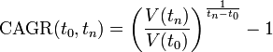

3.1.Understanding Balanced Funds
A balanced fund is a type of hybrid fund, which is an investment fund characterized by its diversification among two or more asset classes. The amounts the fund invests into each asset class usually must remain within a set minimum and maximum value. Another name for a balanced fund is an asset allocation fund[8].
Balanced fund portfolios do not materially change their asset mix, unlike life-cycle funds, which adjust the holdings to lower the risk as an investor's retirement date approaches. Balanced funds also differ from actively managed funds, which may evolve in response to the investor's changing risk-return appetite or overall investment market conditions.

3.2. TAXABILITY
The tax implications of the top balanced funds are as follows –
- For equity-oriented funds
The mutual funds with an equity-based investment ratio of more than 65% fall under the class of equity assets for the purpose of taxation. Thus, these funds are liable for 15% taxation on its short-term capital gains or STCG. Here, STCG includes all the profits booked with a year of the equity-related ratio[9].
If investors hold the funds for over a period of 12 months, then they will be taxed at the rate of 10% on the long term capital gains or LTCG. However, this tax regime is applicable only if the gains exceed Rs. 1 Lakh in total.
- For debt-oriented funds
Hybrid funds that are more debt-oriented are taxed under the regime for debt assets. Here, short term capital gains are taxed at 20% with benefits from indexation. Also, taxation on long term capital gains is considered only when investors hold these funds for more than 36 months[10].
Therefore, as far as tax implications are considered, equity-oriented hybrid funds hold advantages other the debt-oriented ones.
3.3. OBJECTIVES OF THE STUDY
- To Study The Mutual Fund Industry in India.
- To analyze the risk and returns of selected balanced fund.
- To analyze the CAGR of selected Balanced Funds With Reliance Balanced Fund
- To study the correlation of returns between the select mutual funds and nifty returns.
- To offer permanent suggestions for the investors to invest
- To find the preferred source of gathering information and advice before investing in mutual funds.
4. DATA ANALYSIS & INTERPRETATION
SBI BALANCED FUND 2020(AUG)-2023(JUNE)
DATE | NAV’S |  | REUTRNS(X) | (X- AVG) | (X-AVG)^2
01.08.20 | 39.18 |  | -- | -- | --
29.09.20 | 37.53 |  | -0.0426 | -0.0473 | 0.0022
30.10.20 | 34.44 |  | -0.1897 | -0.1943 | 0.0189
31.11.20 | 28.18 |  | -0.2221 | -0.2268 | 0.0519
28.12.20 | 27.03 |  | -0.0425 | -0.0472 | 0.0022
31.12.21 | 29.19 |  | 0.0718 | 0.0662 | 0.0044
30.01.21 | 28.02 |  | -0.0382 | -0.0428 | 0.0018
27.02.21 | 26.98 |  | -0.0385 | -0.0432 | 0.0019
31.03.21 | 28.73 |  | 0.0619 | 0.0563 | 0.0032
29.04.21 | 32.45 |  | 0.2196 | 0.2100 | 0.0121
29.05.21 | 40.57 |  | 0.2001 | 0.1955 | 0.0382
30.06.21 | 40.43 |  | -0.0035 | -0.0181 | 0.0001
30.07.21 | 42.71 |  | 0.0534 | 0.0488 | 0.0024
31.08.21 | 43.25 |  | 0.0125 | 0.0079 | 0.0001
30.09.21 | 45.92 |  | 0.0581 | 0.0535 | 0.0029
30.10.21 | 43.93 |  | -0.0453 | -0.0499 | 0.0025
30.11.21 | 46.21 |  | 0.0473 | 0.0427 | 0.0018
31.12.21 | 47.73 |  | 0.0339 | 0.0293 | 0.0019
29.01.22 | 46.53 |  | -0.0258 | -0.0304 | 0.0019
26.02.22 | 46.03 |  | -0.0209 | -0.0205 | 0.0002
31.03.22 | 48.46 |  | 0.0501 | 0.0455 | 0.0021
30.04.22 | 49.34 |  | 0.0178 | 0.0182 | 0.0002
31.05.22 | 47.58 |  | -0.0370 | -0.0421 | 0.0017
30.06.22 | 49.2 |  | 0.0329 | 0.0283 | 0.0018
30.07.22 | 50.18 |  | 0.0195 | 0.0199 | 0.0002
30.08.22 | 50.56 |  | 0.0075 | 0.0029 | 0.0000
30.09.22 | 53.75 |  | 0.0593 | 0.0547 | 0.0030
29.10.22 | 53.99 |  | 0.0044 | -0.0002 | 0.0000
30.11.22 | 53.01 |  | -0.0185 | -0.0231 | 0.0005
31.12.22 | 53.7 |  | 0.0128 | 0.0182 | 0.0001
31.01.23 | 49.72 |  | -0.1800 | -0.1847 | 0.0072
28.02.23 | 48.21 |  | -0.0335 | -0.0381 | 0.0020
31.03.23 | 50.51 |  | 0.0475 | 0.0429 | 0.0018
29.04.23 | 50.7 |  | 0.0037 | -0.0019 | 0.0000
31.05.23 | 49.32 |  | -0.0280 | -0.0326 | 0.0021
30.06.23 | 49.84 |  | 0.0204 | 0.0058 | 0.0000
SUM |  |  | 0.2119 |  |  | 0.2082
COUNT(N) |  | 36 | 35 | 35 |  | 35
AVG |  |  | 0.0046
VARIANCE(S2) |  |  |  |  |  | 0.0047
SD(S) |  |  |  |  |  | 0.0682
CAGR |  |  | 0.0069

SBI BALANCED FUND RETURNS
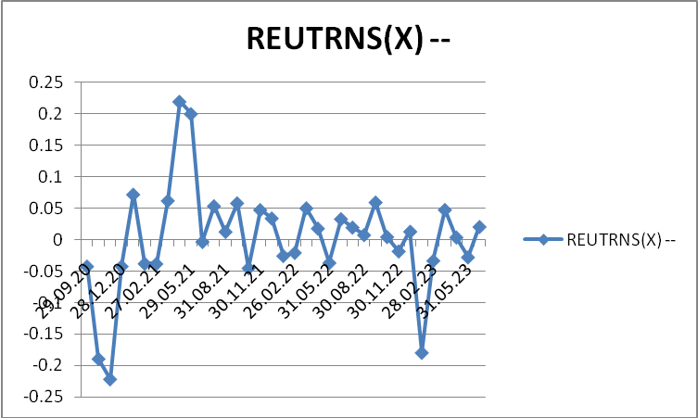

INTERPRETATION
From the above table it is clear that the SBI BALANCED FUND has offred (0.0046) as a avarage return of over all 3year period. The Risk associate for the fund is (0.0682).the CAGR is (0.0069) for same period.
The maximum return offerd by the fund is (0.2001) at the period 2021 (may), the least return is (-0.2221) at the period 2020 (oct).
ING VYSYA BANCED FUND 2020(AUG)-2022(JUNE)
DATE | NAV’S | REUTRNS(X) | (X- AVG) | (X-AVG)^2
01.08.20 | 20.05 | -- | -- | --
29.09.20 | 20.01 | -0.0020 | -0.0070 | 0.0000
30.10.20 | 18.18 | -0.2037 | -0.2087 | 0.0218
31.11.20 | 19.86 | -0.2201 | -0.2251 | 0.0507
28.12.20 | 18.99 | -0.0622 | -0.0672 | 0.0045
31.12.21 | 19.81 | 0.0554 | 0.0503 | 0.0025
30.01.21 | 19.58 | -0.0208 | -0.0218 | 0.0004
27.02.21 | 19.06 | -0.0370 | -0.0420 | 0.0018
31.03.21 | 19.88 | 0.0551 | 0.0501 | 0.0025
29.04.21 | 21.63 | 0.2052 | 0.2002 | 0.0200
29.05.21 | 20.21 | 0.1730 | 0.2180 | 0.0282
30.06.21 | 20.06 | -0.0025 | -0.0075 | 0.0001
30.07.21 | 21.36 | 0.0619 | 0.0558 | 0.0031
31.08.21 | 21.47 | 0.0051 | 0.0001 | 0.0000
30.09.21 | 22.56 | 0.0483 | 0.0433 | 0.0019
30.10.21 | 21.70 | -0.0396 | -0.0447 | 0.0020
30.11.21 | 22.78 | 0.0474 | 0.0424 | 0.0018
31.12.21 | 23.48 | 0.0298 | 0.0248 | 0.0006
29.01.22 | 22.70 | -0.0344 | -0.0394 | 0.0021
26.02.22 | 22.75 | 0.0022 | -0.0029 | 0.0000
31.03.22 | 23.63 | 0.0372 | 0.0322 | 0.0020
30.04.22 | 23.80 | 0.0071 | 0.0021 | 0.0000
31.05.22 | 23.61 | -0.0180 | -0.0181 | 0.0002
30.06.22 | 24.58 | 0.0395 | 0.0344 | 0.0012
30.07.22 | 24.79 | 0.0185 | 0.0034 | 0.0000
30.08.22 | 25.04 | 0.0200 | 0.0049 | 0.0000
30.09.22 | 26.52 | 0.0558 | 0.0518 | 0.0026
29.10.22 | 26.76 | 0.0190 | 0.0039 | 0.0000
30.11.22 | 26.46 | -0.0218 | -0.0219 | 0.0003
31.12.22 | 26.54 | 0.0030 | -0.0020 | 0.0000
31.01.23 | 24.70 | -0.0745 | -0.0795 | 0.0063
28.02.23 | 24.18 | -0.0220 | -0.0266 | 0.0007
31.03.23 | 25.65 | 0.0573 | 0.0523 | 0.0027
29.04.23 | 25.64 | -0.0004 | -0.0054 | 0.0000
31.05.23 | 25.31 | -0.0180 | -0.0181 | 0.0003
30.06.23 | 25.64 | 0.0129 | 0.0078 | 0.0001
SUM |  | 0.1768 |  | 0.1891
COUNT(N) | 36 | 35 | 35 | 35
AVG(MEAN) |  | 0.0050
VARIANCE(S2) |  |  |  | 0.0041
STANDERED D |  |  |  | 0.0640
CAGR |  | 0.0071

ING VYSYA BALACED FUND
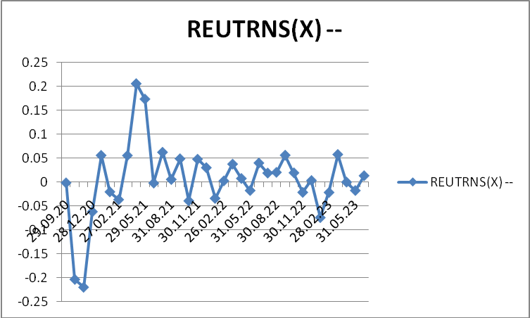

INTERPRETATION
From the above table it is clear that the ING VYSYA BALANCED FUND has offred (0.0050) as a avarage return of over all 3year period. The Risk associate for the fund is (0.0640).the CAGR is (0.0071) for same period.
The maximum return offerd by the fund is (0.1730) at the period 2021 (may), the least return is (-0.2201) at the period 2020 (Oct).
PERFORMANCE OF THE FUNDS FROM 2020- 2023
Name of the Company | CAGR | Standard Deviation
1.SBI | 0.0069 | 0.0682
2.ING VYSYA | 0.0071 | 0.0640
3.KOTAK | 0.0023 | 0.0574
4.RELIANCE FINANCIAL | 0.0020 | 0.1934
5.NIFTY | -0.0378 | 0.1934

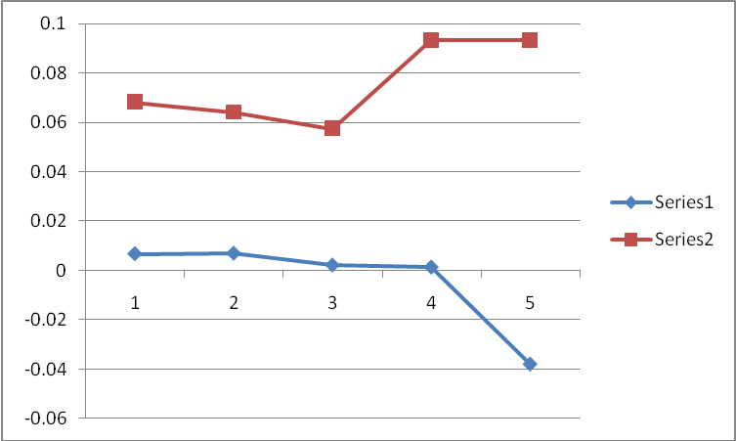

INTERPRETATION
By observing at the above table we can say that ING VYSYA Balanced fund is offering more CAGR i.e.(0.071), RELIANCE FINANCIAL offering (0.020) only, in terms of risk KOTAK Balanced fund has minimum Risk of(0.0574), and RELIANCE FINANCIAL has maximum Risk of (0.1934) in the same period, the NIFTY offered negative CAGR is (-0.0378) with more risk.
6. CONCLUSION
In the modern business world people wanted to get more &more return with minimum risk for their investment. For this purpose the investor is finding plenty of investment avenues for their investment, among all those mf could one of the better alternatives to satisfy the needs of the investor. The study has targeted to analyze and compare the risk and returns of different select mutual fund.
The study also analyzed the correlation b/w NSE Nifty and select MF.
From the study the researching found that most of the select funds are performing above the market, i,e, nifty as bench marketing.
7. References:
[1] TRIPATHI, S., & JAPEE, D. G. P. (2020). PERFORMANCE EVALUATION OF SELECTED EQUITY MUTUAL FUNDS IN INDIA.
[2] Sharma, K. B. (2020). PERFORMANCE ANALYSIS OF MUTUAL FUND: A COMPARATIVE STUDY OF THE SELECTED DEBT MUTUAL FUND SCHEME IN INDIA.
[3] Tripathi, S. (2020). AN EMPIRICAL STUDY OF MUTUAL FUND AWARENESS AMONG THE PEOPLE OF AHMEDABAD.
[4] Panigrahi, C. M. A., Mistry, M., Shukla, R., & Gupta, A. (2020). A Study on Performance Evaluation of Equity Linked Saving Schemes (ELSS) of Mutual Funds. NMIMS JOURNAL OF ECONOMICS AND PUBLIC POLICY, 5(1).
[5] www.cleartax.com
[6] www.amfi.com
[7]http://www.tatamutualfund.com/navs-dividends/navs-dividends
[8]https://www.axismf.com/latest-nav-and-dividend-history [9]https://www.idfcmf.com/IDFC-Core-Equity-Fund-(Formerly-Known-as-IDFC-Classic-Equity-Fund)-39
[10]https://www.bnpparibasmf.in/investor-centre/nav-history

