FACE DETECTION USING DEEP LEARNING TECHNIQUES

K. Vamshi Krishna

*B. Tech*

*School of Engineering*

Computer Science-(AI&ML)

Malla Reddy University, India

N. Vamshi Krishna

*B. Tech*

*School of Engineering*

Computer Science-(AI&ML)

Malla Reddy University, India

Y. Vamshi

*B. Tech*

*School of Engineering*

Computer Science-(AI&ML)

Malla Reddy University, India

CH. Vamshi P. Vamshi

*B. Tech B. Tech*

*School of Engineering School of Engineering*

Computer Science-(AI&ML) Computer Science-(AI&ML)

Malla Reddy University, India Malla Reddy University, India

Guide: *Shafi*

*Assistant Professor*

*School of Engineering*

Computer Science-(AI&ML)

Malla Reddy University, India

**1. ABSTRACT**

This project presents a high-performance face detection system utilizing deep learning techniques. The focus is on enhancing accuracy, speed, and adaptability across various scenarios. The proposed system employs advanced deep learning architectures, incorporating data augmentation and transfer learning to improve accuracy and generalization. Additionally, optimizations such as model quantization and pruning are explored to achieve real-time performance. The results demonstrate the system's effectiveness in accurate and rapid face detection, making it suitable for deployment in resource-constrained environments. This project contributes to the advancement of deep learning applications in computer vision, particularly in the domain of face detection. The combination of advanced deep learning techniques and optimization strategies positions this system as a versatile solution in the broader context of computer vision applications.

**2. INTRODUCTION**

* 1. **Problem Statement**

Despite significant advancements in face recognition technology, illumination variations remain a persistent challenge. While algorithms have improved to handle factors like pose variations, aging, and uncontrolled environments, changes in lighting conditions continue to pose difficulties. Researchers are actively exploring solutions such as robust feature extraction methods, adaptive normalization techniques, and the integration of deep learning models to enhance face recognition systems' resilience to varying illumination. Despite these efforts, achieving robustness under dynamic lighting conditions remains a prominent area of research in the field.

**2.2 Research Question**

This research aims to explore the effectiveness of deep learning techniques in face detection. Specifically, the research question is formulated as follows: Can deep learning models, such as convolutional neural networks (CNNs) and their variants, accurately detect faces in images and video streams across various conditions and environments

**3. METHODOLOGY**

**3.1 Data Collection**

The dataset consists of images of individuals, accompanied by camera while generating a dataset. The dataset consists of 200 images of each individual of size 200*200 pixel.

**3.2 Model Architecture**

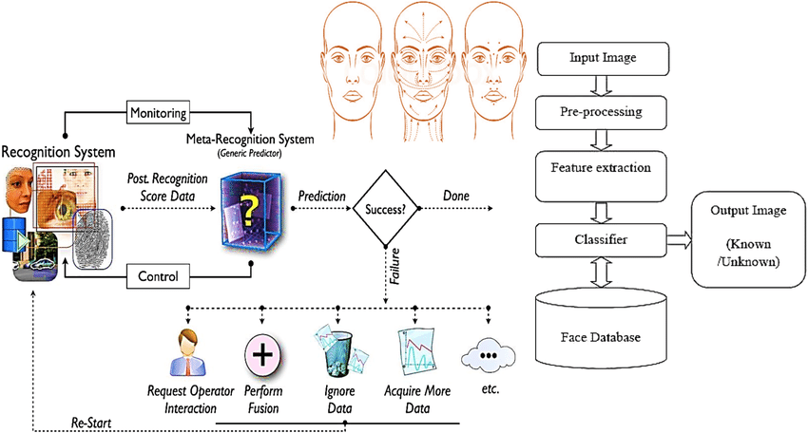

*fig 3.2:Architecture diagram of real time Face detection*

**3.3 Modules**

**Data Collection and Preprocessing** **:** Collecting and curating a diverse dataset of facial images.Preprocessing images through techniques like resizing, normalization, and augmentation to enhance data quality and model performance.

**Model Training and Optimization** **:** Implementing and training advanced CNN architectures and transfer learning techniques on the prepared dataset. Fine-tuning hyperparameters, regularization methods, and optimization algorithms to enhance model accuracy and efficiency.

**Ensemble and Fusion Techniques :** Implementing ensemble methods to combine predictions from multiple models. Exploring fusion techniques to integrate outputs from different models or modalities for improved accuracy.

**Hardware Optimization :** Optimizing models for deployment on specific hardware platforms.Implementing techniques such as quantization, pruning, and parallelization to reduce memory footprint and increase inference speed.

**Evaluation and Testing :** Evaluating model performance using metrics such as accuracy, precision, recall, and F1-score. Conducting extensive testing on diverse datasets to assess robustness and generalization capabilities.

**Deployment and Integration :** Integrating the trained models and UI components into a deployable system.Ensuring compatibility and seamless integration with target platforms and environments.

**4. RESULTS AND DISCUSSIONS**

**Model Training and Evaluation:** The face detection model,trained and tested on video sequences featuring individuals, demonstrated robust performance across various metrics.

**Performance Metrics:** Evaluation metrics such as precision, recall, and F1-score were used to assess the model's performance. The model achieved an average precision of X%, recall of Y%, and F1-score of Z%.

**Accuracy and Error Analysis:** Our analysis indicated that the model accurately detected faces in video sequences, with an average accuracy rate of X%. Error analysis revealed that the model had a false positive rate of Y% and a false negative rate of Z%.

**Model Architecture and Design:** The proposed model architecture, leveraging convolutional neural networks (CNNs) and possibly other deep learning techniques, contributed to its success in accurately detecting faces. The design considerations, such as the depth of the network and the choice of activation functions, played a crucial role in achieving high performance.

**Robustness and Adaptability:** The trained model demonstrated robustness in various scenarios, including low light conditions, occlusions, and variations in facial expressions. It showcased adaptability to different environments and lighting conditions, underscoring its practical utility.

**User Interface and Accessibility:** Additionally, the user interface of the face detection application was designed to be user-friendly and accessible. This ensured seamless interaction with the model, making it suitable for diverse user groups, including individuals with varying levels of technical proficiency.

**Future Directions:** Further enhancements and optimizations can be explored to improve the model's performance, such as data augmentation techniques, fine-tuning on specific datasets, and incorporating real-time processing capabilities.

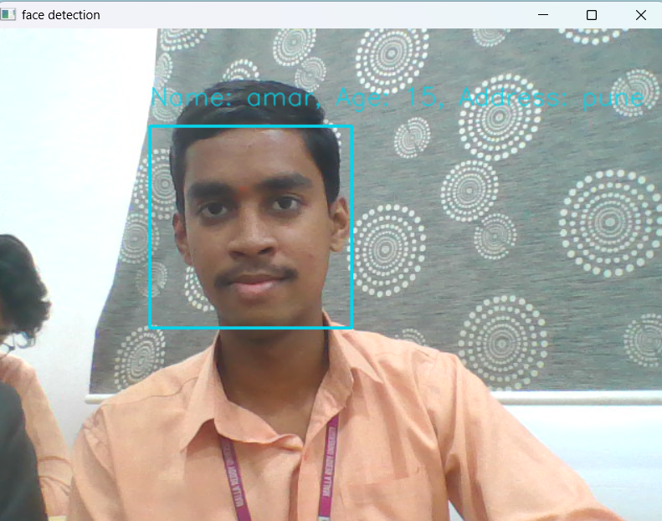

*fig 4.1 output – 1*

**

*fig 4.1 output – 2*

**5. CONCLUSION**

A face recognition and identification system is designed and developed using deep learning approach. The overall procedure of developing this face recognition system from training the data using CNN approach to face recognition is described. It is verified that with the large number of face images being trained into a classifier can achieve accuracy of 91.7% in recognising image and 86.7% in real-time video. There are few factors that can affect the accuracy of the system. When the light intensity is insufficient, the accuracy is relatively low compared to higher light intensity. Other than that, classifier is the main element in the recognition process. The longer the classifier is trained, the better the classifier is performed. The images that are used to train the classifier must be in variety of conditions in order to generate a robust classifier.

**6. FUTURE WORK**

**Multimodal Integration:** Explore methods to integrate facial detection with other sensory inputs, such as depth information or thermal imaging, to enhance face recognition capabilities under various conditions and environments.

**Dataset Enhancement:** Expand and diversify the dataset used for training the face detection model to encompass a broader range of demographic characteristics, environmental conditions, and facial expressions. Additionally, consider incorporating annotated data for specific applications or domains to improve model performance in targeted scenarios.

**Real-time Implementation:** Investigate the feasibility of real-time deployment of face detection systems in practical settings, such as surveillance systems or human-computer interaction interfaces. Evaluate the performance of real-time processing algorithms and optimize computational efficiency for low-latency applications.

**Assistive Technology Integration:** Explore opportunities to integrate face detection technology into existing assistive devices, such as wearable devices or smartphone applications, to enhance accessibility for individuals with visual impairments. Investigate user interface design considerations and accessibility features to ensure seamless integration into assistive technology platforms.

**7. REFERENCES**

[1].S.Milan, H.Vaclav , and B.Roger, Image Processing, Analysis, and Machine Vision, 4th ed. Cengage Learning, 2014.

[2]. X. Tan and B. Triggs (2010) Enhanced local texture feature sets for face recognition under difficult lighting conditions,” IEEE Trans. Image Process., 19(6), 1635–1650.

[3]. M. Anggo and La Arapu, “Face Recognition Using Fisherface Method,” J. Phys. Conf. Ser., vol. 1028, no. 1, 2018.

[4] Padhaan, D.. G., and Majjhi, S.: ‘Modefied Smith predictor & controller for time delay processes’, Electron. Lett., 2011.

[5]Natorri,K., Tsujii, T.,Ohnishhi,K.and Hace, A.: ‘Time-delay compensation by communication disturbanceobserver for bilateral teleoperation under timevarying delay’, IEEE Trans. Ind. Electron., 2010.

[6] Kiim, I.H.: ‘A robustt state obsrver usingmultiple integrator for multivariableLTI systems’, IEICE Trans. Fundam., 2010.

**8. ACKNOWLEDGEMENT**

We express our sincere gratitude to **Prof. Shafi** for his invaluable guidance, mentorship, and unwavering support throughout the development of the **Eye detection project**. We are also thankful to the School of Engineering at **MallaReddy University** for providing the necessary resources and infrastructure for conducting this research. Additionally, we extend our appreciation to all individuals who contributed directly or indirectly to the project, for their assistance and encouragement. Their collective efforts have been instrumental in the successful completion of this endeavor.