Bone Detection Whether Fractured or Not Using CNN

P. Srinika

*School Of Engineering B.Tech Computer Science-AIML Malla Reddy University*

India

B. Uday Kiran

*School Of Engineering B.Tech Computer Science-AIML Malla Reddy University*

India

Y. Sriya

*School Of Engineering B.Tech Computer Science-AIML Malla Reddy University*

India

B. Varshitha Reddy

*School Of Engineering B.Tech Computer Science-AIML Malla Reddy University*

India

G. Sumanth Reddy

*School Of Engineering B.Tech Computer Science-AIML Malla Reddy University*

India

Prof R. Karthik *Assistant Professor Malla Reddy University* India

**ABSTRACT**

Machine learning techniques, particularly deep learning, play a crucial role in medical image processing, including segmentation tasks. Classical algorithms like K-means clustering and random forests, while less accurate than deep learning, are often more sample efficient and have simpler structures. Deep learning models such as artificial neural networks (ANNs), convolutional neural networks (CNNs), and recurrent neural networks (RNNs) have shown remarkable performance in image segmentation. These models are trained on labeled data to accurately identify and segment anatomical structures or anomalies in medical images.Deep learning's ability to automatically learn hierarchical features from data makes it particularly well-suited for medical image analysis, where the complexity and variability of anatomical structures can be challenging. For example, CNNs can automatically learn features at different levels of abstraction, enabling them to identify complex patterns in medical images.The use of deep learning in medical image processing not only improves segmentation accuracy but also enhances efficiency, enabling faster and more accurate diagnosis and treatment planning. Moreover, the continuous advancements in deep learning algorithms and hardware acceleration have further boosted their applicability and performance in medical imaging, making them indispensable tools in modern healthcare.

### INTRODUCTION

Medical images, such as MRI scans, CT scans, and X-rays, play a crucial role in diagnosing and treating various medical conditions. The process of manually analyzing these images can be time- consuming and prone to errors. Machine learning algorithms offer a promising approach to automate this process and improve diagnostic accuracy.By training machine learning models on labeled medical images, it is possible to develop systems that can automatically classify images and identify potential diseases or abnormalities. These models can also assist in surgical planning by providing detailed insights into the patient's condition based on the images.For example, a machine learning model trained on MRI scans can identify specific patterns indicative of conditions like tumors or fractures. This information can then be used by healthcare professionals to make more informed decisions about the patient's treatment plan.Overall, leveraging machine learning for the classification of medical images holds great potential for improving patient care, reducing diagnostic errors, and enhancing surgical outcomes.

.

# Objective of Format:

The main objective of this project is to build a machine learning system which takes medical image as the input and classifies whether the x-ray consists of fractured or not fractured images.We use machine learning algorithms for the classification of data. We also use deep learning techniques like convolutional neural networks (CNN) for the classification of images.

# Limitations of the project:

* It is not very effective in the case of small data.
* Require high knowledge on machine learning development.
* It is difficult to maintain the system.
* It is not widely used at present.

### LITERATURE REVIEW

#### Convolutional neural network techniques for medical image processing:

In medical image processing, convolutional neural networks (CNNs) are crucial. They excel in tasks like identifying objects, outlining boundaries, and categorizing elements in complex medical images. CNNs effectively detect abnormalities, diagnose conditions like tumors, and precisely delineate organsby discerning intricate patterns. Leveraging their hierarchical architecture, CNNs grasp important features at multiple levels, and diagnosis accuracy.

Their integration has notably enhanced diagnostic procedures, ensuring precise and efficient patient care. Ultimately, CNNs' deployment leads to improved treatment outcomes and automationin medical diagnostics, benefiting both healthcare providers and patients.

#### Deep Learning for Medical Image Segmentation:

This review evaluates deep learning methods for medical image segmentation, focusing on Convolutional Neural Networks (CNNs), Fully Convolutional Networks (FCNs), U-Net, Convolutional Residual Networks (CRNs), and Recurrent Neural Networks (RNNs). It discusses challenges such as class imbalance and object size variability, along with training techniques like deeplysupervised learning. Overall, deep learning shows promise for precise and efficient medical image segmentation.

### PROBLEM STATEMENT

Traditional analysis of medical images, such as MRI scans, CTscans, and X-rays, relies heavily on manual interpretation by radiologists. This process can be time-consuming, subject to human error, and may miss subtle indications of disease. The development of machine learning-powered medical image processing models aims to automate and enhance the diagnosticprocess, enabling faster and more accurate disease identification, potentially leading to improved surgical planningand patient outcomes.

The early detection of diseases through medical image analysis is crucial for timely intervention and improved patient outcomes. However, manual identification of subtle diseasemarkers can be challenging. Machine learning-based medical image processing has the potential to revolutionize early diseasedetection, enabling more effective and personalized treatment plans.

### METHODOLOGY

#### EXISTING SYSTEMS:

There are existing systems which are like our project. Some of them are X-Rays, Computed Tomography (CT), Magnetic Resonance Imaging (MRI) etc. But these existing systems havemany flaws. Because these are medical images, but these images contain much noise or unwanted outliers which results in inaccurate predictions.

#### PROPOSED SYSTEM:

In our medical image processing project, we start by collecting a dataset of X-ray images, specifically focusing on bone X-rays. These images are then used to train a machine learning model, employing convolutional neural networks (CNNs) due to their effectiveness in image classification tasks.During the training phase, the CNN learns to differentiate between fractured and non- fractured bone X-rays by extracting relevant features from the images. This process enables the model to classify new X-ray images provided by the user accurately.By leveraging machine learning and CNNs, our goal is to create a robust and accurate system for automated fracture detection in bone X-rays. This system could potentially assist healthcare professionals in diagnosing fractures more efficiently, leading to improved patient care and outcomes.

### ARCHITECTURE

We can use the test dataset to get accuracy of the dataset.

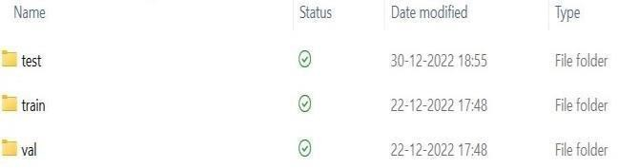

As mentioned above the medical images are already classified into the train, test and validation sets.

The train, test and validation sets consist of images of x-rays already classified as fractured and not fractured (Stable).Fractured folder consists of the x-ray images in fractured conditions. A stable folder consists of x-ray images in normal condition.

### DATA PREPROCESSING TECHNIQUES:

Preprocessing is one of the main phases of machine learning. In this preprocessing phase one can describe the details about their respective datasets, clean the datasets if any outliers are present in the dataset. If the dataset contains missing values, we can fill in the missing values in this preprocessing phase. As our dataset is a image dataset there is no need for cleaning the datasets.

In this phase of pre-processing, split the training, testing, validation sets to x_train, y_train, x_test, y_test, x_val and y_val. This helps to divide the dataset to features and labels.

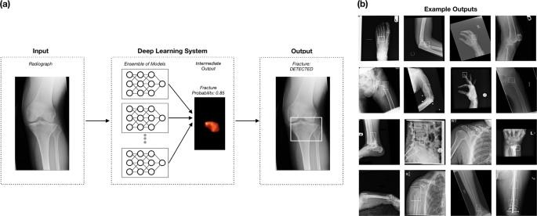

### DESIGN

In our project medical image processing, we consider X-

This features and labels representation is used to train the

Rays of bones which are trained by using Convolutional neural network (CNN) as it classifies whether the X-Ray of bones are fractured or not. Our project helps the patients to analyze the fractures of bones so that it gives brief information about how much percentage of the bone is fractured and how depth the injuryis.

### DATA SET DESCRIPTION:

As the aim of this project is medical image processing, we requireX-Rays as the input for the model. The dataset consists of training, validation, and testing dataset. So as the file contains already consists

of train, test, validation sets there is no need of using cross validation to retrieve train, test and validation sets. The dataset consists of only X-Ray images. Those images are already classified as fractured and not fractured. So that we can directly use them in training the model.

model. So that features(images) are given as images and labels are predicted as outputs. For our model, the labels are 0, 1. Zero (0) represents bone is fractured and One (1) represents the bone is normal. We perform a grayscale normalization to reduce the effectof illumination's differences. Because CNN converges faster on [0..1]

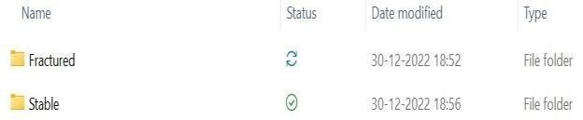

rather than on [0..255].

As a part of preprocessing data, we performed data augmentation.To avoid overfitting problem, we need to artificially expand our dataset. We can make the existing dataset even. larger.The idea is to alter the training data with small

transformations to reproduce the variations. Approaches that alter the training data in ways that change the array representation while keeping the label, the same are known as data augmentation techniques. Some popular augmentations people use are grayscales, horizontal flips,vertical flips, random crops, color jitters, translations, rotations, and much more. By applying just, a couple of these transformations to our training data, we can easilydouble or triple the number of training examples and create a veryrobust model

### METHODS AND ALGORITHMS:

**Classification:** Classification is a supervised machine learning method where the model tries to predict the correct label of a given input data. In classification, the model is fully trained using the training data, and then it is evaluated on test data before being usedto perform prediction on new unseen data.

**Convolutional neural network:** Medical image processing is an example for image classification. As every pixel should be verified accurately, we use convolutional neural network for the image classification. Convolutional Neural Networks come under the subdomain of Machine Learning which is Deep Learning. Image classification involves the extraction of features from the image to observe some patterns in the dataset.

A convolutional neural network can have tens or hundreds of layers that each learn to detect different features of an image. Filters are applied to each training image at different resolutions, and the output of each convolved image is used as the input to thenext layer. The filters can start as very simple features, such as brightness and edges, and increase in complexity to features that uniquely define the object.

A CNN is composed of an input layer, an output layer,and many hidden layers in between.

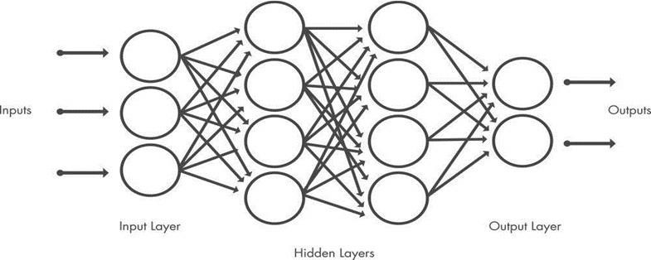

These layers perform operations that alter the data with the intent of learning features specific to the data. Three of the most common layers are convolution, activation or ReLU, and pooling.

**Convolution** puts the input images through a set of convolutional filters, each of which activates certain features from the images.

**Rectified linear unit (ReLU)** allows for faster and more effective training by mapping negative values to zero and maintainingpositive values. This is sometimes referred to as *activation*, because only the activated features are carried forward into the next layer.

**Pooling** simplifies the output by performing nonlinear down sampling, reducing the number of parameters that the network needs to learn.

These operations are repeated over tens or hundreds of layers, with each layer learning to identify different features.

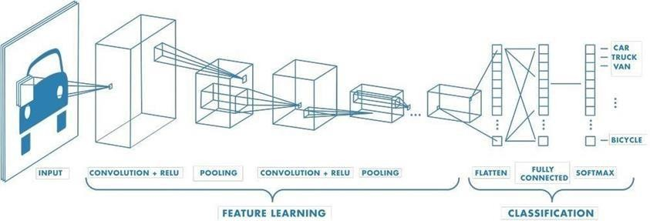

### BUILD A MODEL

Collect and annotate a dataset which consists of records of medical X-Rays of Bone which describes fractured or not fractured. The dataset should be large enough to provide the model with sufficientexamples to learn from, but not so large that it takes a long time totrain the model.

Preprocess the data so that the raw data which we collected from repository is converted into a clean data set. Choose the model, here we used classification model and deep learning algorithm i.e., convolutional neural networks.

Train the model on the pre-processed data on chosen machine learning model. You may need to experiment with different values for the hyper parameters, such as the learning rate and batch size, to find the best settings for your dataset.

Test the trained model on a separate dataset to evaluate its performance. You can use metrics such as accuracy, precision, recall, and F1 score to assess the model's performance.

Once the model is performing well, you can now test the model by providing required parameters as input to the model, so the predicted output is shown.

### EVALUATION

In the context of machine learning, performance metrics refer to how well an algorithm performs depending on various criteria such as precision, accuracy, recall, F1 score and so on. The next sectionsgo through several performance metrics.

**ACCURACY:** The percentage of correct test data predictions referred to as accuracy. It is easy to calculate by dividing the total number of forecasts by the number of correct guesses.

**PRECISION:** The precision score is used to assess the model’s accuracy in counting genuine positives correctly among all positive predictions.

**RECALL:** The recall score is used to assess the model’s performancein terms of accurately counting true positives among all actual positive values.

**F1_SCORE:** F1-score is the harmonic mean of precision and recall score and utilized as a metric in situations when choosing either precision or recall score can result in a model with excessive false positives or false negatives.

### DEPLOYMENT AND RESULTS

#### INTRODUCTION:

For deploying medical image processing, we have taken Bone X-Ray images. These images describe whetherthe bone in the X-ray is broken or not. We used classification mechanism for the deployment. In the processof image classification, we used convolutional neural networks. So, at the end of the project development, the user can include the image and can predict whether the bone is fractured or not.

#### FINAL RESULTS:

After training the model, the user can provide his/her medical x-ray image to check whether the bone is fracturedor not. As in the above code mentioned, labels are given as [‘Fractured’,’Stable’] if the bone is fractured the output, willbe zero (0), if the bone is not fractured, the model return one(1). After training the model we can produce the classification report,

accuracy, and other performance metrics to measure how well our model is trained.

Accuracy of the model determines how well the model is trained.

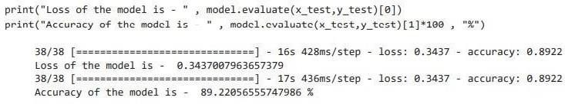

## Above image describes that after training, the accuracy ofthe model is 89.2205655574779%.

### CONCLUSION

#### PROJECT CONCLUSION:

In our medical image processing project, we utilized a dataset of human bone X-rays to classify fractures. We trained our model using a classification technique and the deep learning method of convolutional neural networks (CNNs). CNNs are particularly effective for image analysis tasks as they can extract intricate features from images by analyzing each pixel.During the training process, the CNN learned to distinguish between fractured and non- fractured bone X-rays by analyzing patterns and features in the images. This enabled us to build a system capable of processing medical images and accurately identifying bone injuries.By leveraging CNNs and classification techniques, our system can assist healthcare professionals in diagnosing bone fractures more efficiently and accurately, potentially leading to improved patient care and outcomes.

#### FUTURE SCOPE:

In our medical image processing project, we focused on classifying fractures in human bone X-rays. We achieved this by training our model using a classification technique and the deep learning method of convolutional neural networks (CNNs). CNNs excel at image analysis by extracting detailed features from each pixel, making them ideal for our task.Throughout the training phase, the CNN learned to differentiate between fractured and non-fractured bone X- rays by analyzing patterns and features in the images. This enabled us to develop a system capable of processing medical images and accurately identifying bone injuries.By leveraging CNNs and classification techniques, our system can significantly assist healthcare professionals in diagnosing bone fractures with greater efficiency and accuracy. This advancement has the potential to enhance patient care and outcomes by enabling quicker and more precise diagnoses.

### REFERENCES

1. Ed.Charu Aggarwal, CRC Press, 2014 Data Classification: Algorithms and Applications [https://www.mygreatlearning.com/blog/what-is-machine-](https://www.mygreatlearning.com/blog/what-is-machine-learning/) [learning/](https://www.mygreatlearning.com/blog/what-is-machine-learning/)
2. About convolutional neural networks: [https://www.mathworks.com/discovery/convolutional-](https://www.mathworks.com/discovery/convolutional-%20neural%20networkmatlab.html#%3A~%3Atext%3DA%20convolutional%20neural%20network%20(CNN%2C%2Dseries%2C%20and%20signal%20data)

## [%20neural%20networkmatlab.html#:~:text=A%20convoluti](https://www.mathworks.com/discovery/convolutional-%20neural%20networkmatlab.html#%3A~%3Atext%3DA%20convolutional%20neural%20network%20(CNN%2C%2Dseries%2C%20and%20signal%20data) [onal%20neural%20network%20(CNN,%2Dseries%2C%20a](https://www.mathworks.com/discovery/convolutional-%20neural%20networkmatlab.html#%3A~%3Atext%3DA%20convolutional%20neural%20network%20(CNN%2C%2Dseries%2C%20and%20signal%20data) [nd%20signal%20data.](https://www.mathworks.com/discovery/convolutional-%20neural%20networkmatlab.html#%3A~%3Atext%3DA%20convolutional%20neural%20network%20(CNN%2C%2Dseries%2C%20and%20signal%20data)

[https://medium.com/analytics-vidhya/build-an-image-](https://medium.com/analytics-vidhya/build-an-image-classification-model-using-convolutional-neural-networks-in-pytorch-45c904791c7e) [classification-model-usingconvolutional-neural-networks-](https://medium.com/analytics-vidhya/build-an-image-classification-model-using-convolutional-neural-networks-in-pytorch-45c904791c7e)

[in-pytorch-45c904791c7e](https://medium.com/analytics-vidhya/build-an-image-classification-model-using-convolutional-neural-networks-in-pytorch-45c904791c7e) [https://www.guru99.com/convnet-](https://www.guru99.com/convnet-tensorflow-image-classification.html) [tensorflow-image-](https://www.guru99.com/convnet-tensorflow-image-classification.html) [classification.html](https://www.guru99.com/convnet-tensorflow-image-classification.html) [https://www.techtarget.com/searchenterpriseai/definition/de](https://www.techtarget.com/searchenterpriseai/definition/deep-learning-deep-neural-network) [ep-](https://www.techtarget.com/searchenterpriseai/definition/deep-learning-deep-neural-network) [learning-deep-neuralnetwork](https://www.techtarget.com/searchenterpriseai/definition/deep-learning-deep-neural-network)

**ACKNOWLEDGEMENT**

We express our sincere gratitude to **Prof. R Karthik** for his invaluable guidance, mentorship, and unwavering support throughout the development of the **Medical Image Processing with Deep Learning Technique project**. We are also thankful to the School of Engineering at **Malla Reddy University** for providing the necessary resources and infrastructure for conducting this research. Additionally, we extend our appreciation to all individuals who contributed directly or indirectly to the project, for their assistance and encouragement. Their collective efforts have been instrumental in the successful completion of this endeavor.