Plant Disease Detection Using Deep learning

***Abstract –*** Deep learning, a subfield of artificial intelligence, has garnered significant attention in recent years due to its capabilities in automatic learning and feature extraction. This paper provides a comprehensive review of the research progress in utilizing deep learning technology for the identification of crop leaf diseases. The advantages of deep learning, including objective feature extraction and improved research efficiency, are highlighted, particularly in comparison to traditional methods reliant on manual feature selection. Moreover, the paper discusses the current trends, challenges, and advancements in the detection of plant leaf diseases using deep learning and advanced imaging techniques. By presenting both the progress and the unresolved challenges, this review aims to serve as a valuable resource for researchers in the fields of plant disease detection and pest management.

***Keywords –* Deep learning, crop leaf disease identification, plant disease recognition, advanced imaging techniques, research progress, challenges.**

1. Introduction

India is a cultivated country and about 70% of the population depends on agriculture. Farmers have large range of diversity for selecting various suitable crops and finding the suitable pesticides for plant. Disease on plant leads to the significant reduction in both the quality and quantity of agricultural products. The studies of plant disease refer to the studies of visually observable patterns on the plants. Monitoring of health and disease on plant plays an important role in successful cultivation of crops in the farm. In early days, the monitoring and analysis of plant diseases were done manually by the expertise person in that field. This requires tremendous amount of work and also requires excessive processing time. The image processing techniques can be used in the plant disease detection. In most of the cases disease symptoms are seen on the leaves, stem and fruit. The plant leaf for the detection of disease is considered which shows the disease symptoms. This paper gives the introduction to image processing technique used for plant disease detection.

1. LITERATURE SURVEY

In this section, various method of image processing for plant disease detection is discussed.

The vegetation indices from hyper spectral data have been shown for indirect monitoring of plant diseases. But they cannot distinguish different diseases on crop. Wenjiang Huang et al developed the new spectral indices for identifying the

# 

winter wheat disease. They consider three different pests (Powdery mildew, yellow rust and aphids) in winter wheat for their study. The most and the least relevant wavelengths for different diseases were extracted using RELIEF-F algorithm. The classification accuracies of these new indices for healthy and infected leaves with powdery mildew, yellow rust and aphids were 86.5%, 85.2%, 91.6% and 93.5% respectively [1]. Enhanced images have high quality and clarity than the original image. Color images have primary colors red, green and blue. It is difficult to implement the applications using RGB because of their range i.e. 0 to 255. Hence they convert the RGB images into the grey images. Then the histogram equalization which distributes the intensities of the images is applied on the image to enhance the plant disease images.

Monica Jhuria et al uses image processing for detection of disease and the fruit grading in [3]. They have used artificial neural network for detection of disease. They have created two separate databases, one for the training of already stored disease images and other for the implementation of the query images. Back propagation is used for the weight adjustment of training databases. They consider three feature vectors, namely, color, textures and morphology [3]. They have found that the morphological feature gives better result than the other two features.

Zulkifli Bin Husin et al, in their paper [4], they captured the chilli plant leaf image and processed to determine the health status of the chilli plant. Their technique is ensuring that the chemicals should apply to the diseased chilli plant only. They used the MATLAB for the feature extraction and image recognition. In this paper pre-processing is done using the Fourier filtering, edge detection and morphological operations. Computer vision extends the image processing paradigm for object classification. Here digital camera is used for the image capturing and LABVIEW software tool to build the GUI.

The segmentation of leaf image is important while extracting the feature from that image. Mrunalini R. Badnakhe, Prashant

R. Deshmukh compare the Otsu threshold and the k-means clustering algorithm used for infected leaf analysis in [5]. They have concluded that the extracted values of the features are less for k-means clustering. The clarity of k-means clustering is more accurate than other method.

The RGB image is used for the identification of disease. After applying k-means clustering techniques, the green pixels is identified and then using otsu’s method, varying threshold value is obtained. For the feature extraction, color co- occurrence method is used. RGB image is converted into the

 

HSI translation. For the texture statistics computation the SGDM matrix is generated and using GLCM function the feature is calculated [6].

The FPGA and DSP based system is developed by Chunxia Zhang, Xiuqing Wang and Xudong Li, for monitoring and control of plant diseases [7]. The FPGA is used to get the field plant image or video data for monitoring and diagnosis. The DSP TMS320DM642 is used to process and encode the video or image data. The nRF24L01 single chip 2.4 GHz radio transmitter is used for data transfer. It has two data compress and transmission method to meet user’s different need and uses multi-channel wireless communication to lower the whole system cost.

Shantanu Phadikar and Jaya Sil uses pattern recognition techniques for the identification of rice disease in [9]. This paper describes a software prototype for rice disease detection based on infected image of rice plant. They used HIS model for segmentation of the image after getting the interested region, then the boundary and spot detection is done to identify infected part of the leaf.

1. BASIC STEPS FOR DISEASE DETECTION

In this section, the basic steps for plant disease detection and classification using image processing are shown (Fig. 1)).

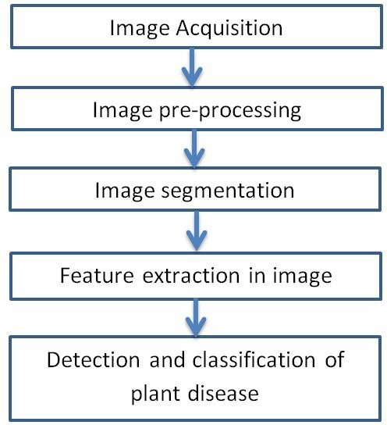

Fig. 1) Basic steps for plant disease detection

and classification

1. Image Acquisition

The images of the plant leaf are captured through the camera. This image is in RGB (Red, Green And Blue) form. color transformation structure for the RGB leaf image is created, and then, a device-independent color space transformation for the color transformation structure is applied [6].

1. Image Pre-processing

To remove noise in image or other object removal, different pre-processing techniques is considered. Image clipping i.e. cropping of the leaf image to get the interested image region. Image smoothing is done using the smoothing filter. Image enhancement is carried out for increasing the contrast.

the RGB images into the grey images using colour conversion using equation (1).

f(x)=0.2989*R + 0.5870*G + 0.114.*B (1)

Then the histogram equalization which distributes the intensities of the images is applied on the image to enhance the plant disease images. The cumulative distribution function is used to distribute intensity values [2].

1. Image Segmentation

Segmentation means partitioning of image into various part of same features or having some similarity. The segmentation can be done using various methods like otsu’ method, k-means clustering, converting RGB image into HIS model etc.

* 1. Segmentation using Boundary and spot detection algorithm: The RGB image is converted into the HIS model for segmenting. Boundary detection and spot detection helps to find the infected part of the leaf as discussed in [9]. For boundary detection the 8 connectivity of pixels is consider and boundary detection algorithm is applied [9].
  2. K-means clustering:

The K-means clustering is used for classification of object based on a set of features into K number of classes. The classification of object is done by minimizing the sum of the squares of the distance between the object and the corresponding cluster.

The algorithm for K –means Clustering:

* + 1. Pick center of K cluster, either randomly or based on some heuristic.
    2. Assign each pixel in the image to the cluster that minimizes the distance between the pixel and the cluster center.
    3. Again compute the cluster centers by averaging all of the pixels in the cluster. Repeat steps 2 and 3 until convergence is attained.
  1. Otsu Threshold Algorithm:

Thresholding creates binary images from grey-level images by setting all pixels below some threshold to zero and all pixels above that threshold to one. The Otsu algorithm defined in

[5] is as follows:

1. According to the threshold, Separate pixels into two clusters
2. Then find the mean of each cluster.
3. Square the difference between the means.
4. Multiply the number of pixels in one cluster times the number in the other

The infected leaf shows the symptoms of the disease by changing the color of the leaf. Hence the greenness of the leaves can be used for the detection of the infected portion of the leaf. The R, G and B component are extracted from the image. The threshold is calculated using the Otsu’s method. Then the green pixels is masked and removed if the green pixel intensities are less than the computed threshold.

1. Feature Extraction

Feature extraction plays an important role for identification of an object. In many application of image processing feature extraction is used. Color, texture, morphology, edges etc. are the features which can be used in plant disease detection.

In paper [3], Monica jhuria et al considers color, texture and morphology as a feature for disease detection. They have found that morphological result gives better result than the other features. Texture means how the colour is distributed in the image, the roughness, hardness of the image. It can also be used for the detection of infected plant areas.

i] Color co-occurrence Method :

In this method both color and texture are taken into account to get an unique features for that image. For that the RGB image is converted into the HSI translation.



- (2)



- (3)



- (4)

For the texture statistics computation the SGDM matrix is generated and using GLCM function the feature is calculated.

ii) Leaf color extraction using H and B components:

The input image is enhanced by using anisotropic diffusion technique to preserve the information of the affected pixels before separating the color from the background [8]. To distinguish between grape leaf and the non-grape leaf part, H and B components from HIS and LAB color space is considered. A SOFM with back propagation neural network is implemented to recognize colors of disease leaf.

1. Classification
2. Using ANN:

After feature extraction is done, the learning database images are classified by using neural network. These feature vectors are considered as neurons in ANN [3]. The output of the neuron is the function of weighted sum of the inputs. The back propagation algorithm, modified SOM; Multiclass Support vector machines can be used.

1. Back propagation:

BPNN algorithm is used in a recurrent network. Once trained, the neural network weights are fixed and can be used to compute output values for new query images which are not present in the learning database.

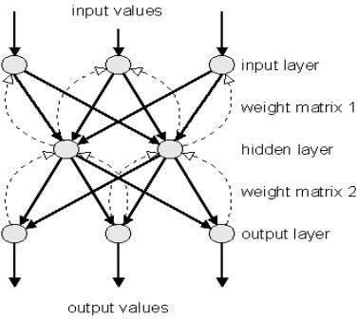Fig. 2) Back propagation Network Testing of query images :

After getting the weight of learning database, then testing of query image is done. The fig. 3) shows the flowchart for the testing of query image using the neural network techniques.

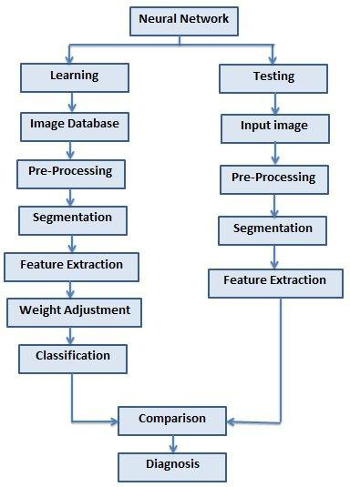

Fig. 3) Working principle of ANN

1. CONCLUSION

The accurately detection and classification of the plant disease is very important for the successful cultivation of crop and this can be done using image processing. This paper discussed various techniques to segment the disease part of the plant. This paper also discussed some Feature extraction and classification techniques to extract the features of infected leaf and the classification of plant diseases. The use of ANN methods for classification of disease in plants such as self- organizing feature map, back propagation algorithm, SVMs etc. can be efficiently used. From these methods, we can accurately identify and classify various plant diseases using image processing techniques.

References

1. Wenjiang Huang, Qingsong Guan, Juhua Luo, Jingcheng Zhang, Jinling Zhao, Dong Liang, Linsheng Huang, and Dongyan Zhang, “New Optimized Spectral Indices for Identifying and Monitoring Winter Wheat Diseases”, IEEE journal of selected topics in applied earth observation and remote sensing,Vol. 7,

No. 6, June 2014

1. Dr.K.Thangadurai, K.Padmavathi, “Computer Visionimage Enhancement For Plant Leaves Disease Detection”, 2014 World Congress on Computing and Communication Technologies.
2. Monica Jhuria, Ashwani Kumar, and Rushikesh Borse, “Image Processing For Smart Farming: Detection Of Disease And Fruit Grading”, Proceedings of the 2013 IEEE Second International Conference on Image Information Processing (ICIIP-2013
3. Zulkifli Bin Husin, Abdul Hallis Bin Abdul Aziz, Ali Yeon Bin Md Shakaff Rohani Binti S Mohamed Farook, “Feasibility Study on Plant Chili Disease Detection Using Image Processing Techniques”, 2012 Third International Conference on Intelligent Systems Modelling and Simulation.
4. Mrunalini R. Badnakhe, Prashant R. Deshmukh, “Infected Leaf Analysis and Comparison by Otsu Threshold and k-Means Clustering”, International Journal of Advanced Research in Computer Science and Software Engineering, Volume 2, Issue 3, March 2012.
5. H. Al-Hiary, S. Bani-Ahmad, M. Reyalat, M. Braik and Z. ALRahamneh, “Fast and Accurate Detection and Classification of Plant Diseases”, International Journal of Computer Applications (0975 – 8887)Volume 17– No.1, March 2011
6. Chunxia Zhang, Xiuqing Wang, Xudong Li, “Design of Monitoring and Control Plant Disease System Based on DSP&FPGA”, 2010 Second International Conference on Networks Security, Wireless Communications and Trusted Computing.
7. A. Meunkaewjinda, P. Kumsawat, K. Attakitmongcol and A. Srikaew, “Grape leaf disease detection from color imagery using hybrid intelligent system”, Proceedings of ECTI-CON 2008.
8. Santanu Phadikar and Jaya Sil, “Rice Disease Identification using Pattern Recognition”, Proceedings of 11th International Conference on Computer and Information Technology (ICCIT 2008) 25-27 December, 2008, Khulna, Bangladesh.