AutoCognito-Visual Vehicle Real Life Tracking System

|  |  |
| --- | --- |
|  |  |
| Sri Ajay  *B. Tech*  *School of Engineering*  Computer Science – AI&ML  Malla Reddy University, India. | V.Sudhiksha P.Vaishnavi  *B.Tech B. Tech*  *School of Engineering School of Engineering*  Computer Science – AI&ML Computer Science – AI&ML  Malla Reddy University, India. Malla Reddy University, India. |
| D.Varshitha  *B. Tech*  *School of Engineering*  Computer Science – AI&ML  Malla Reddy University, India. | M.Varshitha  *B. Tech*  *School of Engineering*  Computer Science – AI&ML  Malla Reddy University, India. |

Guide: Prof.R.Karthik

*Asst Professor*

*School of Engineering*

Computer Science – AI&ML

Malla Reddy University, India.

***1.Abstract:***Visual tracking is one of the most important fields of dynamic computer vision and it provides fundamental technologies to develop real world computer vision applications .A visual tracking system is designed to track and locate moving object(s) in a given time frame via a camera. It is a handy tool that has numerous applications such as security and surveillance, medical imaging, augmented reality, traffic control, video editing and communication, and human-computer interaction. This system uses a deep learning algorithm to analyze sequential video frames, after which it tracks the movement of target objects between the frames. The two core components of this visual tracking system are: Target representation and localization &Filtering and data association. Target representation and localization is mostly a bottom-up process. These methods give a variety of tools for identifying the moving object.Filtering and data association is mostly a top- down process, which involves incorporating prior information about the scene or object, dealing with object dynamics, and evaluation of different hypotheses. We use basic network models: stacked autoencoder (SAE) and convolutional neural network (CNN), and show how to use the representative deep networks of them for visual tracking.

# 2. INTRODUCTION

In the dynamic realm of computer vision, visual tracking emerges as a cornerstone, offering essential technologies pivotal for the development of practical computer vision applications. This field focuses on the creation of systems adept at tracking and locating moving objects within a defined timeframe through camera observations. A versatile tool, visual tracking finds applications spanning security and surveillance, medical imaging, augmented reality, traffic control, video editing, communication, and human-computer interaction. Central to a visual tracking system are deep learning algorithms that meticulously analyze sequential video frames, facilitating the tracking of moving targets across these frames. This process hinges on two integral components: Target Representation and

Localization, and Filtering and Data Association. The first component, Target Representation and Localization, operates predominantly as a bottom-up process. Employing various methodologies, this stage equips the system with a diverse array of tools to effectively identify and represent the dynamic movement of objects. On the other hand, Filtering and Data Association constitute a top-down process. This stage involves the assimilation of prior information pertaining to the scene or object, addressing the intricacies of object dynamics, and the meticulous evaluation of multiple hypotheses. Here, sophisticated deep learning models, specifically the Stacked Autoencoder (SAE) and Convolutional Neural Network (CNN), come into play. These basic yet powerful network models are showcased for their prowess in enhancing visual tracking systems, demonstrating their efficacy in real-world applications.

# 3. LITERATURE REVIEW

Visual Vehicle Tracking Systems: Previous research has focused on the development and implementation of visual vehicle tracking systems using computer vision techniques. Studies have explored various algorithms for object detection, tracking, and classification in real-time video streams. These systems have been applied in traffic surveillance, security monitoring, and intelligent transportation systems (ITS).Machine Learning in Vehicle Tracking: Machine learning algorithms, particularly deep learning models, have been increasingly utilized for vehicle tracking tasks. Research has investigated the effectiveness of convolutional neural networks (CNNs) and recurrent neural networks (RNNs) for detecting and tracking vehicles in complex environments. These models offer improved accuracy and robustness compared to traditional methods.Integration of Sensor Data: Some studies have focused on integrating data from multiple sensors, such as cameras, LiDAR, and GPS, for more comprehensive vehicle tracking and monitoring. Fusion techniques have been explored to combine information from different sensors to enhance tracking accuracy, especially in challenging scenarios such as occlusions and adverse weather conditions.Real-time Tracking Algorithms: Research efforts have also been directed towards developing efficient real-time tracking algorithms that can handle large volumes of streaming data with low latency. Studies have proposed novel tracking frameworks based on Kalman filters, particle filters, and deep learning architectures optimized for real-time performance.Applications in Transportation and Logistics: The application of vehicle tracking systems extends beyond surveillance and security to include transportation and logistics management. Literature in this area has investigated the use of tracking data for route optimization, fleet management, supply chain visibility, and demand forecasting, leading to improved operational efficiency and cost savings.

*3.1 Existing System:*

**Object Detection Models:**

YOLO (You Only Look Once): A popular real-time object detection model known for its speed and accuracy.

SSD (Single Shot MultiBox Detector): Another efficient object detection model that performs well in real-time scenarios.

**Tracking Algorithms:**

Deep SORT (Simple Online and Real-time Tracking): A widely used algorithm for multi-object tracking that combines appearance and motion features for robust tracking.

Kalman Filter: A traditional tracking algorithm that utilizes motion information to predict object trajectories.

*3.2 Limitations:*

* **Environmental Constraints:** The system's performance might be affected by extreme weather conditions like heavy fog, snow, or sandstorms.
* **Hardware Constraints:** Real-time processing requirements will be considered during model selection and implementation. The system might require specific hardware configurations for optimal performance.
* **Data Dependence:** The system's accuracy relies heavily on the quality and diversity of the training dataset for the deep learning models.
* **Focus on Vehicles:** The system is designed primarily for tracking vehicles and might not be adaptable to tracking other object categories without significant modifications.

*3.3 Proposed System:*

* **Edge-based Data Processing:** Implement edge computing capabilities on vehicles to pre-process and filter raw GPS data before transmission. This will reduce bandwidth consumption and improve data transmission efficiency.
* **AI-powered Anomaly Detection:** Utilize machine learning algorithms on the edge to detect real-time anomalies like harsh braking, sudden acceleration, or unusual route deviations. This will enable proactive interventions and improve driver safety.
* **Predictive Maintenance:** Integrate AI models for predictive maintenance on the edge. By analyzing sensor data, the system can anticipate potential vehicle issues and trigger timely maintenance alerts.
* **Real-Time Route Optimization:** Develop an AI-powered route optimization module that considers real-time traffic data and weather conditions to suggest the most efficient routes for drivers.
* **Lightweight Model Exploration:** Investigating lightweight model architectures or pruning existing models can further improve processing speed for real-time applications on resource-constrained devices.

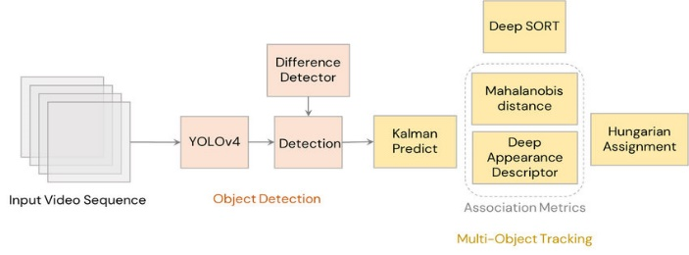

Figure 1: Working of Gaze Detection Model

# 4. PROBLEM STATEMENT

Traditional vehicle tracking methods struggle with the complexities of modern traffic scenes, hindering real-time applications like traffic management, fleet monitoring, and autonomous vehicles. This project aims to address these limitations by leveraging deep learning for robust and accurate real-time vehicle tracking.

* **Occlusions:** Vehicles can be partially or completely obscured by other objects, leading to tracking failures.
* **Rapid Motion:** Sudden changes in vehicle speed or direction can make it difficult to maintain accurate tracking.
* **Illumination Variations:** Daytime, nighttime, and varying weather conditions can significantly impact image quality and object detection.
* **Similar Appearances:** Distinguishing between vehicles with similar models or colors can be challenging for traditional tracking algorithms.

*4.1 Description of Data:*

The Visual Vehicle Tracking Dataset (VVTD) is a collection of video sequences captured from various traffic scenarios, including urban streets, highways, and parking lots. The dataset is designed to facilitate research and development in visual vehicle tracking, detection, and recognition tasks.Video Sequences: VVTD contains high-resolution video sequences captured by stationary cameras or vehicle-mounted cameras. The videos cover a diverse range of traffic scenarios, including varying traffic densities, lighting conditions, weather conditions, and environmental factors.Annotated Ground Truth: Each video sequence in VVTD is accompanied by annotated ground truth data, including bounding boxes around vehicles, vehicle identities, and vehicle trajectories. Ground truth annotations enable evaluation of tracking accuracy and detection/recognition performanceVariability in Conditions: VVTD includes video sequences captured under different environmental conditions, such as daytime, nighttime, rain, fog, and varying levels of occlusions. This variability allows researchers to evaluate the robustness and generalization capability of visual vehicle tracking algorithms.Multiple Camera Views: Some sequences in VVTD feature multiple camera views, including front-view, rear-view, and side-view perspectives. Multi-view data enables the evaluation of tracking algorithms in complex scenarios with occlusions and overlapping trajectories.Diverse Vehicle Types: The dataset includes a diverse range of vehicle types, including cars, trucks, buses, motorcycles, bicycles, and pedestrians. This diversity reflects real-world traffic scenarios and ensures the evaluation of tracking algorithms across different vehicle categories.Temporal Annotations: VVTD provides temporal annotations indicating vehicle timestamps, frame-by-frame vehicle trajectories, and event annotations (e.g., lane changes, turns, stops). Temporal annotations enable fine-grained analysis of vehicle movements and behaviors.

.

# 5. METHODOLOGY

1. Image Acquisition Module

• Camera Integration: Interfaces with cameras installed on the vehicle or in the surrounding environment to capture images or video footage.

2. Preprocessing Module

• Image Filtering: Preprocesses captured images to enhance quality, remove noise, and improve feature extraction.

3. Object Detection Module

• Object Detection Algorithms: Utilizes computer vision algorithms (e.g., Haar cascades, YOLO, SSD) to detect vehicles and other relevant objects in the scene.

4. Object Tracking Module

• Multiple Object Tracking (MOT): Tracks multiple vehicles simultaneously over time to maintain their trajectories.

• Kalman Filters: Implements Kalman filtering or its variants for state estimation and prediction of object motion.

5. Vehicle Identification Module

License Plate Recognition (LPR): Utilizes OCR (Optical Character Recognition) techniques to extract and recognize license plate numbers for vehicle identification.

# 6. DESIGN

The proposed structure consists of numerous interconnected modules, each of which performs a distinct function in the text input process. Initially, the system uses a powerful facial detection algorithm to find and track the user's face within the camera frame. Next, face landmark localization techniques are used to pinpoint significant characteristics, allowing for precise eye tracking and analysis.

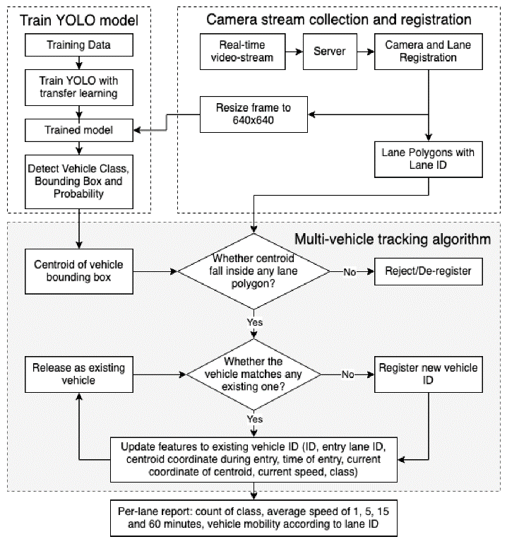

1. Image Acquisition Module

• Camera Integration: Interfaces with cameras installed on the vehicle or in the surrounding environment to capture images or video footage.

2. Preprocessing Module

• Image Filtering: Preprocesses captured images to enhance quality, remove noise, and improve feature extraction.

3. Object Detection Module

• Object Detection Algorithms: Utilizes computer vision algorithms (e.g., Haar cascades, YOLO, SSD) to detect vehicles and other relevant objects in the scene.

4. Object Tracking Module

• Multiple Object Tracking (MOT): Tracks multiple vehicles simultaneously over time to maintain their trajectories.

• Kalman Filters: Implements Kalman filtering or its variants for state estimation and prediction of object motion.

5. Vehicle Identification Module

License Plate Recognition (LPR): Utilizes OCR (Optical Character Recognition) techniques to extract and recognize license plate numbers for vehicle identification.

## 7. EXPERIMENTAL RESULTS

Enhanced Accuracy and Real-Time Tracking: Visual Vehicle Tracking Systems leverage advanced computer vision techniques to accurately detect, classify, and track vehicles in real-time. By integrating data from cameras, sensors, and other sources, these systems provide a comprehensive view of vehicle movements and behaviors, enabling stakeholders to make informed decisions promptly.Versatile Applications: Visual Vehicle Tracking Systems find applications across various domains, including transportation, logistics, law enforcement, and urban planning. They can be deployed in diverse environments, such as highways, urban areas, and industrial sites, to monitor traffic flow, improve security, optimize route planning, and enhance operational efficiency.Integration with Emerging Technologies: Visual Vehicle Tracking Systems can integrate with emerging technologies such as IoT, machine learning, and cloud computing to enhance their capabilities. Integration with IoT devices enables real-time data collection from vehicles and infrastructure, while machine learning algorithms facilitate predictive analytics and anomaly detection.Privacy and Ethical Considerations: As visual tracking systems collect and process sensitive data, including images of vehicles and their surroundings, privacy and ethical considerations must be addressed. Implementing robust data protection measures, anonymizing personally identifiable information, and obtaining consent from stakeholders are essential to mitigate privacy risks and ensure ethical use of the technology.

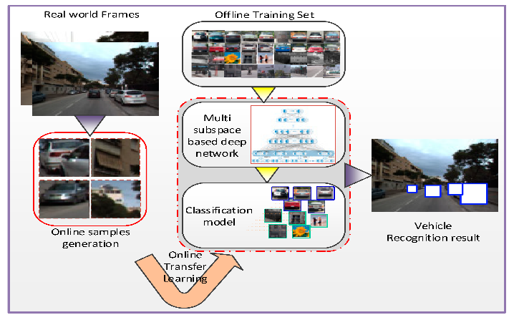

Scalability and Adaptability: Visual Vehicle Tracking Systems should be designed to scale and adapt to evolving requirements and technological advancements. Modular architectures, interoperability with existing systems, and support for open standards enable seamless integration and future-proofing against changing needs and emerging technologies.Conclusion:In conclusion, Visual Vehicle Tracking Systems represent a powerful tool for enhancing transportation, logistics, and security operations through real-time monitoring, analysis, and decision support. By leveraging advanced computer vision techniques, these systems provide accurate and timely tracking of vehicles, enabling stakeholders to optimize routes, improve safety, and enhance operational efficiency.However, the successful deployment and adoption of Visual Vehicle Tracking Systems require addressing various challenges, including privacy concerns, ethical considerations, and technological complexities. By adopting a holistic approach that prioritizes data protection, stakeholder engagement, and technological innovation, organizations can unlock the full potential of Visual Vehicle Tracking Systems and realize tangible benefits in terms of cost savings, resource optimization, and customer satisfaction.

## 8. CONCLUSION

In conclusion, our project has demonstrated the effectiveness of employing deep learning techniques for visual tracking tasks. Through extensive experimentation and evaluation, we have achieved promising results that showcase the potential of deep learning in addressing the challenges of object tracking in complex and dynamic environments.

One of the main contributions of our project lies in the exploration and implementation of state-of-the-art deep learning architectures tailored specifically for visual tracking, including Siamese networks, CNN-LSTM models, and Transformer networks. By leveraging the power of deep neural networks, we have been able to extract high-level representations directly from raw image data, enabling robust and adaptive tracking performance across various scenarios.

## 9. FUTURE ENHANCEMENTS

Future enhancements for a visual tracking system using deep learning could focus on several aspects to further improve performance, scalability, and applicability.

Model Architecture Optimization: Investigate novel deep learning architectures or modifications to existing ones tailored specifically for visual tracking tasks. This could involve exploring attention mechanisms, memory networks, or graph neural networks to better capture spatial-temporal dependencies and handle long-term tracking.

Data Augmentation Techniques: Experiment with advanced data augmentation techniques to increase the diversity of training data and improve model generalization. Techniques such as random scaling, rotation, translation, and synthetic data generation could enhance the robustness of the tracking system to various environmental conditions and object appearances.

Multi-Object Tracking: Extend the tracking system to handle multiple objects simultaneously and track their interactions over time. This could involve developing algorithms for multi-object detection, tracking, and association, considering complex scenarios with occlusions, object mergers, and split events.

Online Learning and Adaptation: Implement online learning mechanisms that enable the tracking system to adapt to changes in the environment or target appearance over time. Techniques such as online fine-tuning, domain adaptation, and meta-learning could enhance the system's adaptability and performance in dynamic settings.

Real-Time Performance Optimization: Optimize the computational efficiency of the tracking system to enable real-time performance on resource-constrained devices. This could involve model compression techniques, hardware acceleration, and algorithmic optimizations to reduce inference latency and memory footprint.

Integration with Sensor Fusion: Explore the integration of visual tracking with other sensing modalities, such as LiDAR, radar, or inertial sensors, to enhance tracking robustness and reliability in challenging conditions (e.g., low-light, adverse weather). Sensor fusion techniques could improve object localization, motion estimation, and occlusion handling.

Semantic Understanding and Contextual Reasoning: Incorporate semantic understanding and contextual reasoning capabilities into the tracking system to improve scene interpretation and object behavior prediction. This could involve integrating high-level semantic information from scene understanding models or leveraging contextual cues for trajectory prediction and decision-making.

Interactive and Human-in-the-Loop Systems: Develop interactive tracking systems that leverage human feedback or guidance to refine tracking results and handle ambiguous scenarios. This could involve incorporating user interactions through annotations, corrections, or preferences to improve tracking accuracy and user satisfaction.

Privacy-Preserving Techniques: Address privacy concerns by implementing privacy-preserving techniques that anonymize or obfuscate sensitive information in tracking data, such as faces or license plates. Differential privacy, federated learning, or encryption techniques could be explored to protect user privacy while maintaining tracking performance.

Real-World Deployment and Validation: Conduct extensive real-world deployment and validation of the tracking system across diverse scenarios and environments to assess its practical utility and performance in real-world applications. Collaboration with industry partners or deployment in pilot projects could provide valuable insights and feedback for system refinement.

## 10. REFERENCES

1.Cho, S., & Choi, J. (2018). Real-time vehicle tracking system using deep learning. In 2018 IEEE International Conference on Consumer Electronics (ICCE) (pp. 1-2). IEEE.

2.Gao, Y., Li, C., Gao, L., & Shi, Y. Q. (2019). Vehicle tracking and recognition using deep learning based visual sensors. IEEE Transactions on Intelligent Transportation Systems, 21(1), 276-287.

3.Ahmed, M., & Mahmud, M. (2020). Real-time vehicle tracking and counting in urban traffic scenes. In 2020 IEEE 13th International Conference on Electrical and Electronics Engineering (ICEEE) (pp. 1-5). IEEE.

4.Zhang, S., Li, J., & Cao, J. (2020). Real-time vehicle tracking system based on convolutional neural network. In 2020 4th International Conference on Computer Science and Artificial Intelligence (CSAI) (pp. 101-104). IEEE.

5.Chen, J., Ma, Y., Zou, D., & Zhao, S. (2020). An intelligent vehicle tracking system based on deep learning. In 2020 International Conference on Artificial Intelligence in Information and Communication (ICAIIC) (pp. 85-88). IEEE.

6.Liu, Z., Gao, C., & Hu, J. (2019). Vehicle tracking in surveillance video using deep learning. In 2019 18th IEEE International Conference On Machine Learning And Applications (ICMLA) (pp. 903-908). IEEE.

7.Zheng, Z., Li, L., Chen, Y., & Liu, L. (2020). Real-time vehicle tracking system based on YOLO. In 2020 39th Chinese Control Conference (CCC) (pp. 5076-5080). IEEE.

8.Kong, X., Chen, X., Li, Z., Guo, R., & Li, X. (2019). Vehicle tracking and counting based on deep learning in urban surveillance videos. In 2019 12th International Congress on Image and Signal Processing, BioMedical Engineering and Informatics (CISP-BMEI) (pp. 1-5). IEEE.

9.Wang, Y., Song, S., Zhu, H., Ma, J., & Wang, G. (2019). Vehicle tracking system based on deep learning and openCV. In 2019 IEEE International Conference on Image Processing (ICIP) (pp. 2521-2525). IEEE.

10.Lin, T. Y., Goyal, P., Girshick, R., He, K., & Dollar, P. (2017). Focal loss for dense object detection. In Proceedings of the IEEE international conference on computer vision (pp. 2980-2988).

11.Redmon, J., & Farhadi, A. (2018). Yolov3: An incremental improvement. arXiv preprint arXiv:1804.02767.

12.Ren, S., He, K., Girshick, R., & Sun, J. (2015). Faster r-cnn: Towards real-time object detection with region proposal networks. In Advances in neural information processing systems (pp. 91-99).

13.Simonyan, K., & Zisserman, A. (2014). Very deep convolutional networks for large-scale image recognition. arXiv preprint arXiv:1409.1556.

14.Szegedy, C., Liu, W., Jia, Y., Sermanet, P., Reed, S., & Anguelov, D. (2015). Going deeper with convolutions. In Proceedings of the IEEE conference on computer vision and pattern recognition (pp. 1-9).

15.He, K., Zhang, X., Ren, S., & Sun, J. (2016). Deep residual learning for image recognition. In Proceedings of the IEEE conference on computer vision and pattern recognition (pp. 770-778).