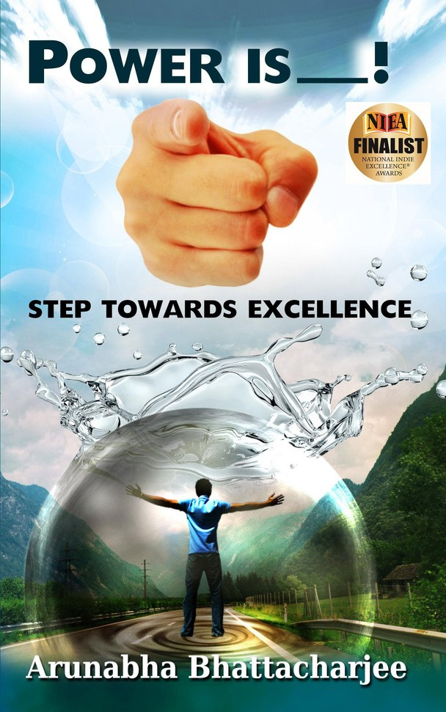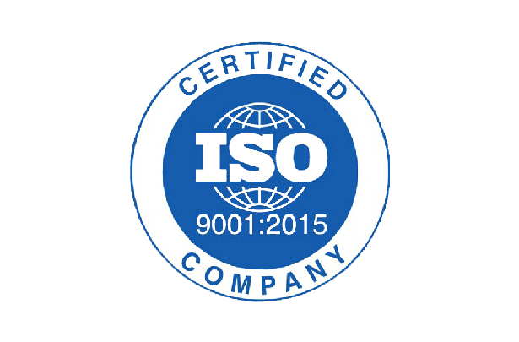

Arunabha Bhattacharjee, DMS



Contact

Mobile: +971585943305

Email:

[askarunabha@gmail.com](mailto:askarunabha@gmail.com)

LinkedIn : https://[www.linkedin.com/in/](http://www.linkedin.com/in/)

arunabha-bhattacharjee/

Personal:

arunabhabhattacharjee.com

Aspiration:

Ask Arun

Top Skills

High Impact leadership

Cross culture leadership NLP at work

Neuro-leadership Ex. coaching Stress management Leadership essentials

for Managers

Effective presentation skills

## Author| International Speaker | TEDx Speaker

Leadership Trainer | Executive Coach | Keynote Speaker | Leadership Coach | Motivational Speaker |Founder – Academy Of Inspired Leadership- Ask Arun | LOA Coach | Career Coach

# SUMMARY

Arunabha Bhattacharjee, DMS is in a quest to inspire and create a pool of global leaders.

A TEDx Speaker, **Doctorate In Management Studies and**

**Tagged as India’s Youngest Motivational Author**, is also a Leadership Coach, Executive Coach, Career transformational coach, **Renowned LOA coach** and motivational speaker across corporates and campuses in Asia.

**He has been mentored by** the World's leading Trianer – Joeel and Natalia Riveria , USA.

He is also a Chartered Economist and a fellow of GAFM, USA.

Arunabha has over 50,000+ followers in Social media and has garnered over 2million+ views of his talks across online platforms. He is the founder of Academy of Inspired Leadership

–

a movement focusing on creating leaders across the globe through the magic of inspiration and belief.

Having led multi-million-dollar business units at

ICICI and HSBC and bringing rich experience from HR and leadership roles at Axis and Seguro he has worked with 10000 + leaders in world- class companies, including **ICICI, HSBC, AXIS, Seguro, Teleperformance, PAYTM** to foster dramatic growth, Personal Mastery, Career switch to Coaching, Mentoring, Training and leadership development. He has also impacted 65,000+ lives across Asia through his online and offline training initiatives.

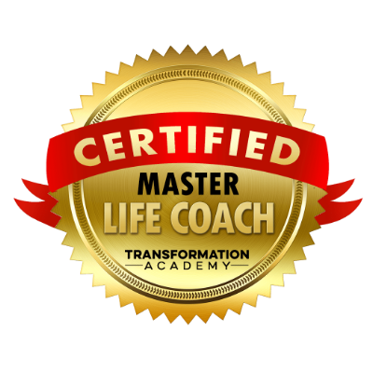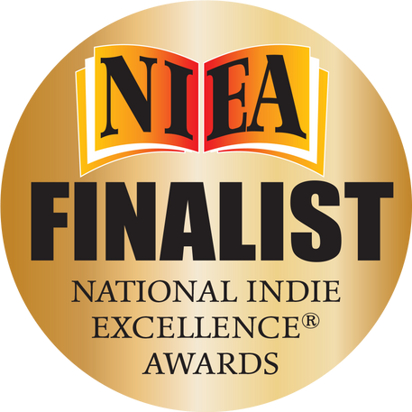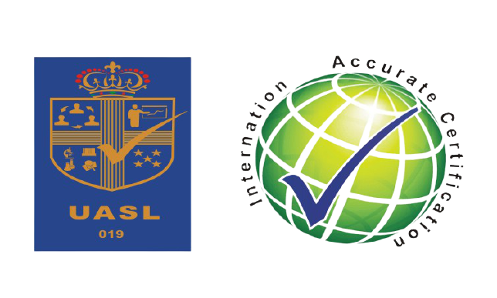

# CERTIFICATIONS

Areas of Mastery

Leadership interventions Leadership Coaching Spiritual Leadership

and Coaching Career Coaching, CXO coaching Group Coaching Emergenetics Neuroleadership Neurosales

Ontological Coaching Corporate spirituality Accelerated Learning Coach the Coach Millennial Leadership Emotional Intelligence Neuro-Linguistic Programming (NLP)

at work

Mindfulness at work Agile Workshops Design Thinking Blue Ocean Strategy DISC

Certified International Trainer & Coach , (ILA) ICF- CCE Executive Coach and Corporate Trainer

Certified Master Life Coach ( Transformation Inc,USA) PGCIHRM ( Cambridge International Quali, UK) Certified Master Life Coach ( Transformation Inc, USA)

Certified Training & Development Manager (Vskills) to name a few.

# HONORS-AWARDS

## Dr.Baba Saheb Ambedkar Award Recipient

India Leadership Award Recipient

## National Youth Icon at World Youth Summit

NIEA(US) Finalist Award

Global Leadership Coach- Barak Awards Book Of Achievers Recipient

NE Person of the Year to name a few.

# PUBLICATIONS

Arunabha Bhattacharjee- The Inspirational Speaker- viralindiandiary.com

## Nations Youngest Motivational Writer- TNT

The Seeker of Happiness- Yourstory.com

## Journey of India’s Youngest Motivational Speaker-The youth to name a few.

**His Dream Project**:

Academy of Inspired Leadership- AskArun

## Workshop Locations:

**India, UAE, BAHRAIN, BANGLADESH, SPAIN**