“**EXPERIMENTAL STUDY OF PLASTIC BRICKS MADE FROM WASTE PLASTICS**”

##### A DISSERTATION

*submitted by*

## Miss. AMRUTA ANIL KALE

*for the award of the degree*

*of*

## MASTER OF STRUCTURAL ENGINEERING

*Under the guidance of*

## Prof. Hemant B. Dahake



DEPARTMENT OF CIVIL ENGINEERING

## G H Raisoni University, Amravati

**Established under Govt. of Maharashtra Act Mah XXIX of 2018**

**Anjangaon Bari Road, Amravati-444701.**

June 2024

### CERTIFICATE

### This is to certify that the report entitled

### EXPRIMENTAL STUDY OF PLASTIC BRICKS MADE FROM WASTE PLASTICS

### is a bonafide work and it is submitted to

### G H Raisoni University, Amravati

### by

### Miss.Amruta Anil Kale

### For the partial fulfillment of the requirement in the degree of

### Master of Technology in Structural Engineering, during the academic year 2023-24.

**Prof H. B. Dahake Prof H. B. Dahake**

**Project Guide Head of the Department**

**………………… Dean**

**External Examiner School of Engineering & Technology**

#### 

**CONTENTS**

**Contents Page No**.

1. **INTRODUCTION 01**
   1. Definition
   2. Brief introduction
   3. Global Production of Plastic and Generation of Waste Plastic
   4. Current world production rate of plastics
   5. Future projection of plastic production
   6. Plastic types
2. **LITERATURE REVIEW 08**
   1. Overview
3. **OBJECTIVES 10**
4. **COMPONENTS & SPECIFICATION 11**
5. **METHODOLOGY 13**
   1. Plastic collection
   2. Manual sorting
   3. Chipping
   4. Melting of plastic material
   5. Mixing of material
   6. Placing
   7. Demolding
6. **TEST ON BRICKS 16**
   1. compression strength test
   2. water absorption test
   3. Temperature test
7. **CONCLUSION 19**
8. **REFERENCES 20**

# ACKNOWLEDGEMENT

I would like to acknowledge my deep sense of gratitude to Prof H. B. DAHAKE, my Dissertation Guide and Prof H. B. Dahake, Head of Department of Civil Engineering, G H Raisoni University, Amravati for his guidance and encouragement. He gladly accepted all the pains in going through my work again and again and gave me opportunity to learn essential research skills. This dissertation would not have been possible without his insightful and critical suggestions, his active participation in constructing right models and a very supportive attitude. I will always remain grateful to him for giving right direction to my research study.

I express my sincere thanks to the Hon. Vice Chancellor, Dean Student Affairs, Dean Academics, for providing the necessary facilities for carrying out the research work and for providing me with their timely suggestions. I express my sincere thanks, to Dean, School of Engineering and Technology. I express my sincere thanks to all the staff members of G H Raisoni University and my classmates who have provided their valuable time, support and cooperation during the research work.

I express my gratitude to lab assistant for providing access to their project site/organization and helped with the necessary data and information which are essential to be used in my research work.

Last but not least, I would like to acknowledge the support of my parents and my siblings for their continuing support and encouragement.

**`**

### Miss. Amruta Anil Kale

# ABSTRACT

This report outlines the utilization of municipal plastic waste (MPW) in construction industries. Plastic is a non-bio-degradable substance which takes thousands of years to decompose that creates land as well as water pollution to the environment. The quantity of plastic waste in Municipal Solid Waste (MSW) is expanding rapidly. It is estimated that the rate of usage is double for every 10 years. The Plastic usage is large in consumption and one of the largest plastic wastes is polyethylene (PE). The utilization of earth-based clay material resulted in resource depletion and environmental degradation

Utilizing MPW as construction materials especially in production of bricks is one of a promising step towards a sustainable resources and waste management. Plastic waste can substitute either partially or completely one or more of the materials in brick production. Further research based on recent research and a better understanding in utilization of plastic waste in brick is needed to produce a high durability and quality of bricks as well as to achieve the optimum balance in all aspects especially in terms of cost and functionality.

The plastic waste is the hazardous problem in today’s world. This is most dangerous problem in front of humanity. The most hazardous type of wastes are HDPE and PTE and the plastic below 50micron is also causing a serious problem. These plastic mixed in the soil, it directly effects on fertility of the soil. Nowadays, the large amount of plastic is deposited into sea. So, we try to finding efficient way to solve this problem of plastic waste. So, we added this plastic wastes into the bricks and create the bricks by using plastic wastes. It is most economical solution present in the construction industry and it is also economical and environment friendly solution of the plastic wastes. As per this study it can considered to use plastic waste as a binding material instead of cement in manufacture of bricks. The present investigation at manufacturing Bricks and Floor Tiles using Waste Plastic in different properties with crushed sand without use of cement and comparing it with normal bricks. To evaluate different physical and mechanical properties, tests as per IS Specification on the Plastic Bricks these result compared with the normal bricks.

***Key Words: Plastic Bricks, Plastic, Crushed Sand, etc.***

# CHAPTER - 1

**INTRODUCTION**

## DEFINITION Plastics:

Plastics are a wide range of [synthetic](https://en.wikipedia.org/wiki/Synthetic_polymers) or semi-synthetic materials that use polymers as a main ingredient. Their [plasticity](https://en.wikipedia.org/wiki/Plasticity_(physics)) makes it possible for plastics to be [moulded,](https://en.wikipedia.org/wiki/Injection_moulding) [extruded](https://en.wikipedia.org/wiki/Extrusion) or [pressed](https://en.wikipedia.org/wiki/Compression_molding) into solid objects of various shapes. This adaptability, plus a wide range of other properties, such as being lightweight, durable, flexible, and inexpensive to produce, has led to its widespread use. Plastics typically are made through human industrial systems. Most modern plastics are derived from [fossil fuel-based chemicals](https://en.wikipedia.org/wiki/Petrochemical) like [natural](https://en.wikipedia.org/wiki/Natural_gas) [gas](https://en.wikipedia.org/wiki/Natural_gas) or [petroleum](https://en.wikipedia.org/wiki/Petroleum); however, recent industrial methods use variants made from renewable materials, such as [corn](https://en.wikipedia.org/wiki/Corn) or [cotton](https://en.wikipedia.org/wiki/Cotton) derivatives.

## Brief Introduction

Plastics are made up of synthetic organic polymers which are widely used in different applications ranging from water bottles, clothing, food packaging, medical supplies, electronic goods, construction materials, etc. In the last six decades, plastics became an indispensable and versatile product with a wide range of properties, chemical composition and applications. Although, plastic was initially assumed to be harmless and inert, however, many years of plastic disposal into the environment has led to diverse associated problems. Environmental pollution by plastic wastes is now recognized widely to be a major environmental burden, especially in the aquatic environment where there is prolong biophysical breakdown of plastics, detrimental negative effects on wildlife, and limited plastic removal options.

In many instances, sheeting and packaging plastics are disposed of after usage, however, because of their durability, such plastics are located everywhere and persistent in the environment. Research on the monitoring and impacts of plastic wastes is still at the infancy stage, but thus far, the reports are worrisome. In human occupational and residential environment, plastics made of petrol-based polymer are present in high quantity. At the end- of-life of these plastics, they are usually land-filled together with municipal solid waste. Plastics have several toxic constituents among which are phthalates, poly-fluorinated

chemicals, bisphenol A (BPA), brominated flame retardants and antimony trioxide which can leach out to have adverse effects on environmental and public health. Plastics in electronic waste (e-waste) have become a serious global environmental and public health concern due to its large production volume and the presence of inadequate management policies in several countries. Reports from China, Nigeria, and India indicated that plastic hazardous substances from e-wastes can migrate beyond the processing sites and into the environment.

## Global Production of Plastic and Generation of Waste Plastic

In modern life, plastics are ubiquitous. Its early usage dated back to 1600 B.C., at the time when human hands shaped natural rubber and polymerized into different useful objects in prehistoric Mesoamerica. Diverse usage and manufacturing of plastics and plastic products began in 1839 when polystyrene (PS) and vulcanized rubber were discovered. Production of bakelite which is the first truly synthetic polymer was in 1907 in Belgium, however, by 1930, bakelite was everywhere, especially in fashion, communication and electrical and automotive industries. It took a decade after this for mass production of plastics to begin and it has constantly expanded ever since.

As at 2008, the annual plastic production was estimated to be 245 million tons globally. At present, single-use packaging is the largest sector, accounting for almost 40% of the overall plastic usage in Europe, this is followed by consumer goods, materials for construction, automotive, electrical and agriculture applications at 22%, 20%, 9%, 6% and 3%, respectively. It was estimated in 2015, that the highest rate of production is in Asia (with 49% of total global output, with China as the largest world producer (28%), followed by North America and Europe at 19% each. In terms of production, the rest regions are of lesser importance although not necessarily in terms of plastic consumption.

Table 1 provides the total plastics waste consumption in India during last decade.

|  |  |  |
| --- | --- | --- |
| S.N. | Year | Consumption (Tones) |
| 1 | 1996 | 61,000 |
| 2 | 2000 | 3,00,000 |
| 3 | 2001 | 4,00,000 |
| 4 | 2007 | 8,50,000 |

*Source: Central Pollution Control Board; Table 1 Plastic waste consumption in India*

A national plastic waste management task force in 1997 projected the polymers demand in the country. Table 2 documents the demand of different polymers in India during years 1995-96, 2001-02 and 2006-07. The comparison of demand and consumption from Table 2 and Table 1 indicates that projections are correct. More than one-fourth of the consumption in India is that of PVC which is being phased out in many countries. Poly bags and other plastic items except

for PET, in particular, have been a focus because it has contributed to host of problems in India such as choked sewers, animal deaths, and clogged soils. The ways of getting rid of it are harmful; hence there is a need to find the solution to such a devastating problem.

Source: National Plastic Waste Management Task Force; Table 2 Polymers demands in India (million tons)

|  |  |  |  |  |
| --- | --- | --- | --- | --- |
| SN | Type of polymer | 1995-96 | 2001-02 | 2006-07 |
| 1 | Polyethylene | 0.83 | 1.83 | 3.27 |
| 2. | Polypropylene | 0.34 | 0.88 | 1.79 |
| 3. | Polyvinyl chloride | 0.49 | 0.87 | 1.29 |
| 4. | Poly ethylene terephthalate | 0.03 | 0.14 | 0.29 |

## Current World Production Rate of Plastics

Globally, plastic production was estimated to be 380 million tonnes in 2018. Since 1950 to 2018, plastics of about 6.3 billion tonnes have been produced worldwide, 9% and 12% of which have been recycled and incinerated, respectively. Plastics of about 5 million tonnes are yearly consumed in UK alone, with only about one-quarter recycled, and the rest landfilled. It has been suggested by researchers that by 2050, oceans might contain more plastics than fish in terms of weight. Yearly, approximately 500 billion plastic bags are used out of which an estimated 13 million tonnes ends up in the ocean, killing approximately 100,000 marine lives.

## Future Projection of Production Plastic

Plastic productions has increased in twenty-fold since 1964. Globally, approximately 311 million tonnes of plastics were produced in 2014, expected to double in about 20-year time and possibly quadruple by 2050. International Energy Agency World Energy Outlook in 2015 estimated that, the largest application, plastic packaging (26% of the overall volume), is envisaged to have continuous strong growth, which might double within 15 years, with a possibility of fourfold increase by 2050, to about 318 million tonnes yearly, which is higher than the whole plastic industry today.

## Plastic Types

There are different types of plastics based on their constituents and type of materials used in their production. Table 1 shows the different types of plastics, their properties and common uses.

### Polyethylene Terephthalate (PET)

Polyethylene terephthalate (PET) is a type of plastic which is smooth, transparent and relatively thin. It is also called stomach plastics. PET is commonly used during disposable salad dressing, juice, mouthwash, vegetable oil, cosmetics, soft drinks, margarine and water bottles production, because it is anti-inflammatory and fully liquid. PET is also anti-air, preventing entrance of oxygen into it. Antimony trioxide, an inorganic compound, is used as a catalyst for the production of PET and rubber vulcanization. Plastics made from PET must be prevented from high temperatures so as to prevent the leaching of some toxic additives such as acetaldehyde, antimony and phthalates. Antimony is a possible human carcinogen. Generally, PET is manufactured for single use only.

### High-density polyethylene

Worldwide, the most used plastic is polyethylene. High-density polyethylene is a heat-resistant plastic produced from petroleum. It is a major constituent of refrigerators, detergent bottles, toys, milk containers, varieties of plastic grocery bags, etc. No phthalates or BPA is present in high-density polyethylene. High-density polyethylene container is generally considered safe for drink and food because it has no reported health risk even though some studies showed that a long time exposure of the plastics to sunlight can make it harmful.

### Polyvinyl Chloride (PVC)

Polyvinyl Chloride (PVC), a type of heat-resistant polymer, is used for packaging fruit juice, cooking oil, etc. PVC is considered highly toxic due to the presence of chemical constituents like heavy metals, dioxins, BPA and phthalates. Depending on non-plasticization, PVC is flexible due to the presence of phthalates. Phthalates are harmful to humans. The entire PVC life cycle which include the production, usage and disposal are capable of causing severe environmental and public health risks, hence, its usage has considerably reduced. However, due to cost-effectiveness and versatility, PVC remains very popular in the production of consumer goods. PVC have been reported to cause chronic bronchitis, birth defects, genetic changes, cancer, skin diseases, deafness, vision failure, ulcers, liver dysfunction and indigestion.

### Low-density polyethylene

Low-density polyethylene is heat resistant, fragile, flexible and rigid. It is commonly used in packaging of milk, frozen foods and juices. Because the plastic does not have any component that is harmful to human body, its usage is termed safe for beverages and food.

### Polypropylene

Polypropylene, a type of plastics, is strong and semi-transparent. It is heavier and stronger than polyethylene. It is used for packaging medicine, yogurt, ketchup, beverage, etc. Plastics made of polypropylene have no harmful substances and like polyethylene, polypropylene containers are considered safe for humans as packages for food and beverages.

### Polystyrene

Polystyrene, a type of petroleum-based plastic, contains benzene which is carcinogenic to humans. Polystyrene is commonly used in the production of insulators and packaging materials. Products from styrene are hazardous to health. Report of Dowty, et al. showed that a long-term exposure to small quantity of styrene can be neurotoxic and causing cytogenetic, carcinogenic and hematological effects. The International Agency for Research on Cancer (IARC) has categorized styrene as a human carcinogen.

### Polycarbonate

Polycarbonates are used for packaging consumer goods such as reusable bottles. It contains BPA. Due to exposure to high temperature, BPA can be leached from polycarbonated container into the drink or food stored in them. Because BPA's health risk has been reported in several studies, the usage of polycarbonate plastics have greatly decreased.

## Size of Plastics: Macro and Microplastics

Size of plastics can be used for their classification, aside the plastic types and their chemical composition. There are two major classifications of plastics at sea: 1) Macro (these are plastics higher 20 mm in diameter) and;

1. Micro (plastics which are less than 5 mm in diameter) plastics.

Of these two plastic sizes, the microplastics are the major pollutants documented for deteriorating the ecosystem. This microplastics are either produced by design and are called primary microplastics, or they are formed as a result of degradation of macroplastic called secondary microplastics.

The major issues in plastic waste centered around the microplastics due to an increase difficulty in their monitoring and a greater effect at the physical and chemical levels on environmental and public health, because of their higher volume-to-surface area ratio. Inadequate waste management and indiscriminate dumping are the major routes of entry of microplastics into the marine environment. Direct production of microplastics such as plastic pellets is common, as such are used in fabricating larger items as raw material, however, microplastics can also be produced through mechanical disintegration of larger plastics or plastic products. This is the case in the breakdown of plastic ropes to finer filaments such as microfibers.

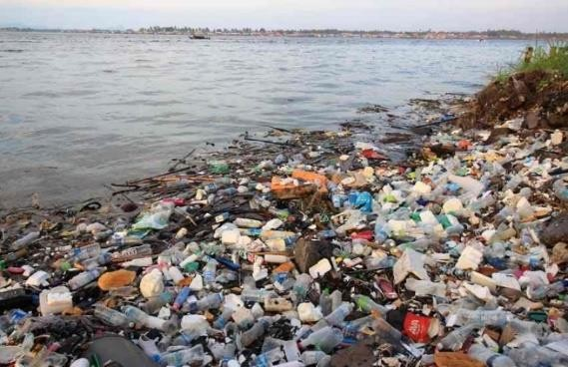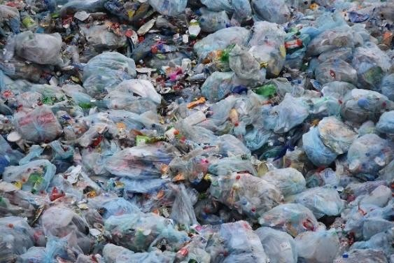Environmental release of large quantities of microplastics is in form of cosmetic products and cleaning ingredients such as toothpaste and microbeads in face-wash. Because of the health

effects of microplastics, countries like Canada, USA and others are now phasing out their usage in certain personal care products. Reports of recent research suggest that the detrimental effects of microplastics especially microbeads, micro plastic fibres and degraded macroplastics in aquatic environment might be higher than that of macroplastics, although studies and legislations to manage plastic pollution are still inadequate.

## Urbanization and Plastic Waste

Urbanization caused a vast and rapid growth of construction industries which requires a lot of building materials that utilizes natural resources either in their production plant or as the materials itself. More recently the world concern about the demands for construction materials and the rate production of plastic that increases swiftly every year. In turn, both industries contribute in increasing the MSW. Since the rate of production is projected to double the value in every 10 years, a more sustainable and safer way is needed to be taken into action. Banning or minimizing plastic usage is not practicable to solve the problem as it is nearly impossible for different sectors to run efficiently without plastic. Mining of natural resources on the other hand is an energy waste process as only 900 million tons of raw materials is produced from 6000 million tons of waste generated. They may be differ in constitution of raw materials but posses the same in contributing to various environmental threats. Hence, utilizing plastic waste

in brick production can solve both the MPW and demands for construction materials. Previous studies showed the possibility of using plastic waste in bricks application but the bricks produced are still lacking of durability as a safe construction materials. The aim of this paper is to review the application of plastic waste in bricks.

# CHAPTER- 2

**LITERATURE REVIEW**

## OVERVIEW

* + 1. **“Fabrication and testing of Plastic sand bricks” by S S Chauhan, Bhusan Kumar, Prem Shankar Singh, Abuzaid Khan, Hrithik Goyal, Shivank Goyal (2019).** They mixed the river sand and the PET plastic (molten form) in the ratio of 1:2, 1:3, 1:4 for mould size of (230*100*75) mm for which they found maximum compressive strength on the ratio of 1:2 mixture for the same size of the bricks. The water absorption of these bricks was observed less than 5% that is less than conventional clay bricks i.e. 15-20%. However, they failed in maintaining fire resistance property of these bricks.
    2. **“Utilization of plastic waste in manufacturing of plastic sand bricks.” By Arvind Singhal, Dr. Om Prakash Netula (2018).** They used the mixture of plastic and stone dust in the molten form in the ratio of 3:7 in standard brick mould for which stone dust was sieved through 4.75 mm using sieve analysis and conducted test on water absorption to be found as 0%. Compressive strength of plastic sand bricks is 5.6 N/mm2 at the compressive load of 96 KN**.**
    3. **“Plastic in Brick Application.” By Siti Nabilah Amir & Nur Zulaikha Yusof (2018).** The studies showed the possibility of using plastic as binder with the aid of catalyst through depolymerisation of PET to replace cement. It was observed that a significant decrease in compressive strength is observed for more than 50% replacement of binder with PET waste. With increased amount of PET, the softening point of the bricks produced was also increased. They used the different size of moulds like (150*150*150) mm, (200*100*100) mm etc.
    4. **“Study of plastic dust brick made from waste plastic” by Ronak Shah, Himanshu Garg, Parth Gandhi, Rashmi Patil, Anand Daftardar (2017).** They used plastic dust as the main component of waste product which is the by – product of many industrial products such as PVC pipes and they have heated plastic dust at 220℃. The final product from plastic dust was tested for the compressive strength and it was observed as 6.66 N/mm2 which is higher than conventional bricks (3-5 N/mm^2).

**5.Muyen Z, Barna TN, Hoque MN (2016) Strength properties of plastic bottle bricks and their suitability as construction materials in Bangladesh. Progressive Agriculture 27(3): 362-368.**

The study by Muyen Z. Barna and Hoque M.N. aligns with existing literature on sustainable construction materials and plastic waste management. Similar research has highlighted the feasibility of using recycled materials like plastic bottles in construction, citing benefits such as reduced environmental impact and enhanced affordability. Studies from other regions corroborate the findings, emphasizing the importance of mechanical testing and durability assessments in evaluating new construction materials.

**6.Hiremath PM, Shetty S (2014) Utilization of waste plastic in manufacturing of plastic- soil bricks.**

**International Journal of Technology Enhancement and Emerging Engineering Research 2347-4289**

The study by Hiremath PM and Shetty S aligns with existing literature on sustainable construction materials and waste management. Similar research has highlighted the feasibility of using waste plastic in construction materials, emphasizing benefits such as reduced environmental impact and economic savings. Studies from different regions and contexts reinforce the findings, underscoring the importance of mechanical testing and environmental assessments in evaluating recycled materials for construction.

# CHAPTER – 3

**OBJECTIVE**

## Objective

* + - To compare strength of plastic bricks with normal clay bricks.
    - To vary the percentage of plastic in bricks to determine the strength performance.
    - Cost comparison in between plastic bricks and normal clay bricks.
    - To produce cost effective Bricks by using the plastic waste.
    - To reduce the environmental and ecological challenge associated with plastic.To
    - provide eco-friendly bricks.
    - To replace the cement by plastic as a binding material.
    - To get light weight bricks.
    - To get less water absorption property.

# CHAPTER-4

**COMPONENTS AND SPECIFICATION**

First, we need to collect the plastic waste and separate it from other wastes. After that we need to dry the plastic waste if it is wet and has a content of moisture as we need to use dry plastic. Then we have to crush the plastic waste in small particles. After than the crushed particles need to make fine size particles. After that we have to heated it on a furnace till it is in a liquid form, then we are going to add M-Sand into melt plastic. We can mix it properly and make a mix. We poured the mic into moulds. Keep the mould for dry and then demould it and have tests.

## 4.1MATERIAL USED IN PROJECT

In this Project the various materials used for the manufacture of floor tiles and bricks using plastic waste discuss below,

* + 1. Plastic Waste
    2. Crushed Sand

## 4.1.1) Plastic waste: -

The word plastic derives from Greek word meaning “capable of being shaped or molded”. The plasticity of the material during manufacture allows it to be cast, pressed into variety of shapes such as films, fibers, plates, tubes, bottles, boxes, etc. The construction industries make use of plastic for a wide range of application because of its veracity, strength, to weight ratio, durability, corrosion, resistance, etc. As a plastic is manufacture in the form of pipes, cables, covering panel, films, sheets, etc.

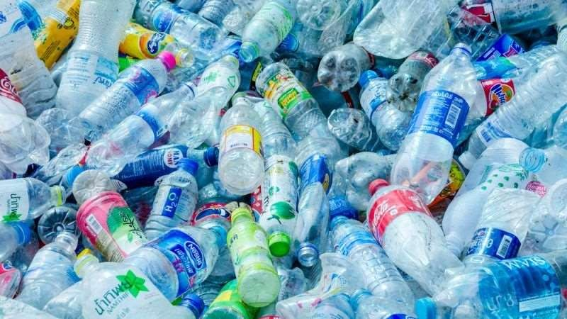

Fig. 3.1 Plastic Waste

## Crushed Sand: -

Crushed Sand is a fine aggregate that is produced/ manufactured by crushing huge suitable boulders and rocks. Crushed sand is also known as M-Sand or manufactured sand, since it is manufactured artificially. Nowadays, all major buildings construction are done using crushed or M-sand is an economical and eco-friendly alternative for river sand. The source of Crushed sand is a quarry. It is manufactured by Crushing rocks, quarry stones or larger aggregate pieces into sand size particles in a factory or quarry. The shape of Crushed sand is cubical and angular and has a rough texture and hence better for concrete. No moisture content. The compressive strength as well as the flexural strength of concrete made from Crushed sand are higher than natural sand. It does not contain silt as it manufacturing by crushing aggregates. However, if screen is not proper sometimes it may contain some dust. It is artificially manufactured so there are no oversized materials. It does not contain any marine products. It causes less damage to the environment as compared to natural sand. Better quality as compared to natural sand because it is manufactured in a controlled environment. Approximate 2.73 (It will depend on parent rock.) M-Sand was used as partial replacement of fine aggregate. The bulk density of Manufactured sand was 1.75 kg/m3 , specific gravity and fineness modulus was found to be 2.73 and 4.66, respectively.

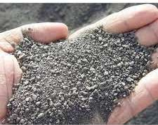

Fig. 3.3 Crushed Sand

# CHAPTER - 5

**METHODOLOGY**

1. **5.1)**  **Plastic Collection**
2. **5.2) Manual Sorting**
3. **5.3) Chopping**
4. **5.4) Melting of Plastic Material**
5. **5.5) Mixing of Material**
6. **5.6) Placing**
7. **5.7) Cooling**
8. **5.8)** **Demoulding**

**5.1) Plastic Collection:** The plastic wastes for recycling were collected around the Yavatmal city. Different types of plastics are used {(i.e Polyethylene Terephthalate (PET), High Density Polythene (HDPE), Polyvinyl Chloride (PVC), Low Density Polyethylene (LDPE)}, Polystyrene

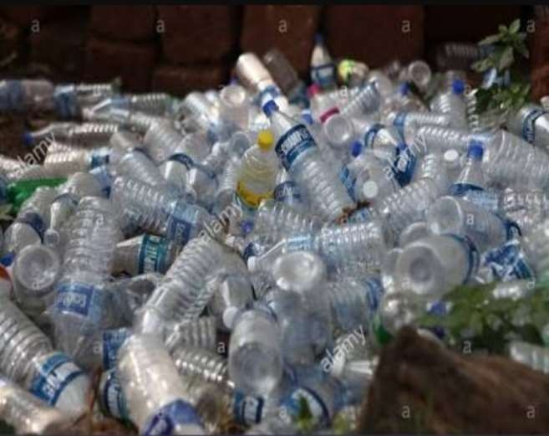

Fig. 3.4 Plastic Collection

* 1. **Manual Sorting:** Each plastic waste type were separated from each other and unwanted material were removed from the waste, like in waste plastic bottles, the plastics normally attached on the skin of bottles and the bottle caps were removed.
  2. **Chipping:** The various plastic waste sorted were then chopped into smaller pieces.
  3. **Washing**: The chips were then washed to remove glue, paper labels, dirt and may remnants of the product they once contained.
  4. **Melting of Plastic Material:** The selected waste plastic from different elements is weighed crushed and then melted in a container at its melting point (150- 170oC).

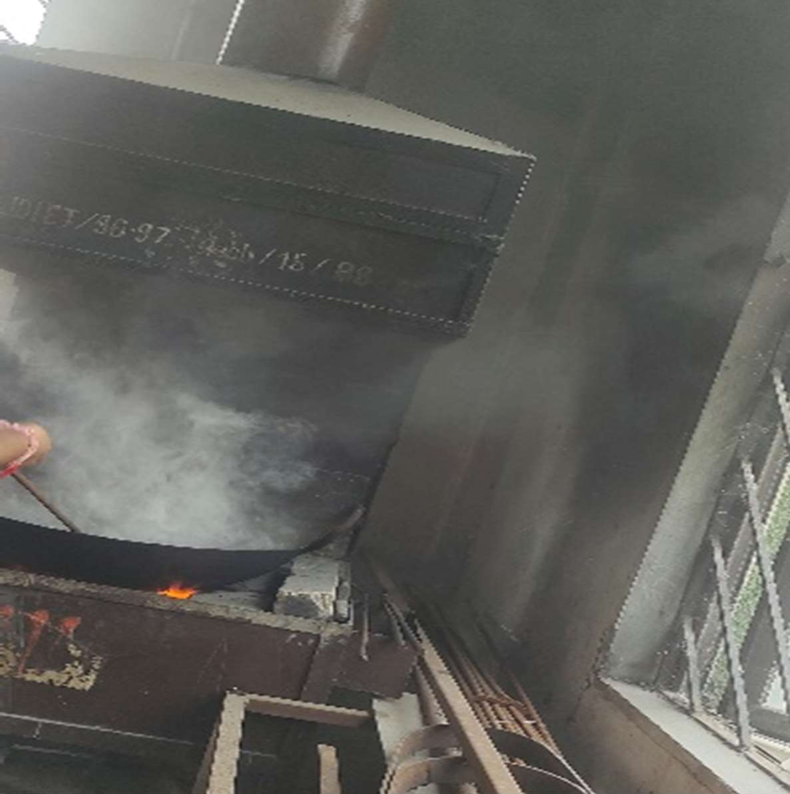

Fig. 3.5 Melting of plastic material

* 1. **Mixing of Material:** After the waste plastic is melted, the crushed sand and fly ash is added to it in the same container during melting and the mixture is stirred continuously mixed is obtain. Care shall be taken show that the mixture does not catch fire.

**5.7) Placing of resin (Plastic + Crushed Sand) into mould:** Once the homogenous mixture of waste plastic in melted form and crushed sand is formed, the mixture is fed into a mould of 19cm x 9cm x 9cm (For Bricks). The mould are coated with oil for easy demoulding, before placing the mixture, the moulds are prepared by MS base plate.

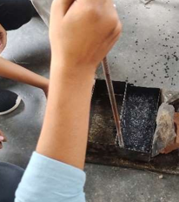

* 1. **Cooling:** After moulding and compacting the mould are allowed to cool for 24 hours.

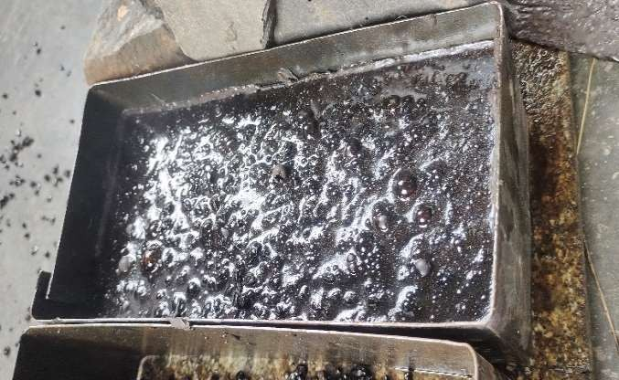

Fig. 3.7 Cooling

* 1. **Demoulding:** Once the mould is completely prepared. The mould is cooled either by air cooling or by placing it in water, after the mould is cooled, the brick and tile is removed from the mould. The Brick and floor tile is now ready with a good surface finish at the top.

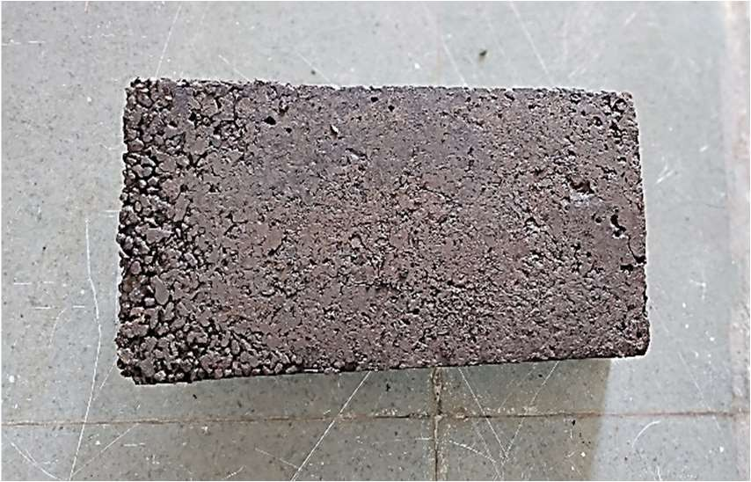

Fig. 3.8 Demoulding

# CHAPTER-6

**RESULTS**

# TESTS ON BRICKS

The tests which are conducted are as follows: -

* 1. **Compressive Strength Test: -**

Compression test is one of the most important mechanical tests. It helps in determining the capacity of material to withstand the compression loading, which is called as compression strength of material. In this test, the piece of material is subjected to end loading which produces crushing action. Specimen are limited to such a length, that bending due to column action does not take place of uniform stressing a circular area is preferred. Rectangular & square are also used for compression tests for metals.

**Procedure: -**

1. Measure the actual dimension of specimen.
2. Keeping the specimen in the jaw of CTM carries compression test.
3. Compression load is applied & noted down from the dial.
4. Breaking & crushing strength can be found out.
   1. **Water Absorption Test: -**

In this test, bricks are weighed in dry condition and let them immersed in fresh water for 24 hours. After 24 hours of immersion, those are taken out from water and wipe out with cloth. Then, brick is weighed in wet condition. The difference between weights is the water absorbed by brick. The percentage of water absorption is then calculated.

**Procedure: -**

* 1. Take a sample brick and weight it as W1.
  2. Then place the Sample brick in the water for 24 hours.
  3. After 24 hours take out the sample brick from water and rest it for some time and then take weight of it as W2.
  4. % of water absorption=((W2-W1)/W1) X100
  5. **Temperature Test: -**

As the Brick made up plastic, we need to know the melting point hence oven test is performed. The brick is kept in oven for 2 hours at above 150oC and after 2 hours its condition is verified.

## Fire Resistance Test: We already perform fire test but it catches fire

## So, we are still studying and working on it.

# CHAPTER-7

**RESULTS**

**Tests On Brick**

## 7.1 Compressive Strength Test

Table No . Compressive Strength Test

|  |  |  |  |  |  |
| --- | --- | --- | --- | --- | --- |
| **Sr. No** | **Proportion Name** | **Plastic Waste** | **Crushed Sand** | **Compressive Strength (N/mm2)** | **Average** |
| 1 | PB-1 | 1 | 1 | 5.95 | 5.94 |
| 1 | 1 | 5.87 |
| 1 | 1 | 6 |
| 2 | PB-2 | 1 | 1.5 | 4.8 | 4.53 |
| 1 | 1.5 | 4.5 |
| 1 | 1.5 | 4.3 |
| 3 | PB-3 | 1 | 2 | 3.0 | 2.98 |
| 1 | 2 | 2.86 |
| 1 | 2 | 3.1 |

## 7.2 Water Absorption Test

Table No 5.2. Water Absorption Test

|  |  |  |  |  |
| --- | --- | --- | --- | --- |
| **Sr. No** | **Proportion Name** | **Plastic Waste** | **Crushed Sand** | **Water Absorbed (%)** |
| 1 | PB-1 | 1 | 1 | 14 |
| 1 | 1.5 | 15.07 |
| 1 | 2 | 15.2 |

## 7.3 Temperature Test

The brick is kept in an oven for 2 hours at above 1500 c and condition is verified as there is no change in shape, size, and appearance in the brick.

|  |  |  |  |
| --- | --- | --- | --- |
| **Sr.**  **No.** | **Red Bricks** | **Fly Ash Brick** | **Plastic Brick** |
| 1 | Red Bricks are manufactured from Clay Soil | These Bricks are made from cement, slag, fly ash. | These Bricks are made from waste plastic and crushed sand |
| 3 | Redbrick has the colour red to light brown depending upon the type of clay used. | Fly ash brick has a Cement grey colour | Plastic Brick has a Greyish black in colour |
| 4 | Red Brick has compressive strength – 3 to 3.5 N/mm² | Fly Ash Bricks has compressive strength – 7 to 9 N/mm² | Plastic Brick has compressive strength  – 3.5 to 4.5 N/mm² |
| 5 | Density: 1600-1750 kg/m3 | Density: 1700-1850 kg/m3 | Density: 1200-1400 kg/m3 |
| 6 | Red Brick wastage on site is more than 10 % | Fly Ash Bricks wastage on site is around 2 – 5  % | Plastic Bricks wastage on site is around 5 % |
| 7 | Red Brick has Water Absorption of about 20  – 25 % | Fly Ash Bricks has Water Absorption of about 6 -12 % | Plastic Bricks has Water Absorption of about 10 -15 % |
| 8 | Red Brick Weight is 3.5 kg | Fly Ash Bricks Weight is 2.6 kg | Plastic Bricks Weight is 3 kg |
| 9 | Red Brick Cost is about Rs. 7 to 8 | Fly Ash Bricks Cost is about Rs. 5 to 6 | Plastic Bricks Cost is about Rs. 4 to 6 |

# CONCLUSION

The proposed project presented above intends to resolve in reducing the plastic waste disposal problem as it utilizes the waste even in its finest form and converts that useless material into a useful construction material. Extruder machine plays a prominent role in the conversion of waste plastic into its melted form. Also, extruder does not possess any threats to the environment and hence can be used without any restriction. It also helps in reducing the usage of natural resources which are utilized during the manufacturing of burnt bricks, also it reduces the pollution which is generated from kiln during brick manufacturing. The final end product can be used as brick, which is having a higher strength than conventional brick. Also, the water absorption capacity is higher in comparison to conventional brick with a lower weight. Its uses are not restricted as only brick; it can even be utilized as a building block by increasing the dimension of the mould. Also, it reduces the use of wire used for fencing. Floor tiles, sleepers, etc. can also be produced from it. This brick also turns out to be economical than conventional brick, by reducing the cost of incinerators for burning purpose and landfills.

# CHAPTER-8

**REFERENCES**

1. S S Chauhan, Bhusan Kumar, Prem Shankar Singh, Abuzaid Khan, Hrithik Goyal, Shivank Goyal, “Fabrication and testing of Plastic Sand Bricks” on ICCEMME 2019.
2. Rajarapu Bhushaiah, Shaik Mohammad, D. Srinivasa Rao, “An Overview of Study of Plastic Bricks Made From Waste Plastic” International Research Journal of Engineering and Technology (IRJET) (April 2019)
3. V. Velumurugan , R. Gokul Raj , A.Harinisree, “An Overview of Rebuilding of Plastic Waste to Pavement Bricks” International Journal for Research in Applied science & Engineering and Technology (April 2019)
4. Arvind Singhal, Dr. Om Prakash Netula, “Utilization of plastic waste in manufacturing of plastic sand bricks” on 17th June 2018 at 3rd International conference on New Frontiers of Engineering, Science, Management and Humanities. ISBN: 978-93-87433-29-8.
5. Siti Nabilah Amir & Nur Zulaikha Yusof, “Plastic in Brick Application” on 4th September 2018 by LUPINE PUBLISHERS. ISSN: 2637-4668. DOI: 10.32474/TCEIA.2018.03.000152.
6. Aiswaria K, Khansa Abdulla, E B Akhil, Haritha Lakshmi V G, Jerin Jimmy “Manufacturing and Experimental Investigation of Bricks with Plastic And M-Sand” International Journal of Innovative Research in Science, Engineering and Technology Vol. 7, Issue 6, June 2018
7. Ronak Shah, Himanshu Garg, Parth Gandhi, Rashmi Patil, Anand Daftardar. “Study of plastic dust brick made from waste plastic.” on International journal of mechanical and production engineering. ISSN: 2320-2092, volume-5, issue-10, OCT - 2017.
8. A.S. Manjrekar, Ravi, D. Gulpatil, Vivek P. Patil, Ranjit S. Nikam, Chetali M. Jeur (2017). "Utilization of Plastic Waste in Foundry Sand Bricks", International Journal for Research in Applied Science & Engineering Technology (IJRASET).
9. Loukham Gerion Singh, Pongsumbam Boss Singh, Suresh Thokchom (2017). "Manufacturing Bricks from Sand and Waste Plastics", National Conference on Innovations in Science and Technology (NCIST-17).
10. Dinesh.S, Dinesh.A, Kirubakaran.K, “UTILISATION OF WASTE PLASTIC IN MANUFACTURING OF BRICKS AND PAVER BLOCKS’’ International Journal of Applied Engineering Research, ISSN 0973-4562, Volume 1, 2016.
11. Gopu Mohan C, Jikku Mathew, JithinX Ninan Kurian, John Thomas Moolayil, “FABRICATION OF PLASTIC BRICK OMANUFACTURING MACHINE AND BRICK LANALYSIS” International Journal of Innovative Research in Science and Technology, ISSN (online) 2349-6010, Volume 2, Issue 11th April 2016
12. Sina Safinia, Amani Alkalbani. "Use of Recycled Plastic Water Bottles in Concrete Blocks" Middle East College, KOM, Rusayl, Muscat PC 124, Oman 2016.
13. Dibya Jivan Pati, Riken Homma, Kazuhisaikt, “PLASTIC BOTTLES MASONRY AS ALTERNATE SOLUTION TO HOUSING PROBLEMS IN URBAN AREA OF INDIA” International Journal of Architecture Planning and Building Engineering, ISSN 2455-5045, Volume 2, Issued 2nd April 2015.
14. Maneeth. P.D, Pramod. K, Kishore Kumar, Shanmukha Shetty, “UTILISATION OF WASTE PLASTIC IN MANUFACTURING OF PLASTIC-SOIL BRICKS’’ International Journal of Engineering Research and Technology (IJERT), Volume 3, ISSN 2278-0181, Issued 8th August 2014.
15. Amit Gawande, G. Zamare., V.C Range., Saurabh Taye, G. Barnacle. “an overview on waste plastic utilization in asphalting of roads”, Journal of Engineering Research and Studies (JERS), Vol. III, Issue II, April June 2012, pp 01-05.
16. Bharath Raj, Varshith A, Rashmitha Kotian, N.G. Ashwath. “Study on Laterite-Cement bricks” Project report, K.V.G College of Engineering, Sullia.DK. 2011-2012.
17. Hiremath PM, Shetty S (2014) Utilization of waste plastic in manufacturing of plastic-soil bricks. International Journal of Technology Enhancement and Emerging Engineering Research 2(4): 2347-4289
18. Gopu Mohan. C, Jikku Mathew, Jithin Ninan Kurian, John Thomas Moolayil, “FABRICATION OF PLASTIC BRICK MANUFACTURING MACHINE AND BRICK ANALYSIS” International Journal of Innovative Research in Science and Technology, ISSN (online) 2349-6010, Volume 2, Issue 11th April 2016.
19. Dibya Jivan Pati, Riken Homma, Kazuhisaikt, “PLASTIC BOTTLES MASONRY AS ALTERNATE SOLUTION TO HOUSING PROBLEMS IN URBAN AREA OF INDIA” International Journal of Architecture Planning and Building Engineering, ISSN 2455-5045, Volume 2,Issued 2nd April 2015.
20. Dr.M. Mageswari, J.S. Chiranjeevi, K. Magesh, , “An Overview of Plastics Bricks” International Research Journal in Advance Engineering And Technology (10- 04-2018)