**CONTENTS**

|  |  |  |
| --- | --- | --- |
| **Chapter** | **Chapter Name** | **Page No** |
| **1** | **Introduction** | **1-4** |
| **2** | **Literature Survey** | **5-6** |
| **3** | **History** | **7-9** |
| **4** | **Problem Definition**  **4.1 Problem faced in solar power plant**  **4.2 Low efficiency of solar power plant**  **4.3 Removal of dust and dirt** | **10-13** |
| **5** | **Objective** | **14** |
| **6** | **Methodology**  **6.1 Mechanical Components**  **6.2 Electrical Components**  **6.3 Automation Components**  **6.4 Hardware Setup**  **6.5 Circuit Diagram**  **6.6 PLC Programing**  **6.7 SCADA Designing**  **6.8 Working** | **15-18**  **19-20**  **21-23**  **24**  **25**  **26-31**  **32-33**  **34** |
| **7** | **Results** | **35-38** |
| **8** | **Advantages and Disadvantages** | **39** |
| **9** | **Conclusion and scope of work** | **40** |
| **10** | **References** | **41** |

**LIST OF FIGURES**

**Figures Page No**

Fig.1.1 Global variations in irradiation 1

Fig.1.2 Energy potential from PV around the world 1

Fig.1.3 Solar Power Plant 4

Fig.2.1 NASA's Mars Exploration Rover 6

Fig6.1 Working Modal of Automatic Cleaning System 15

Fig6.2 Rack and Pinion 16

Fig.6.3 DC gear motor 17

Fig.6.4 Water Pump 17

Fig.6.5 Limit Switch 18

Fig.6.6 Wiper 18

Fig.6.7 Solar Panel 19

Fig.6.8 SMPS(switch-mode power supply) 20

Fig.6.9 Relay 20

Fig.6.10 WPL Soft programming software 22

Fig.6.11 KEP Server working 23

Fig.6.12 Delta PLC DVP-SS2 Series 26

Fig.6.13 Plant View in SCADA 32

Fig.6.14 RTC Scheduling in SCADA 33

Fig.7.1 Efficiency of Solar Panel without Cleaning 36

Fig.7.2 Efficiency of Solar Panel without Cleaning 38

Fig.7.2 Efficiency of Solar Panel without Cleaning 38

**Chapter 1**

**INTRODUCTION**

There is more than enough solar radiation available around the world to satisfy the demand for solar power systems. The proportion of the sun’s rays that reaches the earth’s surface is enough to provide for global energy consumption 10,000 times over. On average, each square metre of land is exposed to enough sunlight to produce 1,700 kWh of power every year.

The statistical information base for the solar energy resource is very solid. The US National Solar Radiation database, for example, has logged 30 years of solar radiation and supplementary meteorological data from 237 sites in the USA.

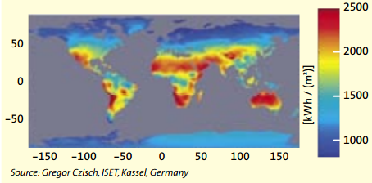

**Fig.1.1 Global variations in irradiation**

Figure 1.2 shows the estimated potential energy output from solar PV generators in different parts of the world. The calculation used here takes into account the average efficiency of modules and converters as well as the correct angle to the sun required at different latitudes

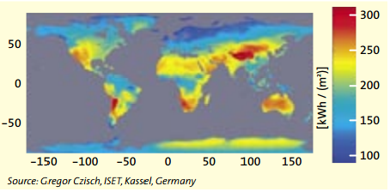

**Fig.1.2 Energy potential from PV around the world**

**1.1 Photovoltaic Energy**

“Photovoltaic” is a marriage of two words: “photo”, meaning light, and “voltaic”, meaning electricity. Photovoltaic technology, the scientific term used to describe what we use to convert solar energy into electricity, generates electricity from light. We use a semi-conductor material which can be adapted to release electrons, the negatively charged particles that form the basis of electricity. The most common semi-conductor material used in photovoltaic (PV) cells is silicon, an element most commonly found in sand.

All PV cells have at least two layers of such semi-conductors, one positively charged and one negatively charged. When light shines on the semi-conductor, the electric field across the junction between these two layers causes electricity to flow, generating DC current. The greater the intensity of the light, the greater the flow of electricity.

A photovoltaic system therefore does not need bright sunlight in order to operate. It also generates electricity on cloudy days by a rationing of the energy output that depends on the density of the clouds. Due to the reflection of sunlight, days with slight cloud can even result in higher energy yields than days with a completely cloudless sky. Generating energy through solar PV is quite different from how a solar thermal system works, where the sun’s rays are used to generate heat, usually for hot water in a house, swimming pool etc.

**1.2 Solar Panel**

Solar panel refers to a panel designed to absorb the sun's rays as a source of energy for generating electricity or heating.

A [photovoltaic](https://en.wikipedia.org/wiki/Photovoltaic) (PV) module is a packaged, connect assembly of typically 6×10 [solar cells](https://en.wikipedia.org/wiki/Solar_cell). Solar Photovoltaic panels constitute the [solar array](https://en.wikipedia.org/wiki/Solar_array) of a [photovoltaic system](https://en.wikipedia.org/wiki/Photovoltaic_system) that generates and supplies [solar electricity](https://en.wikipedia.org/wiki/Solar_electricity) in commercial and residential applications. Each module is rated by its [DC](https://en.wikipedia.org/wiki/Direct_current) output power under standard test conditions, and typically ranges from 100 to 365 watts. The [efficiency](https://en.wikipedia.org/wiki/Solar_cell_efficiency) of a module determines the area of a module given the same rated output – an 8% efficient 230 watt module will have twice the area of a 16% efficient 230 watt module. There are a few commercially available solar panels available that exceed 22% efficiency and reportedly also exceeding 24%. A single solar module can produce only a limited amount of power; most installations contain multiple modules. A photovoltaic system typically includes a panel or an array of solar modules, a [solar inverter](https://en.wikipedia.org/wiki/Solar_inverter), and sometimes a [battery](https://en.wikipedia.org/wiki/Battery_(electricity)) and/or [solar tracker](https://en.wikipedia.org/wiki/Solar_tracker) and interconnection wiring.

The price of solar power has continued to fall so that in many countries it is cheaper than ordinary [fossil fuel](https://en.wikipedia.org/wiki/Fossil_fuel) electricity from the grid (there is "[grid parity](https://en.wikipedia.org/wiki/Grid_parity)").

**1.3 Solar Plant**

Solar energy is the energy from sun radiation. This energy can be harnessed as solar thermal energy and solar photovoltaic. Solar power plant uses solar PV to generate energy, Let us see in detail how solar power plant works.

Solar panel generate DC power when sun rise directly hit the panel. This DC power intern feed into an inverter that convert it to an AC power. This AC power is feed in to your distributor board from their it flows to the electrical load. This is the basic layout of solar plant.

But solar plant need some backup source. The backup power source could be grid for instant or a storage mechanism as battery. Why is this backup required, the sunshine is not constant it varies during the day due to the whether change. A passing cloud can reduce the amount of sunshine hitting the solar panel reducing the power generation. This variation in some condition can damage the load. In order to avoid this problem the power from solar plant is linked with the power from other source. By using this solar power with other source we can ensure that load receive steady safe and reliable power,

Solar power plant can be integrated with

1. GRID TYPE

In this grid type plant they has no other backup power source. This is known as grid type plant as it is always in sink with grid. This is recommended to plant only to organisation that has a guaranteed supply of grid power. This will not suit you if you suffer from frequent power interruption.

1. OFF GRID TYPE

This type does not integrate with grids instead it only integrate with battery bank and diesel generation. This can be used in location that are not connected the grid at all. This can be used for home application.

1. HYBRID TYPE

In this type the solar power plant can integrated with grid as well as battery and diesel generation. This is recommended to plant who has grid power but with frequently interruption and need with critical load to be powered continuously. Most of the industrial and commercial consumer in India are under this category and required this type of solar plant.

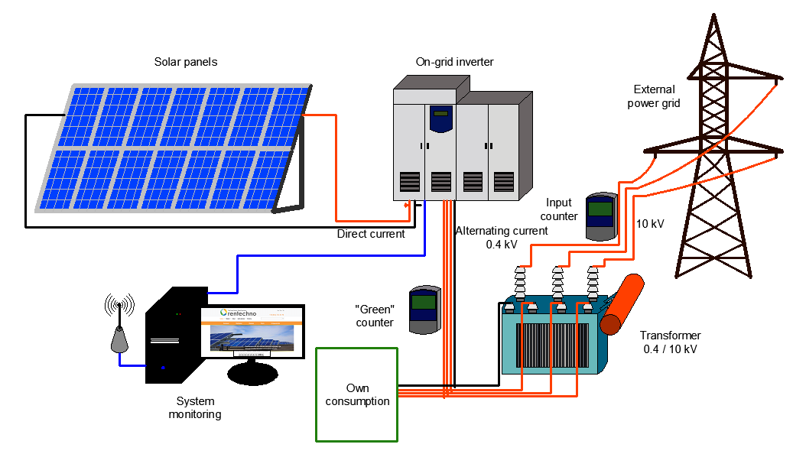

**Fig.1.3 Solar Power Plant**

**Chapter 2**

**LITERATURE SURVEY**

The recent upsurge in the demand of PV systems is due to the fact that they produce electric power without hampering the environment by directly converting the solar radiation into electric power. Solar energy is completely natural, it is considered a clean energy source. So the study on improving the efficiency of solar panel is very necessary. various methods of efficiency improvement of solar panel, We can improve efficiency of solar panel by using solar tracker with panel which continuously tracks sunlight throughout the day to get maximum solar energy. Second method to improve the efficiency is dust cleaning. Dust is barrier between sunlight and solar panel. Third method is cooling technique. As panel temperature increases output voltage of solar panel decreases so cooling of panel is necessary for improvement of efficiency.[2]

Shading and overheating of photovoltaic cells can result in a significant energy reduction of PV systems. Tilting and natural ventilation allows the build up of fine sand to be blown off from the PV array’s surface. However, dust particles tend to gradually accumulate on the PV surface making the cleaning task more difficult and reduces the overall PV panel efficiency due to the combined effect of shading and heating.[3]

Accumulation of dust from the outdoor environment on the panels of solar photovoltaic (PV) system is natural. There were studies that showed that the accumulated dust can reduce the performance of solar panels, but the results were not clearly quantified. The objective of this research was to study the effects of dust accumulation on the performance of solar PV panels. Experiments were conducted using dust particles on solar panels with a constant-power light source, to determine the resulting electrical power generated and efficiency. It was found from the study that the accumulated dust on the surface of photovoltaic solar panel can reduce the system’s efficiency by up to 50%.[1]

Current labour-based cleaning methods for photovoltaic arrays are costly in time, water and energy usage and lack automation capabilities. In this paper a novel design is presented for the first ever human portable robotic cleaning system for photovoltaic panels, which can clean and maneuver on the glass surface of a PV array at varying angles from horizontal to vertical.[4]

In order to regularly clean the dust, a automatic cleaning system has been designed, which senses the dust on the solar panel and also cleans the module automatically. This automated system is implemented using 8051 microcontroller which controls the DC gear motor. This mechanism consists of a sensor (LDR). While for cleaning the PVmodules, a mechanism consists of a sliding brushes has been developed. In terms of daily energy generation, the presented automatic-cleaning scheme provides about 30% more energy output when compared to the dust accumulated PV module (module kept stationary on ground).[5]

A small but important uptick in electrical output from the solar panels on NASA's Mars Exploration Rover Spirit this month indicates a beneficial Martian wind has blown away some of the dust that has accumulated on the panels.

The cleaning boosts Spirit's daily energy supply by about 30 watt-hours, to about 240 watt-hours from 210 watt-hours. The rover uses about 180 watt-hours per day for basic survival and communications, so this increase roughly doubles the amount of discretionary power for activities such as driving and using instruments. Thirty watt-hours is the amount of energy used to light a 30-watt bulb for one hour. The last prior cleaning event that was as beneficial as this one was in June 2007. Winds cleaned off more of the dust that time, but a dust storm in subsequent weeks undid much of the benefit.[6]

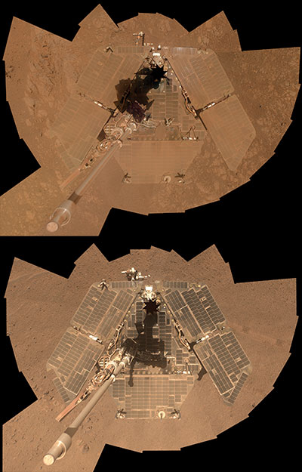

**Fig.2.1 NASA's Mars Exploration Rover**

**Chapter 3**

**HISTORY**

Every day, the surface of planet earth is blasted with so much solar energy that, if harnessed, 60 seconds worth could power the worlds total energy requirements for one year. The sun is a colossal fusion reactor that has been burning, for more than 4 billion years. In just 1 day, it provides more energy than the current human population would consume in 27 years. By some estimates, the amount of solar reaction striking the earth every 72 hours is equivalent to all energy stored in the planet's coal, oil and natural gas reservoirs. Solar radiation is free and natural recourse, yet converting into an energy source is a relatively new idea.

The devices used in photovoltaic conversion are called solar cells. When solar radiations fall on this devices, it is converted directly into DC electricity. The principal advantages associated with solar cells are that they have no moving parts, required little maintenance and work quite satisfactorily with beam or diffused radiation. Also they are readily adapted

The use of photovoltaic energy (aka. solar cells) started way back in 1876. William Grylls Adams along with a student of his, Richard Day, discovered that when selenium was exposed to light, it produced electricity. An electricity expert, Werner von Siemens, stated that the discovery was "scientifically of the most far-reaching importance". The selenium cells were not efficient, but it was proved that light, without heat or moving parts, could be converted into electricity.

In the year 1956, the first solar cells are available commercially. The cost however is far from the reach of everyday people. At $300 for a 1 watt solar cell, the expense was far beyond anyone's means. 1956 started showing us the first solar cells used in toys and radios. These novelty items were the first item to have solar cells available to consumers.

In the late 1950's and early 1960's satellites in the USA's and Soviet's space program were powered by solar cells and in the late 1960's solar power was basically the standard for powering space bound satellites.

In the early 1970's a way to lower to cost of solar cells was discovered. This brought the price down from $100 per watt to around $20 per watt. This research was spearheaded by Exxon. Most off-shore oil rigs used the solar cells to power the waning lights on the top of the rigs. The period from the 1970's to the 1990's saw quite a change in the usage of solar cells.

Today we see solar cells in a wide variety of places. You may see solar powered cars. There is even a solar powered aircraft that has flown higher than any other aircraft with the exception of the Blackbird. With the cost of solar cells well within everyone's budget, solar power has never looked so tempting.

Recently new technology has given us screen printed solar cells, and a solar fabric that can be used to side a house, even solar shingles that install on our roofs. International markets have opened up and solar panel manufacturers are now playing a key role in the solar power industry.

A cleaning event is a phenomenon whereby dust is removed from solar panels, particularly ones on Mars, by the action of wind. The term cleaning event is used on several NASA WebPages; generally the term is used in reference to the fact that Martian winds have blown dust clear off the solar panels of probes on Mars increasing their energy output

The term started being used in 2004 as the Mars Exploration Rovers' solar panels started to benefit from these events. The rovers were expected to last about 90 sols (Martian days) on Mars, after which dust would cover their solar panels and reduce solar power to levels too low for the rovers to operate. However, power levels went back up due to the cleaning events caused by the winds in the Martian atmosphere. Periodic cleaning events have allowed the MER rovers to operate far longer than the planned 3 months. While Spirit rover finally ceased operation in 2011, Opportunity rover remains active as of 2017, more than 13 years after landing.

Cleaning events can either be rapid, such as overnight, or over many days where solar power slowly goes up. For example, the MER-A Spirit rover, on April 18, 2009 and April 28, 2009 the power output of the solar arrays were increased by cleaning events. The power output of Spirit's solar arrays increased from 223 watt hours per day on March 31, 2009 to 372 watt hours per day on April 29, 2009. Other factors that affect solar power output include the opacity of the Martian atmosphere and Martian seasonal changes. The Materials Adherence Experiment had a glass plate that allowed the dust to be cleared off and protected a Gallium arsenide photo-cell. It was part of the Mars Pathfinder program in the 1990s.

**Chapter 4**

**PROBLEM DEFINITION**

**4.1 Problem faced in Solar Power Plant**

Solar energy is a sustainable energy source. It is renewable as well. It has many applications like solar water heaters, solar air heaters and electricity generation. It has its advantages as well as disadvantages. Some of the disadvantages are

1. Low efficiency of solar power conversion.
2. Initial cost incurred in purchasing solar panels and their installation is fairly high enough to think about it twice.
3. Obviously the plant won't be in working condition during night time.   
   The weather is also a big factor in reducing the efficiency of solar system used.

**4.2 Low Efficiency of Solar Power Plant**

Besides solar panels efficiency and size, there are other factors that affect how much power your solar panels will create. Living in Arizona will get more solar radiation than someone who lives in the mid west. Solar energy output is also affected by weather and seasonal variations. The angle of the sun to the solar panel changes with the time of day and seasonal variations. Cloudy and rainy days also contribute to less effectiveness of the sunlight collection.

**4.2.1 Solar Panel Pitch and Orientation**

A non-tracking PV systems in the Northern Hemisphere should face true south. The positioning angle directly relates to the angle of latitude, if you live at 35.2 degrees North of the equator (Flagstaff, AZ), your panel should face directly South at a 35.2-degree angle. Remember that if the solar panels are being installed on a roof, take into account the pitch of the roof.

For maximum performance adjust your solar panels twice a year. In the summer months the sun is high overhead, catch more sunlight by tilting solar panel at a lower angle. During the winter, the sun moves across the sky at a lower angle, angle solar panels higher during these months. Large commercial systems have solar tracking systems that automatically follow the sun’s tilt through the day. Due to their high costs, they are not typically used for residential solar installs.

**4.2.2 Temperature**

High temperature can severely reduce the solar panel’s production of power. Higher temperature increases the conductivity of the semiconductor, charges become balanced within the material, reducing the magnitude of the electric field, inhibiting the charge separation, which lowers the voltage across the cell. Depending on the location, heat can reduce the output by 10% to 25%.

In the built environment, there are a couple of ways to deal with high temperature. Install solar panels on a mounting system a few inches off the roof, this will help cool them by allowing air circulation. Use photovoltaic panels that are designed to be more efficient in hotter climates. Ensure that panels are constructed with light-colored materials, to reduce heat absorption. Inverters and combiners can be moved into the shaded area behind the array.

**4.2.3 Shade**

Shade can be the enemy of solar power. The way solar is designed even a little shade on one panel can shut down solar production on all the other panels. Solar cells are connected in series, and will operate at the current level of the weakest cell, if one solar cell is shaded it will adversely influence the output of all other cells. When deciding on a location for your solar panels do a shading analysis, make sure no shadows will fall on the solar panel array during peak sunlight hours. This may mean trimming a few trees.

**4.2.4 DUST AND DIRT**

Solar cells can not absorb light as effectively when the surface of the solar panels are covered with dirt or birds droppings, which doesn’t get washed by the rain. Making frequent physical inspections and spraying water on your modules can help reduce the problem.

This can reduce output and efficiency of the system completely if left untreated for years. A typical cleaning will result in a 10%-60% increase in efficiency.

**4.3 REMOVAL OF DUST AND DIRT**

Dusty environment accumulation of dust on the solar panels leads to reduction of the transmittance of the panel. Solar desalination plants in some of the middle-east countries like the solar desalination plant of Abu Dhabi suffers from the deposition of dust on its solar plates. The effect of the accumulated dust will be reduced with the increasing of tilt angle, since the tilt angle will affect the exposure time to the sunlight also. But the best way to eliminate the effect of the accumulated dust on the solar panels is to clean the panels. Cleaning the solar panels is normally by washing which is tedious and cumbersome and also expensive in terms of the labour involved and time. In practice cleaning of solar panels should be frequently done.

The cleaning method is summarized as natural means, mechanical means.

**4.3.1 Natural removal of dusts**

The natural powers are employed to remove the dusts, such as wind power, gravitation and the scour of the rainwater. The effect of this method is not very well. Gaier J, Davis P and Marabito reported that they had studied the validity of this method. It is viable that the solar cell array can be turned to vertical or oblique position to remove the dusts easily when early morning, late evening, night and a rainy day. However, the rotation of the large solar cell array is very difficult.

**4.3.2 Manual removal of dusts**

The mechanical methods remove the dusts by brushing, blowing, vibrating and ultrasonic driving. The brushing methods clean the solar cell with something like the broom or brush that were driven by the machine was designed just like windscreen-wiper. However, firstly, because of the small size and the strong adhesively of the dusts, the cleaning method is inefficient. Secondly, the abominable working environment of the solar cell makes the maintenance of the machine difficult. Then, due to the large area of the solar cell array, the cleaning machine is powerful. Lastly, the surfaces of the solar cell maybe were damaged by the brush when wiping. The blowing method cleaning the solar cell with wind power is an effective cleaning one except the low efficiency, high energy-consumption and the unsatisfactory maintainability of the blower.

**MONTHLY CLANING STATEMENT AS PER THE WELSPUN SOLAR POWER PLANT**

During our visit to welspun power plant the data collected from there was very significant to prove that the manual/labor based cleaning system is costlier and time consuming, the data collected is as follows

* The cleaning process is outsourced and the costing done for this process is 45paise/panel.
* Welspun solar power plant is a 17MW pant spread over a area of 100acres.
* 1MW consists of 4,252 panels and the total plant consists of 72,284 panels.
* Therefore the cost involved to clean the plant for once is 32,527RS.
* Cleaning is done 4 times a month.
* Total annual cost for cleaning is = 15,61,296RS.

Since manual cleaning costs more and require more time for cleaning the panels.

In practice cleaning of solar panels should be frequently done which makes the

process more laborious and expensive. Hence an innovative method of automatic cleaning of solar panel has been proposed.

**Chapter 5**

**OBJECTIVE**

**5.1 Project Goals**

* Design a mechanism to detect obstructions on solar panels causing significant loss of power.
* Design a cleaning mechanism that runs across the length of the panels.
* Improve overall solar panel efficiency.

**5.2 Features**

* To increase the efficiency of the plate.
* To increase life of the plate.
* To reduce cleaning cost of the cleaning process.
* To reduce the labour cost.
* To reduce the time of the cleaning.
* Automatic cleaning system.
* Controlling by it self.
* To remove dust particles.

**Chapter 6**

**METHODOLOGY**

The cleaning unit moves on the central part of the panel in a back and forth motion. The wiper mounted on the fixture and tool unit reciprocates in the forward and backward direction. The cleaning unit along with the wiper moves along the central panel spraying the water droplets towards the other end of the panel. It forces the dust to move in the direction of the motion of the cleaning unit and finally flows it away at the edge of the panel. Once the cleaning unit reaches the other end, the water spraying stops and it again returns back. Once it reaches the home position, it sends the signals to the PLC. The cleaning unit stops here i.e. tool.

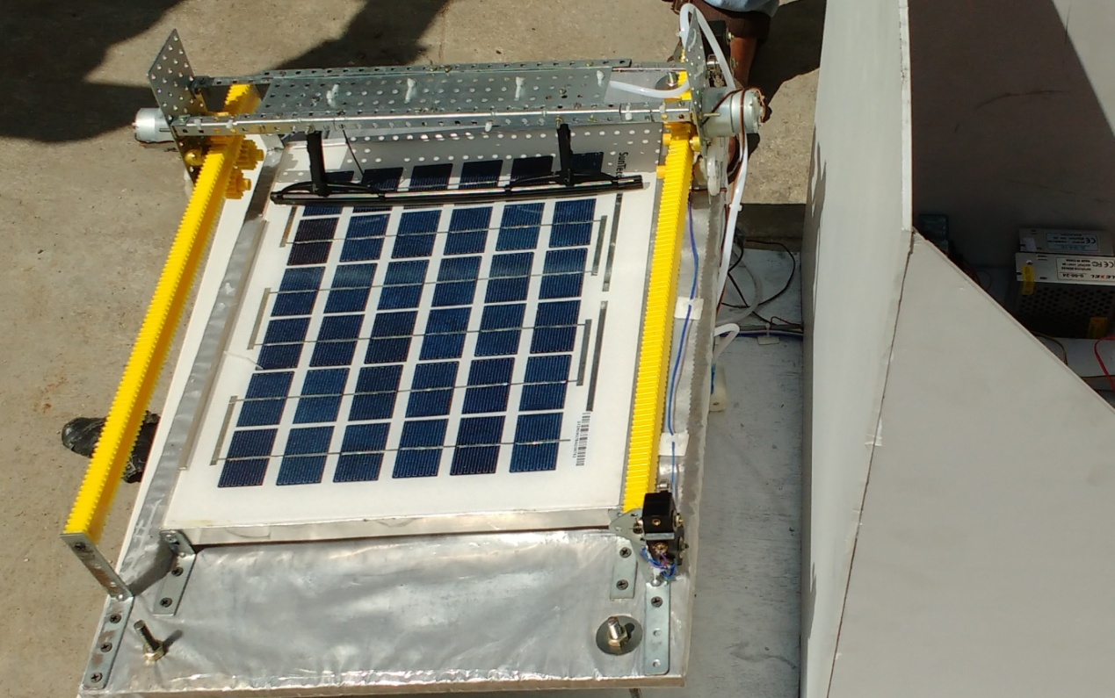

**Fig6.1 Working Modal of Automatic Cleaning System**

**6.1 MECHANICAL COMPONENTS**

**6.1.1 RACK AND PINION:**

Rack and pinion is used to convert a rotary motion into translating motion or vice versa (either the pinion drives the rack or the rack drives the pinion). Fig. Shows a rack in mesh with a pinion. The rack and pinion is used in consolidating the lap in scutcher of conventional blow rooms (rack drives the pinion) and to drive the bobbin carriage of moving machines (pinion drives the rack ). Rack can be imagined as a spur gear having an infinitely larger diameter. Therefore the rack has an infinite number of teeth and a base circle which is infinite distance from the pitch point. With infinite diameter of base circle, the involute outline of teeth on rack became straight lines. **Specifications of Rack and pinion :**

* **Material** - Plastic
* **Colour** - yellow
* **No. of teeth on Pinion -** 16
* **Diameter of Pinion -**
* **Length** - 146mm
* **Height** - 8mm
* **Width** - 8mm

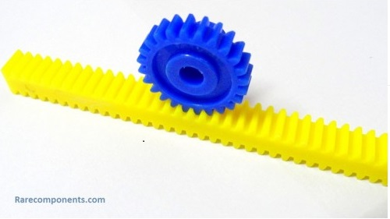

**Fig6.2 Rack and Pinion**

**6.1.2. DC GEAR MOTOR:**

A DC Motor is a class of electrical machine that convert direct current electrical power into mechanical power. The most common type rely on the forces produced by the magnetic field. DC motors speed can be controlled over a wide range by using a variable supply voltage or by changing the strength of current in the field winding.

**Specification of DC motor:**

* **Voltage** - 12 V
* **Speed** - 30 rpm
* **Current** - 0.5- 1 A
* **Power** - 6W



**Fig.6.3 DC gear motor**

**6.1.3. WATER PUMP DC 12V**

This is a small size submersible pump motor which can be operated by 2.5V~6Vpower supply. It can pump up to 120 litre per hour with very low current consumption of 220mA.

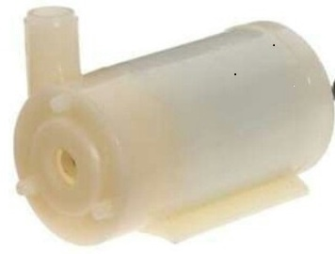

**Fig.6.4 Water Pump**

**Specifications:**

* **Operating Voltage -** 2.5to 6V
* **Operating Current -** 130 to 220mA
* **Flow Rate** - 80 to 120 L/H
* **Maximum lift** - 40 ~ 110mm
* **Material** - Engineering Plastic

**6.1.4. LIMIT SWITCH**

They are used for controlling machinery as part of a [control system](https://en.wikipedia.org/wiki/Control_system), as a safety [interlocks](https://en.wikipedia.org/wiki/Interlock_(engineering)), or to count objects passing a point. A limit switch is an electromechanical device that consists of an actuator mechanically linked to a set of contacts. When an object comes into contact with the actuator, the device operates the contacts to make or break an electrical connection.

Limit switches are used in a variety of applications and environments because of their ruggedness, ease of installation, and reliability of operation. They can determine the presence or absence, passing, positioning, and end of travel of an object. They were first used to define the limit of travel of an object; hence the name "Limit Switch".

[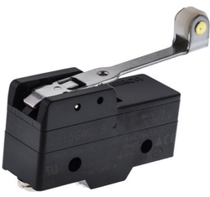](https://en.wikipedia.org/wiki/File:Eindschakelaar_op_de_Mallegatsluis_in_Gouda.JPG)

**Fig.6.5 Limit Switch**

**6.1.5. WIPER**

A wiper generally consists of a metal arm, pivoting at one end and with a long rubber blade attached to the other. The arm is powered by a motor, often an [electric motor](https://en.wikipedia.org/wiki/Electric_motor), although pneumatic power is also used in some vehicles and cleaning the glass surfaces. The blade is swung back and forth over the glass, pushing water or other precipitation from its surface. The speed is normally adjustable, with several continuous speeds and often one or more "intermittent" settings.

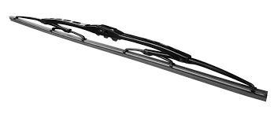

**Fig.6.6 Wiper**

**6.2 ELECTRICAL COMPONENTS**

**6.2.1.SOLAR PANEL**

Solar panel absorbs the sunlight as a source of energy to generate **electricity** or **heat.** Interconnected silicon cells joined together to form a circuit. At cell structure level, different kinds of panels exist, such as monosilicon, polysilicon or thin-film.

* **Solar Cell:** Semiconductor device that converts sunlight into director current (DC) electricity.
* **Module:** PV module consists of PV cell circuits sealed in an environmentally protective laminated and are the fundamental building block of PV system.
* **Solar Panel:** Includes one or more PV modules assembled as a pre-wired, field-instable unit.
* **String:** A string is a group of modules wired in series. Basic electrical physics tells us that connecting electrical sources in series increases voltage, which is exactly the goal of a string.

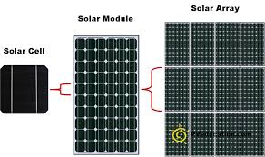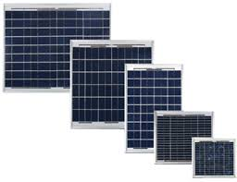

**Fig.6.7 Solar Panel**

**6.2.2.SMPS**(switch-mode power supply)

The electronic power supply integrated with the switching regulator for converting the electrical power efficiently from one form to another form with desired characteristics is called as Switch-mode power supply. It is used to obtain regulated DC output voltage from unregulated AC or DC input voltage.

Switched mode power supplies are used to power a wide variety of equipment such as computers, sensitive electronics, battery-operated devices and other equipment requiring high efficiency.

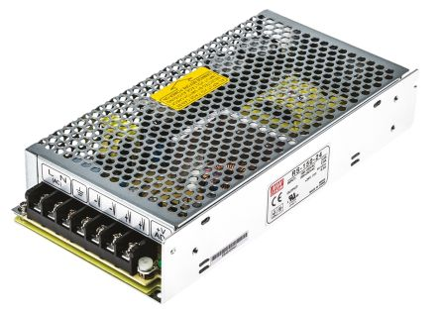 Switched-mode power supplies are classified according to the type of input and output voltages. The four major categories are:

* AC to DC
* DC to DC
* DC to AC
* AC to AC

**Fig.6.8 SMPS(switch-mode power supply)**

**6.2.3 RELAYS**

Relays are the primary protection as well as switching devices in most of the control processes or equipment regardless of whether they are electronic or electromechanical.

All the relays respond to one or more electrical quantities like voltage or current such that they open or close the contacts or circuits. A relay is a switching device as it works to isolate or change the state of an electric circuit from one state to another. These are found in all sorts of devices. Relays allow one circuit to switch over to a second circuit that can be completely separated from the first. There is no electrical connection inside the relay between the two circuits – the link is magnetic and mechanical only.

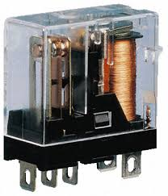

**Fig.6.9 Relay**

**6.3 AUTOMATION COMPONENTS**

# 6.3.1 PROGRAMMABLE LOGIC CONTROLLER

[A **Programmable Logic Controller (PLC)** is an industrial digital computer](https://en.wikipedia.org/wiki/Digital_computer) which has been ruggedized and adapted for the control of manufacturing processes, such as [assembly lines](https://en.wikipedia.org/wiki/Assembly_line), or [robotic](https://en.wikipedia.org/wiki/Robotic) devices, or any activity that requires high reliability control and ease of programming and process fault diagnosis.

They were first developed in the automobile industry to provide flexible, ruggedized and easily programmable controllers to replace hard-wired relays and timers. Since then they have been widely adopted as high-reliability automation controllers suitable for harsh environments. A PLC is an example of a "hard" [real-time](https://en.wikipedia.org/wiki/Real-time_computing) system since output results must be produced in response to input conditions within a limited time, otherwise unintended operation will result.

PLCs can range from small "building brick" devices with tens of I/O in a housing integral with the processor, to large rack-mounted modular devices with a count of thousands of I/O, and which are often networked to other PLC and [SCADA](https://en.wikipedia.org/wiki/SCADA) systems. They can be designed for multiple arrangements of digital and analog inputs and outputs (I/O), extended temperature ranges, immunity to [electrical noise](https://en.wikipedia.org/wiki/Noise_(electronics)), and resistance to vibration and impact. Programs to control machine operation are typically stored in battery-backed-up or [non-volatile memory](https://en.wikipedia.org/wiki/Non-volatile_memory).

It was from the automotive industry in the USA that the PLC was born. Before the PLC, control, sequencing, and safety interlock logic for manufacturing automobiles was mainly composed of [relays](https://en.wikipedia.org/wiki/Relay), [cam timers](https://en.wikipedia.org/wiki/Cam_timer), [drum sequencers](https://en.wikipedia.org/wiki/Drum_sequencer_(controller)), and dedicated closed-loop controllers. Since these could number in the hundreds or even thousands, the process for updating such facilities for the yearly model [change-over](https://en.wikipedia.org/wiki/Changeover) was very time consuming and expensive, as [electricians](https://en.wikipedia.org/wiki/Electrician) needed to individually rewire the relays to change their operational characteristics.

There are two types of contacts in PLC's and they are normally open and normally closed switches. A normally open contact means the contact is on when pressed/closed, and a normally closed contact is on when open/not pressed. Contacts represent the states of real world inputs like sensors, switches, if the part is present, empty, full, etc. PLC's also consist of coils, which are outputs like motors, pumps, lights, timers, etc. The PLC examines inputs and turns coils on or off whenever it is needed. They can also be used as inputs to other rungs in the ladder diagram.

Some of the manufacturers or types of PLCs are given below:

* Delta PLCs.
* Allen Bradley PLCs (AB)
* ABB PLCs (Asea Brown Boveri)
* Siemens PLCs.
* Omron PLCs.
* Mitsubishi PLCs.
* Hitachi PLCs.
* General Electric (GE) PLCs

We are using Delta PLCs for the automation of the cleaning unit in the solar plant.

**6.3.2 WPL Soft**

WPLSoft is a program-editing software made for the Delta DVP-PLC series used under WINDOWS. Except for general program planning and other general functions (e.g. cut,paste, copy, multi-windows, etc.) of WINDOWS, WPLSoft, in addition, has provided variousChinese/English commentary-editing and other special functions (e.g. survey and edit thelisted register, the setup, the data readout, the file saving, and monitor and set up diagrams of various contacts, etc.).

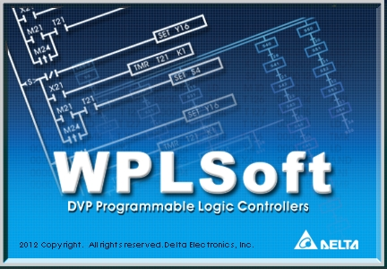

**Fig.6.10 WPL Soft programming software**

**6.3.3 Supervisory control and data acquisition (SCADA)**

SCADA is a [computerized](https://en.wikipedia.org/wiki/Computerized) [control system](https://en.wikipedia.org/wiki/Control_system) architecture that uses computers, networked data communications and [graphical user interfaces](https://en.wikipedia.org/wiki/Graphical_user_interfaces) for high-level process supervisory management, but uses other peripheral devices such as [programmable logic controllers](https://en.wikipedia.org/wiki/Programmable_logic_controller) and discrete [PID controllers](https://en.wikipedia.org/wiki/PID_controller) to interface to the process plant or machinery. The operator interfaces which enable monitoring and the issuing of process commands, such as controller set point changes, are handled through the SCADA supervisory computer system. However, the real-time control logic or controller calculations are performed by networked modules which connect to the field sensors and actuators.

Wonderware Intouch SCADA is used in the automation in this project.

**6.3.4 KEPserverEx**

This software based server is designed for accurate communications, quick setup, and unmatched interoperability between client applications, industrial devices, and systems. The server provides a wide range of plug-ins and device drivers and components that suit most communication needs. The plug-in design and single user interface provides consistent access from standards-based applications and non-standards-based applications with native interfaces.





**Fig.6.11 KEP Server working**

**6.4 HARDWARE SETUP**

**6.4.1 MCB interface to Switch Mode Power Supply(SMPS)**

* MCB is a circuit breaker.
* MCB is used to take the input of 230V AC supply.
* This current from MCB is given as an input to the SMPS of 24V& 12V.
* The main function of MCB is to avoid the shorts circuits in the system.

**6.4.2 Switch Mode Power Supply (SMPS 24V) interfaced with PLC**

* SMPS is a device used to convert the input of 230V AC supply to 24V DC supply.
* This output of SMPS 24V DC is given as an input to the PLC.

**6.4.3 Switch Mode Power Supply (SMPS12V) interfaced with other device**

* This 12V SMPS output connection is given to the two 12V gear DC Motor and two 6V DC pumps.

**6.4.4 PLC interfaced with various input & output**

PLC is the commanding device for various input and output.

The PLC consist of two connection ports.

**Input Port**

This input port have four different device input slots:

1. Limit switch 1
2. Limit switch 2
3. Start push button
4. Stop push button

**Output Port**

This output port has five different device output slots:

1. For motor reverse
2. For motor forward
3. Green working light
4. Red stop light
5. Green start light

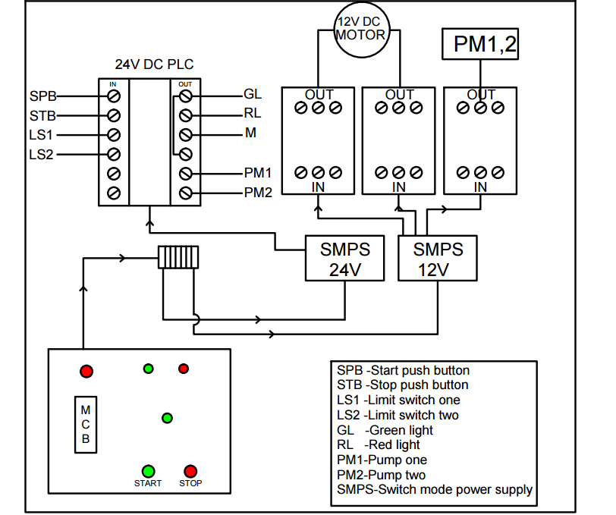**6.5 CIRCUTE DIAGRAM**

**6.6 PLC PROGRAMING**

**6.6.1 DELTA PLC**

Programmable logic controller (PLC) is a control system using electronic operations. It's easy storing procedures, handy extending principles, functions of sequential/position control, timed counting and input/output control are widely applied to the field of industrial automation control.

Delta's DVP series programmable logic controllers offer high-speed, stable and highly reliable applications in all kinds of industrial automation machines. In addition to fast logic operation, bountiful instructions and multiple function cards, the cost-effective DVP-PLC also supports various communication protocols, connecting Delta's AC motor drive, servo, human machine interface and temperature controller through the industrial network in to a complete "Delta Solution" for all users.

Delta plc used in this project is **DVP-SS2 Series**

The DVP-SS2 Series is Delta Electronics' second generation of slimline industrial PLCs. The DVP-14SS211R features high speed counters, a flexible serial port, real-time monitoring and an expansion bus that allows matching modules to be mounted on the right side of the PLC without external wiring.

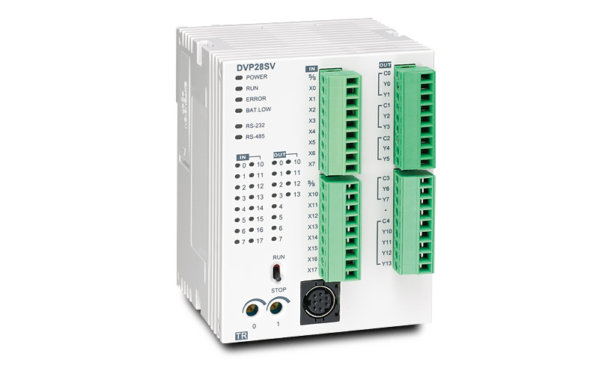

**Fig.6.12** **Delta PLC DVP-SS2 Series**

**Specifications:**

|  |  |
| --- | --- |
| Power: | 20.4 to 28.8 VDC |
| Digital Inputs: | 8 inputs, 24 VDC sink or source¹ |
| Digital Outputs: | 6 relay outputs |
| Output Rating: | 1.5A each output |
| Communication Port: | RS-232 and RS-485, Modbus ASCII/RTU master or slave |
| Program Capacity: | 8 k steps |
| IO Points: | Up to 238 via expansion modules |
| Software Up/Down Counters: | Any input, up to 10 kHz on a single input |

**6.6.2 TYPES OF DELTA PROGRAMING**

The following is a list of programming languages specified by standard:

* Ladder diagram(LD)
* Sequential Function Charts(SFC)
* Function Block Diagram(FBD)
* structured test(ST)

we are using ladder diagram programming language for programming the program of project.

**Ladder diagram(LD)**

Ladder logic has evolved into a [programming language](https://en.wikipedia.org/wiki/Programming_language) that represents a program by a graphical diagram based on the [circuit diagrams](https://en.wikipedia.org/wiki/Circuit_diagram) of [relay logic](https://en.wikipedia.org/wiki/Relay_logic) hardware. Ladder logic is used to develop software for [programmable logic controllers](https://en.wikipedia.org/wiki/Programmable_logic_controller) (PLCs) used in industrial control applications.

**PLC Registers and Relays**

* X(Input Relay): Bit memory represents the physical input points and receives external input signals.
* Y(Output Relay):Bit memory represents the physical output points and saves the status to be refreshed to physical output devices.
* M(Internal Relay):Bit memory indicates PLC status.
* S(Step Relay):Bit memory indicates PLC status in Step Function Control (SFC) mode. If no STL instruction is applied in program, step point S can be used as an internal relay M as well as an annunciator.
* T(Timer):Bit, word or double word memory used for timing and has coil, contact and
* register in it. When its coil is ON and the set time is reached, the associated contact will be energized. Every timer has its resolution (unit:1ms/10ms/100ms).
* C(Counter):Bit, word or double word memory used for counting and has coil, contact and register in it. The counter count once (1 pulse) when the coil goes from OFF to ON. When the predefined counter value is reached, the associated contact will be energized. There are 16-bit and 32-bit high-speed counters available for users.

**6.6.3 PROJECT PROGRAM**

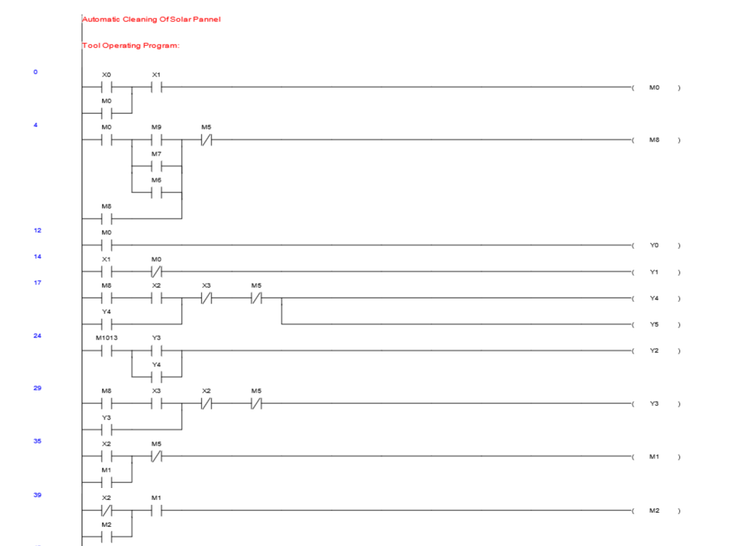

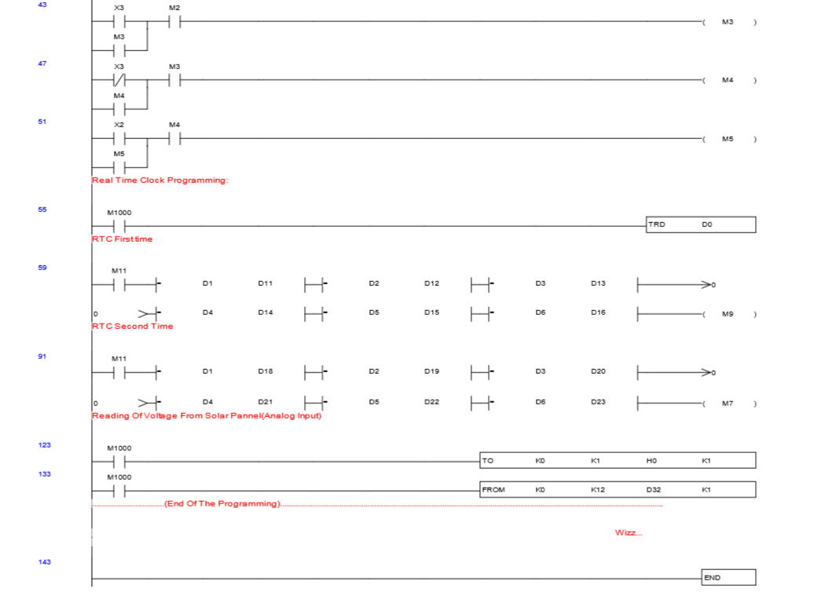

**INPUTS**

X0--Start Push Button

X1--Stop Push Button

X2--Initial Limit Switch

X3--Final Limit Switch

**OUTPUTS**

Y0--ON Light

Y1--OFF Light

Y2--Blinking Light

Y3--Motor Forward

Y4--Motor Reverse

Y5--Pump ON

**6.7 SCADA DESIGNING**

**6.7.1 PLANT VIEW IN SCADA**

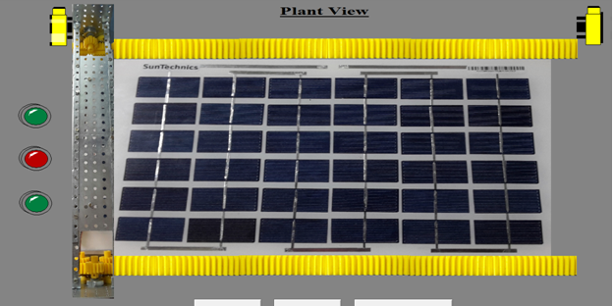

**Fig.6.13** **Plant View in SCADA**

**6.7.2 RTC SCHEDULING IN SCADA**

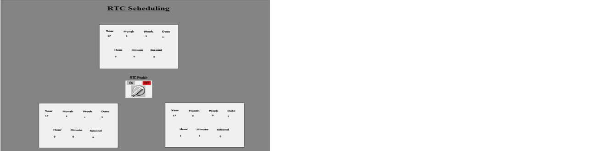

**Fig.6.14** **RTC Scheduling in SCADA**

**6.8 WORKING OF SYSTEM**

As the RTC(Real Time Clock) are set already when the time arrived as set in RTC, The power supply is given to the cleaning tool through the PLC.

The cleaning tool moves on the surface part of the solar panel in a forward and backward motion. At this point when the cleaning tool is at its initial state, the limit switch 1 is in actuated position or in ON condition. Thus this gives an first input signal to PLC, there by an output signal is given through the PLC to the gear motors which runs in a forward direction(clockwise).

As soon as the gear motor starts moving, the pumps gets actuated and the spraying action starts. The wiper mounted on the cleaning tool units also start moving in the forward direction. This entire cleaning tool is carried by the pinion which is guided by rack. Along the entire path, the water is spread on the solar panel it forces the dust to move in the direction of the motion of the cleaning unit and simultaneously the wiper wipes the panel finally flows it away at the edge of the panel. Once the cleaning unit reaches the other end, limit switch 2 gets actuated.

Thus this give the second input signal to PLC, there by an output signal is given through the PLC to the gear motors which now runs in backward direction(anti clockwise). As soon as the motor is reversed the pumps gets off and the spraying action is stop. Now the cleaning tool starts moving towards the initial position, their by the wiper fully wipes the panel without the water spraying. As the cleaning tool comes to the initial position the cycle completes and the process is stop.

Thus now the cleaning tool will be moving on the solar panel to clean when the RTC are set for the next cycle and the process repeats.

**Chapter 7**

**RESULTS**

As said in the problem description, how is dust reduces efficiency of the solar power plants and how effective is automatic cleaning system is better comparing to another systems. Below are the data which show how effectively the cleaning system works.

Formula to find efficiency of solar panel

Efficiency = $\frac{ \text{Output Power in }\text{Watts}\text{(}\text{P)} }{Input Power×Area(A)}×100$

A=Area of solar panel in m2

P = Power in watts [Voltage(V)×Current(I)]

Input Power = 1000 w/m2

**Table.1 Efficiency of Solar Panel without Cleaning system**

|  |  |  |  |  |  |
| --- | --- | --- | --- | --- | --- |
| **SL NO** | **DATE** | **Voltage**  **(Volts)** | **Current**  **(Amps)** | **Power**  **(Watts)** | **Efficiency**  **(٪)** |
| 1 | 12-03-2017 | 9.65 | 0.2 | 1.93 | 2.23 |
| 2 | 13-03-2017 | 9.61 | 0.2 | 1.92 | 2.22 |
| 3 | 14-03-2017 | 9.57 | 0.2 | 1.91 | 2.22 |
| 4 | 15-03-2017 | 9.54 | 0.2 | 1.91 | 2.21 |
| 5 | 16-03-2017 | 9.48 | 0.2 | 1.90 | 2.19 |
| 6 | 17-03-2017 | 9.45 | 0.2 | 1.89 | 2.19 |
| 7 | 18-03-2017 | 9.41 | 0.2 | 1.88 | 2.18 |
| 8 | 19-03-2017 | 9.39 | 0.2 | 1.88 | 2.17 |
| 9 | 20-03-2017 | 9.26 | 0.2 | 1.85 | 2.14 |
| 10 | 21-03-2017 | 9.05 | 0.2 | 1.81 | 2.09 |
| 11 | 22-03-2017 | 8.94 | 0.2 | 1.79 | 2.07 |
| 12 | 23-03-2017 | 8.76 | 0.2 | 1.75 | 2.03 |
| 13 | 24-03-2017 | 8.61 | 0.2 | 1.72 | 1.99 |
| 14 | 25-03-2017 | 8.4 | 0.2 | 1.68 | 1.94 |
| 15 | 26-03-2017 | 8.26 | 0.2 | 1.65 | 1.91 |
| 16 | 27-03-2017 | 7.96 | 0.2 | 1.59 | 1.84 |

**Fig.7.1 Efficiency of Solar Panel without Cleaning system**

The above graph shows how the efficiency of the panel goes on decreasing day by day due to dust accumulation. It was absorbed that there was drop of efficiency of 18% for 15 days of data collected.

**Table.2 Efficiency of Solar Panel with the Cleaning system**

|  |  |  |  |  |  |
| --- | --- | --- | --- | --- | --- |
| **SL NO** | **DATE** | **Voltage**  **(Volts)** | **Current**  **(Amp)** | **Power**  **(Watts)** | **Efficiency**  **(٪)** |
| 1 | 28-03-2017 | 9.52 | 0.2 | 1.90 | 2.20 |
| 2 | 29-03-2017 | 9.45 | 0.2 | 1.89 | 2.19 |
| 3 | 30-03-2017 | 9.4 | 0.2 | 1.88 | 2.18 |
| 4 | 31-03-2017 | 9.49 | 0.2 | 1.90 | 2.20 |
| 5 | 01-04-2017 | 9.44 | 0.2 | 1.89 | 2.19 |
| 6 | 02-04-2017 | 9.4 | 0.2 | 1.88 | 2.18 |
| 7 | 03-04-2017 | 9.56 | 0.2 | 1.91 | 2.21 |
| 8 | 04-04-2017 | 9.51 | 0.2 | 1.90 | 2.20 |
| 9 | 05-04-2017 | 9.42 | 0.2 | 1.88 | 2.18 |
| 10 | 06-04-2017 | 9.59 | 0.2 | 1.92 | 2.22 |
| 11 | 07-04-2017 | 9.5 | 0.2 | 1.90 | 2.20 |
| 12 | 08-04-2017 | 9.45 | 0.2 | 1.89 | 2.19 |
| 13 | 09-04-2017 | 9.55 | 0.2 | 1.91 | 2.21 |
| 14 | 10-04-2017 | 9.5 | 0.2 | 1.90 | 2.20 |
| 15 | 11-04-2017 | 9.47 | 0.2 | 1.89 | 2.19 |
| 16 | 12-04-2017 | 9.6 | 0.2 | 1.92 | 2.22 |
| 17 | 13-04-2017 | 9.59 | 0.2 | 1.92 | 2.22 |
| 18 | 14-04-2017 | 9.5 | 0.2 | 1.90 | 2.20 |
| 19 | 15-04-2017 | 9.59 | 0.2 | 1.92 | 2.22 |
| 20 | 16-04-2017 | 9.54 | 0.2 | 1.91 | 2.21 |
| 21 | 17-04-2017 | 9.44 | 0.2 | 1.89 | 2.19 |
| 22 | 18-04-2017 | 9.61 | 0.2 | 1.92 | 2.22 |
| 23 | 19-04-2017 | 9.59 | 0.2 | 1.92 | 2.22 |
| 24 | 20-04-2017 | 9.5 | 0.2 | 1.90 | 2.20 |
| 25 | 21-04-2017 | 9.65 | 0.2 | 1.93 | 2.23 |
| 26 | 22-04-2017 | 9.61 | 0.2 | 1.92 | 2.22 |
| 27 | 23-04-2017 | 9.5 | 0.2 | 1.90 | 2.20 |
| 28 | 24-04-2017 | 9.65 | 0.2 | 1.93 | 2.23 |

**Fig.7.2 Efficiency of Solar Panel without Cleaning system**

The above graph shows how efficiency of the solar panel when the automatic cleaning system was installed. The RTC was set for every third days, hence the system cleaned the panel for every third day and their was gain in the efficiency of the panel.

**Fig.7.2 Efficiency of Solar Panel without Cleaning system**

The above graph helps us to understand how useful is to cleaning system to improve the efficiency of the solar panel. From the above data it was clear that their was 18% increases in the efficiency.

**Chapter 8**

**ADVANTAGES AND DISADVANTAGES**

**8.1 ADVANTAGES**:

* Increases efficiency of solar plate.
* Sometime dust or other particles remains long time on a solar panel, so it damages the aluminium strip of solar plate. So we avoid these damages by this system.
* Increases the gain as much as 5 to 30% in output from your solar panels.
* Eliminate build-up of dirt and debris and potential damage to solar panels.
* Automatic self-cleaning mechanism that can be attached to solar panels and operated without human operation.
* Minimise the cost of cleaning as compared to manual.
* Remote control is possible.
* The entire plant can be handled by using single PLC system.

**8.2 DISADVANTAGES:**

* “Wiper Blade” which consists of an rubber band would need to be changed.
* Needs to be scaled for a larger project (ex: increase the torque of the motor ).
* To take care of cleaning water, to avoid nozzles blockages.
* Skilled labour is required to handle the system

**Chapter 9**

**CONCLUSION AND SCOPE OF THE PROJECT**

**9.1 CONCLUSION**

The main conclusions can be summarized as: The losses of the output power of the fixed solar panel at a tilt angle(35) is about 25% of the rated yield and can be higher depending on the dust form. The dirt and bird drop make a hotspot in the panel, and it can make temporary fail in the panel. Dry cleaning can' not remove all the dirt on the surface of the solar panel, but it is able to remove the outer layers of the dust. Cleaning solar panel with water increases the cleaning efficiency by removing majority of the dirt deposited on the panel. No external powers are required as the self- cleaning system takes its power from the battery of the solar panel. This device is made up of lightweight material, so the power consumed is low . Comparing the costs of cleaning by Manual operation and Automatic operation the cost for automatic cleaning is proved to be more economic and significantly less cumbersome particularly in systems having large number of solar panels. Also frequent periodic cleaning ensures that the solar panel works with a good transmittance consistently at all times.

**9.2 FUTURE SCOPE OF PROJECT**

1. Wireless transmission:- the movement of the tool which is done by PLC can be done wireless by using radio frequency which will reduce the cost involved in installing the system and also the complexity in maintaining the system will be reduced.
2. Wireless monitoring:- the present system which is monitored by SCADA through interfacing with PLC by wiring can also be done wireless.
3. Replacing the rack and pinion mechanism with other type of mechanism like track system for bigger power plants.
4. Interfacing with VFD (variable-frequency drive)drives for optimizing the power consumed by the system.
5. Using LDR sensor, it helps to sense amount of dust on panel and cleans the module automatically.