Simulation of Double Boost DC-DC Converter With Solar PV System Fed BLDC Motor

**E. Vishnuvarthini1, K. Logavani2,**

1PG Scholar, Power Electronics and Drives, Government college of Engineering salem.2Associate professor Department Of EEE, Government college of Engineering, Salem-636 011, Tamil Nadu, INDIA.

________________________________________________________________________________________________________

*Abstract :*  The expanded requirement for renewable sources of energy systems in order to generate the power, store energy, and connect the energy storage devices with applications has turned into a major challenge. Energy storage using batteries is in the majority of suitable cases for energy sources like solar, wind, etc. In this paper, double boost converter is designed and simulated for energy storage, interfaced with an output drive. Based on the requirements, the power that is extracted from the solar panel during the daytime is utilized to charge the batteries through the double boost converter. The proposed double boost converter in terms of operating principles and power flow can significantly enhance the system efficiency. To develop the suggested approach’s control hardware, and prototype model results are obtained to test the proposed double boost converter control system’s efficiency and practicality. Overall, the efficiency of the converter's output has shown an improvement. The success rate is 96.5% when charging an ESS, 98.1% when discharging an ESS, and 95.7% overall.

*IndexTerms* - BLDC motor; DC–DC converter; MPP tracking; solar PVsystem; double boost converter (DBC); energy storage device (ESD)

*________________________________________________________________________________________________________*

# **I.Introduction**

Renewable energy is environmentally friendly, but its constant yet variable DC voltage has a disadvantage. For example, solar panels depend on the position of the sun in the sky, as well as the hours of the day, which affects not only the amount of power that is produced but also the current that is transmitted. Since the wind speed is not controllable, the output voltage of the generator is not sufficient to power the inverter directly. Therefore, the DC voltage converter (or other bldc motor load) must be connected to power the output drive.

A non-isolate double boost converter can be built with shared switches. The regenerative energy energy system is connected to a three port circuit. During the day, the solar panels collect energy and send it to the double boost converter. The three port bidirectional one storage inductor charges the batteries. Multiple port converters have been studied for electric vehicles (EVs), energy storage (ES) and PV (PV). Multi-port converters need only a few conversion stages. The power density and conversion efficiency of these converters are very high when compared with conventional converters. For applications of higher power, isolated DBCs are needed. Non-isolated DBC may offer high efficiency, high power output and low cost in low power applications due to the reduction of transistors in a DBC. Single-switch DBC is a DBC family consisting of dual input/output converters with an additional power flow path. It has a very small size and high integration ratio. The two inductor bidirectional converters and two inductive boost converters combine to form a single DBC family. This DBC allows for the regulation of switching frequency as well as duty cycle. The usefulness and efficiency of the DBC are severely limited by the lack of a separate control approach, A multi-port step-up / step-down converter can be constructed with shared switches and connected to a three-port energy storage system. Different types of multi-port converter have been studied for electric vehicles (EVs), power storage (ES) and DC-to-DC converter circuits. Non-isolation DBCs offer high efficiency, high power output, and low cost in low power applications by decreasing the number of integrated transistors in a circuit. This is due to the high power density and high conversion efficiency of non-isolation bidirectional converters, which do not have isolation, but are inexpensive, easy to construct, and have limited internal components.

This DBC can be further improved and optimized with the help of the proposed magnetic integration technique. High voltage gain non-isolation DBCs are very challenging and complex in design. An important addition to this study is the single stage power conversion that takes place between bldc motor load port and PV or between bldc motor load port depending on the design. Power density can be improved by sharing passive power devices in different power flow modes. Efficiency can be improved by reducing the conversion gain by series connecting the PV in series during the discharge domain and making parallel connection between them during the charging domain. Generally, a PV panel is capable of producing the DC, except for most common household appliances such as fans. It can also use single phase induction motors, so conversion loss may have occurred in the operation of the DC to AC converter. This type of difficulty cannot be eliminated by replacing an AC induction motor by a DC motor.

The disadvantage of a DC motor, however, is its high maintenance cost, low rpm application and high EM (electromagnetic (noise). A BLDC is used as an alternative because it has an improved power to weight ratio over a conservative induction motor. The advantage of a BLDC is that it is openly able to power run of DC, but for speed control of a BLDC drive, it has the advantage of additional current sensors and control.

**2.PROPOSED SYSTEM**

**2.1 CIRCUIT OF PROPOSED SYSTEM**

The DC/DC Converter, In commonly used in standalone renewable power systems in order to provide continuous and stable power to the electricity bldc motor loads.Interfaces Renewable Energy Source and Bldc motor load.

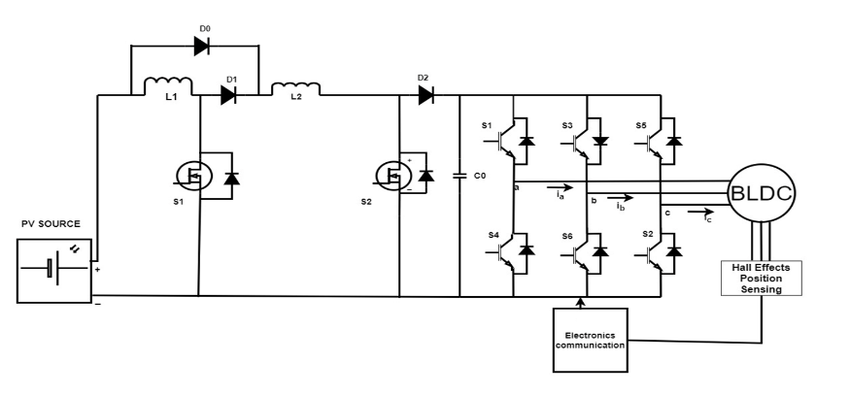

**Figure 2.1 Circuit Diagram Of Proposed System**

In this figure 2.1 shown the diagram of proposed system that can using the photovoltaic source act as a input and its gives to converter then universal bridge given to motor bldc motor load as BLDC.

**2.2 DESIGN OF CONVERTER AND OPERATING PRINCIPLES**

The foundation of the converter is established by the voltage extension cell and switching circuit built around an inductor, as illustrated in Figure 2.1.

Energy transmission from a power generator to a bldc motor load According to the two operating modes and Kirchhoff’s Current Law (KCL), we can obtain the current stress of each device of the proposed converter. In the two operating modes, the capacitor current is represented by *ICon* and *ICoff*, and the equation is as follows.

Icon =−Io(1)

Icoff = ID3 −Io (2)

where *Io* represents the output current and *I*D3 represents the current flowing through diode D3. By applying ampere-second balance to the capacitor, the following equation can be obtained as

Io·D =( ID3 −Io ) . (1−D) (3)

According to Equation (7), the current stress of diode D3 can be expressed as:

ID3 =(4)

Ignoring the loss of th e converter, assuming that the input power and the output power are the same, the following equation can be obtained as:

*Vin* · *Iin* = *Uo* · *Io* (5)

From (4) and (9), the relationship between input current *Iin* and output current *Io* can be expressed as follows:

*Iin* = 1 +*D .I0* (6)

*1-D*

According to the operating principle of the ON mode, the current stress of the switches S1, S2 and the diode D1 can be obtained as:

*I*S1 = *I*S2 = *I*D1 = *Iin* = 1 + *D* · *Io* (7)

2 2(1 − *D*)

where *I*S1 and *I*S2 represent the current flowing through switches S1 and S2, respectively, and *I*D1 represents the current flowing through the diode D1.

According to the operating principle of the OFF mode, the current flowing through the diode D2 is equal to that of diode D3, and it can be described as follows:

*I*D2 = *I*D3 = *Io* (8)

1 − *D*

Finally, according to Equations (5) and (6) and the root mean square principle of the capacitor current, the current stress *IC*1 of capacitor *C*1 can be obtained as:

*IC*1 = . Io (9)

# ***2.2.1Calculation of Inductor and Capacitor of Converter***

The parameters of the experimental prototype are as follows: the input voltage is 20 V, the rated output voltage is 100 V, the rated bldc motor load is 100 Ω, the output power rating is 100 W, the values of inductors *L*1 and *L*2 are both 0.35 mH, the value of the capacitor is 47 µF, the type of switch is IFR640N, the type of diode is DFE10I600PM and the switching frequency is 20 kHz.

According to Equation the inductance value can be calculated as:

*L*1 = *L*2 =Vin × *D* (10)

2× ∆*IL* × *f*

where ∆*IL* is the inductor current ripple; taking 20% of the average current as the inductor current ripple, the inductance value of the two inductors can be calculated to be 0.35 mH.

According to Equation, the capacitance value can be calculated as:

(11)

where ∆*U* is the output voltage fluctuation, taking 1% of the average output voltage as the capacitor voltage fluctuation, and the capacitor value can be calculated as 47 µH,the output capacitor (C0) starts discharging to the BLDC Motor bldc motor load.

**2.2.1 MODE ON**

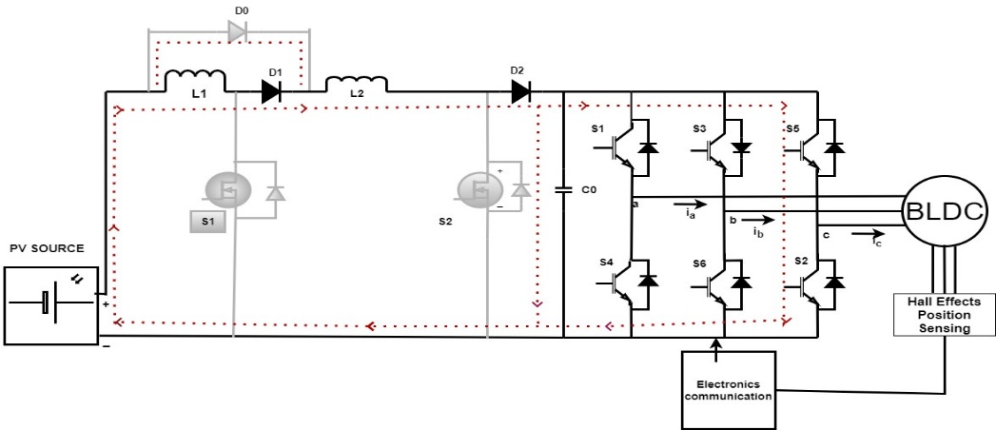When switches S1 and S2 are turned on, that is, the converter is in the ON operating mode, the inductors *L*1 and *L*2 are charged by the input power source, and the inductors absorb energy; the capacitor *C*1 supplies energy to the bldc motor load. The operating mode of the proposed converter is shown in Figure2.2.

**Fig.2.2 mode on circuit digram**

In this mode, diode D1 is turned on, and diodes D2 and D3 are turned off under reverse voltage. During this stage, there are three loops in the equivalent circuit. The input power Vin charges the inductor L1 through the switch S1 to form the first loop. The input power Vincharges the inductor L2 through the switch S2 to form the second loop. The output capacitor *C*1 provides energy to the bldc motor load to form the third loop. The voltages across the two inductors *L*1 and *L*2 are the voltages Vin of the input voltage power source.

then the turn-on time of switches S1 and S2 is *D* × *TS* in one cycle. Suppose that the currents through the inductors *L*1 and *L*2 are *IL*1 and *IL*2, respectively. In this stage, the currents of the two inductors are equal, and the energy absorbed by the two inductors in a PWM period is shown in Equation (1).

*WL* = Vin × *IL* × *D* × *TS* (12)

where *WL* represents the energy absorbed by the inductor during the turn-on period of the switch.output capacitor C0 begins to discharge to bldc motor load.

**2.2.2 MODE OFF**

When the switches S1 and S2 are turned off, that is, the equivalent circuit is in the OFF mode, the inductors *L*1 and *L*2 are connected in series with the input power source to provide energy to the bldc motor load and charge the capacitor *C*1; the operating mode of the converter is shown in Figure2.3.

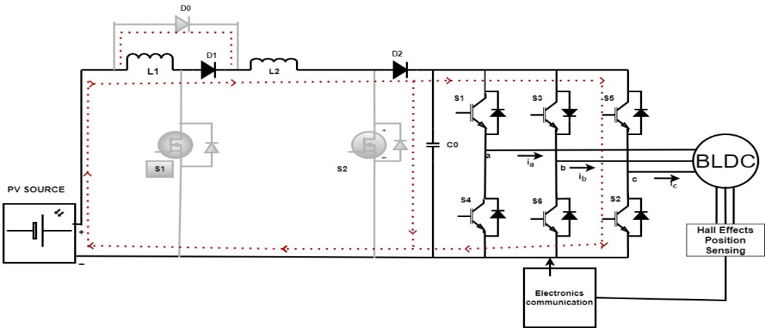

**Fig2.3;mode off circuit diagram**

In this mode, diodes D2 and D3 are turned on, and diode D1 is turned off under reverse voltage. During this stage, there is only one loop in the equivalent circuit. The input power source Vin and inductors *L*1 and *L*2 are connected in series to provide energy to the bldc motor load and charge the output capacitor *C*1. By ignoring the conduction voltage drop in the diode, the voltage across the two inductors *L*1 and *L*2 are the voltage Vin of the input voltage. The voltage and current reference directions on the inductor are uncorrelated, and the energy released by the two inductors in a PWM period is shown in Equation (13).

*WL*j =(1/2) *Uo -Uin* × *IL* × (1 − *D*) × *TS* (13)

where 1 − *D* represents the turn-off period of the switch, and *WL*’ represents the energy released by the inductor during the turn-off period of the switch.Based on the law of the conservation of energy, the following equation can be obtained as Equation (3).

*WL* = *WL*j (14)

According to Equations (1)–(3), the voltage gain *GD* of the proposed converter can be obtained as shown in Equation (14).

*GD* = 1 + *D* (15)

1 − *D*

.

By calculating this, the relationship between the voltage gain and the duty cycle *D* of the proposed double-boost converter can be obtained, as shown in Figure 4

**2.3** **MATHEMATICAL MODELING OF PROPOSED SYSTEM**

**2.3.1 PV MODELING**

The mathematical representation of a PV module can be derived from the equivalent circuit of a PV solar cell. The photocurrent, denoted as Ic, is determined by the temperature and solar irradiation of the cell, while Rs and Rsh represent the series and shunt resistances of the PV cell. The nonlinear voltage-current characteristic of the PV solar cell can be assessed using the Equation.

$I_{pv}$ = $I_{C}-I_{O}\left[\exp\left(\frac{q\left(v_{Pv}+R_{s}I_{pv}\right)}{kT}\right) -1\right] - \frac{v_{Pv}+R_{s}I_{pv}}{R_{sh}}$ (4)

## **2.3.2 THE FLOW OF ELECTRICITY IN SOLAR CELL**

Electrons, bearing a negative charge, migrate towards the front surface of the solar photovoltaic cell, resulting in an electrical charge imbalance. The electrical conductors on the cell then capture these electrons. Once the conductors are linked in an electrical circuit to an external bldc motor load and electricity is able to pass through the circuit.

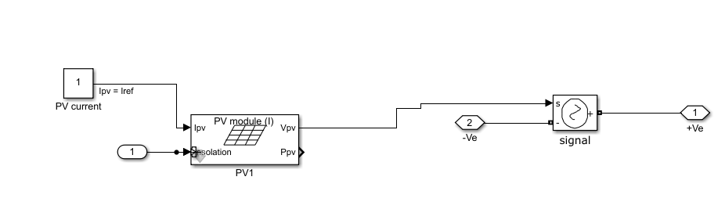

**Figure 2.4 Simulation of PV**

**2.4 CONTROLLERS**

This is the mechanism or algorithm responsible for processing the sensor input and producing the control output. It evaluates the measured process variable against the target set point and computes the error signal. Using this error signal, the controller produces the control output for the actuator.

**2.4.1 VOLTAGE CONTROLLER**

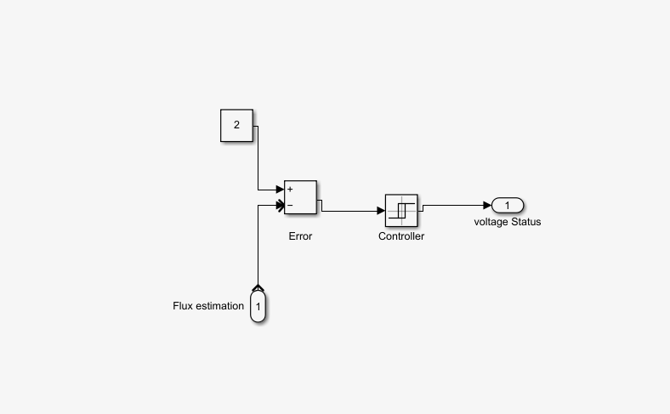The DC-DC Voltage Controller block utilizes discrete-time proportional-integral (PI) DC-DC voltage control with feedforward (FF) for optimizing transient response. It can provide either a duty cycle or a current control signal. Additionally, an anti-windup gain is implemented to prevent integral gain saturation.

**Figure 2.5 Simulation of Voltage Controller**

**Table 2-controlled voltage source block properties**

|  |  |
| --- | --- |
| **Source Type** | DC |
| **Initialize** | On |
| **Amplitude** | 230 |

**2.4.2 PI CONTROLLER**

The PI Proportional and Integral controller is a widely utilized technique in control systems to rectify the discrepancy between the desired setpoint and the actual value, based on feedback. Over the past decade, Permanent Magnet Brushless DC (BLDC) motors have found significant applications in various industries such as E-mobility (Electric vehicles, Electric bicycles), Industrial robots, and CNC machine tools. BLDC motors are crucial components in numerous industrial automation applications due to their exceptional efficiency and high torque-to-power ratios. Unlike traditional motors, Brushless DC motors operate without brushes on the rotor, resulting in minimal maintenance requirements. In the presented approach, the Hall Effect sensors are employed to commutate the BLDC motor. Furthermore, an algorithm is proposed for closed-loop PWM speed control of BLDC motors, where a predetermined value or user control is utilized to regulate the motor speed.

**Table 3-Discrete PI Controller block properties**

|  |  |  |
| --- | --- | --- |
| **PARAMETER** | **SYMBOL** | **VALUE** |
| Proportional gain | kp | 0.1 |
| Integral gain | ki | 1 |
| Sample time | - | 50e-6 |
| Output limits | Upper  lower | 1e6  10e6 |

**2.4.3 PID CONTROLLER**

Simultaneously, the PID controller's constant coefficients, namely Kp, Ki, and Kd, are utilized to establish a set of values. By incorporating these values, the modified controller suggested can be adapted to any desired dimension.

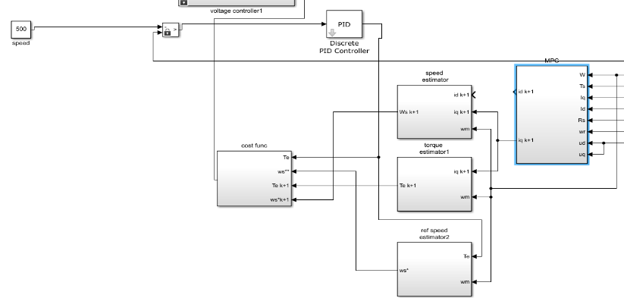

**Figure 2.6 Simulation of PID Controller**

**Table 3-Discrete PID Controller Block Properties**

| **Name** | **Kp** | **Ki** | **Kd** | **Tc D** | **Par Limits** | **Init** | **Ts** |
| --- | --- | --- | --- | --- | --- | --- | --- |
| Discrete PID Controller | 11.2 | 90 | 2.4 | 1 | [100 -100] | 0 | 0.5 |

**3.SIMULATION PARAMETER SPECIFICATIONS**

**Table 4 : Simulation parameter specification of double boost converter**

|  |  |
| --- | --- |
| **PARAMETERS** | **SPECIFICATIONS** |
| Inductor L1 | 100µH |
| Inductor L2 | 100 µH |
| Capacitors CO | 10 µF |
| Switch | 2Power MOSFET |
| Diode | 3Power Diode |
| Switching frequency | 50kHz |
| Input supply | 1800 W |
| Cell Temperature | 250 C |
| Irradiance | 1000W/m2 |

3.1 SIMULATION CIRCUIT

It has evolved over a period of years with input from many users. In university environments, it is the standard instructional tool for introductory and advanced courses in mathematics, engineering, and science. In industry, MATLAB is the tool of choice for high-productivity research, development, and analysis. Its features a family of add-on application-specific solutions called toolboxes*.*Very important to most users of MATLAB, toolboxes allow you to learn and apply specialized technology.The figure displays the simulation circuit of the proposed system. The simulation was conducted using MATLAB 2021a version with the ode23tb solver. To execute the simulation and observe the outcomes, the discrete powergui with a time constant of 5e-7 was employed.

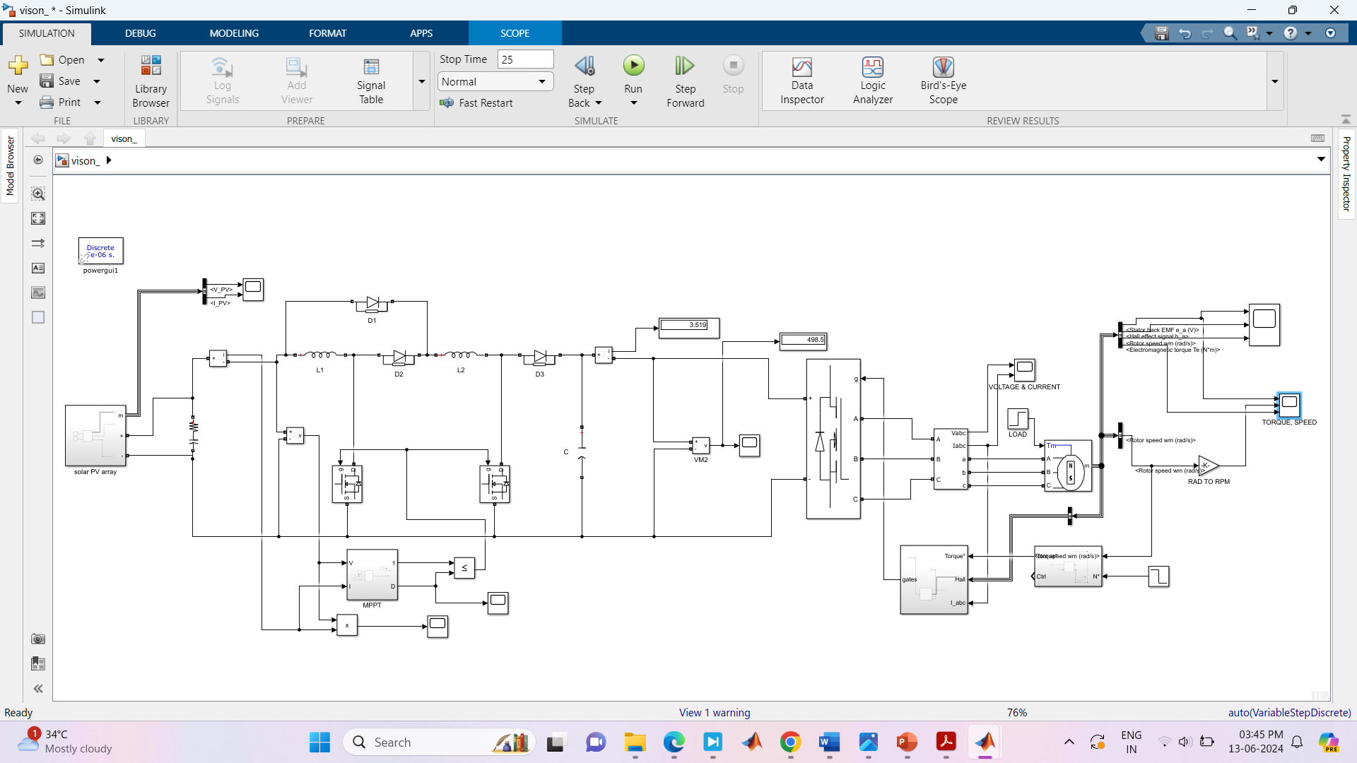

**Figure 3.1 Simulation of DBC Circuit.**

3.2 SIMULATION RESULT

The system simulation was created utilizing MATLAB/Simulink. A prototype of the DC-DC Converter under consideration has been constructed and examined. In order to attain the target output voltage, the simulation circuit was formulated in MATLAB, incorporating the necessary components available in MATLAB/Simulink.

**3.2.1 PANEL VOLTAGE**

The voltage obtained from the panel is depicted in Figure 3.1. The Simulink model utilizes a user-defined panel. By increasing the series and parallel strings, the desired voltage has been achieved.

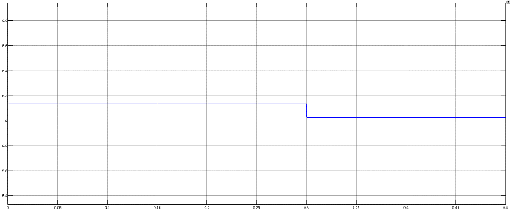

Figure 3.1 Waveform of PV

**3.2.2 CONVERTER VOLTAGE**

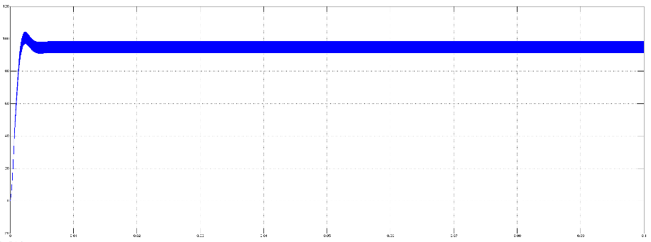The output voltage obtained from the Double boost converter converter for the designed duty cycle is illustrated in Figure 3.2. By utilizing the double boost converter, the voltage of the PV panel is effectively increased.

Figure 3.2 Waveform of double boost Converter Voltage

**3.2.3 UNIVERSAL BRIDGE**

In Figures 3.3 and 3.4 depict the universal bridge with and without a filter. The plot was obtained prior to the filter being utilized in the circuit, showing ripples in the waveform.

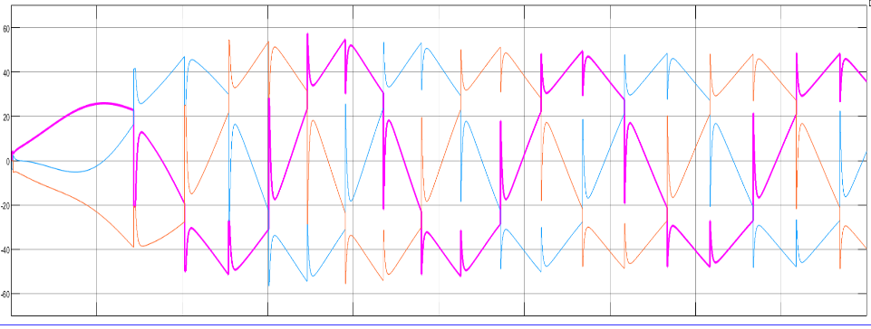

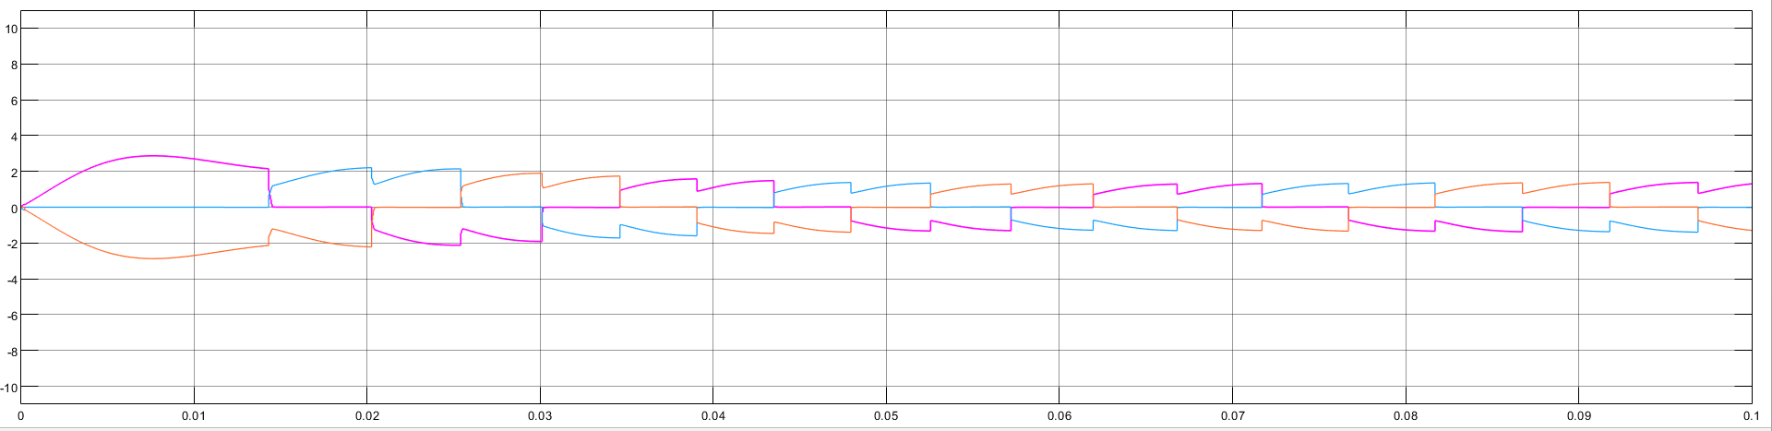Figure 3.3 Waveform UB Without Filter

Figure 3.4 Waveform UB With Filter

**3.2.4 SWITCHING PWM GENERATOR**

The figure 3.5 shows the switching pulse width modulation given to the double boost converter.

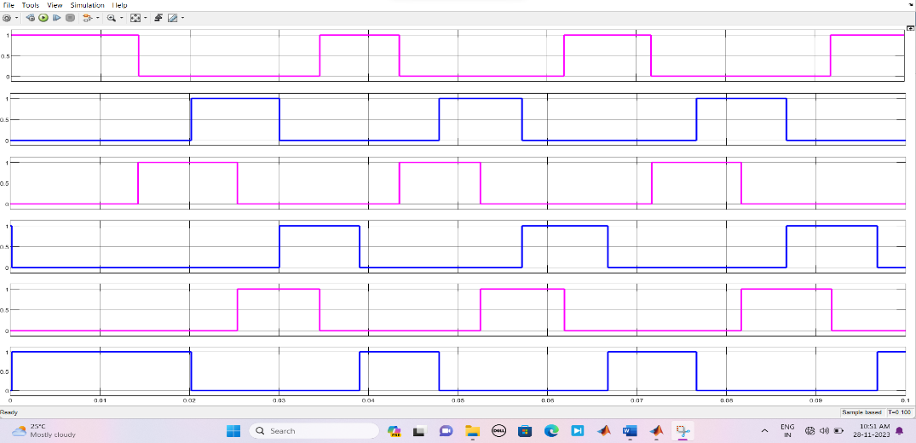

Figure 3.5 Waveform of Switching PWM Generator

**3.2.3 BUS SELECTOR OF HALL SIGNAL**

In this figure shown the hall signal that from bus selector of bldc.

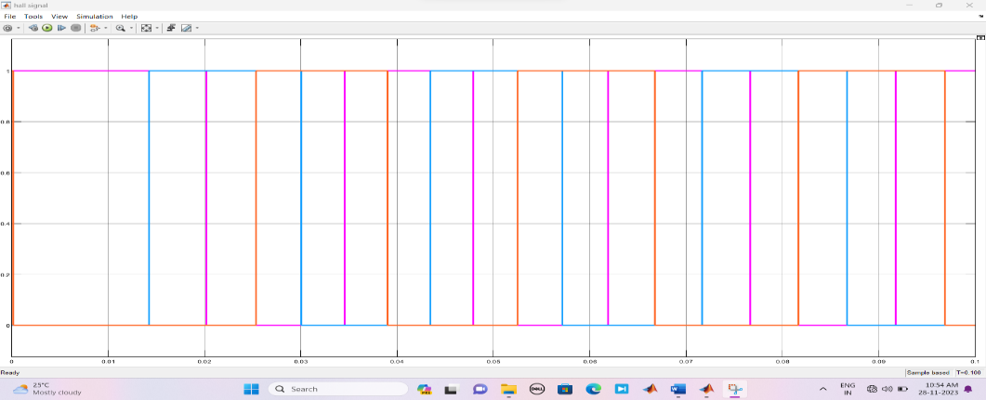

Time (sec)

Figure 3.6 Waveform of Hall Signal

**3.2.4 HALL SENSOR PWM MODULE**

In figure 3.7 this shows using hall sensor for bldc motor with pulse with modulation

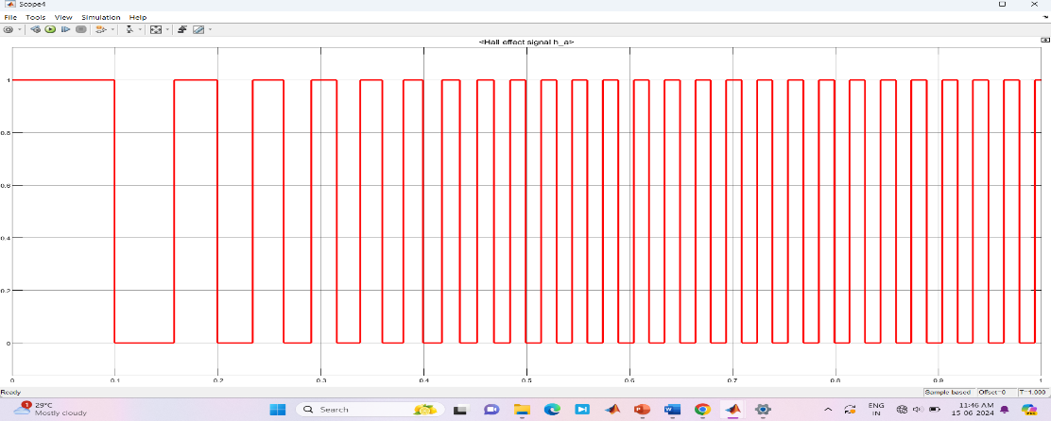

Time (sec)

Figure 3.7 Waveform Hall Sensor PWM Module

**3.2.3 STATOR CURRENT**

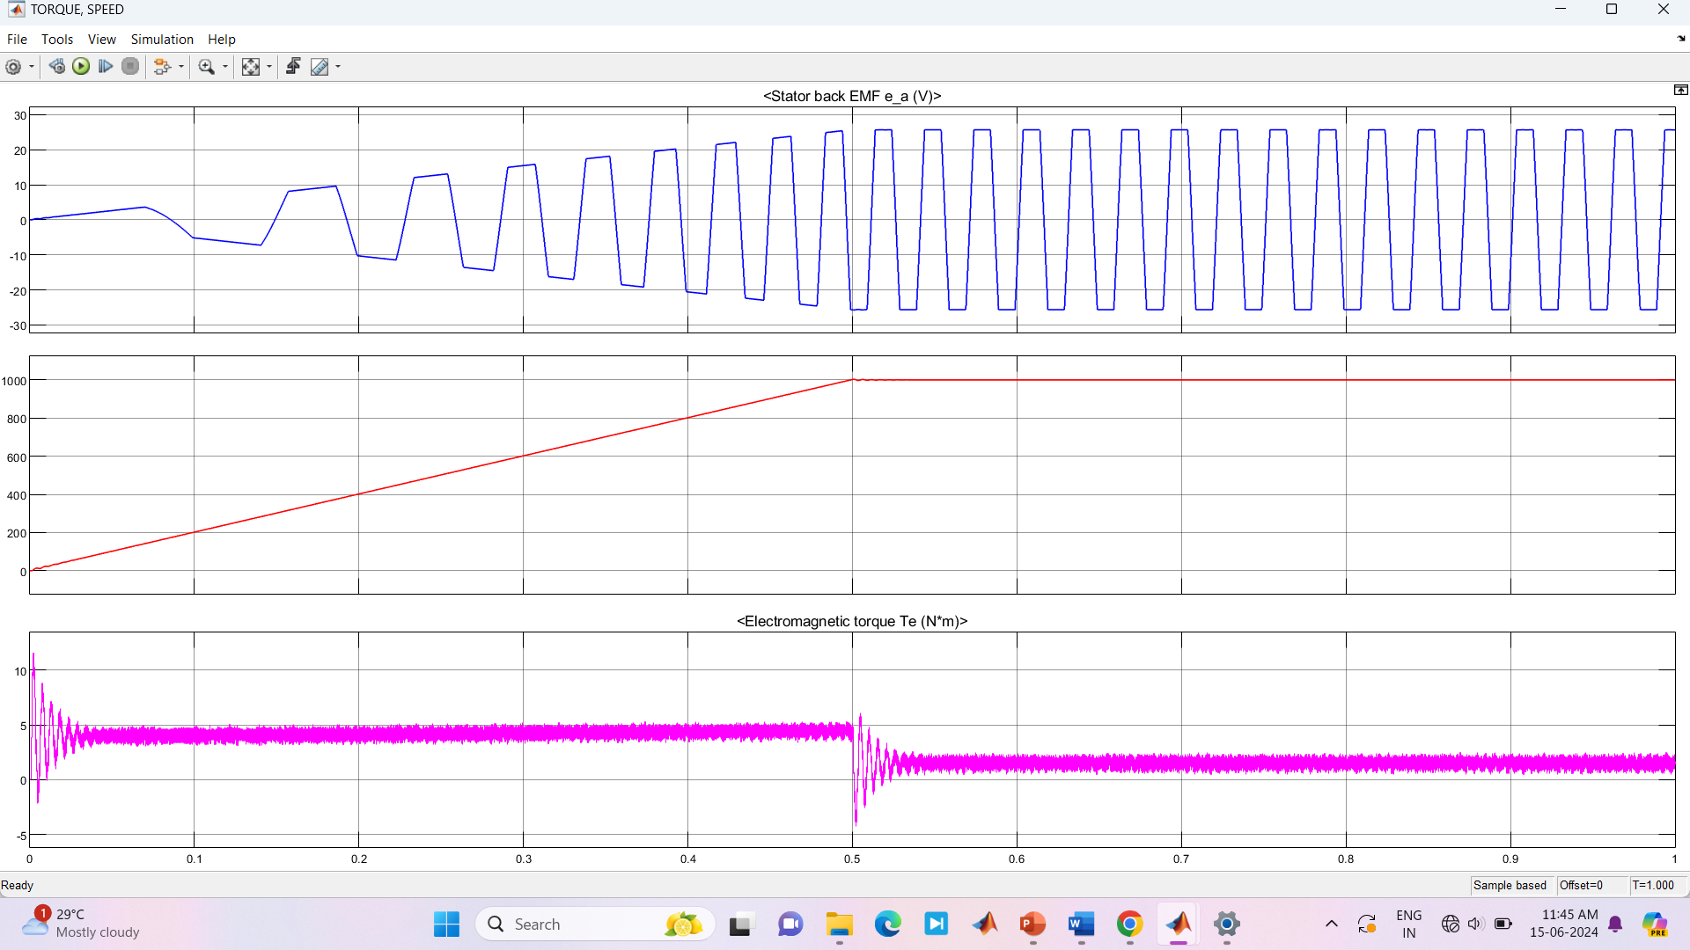The simulation output waveform of the stator current is displayed in Figure 3.8. The time is represented on the X-axis, while the magnitude of current for the stator waveforms is shown on the Y-axis.

Time (sec)

Figure 3.8 Waveform of Stator

**3.2.5 ROTOR SPEED**

In figure 3.10 shows output waveform of speed in BLDC motor ,to calculate speed by x axis is represents speed and y axis is represents time.

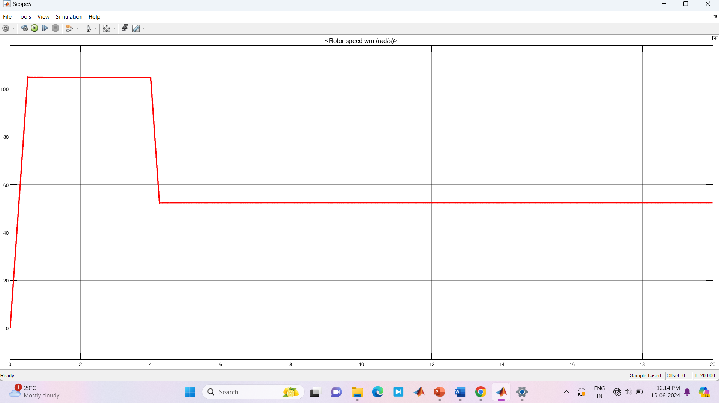

Time (sec)

Figure 3.10 Waveform of Speed

**3.2.6 TORQUE**

In figure 3.11 output waveform in torque from BLDC Shows, X axis represents Torque and Y axis represents time.

Time (sec)

Figure 3.11 Waveform of Torque

CONCLUSION

In this study, we have introduced a novel DC-DC converter that combines solar PV and a battery to power a BLDC motor. This converter has been designed to efficiently manage power simultaneously. Unlike traditional converters, the power generation sources directly charge the battery, regardless of the bldc motor load power. As a result, the overall output efficiency of the converter is significantly improved. The results clearly demonstrate that the converter is capable of maximizing power generation from solar PV during radiation and effectively controlling the battery to maintain a constant output value during irradiation. The proposed design exhibits an impressive efficiency of 96.5% while charging an ESS, 98.3% during discharge, and 95.76% when not charging an ESS. In the future, this innovative system can be implemented with a hysteresis comparator approach for automotive fuel pump applications.

**REFERENCE**

1. J.A. Morales-Saldana, et al, Modeling of a Cascade Boost Converter with Single Switch, The 32nd Annual Conference of the IEEIndustrial Electronics Society, 2016.
2. H.C. Iu, “Experimantal Study of Instabilities in Two paralle- Connected Boost Converter under Current Mode Control”, 11th European Conference on Power Electronics and Applications, 2019.
3. M. Veerachary, “General Rules for Signal Flow Graph Modeling and Analysis of DC-DC Converters”, IEEE Trans. On Aerospace and Electronics Systems, Vol. 40, No. 1, pp. 259-271, Jan, 2020.
4. N.Vazquez, L.Estrada, C. Hernandez and E. Rodriguez, « The Tapped-Inductor Boost Converter”, IEEE International Conference on Industrial Electronics (ISIE), 2019.
5. Mudhol, A.; Pius, A.J.P. Design and implementation of boost converter for photovoltaic systems. *Int. J. Innov. Res. Electr. Electron. Instrum. Control. Eng.* **2016**, *4*, 110–114.
6. Hu, H.; Harb, S.; Fang, X.; Zhang, D.; Zhang, Q.; Shen, Z.J.; Batarseh, I. A three-port flyback for PV microinverter applications with power pulsation decoupling capability. *IEEE Trans. Power Electron.* **2012**, *27*, 3953–3964.
7. Ali, A.; Hossein, A.; Amir, F. A novel high step-up DC/DC converter based on integrating coupled inductor and switched-capacitor techniques for renewable energy applications. IEEE Trans. Power Electron. **2015**, 30, 4255–4263.
8. DV Nicolae, Single-Phase Unity Power Factor Rectifier with Improved Dynamic Response for Non-linear Load, International Review of Electrical Engineering, Vol.2 No. 4, pp. 537-543, July-August 2007.
9. Axelrod, B.; Berkovich, Y.; Shenkman, A.; Golan, G. Diode-capacitor voltage multipliers combined with boost-converters: Topologies and characteristics. IET Power Electron. **201**, 5, 873–884.
10. G. Thiele and E. Bayer, Voltage Doubler/Tripler Current-Mode Charge Pump Topology with Simple “Gear Box”, 38th IEEE Powern Electronics Specialists Conference, 2021
11. B.S. Min, N.J Park and D.S. Hyun, “A Novel Current Sharing Technique for Interleaved Boost Converter”, 38th IEEE Power Electronics Specialists Conference, 2020
12. Batarseh, Power Electronics Circuits, John Wiley & Sons, Inc. 2019, pp. 189-199
13. Q. Zhou, Y. Huang, F. Zeng and Q-S. Chen, “Dynamic analysis of DC-DC Converter Based on Its Nonlinear Characteristics”, The 32nd Annual Conference of the IEEE Industrial Electronics Society, 2021
14. Motahhir, S.; El Ghzizal, A.; Sebti, S.; Derouich, A. Modeling of photovoltaic system with modified incremental conductance algorithm for fast changes of irradiance. *Int. J. Photoenergy* **2018**, *2018*, 3286479.
15. Mirza Fuad Adnan, Mohammad Abdul Moin Oninda, Mirza Muntasir Nishat, Nafiul Islam, “Design and Simulation of a DC - DC BoostConverter with PID Controller for Enhanced Performance”, IJERT, Vol. 6 Issue 09, September – 2017.
16. Wang, P.; Zhou, L.; Zhang, Y.; Li, J.; Sumner, M. Input-Parallel Output-Series DC-DC Boost Converter with a Wide Input Voltage Range For Fuel Cell Vehicles. IEEE Trans. Veh. Technol. **2017**, 66, 7771–7781.
17. Y. Bercovich, B. Axelrod, S. Tapuci and A. Ioinovici, “A Family of Four-Quadrant DC-DC Converters”, 38th IEEE Power Electronics Specialists Conference, 2022