Development of North Eastern Region of India through Union Budget Allocation from 2022 to 2024-2025
Tenzin Jamba,
Student, Department of Public Administration, The Assam Royal Global University, Guwahati, Assam
Abstract
The promotion of socio-economic growth and the strengthening of trade links have been made possible by initiatives such as the Act East Policy and the North East Special Infrastructure Growth Scheme (NESIDS). In addition, there are numerous of potential for tourism and sustainable development due to the region's scenic landscapes and natural resources. While maintaining the natural balance, an emphasis on ethically using these resources might result in long-term economic rewards. This paper's primary goals are to compare funding allotted to various development programs in 2022–2023; 2023–2024; and 2024–2025; and to recommend actions aimed at promoting development in the Northeastern region.
Keywords: Socio-Economic Development, North Eastern Region of India, Sustainable Development, NESIDS, Prime Minister’s Development Initiative for North East Region.

Introduction

The eight states that makeup North East India are Arunachal Pradesh, Assam, Meghalaya, Manipur, Mizoram, Nagaland, Tripura, and Sikkim. Spanning 262185 square kilometers, the region accounts for almost 8% of the nation's total land area. The area was connected to the Indian mainland by a slender 22-kilometer-wide strip of land known as "chicken neck."

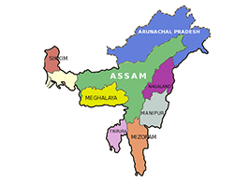 North-East India borders Bangladesh on the south and west, Myanmar on the east, China and Bhutan on the north, and Myanmar on the east. The issues and quirks are even more noticeable in the Northeast, where the international border makes up 98% of its boundaries. In Arunachal Pradesh, there are 13 people per square kilometer, while in Assam, there are 340 people per square kilometer. The vast majority of the tribal population resides in this area. More than 160 tribes are scheduled. One of the seven priorities, which serve as the "Saptarishi" directing the government "through the Amrit Kaal," is "inclusive development," which was highlighted in Finance Minister Nirmala Sitharaman's Budget for 2023–2024.

Highlight of Interim Budget 2024-25
Direct Tax Proposals
· Under the new tax regime, taxpayers earning up to Rs. 7 lakh will not be required to pay any taxes.
· Existing domestic enterprises will pay corporation taxes at a rate of 22% while selecting new manufacturing companies will pay tax at a rate of 15%.
· Nearly the past 10 years, direct tax collections have increased by nearly three times, while the number of return filers has decreased by 2.4 times.
Goods and Services Tax
l In FY24, the average monthly gross GST collection increased to Rs. 1.66 lakh crore, according to the Finance Ministry.
l In the post-GST period of 2017–23, the tax buoyancy of state revenue increased from 0.72 in 2012–16 to 1.22.
l (https://pib.gov.in/newsite/unionbudget2024.aspx, 2024)
Roadmap for Viksit Bharat 2047
The focus of this year's budget was Viksit Bharat, wherein the government aimed to envision a developed India by 2047. Viksit Bharat Budget 2024's four pillars are "Annadata" (Farmers), "Mahilayen" (Women), "Yuva" (Youth), and "Garib" (Poor).

Amrit Kaal as Kartavya Kaal
Sustainable Development/Green Energy
l Funding to bridge the reliability gap for offshore wind energy with a one-gigawatt initial capacity. The finance minister pledged to achieve "Net Zero" under Amrit Kaal by 2070, highlighting the need for sustainable development. Regarding this, the FM suggested:
Establishing a 100 MT coal gasification and liquefaction capacity by 2030. Enforcing the obligatory mixing of compressed biogas, PNG, and CNG for household use.

Healthcare: Girls between the ages of 9 and 14 are being strongly encouraged to get vaccinated against cervical cancer by the government.
Housing: The 3 crore residences that the Pradhan Mantri Awas Yojana (Grameen) set out to build are almost there, and another 2 crore are to be built over the next five years.
Tourism: To draw in business and foster chances for regional entrepreneurship, states will be urged to build famous tourist destinations.
Agriculture and Food Processing: All agro-climatic zones will see an expansion in the use of Nano-DAP.To attain Atmanirbharta for oilseeds, the Atmanirbhar Oilseeds Abhiyan plan will be developed.

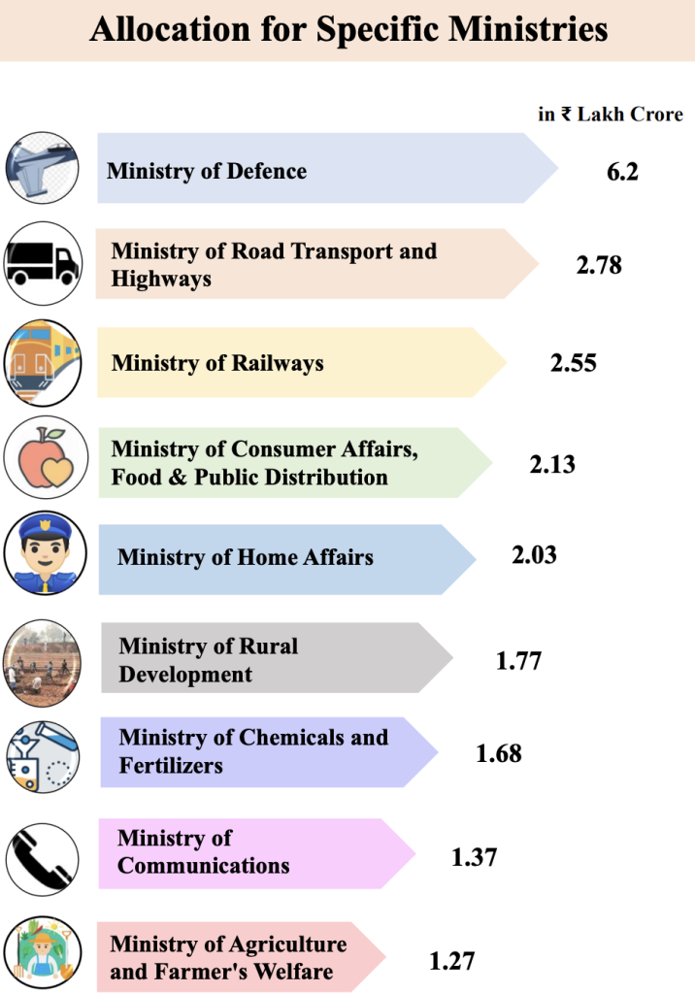
SCHEMES
- • The Prime Minister-led Union Cabinet has approved the ₹12882.2 crore extension of the Ministry of Development of the North Eastern Region (MDoNER) schemes for the fiscal years 2022–2026.
• The government announces the UNNATI (Uttar Poorva Transformative Industrialization Scheme), 2024, for the Northeastern Region (NER)! This strategy, with its innovative perspective and customized approach, has the potential to transform the industry and service sectors by meeting their ever-changing demands.
- • The project approved (but not yet finished) under the previous schemes listed below:
(i) Road/bridge projects under the NESIDS (ii) North East Road Sector Development Schemes (NERSDS)

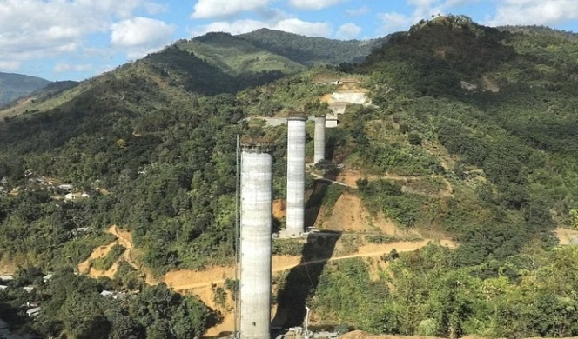
The Northeast Frontier Railway has built India’s tallest railway pier bridge in the Tamenglong district of Manipur.
- As of 26.12.2023, 14 projects totaling ₹3138.68 crore have been recommended for sanction, and nine (9) projects worth ₹855.85 crore have already received approval. Furthermore, under PM-DevINE, 12 projects totaling ₹983.05 crore have been approved in principle (chosen).

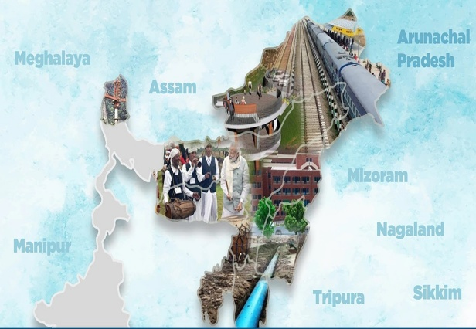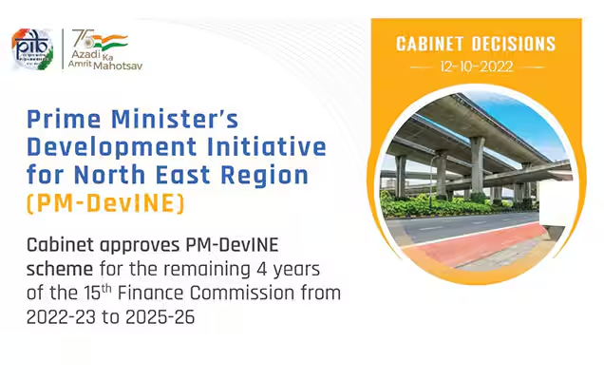

The Problem

The Northeast has had a great number of insurgencies. Insurgency in the Northeast has its roots in the region's geography, history, and a variety of socioeconomic issues. Numerous factors, including geography, socioeconomic development, political and economic conditions, historical, history, and environmental changes, contribute to these insurgencies. Other contributing factors include social, cultural, ethnic, and linguistic variety (Meenu, 2013).
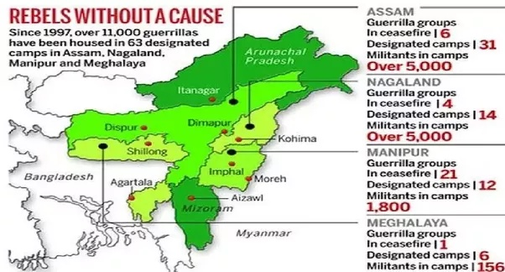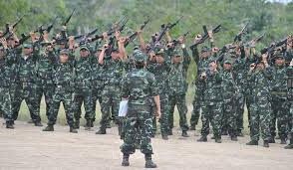

Literature Review
· The chapter "Problems and Prospects for Development of North Eastern Region of India" by Sukanta Sarkar and Dr. Suman Kalyan Chaudhury (2016) examined the region's current state of development. The human development index in India is determined to be below 0.62, with the North Eastern Region of the country having even worse values (Sukanta Sarkar, 2016)
Using documents from the Planning Commission and the Ministry of Women and Child Development, Government of India, released in 2002 and 2009, respectively, Nayak, Purusottam, and Ray, Santanu (2010) conducted a critical evaluation of the process of expanding human capabilities in the northeastern states of India. Using a variety of indices, including the HDI, HPI, GPI, GDI, and GEM, the Northeastern States are compared not only with one another but also with the corresponding performance at the national level. The paper concludes that to achieve a sustainable increase in human capacities, there must be a parallel expansion of economic opportunities for different sections of society and both sexes (Nayak, 2019).

Objectives
· To compare the budget allocation to different development schemes in 2022-23, 2023-24 and 2024-25.
· To suggest measures to increase development in the Northeastern region.
Research Mythology
The data was taken from the Ministry of Development's website in the North Eastern Region and is only related to budget allocation for different ministries. For secondary data, statistical methods were used, and the percentage was calculated after comparing the budget allocations in different years.
MINISTRY OF DEVELOPMENT OF NORTH EASTERN REGION
Budget allocation | Actual 2022-23 | Revised 2022-24 | Percentage | Revised 2023-24 | Budget 2024-25 | Percentage
- Centre’s expenditure  - Secretariat | 29.93 | 32.17 | 7.4% | 32.17 | 32.34 | 0.50%
Central Sector Schemes/projects  - Schemes on North east council | 370.17 | 800.00 | 11.61% | 800.00 | 1000.00 | 20%
Central Pool of Resource for North East and Sikkim  - North East Special Infrastructure Development Schemes(NESIDS)  3.1. NESIDS Programme  Total – NESIDS  - Prime Minister’s Development Initiative for North East Region(PM-DevINE) | 219.43  458.37  121.19 | 2490.16  2490.16  2200.00 | 91.19%  81.59%  94.49% | 2490.16  2490.16  2200.00 | 2380.66  2380.66  2055.00 | -4.59%  -4.59%  -7.05%
Total-Central Sector Schemes/Project | 936.18 | 5850.16 | 83.99% | 5850.16 | 5865.66 | 0.25%
B. DEVELOPMENTAL HEEADS  General Services  - Loans for Village & Small Industries  - Other Loans to Industries & Minerals  Total-Economic Service | 2.00  50.00  52.00 | 4.00  60.00  64.00 | 50%  16.66%  18.75% | 4.00  60.00  64.00 | 2.00  70.00  72.00 | -100%  14.28%  11.11%
Others  - North Eastern Areas  - Grants-in-aid to State Governments  - Capital Outlays on North Eastern Areas | 671.56  -67.34  284.28 | 1739.27  ……  4026.10 | 61.39%  ……  92.94% | 1739.27  ….  4026.10 | 1979.61  ….  3782.35 | 12.14%  ……  -6.44%
GRAND TOTAL | 989.956 | 5892.00 | 83.19% | 5892.00 | 5900.00 | 0.13%
C. INVESMENT IN PUBLIC ENTERPRISES  - North East Region Agricultural Marketing Corporation Limited  - North Eastern Handicraft & Handlooms Corporation Development limited  Total | 1.89  2.00  3.89 | 9.17  5.00  14.17 | 79.38%  60%  72.5% | 9.17  5.00  14.17 | 2.00  7.19  9.19 | -358.5%  30.45%  -54.18%
( Source: https://openbudgetsindia.org/organization/ministry-of-development-of-north-eastern-region)
Findings
A. Center’s Expenditure
• The Secretariat's budget for 2024–25 is 0.50% higher than its budget for 2023–24.
• The budget for the Central Sector Schemes/Projects on the North East Council is 20% more in 2024–25 than it was in 2022–23.
• The NESIDS Program under the Central Pool of Resources for North East & Sikkim has a -4.59% decline in the budget for 2024–25 compared to the budget for 2022–23. The NESIDS program as a whole has a -4.59 decrease.
• Under the Central Pool of Resources for North East & Sikkim, the Prime Minister's Development Initiative for North East Region (PM-Devine) budget for 2024–25 is -7.05% lower than the budget for 2022–24.
• The total increase for all Central Sector schemes and projects in the budget 2024–25 is 0.29% more than in the budget 2022–23.

B. Developmental Heads
C. The budget for 2024–2025 has a 100% reduction in loans for villages and small industries under general service compared to the budget for 2022–2023.
• The budget 2024–25 for Other Loans to Industries & Minerals is 14.28% higher than the budget 2022–2023 for the same category.
• The overall increase in the budget for 2024–25 is 11.11% more than that of the Economic Service budget for 2022–2023.
• The North Eastern Areas budget for 2024–25 increased by 12.14% over 2022–2023 under the category of Others.
• The Grant-in-aid to State Governments under Others in the budget 2024–25 is unchanged from the budget 2022–23.
• The capital expenditures for North Eastern Areas under Others in the budget 2024–25 are -6.44% lower than in the budget 2022–23.
· There is a 0.13% of increase in the budget 2024-25 to 2022-24 of the Developmental Heads (https://www.indiabudget.gov.in/, 2024).

D. Investment in Public Enterprises
• The budget 2024–25 of the North East Region Agricultural Marketing Corporation Limited is -358.5% lower than the budget 2022–23.
• Compared to the budget 2022–2023 of North East Handicrafts & Handlooms Corporation Limited, the budget 2024–2025 is increased by 30.45%.
• The investment in public enterprises is -54.18% lower in the budget 2024–25 than it is in the budget 2022–23.

Suggestions
• There are several potentials for tourism and sustainable development due to the region's natural riches and picturesque scenery. The emphasis on properly utilizing these resources can result in long-term financial gains while maintaining the ecological balance.
A key component of empowering the local populace and resolving persistent problems with unemployment and underdevelopment is investing in education, healthcare, and skill development.
Conclusion
The northeastern development of India is a varied and intricate undertaking, with a distinct set of opportunities and challenges. This region has great potential for regional integration and economic progress because of its advantageous geopolitical location and rich cultural variety. The emphasis on infrastructure upgrades, such as improved connectivity through air, rail, and road networks, which have enabled greater integration with the rest of India and adjacent countries, has been crucial to this development. The promotion of socio-economic growth and the strengthening of trade links have been made possible by initiatives such as the Act East Policy and the North East Special Infrastructure Growth Scheme (NESIDS).

References
https://pib.gov.in/newsite/unionbudget2024.aspx. (2024, Feburary 4). Retrieved May 5, 2024, from Union Budget 2024-25.
https://www.indiabudget.gov.in/. (2024, Feburary). Retrieved May 5, 2024, from Budget at a glance.
Meenu. (2013). Origin of Maoist and Social Justice. Academic views and reviews, International Journal , 25-34.
Nayak, P. &. (2019). Human Development in North East India - A Critical Appraisal.
Sukanta Sarkar, S. K. (2016). Problems and Prospects for development of North Eastern Region of India. In Environmental Studies. genNEXT Publication, New Delhi.
Meenu (2022), New Public Management and E-Governance in India: An Empirical Assessment of governance in the Public Sector, Futuristic Trends For Sustainable Ecosystem, Taylor &Francis Group,CRC Press.

