**Analysis of Building Stability by Indian and European Codes**

**DIPANSHU JAKHAR**

**ABSTRACT**

When precast concrete is constructed, the concrete is handled in a regulated industrial setting as it is poured into molds in accordance with standards. The concrete is then brought to the building site and placed where it is needed. Thus, a comparison of the building's stability study according to the Indian and Euro codes is done in this report. The process of manually calculating a stability check involves first calculating the horizontal load that will be applied to the structure through the computation of mass load and wind analyses. The mass load and wind load are included in the horizontal load. The geometrical imperfection load and the critical direction of both loads are then applied at floor levels. Second, the floor loads are divided among the stability walls at each floor level according to the relative stiffness of each wall. Lastly, each wall's local stability is examined. The following are the local stability checks: Sliding check; overturning check.

Every analysis and design is completed in accordance with Indian and European norms. in order to be able to compare the two at the end. Following the same procedure, the study concludes that the European Code's structural design is significantly safer than the Indian Code's because the European Code takes more safety factors into account, such as using mass load for low seismic zones where the Indian Code does not have such a parameter.

**KEYWORDS –**

Stability analysis, wind load, mass load, lateral load, comparison of Euro code and Indian Code, manual stability analysis.

**1. Introduction**

* Snedkerhaven is a residential structure located in Hvidovre, Denmark.
* It is a 4 Story structure and has a basement as well. it contains two blocks A and C and has a common basement.
* The dimensions of the Structure are Length =62m, Width =9.8m, and height =12.5m including a parapet of 0.5m.
* It is a complete Pre-Cast Concrete structure.
* A full detailed Stability Analysis will be carried out.
* Structural stability is the most critical concern in the
* Pre-Cast Structure.
* That is the reason the possibility of progressive collapse should be taken care of.

## 1.2 objectives of the study

* To know the structure stability of a sneadkerhaven building Denmark by manual calculation using European code and Indian code.
* Study and compare stability of structure from both the codes to attain with the differences between both codes.

## 1.3 Scope of the study

The scope of this paper is to find out and compare the stability analysis of building using European code and Indian code and adopt methodology of wind analysis and mass load analysis for the calculation of manual stability analysis of the building to know what the difference in using different codes is.

**2. Literature Review**

* a, T. r. (2018). COMPARATIVE STUDY OF ZONE 2 AND ZONE 3 FOR
* EQUIVALENT . Banglore: International Research Journal of Engineering and Technology (IRJET).
* Bhatt, P. (2011). Prestressed concrete desgin to Eurocodes hardcover. uk: Taylor & Francis Ltd.
* Jain`, A. (2012). Reinforced CXoncrete - Limit State Desgin (7 ed.). Delho: Laxmi Publication.
* Roy1, A. (2020). Comparative Study of International Structural Building Codes west bengal: International Research Journal of Engineering and Technology (IRJET) .
* Standard, B. o. (2000). IS 456:2000 Indian Standard code oractice for plain & Reinforced concrete (Vol. 4). new delhi: Bueau of Indian Standard.
* Trevor Draycott, P. B. (2009). Structural Elements Desgin Manual: working with Eurocode. UK: Taylor & Francis Group.

**3. Research Methodology**

After going through above literature, the researcher found that nowadays different countries use their codel provision to make their structure like-International building code,Indian code**,** Euro code etc.And it was also found that there is no study has been done so far which tells about the difference in the results of these codes. So, this study has been conducted to know the difference. For which we have taken a building in which we will do manual stability analysis by applying both Euro code and Indian code and see the difference between both the result. The study was undertaken to understand the stability of structure by doing a comparative analysis of a building using Euro code and Indian code to know whether the structure is stable from both the codes or not and what new can be found from this study. For this purpose, the below methodology has been used.

## 3.1 Method for data collection

For the achievement of the objectives of the study, data was collected through secondary source i.e., the company which has made this building (Ramboll company).

**4. RESULT AND DISCUSSION**

## 4.1 Comparison of stability analysis

# 

**FIG .4.1 Comparison chart of wind load on each floor level at Wall no.22**

# 

**FIG.4.2Comparision chart of wind load on each floor level at Wall no.21**

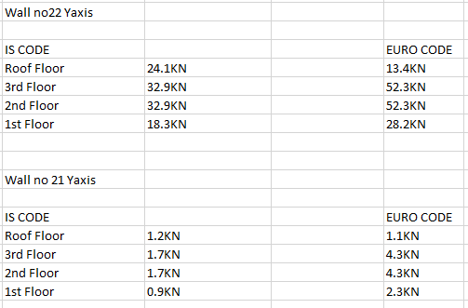

**FIG 4.3 Loads on Each Floor**

* The graph shows the wind load on each floor right side shows the wind load on each floor which is fined by applying Euro code BS EN 1991-1-4 in which we have taken the basic wind speed 24m/s and left-hand side graph represent the wind load on each floor which is find by applying Indian code IS 875 Part 3 in which we assumed that basic wind speed is 39m/s.
* But after applying the greater value of basic wind speed 39m/s in case of Indian code-based solution the load in the wall is lesser than the load on same wall calculated on the basis of Euro code.
* It is clear that Euro code provide more factor of safety as compare to Indian code because it provides higher value of load on the lesser value of basic wind speed.
* Due to which the cost of the same construction project with Euro Standard is more costly than the Indian Standard because of more construction material. it is because it provides more design load. Which means it gives more concern to safety and provides more factor of safety as compared to Indian standard.

## 4.2 Stability check of walls

**Wall no 22**

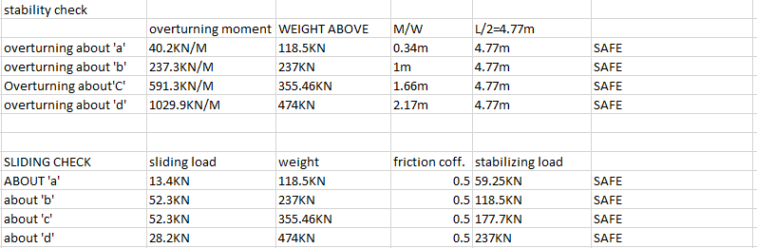

# 5. CONCLUSION AND SUGESSTION

## 5.1 CONCLUSION

In this study comparing the SNEADKERHAVEN building's stability analysis. In order to determine the stability of the structure, the researcher uses two separate codes: the Indian code and the Euro code. The data for this study comes from the Ramboll firm in Gurgaon, and the stability of the structure is calculated manually using wind analysis.

The comparison study's findings lead to the following deductions:

* Whereas we used basic wind velocity of 24 m/s in the European Code, we utilized basic wind velocity of 39 m/s in the Indian Code. Consequently, we discovered that, in contrast to Indian code, where the wind velocity is larger but the wind load is still low, even with less wind velocity, European code gives a significant wind load. It demonstrates unequivocally that the European Code gives greater weight to safety when constructing structures, which enables them to support heavier weights.
* • Based on the manual calculation of the stability analysis of the Sneadkerhaven building, it can be determined that the building is stable in every way and is capable of withstanding any loads that may be applied to it over the course of its lifespan, as examined in both the Indian and European codes.
* • The Euro Code takes into account a greater number of criteria for stability analysis than the Indian Code. For example, the Euro Code considers mass load when calculating the low seismic zone, but the Indian Code does not include any such characteristics.
* • Additionally, I have seen firsthand that calculations made using European code are far more intricate than those made using Indian code since the former has more specialized terminology, which makes it more accurate and more practical.

## 5.2 SUGGESTION

* Whereas both codes are excellent in their own right, the European code takes certain factors into account whereas the Indian code does not. For the safety of the structure, for example, mass load for a low seismic zone, we must thus take some parameters of the Euro Code into account if we are not employing it.
* Due to their extended lifespan and stringent safety requirements, large projects like building roads, trains, dams, and other infrastructure must adhere to the Euro Code.