Distributed Operating System

Authors Name :- Dr. Anish Patel Department Name:- Computer Science, Seva Sadan Mahavidyalaya, Burhanpur City:- Burhanpur(M.P.) Country: India Email:- [onlypatel7111 @gmail.com](mailto:onlypatel7111@gmail.com)

Authors Name :- Dr. Anil Choudhary Department Name:- Computer Science, Seva Sadan Mahavidyalaya, Burhanpur City:- Burhanpur(M.P.) Country: India Email:- [anilmchoudhary1796@gmail.com](mailto:anilmchoudhary1796@gmail.com)

# ABSTRACT

The paper aims at providing a whole survey of distributed operative systems. This paper additionally explain intimately numerous key style problems concerned in the building of such system. A distributed operative system may be a software system over a set of independent, networked, communication, and physically separate procedure nodes. Each individual node holds a selected software system set of the global mixture package. every set may be a composite of 2 distinct service provisioners. The first is a marginal kernel, or microkernel, that directly controls that node’s hardware. Second may be a higher-level collection of system management parts that coordinate the node's individual and cooperative activities. These parts abstract microkernel functions and support user applications. The microkernel and also the management parts collection work along.

# INTRODUCTION

A distributed software system is associate software system that runs on variety of technologies whose operate is to form out there a helpful set of services, generally to make the set of machines act additional sort of a solely machine. A distributed OS provides the essential services and functionality needed of associate OS, adding attributes and particular configurations to permit it to support additional necessities like increased scale and availability. To a user, a distributed OS works in a very manner almost like a single-node, monolithic in operation system. That is, though it consists of multiple nodes, it seems to users and applications as a single node. Separating negligible system-level practicality from additional user-level standard services provides a “separation of mechanism and policy.”

# EXAMPLES OF DISTRIBUTED OPERATIVE SYSTEMS

**l. IRIX operative system**; is that the implementation of UNIX System V, un harness three for atomic number 14 Graphics multiprocessor workstations.

1. **genus** Aix software system for IBM RS/6000 computers.
2. **Solaris software** system for SUN digital computer workstations

**GOALS**

1. There area unit many various kinds of distributed computing systems and lots of challenges to beat in with success coming up with one. the most goal of a distributed computing system is to attach users and resources in a clear, open, and ascendible way.
2. One style goal in building a distributed system is to create one system image; to own a set of freelance computers seem as one system to the user.

# Hardware Concepts

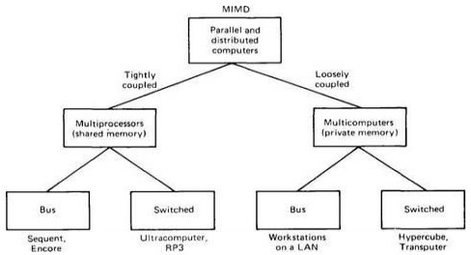

Although all Distributed Systems incorporates multiple CPUs, there square measure alternative ways of interconnecting them and the way they convey Flynn (1972) known 2 essential characteristics to classify multiple processor laptop systems: the number of instruction streams and therefore the range of knowledge streams

1. Uniprocessors SISD
2. Array processors square measure SIMD – processors cooperate on one downside
3. MISD - No illustrious pc fits this model
4. Distributed Systems square measure MIMD MIMD is split into 2 classifications

**Tightly-coupled** - short delay in communication between computers, high rate (e.g., Parallel computers acting on connected computations)(MULTIPROCESSORS) Loosely-coupled - giant delay in communications, Low rate (Distributed Systems acting on unrelated computations)(MULTICOMPUTERS) Can be additional sub classified as Bus - All machines connected by single medium (e.g., LAN, bus, backplane, cable) Switched - Single wire from machine to machine, with presumably completely different wiring patterns (e.g, Internet)

# MULTIPROCESSORS: CPUS have shared memory.

1. **Bus-based multiprocessors:** In a bus-based system, all CPUs square measure connected to 1 system bus. System memory and peripherals are connected to it bus. If hardware A writes a word to a memory location and hardware B will browse that very same word
2. Switched Multiprocessors Used for more than 64 CPUs

* Split memory into smaller modules
* Connect all CPUs to each memory module,
* two common method between communicating hosts, allowing other hosts to communicate without seeing their network speeds diminish. The huge benefit of switching is that it gives us a scalable network,.

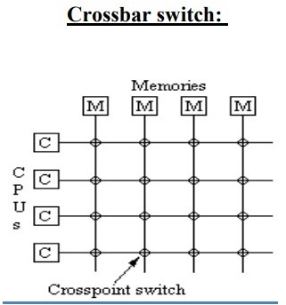

# MULTICOMPUTERS: CPUs have separate memories.

1. **Bus-based multicomputers:** Bus-based multicomputers square measure easier to style in this we don’t ought to cope with problems with shared memory: each CPU merely has its own native memory. The communication network between the two could be a bus (for example, associate space network|LAN} native area network).

# Switched Multicomputers:

With a switched interconnect, all hosts hook up with a network switch. The switch moves traffic solely back at any time after the write, the memory is coherent.

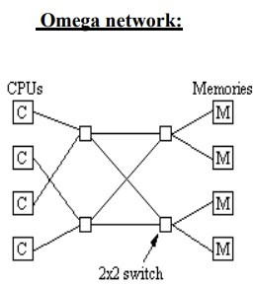

**SOFTWARE CONCEPTS** : There is no single definition or goal of distributed software but in designing distributed software, we often touch upon the same set of goals and problems. These general goals are transparency and scalability. This covers problems as diverse as: A network of redundant web servers

# ADVANTAGES OVER CENTRALIZED SYSTEMS

1. Speed: When used to implement parallel processing where only goal is to achieve maximum speed on a single problem, distributed systems can achieve very high specd as compared to the centralized ones.
2. Inherent Distribution: Another reason for building a distributed system is that some applications are inherently distributed. Banking, Airline reservation etc. are examples of the applications that are inherently distribute.
3. Reliability: one is higher reliability. By distributing the workload over many machines, a single chip failure will bring down at most one machine, leaving the rest intact. For critical applications, such as control of nuclear reactors or aircraft, using a distributed system to achieve high reliability may be a dominant consideration.
4. Incremental Growth: It may be possible to simply add more processors to the system, thus allowing it to expand gradually as the need arises.

**DESIGN ISSUES**

1. **Transparency :** At the high levels, transparency means hiding distribution from the users. At the low levels, transparency means hiding the distribution from the programs. There are several forms of transparency:
2. **Location transparency :** Users don’t care where the resources are located. Migration transparency: Resources may move at will.
3. **Replication transparency:** Users cannot tell whether there are multiple copies of the same resource.
4. **Concurrency transparency:** Users share resources transparently with each other without interference.
5. **Parallelism transparency:** Operations can take place in parallel without the users knowing.
6. **Flexibility:** It should be easy to develop distributed systems. One popular approach is through the use of a microkernel. A microkernel is a departure from the monolithic operating systems that try to handle all system requests. Instead, it supports only the very basic operations: IPC, some memory management, a small amount of process management, and low-level I/O. All else is performed by user-level servers.
7. **Reliability :** Reliability encompasses a few factors: data must not get lost, the system must be secure, and the system must be fault tolerant.
8. **Performance:** The communication links may be slow and affect network performance. If we exploit parallelism, it may be on a fine grain (within a procedure, array ops, etc.) or a coarse grain (procedure level, service level).
9. **Scalability**: We’d like a distributed system to scale indefinitely. This generally won’t be possible, but the extent of scalability will always be a consideration.

# APPLICATIONS

**Network applications:**

* World wide web and peer-to-peer networks Massively multiplayer online games and virtual reality communities o Distributed databases and distributed database management systems Distributed information processing systems such as banking systems and airline reservation systems **Real-time process control**:
* Aircraft control systems Industrial control systems **Parallel computation:**
* Scientific computing, including cluster computing and grid computing and various volunteer computing project.

# CONCLUSION

Distributed systems carries with it freelance CPUs that work along to form absolutely the system appear as if a single laptop. they need variety of doable selling points, together with sensible price/performance ratios, the potential to match distributed applications well, probably high consistency and progressive increase because the work grows. They even have some disadvantages, like additional composite computer code, potential communication bottlenecks, and weak security. all the same, there's important interest worldwide in building and putting in them. Distributed in operation systems flip the whole set of hardware and computer code into one integrated system, very like a usual timesharing system. Distributed systems have to be compelled to be designed suspiciously. A key topic is simplicity — concealing all the distribution from the users and still from the applying programs. Another issue is flexibility. the design should be created with the theme of creating potential changes simple.

# REFERENCES

1. Dos concepts and design By Pradeep K. Sinha
2. Dos concepts and design ByAndrew S.Tanenbaum
3. Distributed Systems: Principles and Paradigms Hardcover, By Andrew S. Tanenbaum (Author), Maarten van Steen (Author)
4. [www.cs.usfca.edu](http://www.cs.usfca.edu/)
5. [www.cs.columbia.edu](http://www.cs.columbia.edu/)
6. [www.b-u.ac.in/sde_book/distrib_computing.pdf](http://www.b-u.ac.in/sde_book/distrib_computing.pdf)