**OPTIMIZATION OF COOLING TOWER PERFORMANCE ANALYSIS**

Ms. Vidhi Chandan1 and Prof. Vishal Sapate2

1PG student, Department of Civil Engineering, G.H. Raisoni University ,School of Engineering and Technology, Amravati.

2Assistant Professor, Department of Civil Engineering, G.H. Raisoni University ,School of Engineering and Technology, Amravati.

**ABSTRACT:**

The cooling tower is a device that transforms hot water into cold water through direct air contact, operating on the temperature difference between the air inside the tower and the outside environment. The natural draft cooling tower is one of the most widely used types due to its efficiency. The hyperbolic shape of the cooling tower is preferred for its durability, stability, and the large area it provides based on its design. Given its critical role in atomic and chemical plants, it is essential to continuously assess the cooling tower's stability under its own weight and lateral loads such as wind and earthquake forces. To ensure this, cooling towers are tested for wind loads, taking into account the fixity-based shell. Wind loads on these towers are designed as pressure loads using distributed wind pressure coefficients, in accordance with the guidelines provided in the IS 11504-1985 code, which specifies the design wind pressure on various structures.

**Keywords**: cooling tower, stress, forces and loads

1. **INTRODUCTION:**

A cooling tower is a tall cylindrical structure typically made of reinforced concrete, used to cool water or condense steam from industrial processes. It functions as a heat rejection device by transferring waste heat to the atmosphere through the cooling of a water stream to a lower temperature. There are two main shapes of cooling towers: hyperboloid (or hyperbolic) and rectangular. Hyperboloid cooling towers are typically between 130-200 meters tall and have a diameter of approximately 100 meters, while rectangular cooling towers are about 40 meters tall and 80 meters long.

Cooling towers are constructed using concrete and reinforced steel bars (rebar). The choice of foundation for each type of cooling tower—whether individual foundations, ring foundations, or piling—is determined based on the specific ground conditions at the installation site. These towers find applications in various industries such as oil refineries, petrochemical plants, chemical plants, thermal power stations, and HVAC systems for cooling buildings.

The safety and structural integrity of hyperbolic cooling towers are critical for ensuring the continuous operation of power plants. Depending on the geographical location of the cooling tower, seismic considerations may dictate its design to withstand potential earthquakes.

1. **REVIEW OF LITERATURE:**

Athira C R et al, 2016 [1] The safety and operational continuity of hyperbolic cooling towers in power plants depend significantly on their structural design considerations, influenced primarily by wind and earthquake conditions at the site. Comparative analyses using different methods revealed that under El-Centro earthquake conditions, nonlinear dynamic time history analysis exhibited higher nodal drift compared to equivalent static and response spectrum methods. The percentage variations between these methods were found to be 30% (ES vs. RS), 63% (RS vs. TH), and 73% (ES vs. TH). This study concludes that time history analysis accurately predicts structural responses due to its inclusion of P-Δ effects and material/geometric nonlinearities, which are crucial for real-world applications.

Akash Goyal et al, 2017 [2] This study investigates the structural behavior of hyperbolic cooling towers under seismic, wind, and dead load conditions, focusing on the influence of geometric parameters (top diameter, throat diameter, and height). The analysis emphasizes the significant role of earthquake zones in determining structural responses. Findings suggest that a tower configuration with 300 mm thickness, 60 m throat diameter, and 250 m height is optimal, but heights exceeding 159 m (from practical experience) should be approached cautiously, with 170 m identified as a critical threshold.

Athira C R, et al [3] This paper examines the structural analysis of two cooling towers standing at heights of 122 m and 200 m above ground level. Using ANSYS software, the study focuses on wind load calculations by assuming fixed conditions at the base of the tower shells. Wind pressures are computed using circumferentially distributed design coefficients as per IS: 11504-1985 and design pressures at various levels following IS: 875 (Part 3)-1987. The analysis employs 8-noded shell elements (SHELL 93) with 5 degrees of freedom per node to assess the towers' response to wind loads.

1. **METHODOLOGY**

Building modeling involves the meticulous assembly and representation of its load-bearing components, aiming to accurately depict their mass distribution, strength, stiffness, and deformability. This chapter begins by providing an overview of essential parameters such as material properties and basic geometric characteristics necessary for defining the model. Emphasizing the significance of capturing nonlinear properties in structural elements, particularly for nonlinear analysis, is crucial in ensuring precise structural assessments. For this study, STAAD Pro v8i serves as the tool of choice for both modeling and analyzing the structures.

Outlined below are ten distinct models of cooling towers, each characterized by varying heights and seismic design considerations:

1. Model-I: Cooling Tower with a height of 10 meters located in seismic zone-II.
2. Model-II: Cooling Tower with a height of 10 meters located in seismic zone-III.
3. Model-III: Cooling Tower with a height of 10 meters located in seismic zone-IV.
4. Model-IV: Cooling Tower with a height of 10 meters located in seismic zone-V.
5. Model-V: Cooling Tower with a height of 15 meters located in seismic zone-II.
6. Model-VI: Cooling Tower with a height of 15 meters located in seismic zone-III.
7. Model-VII: Cooling Tower with a height of 15 meters located in seismic zone-IV.
8. Model-VIII: Cooling Tower with a height of 15 meters located in seismic zone-V.
9. Model-IX: Cooling Tower with a height of 20 meters located in seismic zone-II.
10. Model-X: Cooling Tower with a height of 20 meters located in seismic zone-III.

Each model configuration is meticulously designed to simulate realistic structural responses under seismic loading conditions, utilizing comprehensive modeling techniques to ensure accurate representation and analysis of their behavior.

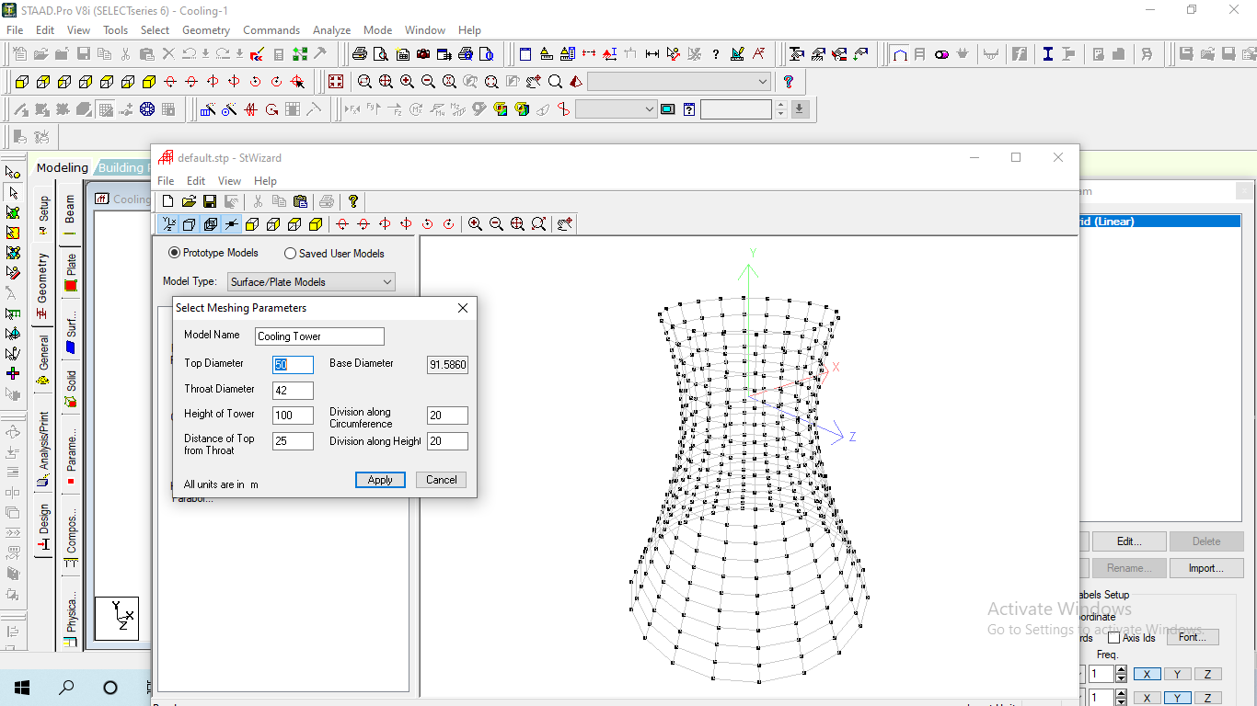

Figure 1: Selecting meshing parameters

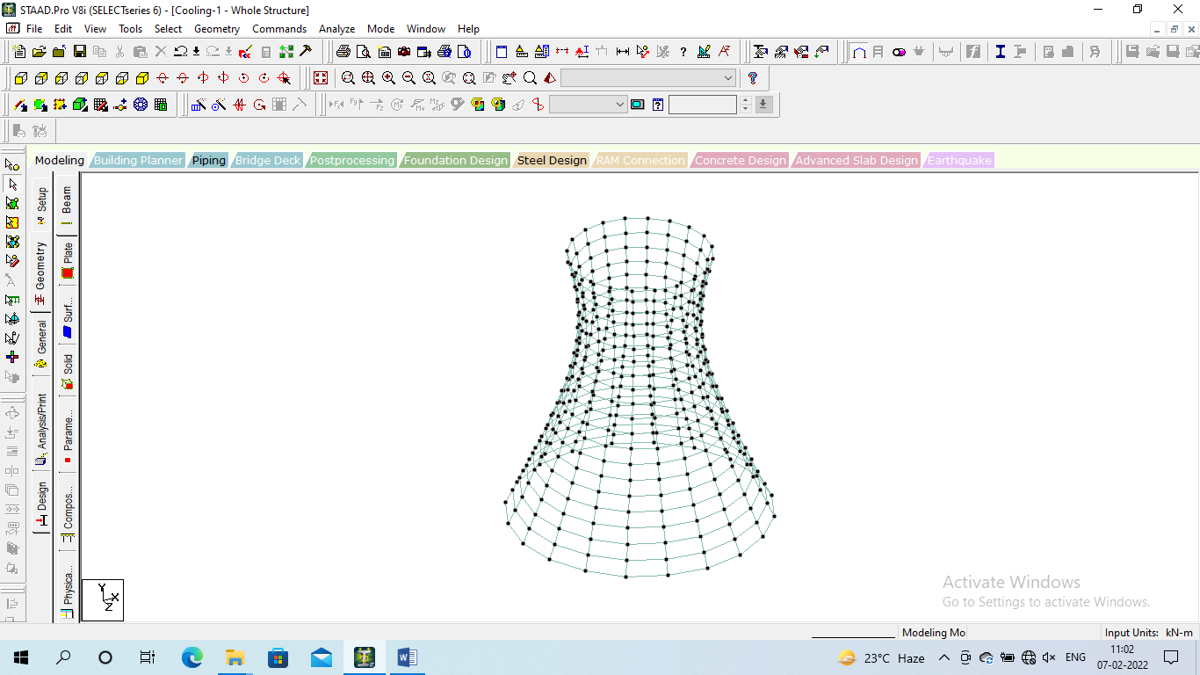

Figure 2: Geometry of the cooling tower

**4. RESULTS**

Table 1:Displacement for all the models

|  |  |  |  |  |
| --- | --- | --- | --- | --- |
|  | Horizontal | Vertical | Horizontal | Resultant |
|  | X mm | Y mm | Z mm | mm |
| Model-1 | 40.575 | 90.711 | 40.575 | 95.355 |
| Model-2 | 4S0.575 | 90.711 | 40.575 | 95.355 |
| Model-3 | 40.575 | 90.711 | 40.575 | 95.355 |
| Model-4 | 40.575 | 90.711 | 40.575 | 95.355 |
| Model-5 | 40.614 | 127.762 | 40.614 | 133.151 |
| Model-6 | 40.614 | 127.762 | 40.614 | 133.151 |
| Model-7 | 40.614 | 127.762 | 40.614 | 133.151 |
| Model-8 | 40.614 | 127.762 | 40.614 | 133.151 |
| Model-9 | 80.935 | 172.992 | 80.935 | 187.56 |
| Model-10 | 80.935 | 172.992 | 80.935 | 187.56 |

The table presents the displacement measurements for various structural models, focusing on horizontal and vertical displacements, as well as the resultant displacement, which combines these effects. Each model is characterized by its respective displacement values. Models 1 through 4 exhibit identical displacements, with horizontal (X and Z) and vertical (Y) displacements of 40.575 mm and 90.711 mm respectively, resulting in a combined resultant displacement of 95.355 mm. Models 5 through 8 show slightly higher values, with horizontal (X and Z) displacements of 40.614 mm and a vertical (Y) displacement of 127.762 mm, resulting in a resultant displacement of 133.151 mm. Models 9 and 10 have the highest displacement values, with horizontal (X and Z) displacements of 80.935 mm and a vertical (Y) displacement of 172.992 mm, leading to a resultant displacement of 187.56 mm. These variations highlight the differences in structural responses and deformation patterns among the models under the same or similar loading conditions.

|  |
| --- |
|  |
| Figure 3: Horizontal Displacement (X) for all the models |
|  | |
| Figure 4: Horizontal Displacement (Z) for all the models | |

Table 2:Plate stresses for all the models

|  |  |  |  |  |
| --- | --- | --- | --- | --- |
|  | Shear | Membrane | | |
|  | SQY (local) N/mm2 | SX (local) N/mm2 | SY (local) N/mm2 | SXY (local) N/mm2 |
| Model-1 | 15.126 | 148.791 | 6.403 | 0.021 |
| Model-2 | 15.126 | 148.791 | 6.403 | 0.033 |
| Model-3 | 15.126 | 148.791 | 6.403 | 0.05 |
| Model-4 | 15.126 | 148.791 | 6.403 | 0.075 |
| Model-5 | 14.863 | 140.137 | 4.889 | 0.03 |
| Model-6 | 14.863 | 140.137 | 4.889 | 0.048 |
| Model-7 | 14.863 | 140.137 | 4.889 | 0.072 |
| Model-8 | 14.863 | 140.137 | 4.889 | 0.108 |
| Model-9 | 51.845 | 168.963 | 22.889 | 0.067 |
| Model-10 | 51.845 | 168.963 | 22.889 | 0.108 |

The table presents the plate stresses for ten different models, focusing on shear and membrane stresses. The shear stress component, \(SQY\), is measured in N/mm² and remains consistent within specific model groups, showing values around 15.126 N/mm² for Models 1-4 and 14.863 N/mm² for Models 5-8, with a higher value of 51.845 N/mm² for Models 9-10. The membrane stresses \(SX\) and \(SY\) are relatively stable across the models, with \(SX\) around 148.791 N/mm² for Models 1-4, 140.137 N/mm² for Models 5-8, and 168.963 N/mm² for Models 9-10. Similarly, \(SY\) is 6.403 N/mm² for Models 1-4, 4.889 N/mm² for Models 5-8, and 22.889 N/mm² for Models 9-10. The membrane shear stress \(SXY\) varies more significantly, increasing within each model group, ranging from 0.021 N/mm² to 0.108 N/mm². These variations in stresses indicate different structural behaviors and responses to loading conditions across the models.

|  |
| --- |
|  |
| Figure 5: Shear stress (SQY) for all the models |

|  |
| --- |
|  |
| Figure 6: Membrane stress (SQY) for all the models |

**5. CONCLUSIONS**

Based on the detailed analysis presented in the tables, several key conclusions can be drawn regarding the stress distribution, reaction forces, moments, and displacement characteristics across the various structural models:

* + Models 1 to 4 show consistent principal stresses at the top (446.805 N/mm²) and bottom (370.937 N/mm²), with Von Mises and Tresca stresses aligning closely. This indicates uniform stress distribution in these models.
  + Models 5 to 8 exhibit slightly lower top principal stresses (441.537 N/mm²) and higher bottom stresses (376.783 N/mm²), with Von Mises and Tresca stresses also remaining consistent. These differences suggest minor variations in stress distribution compared to Models 1 to 4.
  + Models 9 and 10 present the highest principal stresses at the top (457.261 N/mm²) and bottom (377.973 N/mm²), with Von Mises stresses of 403.653 N/mm² at the top and 348.498 N/mm² at the bottom. These values highlight significant stress concentrations, especially at the top of the structure.

**REFERENCES**

1. Parth.R.Chhaya, Nizam.M.Mistry andAnuj.K.Chandiwala, “A Review On Effect Of Wind Loading On Natural Draught Hyperbolic Cooling Tower”, International Journal of Advance Engineering and Research Development, Volume 1, Issue 12, December -2014.

2. Priya Kulkarni and S. K. Kulkarni, “Thermal Effect on RCC Hyperbolic Cooling Tower”, International Journal of Innovative Research in Science, Engineering and Technology, Vol. 4, Issue 9, September 2015.

3. Sachin Kulkarni and Prof A.V. Kulkarni, “Modal Analysis Of Reinforced Concrete Cooling Towers”, International Journal of Advance Engineering and Research Development, Volume 1, Issue 12, December -2014.

4. Iqbal Hafeez Khan, Rakesh Patel and Aslam Hussain, “Parametric Analysis Of Hyperbolic Cooling Tower Under Seismic Loads Through Staad.Pro”, International Research Journal of Engineering and Technology (IRJET), Volume: 02 Issue: 09 | Dec-2015.

5. Pujaa Venkataiah and , P. Prakash, “Seismic Analysis and Design of a Hyperbolic Cooling Tower”, International journal of scientific engineering and technology research, Vol.05,Issue.12, May-2016, Pages:2413-2415.

6. Akash Goyal, A N Shankar and S K Sethy, “Parametric Analysis of Hyperbolic Cooling Tower under Seismic Loads, Wind Loads and Dead Load through Staad. Pro”, International Journal of Engineering Research & Science (IJOER), Vol-3, Issue-8, August- 2017.

7. Athira C R, Rahul K R, Reshma R Sivan, Seethu vijayan and Nithin V Sabu, “Linear and Nonlinear Performance Evaluation and Design of Cooling Tower at Dahej”, IOSR Journal of Mechanical and Civil Engineering (IOSR -JMCE), International Conference on Emerging Trends in Engineering & Management.

8. R. Purusothaman, “Planning, Designing And Analysing Of Cooling Tower”, International Journal of Advanced Research in Civil,Structural,Environmental and Infrastructure Engineering and Developing, Volume: 3, Issue: 1,Special Issue: 1 ,Mar,2018.

9. Dr. S. N. Tande and Snehal S. Chougule, “Linear and Nonlinear Behaviour of R. C. Cooling Tower under Earthquake Loading”, International Journal of Latest Trends in Engineering and Technology, 2(4), 2013, 370-379.

10. Shailesh S. Angalekar and Dr. A. B. Kulkarni, “Analysis of Natural Draught Hyperbolic Cooling Towers by Finite Element Method Using Equivalent Plate Concept”, International Journal of Research and Applications, 1(2), 144-148