**A STUDY ONLINE TRADING MECHANISIM**

1M. Abdul Basid, Assistant Professor, Dept. of MBA, Santhiram Engineering College(A), Nandyal,A.P., India

2K. Chinna Manidhar, Student, Dept. of MBA, Santhiram Engineering College(A), Nandyal,A.P., India

**Abstract:**

A study on evaluation of online trading facilities with reference to financial services of various sectors .The main objective of the research was to evaluate the online trading facilities of which was carried out a period of specified deals. This paper study conducted is descriptive in nature and the sample size used for this study is 200. The method used for this study is Primary and secondary data collection method. For colleting the data structured questionnaire was used in this study. Percentage analysis and graphical representation were used for analyzing and interpretation. This paper mainly focuses on customer feedback and suggestions that would be useful to to take necessary actions to solve them in a better manner. The findings revealed that most of the respondents are satisfied with the online trading facilities provided by the organization. The work would surely help to forecasts the customer needs and help the company to take the necessary steps.

**Index terms:** Online trading, Financial management, Financial control

**1.Introduction:**

Financial Management is about preparing, directing and managing the money activities of a company such as buying, selling and using money to its best results to maximise wealth or produce best value for money. It is basically applying general management concepts to the cash of the company. Financial Management can also be defined as – The management of the finances of a business / organisation in order to achieve financial objectives. “Financial management is concerned with raising financial resources and their effective utilization towards achieving the organizational goals” Dr. S. N. Maheshwari[1].

“Financial management is the process of putting the available funds to the best advantage from the long term point of view of business objectives” Richard A. Brealey. It is crucial for both public and private sector organisations.

Taking a commercial business as the most common organizational structure, the key objectives of financial management would be to:

• Create wealth for the business

• Generate cash, and

• Provide an adequate return on investment bearing in mind the risks that the business is taking and the resources invested

**1.1.There are three key elements to the process of financial management:**

**(1) Financial Planning:** Management need to ensure that enough funding is available at the right time to meet the needs of the business. In the short term, funding may be needed to invest in equipment and stocks, pay employees and fund sales made on credit. In the medium and long term, funding may be required for significant additions to the productive capacity of the business or to make acquisitions. This links in with the financial decision making process and forecasting.

**(2) Financial Control:** Financial control is a critically important activity to help the business ensure that the business is meeting its objectives. Financial control addresses questions such as:

• Are assets being used efficiently?

• Are the businesses assets secure?

• Do management act in the best interest of shareholders and in accordance with business rules?

**(3) Financial Decision-making:**

The key aspects of financial decision-making relate to investment, financing and dividends:

•**Investments must be financed in some way** – however there are always financing alternatives that can be considered. For example it is possible to raise finance from selling new shares, borrowing from banks or taking credit from suppliers. This is connected with the capital budget and forecasting when dealing with fixed assets and projects[2].  
**•Financial option**s – this is connected to the raising of finance from various sources like banks or financial investors, which will depend on the options of the type of source, period of financing, cost of financing and the net present returns generated.  
•A key financing decision is whether profits earned by the business should be retained rather than distributed to shareholders via dividends. If dividends are too high, the business may be starved of funding to reinvest in growing revenues and profits further.

All these areas of financial management apply to your personal life and family life, how families finances are managed are all related to financial management.

**2. ONLINE TRADING:**

**2.1.Definition:**

Online trading is basically the act of buying and selling financial products through an online trading platform. These platforms are normally provided by internet based brokers and are available to every single person who wishes to try to make money from the market. Before getting in to the online trading we should know some things about the internet, e-commerce and etc.

**3. TRADING ARRANGEMENTS:**

The open outcry system, prevalent a few years ago on regional stock exchanges, has been replaced by on-line screen-based electronic trading system. NSE and OTCEI had adopted screen-based trading right from inception. With almost all the exchanges going electronic, trading has shifted from the floor to the brokers’ office where trades are executed through a computer terminal. All stock exchanges together have 8000 terminals spread across the country. In a screen-based trading system, a member can feed into the computer the number of securities and the prices at which he would like to transact and the transaction is executed as soon as it finds a matching order from a counter party[3]. The electronic trading system is superior to the open outcry system of information efficiency by a allowing faster incorporation of price sensitive information into prevailing prices and thereby helps in efficient price discovery. This also results in operational efficiency as there is a reductio9n in time, cost, risk of error, and fraud and elimination of a chain of brokers and jobbers, which result in low transaction costs.

**4. ONLINE EQUITY TRADING:**

Generally, online trading refers to buying and selling securities via the Internet or other electronic means such as wireless access, tough-tone, telephones and other new technologies. With online trading, in most cases customers access a brokerage firm's Web Site through their regular Internet Service provider. Online there. Customers may consult information provided on the Web Site and log into their accounts to place orders and monitor account activity[4].

5. **THE ONLINE TRADING PROCESS:**

To avail of online trading services the following steps may be followed

Step: 1 registers on the web site

Step: 2 complete registration documentation

Step: 3 open depository account

Step: 4 open bank account.

**5.1.Dematerialization (DMAT):**

Dematerialization trading in now compulsory for all investors Beginningfirst week of January, 1999 investor can trade in specific script only in the dematerialization from. They can provide and receive only in the dematerialization form and share certificates will to be changed for these scripts. A depository is an organization where securities of a shareholder are held in the electronic from at the request of the shareholders through depository participants (DPs). If an investor wants services offered by a depository, he would have to open an account with it through DP-similar to opening a bank account.

**5.2. Functions of depository:**

**Corporate action:**

The depository will track and benefits due to the clients, and will be the job of timely collection of benefits like rights issues, bonus dividends redemption, warrants etc.,

**Book entry settlement / accounting:**

Depository will accomplish settlement work via computerized accounting systems. The book keeping entry will ensure elimination of the physical packaging movement of share certificate.

**Safe keeping:**

Safe keeping function involves the storage of securities in a secure location.

**PLEDGING:** Depository will allow securities to be used as collateral to secure loans/options/future contracts and other form of credit.

**Transfer and registration:**

The use of single nominee name by the depository for all physical security holding of its participant members accelerates transfer process. In a dematerialized system elimination of all movement of securities is done and it reduces the transfer process to a book entry activity.

**Funds handling:**

the involves handling of funds be it collecting funds from issuing companies such as dividend, interest or distribution of funds to participants connected with the settlement of securities transaction.

**Legal issues:**

Implementation of depository system would require some legal issues to be resolved before the could be implemented. The issues pertain to:

* Settlement by book-entry.
* Vesting of beneficial owner rights.
* Pledges and release of pledges.

**6. DE - MATERIALIZATION PROCESS AND PROCEDURE:**

**Opening a depository account:**

Investors, both individuals and non-individuals, have a choice to open a demat account with any CDSL, DP. Individual investors could be Indian residents or NRIs. Non-individual BOs include corporate, FIs, FIILs, Mutual Funds, Trusts etc. Under two-way fungibility of ADR/GDR, non-residents can also open a demat account with a CDSL DP. A BO should consider fee structure, location convenience and the track record of the DP before selecting a DP for-opening his BO account. More than one demat account can be opened in identical names with the same or different DPs with the same depository and / or with both the depositories. A demat account can be maintained even with 'nil' balance as there is no requirement of holding any minimum - security balance in a demat account. Facilitate recording of changes of address, transmission etc.,- For all investments held in the a/c, instead of advising each company separately about the change in address, bank account particulars, nomination, deletion of name in cse of joint holder, one single advice to the DP takes care of all such changes.

**7. PRICES OF ICICI BANK.**

**FIRST WEEK.**

|  |  |  |  |  |
| --- | --- | --- | --- | --- |
| **DATE** | **OPEN** | **HIGH** | **LOW** | **CLOSE** |
| 27-12-2022 | 1165 | 1210.05 | 1163 | 1205.5 |
| 28-12-2022 | 1202 | 1235 | 1200 | 1227 |
| 31-12-2022 | 1240 | 1288 | 1237 | 1282 |
| 01-01-2023 | 1302.5 | 1352.05 | 1301 | 1347 |
| 02-01-2023 | 1339.05 | 1322.5 | 1248 | 1248 |

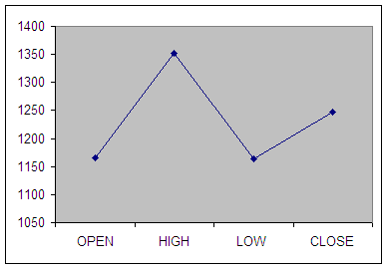

**Interpretation of first week graph:**

Open = 1165

High = 1352.05

Low = 1163

Close = 1248

**CALCULATION OF B.E.P. :**

B.E.P = High Value + Low Value / 2

= 1352.05+1163/2

= 1257.52

**SECOND WEEK:**

|  |  |  |  |  |
| --- | --- | --- | --- | --- |
| **DATE** | **OPEN** | **HIGH** | **LOW** | **CLOSE** |
| 03-01-2023 | 1238.5 | 1285 | 1233 | 1238.5 |
| 04-01-2023 | 1240 | 1302.2 | 1238 | 1287.55 |
| 07-01-2023 | 1322.05 | 1394.25 | 1322.05 | 1394.25 |
| 08-01-2023 | 1392.5 | 1710 | 1384.05 | 1384 |
| 09-01-2023 | 1388.5 | 1398 | 1360 | 1362.7 |

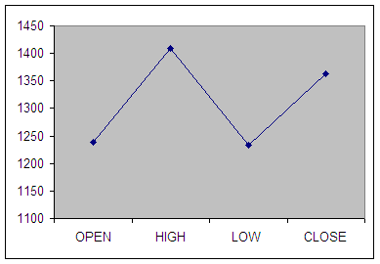

**Interpretation of Second week graph:**

Open = 1238.5

High = 1710

Low = 1233

Close = 1362.7

**CALCULATION OF B.E.P. :**

B.E.P = High Value + Low Value / 2

= 1710 + 1233 / 2

= 1321.50

**THIRD WEEK:**

|  |  |  |  |  |
| --- | --- | --- | --- | --- |
| **DATE** | **OPEN** | **HIGH** | **LOW** | **CLOSE** |
| 10-01-2023 | 1370.65 | 1720 | 1370 | 1707 |
| 11-01-2023 | 1712 | 1752 | 1396 | 1735 |
| 17-01-2023 | 1748 | 1755 | 1729 | 1739 |
| 15-01-2023 | 1742 | 1774 | 1735 | 1741 |
| 16-01-2023 | 1768 | 1769 | 1759 | 1760 |

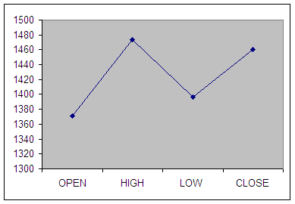

**Interpretation of Third week graph:**

Open = 1370.65

High = 1774

Low = 1396

Close = 1760

**CALCULATION OF B.E.P. :**

B.E.P = High Value + Low Value / 2

= 1774 + 1396 / 2

= 1735

**FOURTH WEEK*:***

|  |  |  |  |  |
| --- | --- | --- | --- | --- |
| **DATE** | **OPEN** | **HIGH** | **LOW** | **CLOSE** |
| 17-01-2023 | 1732 | 1746 | 1730 | 1727 |
| 18-01-2023 | 1722.5 | 1729 | 1389 | 1392.2 |
| 21-01-2023 | 1368 | 1369 | 1341 | 1340.7 |
| 22-01-2023 | 1335.01 | 1362 | 1322.05 | 1360 |
| 23-01-2023 | 1347 | 1706 | 1347 | 1387 |

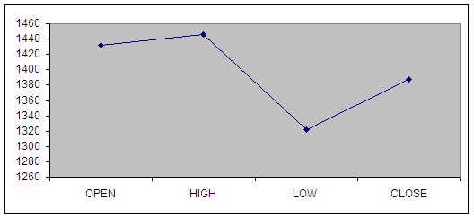

Interpretation of Fourth week graph:

Open = 1732

High = 1746

Low = 1322.05

Close = 1387

**CALCULATION OF B.E.P. :**

B.E.P = High Value + Low Value / 2

= 1746 + 1322.05/ 2

= 1384.02

**FIFTH WEEK:**

|  |  |  |  |  |
| --- | --- | --- | --- | --- |
| **DATE** | **OPEN** | **HIGH** | **LOW** | **CLOSE** |
| 24-01-2023 | 1380 | 1705 | 1372.5 | 1388 |
| 25-01-2023 | 1385 | 1720 | 1382.1 | 1705 |
| 28-01-2023 | 1388 | 1392 | 1246 | 1250 |
| 29-01-2023 | 1239.85 | 1286 | 1201.10 | 1277.30 |
| 30-01-2023 | 1299 | 1299.90 | 1191.10 | 1223.85 |
| 31-01-2023 | 1244 | 1224 | 1167 | 1187.40 |

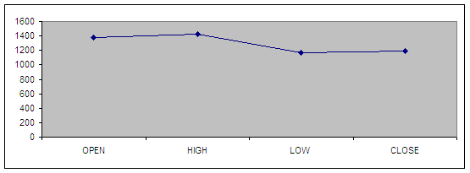

**Interpretation of Fifth week graph:**

Open = 1380

High = 1720

Low = 1167

Close = 1187.40

**CALCULATION OF B.E.P. *:***

B.E.P = High Value + Low Value / 2

= 1720 + 1167/ 2

= 1293.5

**8.CONCLUSION**

In the present scenario to compete with the Broker’s would require sound infrastructure and trading as per international standards.

The concept of business has changed today, this is a service oriented industry hence the survival would require them to provide the best possible service to the clients.

The benefits of depository system are significant. Introduction of depositories will improve the market efficiency, through adopting criteria for describing scrip depositors eligible. If the company is not able to meet the criteria , the company gels to be shifted to paper based market. This leads to falloff image of the company. Hence, the company will try their best to reach the eligible criteria to move into system.

Secondly, the paper management will substantially reduce. This helps in savings in time for allotment/transfer of scripts. This improves internal systems effectively.

Thirdly, the intensity of trading in the script is likely to increase substantially. The experiences of the developed countries, these who are introduced the depository system, shows that there will be around 5 to 6 times increase in the turnover. This happens due to investors indulging more and more in buying and selling even for marginal trading profits.

Fourthly, the cost of bad deliveries, forged share certificates and unproductive back office activity will vanish for corporate.

Last but not least, the depository system will bring in a sea change in corporate democracy, particularly in corporate management price discovery in market place and proxy exercise etc.

**9. References:**

**BOOKS REFFERED:**

1. Khan M.Y., "Financial Services", 2010, 5th Ed. Tata McGraw-Hill, Pvt Ltd., New Delhi.
2. Gordon and Natarajan, "Financial Markets and Services", 2009, HPH, 7th Ed. Mumbai.
3. Avadhani. V.A., "Financial Services in India" 2009, 1st Ed. HPH.
4. Punithavathy Pandin, "Financial Services and Markets", 2009 Vikas Publishing House.

**WEBSITES:**

* [www.smcglobalsecurities.com](http://www.smcglobalsecurities.com/)
* [www.bseindia.com](http://www.bseindia.com/)
* [www.sebi.com](http://www.sebi.com/)
* [www.moneycontrol.com](http://www.moneycontrol.com/)
* [www.economictimes.com](http://www.economictimes.com/)
* [www.nseindia.com](http://www.nseindia.com/)