A STUDY ON MECHANISM OF ONLINE TRADING
¹M. Nagaraju, Assistant Professor, Dept. of MBA, Santhiram Engineering College(A), Nandyal,A.P., India
²P. Rama Suresh, Student, Dept. of MBA, Santhiram Engineering College(A), Nandyal,A.P., India
Abstract:
Online trading definition is a basic understanding of online trading processes. Since the invention of Internet people have beena able to do practically everything virtually. Due to the Internet online trading has become one of the most popular ways to trade as far as stock trading turned out to be as available to independent investors as possible. Online trading gives both beginners who've just had a single day trading course and advanced traders an opportunity to trade stocks, options, forex and futures all over the world without physical presence of a broker and with much lower commissions, because everything is done online.
Index terms: internet sevice, online trading, Stocks, security
1.Introduction:
“Change is the law of nature”. There were times when man was a wanderer or a normal. He himself had to go place to place in search of food, water and now everything is available at your doorstep just at the click of the mouse. The growth of information technology has affected almost all sectors of life. Internet has enabled us to get every information at our doorstep[1]. When Internet has affected all sectors he could “stock markets” the most important player of the economy, has remained far behind? Like all other sectors Internet has set its feet in the stock markets also. Internet trading commissions are clearly posted on the websites of the various services, and are typically a fixed rate charge, depending upon the type of security being traded and the size of trade. In theory, therefore, an Interest investor always knows what commission he is being charged on each trade. Internet investors can take as much time as they would like to take prior to placing a trade order. Similarly the online investor likely does not have to worry that his broker is making unauthorized trades. Since there is no individual broker making a commission, the only person who is authorized to trace in the account is the actual investor[2]. Furthermore, the internet investor can never become a victim of excessive trading (where for the broker) since the investor maintains total control over the number of transactions which take place in the account. All of these positive features of internet trading may lead the unwary investor to believe that Internet trading is a way to take control of their finances and save more money in the process. Unfortunately, this is not always the case. The advantages of Internet stock trading have also its weaknesses and these weaknesses present significant drawbacks for the average investor. First and foremost, the average investor is not an expert in the financial markets. There is a danger for allowing the autonomy of online trading to hull you into the belief that you are an expert investor. An online investor sitting at home at a personal computer also foregoes proper investment advice and financial planning, perhaps among the most valuable services provided by traditional brokers.
There are, of course, additional risks relative to performing transactions over the Internet especially on a shared computer[3]. Those people whom investors have provided their account number and password can freely trade that account while the investor will have little, if any, resource against the brokerage firm for the breach of security.
2. Evolution of broking in india:
The evolution of a broking in India can be categorized in three phases -
Stockbrokers will offer on their sites features such as live portfolio manager, live quotes, market research and news, etc. to attract more investors. Brokers will offer online broking and relationship management by providing and offering analysis and information to investors during broking and non-broking hours based on their profile and needs, i.e. customized services. Brokers (now e-brokers) will offer value management or services like initial public offering online, on-line asset allocation, portfolio management, financial planning, tax planning, insurance services, etc. and enables the investors to take better and well considered decisions[4].
The actual definition of “Online Trading” is as explained below:
“Online trading is a service offered on the internet for purchase and sale of shares. In the real world you place orders on your stockbroker either verbally (personally or telephonically) or in a written form (fax).” In online trading, you will access a stockbroker’s website through your internet enabled PC and place orders through the broker’s internet based trading engine. These orders are routed to the stock exchange without manual intervention and executed thereon in a matter of a few seconds.The net is used as a mode of trading in internet trading. Orders are communicated to the stock exchange through website.
3.Objectives:
Internet trading is expected to
- Increase transparency in the markets
- Enhance market quality through improved liquidity, by increasing quote continuity and market depth
- Reduce settlement risks due to open trades, by elimination of mismatches
- Provide management information system
- Introduce flexibility in system, so as to handle growing volumes easily and to support nationwide expansion of market activity.
- Besides, through internet trading three fundamental objectives of securities regulation can be easily achieved, these are:
- Investor protection
- Creation of a fair and efficient market, and
- Reduction of the systematic risks.
Some of the brokers offering net trading include ICICI direct, kotakstreet, etc.
4. Requirements for net trading:
For investors:
1. Installation of a computer with required specification
2. Installation of a modem
3. Telephone connection
4. Registration for on-line trading with broker
5. A bank account
6. Depository account
7. Compliance with SEBI guidelines for net trading
4.1.The following should be produced to get a demat account and online trading account:
As identity proof & address proof any one of the following:
- Voter ID card
- Driving license
- PAN card( in case of to trade more than 50000)
- Ration card
- Bank pass book
- Telephone bill
4.2.Other requirements, which are necessary
- First page of the bank pass book and last 6 months statement.
- Bank manager’s signature along with bank’s seal, manager registration code on photograph.

5.Internet service:
Internet is a worldwide, self-governed network connecting several other smaller networks and millions of computers and persons, to mega sources of information. This technology shrinks vast distances, accelerating the pace of business reforms and revolutionizing the way companies are managed[5]. It allows direct, ubiquitous links to anyone anywhere and anytime to build up interactive relationships. A combination of time and space, called the Internet promises to bring unprecedented changes in our lives and business. Internet or net is an inter-connection of computer communication networks spanning the entire globe, crossing all geographical boundaries. It has re-defined the methods of communication, work study, education, business, leisure, health, trade, banking, commerce and what not it is virtually changing every thing and we are living in dot.com age. Net being an interactive two way medium, through various websites, enables participation by individuals in business to business and business to consumer commerce, visit to shopping arcades, games, etc. in cyber space even the information can be copied, downloaded and retransmitted.
6.E-commerce:
Electronic commerce is associated with buying and selling over computer communication networks. It helps conduct traditional commerce through new way of transferring and processing of information[6]. Information is electronically transferred from computer to computer in an automated way. E-commerce refers to the paperless exchange of business information using electronic data inter change, electronic technologies.
7.For stock brokers:
1. Permission from stock exchange for net trading
2. Net worth of Rs. 50 lac
3. Adequate back-up system
4. Secured and reliable software system
5. Adequate, experienced and trained staff
6. Communication of order (trade confirmation to investor by e-mail)
7. Use of authentication technologies
8. Issue of contract notes within 24 hours of the trade execution
9. Setting up a website.
The net is used as a medium of trading in internet trading. Orders are communicated to the stock exchange through website. Internet trading started in India on 1st April 2100 with 79 members seeking permission for online trading[7]. The SEBI committees on internet based securities trading services has allowed the net to be used as an Order Routing System (ORS) through registered stock brokers on behalf of their clients for execution of transaction.
Under the Order Routing System the client enters his requirements (security, quantity, price, and buy/sell) in broker's site. They are checked electronically against the clients account and routed electronically to the appropriate exchange for execution by the broker. The client receives a confirmation on execution of the order. The customer's portfolio and ledger accounts get updated to reflect the transaction. The user should have the user id and password to enter into the electronic ring. He should also have demat account and bank account[8]. The system permits only a registered client to log in using user id and password. Order can be placed using place order window of the website.
8. Procedure for Net Trading:
Step 1: Those investors, who are interested in doing the trading over internet system i.e. NEAT-IXS, should approach the brokers and get them self registered with the Stock Broker.
Step 2: After registration, the broker will provide to them a Login name, Password and personal identification number (PIN).
Step 3: Actual placement of an order. An order can then be placed by using the place order window as under:
(a) First by entering the symbol and series of stock and other parameters like quantity and price of the scrip on the place order window.
(b) Second, fill in the symbol, series and the default quantity.
Step 4: It is the process of review. Thus, the investor has to review the order placed by clicking the review option. He may also re-set to clear the values.
Step 5: After the review has been satisfactory, the order has to be sent by clicking on the send option.
Step 6: The investor will receive an "Order Confirmation" message along with the order number and the value of the order.
Step 7: In case the order is rejected by the Broker or the Stock Exchange for certain reasons such as invalid price limit, an appropriate message will appear at the bottom of the screen. At present, a time lag of about 10 seconds is there in executing the trade.
Step 8: It is regarding charging payment, for which there are different mode. Some brokers will take some advance payment from the investor and will fix their trading limits. When the trade is executed, the broker will ask the investor for transfer of funds to his account[9]. Internet trading provides total transparency between a broker and an investor in the secondary market. In the open outcry system, only the broker knew the actually transacted price. Screen based trading provides more transparency. With online trading investors can see themselves the price at which the deal takes place.
The time gap has narrowed in every stage of operation. Confirmation and execution of trade reaches the investor within the least possible time, mostly within 30 seconds. Instant feedback is available about the execution. Some of the websites also offer;
- News and research report
- BSE and NSE movements
- Stock analysis
- IPO and mutual fund centers
8.1.Step by step procedure in online trading:
Following steps explain the step by step approach to on-line trading:
- Log on to the stock broker's website
- Register as client/investor
- Fill the application form and client broker agreement form on the requisite value stamp paper
- Obtain user ID and pass word
- Log on to the broker's site using secure user ID and password
- Market watch page will show real time on-line market data
- Trade shares directly by entering the symbol or number of the security
- Brokers server will check your limit in the on-line account and demat account for the number of shares and execute the trade
- Order is executed instantly (10-30 seconds) and confirmation can be obtained.
- Confirmation is e-mailed to investor by broker
- Contract note is printed and mailed in 24 hours
- Settlement will take place automatically on the settlement day
- Demat account and the bank account will get debited and credited by electronic means.
8.2.Online trading has led to additional features such as:
- Limit / stop orders: orders that can be go unfilled, but there is an extra Charge for this leeway facility since one need to hold a price.
- Market orders: orders can be filled at unexpected prices, but this type is much more risky, since you have to buy stock at the given price.
- Cash account: where funds have to be available prior to placing the order.
- Margin account: where orders can be placed against stocks, to increase Purchasing power.
9.Advantages of Online Trading:
- Online trading has made it possible for anyone to have easy and efficient access to more reports and charts than it was previously possible if one went to any brokers' office. Thus we have access to a lot more information online[10].
- Online trading has let room for smaller organizations to compete with multinational organizations since it is no longer a leg it issue. Being online does not identify the size of any particular organization, therefore, this additional power to the underdogs.
- Online trading has allowed companies to locate themselves where they want as physical location is not an issue anymore. Companies can establish themselves according to their gains and losses, for instance where tax (sales and value added taxes) is best suited to them.
- Online trading gives control to individuals and they can exercise it over accounts thus comprehend what is going on when they trade. It is like going back to school and re-educating oneself on how to trade online.
- Individuals’ benefit by saving comparatively a lot more when trading online as the cost per trade is less.
- Individuals can invest in a variety of products, unlike earlier when people bought bonds, mutual funds, and stock for long-term basis and sat on them. Now they can invest in stocks, stock and index options mutual funds, government, and even insurance.

10. Research Methodology
The data collection methods include both primary and secondary Collection methods.
Primary method: This method includes the data collected from the personal interaction with authorized members of Indiabulls Ltd.
Secondary method: The secondary data collection method includes:
- The brochures and material provided by Indiabulls Ltd.
- The data collected from the magazines of the NSE, economic times, etc.
- Various books relating to the investments, capital market and other related topics.
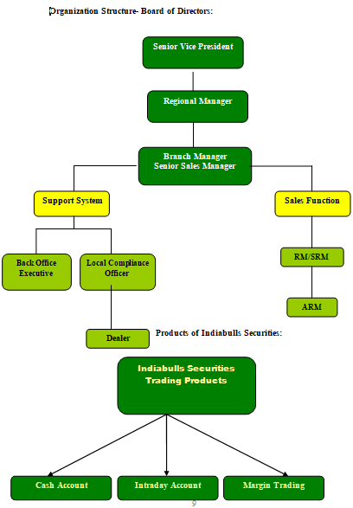

Indiabulls Securities provide three products for trading. They are
- Cash Account
- Intraday Account
- Margin Trading (Mantra)

Cash Account: It provides the client to buy 4 times of cash balance in his trading account.
Intraday Product: It provides the client to buy 8 times of his cash balance in the trading account.
Mantra Account: Also called as margin trading, is a special account to buy on leverage for a longer duration
Indiabulls Financial Services Ltd:
Indiabulls Financial Services Ltd. was incorporated in the year 2105.The Auditors of Indiabulls Financial Services Ltd. are Deloitte, Haskins & Sells. The main activity of this company is in relation to securities and stock brokerage. It was also responsible for setting up one of India’s first trading platforms.
11.Settlement of transactions:
Clearing of transaction in the form of shares and cash is called settlement. Buyers will take the delivery of shares through the depository participants like Networth Stock Broking Ltd and others.
Finally, the settlement is made by means of delivering the share certificates along with the transfer deeds. The transferor (or the seller) duly signed transfer deed. It bears a stamp of the selling broker. The buyer then fills up the certificates fills up the particulars in the transfer deed. Settlement can be done in the following way.
Spot settlement: under this method, the delivery of securities and payment for them are affected on the day of the contract itself.
Rolling settlement: Under this rolling settlement the trading is on “T+2”,basis i.e. if Monday is trading day then Wednesday is the paying day . In case on non-delivery, the securities will go for auction.
11.1.Details of procedures:
Delivery in : The members who are in pay-out position delivers share certificates in to clearing house within the settlement period along with the delivery Chelan filled in with the details of share certificates which has folio numbers or distinctive numbers etc.
Delivery out: The buyer of shares who made pay in position will take delivery of shares from the clearing house.
Pay-in: The member who is in paying position shall pay for value of shares with in the trading settlement period (T+2).
Payout: The cheques paid in the clearinghouse will be paid to members who are in paying position.
All disputes arising between members regarding non-deliveries, non-payments, good and bad deliveries pertaining to the settlement will be settled by the settlement committee of the exchange.
The given flow chart clearly explains the process of online trading:

12.Company :MARUTI SUZUKI INDIA LTD. 532500
All Prices in TABLE NO 4.4
Date | Open | High | Low | Close | WAP | No. of  Shares | No. of  Trades | Total Turnover
14/12/22 | 4,510.00 | 4,580.00 | 4,482.00 | 4,569.80 | 4,528.09 | 70,147 | 4,568 | 31,76,31,797
15/12/22 | 4,595.00 | 4,636.00 | 4,562.30 | 4,621.60 | 4,596.26 | 32,883 | 4,402 | 15,11,38,884
20/12/22 | 4,650.00 | 4,654.00 | 4,603.00 | 4,621.95 | 4,623.96 | 34,332 | 4,051 | 15,87,49,782
21/12/22 | 4,640.00 | 4,678.00 | 4,574.05 | 4,666.00 | 4,620.31 | 48,577 | 4,636 | 22,42,46,596
21/12/22 | 4,678.00 | 4,701.00 | 4,611.00 | 4,621.25 | 4,657.10 | 50,321 | 6,030 | 23,43,31,115
21/12/22 | 4,602.00 | 4,656.21 | 4,602.00 | 4,639.60 | 4,637.90 | 22,585 | 2,751 | 10,47,46,940
22/12/22 | 4,635.00 | 4,644.00 | 4,535.05 | 4,621.75 | 4,620.43 | 21,446 | 1,955 | 8,51,54,685
23/12/22 | 4,621.10 | 4,653.00 | 4,621.10 | 4,635.21 | 4,634.94 | 21,997 | 2,327 | 9,26,84,851
24/12/22 | 4,644.00 | 4,644.00 | 4,588.75 | 4,594.40 | 4,603.48 | 21,885 | 1,893 | 9,15,40,249
28/12/22 | 4,610.00 | 4,640.00 | 4,590.00 | 4,635.35 | 4,622.11 | 13,598 | 1,821 | 6,28,51,410
29/12/22 | 4,629.40 | 4,655.90 | 4,610.10 | 4,638.60 | 4,632.28 | 15,004 | 2,495 | 6,95,02,797
30/12/22 | 4,639.00 | 4,642.00 | 4,578.05 | 4,588.45 | 4,610.61 | 21,211 | 2,120 | 8,38,25,582
31/12/22 | 4,587.00 | 4,641.65 | 4,567.15 | 4,615.35 | 4,593.65 | 72,811 | 3,456 | 33,44,68,391
1/01/23 | 4,630.50 | 4,665.00 | 4,606.55 | 4,635.05 | 4,637.06 | 45,948 | 3,156 | 21,30,63,532
4/01/23 | 4,640.00 | 4,656.30 | 4,575.00 | 4,583.40 | 4,605.97 | 21,221 | 2,703 | 8,85,26,662
5/01/23 | 4,581.00 | 4,600.00 | 4,556.55 | 4,568.35 | 4,575.05 | 21,855 | 3,023 | 9,99,87,631
6/01/23 | 4,598.00 | 4,600.00 | 4,464.10 | 4,479.55 | 4,524.33 | 29,414 | 3,395 | 13,30,78,742
7/01/23 | 4,464.00 | 4,464.00 | 4,252.00 | 4,266.55 | 4,301.70 | 82,747 | 7,946 | 35,59,53,217
8/01/23 | 4,281.00 | 4,325.80 | 4,215.80 | 4,215.65 | 4,236.66 | 81,035 | 9,299 | 34,33,21,570
11/01/23 | 4,210.00 | 4,298.00 | 4,145.00 | 4,279.45 | 4,250.48 | 60,237 | 6,577 | 25,60,36,348
12/01/23 | 4,299.00 | 4,322.00 | 4,261.50 | 4,269.65 | 4,289.24 | 25,846 | 3,355 | 11,08,59,621
13/01/23 | 4,292.00 | 4,309.95 | 4,223.05 | 4,293.40 | 4,275.41 | 38,036 | 3,787 | 20,26,21,399
14/01/23 | 4,250.00 | 4,284.85 | 4,214.60 | 4,249.65 | 4,245.26 | 34,214 | 3,691 | 14,51,62,474
15/01/23 | 4,266.00 | 4,338.00 | 4,251.10 | 4,273.30 | 4,295.78 | 30,669 | 4,211 | 13,21,47,424
21/01/23 | 4,287.55 | 4,290.00 | 4,214.40 | 4,227.60 | 4,224.52 | 29,996 | 4,384 | 12,67,21,845

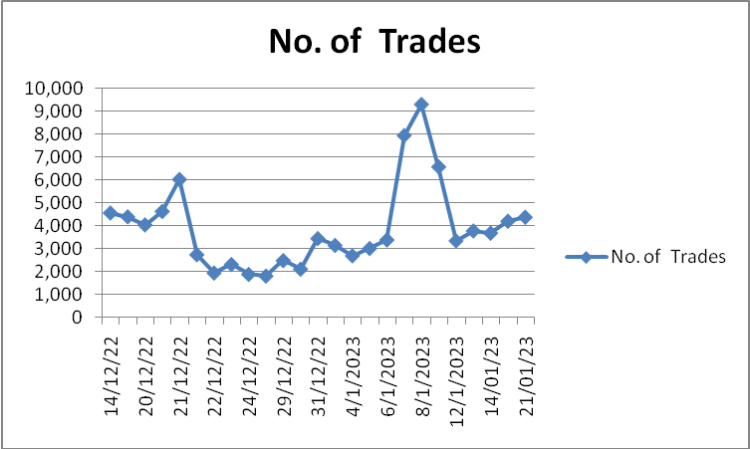
13.Interpretation:
On open value has increased from 4510.00 to 4569.80. Then compare to higher value of EPS 4295.78. Then coming to lower price from 4287.55 to 4227.60. Wholly the conclusion is 4351.47 increased.
Then coming to the volume on the same dates or days volumes are increased. Because totally this session. MARUTI SUZUKI INDIA LTD. EPS value is increased i.e. percentage of 7.88%.
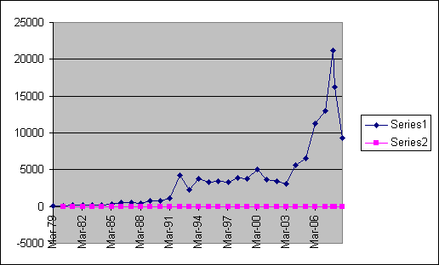
14. Conclusion:
- The comprehensive study of capital market instrument at Inter Connected stock exchange has been an enlightening experience stressing on the positive aspects on Dematerialization.
- And settlement of shares, derivative market and capital instrumentshas done in whole lot of good to the issuer, investor companies and country.
- The depository systems has reduced the lag in delivery and settlement of securities but also supported the cause of providing more liquidity to the security holder, the need for setting up of a depository paper less trading.
- Through online trading system and settlement became inevitable and unavoidable for the smooth and the efficient functioning of the capital market.
- This system has proved its worthiness by increasing in the speed of transactions within T+3 days which are earlier T+5 days.
- Now there is a proposal that the settlement will be done within T+1days in near future which is in it an indication of a boon in the system of demat and capital market instruments.
- It has been fairly long since derivative trading started off on the Indian Indexes.
- Actively has failed to really take off with low figures being transacted in terms of value and volumes.
- The introduction of derivative trading was hailed by the punters in the capital markets but has not really brought about a wave so as to speak.
- There are several factors, which impede the growth of the derivative markets in India.
- Of these factors the absence of clear guidelines on tax-related issues and the high cost of transactions are the most prominent.

15.References:
1. Davies R, Cunningham S. A Review of Online Trading and User Perceptions of Usability and Trust. 2012;118:8. doi:10.7726/jait.2012.1001r.
2. Rahim A. Problems and Prospects of Online Share Trading Practices in India. Int J Marketing Financial Serv Manag Res. 2013;2(4):1–6.
3. Loana AP. Benefits and drawbacks of online trading versus traditional trading. Educational factors in online trading. Ann Fac Econ. 2015;1(1):1253–9.
4. Bade A. Analysis Demat Account And Online Trading . Sch Res J. 2017;4(30):4921–4.
5.V.K.Bhalla,"INVESTMENT MANAGEMENT",S.Chand &Company Pvt Ltd, 2008.
6.Preethi Singh,"INVESTMENT MANAGEMENT" Himalaya Publishing Pvt Ltd,2006
7. V.A.Avadhani "SECURITY ANALYSIS AND PORTFOLIO MANAGEMENT" Himalaya Publishing Pvt.Ltd,2000
8. Michael A. Goldsteina, Pavitra Kumarb and Frank C. Gravesb “Computerized and high frequency trading” The Financial Review
9. Ichael A Goldsteina, Pavitra Kumarb and Frank C. Gravesb “Computerized and high frequency trading” The Financial Review,
10. Dr.C K Gomathy, Article: A Study on the recent Advancements in Online Surveying, International Journal of Emerging technologies and Innovative Research (JETIR)

