**THE EFFECT OF ANCHOLLA FLAKE ON THE GROWTH OF RED TILAPIA (OREOCHROMIS NILOTICUS)**

**Mohd Muslim Mustafa1*, Mohd Mukriz Mohd Kasim1, Nur Aina Lyana Mohamad Ali1, Siti Nor Fatihah Zakaria1 & Muhammad Faris Aliuddin Mohd Zamri1**

1Jabatan Agroteknologi dan Bio-Industri, Politeknik Jeli Kelantan, Jalan Raya Timur-Barat,

17600 Jeli, Kelantan, Malaysia

**ABSTRACT**

The aquaculture industry is an essential sector in today's world. In aquaculture, 50-70% of operating costs come from animal feed sources. Furthermore, the price of fish feed continues to rise every year. Therefore, an innovation fish feed solution has been developed by combining waste material, namely anchovy head, with the readily available aquatic plant Azolla (Azolla sp.) found in Malaysia. This innovation is known as Ancholla flake, and it was tested on juvenile Red Tilapia (Oreochromis niloticus) for a duration of 5 weeks. Proximate analysis was conducted, revealing that Ancholla flake contains 46.5% protein, 1.0% fat, 244 kcal of energy, and 12.2% carbohydrates. The study compared the survival rates, average fish weight, feed conversion ratio (FCR), and feeding cost for three feeding regimes namely Ancholla flake, commercial pellets, and a combination of both. The results of the study showed that the combination of Ancholla flake and commercial pellets had the highest survival rate at 73.3%. Additionally, the average fish weight was 6.79g for the combination, 7.85g for commercial pellets, and 5.5g for Ancholla flake. The FCR for Ancholla flake was 3.5, commercial pellets had an FCR of 1.3, and the combination had an FCR of 1.6. Based on current prices, Ancholla flake was priced at RM1.60/kg, commercial pellets at RM4.60/kg, and the combination at RM3.10/kg. Based on FCR and current prices, the cost of feed per kilogram of fish fed Anchovy flakes is RM5.60, commercial pellets are RM6.00, and the combination is RM5.00. In conclusion, the combination of Ancholla flake and commercial pellets is the preferred feeding option due to its lower cost and sufficient nutritional supply to the fish. Improvements in the production process should involve the use of more advanced equipment to ensure that the product floats longer and maintains its integrity during the feeding process to the fish.

**Keywords:** aquaculture, Azolla, anchovy, tilapia, pellets

1. **INTRODUCTION**

The Aquaculture is the farming system of aquatic life, including animals and aquatic plants, in a controlled environment. The primary goal of aquaculture is to enhance the quality and quantity of aquatic products while providing a source of protein and food for humans. It also encompasses the processing and marketing of aquatic products. Aquaculture continues to grow as an essential industry to meet global demand for aquatic products. However, issues of the weakness of disease management, water pollution, sustainable food resources as well as the rising cost of feed raw materials in the market continually becoming challenges for aquaculture farmers.To ensure the sustainability and quality of aquaculture production, responsible and sustainable aquaculture practices including good husbandry practices, effective disease control, and innovations in aquaculture technology are essential in the farming and production of aquatic products.

The cost of fish feed in aquaculture management becomes a significant factor affecting profitability and operational efficiency. The costs of feed constitute a significant portion of the overall operational costs. Several factors affecting the cost of fish feed in aquaculture including nutrient content, raw material sources, production processes, and local economic factors.

Since the cost of feed is one of the most crucial factors in successful aquaculture operations, it becomes necessity for the farmers to consider the nutritional requirements for their fish. Therefore, the selection of the most suitable feed in terms of quality, nutrition, and price is important and should not be neglected. Monitoring feed costs, seeking effective raw material alternatives, and improving feeding efficiency can help manage feed costs and make aquaculture operations more successful and economically sustainable.

Azolla, a fast-growing aquatic plant, is often referred to as a "super plant" due to its high productivity and has attracted attention as a nitrogen fertilizer and a nitrogen source in fish diets, especially for herbivorous fish (Das et al., 2018). It is an excellent feed ingredient in the fish food industry, with excellent nutritional content, growth-promoting agents, and ease of cultivation (Das et al., 2018; Sheeno & Sahu, 2006). The crude protein content of Azolla is found in the range of 20% - 30%, which is optimal for the growth of healthy fish (Basak et al., 2002; Das et al., 2018; Magouz et al., 2020). In addition to its high protein content, Azolla is also rich in vitamins, minerals, biopolymers, and some probiotics

(Pillai et al., 2002). Feeding dry and processed Azolla enhances growth and food digestion for rohu, common carp, silver carp, mrigal carp, Mozambique tilapia, and Nile tilapia (Fiogbe et al., 2004; Gangadhar et al., 2017). Azolla meal can replace fishmeal up to 20% in the diet of Oreochromis niloticus (Abou et al., 2007) and 10% - 20% in the diet of GIFT tilapia (Magouz et al., 2020).

Anchovy heads typically contain a significantly high protein content, ranging between 50% and 70%, with variations depending on the production group and the moisture level of the material. Apart from protein, calcium content is the second-highest component in anchovy heads, with a range of approximately 25% to 30%. Anchovy heads have a low digestibility rate, ranging from 45% to 55%, depending on the freshwater and marine fish species used in the study. However, with the use of special processing and treatment methods, digestibility can be improved to an optimal level. Additionally, anchovy heads are used as the primary raw material in fish food formulations, especially for freshwater fish. The high sodium chloride content in anchovy heads can stimulate the growth of beneficial bacteria in the fish's digestive tract, traditionally used in the treatment of freshwater fish with problematic diseases. According to information from the Malaysian Veterinary Services Department, the nutritional content in anchovy heads includes dry matter 34.6%, crude protein 54.7%, crude fiber 0.4%, and crude fat 9.0%. Also, energy is found in anchovy heads at a rate of 470 kcal/g.

In Malaysia, there are numerous unutilized resources that can be processed into alternative fish feed. Anchovy (Stolephorus spp.) is a common pelagic fish found in the Malaysian waters. During the processing of anchovies for human consumption, the heads are often discarded as waste. These anchovy heads can be a valuable source of protein and other nutrients for fish feed production. By utilizing anchovy heads and combining them with Azolla, it is possible to create a cost-effective and nutritionally balanced fish feed option for aquaculture.

This study aims to evaluate the effects of feeding red tilapia fry with Ancholla flake, a feed made from a combination of anchovy heads and Azolla. The study compared the performance of red tilapia fed with Ancholla flake to those fed with commercial pellets and a combination of both. The parameters evaluated include survival rate, average fish weight, feed conversion ratio (FCR), and the cost of feeding.

1. **METHODOLOGY**

Method and analysis which is performed in your research work should be written in this section. A simple strategy to follow is to use keywords from your title in first few sentences.

**2.1 Ancholla Flake**

In the process of preparing Ancholla flake, the Azolla plant, anchovy fish heads, green water, and waste vegetables were collected and processed. Azolla plant was obtained for free around Politeknik Jeli, while anchovy fish heads was purchased through the online application for three ringgit malaysia (RM) per kilogram. Green water was obtained from the Fish Propagation House (FPH) at Politeknik Jeli, while waste vegetables were sourced out from several locations.

Once all the ingredients have been prepared, the next step was processing the ingredients for one kilogram of Ancholla flake. All the ingredients were placed into a grinder (570 grams of anchovy fish heads, 430 grams of Azolla) and ground until finely crushed. After that, all the ingredients were evenly mixed to obtain the uniform texture. The suitable tray was prepared and lined with aluminium foil. The ground ingredient was poured into the tray, making sure that the aluminium foil covers the entire surface of the tray to prevent the mixture from sticking or burning.

Next, the tray filled with the ingredients was placed in the oven. The mixture was baked at an appropriate temperature until completely dry. When the mixture has reached the desired consistency, it was removed from the oven and leaves it to cool at room temperature. Then, the dried mixture was crushed to the desired size. The spice grinder was subsequently used to crush the flakes into smaller pieces.

Finally, the Ancholla flake was stored in a clean and suitable airtight container to maintain freshness and shelf life. This formulated fish food now can be used as supplementary food for fish or other aquatic animals, providing the necessary nutrition for their growth and health.

* 1. **Experimental Design**

This study involves the setup of six 2' x 1' x 1' aquariums, in which two aquariums were used to conduct the effectiveness study of Ancholla flake, another two for commercial pellets, and two for the combination of Ancholla flake and commercial pellets. The treatment of the Ancholla flake and commercial pellet mixture is given on an alternating basis every day. A total of ten litres of water is added to each aquarium, and 15 tilapia juveniles were placed in each aquarium. This is done to provide an equivalent environment for each study group. Furthermore, the aeration system was provided in each aquarium to support the oxygen requirements of the fish.

Regarding feeding regime, the fish was fed three times per day, in the morning, at noon, and in the evening. The feeding technique used is the ad-libitum method, where the fish are fed until they are satisfied.

This study was conducted for five weeks, and at the end of each week, sampling was carried out by measuring and weighing the fish. The data obtained from this sampling were used to assess the fish growth, besides the effectiveness of fish feeding using Ancholla flake, commercial pellets, and a combination of both.

* 1. **Data Analysis**

Data analysis was conducted to examine several crucial factors, including survival rate, fish weight gain, specific growth rate (SGR), feed conversion ratio (FCR), and price. Relevant data was collected to analyze these factors before and after the study was conducted. The result of the analysis provides an understanding of the effectiveness of Ancholla flake in the feeding of tilapia fish.

* 1. **Proximate Analysis**

Proximate analysis is a method used to measure the content of water, protein, fat, carbohydrates, fiber, and ash in food or material samples. This method helps assess the nutritional composition and nutritional value of Ancholla flake. It involves drying to measure water content, the Kjeldahl method for protein content, extraction for fat content, calculation for carbohydrate content, gravimetric method for fiber content, and combustion to measure ash content. Proximate analysis provides in-depth insight into the nutritional composition of a food sample.

1. **RESULTS AND DISCUSSION**

**Nutrition of Ancholla flake**

Table 1 show that Ancholla flake consists of 46.5% protein, 12.2% of carbohydrate, 244kcal energy and 1% of fat.

**Table 1.** The proximate analysis of Ancholla flake



**Survival Rate**

Figure 1 shows the survival rates of tilapia (Oreochromis niloticus) fed with three different types of food, namely Ancholla flake, commercial pellets, and a mixture (Ancholla flake and commercial pellets) at percentages of 60%, 60%, and 73.3%, respectively. The results indicate that fish fed with the mixed pellets had the highest survival rate

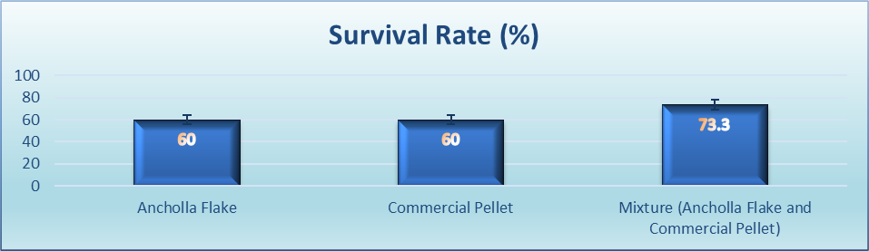

**Figure 1:** The survival rate of tilapia fish (Oreochromis niloticus) in the experiment

**Weight Gain**

Figure 2 display the weight gain rate of tilapia (Oreochromis niloticus) fed with three different types of food, namely Ancholla flake, commercial pellets, and a combination of Ancholla flake and commercial pellets, with respective weight gains of 19.64, 41.14, and 38.81g. The results indicate that fish fed with commercial pellets had the highest weight gain.

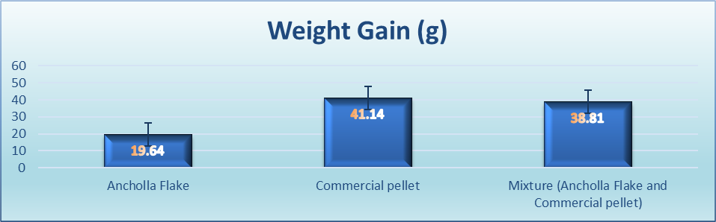

**Figure 2:** The weight gain of tilapia fish (Oreochromis niloticus) in the experiment

**Specific Growth Rate (SGR)**

Figure 3 demonstrate the specific growth rate (SGR % day-1) of tilapia (Oreochromis niloticus) juveniles fed with three different types of food, namely Ancholla flake, commercial pellets, and a combination of Ancholla flake and commercial pellets, with respective SGR values of 1.43, 1.83, and 1.68. The results indicate that fish fed with commercial pellets had the highest SGR.

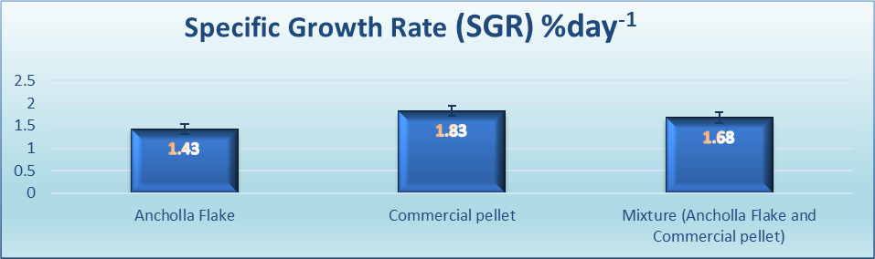

**Figure 3:** The specific growth rate (SGR, % day-1) of tilapia fish (Oreochromis niloticus) in the experiment

**Feed Conversion Ratio (FCR)**

Figure 4 shows the feed conversion ratio (FCR) for tilapia (Oreochromis niloticus) fed with three different types of food, namely Ancholla flake, commercial pellets, and a combination of Ancholla flake and commercial pellets, with FCR values of 3.5, 1.3, and 1.6, respectively. The results indicate that fish fed with commercial pellets had the lowest FCR.

**Figure 4:** The food exchange ratio (FCR) of tilapia fish (Oreochromis niloticus)

in the experiment

**Feed cost**

Figure 5 shows the cost of food used for one kilogram of tilapia (Oreochromis niloticus) fed with three different types of food, namely Ancholla flake, commercial pellets, and a combination of Ancholla flake and commercial pellets, with prices of RM5.60, RM6.00, and RM5.00, respectively. The results indicate that the combination of Ancholla flake and commercial pellets had the lowest cost.

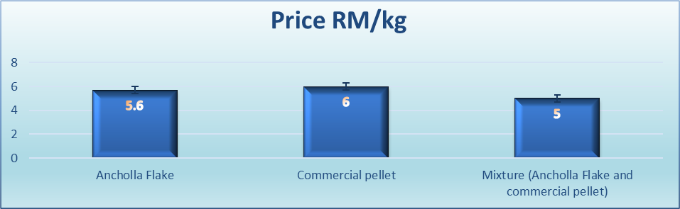

**Figure 4:** The food exchange ratio (FCR) of tilapia fish (Oreochromis niloticus) in the experiment

In general, the quality of dietary protein is a major factor affecting fish growth performance, and protein digestibility is the first measure of its availability to fish. The quality of a dietary protein source depends on its amino acid composition and digestibility. Deficiency in essential amino acids leads to the utilization of poor-quality dietary protein, which subsequently reduces growth and feed efficiency (Halver and Hardy, 2002). In this experimental study, Ancholla flake was produced and the feed contains 46.5% protein, 1.0% fat, 244 kcal of energy, and 12.2% carbohydrates. These nutritional contents are high and sufficient for the needs of juvenile tilapia fish. According to Zeng et al., 2020, the optimal protein diet requirement for GIFT tilapia to achieve maximum growth performance is 374.4, 301.7, and 304.9 g of protein/kg of diet at temperatures of 22, 28, and 34°C. Therefore, the protein content in Ancholla flake is much higher than the usual requirement, hence shows that it is comparable to the commercial feed.

Based on the study conducted over 5 weeks, it was found that the average weight of fish fed with commercial pellets was the highest, at 7.85g. This was followed by the combination of Ancholla flake and commercial pellets with an average weight of 6.79g, and Ancholla flake alone with an average weight of only 5.5g. These results indicate that commercial pellets provide better weight gain because they use high-quality and expensive formulation ingredients. FCR plays a crucial role in assessing how efficiently the food provided to fish can be digested, and it also allows cost calculations that related to fish feeding. In this study, Ancholla flake recorded the highest feed conversion ratio (FCR), which is 3.5, compared to commercial pellets at 1.3 and the combination of Ancholla flake and commercial pellets at 1.6. Based on a study conducted using the biofloc system, an FCR of 1.5 was obtained (Zahra et al., 2019). Despite the relatively high FCR for Ancholla flake, its cost is lower compared to the price of commercial pellets.

Based on the FCR results, alternating or mixing fish feeding every day shows the minimum and most cost-effective feeding strategy, amounting to RM5 to produce one kilogram of fish. In addition, the cost of Ancholla flake alone is RM5.60, while commercial pellets cost RM6.00 to produce one kilogram of fish. The cost of Ancholla flake is calculated based on the purchase of anchovy fish heads and the production cost. If anchovy fish heads can be obtained for free from fish processing plant, the cost of Ancholla flake would be much lower than the current assessment price. The current price for Ancholla flake is RM1.60/kg, commercial pellets RM4.60/kg, and the combination of Ancholla flake and commercial pellets RM3.10/kg.particles may have specific gravity values below 2.0. Soils having heavy substances may have values above 3.0.

1. **CONCLUSION**

Ancholla flake is a good source of nutrition for tilapia fish, even though it yields a higher FCR compared to commercial pellets. However, by combining Ancholla flake with commercial pellets or by alternating their feeding daily, good and more efficient weight gain can be achieved. For fish farmers, they have the option to produce this product themselves, thereby reducing the escalating cost of fish feed each year. The main contribution of this study is to assist farmers in addressing the issue of rising food costs, which is becoming increasingly challenging. Thus, this project has the potential to have a significant impact on freshwater fish farmers in Malaysia while enhancing productivity in the aquaculture sector.

1. **REFERENCES**
2. Das, M., Rahim, F. I., & Hossain, M. A. (2018). Evaluation of fresh Azolla pinnata as a low-cost supplemental feed for Thai silver barb Barbonymus gonionotus. Fishes, 3, 1-15. <https://doi.org/10.3390/fishes3010015>
3. Sheeno, T. P., & Sahu, N. P. (2006). Use of freshwater aquatic plants as a substitute of fishmeal in the diet of Labeo rohita fry. Journal of Fisheries and Aquatic Science, 1, 126–135.
4. Basak, B., Pramanik, M. A. H., Rahman, M. S., Tarafdar, S. U., & Roy, B. C. (2002). Azolla (Azolla pinnata) as a feed ingredient in broiler ration. International Journal of Poultry Science, 1, 29– 34.
5. Magouz, F. I., Dawood, M. A., Salem, M. F., & Mohamed, A. A. (2020). The effects of fish feed supplemented with meal on the growth performance, digestive enzyme activity, and health condition of genetically-improved farmed tilapia. Annals of Animal Science, 20, 1029–1045. <https://doi.org/10.2478/aoas-2020-0016>.
6. Pillai, P. K., Premalatha, S., & Rajamony, S. (2002). Azolla-a sustainable feed substitute for livestock. Leisa India, 4, 15– 17.
7. Fiogbe, E. D., Micha, J. C., & Van Hove, C. (2004). Use of a natural aquatic fern, Azolla microphylla, as a main component in food for the omnivorous–phytoplanktonophagous tilapia, Oreochromis niloticus L. Journal of Applied Ichthyology, 20, 517–520. <https://doi.org/10.1111/j.1439-0426.2004.00562.x>.
8. Gangadhar, B., Umalatha, H., Hegde, G., & Sridhar, N. (2017). Digestibility of dry matter and nutrients from Azolla pinnata by Labeo calbasu (Hamilton, 1822) with a note on digestive enzyme activity. Fishery Technology, 54, 94– 99.
9. Abou, Y., Fiogbe, E. D., & Micha, J. C. (2007). A preliminary assessment of growth and production of Nile tilapia, Oreochromis niloticus L., fed Azolla-based-diets in earthen ponds. Journal of Applied Aquaculture, 19, 5569. <https://doi.org/10.1300/J028v19n04_03>.
10. Halver, J.E. & Hardy, R.W. (2002). Fish Nutrition. In J.R. Sargent, D.R. Tocher, & G. Bell (Eds.), The Lipids, 3rd Edition (pp. 182-246). Academic Press.
11. Zeng, N.-N., Jiang, M., Wen, H., Liu, W., Wu, F., Tian, J., Yu, L.-J., Lu, X., & Guo, Z.-B. (2020). Effects of water temperatures and dietary protein levels on growth, body composition and blood biochemistry of juvenile GIFT tilapia (Oreochromis niloticus). Aquaculture Nutrition, 26(6), 1833-1843. <https://doi.org/10.1111/anu.1>
12. Zahra, S. A., Supono, B., & Putri, B. (2019). The Effect of Different Feeding Rate (FR) on Growth and Survival Rate of Tilapia Juvenile (Orechoromis niloticus) Based Biofloc System. Jurnal Akuakultur Rawa Indonesia, 7(2), 86-98.