**A Study On Employee Management System**

**Kummari Chandra Shekar**

Roll No: 212122672050, Department of Management Studies

Aristotle PG College, Chilkur, Moinabad, Ranga Reddy District, Telangana.

**Mr. S. Mallareddy**

**Assistant Professor**

Aristotle PG College, Chilkur, Moinabad, Ranga Reddy District, Telangana.

sanvalli.mallareddy@gmail.com

**Abstract:**

Employee management system is an application based system, having two applications developed, one for employers to manage employee details and another for employees to mark their attendance. Every organisation whether government or private uses an information system[2.] to store data of their staff. However, in India it is found that many small scale industries use pen and paper to keep a record. However, there are many advanced technology systems available that can do this work but they all are costly for these low level industries. This paper discusses making a system for solving problems for them at a cheaper cost. This system will mark attendance of each employee and calculate the salary of them at the end of month. It also calculates overtime and total working hours of each employee. As in small scale each company has their own holidays preference and variable week off for employees, so all this power is given to the employer to manage holidays and week days of each employee separately. It saves lots of time and has no error in pay calculation hence preventing clashes between HR Team and employees. So that both employer and employee can focus on their work to develop their company.

**Keywords:** Employee management, HR Team and employees

**INTRODUCTION:**

systems and goes through the essence of the problem that should be resolved.

### Background

Most of the contemporary Information systems are based on the Database technology as a collection of logically related data, and DBMS as a software system allowing the users to define, create, maintain and control access to the database.

The process of constructing such kind of systems is not so simple. It involves a mutual development of application program and database. The application program is actually the bridge between the users and the database, where the data is stored. Thus, the well-developed application program and database are very important for the reliability, flexibility and functionality of the system.

The so defined systems differentiate to each other and their development comprises a great variety of tasks to be resolved and implemented.

The basic idea can be depicted on Figure 1.1 below:



**Information System**

U S E R S

**Database System**

**i**

Application Program

|  |  |
| --- | --- |
| Dbase Queries | |
| Retrieve  Insert  Update Delete |  |
|  |

Database

DBMS

Figure 1.1 Database information systems - principle scheme

Information system suggests a computer technology to be used in order to provide information to users in an organization (for instance), as for the purposes of data transformation into useful information; computer hardware and software are designed and used.

A particular case is the Human Resources Information System development. This kind of systems are responsible for storing data of the staff within an organization and generating reports upon request.

Such kind of system could be integrated with other Information systems or modules: Accounting Information System (AIS) – designed to transform financial data into information, or Management Information System (MIS) that provides decision-oriented information to managers, and so on…

“Organizations depend on Information Systems in order to stay competitive. Productivity, which is crucial to staying competitive, can be increased through better Information Systems.”.

### Problem Statement

This report’s documentation goes through the whole process of both application program and database development. It also comprises the development tools have been utilized for these purposes.

**REVIEW OF LITERATURE:**

**ARTICLE: 1**

**Tile: Employee Management System**

**Author:** **Rishabh Bajpayi**

**Source:** **International Journal for Modern Trends in Science and Technology’**

Employee management system is an application based system, having two applications developed, one for employers to manage employee details and another for employees to mark their attendance. Every organisation whether government or private uses an information system[2.] to store data of their staff. However, in India it is found that many small scale industries use pen and paper to keep a record. However, there are many advanced technology systems available that can do this work but they all are costly for these low level industries. This paper discusses making a system for solving problems for them at a cheaper cost. This system will mark attendance of each employee and calculate the salary of them at the end of month. It also calculates overtime and total working hours of each employee. As in small scale each company has their own holidays preference and variable week off for employees, so all this power is given to the employer to manage holidays and week days of each employee separately. It saves lots of time and has no error in pay calculation hence preventing clashes between HR Team and employees. So that both employer and employee can focus on their work to develop their company.

**ARTICLE: 2**

**Tile: Employee Management System**

**Author:** **Kancho Dimitrov Kanchev**

**Source:** **International Journal for Modern Trends in Science and Technology’**

This report includes a development presentation of an information system for managing the staff data within a small company or organization. The system as such as it has been developed is called Employee Management System. It consists of functionally related GUI (application program) and database. The choice of the programming tools is individual and particular.

**3. DATABASE ANALYZING, DESIGN AND IMPLEMENTATION**

I have constructed a database that consists of six data tables. There will be one main table (parent table) and five child tables, related to each other. Patently, for this purpose the necessary primary and foreign keys should be defined into the responding tables. The so defined structure above is made up in conformity with the user’s needs and demands. Each employee of the staff is intended to have several records, responding to his Working History, Contact Person Information, Salary Information, Time Information and Holiday Information, and only one record containing his basic information within the company – his personal details as: date of birth, gender, marital status, address and phone details, and his current working record. An employee is supposed to have not only one record of his Working history, or his Contact Person Information…..For instance, if we take a look to the Time Information data table – an employee may have several records in case he has some experience within the current company. It is absolutely the same with the Salary Information, Contact Person Information and Holiday Information data tables.

The relationships between the data tables are shown in Figure 4-Appendix A.

In Figure 4 we can distinguish six tables that the database consists of. All of the relationships are of type: “one-to-many”. (For more details about the data tables, see Appendix A: Figure 5 - Parent data table Employee_Details and Child data tables - Figure 6, Figure 7, Figure 8, Figure 9, Figure 10).

The primary key fields could be set to Auto-number data type as Access creates these values in an ascending order to ensure that they are unique within a table. Some of the fields should be “adjusted” to accept null-values. It is quite important to be done as it is tightly related to the input fields of the application program. I decided to perform it in the following way: those fields that are compulsory to be filled by the user I have set not to accept any null-values of data and on the other hand, those ones, that can be left blank, are set to accept null-values. It is easy to be performed by changing the Allow Zero Length setting (Appendix A: Figure 11 – Setting a data-field to accept null- values).

**4. ANALYSIS**

This section will give some visual details about the content and the structure of the database that has been designed and constructed for the purposes of the program.

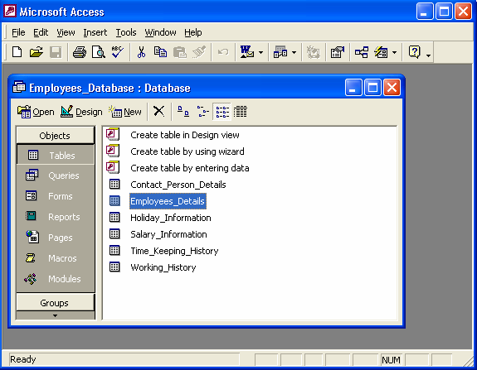MS-Access (2000):

Visual Studio – Microsoft:

Figure A.1

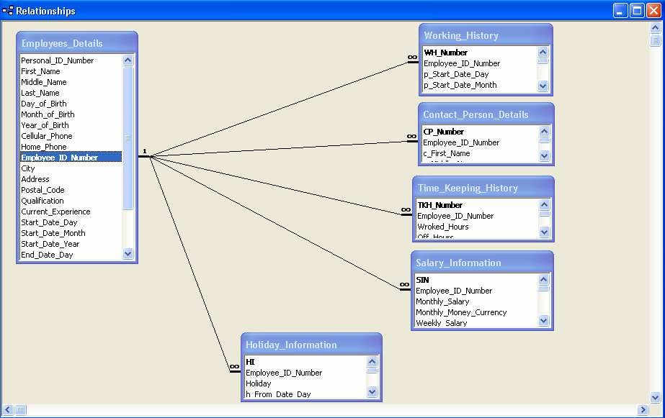

Employees_Details data table

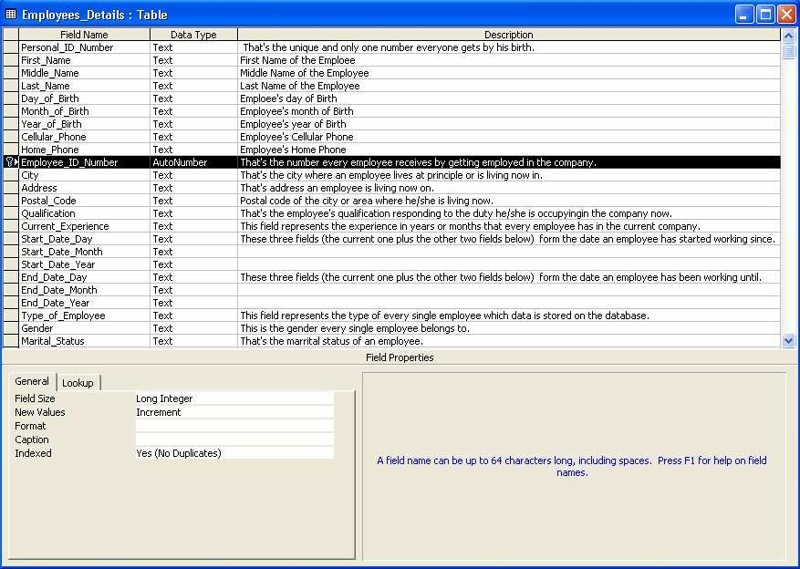

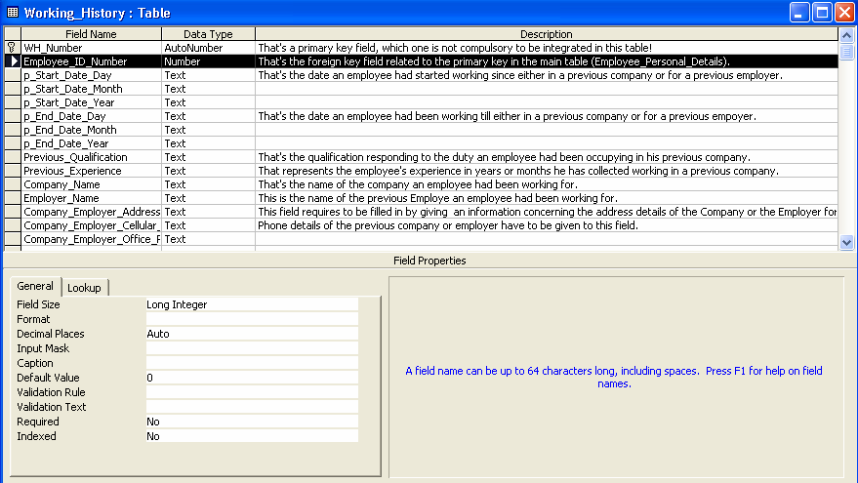

* + 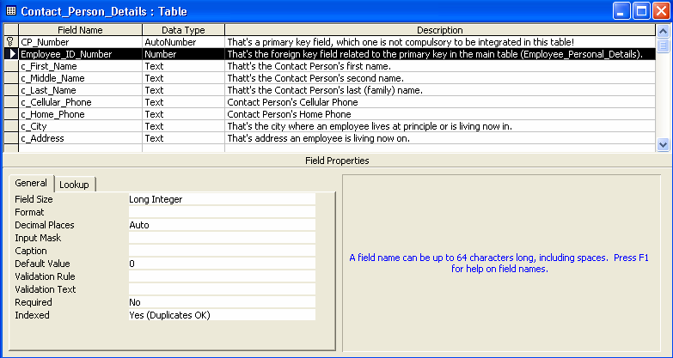Contact_Person_Details data table:

**Appendix B: Program’s Structure and Code Implementation**

This section will give some visual details about the structure of the program has been designed and constructed for the purposes of the program and its basic functions’ code implementation as well.

# **CONCLUSION**

In this report, an information system’s development has been presented. It was emphasized on the basic steps, consequently taken during the project’s development course as a particular attention was turned to the basic operative functions performed upon the data into the database.

The report’s content comprises the whole task solution, starting from the programming environments have been selected, going through the database, the application’s analyze and construction, and finishing with the code-implementation and test-samples, shown separately in Appendix chapters.

As a future work, some additional stuff could be implemented and integrated into the application code making it much more reliable and flexible; especially what concerns a pay-roll module, for instance.

Apparently, the role of such systems is basic and essential within each company that wants to keep a really good control and record concerning its personnel data, functionality and performance on all levels in its structure. Every organization, in nowadays, has the necessity of managing its staff on a really good level as the staff has definitely the greatest merit of building up a company as such as it is. The well- managed staff means giving the appropriate financial award-ness and all kind of benefits as such as they have been deserved. That’s why the development of such systems is not just a programming business – a lot of people are ordinarily involved in such projects and one of the basic requirements is the reliability of the system, especially what concerns the storage of data and all of the operations that will be performed upon it.

# References

1. – Begg Carolyn, Connolly Thomas, Database systems (a Practical approach to Design, Implementation, and Management), Addison-Wesley, an imprint of Pearson Education, University of Paisley (U.K.), Fourth edition 2005
2. – Bodnar George /Duquesne University/, Hopwood William /Florida Atlantic University/, Accounting Information systems, Eighth Edition, Prentice Hall, Upper Saddle River, New Jersey **.**
3. – Andersen Virginia, Access 2000: The Complete Reference, Blacklick, OH, USA: McGraw-Hill Professional Book Group, 2001, http://site.ebrary.com/lib/vaxjo/Doc?id=5002842 (2006-05-25).
4. – Andersson Tobias, [DAB744] C# Course Lectures, School of Mathematics and System Engineering, Växjö University.