**A Web Management Platform for Coronavirus Detection Using**

**CNN**

# Sanitha sajikumar

*Mangalam college of Engineering*

*Kerala technological university*

Sanithasaji2016@gmail.com

***Abstract*—***A web-based platform designed for the identification of coronavirus infections through analysis of chest X-ray scans. Amidst the global pandemic, rapid and accurate diagnosis is paramount. Our platform offers healthcare professionals a streamlined interface to upload and examine X-ray images, utilizing cutting-edge machine learning techniques. By harnessing advanced image processing and deep learning algorithms, our platform aims to expedite the detection process, facilitating early intervention and treatment. Moreover, it provides intuitive visualization tools to aid in result interpretation. Our solution represents a promising advancement in the battle against COVID-19, empowering healthcare providers with a reliable means of screening and monitoring infections through accessible medical imaging data. Our technology uses deep learning models and image processing techniques to help diagnose and treat COVID-19 patients as soon as possible. The software also provides visualization capabilities to help with decision-making and result interpretation. Our method has the potential to be an effective tool in the pandemic response, allowing for the fast screening and tracking of coronavirus infections using easily accessible medical imaging data.The Medical Website is named as Medico.*

1. Introduction

A healthcare technology and service called Secure Patient Information Systems (On Demand Medical Information System that Saves Life) would completely transform the healthcare sector by offering a comprehensive solution for the gathering, organizing, and administration of medical records. It offers practical, safe, easy-to-use, and affordable solutions to all those associated with the healthcare sector—patients foremost—to optimize the utilization of medical data and improve patient outcomes at any time or location.

It is created with the following missions in mind.

1. To make your medical history and alerts quickly available to emergency services in the event that you are unable to communicate. The emergency responders can quickly access all of your vital emergency information.
2. It also arranges all of the non-essential information and medical history you normally give to your healthcare facilities when you

A new system is the Cloud-Based Secure Patient Information Systems System. Specialty hospitals can enter patient information on this website. There is a thumb impression in the patient information. Using the thumb impression, doctors can obtain a patient's past medical history, allergies, heart condition status, surgical history, and other information if they are admitted to the hospital with major injuries. Thus, the course of treatment will be straightforward. The hospital has the ability to SMS the patient's relative if needed. In the event of an accident or emergency, the hospital has the authority to inform the patient's family members that the patient has been admitted. Any registered patient relative can use the patient's GIN to determine whether the patient has been admitted to one of our hospitals.For a more individualized treatment plan for you and a faster diagnosis, this medical information will be required. This could spell the difference between life and death in the immediate aftermath of an emergency. The advent of a new coronavirus called SARS-CoV-2 and the subsequent COVID-19 pandemic have presented hitherto unheard-of difficulties for international healthcare systems. Identification of COVID-19 infections quickly and accurately is essential for efficient disease management and control.

Convolutional Neural Networks (CNNs): For image categorization applications, CNNs are the most popular deep learning models. They have been used to differentiate COVID-19 from other forms of pneumonia and healthy lung tissue by recognizing characteristics from CXR pictures.

Example: To detect COVID-19 instances from CXR images, Wang et al. (2020) created the COVID- Net, a customized deep CNN.

Transfer Learning: Transfer learning has been widely employed because labeled COVID-19 CXR images are not widely available. On smaller COVID-19 datasets, pre-trained models such as VGG16, ResNet, and InceptionV3 are refined.

Promising results have been observed when using chest X-ray pictures to detect COVID-19, particularly when advanced deep-learning techniques are applied. However, there remain challenges related to data scarcity, model generalizability, and clinical integration. Continued research and collaboration between the fields of medical imaging, machine learning, and clinical practice are essential to develop robust and reliable diagnostic tools.

including genesig Real-Time PCR Coronavirus (COVID-19) testing and cobas SARS-CoV-2 for use on the cobas 6800/8800 systems [8]. These tests take a lot of time and money whereas CNN can play a major role in automatic positive patient detection. This can save both time and money which will eventually save lives. Moreover, this can add an extra layer of validation as none of the prevailing tests offer 100% accuracy. CNN is an Artificial Neural Network (ANN) which is first conceptualized in the year of 1943. It is inspired from the human nervous system [9] [10]. Hubel and Wiesel first pointed out that animal visual cortex cells play an important role in detecting lights in the receptive fields [11]. This later inspired to model neocognitron which is considered to be the predecessor of CNN [12]. With very little preprocessing, CNN perceives the images from their visual pattern which makes it precise and popular in image classification. Alexnet, ZFNet, VGGNet are few prominent CNN model for image classification which perform really well in practical scenarios

[13] [14] [15].

Like other image classifications, CNN has been performing really well with medical imaging also. For recent years, it has been used vastly for a different disease or anomaly detection

[16] [17]. CNN does the diagnosis of Coronary Artery Disease (CAD), recognition of stages from bright-field microscopy images of malaria-infected blood, detection of Parkinson’s disease from electroencephalogram (EEG) signals [18] [19] [20]. Researchers have also proposed different CNN models to classify dental images, detect skin diseases, the study of Alzheimer’s disease, and many other diseases [21] [22] [23]. CNN can also play a great role in COVID-19 detection from CT or X-ray images. In this paper, a CNN model is proposed to detect COVID-19 positive patients from chest X-ray images. With very little time and resources, this model successfully detects coronavirus patients with high accuracy. This can help to implement testing of COVID-19 on a much greater scale which would really save both money and time.

Section 2 describes the related works, the proposed model is presented in section 3, section 4 describes the results and analysis and finally, the paper is concluded in section 5.

1. Related Works

Extensive research work is going on for classifying COVID- 19 patient image data. Few researchers have proposed different DL models for classifying chest x-ray images whereas some others have taken CT images into consideration. Narin et. al proposed three pretrained CNN models based on ResNet50, InceptionV3 and Inception-ResNetV2 for detecting COVID- 19 patient from chest X-ray radiographs [24]. It is found that ResNet 50 gives the classifying accuracy of 98% whereas In- ceptionV3 and Inception-ResNetV2 perform with the accuracy of 97% and 87% respectively. But these models have taken only 100 images (50 COVID-19 and 50 normal Chest X-rays) into consideration for training which might result in declined accuracy for a higher number of training images. Zhang et al. propose a DL model for Coronavirus patient screening using their chest X-ray images [25]. This research group has

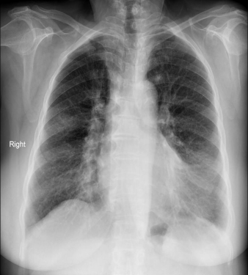 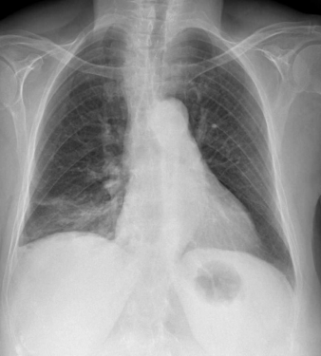

(a) COVID sample 1 (b) COVID sample 2

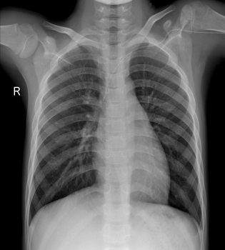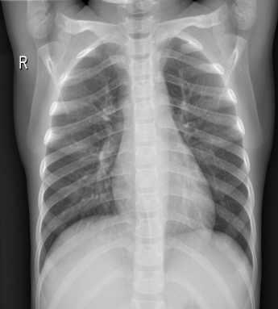

(c) Normal sample 1 (d) Normal sample 2

Fig. 2. (a) and (b) are the PA view of the chest X-rays of COVID-19 positive patients whereas (c) and (d) are of COVID-19 negative people

used 100 chest X-ray images of 70 COVID-19 patients and 1431 X-ray images of other pneumonia patients where they are classified as COVID-19 and non-COVID-19 respectively. This model is formed of three main parts: backbone networks, classification head, and anomaly detection head. The backbone network is a 18 residual CNN layer pre-trained on ImageNet dataset and it is mentionable that ImageNet provides a huge number of a generalized dataset for image classifications. This model can diagnosis COVID-19 and non-COVID-19 patients with an accuracy of 96% and 70.65% respectively. Hall et al. also worked on finding COVID-19 patients from a small set of chest X-ray images with DL [26]. They have used pre-trained ResNet50 and VGG 16 along with their own CNN and this model generates the overall accuracy of 91.24%. Sethy and Behea have also utilized deep features for Coronavirus disease detection [27]. Their model is based on ResNet50 plus SVM which achieved the accuracy and F1-score of 95.38% and 91.41% respectively. Apostolopoulos and Mpesiana utilized CNN transfer learning for detecting COVID-19 with X-ray images [28]. This work has considered 224 chest X-ray images of COVID-19 infected people, 714 images with Pneumonia and 504 images of normal people for training their model. This model achieved the accuracy of 96.78% and sensitivity and specificity of 98.66% and 96.46% respectively. Li et al. used the patients’ chest CT images for detecting COVID-19 with the developed CNN architecture called COVNet [29]. This research group has obtained sensitivity, specificity and

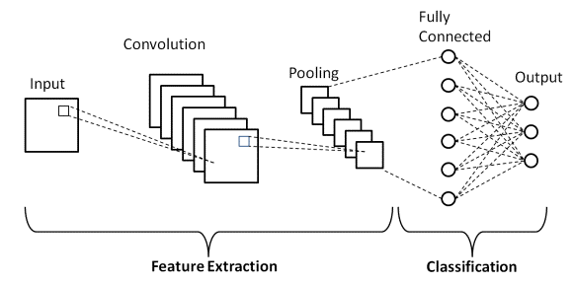

Fig. 3. Workflow diagram of the proposed CNN model for COVID-19 detection

Area Under the Receiver Operating Curve (AUC) of 90%, 96% and 0.96 respectively. Other researchers have also put an effort to detect COVID-19 patient from chest X-ray images in

[30] [31].

Most of the discussed research works in detecting COVID- 19 use pretrained models for their model architecture. These models are pretrained on more generalized dataset like Im- ageNet which might not achieve high accuracy with this medical imaging with bigger dataset. So, a sequential CNN model is proposed that is computationally efficient due to its simplicity in architecture. Moreover this is trained from scratch with the relevant dataset.

1. Proposed CNN Model for COVID-19 Detection
   1. *Dataset Modeling*

For training the proposed model, 165 chest X-ray images of COVID-19 patients are used which are obtained from open Github repository by Cohen et al. [32]. This repos- itory contains patients’ chest X-ray images of COVID-19, SARS, ARDS, Pneumocystis, Streptococcus, Chlamydophila, E.Coli, Legionella, Varicella, Lipoid, Bacterial, Pneumonia, Mycoplasma Bacterial Pneumonia, Klebsiella and Influenza. For training, only the COVID-19 positive X-rays have been taken into consideration and the patient age ranges from 12- 93 years. The training needs the normal or non-COVID-19 chest X-rays also which is obtained from Kaggle dataset naming ”Chest X-ray Images (pneumonia)” [33]. This repos- itory contains 5863 images in two categories- normal and pneumonia. But we have taken 165 (same number as the COVID-19 chest X-ray images) normal chest X-ray images for the training purpose. The whole dataset is primarily split into two categories: training and validation maintaining the ratio of 80% and 20% respectively. Each group of training and validation dataset contains two subcategories: ’Normal’ and

’COVID-19’, containing the respective types of X-ray images. So, for the training, both the subcategories- ’Normal’ and ’COVID-19’ contain 165 chest X-ray images each whereas, the validation dataset contains 41 images for each of the ’Normal’ and ’COVID-19’ sub-categories. For maintaining unanimity and the image quality at the same time, all the images are converted to 224*×*224 pixels. Moreover, all the X-ray images that are used for training and validation of the model are in Posteroanterior (PA) chest view. Fig. 2 presents the sample of PA views of the X-ray images of both COVID-19 positive and negative cases from the training dataset.

* 1. *CNN Modeling*

CNN has been playing a great role in classifying images, in particular medical images. This has opened new windows of opportunities and made the disease detection much more convenient. It also successfully detects recent novel Coro- navirus with higher accuracy. One of the constraints that researchers encounter is a limited dataset for training their model. Being a novel disease, the chest X-ray dataset of COVID-19 positive patients is also limited. Therefore, to avoid overfitting, a sequential CNN model is proposed for classifying X-ray images. Fig 3 depicts the proposed CNN model for COVID-19 detection. This model has 4 main components :

(i) input layers (ii) convolutional layers (iii) fully connected layers and (iv) output layers.

The tuned data set is fed into the input layers of the model. This model is trained on 165 X-ray images of each category: normal and COVID-19. It has four convolutional layers, first one is a 2D convolutional layer with 3*×*3 kernels and Rectified Linear Unit (ReLU) activation function. ReLU is one of the most popular and effective activation functions that are being widely used in DL. ReLU does not activate all the

neurons at the same time making it computationally efficient in comparison to other activation functions like tanh.

The next three layers are 2D convolutional layer along with the ReLU activation function and Max pooling. Max pooling accumulates the features of the convolutional layer by convolving filters over it. It reduces the computational cost as it minimizes the number of parameters thus it helps to avoid overfitting. In each of three layers a 2*×*2 Max pooling layer is added after the convolutional layer to avoid overfitting and to make the model computationally efficient. In the next step of the model, the output of the convolutional layers is converted to a long 1D feature vector by a flatten layer. This output from the flatten layer is feed to the fully connected layer with dropout. In a fully connected layer, every input neuron is connected to every activation unit of the next layer. All the input features are passed through the ReLU activation function and this layer categorizes the images to the assigned labels. The Sigmoid activation function makes the classification decision depending on the classification label of the neurons. Finally, in the output layer, it is declared if the input X-ray image is COVID-19 positive or normal.

1. Results and Analysis

The proposed model is trained for 25 epochs with 10 steps per epoch with the training dataset described in previous section. This model is named as Model 1. For comparative analysis, two more models are also trained with three and five convolutional layers instead of the 4 convolutional layer structure of Model 1. These two models are named Model 2 and Model 3 respectively. In this section, the proposed model (Model 1) is analyzed along with Model 2 and Model 3. The models are trained with a learning rate of 10-4 and a batch size of 32. All the training images are resized to 224*×*224 pixels. Moreover, to avoid overfitting of the models data augmentation is used which includes random cropping and random horizontal flipping. These three models are trained and validated with the same dataset and machine. The validation accuracy and corresponding epochs for all the three models are plotted in Fig 4.

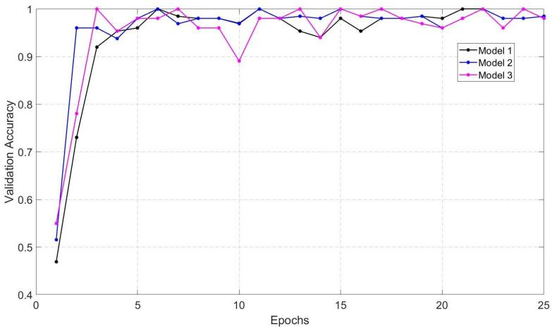

Fig. 4. The validation accuracy and corresponding epochs for all the three models

The overall accuracy is 0.9756, 0.9634, and 0.9634 for Model 1, Model 2, and Model 3 respectively. It clearly shows that the proposed model (Model 1) performs better than the other two in terms of accuracy. The performance of the models is more evident from the metrics like precision, recall, and F-1 score. These performance metrics are calculated from the possible outcomes of the validation dataset which is obtained by the confusion matrix. A confusion matrix has four different outcomes: True Positive (TP), True Negative (TN), False Positive (FP), False Negative (FN). In this case, TP denotes the number of Corona positive patients detected as positive, TN denotes the number of Corona negative cases detected as negative, FP presents the number of cases which are actually negative but detected as Corona positive and FN gives the cases which are actually Corona positive but detected as negative.

Receiver Operating Characteristics (ROC) curve represents the performance of the classifier at different threshold values which plot the TP rates vs FP rates. The confusion matrix and corresponding ROCs of Model 1, Model 2 and Model 3 are presented in Fig 5, Fig 6 and Fig 7 respectively. Top left square of the matrices denotes the TP cases and top right denotes the FN cases whereas bottom left and right squares present the FP and TN cases respectively.

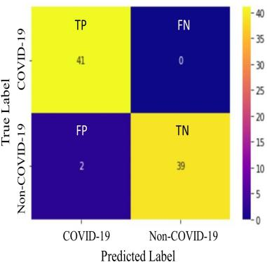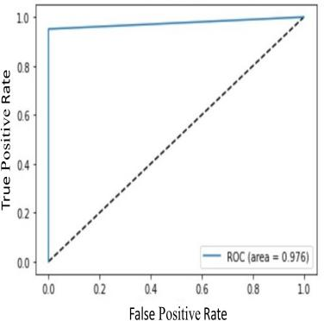

(a) Confusion matrix (b) ROC curve Fig. 5. (a) Confusion matrix and (b) ROC curve of Model 1

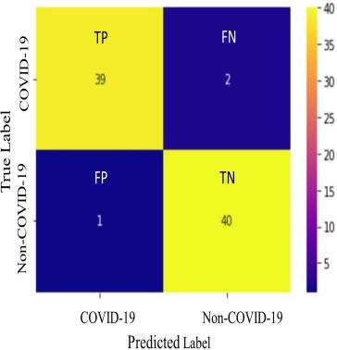

(a) Confusion matrix (b) ROC curve Fig. 6. (a) Confusion matrix and (b) ROC curve of Model 2

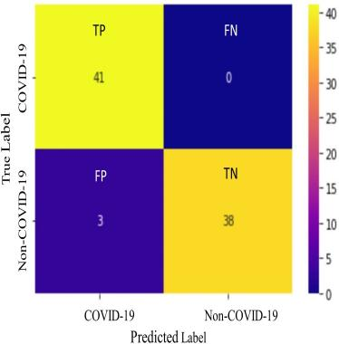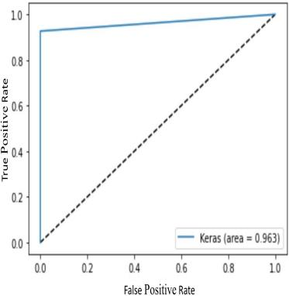TABLE I

Confusion Matrix Parameters and Performance Metrics of the

Models

|  |  |  |  |  |  |  |  |  |
| --- | --- | --- | --- | --- | --- | --- | --- | --- |
| Model | TP | TN | FP | FN | Accuracy  (%) | Precision  (%) | Recall  (%) | F1-  Score |
| Model  1 | 41 | 39 | 2 | 0 | 97.56 | 95.34 | 100 | 97.61 |
| Model  2 | 39 | 40 | 1 | 2 | 96.34 | 97.5 | 95.12 | 96.29 |
| Model  3 | 41 | 38 | 3 | 0 | 96.34 | 93.18 | 100 | 96.46 |

(a) Confusion matrix (b) ROC curve Fig. 7. (a) Confusion matrix and (b) ROC curve of Model 3

Model 1 detects 41 TP and 39 TN cases, Model 2 finds

39 TP and 40 TN cases whereas, Model 3 detects 41 TP and 38 TN cases. The ROC curve areas of Model 1,2 and 3 are respectively 0.976, 0.963, 0.963. It is evident from the confusion matrix and ROC curves that Model 1 performs better in terms of case detection.

Accuracy defines how close the generated result is close to the actual value whereas precision measures the percentage of the relevant results. Recall or sensitivity is another important factor for evaluating a CNN model. It is defined by the percentage of the total relevant results that a model can correctly classify. F1-score combines both precision and recall and it is designated as the weighted average of these two. Equation 1-4 represents accuracy, precision, recall, and F-1 sore respectively.

*TP* + *TN*

*Accuracy* = (1)

*TP* + *TN* + *FP* + *FN*

1. Conclusion

Mass testing and early detection of COVID-19 play an important role in preventing the spread of this recent global pandemic. Time, cost, and accuracy are the few major factors in any disease detection process specially COVID-19. To address these issues, a CNN based model is proposed in this paper for detecting COVID-19 cases from patients’ chest X- rays. A set of 330 chest X-ray images which are equally divided into two classes: ’COVID-19’ and ’Normal’, are used for training the model. Similarly, an equally divided image set of 82 chest X-rays are used for validation of the model. This model performs with accuracy and precision of 97.56% and 95.34% respectively. Moreover, this model is compared to the other two CNN models with a different number of convolutional layers. The comparative studies show better F1-score and overall performance of the proposed model (Model 1) than that of other two. This model can be improved further with the availability of the larger dataset. So, CNN has great prospects in detecting COVID-19 with very limited time, resources, and costs. Though the proposed model shows promising results, it is in no way clinically tested. This model needs further improvements and clinical testing for it to work in clinical diagnosis.

*TP*

*Precision* =

*TP* + *FP*

*TP*

*Recall* =

*TP* + *FN*

*F* 1 *Score* = 2 *× Precision × Recall*

*Precision* + *Recall*

(2)

(3)

(4)

References

1. P. Y. Simard, D. Steinkraus, J. C. Platt *et al.*, “Best practices for convolutional neural networks applied to visual document analysis” in *Icdar*, vol. 3, no. 2003, 2003.
2. K. O’Shea and R. Nash, “An introduction to convolutional neural networks” *arXiv preprint arXiv:1511.08458*, 2015.
3. A. Bhandare, M. Bhide, P. Gokhale, and R. Chandavarkar, “Applications of convolutional neural networks” *International Journal of Computer Science and Information Technologies*, vol. 7, no. 5, pp. 2206–2215, 2016.
4. K. Suzuki, “Overview of deep learning in medical imaging” *Radiolog- ical physics and technology*, vol. 10, no. 3, pp. 257–273, 2017.
5. Y.-C. Wu, C.-S. Chen, and Y.-J. Chan, “The outbreak of covid-19: An

Table I shows the confusion matrix parameters, accuracy, precision, recall and F1-score of the mentioned three models. The F1-score of the Model 1, 2, and 3 are 97.61, 96.29,

96.46 respectively. The overall performance and also the F1- score of the proposed model (Model 1) show better perfor- mance than that of the other two. The accuracy of the proposed model is 97.56% with the precision and recall value of 95.34% and 100% respectively. The overall performance including accuracy and F1-score can be improved further by training the model with a larger dataset.

overview” *Journal of the Chinese medical association*, vol. 83, no. 3,

p. 217, 2020.

1. W. H. O., “Modes of transmission of virus causing covid-19: impli- cations for ipc precaution recommendations: scientific brief, 27 march 2020” World Health Organization, Tech. Rep., 2020.
2. W. H. O. coronavirus disease (COVID-19) dashboard. Geneva: World health organization, 2020. [Online]. Available: https://covid19.who.int/
3. W. H. O. coronavirus disease (COVID-19) newsroom. Genevaworld- healthorganization2020. [Online]. Available: [https://www.who.int/ne](http://www.who.int/news-)ws- room/detail/07-04-2020-who-lists-two-covid-19-tests-for-emergency-use
4. W. S. McCulloch and W. Pitts, “A logical calculus of the ideas immanent in nervous activity” *The bulletin of mathematical biophysics*, vol. 5, no. 4, pp. 115–133, 1943.
5. M. Liang and X. Hu, “Recurrent convolutional neural network for object recognition” in *Proceedings of the IEEE conference on computer vision and pattern recognition*, 2015, pp. 3367–3375.
6. J. Gu, Z. Wang, J. Kuen, L. Ma, A. Shahroudy, B. Shuai, T. Liu,

X. Wang, G. Wang, J. Cai *et al.*, “Recent advances in convolutional neural networks” *Pattern Recognition*, vol. 77, pp. 354–377, 2018.

1. K. Fukushima, “Neocognitron: A self-organizing neural network model for a mechanism of pattern recognition unaffected by shift in position” *Biological cybernetics*, vol. 36, no. 4, pp. 193–202, 1980.
2. A. Krizhevsky, I. Sutskever, and G. E. Hinton, “Imagenet classification with deep convolutional neural networks,” in *Advances in neural infor- mation processing systems*, 2012, pp. 1097–1105.
3. M. D. Zeiler and R. Fergus, “Visualizing and understanding convolu- tional networks” in *European conference on computer vision*. Springer, 2014, pp. 818–833.
4. K. Simonyan and A. Zisserman, “Very deep convolutional networks for large-scale image recognition” *arXiv preprint arXiv:1409.1556*, 2014.
5. G. Litjens, T. Kooi, B. E. Bejnordi, A. A. A. Setio, F. Ciompi,

M. Ghafoorian, J. A. Van Der Laak, B. Van Ginneken, and C. I. Sa´nchez, “A survey on deep learning in medical image analysis” *Medical image analysis*, vol. 42, pp. 60–88, 2017.

1. A. S. Lundervold and A. Lundervold, “An overview of deep learning in medical imaging focusing on mri” *Zeitschrift fu¨r Medizinische Physik*, vol. 29, no. 2, pp. 102–127, 2019.
2. J. Hung and A. Carpenter, “Applying faster r-cnn for object detection on malaria images” in *Proceedings of the IEEE conference on computer vision and pattern recognition workshops*, 2017, pp. 56–61.
3. U. R. Acharya, H. Fujita, O. S. Lih, M. Adam, J. H. Tan, and

C. K. Chua, “Automated detection of coronary artery disease using different durations of ecg segments with convolutional neural network” *Knowledge-Based Systems*, vol. 132, pp. 62–71, 2017.

1. S. L. Oh, Y. Hagiwara, U. Raghavendra, R. Yuvaraj, N. Arunkumar,

M. Murugappan, and U. R. Acharya, “A deep learning approach for parkinson’s disease diagnosis from eeg signals” *Neural Computing and Applications*, pp. 1–7, 2018.

1. S. A. Prajapati, R. Nagaraj, and S. Mitra, “Classification of dental diseases using cnn and transfer learning” in *2017 5th International Symposium on Computational and Business Intelligence (ISCBI)*. IEEE, 2017, pp. 70–74.
2. H. Liao, “A deep learning approach to universal skin disease classifica- tion” *University of Rochester Department of Computer Science, CSC*, 2016.
3. E. Hosseini-Asl, R. Keynton, and A. El-Baz, “Alzheimer’s disease diagnostics by adaptation of 3d convolutional network” in *2016 IEEE International Conference on Image Processing (ICIP)*. IEEE, 2016, pp. 126–130.
4. A. Narin, C. Kaya, and Z. Pamuk, “Automatic detection of coronavirus disease (covid-19) using x-ray images and deep convolutional neural networks” *arXiv preprint arXiv:2003.10849*, 2020.
5. J. Zhang, Y. Xie, Y. Li, C. Shen, and Y. Xia, “Covid-19 screening on chest x-ray images using deep learning based anomaly detection” *arXiv preprint arXiv:2003.12338*, 2020.
6. L. O. Hall, R. Paul, D. B. Goldgof, and G. M. Goldgof, “Finding covid- 19 from chest x-rays using deep learning on a small dataset” *arXiv preprint arXiv:2004.02060*, 2020.
7. P. K. Sethy and S. K. Behera, “Detection of coronavirus disease (covid- 19) based on deep features” *Preprints*, vol. 2020030300, p. 2020, 2020.
8. I. D. Apostolopoulos and T. A. Mpesiana, “Covid-19: automatic de- tection from x-ray images utilizing transfer learning with convolutional neural networks” *Physical and Engineering Sciences in Medicine*, p. 1, 2020.
9. L. Li, L. Qin, Z. Xu, Y. Yin, X. Wang, B. Kong, J. Bai, Y. Lu,

Z. Fang, Q. Song *et al.*, “Artificial intelligence distinguishes covid-19 from community acquired pneumonia on chest ct” *Radiology*, p. 200905, 2020.

1. P. Afshar, S. Heidarian, F. Naderkhani, A. Oikonomou, K. N. Plataniotis, and A. Mohammadi, “Covid-caps: A capsule network-based framework for identification of covid-19 cases from x-ray images” *arXiv preprint arXiv:2004.02696*, 2020.
2. L. Wang and A. Wong, “Covid-net: A tailored deep convolutional neural network design for detection of covid-19 cases from chest x-ray images” *arXiv preprint arXiv:2003.09871*, 2020.
3. J. P. Cohen, P. Morrison, and L. Dao, “Covid-19 image data collection” *arXiv 2003.11597*, 2020. [Online]. Available: https://github.com/ieee8023/covid-chestxray-dataset
4. P. Mooney. Chest x-ray images (pneumonia). [Online]. Available: [https://www.kaggle.com/paultimoth](http://www.kaggle.com/paultimothymooney/chest-xray-pneumonia)ymoone[y/chest-xray-pneumonia](http://www.kaggle.com/paultimothymooney/chest-xray-pneumonia)