# HAB E-BOOKS

Mrs.K.Sugashini & D.Ashwin Kumaar & M.Hak Ashiq & P.Brindhaa

Mrs.K.Sugashini

D.Ashwin Kumaar

[ashwinkumaar877@gmail.com](mailto:ashwinkumaar877@gmail.com)

M.Hak Ashiq

[thakashiq@gmail.com](mailto:thakashiq@gmail.com)

P.Brindhaa

[brindhaapooja@gamil.com](mailto:brindhaapooja@gamil.com)

Sri Shakthi Institute of Engineering and Technology, Coimbatore.

Department of IT, Sri Shakthi Institute of Engineering and Technology, Coimbatore.

**Abstract:**

"HAB E-BOOK" Finding evaluation standards for interactive e-books is the goal of this mixed method study. In order to address the research objectives posed by the study, a Delphi survey comprising of thirty experts was conducted in four rounds to gather both qualitative and quantitative data. Following that, heuristic inquiry approach was applied to analyse twenty interactive e-books. The final stage involved integrating the findings from the heuristic inquiry and the Delphi technique. For interactive e-books, this led to the development of four themes, fifteen dimensions, and thirty-seven criteria. Finally, this study discusses the findings and their consequences and offers results. The goal of an ebook project abstract is to provide a concise and clear summary of the project.Finally, recommendations for additional research are made after the results and their implications are explored in this paper.   
  
A concise overview of the project is intended to be provided by the e book project abstract, which attempts to capture its core.

**Keywords:**

HAB E-BOOKS, Delphi survey, heuristic inquiry, qualitative and quantitative data, Project abstract,

additional research.

**Introduction:**

Books have acted as a catalyst for the spread andAccording to McLuhan (1964, p. 174), books are referred to as "the first teaching machine" and are essential to the teaching and learning process (West, Turner, & Zhao, 2010). Books have acted as a catalyst for the spread and transmission of information for ages. They made progress possible, contributed to the advancement of humanity, and have themselves underwent evolution. An important turning point for electronic books, or e -books, came in 1971. In order to promote the production and dissemination of e-books, Michael Stern Hart launched Project Gutenberg in that same year (Hart, 2004). He also produced the first digital edition of the Declaration of Independence, which was the first e-book in history (Hart, 1992).   
Additional advancements include the first handheld e-book in1997, DOS-based e-books and the Runeberg Project in1992, PDF 1.0 in1993, the first digital hypertext narrative Afternoon in 1980, and E-ink Corporation in 1992.

**HOME PAGE:**

The homepage serves as the central hub of our website, offering users a snapshot of its content and navigation options. It often includes a welcome message or branding elements and about our services and contact details. It also contains feedback option to enhance performances and user experience.

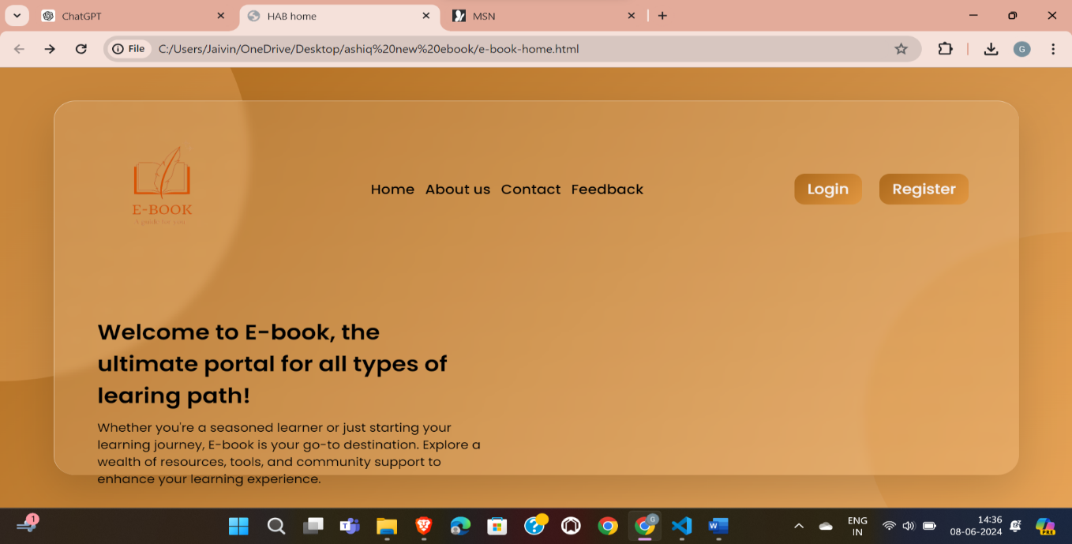

**LOGIN PAGE:**

A login page provides a secure entry point to access a system or application. It

typically features fields for users to input their email and password. After

submission, the system verifies the credentials, granting access if valid or

displaying an error message if not.

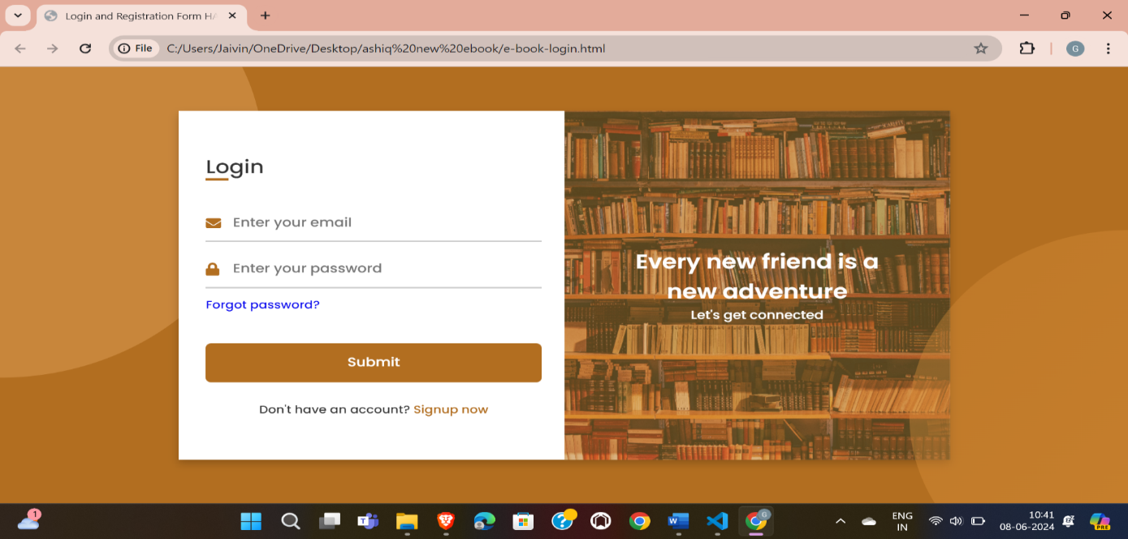

**REGISTER:**

The Sign-Up page is your key to unlocking a world of opportunities within our community. With just a few simple steps, you pave the way to join our network of like-minded individuals. It's a seamless process designed for ease and convenience, ensuring that your journey with us starts off on the right foot. Clear instructions and intuitive design make registering a breeze, empowering you to access exclusive content, connect with others, and embark on a fulfilling experience tailored to your interests and aspirations.

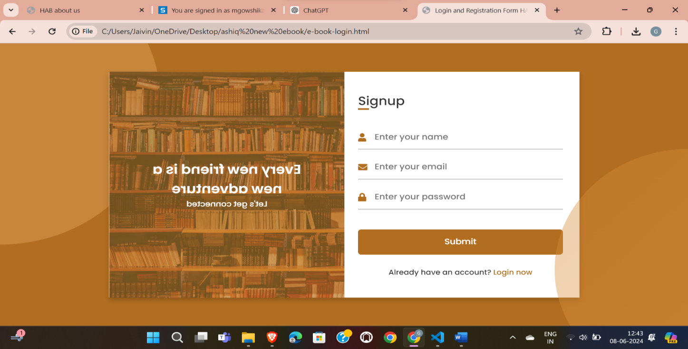

**ABOUT US :**

The About Us page is our digital manifesto, a testament to our journey and purpose. In its succinct lines, we reveal our ethos, values, and aspirations. It's a canvas where our story unfolds, painting a picture of who we are, what we stand for, and why we exist. With clarity and brevity, we invite visitors to join us on our mission, to explore our history, and to understand the driving force behind our endeavors.

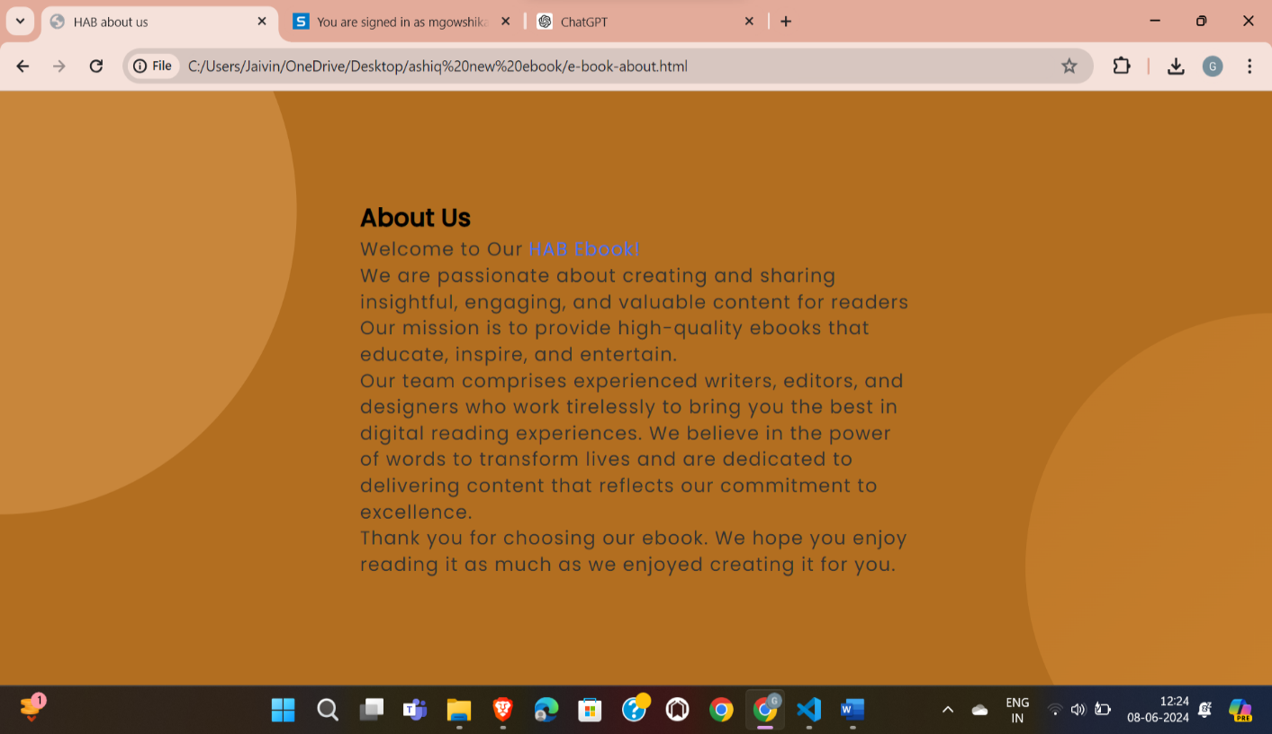

**CONTACT:**

The Contact page is your direct line to us, a bridge connecting you to our team. It's where inquiries meet solutions, and connections are forged. With clear prompts and user-friendly forms, reaching out is effortless. Whether seeking assistance, sharing feedback, or exploring partnership opportunities, this page facilitates seamless communication. Our commitment to responsiveness ensures that every message is received with care and addressed promptly. From queries to collaborations, the Contact page serves as a hub of interaction, fostering meaningful connections and enriching experiences.

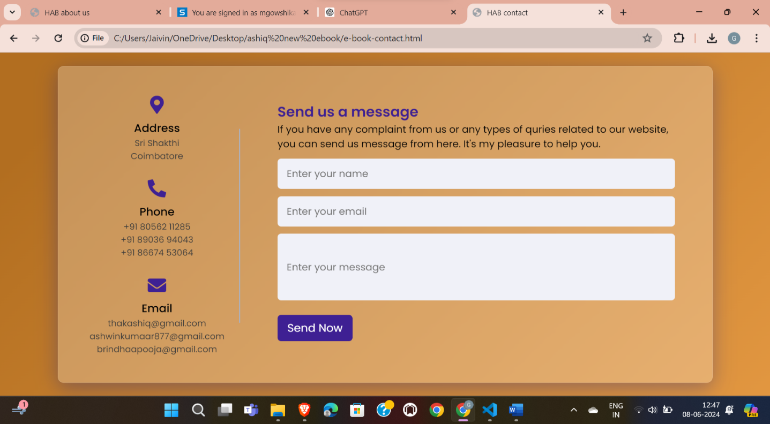

**FEEDBACK:**

The feedback page serves as a platform for users to share their thoughts, experiences, and suggestions regarding a product, service, or experience. It typically features a form where users can submit comments, ratings, and specific feedback. This feedback is invaluable for businesses to understand customer satisfaction, identify areas for improvement, and make informed decisions to enhance their offerings. Additionally, it fosters a sense of engagement and transparency between users and the organization, strengthening the overall relationship and driving continuous improvement efforts.

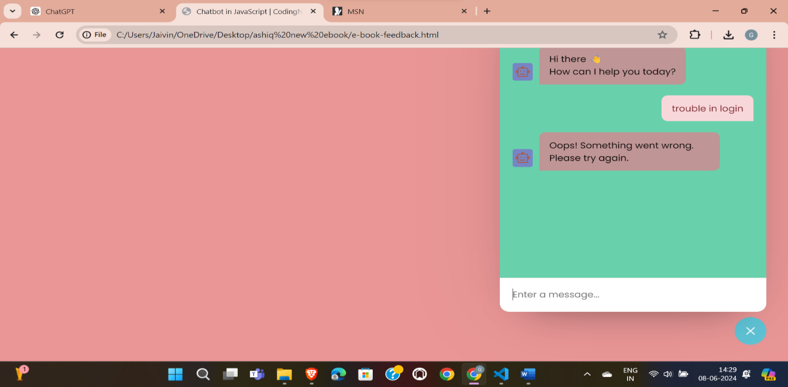

**COURSE SELECTION PAGE :**

The choice selection page is a user interface element designed to present users with a set of

options and facilitate decision-making. It typically displays a list or grid of choices,

allowing users to select one or more options based on their preferences or requirements. This

page often includes intuitive navigation controls and clear instructions to guide users through the

selection process smoothly. Additionally, it may provide relevant information or context to help

users make informed decisions. Overall, the choice selection page aims to streamline user

interactions and enhance the overall user experience.

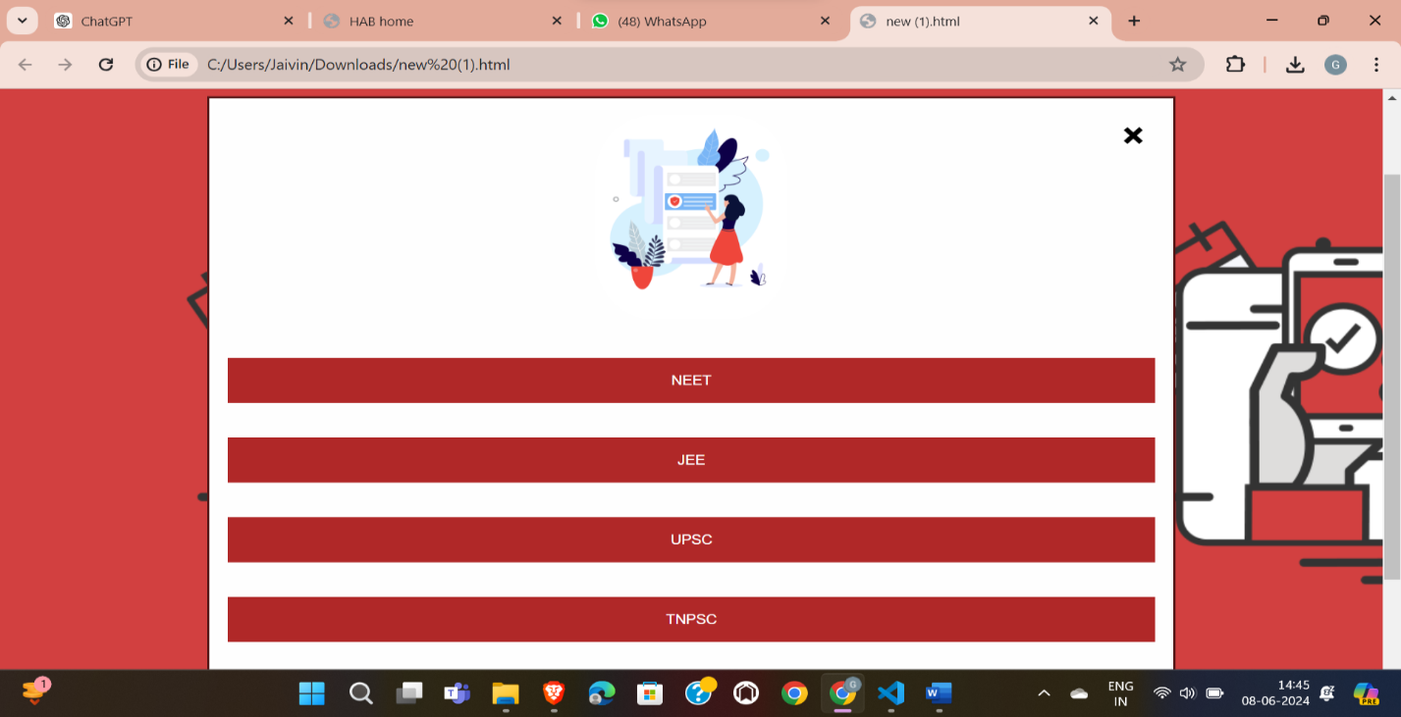

**Reference:**

Ziglio, E., and Adler, M. (1996). looking up at the oracle. Publishers Jessica Kingsley: Bristol, PA.. It was D. G. Altman (1991). Useful Statistics in Medical Research. Chapman & Hall, London. 77 Taylor, Anderson (2003). Research problems and recent breakthroughs regarding modes of engagement in distance education. Handbook of Distance Education, M. Moore, ed., pp. 129–144. NJ – Mahwah: Erlbaum. Bozkurt, A., and M. Ataizi (2014). Review of the book: Instructional Science and E-Learning. 175–178 in Contemporary Educational Technology, 5(2). (2006) Beldarrain, Y. Trends in remote learning: Using new technologies to encourage communication and teamwork among students. 139–153 in Distance Education, 27(2). Bozkaya, M., and A. Bozkurt (2013a). Kriterleri etkileşimli e-kitap değerlendirmektedir. http://www.academia.edu/6007097/Lendirme_Kriterleri_Etkileşimli e-kitap Bozkaya, M., and A. Bozkurt (2013b). E-Kitap Etkileşimli: Yoru, Bugünü ve Yarını. 3.75–76 (http://www.academia.edu/2536903/Etkilesimli_E-Kitap_Dunu_Bugunu ve_Yarini) Bozkurt (2013). Açık ve Uzaktan