**ONLINE GOOD’S**

Mr.M.Kirbadeevi

deepak.siet.ac.in@gmail.com

T.Deepak

t48995622@gmail.com

Sri Shakthi Institute of Engineering and Technology, Coimbatore.

Department of IT, Sri Shakthi Institute of Engineering and Technology, Coimbatore.

**Abstract:**

Online shopping has revolutionized the way we shop, offering unparalleled convenience and access to a vast array of products at our fingertips. Instead of navigating crowded aisles and waiting in long checkout lines, consumers can now browse and purchase items from the comfort of their own homes or on the go via smartphones and tablets.

With online shopping, geographical barriers disappear, allowing shoppers to explore products from around the globe without leaving their homes. This accessibility opens up a world of possibilities, enabling consumers to find unique items and discover niche brands that may not be available locally.

**Introduction:**

• **Convenience**: Shop anytime, anywhere, without the constraints of store hours or travel time.

• **Variety**: Access a vast selection of products ranging from everyday essentials to specialty items.

• **Price Comparison**: Easily compare prices across different retailers to find the best deals and discounts.

• **Reviews and Recommendations**: Benefit from customer reviews and recommendations to make informed purchasing decisions.

• **Personalization**: Enjoy personalized recommendations based on past purchases and browsing history.

• **Ease of Payment**: Secure payment options and multiple payment methods make transactions smooth and hassle-free.

• **Doorstep Delivery**: Have your purchases delivered directly to your doorstep, saving time and effort.

Online shopping has transformed the retail landscape, revolutionizing how consumers purchase goods and services. This essay delves into the evolution, trends, benefits, challenges, and future prospects of online shopping, examining its profound impact on commerce, society, and individual behavior.

**1. Introduction:**

* Definition and Conceptual Framework
* Historical Overview of Online Shopping

**2. Evolution of Online Shopping:**

* Early Beginnings and Milestones
* Technological Advancements and Innovations
* Emergence of E-commerce Giants and Marketplaces

**3. Key Players in the Online Shopping Ecosystem:**

* E-commerce Platforms and Marketplaces
* Retailers and Brands
* Payment Gateways and Financial Institutions
* Logistics and Fulfillment Services

**4. Trends and Dynamics Shaping Online Shopping:**

* Mobile Commerce (M-Commerce)
* Social Commerce and Influencer Marketing
* Personalization and Customer Experience
* Omnichannel Retailing
* Subscription-Based Models
* Virtual Reality (VR) and Augmented Reality (AR) Shopping Experiences

**5. Benefits of Online Shopping:**

* Convenience and Accessibility
* Expanded Product Selection
* Price Transparency and Comparison
* Time and Cost Savings
* Personalized Recommendations
* Seamless Payment and Checkout Processes
* Global Reach and Cross-Border Trade

**6. Challenges and Risks in Online Shopping:**

* Security and Privacy Concerns
* Fraud and Cybersecurity Threats
* Product Authenticity and Quality Assurance
* Customer Service and Returns Management
* Digital Divide and Accessibility Issues
* Environmental Impact and Sustainability

**7. Consumer Behavior and Psychology in Online Shopping:**

* Decision-Making Processes
* Trust and Brand Loyalty
* Impulse Buying vs. Planned Purchases
* Social Influence and Peer Recommendations
* Psychological Pricing Strategies

**8. Socioeconomic Implications of Online Shopping:**

* Impact on Brick-and-Mortar Retailers
* Job Creation and Displacement
* Digital Divide and Inequality
* Cultural and Behavioral Shifts
* Urbanization and Logistics Challenges

**9. Regulatory Framework and Legal Considerations:**

* Consumer Protection Laws
* Data Privacy Regulations
* Taxation and Cross-Border Trade Policies
* Intellectual Property Rights

**10. Future of Online Shopping:**

* Technological Innovations and Disruptions
* Integration of Artificial Intelligence (AI) and Machine Learning (ML)
* Sustainability and Ethical Consumption
* Hyper-Personalization and Predictive Analytics
* Enhanced Customer Engagement and Social Integration

**11. Conclusion:**

* Recap of Key Findings and Insights
* Implications for Businesses, Consumers, and Society
* Recommendations for Future Research and Action

**12. References and Citations:**

* Academic Studies, Reports, and Publications
* Industry Reports and Whitepapers

1:HOME PAGE



Creating an Home page for "ONLINE GOOD’S" involves developing a comprehensive system to manage various aspects of online goods studio. This system should allow administrators to oversee operations, manage client relationships, and ensure smooth functioning of the studio. Here are some key topics and features to include in the admin panel.

Figure:1 Home Page

2: OUR login PAGE

A login page serves as the gateway for users to access restricted areas or personalized features within a website or application. Here are some common uses of a login page in the context of online shopping:

1. **User Authentication**: The primary purpose of a login page is to authenticate users by verifying their identity. Users provide their credentials, such as username/email and password, to gain access to their accounts.



Figure:2 Login Page

1. **Access to Account Information**: Once logged in, users can access their account information, including order history, shipping addresses, payment methods, and saved preferences. This personalized experience enhances user engagement and facilitates repeat purchases.
2. **Shopping Cart Management**: Logged-in users can view and manage items in their shopping carts across multiple sessions. This allows users to save items for later purchase, track prices, and proceed to checkout seamlessly.
3. **Order Tracking and History**: Users can track the status of their orders, view order details, and access order history from their accounts. This feature provides transparency and enhances the post-purchase experience for customers.
4. **Wishlist and Favorites**: A login page enables users to create and manage wishlists or favorites, allowing them to save products they are interested in for future reference. This feature encourages users to revisit the website and facilitates purchase decisions.
5. **Personalized Recommendations**: By analyzing user behavior and purchase history, online retailers can provide personalized product recommendations to logged-in users. These recommendations are based on users' preferences, browsing history, and past purchases, increasing the likelihood of conversion.
6. **Account Security and Privacy**: A login page helps ensure the security and privacy of user accounts by requiring authentication before accessing sensitive information or performing transactions. This protects user data from unauthorized access and enhances trust in the platform.
7. **Communication and Notifications**: Logged-in users may receive personalized communication, such as order confirmations, shipping updates, promotional offers, and personalized recommendations, based on their account preferences and activity.

3:REGISTER PAGE

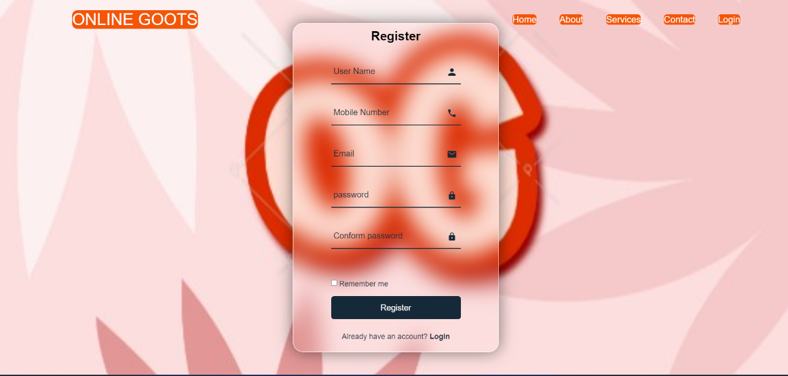

Figure:7.3 Register Page

· **User Registration**: The primary purpose of a register page is to allow new users to create accounts by providing their personal information, such as name, email address, and password. This process typically involves filling out a registration form and agreeing to the website's terms and conditions.

· **Access to Personalized Features**: Once registered, users gain access to personalized features and functionalities within the online shopping platform. This may include the ability to save preferences, manage orders, track shipments, and receive targeted recommendations based on their shopping behavior.

· **Order History and Tracking**: Registered users can view their order history, track the status of current orders, and access detailed order information from their accounts. This feature provides transparency and convenience, allowing users to monitor their purchases and manage returns or exchanges efficiently.

· **Saved Addresses and Payment Methods**: Registered users can save multiple shipping addresses and payment methods to streamline the checkout process. This saves time during future purchases and enhances the overall shopping experience by eliminating the need to enter information repeatedly.

· **Wishlist and Favorites**: Registered users can create and manage wishlists or favorites, allowing them to save products they are interested in for future purchase. This feature encourages users to revisit the website and facilitates purchase decisions by providing a curated list of preferred items.

· **Account Security and Privacy**: Registering for an account enables users to set up account security measures, such as passwords and security questions, to protect their personal information and prevent unauthorized access. This helps build trust in the online shopping platform and ensures the privacy of user data.

· **Communication Preferences**: Registered users can manage their communication preferences, such as opting in or out of promotional emails, newsletters, and notifications. This allows users to tailor their experience to their preferences and stay informed about relevant updates and offers from the online retailer.

4:ABOUT PAGE

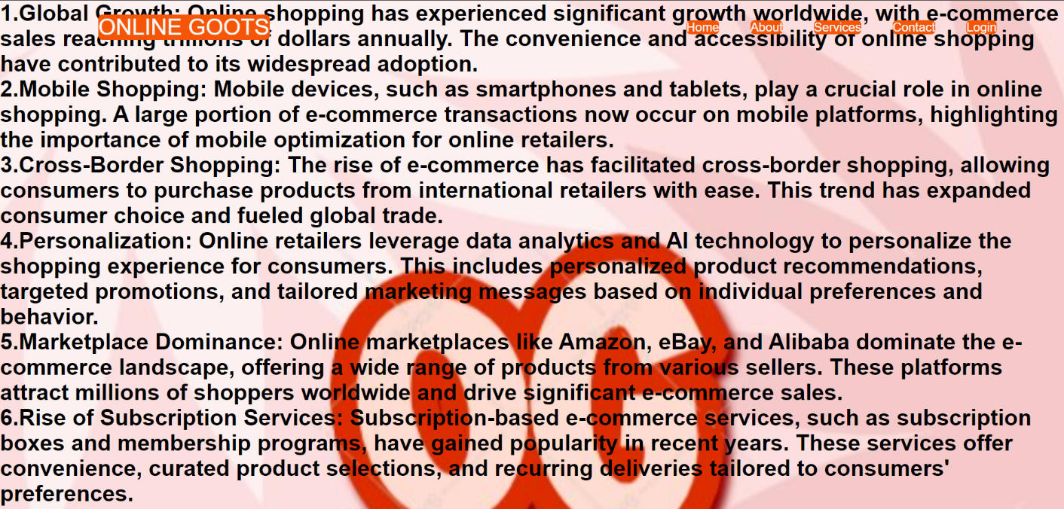

Figure:7.4 About Page

· **Company Overview**: The "About" page provides visitors with an overview of the online shopping company, including its history, background, and founding story. This section may highlight key milestones, achievements, and notable events that have shaped the company's journey.

· **Mission and Values**: The page communicates the company's mission statement and core values, articulating its purpose and guiding principles. This helps visitors understand the company's commitment to excellence, integrity, customer satisfaction, and social responsibility.

· **Brand Identity**: The "About" page communicates the brand identity and personality of the online shopping company, including its unique selling proposition (USP), brand positioning, and brand messaging. This section may include elements such as brand voice, tone, and visual identity.

· **Team and Leadership**: The page introduces visitors to the key members of the company's leadership team, founders, and employees. This section may include brief bios, photos, and professional backgrounds of team members, fostering transparency and building trust with customers.

· **Customer Testimonials**: The "About" page may feature customer testimonials, reviews, and success stories to showcase the company's commitment to customer satisfaction and quality. This social proof helps build credibility and reassures visitors about the reliability of the online shopping platform.

· **Company Culture**: The page provides insights into the company's culture, workplace environment, and employee values. This section may highlight employee perks, initiatives, and corporate social responsibility (CSR) efforts, demonstrating the company's commitment to its workforce and community.

· **Contact Information**: The "About" page typically includes contact information, such as email addresses, phone numbers, and physical addresses, allowing visitors to reach out to the company with inquiries, feedback, or partnership opportunities. This facilitates communication and fosters engagement with customers.

· **FAQs and Policies**: The page may address frequently asked questions (FAQs) about the company, its products, services, shipping policies, returns, and exchanges. This helps address common queries and concerns that visitors may have, providing clarity and transparency.

.

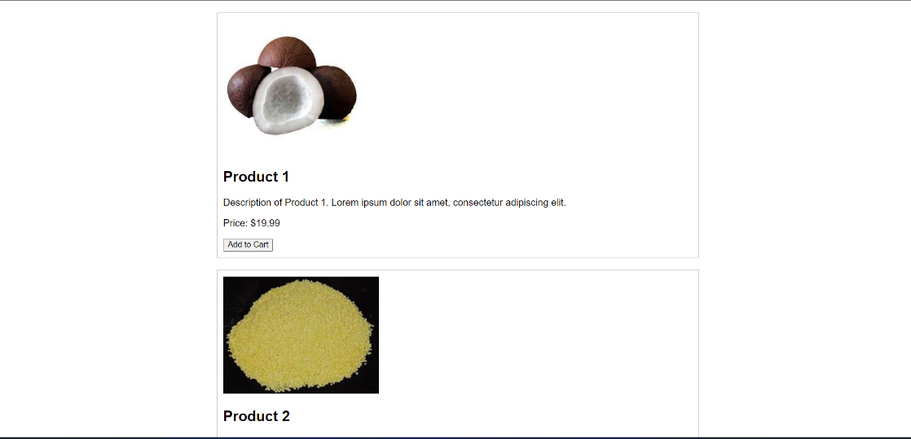

REFERENCE:

• **Spree Commerce**:

* Repository: <https://github.com/spree/spree>
* License: New BSD License
* Technology Stack: Ruby on Rails, JavaScript
* Features: Highly customizable, modular architecture, extensive documentation
* Community: Active community support, frequent updates, and contributions

• **Magento Open Source**:

* Repository: <https://github.com/magento/magento2>
* License: Open Software License 3.0 (OSL-3.0)
* Technology Stack: PHP, MySQL, JavaScript
* Features: Scalable and robust, extensive customization options, large ecosystem of extensions
* Community: Strong community presence, official forums, regular updates and security patches

• **WooCommerce**:

* Repository: <https://github.com/woocommerce/woocommerce>
* License: GNU General Public License version 3 (GPL-3.0)
* Technology Stack: PHP, JavaScript
* Features: Seamless integration with WordPress, customizable themes and plugins, built-in payment gateways
* Community: Large user base, active community forums, extensive documentation and tutorials

• **OpenCart**:

* Repository: <https://github.com/opencart/opencart>
* License: GNU General Public License version 3 (GPL-3.0)
* Technology Stack: PHP, MySQL, JavaScript
* Features: User-friendly interface, multi-store support, extensive admin panel
* Community: Dedicated community forums, marketplace for extensions and themes, regular updates and bug fixes

• **GitHub**:

* Description: The largest and most popular platform for hosting Git repositories, including countless open-source projects related to e-commerce.
* Website: <https://github.com/>

• **GitLab**:

* Description: Another widely used platform for hosting Git repositories, offering features similar to GitHub.
* Website: <https://gitlab.com/>

• **Bitbucket**:

* Description: A Git repository hosting service owned by Atlassian, providing both public and private repository options.
* Website: <https://bitbucket.org/>

• **SourceForge**:

* Description: An older repository hosting service known for its extensive collection of open-source projects across various categories.
* Website: <https://sourceforge.net/>

• **npm (Node Package Manager)**:

* Description: The default package manager for Node.js, hosting many JavaScript packages and modules used in web development, including e-commerce-related libraries.
* Website: <https://www.npmjs.com/>

• **PyPI (Python Package Index)**:

* Description: The official repository for Python packages, where you can find Python libraries and frameworks used in building e-commerce platforms.
* Website: <https://pypi.org/>

• **RubyGems**:

* Description: The package manager for Ruby programming language, hosting Ruby libraries and gems used in e-commerce development with Ruby on Rails.
* Website: <https://rubygems.org/>

• **Packagist**:

* Description: The main Composer repository for PHP, where you can find PHP packages and dependencies used in e-commerce projects.
* Website: <https://packagist.org/>

• **WordPress.org Plugin Directory**:

* Description: The official directory for WordPress plugins, where you can find e-commerce plugins for building online stores with WordPress.
* Website: https://wordpress.org/plugins/

• **Magento Marketplace**:

* Description: The official marketplace for Magento extensions and themes, offering a wide range of add-ons for Magento-based e-commerce stores.
* Website: https://marketplace.magento.com/

• **OpenCart Marketplace**:

* Description: The official marketplace for OpenCart extensions and themes, providing additional functionalities and customization options for OpenCart stores.
* Website: <https://www.opencart.com/>

• **Shopify App Store**:

* Description: The official marketplace for Shopify apps and integrations, offering a variety of tools to enhance Shopify-based e-commerce stores.
* Website: https://apps.shopify.com/

• **BigCommerce App Marketplace**:

* Description: The official marketplace for BigCommerce apps and integrations, providing solutions to extend the capabilities of BigCommerce stores.
* Website: https://www.bigcommerce.com/apps/

• **Envato Market**:

* Description: A digital marketplace offering themes, templates, plugins, and other digital assets, including e-commerce themes and plugins for various platforms.
* Website: <https://themeforest.net/>

• **Codecanyon**:

* Description: Part of the Envato Market, Codecanyon specializes in selling scripts and plugins, including e-commerce-related scripts for building online stores.
* Website: <https://codecanyon.net/>

• **Django Packages**:

* Description: A directory of reusable apps, sites, and tools for Django, where you can find Django packages useful for e-commerce development.
* Website: <https://djangopackages.org/>

• **Vue.js Awesome**:

* Description: A curated list of Vue.js components, libraries, and frameworks, including Vue.js components for building e-commerce interfaces.
* Website: <https://vuejsexamples.com/>

• **React Awesome**:

* Description: A curated list of React components, libraries, and frameworks, including React components for building e-commerce interfaces.
* Website: https://reactjs.org/community/react-awesome/

• **Angular Awesome**:

* Description: A curated list of Angular components, libraries, and frameworks, including Angular components for building e-commerce interfaces.
* Website: <https://github.com/Angular-RU/angular-awesome-list>

• **Joomla Extensions Directory**:

* Description: The official directory for Joomla extensions, where you can find e-commerce extensions for building online stores with Joomla.
* Website: https://extensions.joomla.org/