**FINANCIAL STATEMENT ANALYSIS IN BHARAT HEAVY ELECTRICALS LIMITED.**

**MATKIKAR VAMSHI**

Roll No: 212122672051, Department of Management Studies

Aristotle PG College, Chilkur, Moinabad, Ranga Reddy District, Telangana.

**Mr. M. NANDA KISHORE**

Assistant Professor

Aristotle PG College, Chilkur, Moinabad, Ranga Reddy District, Telangana.

nkishore183@gmail.com

**Abstract:**

*Financial statement is an organized collection of data according to logical and consisted accounting procedures. Its purpose is to convey an understanding of some financial aspects of a business form. It may reveal a series of activities over a given period of time, as in the case of an income statement. The focus of the financial analysis is on key figures in the financial statements and the significant relationships the exists between them. The analysis of financial statements is a process of evaluating relationships between component parts of financial statements to obtain a better understanding of the firm’s position and performance.*

**Keywords:** Financial Statements, Proposed Tools.

**INTRODUCTION:**

**Investors:**

The Investors are interested their money in the firms shares, are not concerned about the firms earnings. They restore more confidence in those firms that show steady growth in earnings. As such, they concentrate on the analysis of the firms present and future profitability. They are also interested in the firm’s financial structure to the extent it influences the firms earning ability and risk.

**Government:**

The financial statements are used to asses tax liability of business enterprise. These statements enable the government to find out whether the business is following various regulations or not.

**Others:**

Trade associations, stock exchange and public at may also analyze the financial statements to judge the financial position of different concerns.

**Definition:**

According to Myres “Financial statement analysis is largely is a study of the Relationship among the various financial factors in a business as disclose by a single set of statement and a study of the trend of these factors as show in a series of statements.

**Financial statements are indicators of the two significant factors**:

1. Profitability
2. Financial Soundness

Analysis and interpretation of financial statements therefore refers to such a treatment of the information contained in the income statement and the balance sheet so as to afford full diagnosis of the profitability and financial soundness of the business.

The term “analysis” means methodical classification of the data given in the financial statements. The term “interpretation” means “explaining the meaning and significance of the data so simplified.

**NATURE**

The financial statement is prepared on the basis of recorded facts. The recorded facts are those that can be expressed in monitory terms. The accounting records and financial statements prepared from those records are based on historical costs. The financial statements are prepared periodically generally for the accounting period.

* Financial statements as composed of data, which are the result of combination of
* Recorded facts concerning business transaction.
* Convention adopted to facilitate the accounting technique.
* Postulates or assumptions made to personal judgment used in the application of the correction and postulates.

**Types of Financial Analysis**

Financial analysis can be classified in to different categories depending upon.

1. The material used
2. The modus operand of analysis

On the basis of materials used. According to this basis financial analysis can be of two types.

**a) External Analysis:**

Those who are outsider for the business do this analysis. The outsiders include investors, credit agencies. Government agencies and other creditors who have no access to the internal records of the company. These persons mainly depends upon, the published financial statements. Their analysis serves only a limited purpose. The position of this analysis has improved in recent times on account of increased governmental control over companies and governmental regulations requiring more detailed disclosures of information by the companies in their financial statements.

**b) Internal analysis:**

This analysis is done by persons who have access to the books of account and other information to the books of accounts related to the business. Executives and employees of the organization or by officers appointed for this purpose by the government or the court under powers vested in them can therefore do such an analysis. The analysis in done depending upon the objective to be active depending upon the objective to be achieved through this analysis.

**REVIEW OF LITERATURE:**

**ARTICLE: 1**

**TITLE:** Financial Statement Analysis

**Author:** Aown Alshowishin

**Source:** **International Journal of Scientific and Research Publications (IJSRP)**

Well-organized accounting provides a systematic and chronological record of business transactions and other events, but also a complete picture of the effects of business transactions in the form of an annual report. The annual report is a legal and regulatory obligation for companies, and thus a potential subject of economic and financial analysis. By analyzing the financial statements, we get a picture of the (credit) creditworthiness of the company. The creditworthiness of a company is a quantitative and qualitative expression of the company's business ability and the security of its business. Creditworthiness assessment is often equated with creditworthiness and liquidity assessment, and as such is reduced to a narrower concept of creditworthiness. On the other hand, solvency in a broader sense implies a synthesized assessment of financial stability, liquidity, solvency, capital adequacy and structure, financial situation, profitability, risk of financial results, profitability and organization of the observed company.

**ARTICLE: 2**

**TITLE:** FINANCIAL STATEMENT ANALYSIS**Author:** 1GOWSALYA R S

**Source:** International Journal for Research Trends and Innovation

The study entitled the financial performance analysis an Company. The objective of this study is to compare the current financial performance with last five years and to study the existing financial position of Company. The data used in this study is secondary data through annual report. The data that used in this study, comparative balance sheet, common size balance sheet, comparative balance sheet analysis ,that the current liabilities is higher than the current asset in every year and it is to be suggest that the company can concentrate on their increasing the level of the current asset. So the company improves this financial position. The study of financial performance on The Company has revealed the great deal of their various financial aspects for five years. The comparative analysis unlocks the overall performance methodology

**ARTICLE: 3**

**TITLE:** Financial Statement Analysis: A Review and Current Issues

**Author:** Andrew B. Jackson

**Source:** **China Finance Review International, forthcoming**

The literature on financial statement analysis attempts to improve fundamental analysis and to identify market inefficiencies with respect to financial statement information. In this paper, I review the extant research on financial statement analysis. I then provide some preliminary evidence using Chinese data and offer suggestions for future research, with a focus on utilising unique features of the Chinese business environment as motivation.

**SEARCH GAP:**

A gap analysis is the process that companies use to compare their current performance with their desired, expected performance. This analysis is used to determine whether a company is meeting expectations and using its resources effectively.

**OBJECTIVES:**

* To provide a strong theoretical framework for analyzing financial statements.
* To study the growth profile of the company during the study period.
* To study the financial position of the company and operation of Bharat Heavy Electricals Limited
* To appraise financial soundness of the company.
* To offer suggestions for improvement in the company.

**S**

**RESEARCH METHODOLOGY:**

**Need For The Study**

1. Every company must consider their liquidity position, profitability and solvency position and also the main attention should be on smooth working capital position.
2. For this analysis the ratios, working capital requirements for the next five years period to enables meaningful planning for the future.
3. Researcher worked and applied various tables in relevant ratio from the data collection in **Bharat Heavy Electricals Limited** Researcher giving more suitable idea to the management and developed the company in various way. Researcher analysis some table in statistical approaches of trend line.

**Scope Of The Study:**

The study mainly attempts to analyze the financial performance of the company selected for the study. The financial authorities can use this for evaluating their performance in future, which will help to analyze financial statements and help to apply the resources of the company properly for the development of the company and IT employees to bring overall growth. The present study attempts to develop a trend analysis model for Sales and Working Capital and Profit and Loss Accounts. There can be forecasting to evaluate the overall performance of the **Bharat Heavy Electricals Limited** in future

**DATA ANALYSIS & INTERPRETATION:**

**Current Ratio**

|  |  |  |  |
| --- | --- | --- | --- |
| **Year** | **Current Assets** | **Current liabilities** | **Current Ratio** |
| 2018-2019 | 13343 | 8446 | 1.57 |
| 2019-2020 | 16331 | 10321 | 1.58 |
| 2020-2021 | 21063 | 14420 | 1.46 |
| 2021-2022 | 27705 | 19821 | 1.39 |
| 2022-2023 | 36901 | 28333 | 1.30 |

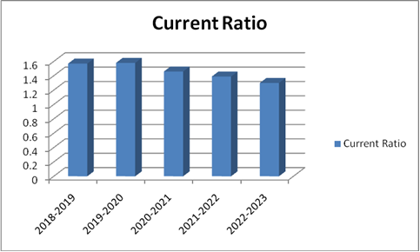

**Interpretation:**

Current ratio during the year 18-19 is the 1.57. In the next year 2020-21 it was maximum 1.58 and in the year 2020- 21 it was 1.46. In the year 2020-21 the current ratio is 1.39 and in the last year 2022--23 the current ratio decreased to 1.30. The ideal value of current ratio 2:1, but during the period of study, the current ratio is lesser than the standard. This shows the current ratio to shows a do down ward which indicates the inefficiency of the company to meet its current obligations

**Liquid Ratio**

|  |  |  |  |
| --- | --- | --- | --- |
| **Year** | **Current Assets** | **Current liabilities** | **Current Ratio** |
| 2018-2019 | 10427 | 8446 | 1.23 |
| 2019-2020 | 12587 | 10321 | 1.21 |
| 2020-2021 | 21021 | 14420 | 1.45 |
| 2021-2022 | 27648 | 19821 | 1.39 |
| 2022-2023 | 36823 | 28333 | 1.29 |

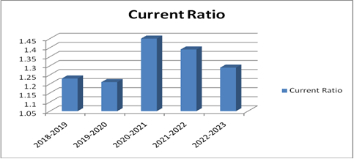

**Interpretation:**

Liquid ratio during the year 2018-2017 it attains the maximum value of 5.20. In the above year it was slightly reduced to 2018– 19 to 1.23. In the next year, 2019-20 it further decreased to 1.21 and in the next year 2021-22 1.39. In the last year decreased 2022—2023 to 1.29.During the period of study, the value of liquid ratio is higher than the ideal value which indicates the efficiency of the company to meet is immediate requirements. The overall trend of liquid ratio shows up and down ward trend.

**Proprietary Ratio:**

|  |  |  |  |
| --- | --- | --- | --- |
| **Year** | **Proprietary Fund** | **Total**  **Assets** | **Proprietary**  **Ratio** |
| 2018-2019 | 6027 | 14483 | 0.41 |
| 2019-2020 | 7301 | 17498 | 0.41 |
| 2020-2021 | 8788 | 22354 | 0.39 |
| 2021-2022 | 10774 | 29344 | 0.36 |
| 2022-2023 | 12939 | 39528 | 0.32 |

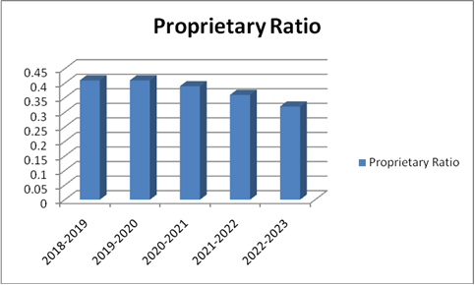

**Interpretation:**

Proprietary ratio during the year 2018-19 and 2019-20 it attains the maximum value of 0.41. In the year2020-21 the proprietary ratio was slightly reduced to 0.39. In the next year, 2021-22 It further reduced to 0.36. During the year 2022-23 it further decreased to 0.32.

**Fixed Assets to Net Worth Ratio:**

|  |  |  |  |
| --- | --- | --- | --- |
| **Year** | **Fixed asset** | **Proprietary**  **Fund** | **Fixed asset to Net worth ratio** |
| 2018-2019 | 1140 | 6027 | 0.18 |
| 2019-2020 | 1167 | 7301 | 0.15 |
| 2020-2021 | 1291 | 8788 | 0.14 |
| 2021-2022 | 1639 | 10774 | 0.15 |
| 2022-2023 | 2627 | 12939 | 0.20 |



**Interpretation:**

Fixed asset to net worth Ratio during the year 2018-19 was 0.18. it was slightly reduced to 0.14 in the 2020-21 year. In the next year 2020-21 and 2021-22 the net worth ratio 0.15. The same is increased to a maximum of 0.20 in the year 2022-2023.

**CONCLUSION**

Bharat Heavy Electricals unit’s baying in India come under the purview of “NAVARATNA” units. There are 14 more Bharat Heavy Electricals units / divisions. Of this Bharat Heavy Electricals limited. The company has been successful in meeting the demanding requirements of not only in India but also international markets in terms of complicity of work as well as Technology etc. BHEL has over the year established its reference in to700 countries across the world. This unit gives more employment ie to thousands and thousands of workers. It gives more protection and safety to the staff working in it besides more concentration to the welfare of the workers. BHEL is developing corporate social responsibility such as self-Employment generation, Environment protection, Education Health management and medical aids and so an. Its focus attention is on 56 adopted villages having nearly 80000in habitations in addition to financial assistance.

**REFERENCES:**

1. www.Bhel.com
2. www.moneycontrol.com
3. www.googlefinance.com