**A Study On Employee Perception Towards Organisation Motivation**

**Abhavathi Kavitha**

Roll No: 212122672101, Department of Management Studies

Aristotle PG College, Chilkur, Moinabad, Ranga Reddy District, Telangana.

**Mr. N. Rajender Reddy**

**Assistant Professor**

Aristotle PG College, Chilkur, Moinabad, Ranga Reddy District, Telangana.

rajender031@gmail.com

**Abstract:**

Perception is what you think of the world around you and vice versa. It is usually just an idea of truth or reality and can differ from person to person.

Due to its subjective nature, perceptions can prove to be quite dangerous, if not controlled or clarified. If you’re an employer, it can be very harmful for your business and your brand image if your employees do not understand your values and culture.

In employee relations, perception is a major factor. Most of the time, it is formed by organizational roles, styles of leadership, styles of communication at the workplace, etc. and so it is very important that the organization be able to form the correct perception in the minds of its employees. Thus, a proper and effective supervision is required to prevent employees from having a wrong understanding

**Keywords:** Perception, brand image, wrong understanding, supervision

**INTRODUCTION:**

Motivating employees to complete their work correctly and on time is one of the major tasks of management. Changing an employee’s perception of his place within a company is sometimes an effective way of improving organizational behavior constructively. Employees who perceive that they have a greater control over their work lives will likely be more motivated to excel within the organizational structure.

Social perception, or the way one individual views others, affects behavior within an organization. Management expert Joseph Champoux writes in his book “Organizational Behavior” that an individual’s social perception can be described in terms of a “target,” or what is being perceived, and a “stimulus threshold,” a certain level of information that must be received in order to make a perceptive assumption on an individual, work process or any other target.

Wrongful social perceptions, such as fundamental attribution error that arises when one person mistakes another person’s characteristics as the cause of a negative event, can lead to problems in organizational behavior.

### Perceptions Affecting Motivation:

A worker’s social perception of others within the organization can affect his motivation to complete work effectively to a large degree. Motivation within an organization remains high if a worker perceives that there are opportunities for personal development or professional advancement, if he feels capable of completing tasks correctly and is involved with various organizational decision-making and goal-setting processes. Motivation can be reduced if the worker perceives a lack of opportunity for growth, a lack of involvement or a lack of opportunities to demonstrate any creativity. This holds true in volunteer organizations as well, as described in Miami University’s student leadership material, “Why Volunteers/Group Members Lose Interest. instance, in order to positively influence employee behavior & future development it has been frequently argued that, employee must experience positive reactions in the practice of the organization.

Having these; differences in perceptions of employee about the existing organization system practice based on their perception of fairness is a big question in NNPC, Abuja.

**REVIEW OF LITERATURE:**

**ARTICLE: 1**

**Tile: Extending the Scope of Organisational Culture: The External Perception of an Internal Phenomenon**

**Author:** **Eric MacIntosh**

**Source:** **Sport Management Review,**

**Abstract**

Organisational culture is known as the values, beliefs and basic assumptions that are guided by leaders and shared by employees, and that explain “how things are done around here.” Organisational culture has primarily been viewed as an internal phenomenon, having an impact on staff behaviour and attitudes, and ultimately influencing organisational performance. Yet, it has more recently been conceptualised as a factor in shaping a company's image in the marketplace. This study examined the external perception of organisational culture according to clients of one company in the Canadian fitness industry. Findings showed that clients’ perception of organisational culture was significantly associated with their satisfaction and intent to stay with that fitness organisation.

**ARTICLE: 2**

**Tile: Role of Intrinsic Rewards in Employee Perception and Motivation**

**Source: Research on Humanities and Social Sciences**

**Author:** **Qamar Farooq**

Employee Motivation has always been the central point of organizations while formulating and designing reward strategy and programs. Rewards carry planned objectives of employee motivation and performance growth completely and clearly set in the purpose behind what organizations achieve through rewards system. Employees tend to gain motivation for a defined intent while organizations focus performance growth and enhanced efficiency by rewarding employees. This study is revolved on the Motivation that employees perceive from different kinds of rewards given by the organizations to its employees. This is a conceptual paper focusing on the different rewards that may affect the performance of employees. Sample employees here taken are managers working in multinational environment from Banks, Government Organizations and LLC companies from the population on the basis of simple random sampling. Basing on dimensions of rewards (i.e. Salary, Promotion, Empowerment, and Recognition) and perceived performance of employees analysis is to be made. Keywords: Intrinsic Rewards, Extrinsic Rewards, Motivation

**ARTICLE: 3**

**Tile: Appraising the impact of organizational communication on worker satisfaction in organizational workplace**

**Author** : **James B. Abugre**

**Source: Business Transformation through Innovation and Knowledge Management:**

Today, more and more businesses depend on communications for their success since a well-organized communication system is shown to be an important factor in stimulating worker satisfaction in organizations. The purpose of this paper is to assess organizational communication and its impact on worker satisfaction in organizational workplace. The paper examines three Ghanaian organizations in the formal sector using a quantitative survey of ninety respondents to gain information for the study. The chi-square test was used with cross-tabulation of the independent and dependent variables to test and answer the hypothesis and research questions formulated for the study. Findings show that there is a significant relationship between efficient organizational communication and employee satisfaction. Findings also show that organizational communication has a positive impact on employee performance. Analysis of the findings further reveals that workers prefer good leadership communication behavior because it has positive effects on workers in organizations. The study proposes that organizations in the formal sector will achieve their objectives if they pay proper attention to the communication processes through efficient organizational communication in the workplace.

.**RESEARCH GAP:**

The study proposes that organizations in the formal sector will achieve their objectives if they pay proper attention to the communication processes through efficient organizational communication in the workplace.

**OBJECTIVES:**

* To know how employee perception on organization motivation can change and create an impact on Organization.
* To see relationship between workplace support and employees motivation.
* To know whether the company culture affects the employee motivation.
* To evaluate the working environment in the companies.
* To find out what are the various factors that motivate the employees.
* To provide a view of employee perception on organization motivation.
* To identify the need of employee perception change
* To know the employees perceptions towards organization success.

**RESEARCH METHODOLOGY:**

**Need For The Study**

Understanding the importance of employee perception, the health of your organization.

• To be retention of employees in our organization.

• To know whether organization motivation can change employee perception.

• The need for a positive self-image at work.

• The need for connection with others.

Being cooperative with employees are major requirement for every organization, as well as organization will require same from the employees but the perception will make a crucial role between organization and employees, so the organization have to be favorable with the employees perception it may be good or bad but the organization need to create a change in every employee according to the organization requirements.

**Scope Of The Study:**

This study is aimed at understanding the employee’s perception of HR practices at IT Industry. This study is confined to the employees of IT Industry. This study tries to address the relationship between employees' perception and its impact on Satisfaction in IT Industry. **Methodology**

One of the important tools for conducting marketing researching is the availability of necessary and useful data. data collection is more of an art than science. data collection is done in many ways. sometimes they are to be collected in a fresh manner or sometimes in one or other way of the data will be gathered the source of information fall under two categories:

1. Primary data
2. Secondary data

##### **PRIMARY DATA:**

Primary data are data gathered for a specific purpose or for a specific research report. for the systematically collecting the data the closed end questionnaire is used. The questionnaire consists of questions relating to various aspects of the study for proper data collection.

##### **SECONDARY DATA:**

Secondary data are data that are collected for another purpose and already exist somewhere .data pertaining to company is collected from company web site company catalogues and magazines. the company profile gives a detailed report of history, various products manufacture by its etc.

**Limitations Of The Study**

All questions were asked

• One of the constraints encountered during data collecting was the lack of time

• This data only from permanent employees was gathered

• The survey was conducted during business hours

**DATA ANALYSIS & INTERPRETATION:**

**Do you feel there is a scope for personal growth such as skill enchantment?**

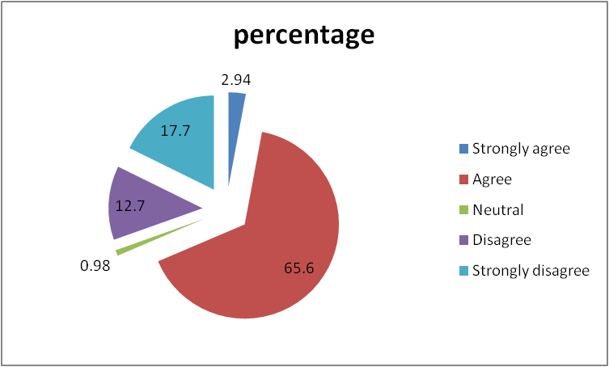

|  |  |  |
| --- | --- | --- |
|  | **No of respondents** | **percentage** |
| Strongly agree | 3 | 2.94 |
| Agree | 67 | 65.6 |
| Neutral | 1 | 0.98 |
| Disagree | 13 | 12.7 |
| Strongly disagree | 18 | 17.7 |

**Interpretation:** As per the report 67% of people were agreed for personal Growth of employees from the organization, strongly agree with 3 persons out of 102 in 100% Strongly disagree with 18 people who are showing less interest in accepting the growth for future use Mean 3.23 Standard deviations is 2.9.

**Day to day decisions here demonstrate that quality and improvement are top priorities?**

|  |  |  |
| --- | --- | --- |
|  | **No of respondents** | **Percentage** |
| Strongly agree | 5 | 4.90 |
| Agree | 75 | 73.52 |
| Neutral | 2 | 1.96 |
| Disagree | 15 | 14.70 |
| Strongly disagree | 5 | 4.90 |

**Interpretation:** As per the survey of this Project 75% were agreed that there Is an improvement. Strongly agree was just 5% out of 102 samples disagree with 15% and strongly disagree 5% Mean is 3.8 Standard Deviation is 3.1313 quality of improvement will be increased day by day in employees.

#### Are there some things we are not doing so great here?

|  |  |  |
| --- | --- | --- |
|  | **No of respondents** | **Percentage** |
| Strongly agree | 10 | 9.80 |
| Agree | 50 | 49.01 |
| Neutral | 13 | 12.74 |
| Disagree | 23 | 22.54 |
| Strongly disagree | 10 | 9.80 |

**Interpretation:** As per this survey 50% of employees are accepted that things doing well where else 23% disagreed neutral 13% out of 102 strongly agree 10% mean calculated at 3.282 standard deviation is 2.800.

**I rarely think about looking for a job at another company?**

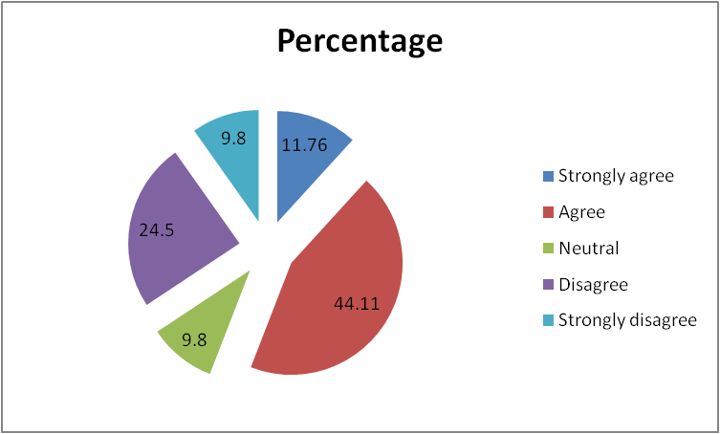

|  |  |  |
| --- | --- | --- |
|  | **No of respondents** | **Percentage** |
| Strongly agree | 12 | 11.76 |
| Agree | 45 | 44.11 |
| Neutral | 10 | 9.80 |
| Disagree | 25 | 24.50 |
| Strongly disagree | 10 | 9.80 |
| Total | 102 | 100% |

**Interpretation:** As per the report that I have come to know here strongly agree are 12 and strongly disagree are 10 when agreed by 45, Coming to know that mean is 3.2325 Standard deviations is 2.67

**STATISTICAL ANALYSIS**

**ANALYSIS OF MEAN AND STANDARD DEVIATION**

|  |  |  |
| --- | --- | --- |
| **QUESTIONS** | **MEAN** | **STANDARD**  **DEVIATION** |
| Do you feel there is a scope for personal  growth such as skill enchantment | 3.2 | 2.9 |
| Day to day decisions here demonstrate that  quality and improvement are top priorities | 3.5 | 3.1 |
| Qualifications of the respondent | 3.5 | 3.1 |
| Are there some things we are not doing so  great here | 3.2 | 2. |
| I rarely think about looking for a job at  another company | 3.2 | 2.7 |
| Gender of the respondents | 4.5 | 3.9 |
| Count of experience | 4.8 | 4.2 |
| Motivation me to go beyond what I would in  a similar role elsewhere | 4.2 | 3.7 |
| I believe there are good career opportunities  for me at this company | 4.3 | 3.8 |
| Are there some things we are doing great  Here | 4.3 | 3.9 |
| I would recommend [company] as a great  place to work | 4 | 3.8 |
| Do you experience personal such as  upgrading your skills | 3.8 | 3.3 |
| Age of the respondent | 4.5 | 4 |

# **CONCLUSION:**

The findings and suggestions provided by this analysis will help to improve the employees working environment e and create the awareness about the employee perception towards organization motivation system in any industries.

Objectives and needs are helpfully to get the need of the project, and the data interpretation is proved that by number of feedback review saying that favorable for the company’s original feedback based on employees perception, and frame work will suggest the real structure of this project to identify the final output overall usability of this project is about employees different perceptions from various organizational motivation.

It is not related to maintaining changes in organization motivation, it is employees perception but also keeping in mind their requirements for long term cooperation for the company requirements .as well as the employee perception always unfavorable or favorable but need to satisfy every employee with the basic commission for what they do.

This study is generally related to employees perception towards organization motivation so finally understanding based on the feedback that I gathered employees perception will change according to the climate it may be a summer, winter, or an influencer so managing every direction towards organization which is effectively impact on organization, so the organization has to deal with favorable of each and every employee without partiality.

##### **REFERENCES:**

* Arun Monappa and Miza S Saiyadain (1999), “Personal Management”, Second Edition; Tata McGraw-Hill publishing Company Limited, New Delhi.
* Beardwell, IAN and Len Holden (1994) “Human Resource Management: A Contemporary Perspective”, First Edition, Mc Millan Indian Limited.
* Irena Grugulis and Dimitrinka Stoyanova (2011), Skill and Performance, British Journal of industrial Relations, Volume 49.
* Yorke, M. (2006). Employability in Higher Education: What it is – What it is not. York: Higher Education Academy.