**The Impact Of Digital Revolution Of Information Technology**

**Mohammed Asim Sohail**

Roll No: 212122672104, Department of Management Studies

Aristotle PG College, Chilkur, Moinabad, Ranga Reddy District, Telangana.

**Mr. N. Rajender Reddy**

**Assistant Professor**

Aristotle PG College, Chilkur, Moinabad, Ranga Reddy District, Telangana.

rajender031@gmail.com

**Abstract:**

Digital technologies have advanced more rapidly than any innovation in our history – reaching around **50 per cent** of the developing world’s population in only two decades and transforming societies. By enhancing connectivity, financial inclusion, access to trade and public services, technology can be a great equaliser.

In the health sector, for instance, AI-enabled frontier technologies are helping to save lives, diagnose diseases and extend life expectancy. In education, virtual learning environments and distance learning have opened up programmes to students who would otherwise be excluded. Public services are also becoming more accessible and accountable through block chain-powered systems, and less bureaucratically burdensome as a result of AI assistance. Big data can also support more responsive and accurate policies and programmes.

However, those yet to be connected remain cut off from the benefits of this new era and remain further behind. Many of the people left behind are women, the elderly, persons with disabilities or from ethnic or linguistic minorities, indigenous groups and residents of poor or remote areas. The pace of connectivity is slowing, even reversing, among some constituencies.

**Keywords:** Digital technologies, financial inclusion, health sector, AI assistance, Big data

**INTRODUCTION:**

It's impossible to design and organise a project, company, or other activity without using IT, which has expanded and changed over the previous 50 years.

When we say "Information Technology," we don't just mean laptops and smartphones; we also mean cutting-edge technology in manufacturing, the automobile and aerospace industries, and a wide range of products for the home. This has not only made our everyday lives easier, but it has also lowered the amount of money and time we spend doing things.

Research reveals that TCS employees work from home for a significant portion of the year, while another 25% of the workforce works "mobile" - on the go. This demonstrates the enormous potential for use in businesses and government institutions that the Internet and other forms of electronic communication have.

Globalization and computerization have changed the way business, politics, culture, and society are organised in recent years. Economic and cultural institutions will eventually merge as a result of globalisation. As a consequence of the application of information technology, this integration happens. Transnational trade in commodities and information as well as the free movement of people are prerequisites for the technology revolution. A global economic infrastructure is therefore made feasible by the Internet and worldwide computer networks. Satellite communication systems, software, and hardware all work together to support the global economy through computer networks (Douglas, 2002, 285-305).

The economic impact of the digital revolution has been wide-ranging. Without the World Wide Web (WWW), for example, globalization and outsourcing would not be nearly as feasible as they are today. The digital revolution **radically changed the way individuals and companies interact**.

**Digital technologies are fundamentally changing how people and businesses work together.**

Across the globe, the pace of digital transformation is accelerating. The private sector continues to invest in disruptive technologies to get ahead of the competition. They adapt their business models to meet ever increasing customer expectations.

The pace of change continues to blur the boundaries of the physical and digital worlds. It is redefining traditional industry sectors and the way we live and work. Emerging technologies, growing amounts of data and smarter ways of getting insights are changing the way people, businesses and governments interact.

Australia’s ongoing success depends on our ability to harness these technological advances to drive economic growth and raise productivity and living standards for all Australians. A key focus of the government’s Digital Economy Strategy is the digital transformation of government itself – ensuring we keep pace with community needs and expectations.Since 2013, the Australian Government has made significant progress on our digital journey. Through our digital transformations, we have made it easier to register a business, transition into aged care and access veterans’ services. We are bringing government into the digital age, investing in digital capability programs and major ICT procurement reforms. We are internationally regarded for the effectiveness of our digital government services.1

In spite of these successes, we must continue to evolve. It is not enough to keep pace with the private sector. In many cases we need to deliver even better services, policies and experiences. By 2025, what people expect will be dramatically different from today. Recognising how Australians live and work must be absolutely central to how we develop and deliver policy and services.

**REVIEW OF LITERATURE:**

**ARTICLE: 1**

**TITLE:** THE IMPACT OF DIGITAL REVOLUTION ON THE COMPETENCES OF BUSINESS INFORMATION TECHNOLOGY STUDENTS IN UNIVERSITY

**Author:** J. Soitinaho

**Source : International Research Journal of Engineering and Technology (IRJET)**

The ongoing digital revolution changes the job profiles of ICT (Information and Communication Technology) professionals radically. This paper presents the results of a study about the skills and competences ICT professionals need in order to respond to the new challenges. The main goal of the study was to provide the required customer input for the development of university level ICT education and especially find the right set of competence profiles.

60 companies and organisations representing both ICT suppliers and customers of all sizes were interviewed. The ICT suppliers represented well-established global companies as well as growth companies. The industry sectors ranged from ICT consultancy to digital game business. The organisations included publicly funded ones as well as non-profit organisations. It was important to select the interviewees diversely from different sectors of business since the digitalisation penetrates everywhere and brings new and agile players in the market. At the same time the job profiles of more established players, who traditionally have absorbed majority of the ICT graduates, are also changing. The interviews were conducted in a semi-structured form during face-to-face meetings. The interview covered the opportunities and challenges the digitalisation brings to the companies and organisations as well as the desired competence profile of the ICT graduate.

**ARTICLE: 2**

**TITLE:** The Impact of the Digital Revolution on the Global Economy

**Author:** Marsel Imamov**Source:** **International Journal of Creative Research Thoughts (IJCRT) www.ijcrt.org**

Today, the economy is undergoing serious changes based on new digital technologies and artificial intelligence, which has affected serious qualitative and structural shifts. The purpose of this work is to study the impact of new technologies on economic processes, the advantages and disadvantages of the rapid development of new technologies. The significance of the research is determined by the relevance of the topic of the work, as well as the importance of tracking the processes of the world economy. The authors conducted a study and revealed that the digital economy is influenced by trends in the use of modern technologies, described the consequences of these changes, as well as the possibility of preventing problems. Globalization, integration, acceleration of integration processes, industrialization, environmental, demographic and political factors of economic life around the world require balanced development of the national economy with special attention. This article examines the ways of economic development and the following consequences. Analysing the results, it can be noted that it is impossible to say unequivocally what can negatively or positively affect the development of the digital economy, because there is an unpredictability factor that needs to be constantly taken into account in research.

**OBJECTIVES:**

* Digital marketing's involvement in Return on Web is to be studied.
* Analyze digital marketing services based on a variety of variables.
* To see whether there is a way to increase their sales?
* An important part of being successful when pitching a customer is being able to communicate effectively with them when they are in person.
* When composing an email, it's important to know how to do it correctly.

**RESEARCH METHODOLOGY:**

**Need For The Study**

With the information in this research, you'll be better prepared to deal with various types of consumers and clients, as well as to create an effective internet campaign.

**Scope Of The Study:**

As a result of my research, I am able to conduct a real-world comparison between classroom knowledge and the real world. It's possible that notions and practises will change if you just study theory and don't put it into practise. While the research helps in the understanding of many digital marketing principles, the actual implementation may vary depending on the circumstances.

**Methodology**

The research design and methodology are presented as follows

**Data collection:**

• Data collecting occurs once the study challenge is determined and the research strategy is drawn up.

• Two categories of data, namely primary and secondary, should be considered while deciding on the study's data gathering approach.

Sources of data

**Primary data**

## Observation is the most prevalent form of data collection. Most of the information about the digital marketing process is gathered from the project manager at the firm. It is also common practise to employ questionnaires as a framework for the investigation.

## Secondary data

There are several sources of secondary data, such as company brochures and records. Studies from the past and current were used to gather secondary data for this one. Qualitative research was employed to accomplish the study's goals. By doing a literature review, the researchers were able to identify the most relevant variables and determinants. Secondary sources were used to compile the data. Secondary sources included publications such as periodicals, websites, and books, as well as information gleaned from corporate officials and records.

**DATA ANALYSIS & INTERPRETATION:**

**IBM FINANCE 2.5**

**1. Are you aware about the growing digitalization of various facets, Including the financial and marketing, of the Indian economy?**

=> Yes 75 per cent

=> No 12 per cent

=> Do not *know/*not say 13 er cent

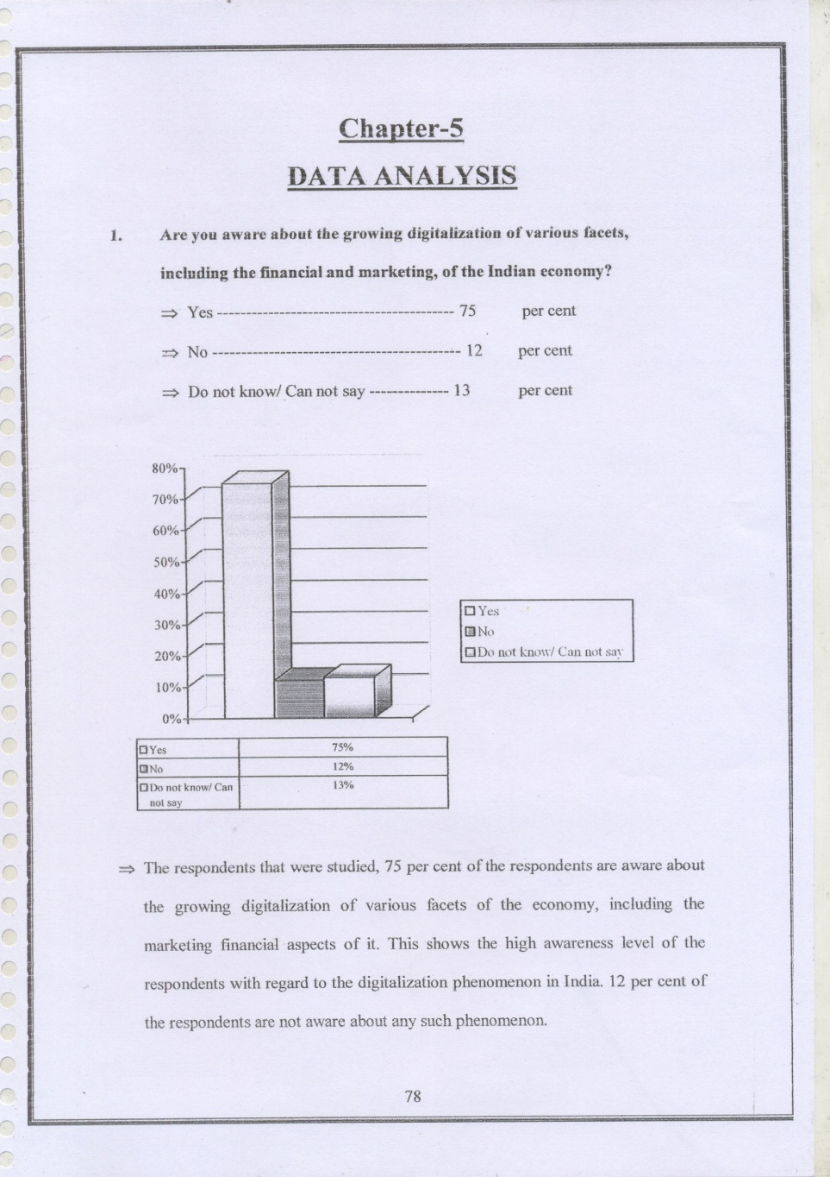

**Interpretation**

Among the people surveyed, 75% are aware of the expanding digitization of different parts of the economy, including marketing finances. This demonstrates the respondents' high degree of familiarity with India's digitization phenomena. Only 12% of the people polled were aware of such an occurrence.

**2. What according to you is more a symbol of the digitalized. Economy and market?**

=> Growth of PCs, Laptops and Computer hardware 64 per cent

=> Growth of mobile phones 62 per cent

=> Digital accounting 34 per cent

=> Digital Marketing practices like Value added services 73 per cent

=> Others 34 per cent

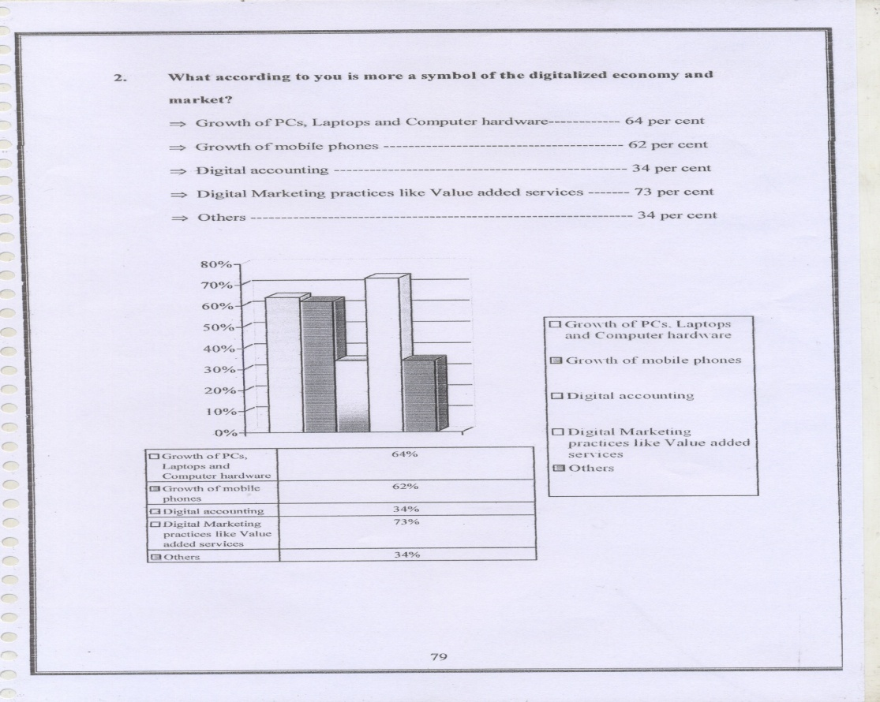

**Interpretation**

According to the survey results, 64% of those polled believe that the increasing density of computer gear, such as PCs and Laptops, is an important indicator of India's economic digitalization. Growth in mobile phones was responsible for 62% of the increase in the number of devices. The use of digital marketing methods by 73% of the respondents was seen as a sign of the digitization of the Indian economy. 34% of those polled said they met the definition of digital accounting.

**3. Do you think that with the growth of the digitalization project in various facets of the economy and its acceptability among the people has brought a change in the marketing strategy of the products and services?**

=:> Yes ……………………………………………………82 per cent

=> No 06 per cent

=> Do not know/ Can not say 12 per cent

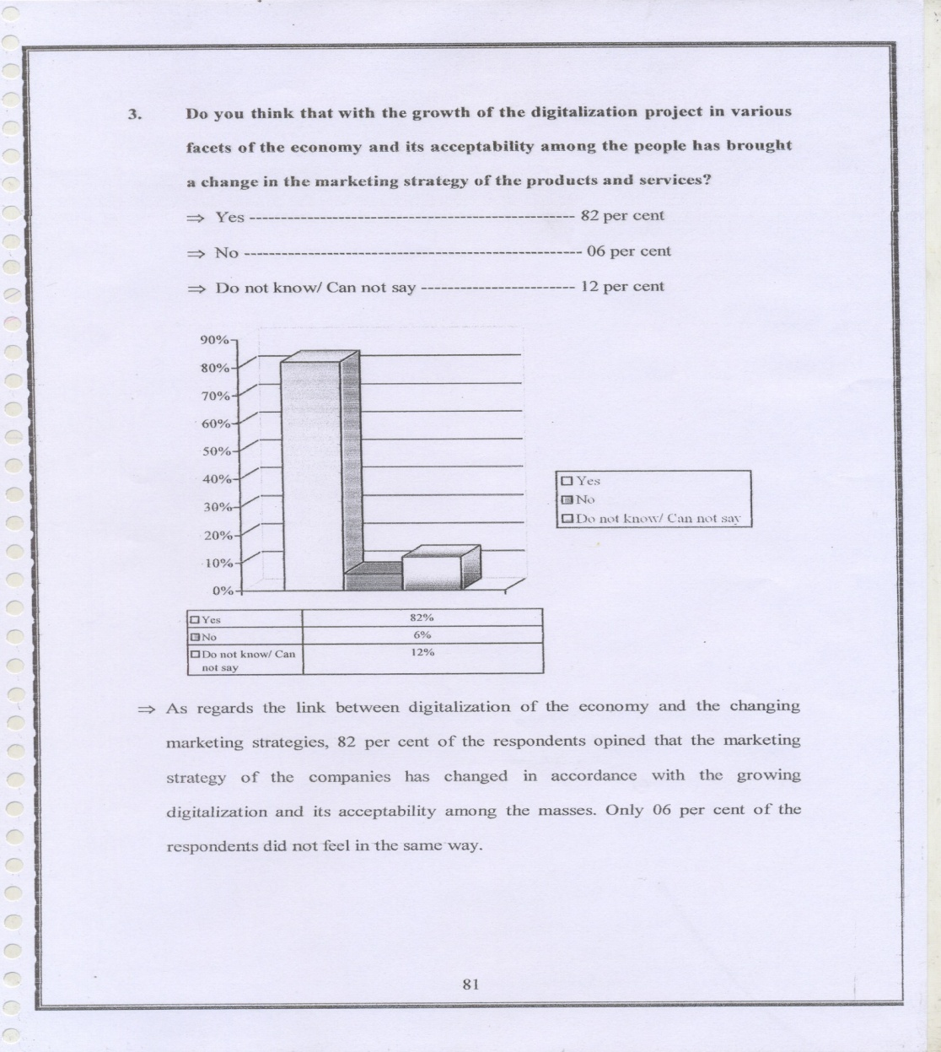

**Interpretation**

82 percent of the respondents said that the marketing strategy of the firms has altered as a result of the increasing digitization of the economy and its widespread acceptance by the general public. Only 6% of those polled said they had a different opinion.

**4. Do you think that risk factor is involved in digital marketing?**

=> Yes 85 per cent

=> N0 14 per cent

=> Do not know/ Can not say 01 per cent

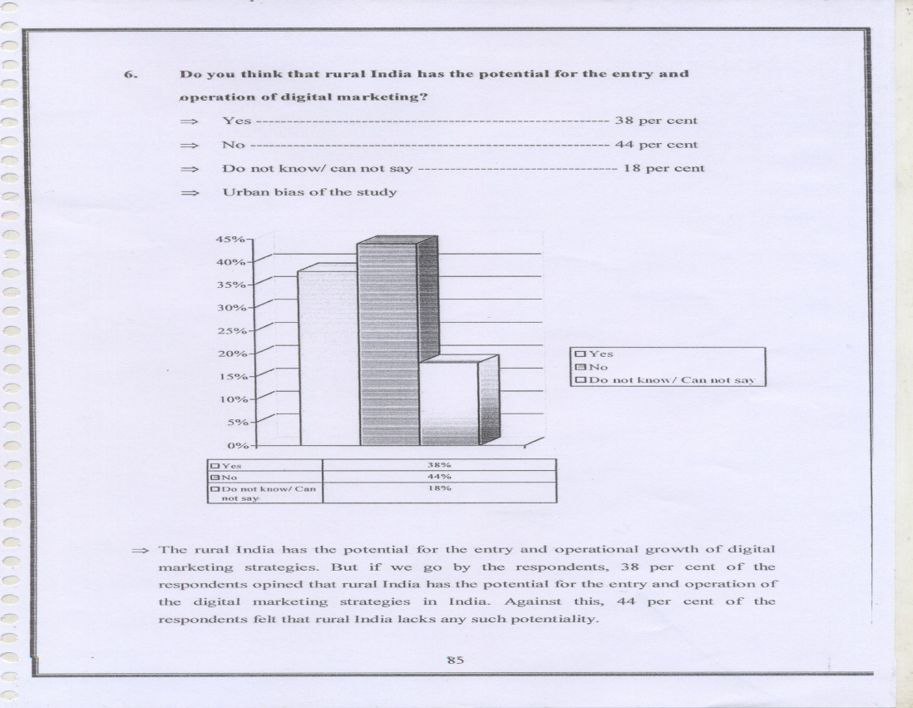

**Interpretation**

85% of the respondents agreed that digital marketing methods have a higher risk factor than conventional marketing techniques, in terms of return, when it comes to the return on investment. 14% of those polled said they were unwilling to consider such a risk factor.

**5. Do you think that rural India has the potential for the entry and Operation of digital marketing?**

=> Yes------------------------------------------------------38 per cent

=> No------------------------------------------------------44 per cent

=> Do not know! can not say-------------------------18 per cent

=> Urban bias of the study

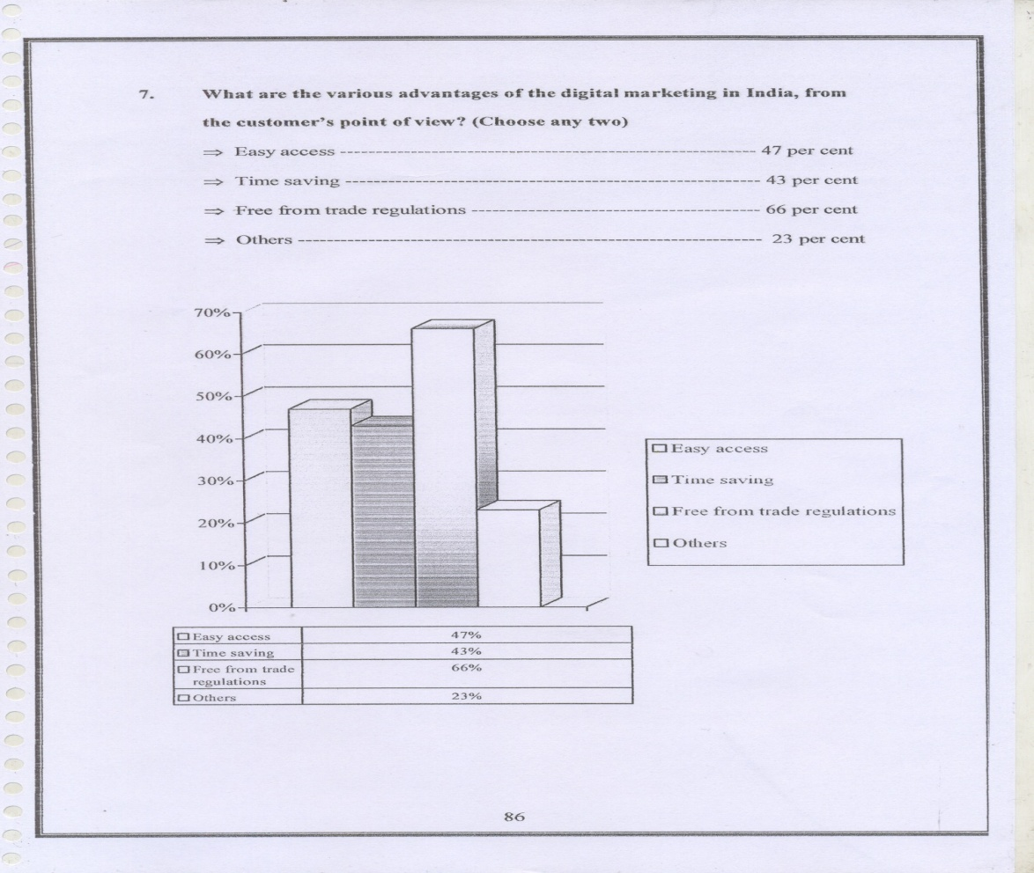

**Interpretation**

In rural India, digital marketing tactics have the potential for both entrance and operational development. In fact, according to the survey respondents, rural India has the potential to be a market for digital marketing tactics in India, with 38% saying so. According to the survey, 44 percent of rural Indians believe that rural India lacks the ability to provide such goods and services.

# **CONCLUSION:**

Successful completion of this internship shows that digital marketing is the future of marketing. Integrated services and integrated channels are part of digital marketing, not only ad placement in portals. Marketers want to make good use of these elements in order to reach their intended demographics and establish a name for themselves. The stewards of a brand in today's digital age aren't marketers; they are the individuals who are linked across the many digital channels.

Customers have a strong preference for digital media over traditional forms of media, which is why brands are looking to enhance their online presence. Furthermore, consumers are voracious readers, making it imperative that companies communicate with them on a two-way basis through digital media.

The greatest way to turn a product into a brand is via digital media. Because it's more affordable and gives marketers a greater number of ways to connect with customers. Digital platforms allow brands to effectively communicate with their target audience. Brands may use digital media to attract new consumers or keep hold of their current ones. Increased brand memory in target demographics may be achieved via the use of digital channels.

##### **REFERENCES:**

* https://www.blockchain.com/
* https://www.ibm.com/blockchain/
* https://en.wikipedia.org/wiki/Blockchain