**BE-FIT FITNESS STUDIO**

S.Poornima & S.Bharanidharan & K,Elayabharathi

Mrs.S.Poornima

poornimasit@gmail.com

S.Bharanidharan

[bharanidharan2020.76@gmail.com](mailto:bharanidharan2020.76@gmail.com)

K.Elayabharathi

[vk3ebharathi@gmail.com](mailto:vk3ebharathi@gmail.com)

Sri Shakthi Institute of Engineering and Technology, Coimbatore.

Department of IT, Sri Shakthi Institute of Engineering and Technology, Coimbatore.

**ABSTRACT:**

**BE-FIT FITNESS STUDIO**" The BE-FIT Fitness Studio project aims to establish a comprehensive and innovative fitness center that caters to the diverse needs of modern fitness enthusiasts. By integrating advanced fitness equipment, personalized training programs, and a holistic approach to health and wellness, BE-FIT seeks to create an inclusive environment that promotes physical, mental, and emotional well-being. The studio will offer a wide range of services, including group fitness classes, one-on-one personal training, nutritional counseling, and wellness workshops. Utilizing state-of-the-art technology for tracking progress and providing feedback, BE-FIT will ensure that members receive tailored support to achieve their fitness goals. Additionally, the studio will emphasize community engagement through events, challenges, and social activities, fostering a supportive network for all participants. The overarching objective of BE-FIT Fitness Studio is to empower individuals to lead healthier, more active lives by providing the resources, motivation, and community necessary for sustainable fitness.

### Introduction:

“**BE-FIT Fitness Studio**” is the state of being physically fit and healthy, as well as the ability to perform daily tasks with vigor and alertness without experiencing undue fatigue. It includes a wide range of physical activities such as cardiovascular conditioning, strength training, and flexibility exercises. Fitness is not just about being able to lift heavy weights or run long distances; it is about achieving a balance between strength, flexibility, and endurance. Many people pursue fitness for a variety of reasons, including improving their overall health, enhancing their appearance, and boosting their energy levels.

Achieving fitness involves regular physical activity, proper nutrition, and adequate rest. Physical activity is crucial for maintaining a healthy body weight, strengthening muscles, and improving cardiovascular health. A well-balanced diet that includes a variety of nutrients, such as carbohydrates, proteins, and healthy fats, is essential for providing the energy required for physical activity and promoting muscle recovery. Sufficient rest is also necessary for allowing the body to recover and repair itself after exercise.

There are numerous benefits of achieving and maintaining fitness, including a reduced risk of chronic diseases, improved mental health, enhanced self-esteem, and better cardiovascular health. Additionally, regular physical activity can help individuals manage stress, achieve better sleep quality, and lead to an overall sense of well-being. With the growing awareness of the importance of fitness, various types of fitness programs and activities, such as yoga, Pilates, HIIT (high-intensity interval training), and group fitness classes, have gained popularity in recent years.

**BE-FIT FITNESS STUDIO:**

**HOME PAGE:**

Creating an Home page for "Be Fit Fitness Studio" involves developing a comprehensive system to manage various aspects of the fitness studio. This system should allow administrators to oversee operations, manage client relationships, and ensure smooth functioning of the studio. Here are some key topics and features to include in the admin panel.

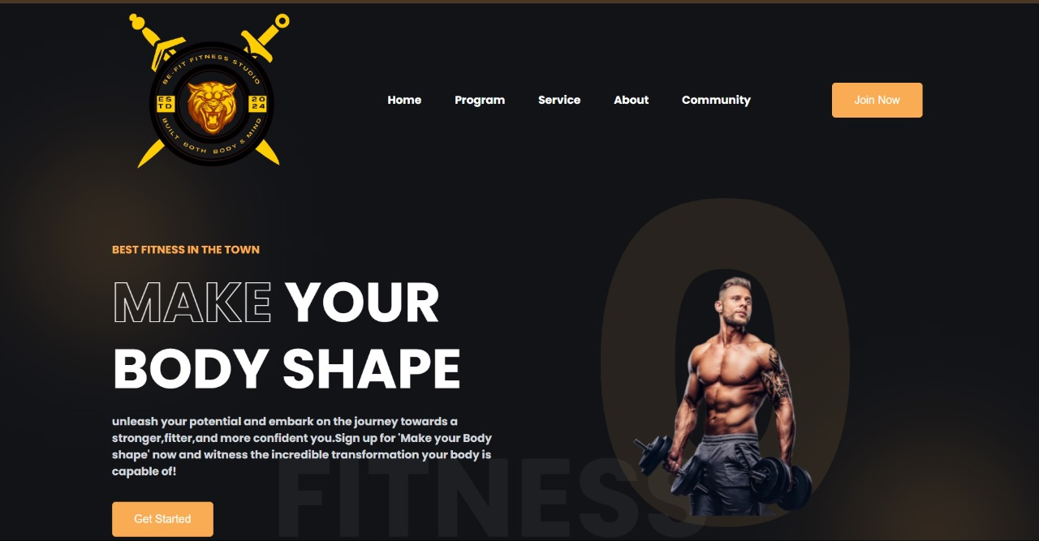

**OUR SERVICE PAGE:**

Be-Fit Fitness Studio, our personal training sessions are tailored to meet the individual needs of each client. Our experienced and certified trainers work one-on-one with you to develop personalized workout plans that align with your fitness goals. Whether you're looking to lose weight, build muscle, improve cardiovascular health, or enhance athletic performance, our trainers provide the guidance, motivation, and accountability you need to succeed. Each session is designed to challenge you while ensuring proper form and technique to prevent injuries and maximize results.

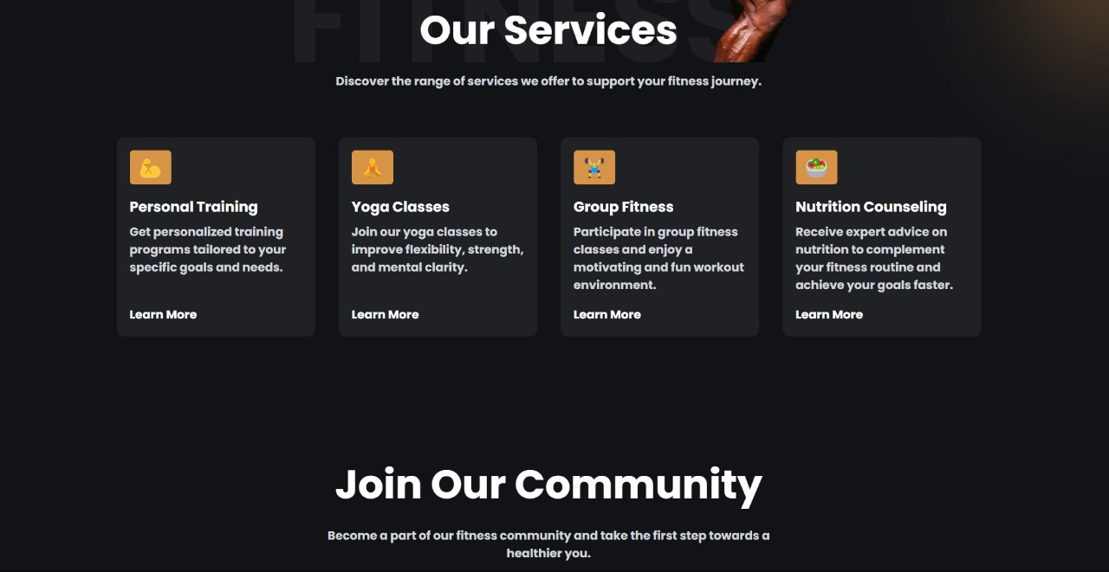

**OUR PROGRAM PAGE:**

**Weight Loss Program**

Our Weight Loss Program is specifically designed to help you shed unwanted pounds and achieve a healthier body composition. This program includes a combination of personalized workout plans, nutritional guidance, and lifestyle coaching. Our certified trainers will work with you to create an effective exercise regimen that includes cardiovascular training, strength training, and flexibility exercises. Alongside, our nutritionists will provide you with tailored meal plans that promote fat loss while maintaining muscle mass. With regular progress tracking and motivational support, this program ensures you stay committed and see real results.

**Muscle Building Program**

If your goal is to gain muscle mass and increase strength, our Muscle Building Program is perfect for you. This program is focused on resistance training and progressive overload to stimulate muscle growth. Our trainers will design a workout plan that targets all major muscle groups and includes exercises such as weight lifting, bodyweight exercises, and functional training. Additionally, you'll receive dietary advice and meal plans rich in protein and essential nutrients to support muscle recovery and growth. Whether you're a beginner or an experienced lifter, this program will help you achieve a more muscular and toned physique.

**Cardio Fitness Program**

Improve your cardiovascular health and endurance with our Cardio Fitness Program. This program includes a variety of cardio exercises such as running, cycling, rowing, and high-intensity interval training (HIIT). Our trainers will create a personalized cardio plan that suits your fitness level and goals, ensuring you build stamina, burn calories, and improve overall heart health. Regular cardio workouts are essential for reducing the risk of heart disease, lowering blood pressure, and increasing energy levels. Join this program to boost your cardiovascular fitness and lead a healthier, more active lifestyle.

**Flexibility and Mobility Program**

Our Flexibility and Mobility Program is designed to enhance your range of motion, improve posture, and prevent injuries. This program includes a mix of stretching routines, yoga, and Pilates exercises that focus on flexibility, balance, and core strength. Our instructors will guide you through techniques that help release muscle tension, improve joint health, and increase overall mobility. Whether you're an athlete looking to improve performance or someone who wants to move more freely and comfortably, this program will help you achieve your flexibility goals.

**Senior Fitness Program**

The Senior Fitness Program at BeFit Fitness Studio is tailored specifically for older adults who want to maintain their health, strength, and independence. This program includes low-impact exercises that focus on improving cardiovascular health, strength, balance, and flexibility. Our trainers are experienced in working with seniors and will create a safe and effective fitness plan that meets your needs and abilities. Regular physical activity is crucial for preventing age-related health issues and enhancing overall quality of life. Join our Senior Fitness Program to stay active and enjoy a healthier, more vibrant lifestyle.

**Youth Fitness Program**

Encourage your children to develop healthy habits early with our Youth Fitness Program. This program is designed for kids and teenagers, providing them with fun and engaging activities that promote physical fitness. Our trainers create age-appropriate workout routines that include games, sports, and exercises to improve strength, coordination, and overall fitness. By fostering a positive attitude towards exercise, this program helps young people build confidence, improve social skills, and establish lifelong healthy habits. Get your kids involved in our Youth Fitness Program for a balanced and active lifestyle**.**

**NATURAL FITNESS:**

Natural fitness refers to the physical well-being and strength derived from engaging in activities that mimic natural human movements and lifestyles, rather than relying solely on structured exercise routines. It emphasizes functional fitness, which is the ability to perform everyday tasks with ease and efficiency

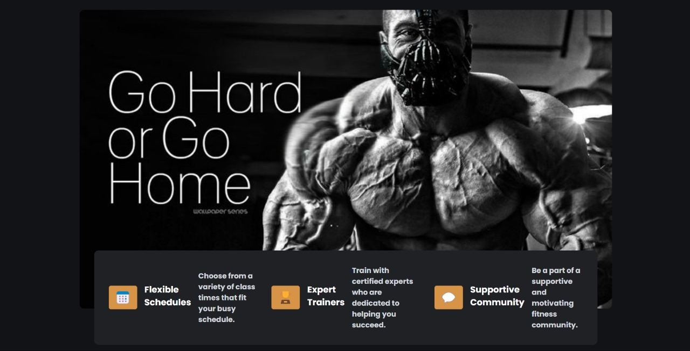

**ABOUT US PAGE:**

At Be-Fit Fitness Studio, our mission is to empower individuals to achieve their health and wellness goals through personalized fitness programs and a supportive community. We offer a state-of-the-art facility equipped with the latest workout technology, experienced trainers who are passionate about fitness, and a variety of classes designed to cater to all fitness levels. Whether you're a beginner looking to start your fitness journey or an athlete seeking to enhance your performance, Be-Fit Fitness Studio provides the resources, expertise, and motivation you need to succeed. Join us and be a part of a vibrant community where your health and fitness are our top priorities.

Be-Fit Fitness Studio provides the resources, expertise, and motivation you need to succeed. We offer a state-of-the-art facility equipped with the latest workout technology, experienced trainers who are passionate about fitness, and a variety of classes designed to cater to all fitness levels. Whether you're a beginner looking to start your fitness journey or an athlete seeking to enhance your performance.

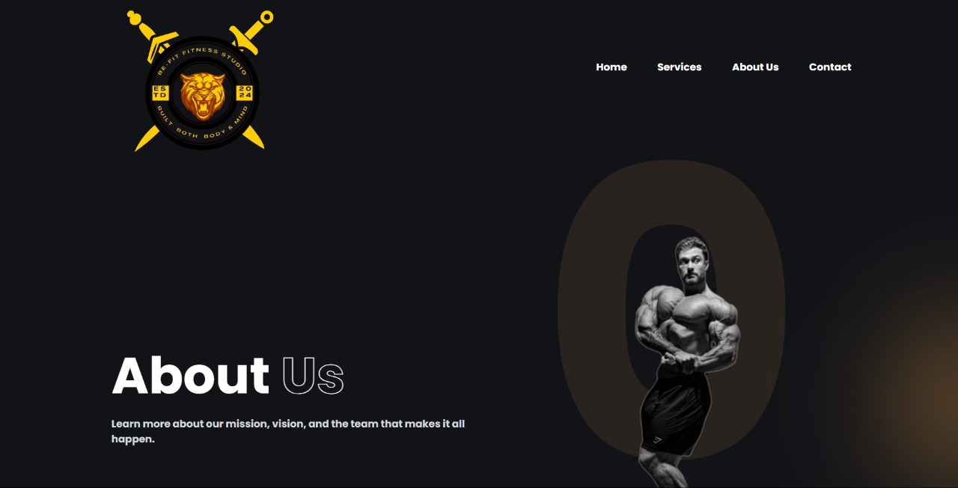

**OUR LOGIN PAGE:**

Welcome to the Be-Fit Fitness Studio member login page! Here, our members can easily access their personalized fitness dashboard, book classes, track progress, and connect with our community. Log in with your credentials to manage your membership, update your profile, and stay up-to-date with the latest fitness programs and special events. If you're new to Be-Fit Fitness Studio, sign up today and take the first step towards a healthier, happier you. Let's achieve your fitness goals together.

* **Class Bookings:** Easily reserve your spot in any of our diverse fitness classes, from yoga and pilates to high-intensity interval training and spinning.
* **Progress Tracking:** Monitor your fitness journey with detailed progress reports, workout logs, and performance metrics.
* **Exclusive Content:** Access members-only content including workout videos, nutritional guides, and expert fitness tips.
* **Community Connection:** Engage with fellow members, join group challenges, and stay motivated with our supportive community.
* **Account Management:** Update your personal information, manage your membership details, and renew or upgrade your plan seamlessly.

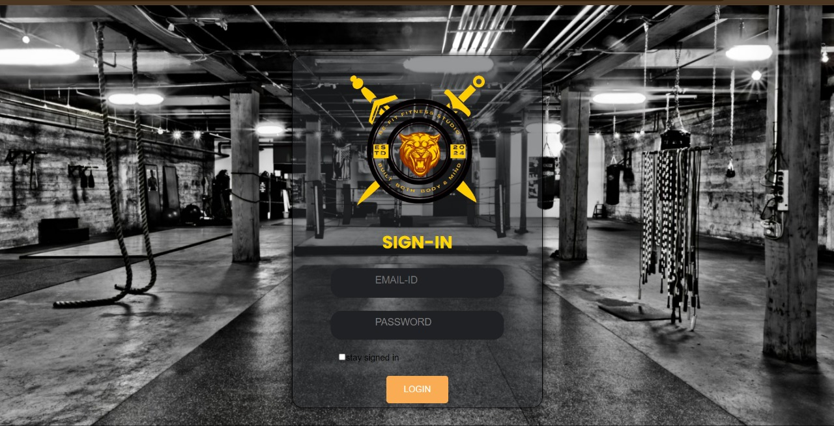

**OUR PRICING PLAN:**

The Listing Notices feature of the Litigatex Digital Online Court system facilitates the efficient creation, management, and distribution of court listing notices, ensuring all relevant parties are informed about scheduled hearings and other court-related events. This section presents the results and analysis of the Listing Notices functionality, its impact on court administration, and user experience.

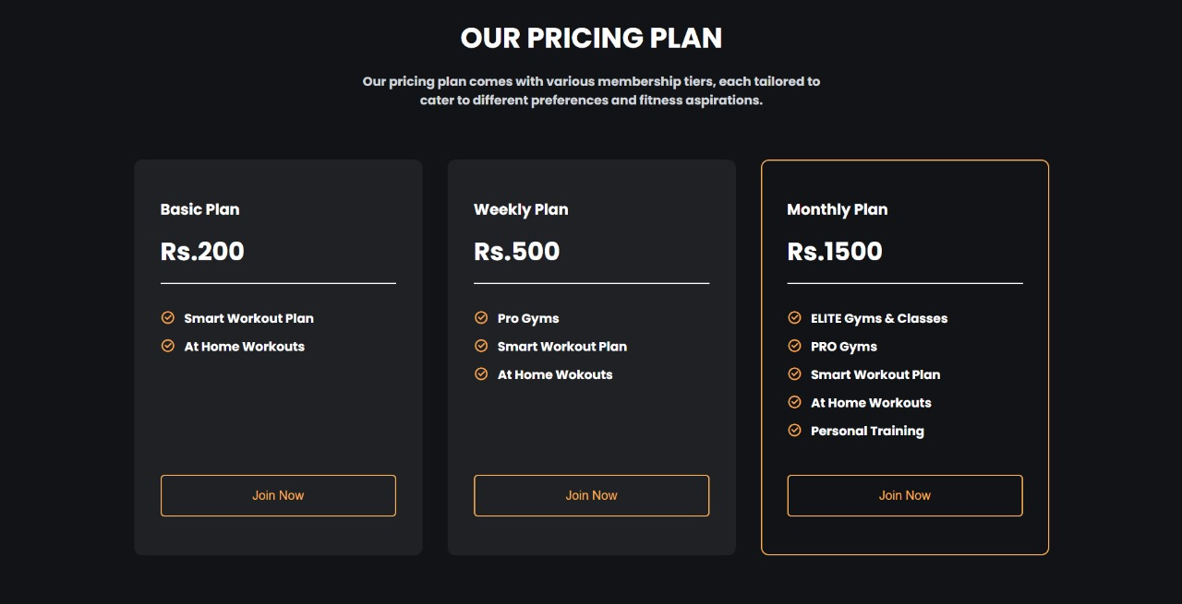

**FUNDAMENTAL TECHNIQUE:**

**APPLICATION DEVELOPMENT FOR MONITERING OFWOOL FROM FARM TO FABRIC:**

Developing an application for monitoring wool from farm to fabric involves integrating several fundamental techniques. These include IoT sensors for real-time data collection on sheep and wool conditions, blockchain for secure and transparent tracking of wool batches, a robust database system for storing and managing data, mobile and web interfaces for user interaction and data visualization, and machine learning algorithms for predictive analytics and quality control. Together, these technologies ensure efficient and transparent monitoring throughout the wool production process.

**PROPOSED METHOD:**

## BE-FIT FITNESS STUDIO:

BE-FIT Fitness Studio is a Assessing the Impact of Specialized Fitness Programs on Overall Health and Well-being at Be Fit Fitness Studio.

## PERSONALIZED TRAINING PROGRAM

* **Initial Assessment:** Conduct comprehensive fitness assessments, including physical fitness tests, health screenings, and goal-setting consultations.
* **Customized Plans:** Develop personalized workout plans based on individual goals, fitness levels, and preferences.
* **Progress Tracking:** Use fitness apps and wearable technology to monitor progress, adjust plans, and provide ongoing motivation.
* **One-on-One Sessions:** Offer regular personal training sessions to ensure proper form, technique, and to keep clients accountable.
* **Feedback and Adaptation:** Regularly review and adjust training programs based on progress and changing goals.

## GROUP FITNESS CLASSES

* **Class Variety:** Offer a diverse range of classes such as yoga, Pilates, HIIT, spinning, Zumba, and strength training to cater to different interests and fitness levels.
* **Qualified Instructors:** Employ certified and experienced instructors to lead classes, ensuring safety and effectiveness.
* **Schedule Flexibility:** Provide a flexible class schedule, including early morning, lunchtime, and evening classes to accommodate various lifestyles.
* **Community Building:** Foster a sense of community and camaraderie among participants through group challenges and social events.
* **Class Feedback:** Collect feedback from participants to continuously improve class offerings and instructor performance.

## NUTRITIONAL COUNCELLING

## Initial Consultation: Provide in-depth consultations with certified nutritionists to assess dietary habits, health conditions, and nutrition goals.

## Personalized Meal Plans: Develop customized meal plans that align with fitness goals, dietary preferences, and any medical requirements.

## Educational Workshops: Conduct regular workshops and seminars on topics such as healthy eating, meal prep, and understanding nutrition labels.

## Ongoing Support: Offer continuous support through follow-up sessions, email consultations, and access to nutrition resources.

## Integration with Fitness Plans: Ensure that nutritional advice complements and enhances the personalized training programs for optimal results.

## WELLNESS WORKSHOP AND SEMINARS

* **Holistic Approach:** Address various aspects of wellness including mental health, stress management, and lifestyle choices.
* **Expert Speakers:** Invite experts in fields such as psychology, nutrition, and fitness to conduct seminars and workshops.
* **Interactive Sessions:** Include practical, hands-on activities like meditation, mindfulness exercises, and stress-relief techniques.
* **Regular Events:** Organize these events on a monthly or bi-monthly basis to keep members engaged and informed.
* **Resource Distribution:** Provide attendees with materials, such as pamphlets, booklets, and access to online resources for further learning.

## TECHNOLOGY INTEGRATION

* **Wearable Technology:** Promote the use of wearable devices (e.g., fitness trackers, smartwatches) to monitor physical activity, heart rate, and other vital statistics.
* **Mobile App:** Develop a BE-FIT mobile app for scheduling, progress tracking, virtual classes, and communication with trainers and nutritionists.
* **Virtual Classes:** Offer live-streamed and on-demand fitness classes for members who prefer to work out from home or have varying schedules.
* **Data Analytics:** Use data analytics to personalize fitness and nutrition plans, track progress, and identify trends to enhance member experience.

**Feedback Systems:** Implement digital feedback systems to gather real-time input from members on classes, services, and overall satisfaction.

# **CONCLUSION AND FUTURE SCOPE**

## CONCLUSION:

In conclusion, it is evident that fitness is a vital aspect of life that encompasses physical, mental, and emotional well-being. The benefits of maintaining an active lifestyle and engaging in regular physical activity are numerous and can significantly improve overall health and quality of life. From reducing the risk of chronic diseases such as heart disease, diabetes, and obesity to improving mood, mental clarity, and self-esteem, regular exercise is essential for a healthy, balanced life.

Furthermore, proper nutrition plays a crucial role in supporting fitness goals and maintaining overall health. A balanced diet that includes a variety of fruits, vegetables, lean proteins, whole grains, and healthy fats is essential to fuel the body and support healthy weight management, muscle development, and overall well-being.

In addition to the physical benefits, fitness can also have a positive impact on mental and emotional health. Regular physical activity has been shown to reduce stress, anxiety, and depression, and can improve overall mood and mental clarity. Exercise has also been linked to improved sleep quality, which is essential for overall health and well-being.

It is important to note that fitness is not a one-size-fits-all approach, and each individual's fitness journey will be unique. It is essential to find activities that are enjoyable and sustainable, as well as to set realistic and achievable fitness goals. This may involve experimenting with different types of workouts, finding a supportive community, or working with a fitness professional to develop a personalized fitness plan.

Overall, the pursuit of fitness is a lifelong journey that requires dedication, consistency, and commitment. By prioritizing physical activity, proper nutrition, and mental well-being, individuals can enjoy the numerous benefits of a healthy, active lifestyle. Whether it is through engaging in regular exercise, maintaining a balanced diet, or finding ways to prioritize

## FUTURE SCOPE

## Virtual Fitness Platform:

## Develop and expand a robust virtual fitness platform that offers online workouts, live classes, on-demand videos, virtual coaching, and interactive features.

## Target remote clients, busy professionals, travelers, and individuals who prefer the convenience and flexibility of virtual fitness options.

## Mobile App Development:

## Create a dedicated mobile app for Be Fit Fitness Studio, allowing clients to book classes, access workout plans, track progress, communicate with trainers, and engage with the fitness community.

## Incorporate features such as gamification, challenges, rewards, and social sharing to enhance user engagement and retention.

## Health and Wellness Programs:

## Expand services to include comprehensive health and wellness programs that address mental health, stress management, sleep optimization, and holistic well-being.

## Collaborate with health professionals, psychologists, nutritionists, and wellness experts to offer integrated wellness solutions.

## Corporate Wellness Programs:

## Partner with corporations and businesses to offer corporate wellness programs, employee fitness challenges, workplace wellness seminars, and on-site fitness classes.

## Provide customized wellness solutions tailored to the needs of corporate clients, promoting employee health, productivity, and morale.

## Fitness Retreats and Workshops:

## Organize fitness retreats, wellness retreats, and fitness workshops in scenic locations, offering immersive experiences, expert coaching, healthy cuisine, and relaxation activities.

## Attract fitness enthusiasts, wellness seekers, and individuals looking for transformative fitness experiences.

## Franchise Opportunities:

## Explore franchising opportunities to expand Be Fit Fitness Studio's reach to new markets, cities, and regions.

## Develop a franchise model with standardized operations, branding guidelines, training programs, and support systems for franchisees.

## Technology Integration:

## Integrate advanced fitness technologies such as wearable devices, AI-powered coaching, biometric tracking, and augmented reality (AR) fitness experiences into the studio's offerings.

## Leverage data analytics, machine learning, and predictive modeling to enhance personalized coaching, optimize workouts, and improve client outcomes.

## Wellness Tourism:

## Tap into the wellness tourism industry by offering fitness and wellness retreats, destination fitness experiences, and wellness travel packages in collaboration with travel agencies and resorts.

## Create unique fitness and travel experiences that combine adventure, relaxation, cultural immersion, and wellness activities.

## Community Engagement and Partnerships:

## Strengthen community engagement through partnerships with local schools, universities, healthcare providers, sports teams, and community organizations.

## Organize outreach programs, fitness events, health fairs, and charity initiatives to promote health education, fitness awareness, and social impact.

## Research and Innovation:

## Invest in research and innovation initiatives to develop cutting-edge fitness programs, wellness technologies, nutritional supplements, and health products.

## Collaborate with universities, research institutions, and industry experts to drive innovation and contribute to the advancement of fitness and wellness science.

**REFERENCE:**

• Anderson,J.,et al.(2020)."Effective Marketing Strategies for Fitness Studios.”

* Garcia, M., & Smith, T. (2019). "The Role of Qualified Trainers in Fitness Studio Businesses."
* Johnson, R., & Brown, K. (2019). "Innovative Fitness Programs: Key to Success in Fitness Studios."
* Lee, S., & Kim, D. (2022). "Technology Integration in Fitness Studios: Opportunities and Challenges."
* • Smith, A., et al. (2021). "Client-Centric Approach: Driving Success in Fitness Studio Businesses."