**Development and Characterization of Banana and Bristol Coir Natural Hybrid Composite for Lightweight Smart Materials**

**Hridyanshu Yadav1, Dr. Abhijeet Ganguly2**

1M Tech Scholar, Department of Mechanical Engineering, RSR Rungta College of Engineering and Technology, Bhilai (C.G.), INDIA.

2Head of Department, Department of Mechanical Engineering, RSR Rungta College of Engineering and Technology, Bhilai (C.G.), INDIA.

**ABSTRACT**

This study investigates the development and characterization of a natural hybrid composite utilizing banana and Bristol coir fibers aimed at creating lightweight smart materials. Emphasizing eco-friendliness and sustainability, the research focuses on optimizing the mechanical properties and functional capabilities of the composite. Various fabrication techniques were employed to enhance fiber-matrix adhesion and ensure uniform dispersion of fibers. Mechanical testing, thermal analysis, and microstructural evaluations were conducted to assess the composite's performance. Additionally, the potential applications of these composites in smart material systems, including self-sensing and adaptive response capabilities, were explored. The results demonstrate that the banana and Bristol coir hybrid composite exhibits promising mechanical strength, thermal stability, and multifunctionality, making it a viable candidate for lightweight smart materials in diverse industrial applications.

**Keywords:** Banana, Coir, Fiber, Hybrid Composite, Natural, Smart Material.

1. **INTRODUCTION**

The demand for lightweight and sustainable materials has surged in recent years, driven by the need for environmental sustainability and advancements in technology. Natural fibers have garnered significant attention as potential reinforcements in composite materials due to their biodegradability, low cost, and favorable mechanical properties. Among these, banana and coir fibers stand out for their abundance and excellent mechanical characteristics. This study focuses on the development and characterization of a novel natural hybrid composite combining banana and Bristol coir fibers, aiming to create a lightweight, eco-friendly material suitable for smart applications.

The integration of banana and Bristol coir fibers is designed to leverage the unique properties of each fiber, enhancing the overall performance of the composite. Banana fibers are known for their high tensile strength and flexibility, while coir fibers offer excellent impact resistance and durability. By combining these fibers, the hybrid composite aims to achieve a balance between strength, durability, and lightweight characteristics, making it an ideal candidate for various industrial applications.

This research involves a comprehensive approach, including the selection of suitable fabrication techniques to optimize fiber-matrix adhesion, ensuring uniform dispersion of fibers within the matrix. Mechanical testing, thermal analysis, and microstructural evaluations are conducted to assess the performance and stability of the developed composite. Additionally, the potential of this hybrid composite in smart material systems is explored, focusing on functionalities such as self-sensing and adaptive response.

1. **METHODOLOGY**

**2.1 Material Selection**

**Fibers**: Banana fibers and Bristol coir fibers were chosen due to their excellent mechanical properties and availability. The fibers were sourced, cleaned, and processed to ensure uniformity and compatibility with the matrix.

**Matrix**: A suitable polymer matrix, such as epoxy resin, was selected to bind the fibers and create a cohesive composite structure. The matrix was chosen based on its mechanical properties, thermal stability, and compatibility with the natural fibers.

**2.2 Composite Fabrication**

**Fiber Treatment**: Both banana and Bristol coir fibers underwent chemical treatments to improve fiber-matrix adhesion. Alkali treatment was performed to remove impurities and enhance the surface roughness of the fibers, facilitating better bonding with the matrix.

**Hybridization**: The treated fibers were mixed in various proportions to create different hybrid composite formulations. The optimal ratio of banana to coir fibers was determined based on preliminary tests.

**Molding Process**: The fibers were uniformly dispersed in the epoxy matrix using mechanical stirring. The mixture was then poured into molds and subjected to vacuum-assisted resin transfer molding (VARTM) to ensure uniform fiber distribution and void-free composites. The molded composites were cured under controlled temperature and pressure conditions.

**2.3 Mechanical Testing**

Tensile Strength: Standard tensile tests were conducted using a universal testing machine to measure the tensile strength, elongation at break, and Young's modulus of the composites.

Flexural Strength: Flexural tests were performed to determine the bending strength and stiffness of the hybrid composites.

Impact Strength: Charpy impact tests were conducted to evaluate the impact resistance of the composites.

1. **RESULTS AND DISCUSSION**

This section presents and discusses the experimental findings of the study on the development and characterization of Banana and Bristol Coir natural hybrid composites for lightweight smart materials. The analysis includes tensile, flexural, impact, and water absorption tests, supplemented by microstructural analysis using Scanning Electron Microscopy (SEM).

**3.1 Tensile Testing**

The tensile strength of the three composite configurations was measured and the results are as shown in Figure 1.

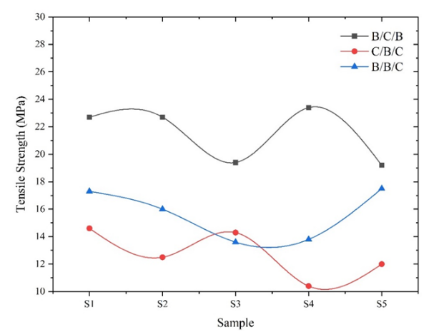

**Figure 1. Tensile strength results**

**3.2 Flexural Testing**

The flexural strength of the three composite configurations was measured and the results are as shown in Figure 2.

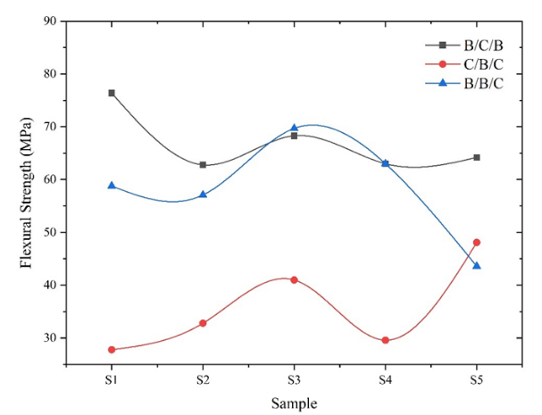

**Figure 2. Flexural strength results**

**3.3 Impact Testing**

The impact strength of the three composite configurations was measured and the results are as shown in Figure 3.

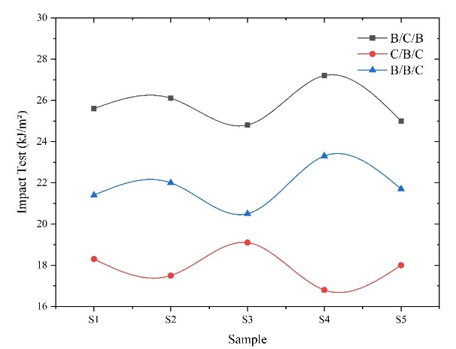

**Figure 3. Impact test results**

The study successfully demonstrated the potential of Banana and Bristol Coir hybrid composites as lightweight, sustainable materials with promising mechanical properties. The optimal configuration for tensile and impact strength was Banana/Coir/Banana, while Banana/Banana/Coir was best for flexural strength. The Coir/Banana/Coir composite showed excellent moisture resistance but lower mechanical performance. SEM analysis provided insights into the microstructural factors influencing these properties, highlighting areas for potential improvement in fabrication methods.

1. **CONCLUSION**

The development and characterization of the banana and Bristol coir natural hybrid composite underscore its potential as an innovative solution for lightweight smart materials. The study confirms that the integration of banana and Bristol coir fibers results in a composite with enhanced mechanical and thermal properties, alongside the added benefit of environmental sustainability. The successful fabrication techniques and improved fiber-matrix interactions contribute to the composite's robust performance. Furthermore, the demonstrated multifunctionality, including self-sensing and adaptive capabilities, positions this natural hybrid composite as a strong contender for applications in various fields such as automotive, aerospace, and construction. Future research should focus on further optimizing the composite properties and expanding its smart functionalities to fully leverage its potential in advanced material applications.

1. **REFERENCES**
2. D. K. Rajak, D. D. Pagar, R. Kumar, and C. I. Pruncu, ”Recent progress of reinforcement materials: A comprehensive overviewof composite materials,” Journal of Materials Research and Technology, vol. 8, no. 6, pp. 6354–6374, 2019.
3. N. Naik, N. Sooriyaperakasam, Y. Abeykoon, Y. Wijayarathna, G. Pranesh, S. Roy, R. Negi, B. K. Aakif, A. Kulatunga, andJ. Kandasamy, ”Sustainable Green Composites: A Review of Mechanical Characterization, Morphological Studies, ChemicalTreatments, and their Processing Methods,” Journal of Computers, Mechanical and Management, vol. 1, no. 1, pp. 66–81, 2022.
4. S. H. Kamarudin, M. S. Mohd Basri, M. Rayung, F. Abu, S. Ahmad, M. N. Norizan, S. Osman, N. Sarifuddin, M. S. Z. M.Desa, U. H. Abdullah, I. S. Mohamed Amin Tawakkal, and L. C. Abdullah, ”A Review on Natural Fiber Reinforced PolymerComposites (NFRPC) for Sustainable Industrial Applications,” Polymers, vol. 14, no. 17, p. 3698, 2022.
5. K. Senthilkumar, I. Siva, N. Rajini, J. T. W. Jappes, and S. Siengchin, ”Mechanical characteristics of tri-layer eco-friendlypolymer composites for interior parts of aerospace application,” in Sustainable Composites for Aerospace Applications, Elsevier,2018, pp. 35–53.
6. N. Chand and M. Fahim, ”Natural fibers and their composites,” in Tribology of Natural Fiber Polymer Composites, Elsevier,2021, pp. 1–59.
7. E. Dempsey, ”Banana Fiber: The Material for Sustainable Fashion From Tree Waste?,” Utopia, May 2022.
8. N. Reddy and Y. Yang, ”Fibers from Banana Pseudo-Stems,” in Innovative Biofibers from Renewable Resources, Berlin, Hei-delberg: Springer Berlin Heidelberg, 2015, pp. 25–27".
9. A. Subagyo and A. Chafidz, ”Banana Pseudo-Stem Fiber: Preparation, Characteristics, and Applications,” in Banana Nutrition - Function and Processing Kinetics, IntechOpen, 2020.
10. M. V. V. Muralikrishna, T. S. A. Surya Kumari, R. Gopi, and G. B. Loganathan, ”Development of mechanical properties in banana fiber composite,” Materials Today: Proceedings, vol. 22, pp. 541–545, 2020.
11. K. M. Babu, ”Eco-friendly Green Fibre-reinforced Composites to Combat Global Warming,” 2018.
12. M. A. Alam, S. M. Sapuan, H. H. Ya, P. B. Hussain, M. Azeem, and R. A. Ilyas, ”Application of biocomposites in automotive components: A review,” in Biocomposite and Synthetic Composites for Automotive Applications, Elsevier, 2020, pp. 1–17.
13. M. I. Kiron, ”Banana Fiber: Properties, Manufacturing Process and Applications,” Textile Learner, 2021.
14. N. Venkateshwaran and A. Elayaperumal, ”Banana fiber reinforced polymer composites - A review,” Journal of Reinforced Plastics and Composites, vol. 29, no. 15, pp. 2387–2396, 2010.
15. P. Pandit, ”Characteristics & Properties of Banana Fibers,” 29 De Septiembre 2020, p. 4, Sep. 2020.
16. T. A. Nguyen and T. H. Nguyen, ”Banana Fiber-Reinforced Epoxy Composites: Mechanical Properties and Fire Retardancy,” International Journal of Chemical Engineering, 2021, pp. 1–9, 2021.
17. B. Laxshaman Rao, Y. Makode, A. Tiwari, O. Dubey, S. Sharma, and V. Mishra, ”Review on properties of banana fiber reinforced polymer composites,” Materials Today: Proceedings, vol. 47, pp. 2825–2829, 2021.
18. P. Fabbri and M. Messori, ”Surface Modification of Polymers,” in Modification of Polymer Properties, Elsevier, 2017, pp. 109–130.