**PERFORMANCE ANALYSIS OF GRAPHENE NANORIBBON FIELD EFFECT TRANSISTOR**

**Sudha B S1, Sneha S K2, T Shweta3**

1Associate Professor, Department of Electronics and Communication Engineering, Dr. Ambedkar Institute of Technology, Bengaluru, Karnataka India

2UG Student, Department of Electronics and Communication Engineering, Dr. Ambedkar Institute of Technology, Bengaluru, Karnataka India

3 UG Student, Department of Electronics and Communication Engineering, Dr. Ambedkar Institute of Technology, Bengaluru, Karnataka India

**ABSTRACT**

Graphene is a very promising material for future electronics because it outperforms silicon in many ways. While traditional transistors (MOSFETs) have problems with short channels, graphene offers unique properties. It's incredibly strong, conducts electricity and heat very well, and functions efficiently at room temperature. It's also incredibly thin, can carry high currents, and is almost completely transparent. Additionally, graphene exhibits a special magnetic behavior. Made of carbon atoms arranged in a honeycomb pattern, graphene is a special form of carbon (allotrope) with some metallic characteristics (semimetal). In this project, we'll analyze and simulate how graphene nanoribbons with a specific structure (armchair chirality) can be used to create transistors. We'll use MATLAB to model and graph the electrical properties of these transistors, including how current varies with voltage at the drain and gate terminals, current density at different channel lengths, conductance, on-off current ratio, channel potential, and density of electronic states. Essentially, this project will explore and model graphene nanoribbons, including their electrical behavior using computer simulations.

**Keywords:** Graphene, MATLAB, Analysis

1. **INTRODUCTION**

Electronic devices are constantly evolving, and silicon has been the go-to material for keeping up with this demand. However, silicon has limitations. As we shrink transistors (MOSFETs) to make even faster devices, we run into problems like leakage and limitations due to the insulating layer used in these transistors. This has opened the door for new materials with better properties.

The number of transistors on a chip has been doubling roughly every two years (Moore's Law), but this trend is nearing its limits as transistors become incredibly tiny. When transistors get very small (sub-100 nanometers), they start to behave differently, creating challenges for engineers. Researchers are looking for new materials with different structures to overcome these limitations of silicon and boost device performance.

Carbon-based materials, like graphene, hold promise for future electronics. Graphene has many desirable qualities, such as high carrier mobility (how easily electrons move through it), high carrier concentration (the number of available electrons), and excellent heat conduction. Additionally, by patterning graphene into thin strips (nanoribbons), we can introduce a band gap, which is necessary for transistors to function as switches.

Graphene nanoribbons (GNRs) are essentially one-dimensional highways for electrons, allowing them to travel with minimal scattering. This leads to very high currents in transistors made with these ribbons. A narrow semiconducting GNR acts as the channel in a special type of transistor called a top-gated field-effect transistor (GNRFET). This project focuses on simulating and analysing the behavior of these GNRFETs using MATLAB software.

Graphene, a single layer of carbon atoms arranged in a honeycomb pattern, is a promising candidate for future nanoelectronics. Devices made from graphene can move electrons very quickly, switch states rapidly due to high carrier velocity, and have excellent heat dissipation due to their thinness. Another advantage is the potential to manufacture large, flat sheets of graphene that can be integrated with existing silicon chip fabrication processes, unlike carbon nanotubes (CNTs). While regular graphene conducts electricity too well (like a metal), we can create a band gap (necessary for transistors) by patterning it into thin nanoribbons, the narrower the ribbon, the larger the band gap.

1. **MODELING AND ANALYSIS**

Fig.1 shows the representation of GNRFET under study. A single layer of armchair Graphene Nano-Ribbon (A-GNR) with index of N=12 is used as the channel material which is taken to be intrinsic. The Index N, defines the number of dimer carbon atom lines transverse to transport direction which is determined by the GNR width, W. The width and length of this GNR channel are assumed to be Wg=33.54nm and L=15nm,respectively.The insulating layers have 0.95nm thickness and consist of the SiO2 material with the dielectric constant of k=4.The source and drain regions are assumed 2 to be heavily doped GNR with doping concentration value of 1*10^16.

The below mentioned flow chart in Fig.2 is designed using self-consistent solution. Here E is energy level in vector form which defines different energy levels. Specify Density of States and Current Density analytically. Initialize Surface Potential as zero. And solve for N and Uscf iteratively using Self-Consistent solution. If du converges to certain value as defined in flow chart, then evaluate current Id.

**2.1 STEPS**

1. 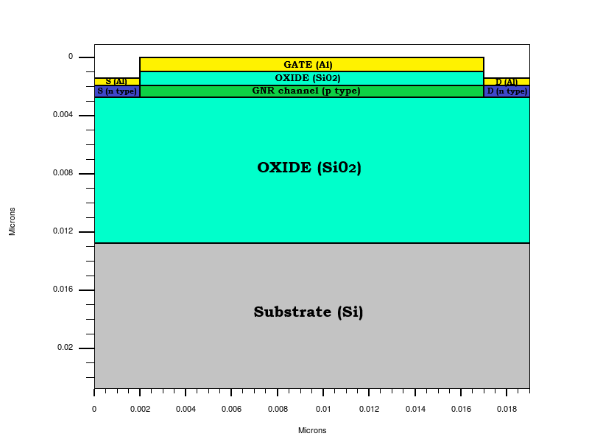Specify the Semiconductor carrier and Current Density J(E) and Density of states D(E) analytically. Fig 1: Structure of GNRFET

Fig.1: Structure of GNRFET

1. Specify Vg, Vd, Vs and Ef.
2. Iteratively solve for Uscf=UL+UP and N.
3. Evaluate the current for the assumed and Vg and Vds.

**2.2 TERMS USED IN THE DERIVATIONS:**

1. DENSITY OF STATES (DOS):

The density of states of a system is described as the number of states per an interval of energy at each energy level available to be occupied. It is mathematically represented by a density distribution and it is generally an average over the space and time domains of the various states occupied by the system.

$D\left(E\right)=\frac{g}{2π}×\frac{1}{E^{2}+(g/2)^{2}}$ (1)

1. FERMI FUNCTION:

If the source and drain regions are coupled to the channel (with VD held at zero), then electrons will flow in and out of the device bringing them all in equilibrium with a common electrochemical potential, µ, just as two materials in equilibrium acquire a common temperature (T). In this equilibrium state, the average (over time) number of electrons in any energy level is typically not an integer, but is given by the Fermi function:

 (2)

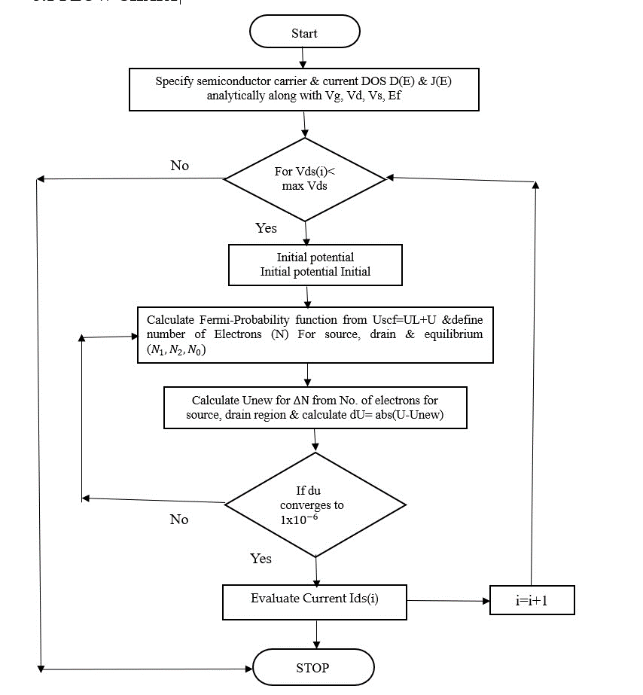

Fig.2: Flowchart of Self- Consistent Potential

## SELF-CONSISTENT POTENTIAL (Uscf):

## Surface potential is defined as potential which is determined between source and drain that is along the channel. So it is determined using self-consistent solution. This can be determined by iteratively solving Electrostatic and Transport equations.

Uscf = UL +UP (3)

## ELECTRON DENSITY (N):

## Electron density is the measure of the [probability](https://en.wikipedia.org/wiki/Probability) of an [electron](https://en.wikipedia.org/wiki/Electron) being present at a specific location within an orbital.

## CURRENT DENSITY (J):

## Current density is defined as the [electric current](https://en.wikipedia.org/wiki/Electric_current) per unit area of cross section. The current density vector is defined as a [vector](https://en.wikipedia.org/wiki/Vector_(geometric)) whose magnitude is the [electric current](https://en.wikipedia.org/wiki/Electric_current) per cross-sectional area at a given point in space, its direction being that of the motion of the charges at this point. In [SI units,](https://en.wikipedia.org/wiki/SI_unit) the electric current density is measured in [amperes](https://en.wikipedia.org/wiki/Ampere) per [square metre.](https://en.wikipedia.org/wiki/Square_metre)

$J\left(E\right)=\frac{1}{2}q(\frac{2}{π}\sqrt{\frac{2(E)}{m^{*}}}$)D(E) (4)

$D\left(E\right)=\frac{g}{2π}×\frac{1}{E^{2}+(g/2)^{2}}$ (5)

$J\left(E\right)=\frac{1}{2}q(\frac{2}{π}\sqrt{\frac{2(E)}{m^{*}}}$)D(E) (6)

$∆N=\left(N_{1}+N_{2}\right)-N_{0}$ (7)

$N_{0}=\int_{-∞}^{+∞}{D\left(E\right)f{}_{0}\left(E\right)dE}$ (8)

$N_{1}=\frac{1}{2}\int_{-∞}^{+∞}{D\left(E\right)f{}_{1}\left(E\right)dE}$ (9)

$N_{2}=\frac{1}{2}\int_{-∞}^{+∞}{D\left(E\right)f{}_{2}\left(E\right)dE}$ (10)

Where, $f_{1}\left(E\right)=f(E+U_{scf}-E_{f1})$ (11)

${ f}_{2}\left(E\right)=f\left(E+U_{scf}-E_{f2}\right)$ (12)

${ U}_{scf}=U_{L}+U_{P}$ (13)

Where,  (14)



 (15)

Where,

D(E) is density of states,

‘g’ is broadening factor

J(E) is current density,

${ U}_{scf}$ is self consistent potential

1. 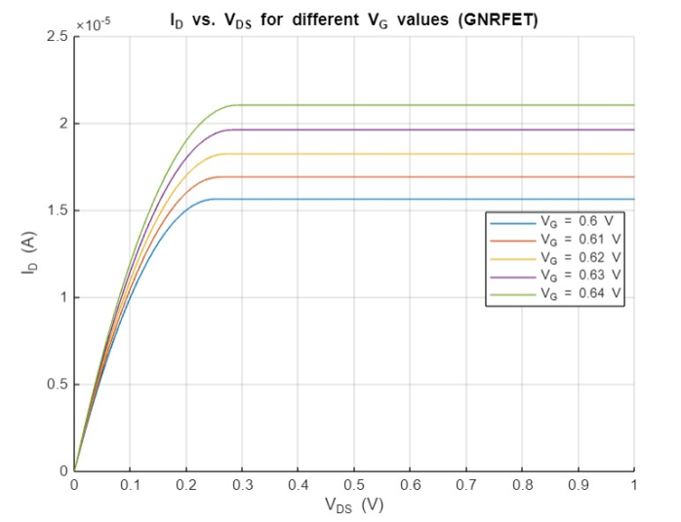**RESULTS AND DISCUSSION**

**3.1 ID vs VDS for different values of VG**

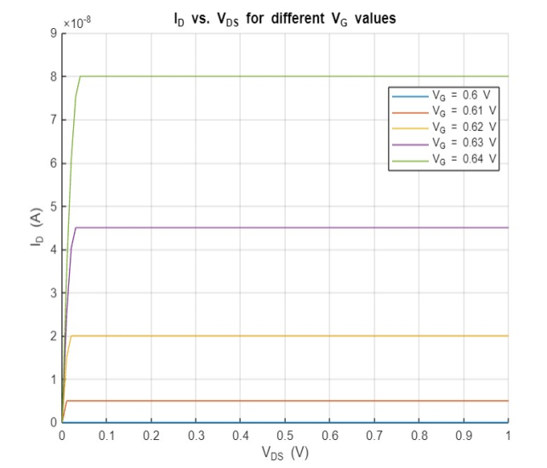

Fig.4: Drain current vs Drain-Source voltage (MOSFET)

Fig.3: Drain current vs Drain-Source voltage (GNRFET)

GNRFET: MATLAB:

Parameters and Performance:

* Higher threshold voltage (0.6 V)
* Lower transconductance parameter (1e-3 A/V)
* Varying drain-source voltage (0.1, 0.2, 0.3 V)
* Varying gate-source voltage (0 .6 to 0.64 V)
* Lower current levels compared to GNRFET
* Smooth transitions between regions
* Suitable for general applications

Parameters and Performance:

* Lower threshold voltage (0.35 V)
* Higher transconductance parameter (5e-4 A/V²)
* Varying gate voltages (0.6 to 0.64 V)
* Varying drain-source (0 to 1)
* Higher current levels

The GNRFET shows higher current and clearer operational regions, making it ideal for high-performance uses. The MOSFET, with its lower current and smoother transitions, is better for standard applications. GNRFETs are more advanced and efficient in handling higher currents and faster switching.

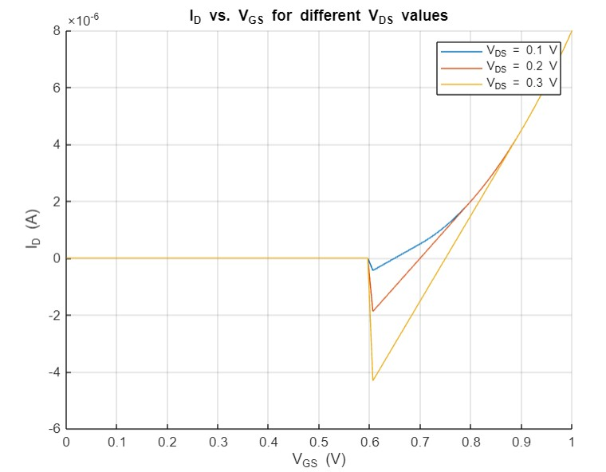**3.2 ID vs VGS for different values of VD**

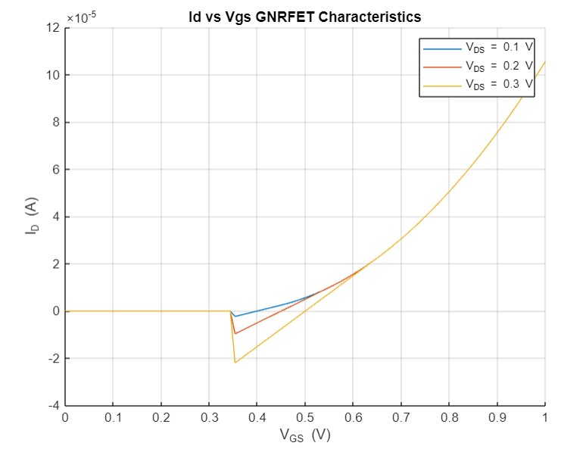

Fig.6: Drain current vs Gate-Source voltage (MOSFET)

Fig.5: Drain current vs Gate-Source voltage (GNRFET)

GNRFET:

* Uses a lower threshold voltage (0.1 V) and a higher transconductance parameter (5e-4 A/V²).
* Produces higher drain current compared to the MOSFET for similar conditions.
* Shows distinct regions (cutoff, linear, and saturation) more clearly.

MOSFET:

* Uses a higher threshold voltage (0.2 V) and a lower transconductance parameter (1e-4 A/V²).
* Generates lower drain current than the GNRFET.
* Shows the same regions but with less pronounced transitions.

GNRFETs demonstrate higher performance with more current and clearer transitions between operating regions, making them better for high-performance applications compared to conventional MOSFETs, which offer moderate current levels and smoother transitions.

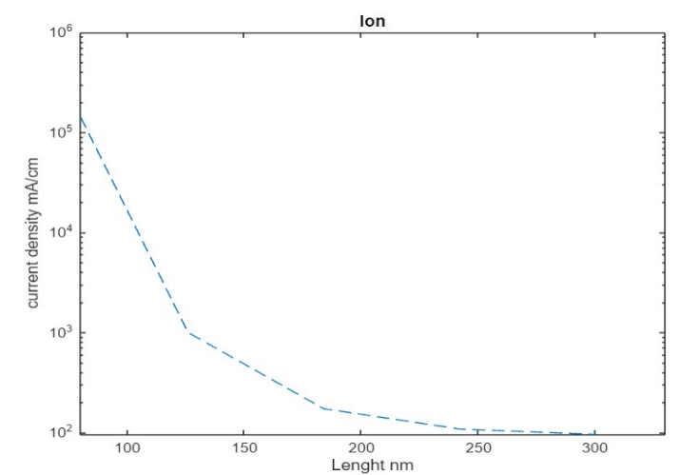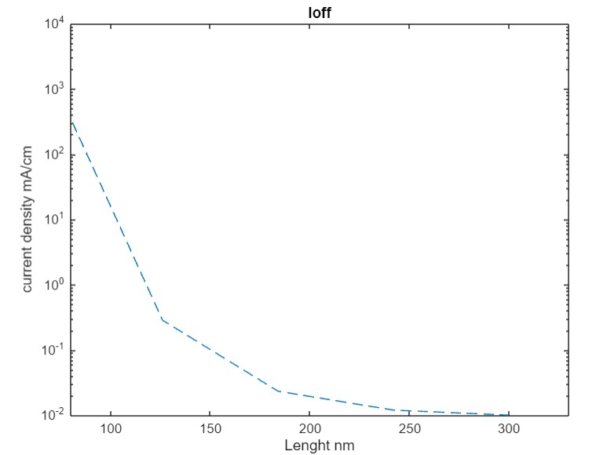**3.3 Current Density vs Gate Length for GNRFET**

Fig.8: IOFF  vs Gate Length

Fig.7: ION  vs Gate Length

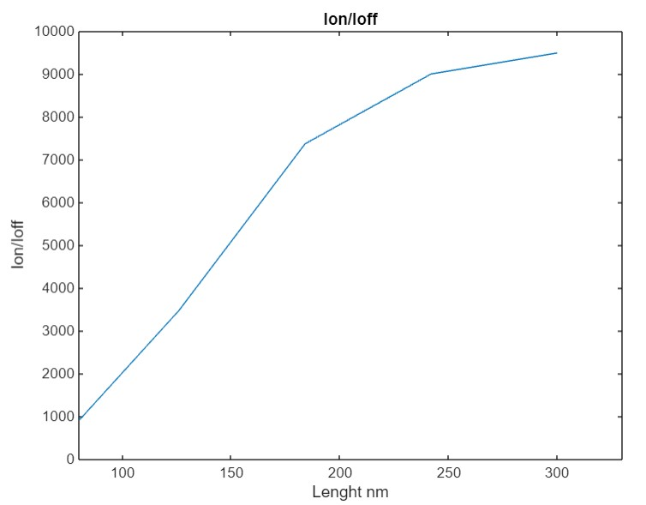

Fig.9: ION /IOFF  ratio

* The plots illustrate how ION , IOFF, and their ratio change with gate length.
* A higher Ion/Ioff ratio indicates better transistor performance, ideal for switching applications.
  1. 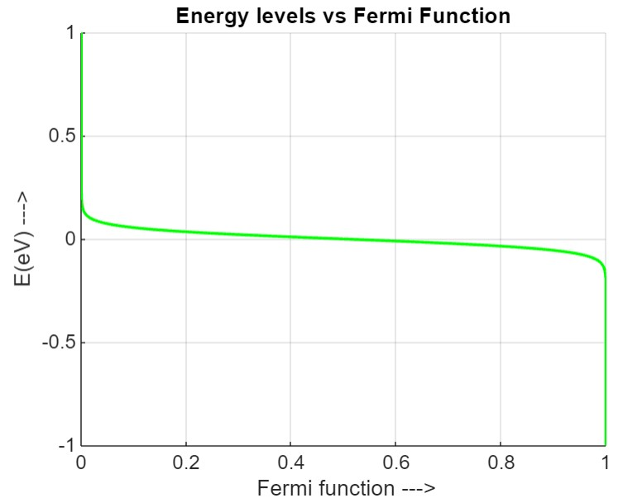**Energy levels vs Fermi Function and Energy vs Density of States for GNRFET**

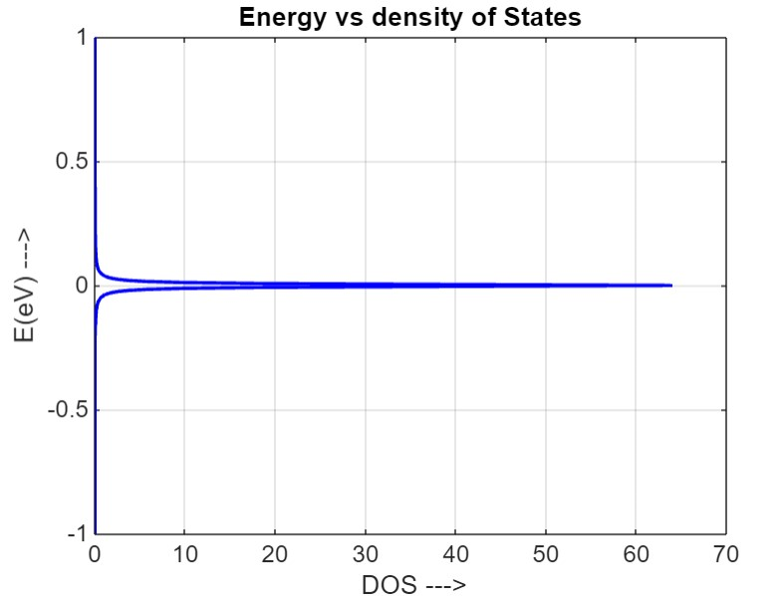

Fig 10: Energy levels vs Fermi Function

Fig 11: Energy vs Density of States

* Displays the DOS vs. Energy (E), indicating how states are distributed across energy levels.
* Shows the Fermi function vs. Energy (E), illustrating the occupancy probability of states at different energy levels.

1. **CONCLUSION**

We developed a model for a Graphene Nanoribbon Field Effect Transistor (GNRFET) using a self-consistent solution approach in MATLAB. We then simulated the transistor's behavior and compared the results with real-world measurements. The simulations showed excellent agreement with the experimental data. This suggests that GNRFETs offer several advantages over traditional MOSFETs, including higher carrier mobility (easier electron movement), a high on-current to off-current ratio (better switching behavior) and a very thin channel for potentially better performance.

**ACKNOWLEDGEMENT**

We would like to thank our Respected guide Sudha B S, Associate Professor, for her valuable guidance and helping us in this work. We would like to show our gratitude to the Electronics and Communication Department, Dr.Ambedkar Institute of Technology, for providing us an opportunity and facilities to carry out the project.

1. **REFERENCES**
2. Huei Chaeng Chin, Cheng Lim, Weng Wong, Vijay Arora, “Enhanced Device and Circuit –Level performance Benchmarking of Graphene Nanoribbon FET against a Nano-MOSFET with Interconnects”, Journal of Nano materials, *Malaysia*, DOI: 10.1155/2014/879813, Article ID 879813, page no. (1-14), 26 march 2014.
3. Supriyo Datta, “Quantum Transport Atom to Transistor*”, Cambridge University Press*, The Edinburgh Building, Cambridge , New York, ISBN 978-0-511-11322-2, 2005.
4. Anisur Rahman, Jing Guo, Supriyo Datta, Fellow, IEEE, and Mark S. Lundstrom, Fellow IEEE, ”Theory of Ballistic Nano Transistors”, IEEE TRANSACTION ON ELECTRON DEVICES, Volume 50, No: 9, page no.(1853-1864), 2003.
5. Mohamed Zakarya Rashed ,Ardalan Lotﬁ “A Graphene nanoribbon ﬁeld-eﬀect transistor Modeling Integrated system technology” Politecnico di Torino III Facolt`a di Ingegneria, June 5, 2014.
6. Ying-Yu Chen , Artem Rogachev , Amit Sangai , Giuseppe Iannaccone , Gianluca Fiori and Deming Chen, “A SPICE-Compatible Model of Graphene Nano-Ribbon Field-Effect Transistors Enabling Circuit-Level Delay and Power Analysis Under Process Variation”, IEEE TRANSACTION*, Italy,* ISBN 978-3-9815370, 2013.
7. R. Van Noorden, *“*Moving towards a graphene world*”* Nature, vol. 442, no. 7100, page no. (228-229), 2006.
8. S. Frank, “Graphene transistors”, Nature Nanotechnology, vol. 5, no. 7, page no.(487–496), 2010.
9. R. Sako, H. Hosokawa, and H. Tsuchiya, “Computational study of edge configuration and quantum confinement effects on graphene nanoribbon transport”, IEEE Electron Device, vol. 32, no. 1, page no. (6–8), 2011.
10. Y.-W. Son, M. L. Cohen, and S. G. Louie, Phys. Rev, “Energy gaps in graphene nanoribbons” Lett., vol. 97, Nov 2006.
11. G. Timp et al, “The Ballistic Nanotransistor,” in IEDM Tech. Digest, page no.(55–58), Dec. 1999