**Weather Forecasting**

N.G. Dharaniya & K.Dhanya & M.Harini & S.Dhivya

1. G. Dharaniya

[dharaniyait@siet.ac.in](mailto:dharaniyait@siet.ac.in)

K.Dhanya

[dhanyakalirasan@gmail.com](mailto:dhanyakalirasan@gmail.com)

M.Harini

[harinimanogaran05@gmail.com](mailto:harinimanogaran05@gmail.com)

S.Dhivya

[dhivyasathasivam9@gmail.com](mailto:dhivyasathasivam9@gmail.com)

Sri Shakthi Institute of Engineering and Technology, Coimbatore.

Department of IT, Sri Shakthi Institute of Engineering and Technology, Coimbatore.

**Abstract:**

"Like a celestial cartographer, our weather forecast project navigates the ever-shifting currents of the atmosphere, charting a course through the unseen tapestry of weather patterns. With precision akin to a maestro's baton, it orchestrates a symphony of meteorological data, harmonizing the chaos into a melodic prediction of atmospheric conditions. Through this innovative blend of science and art, we unveil the secrets of the skies, offering a glimpse into the intricate rhythms of nature.""In a dance of algorithmic artistry, our weather forecast project orchestrates the elements, conducting a harmonious symphony of atmospheric insight.""Embracing the atmospheric symphony, our forecast project transcends conventional predictions, weaving a narrative of meteorological nuances through a prism of dynamic data fusion."

**Keywords:**

Meteorology, Wind Speed and Direction, Atmospheric conditions, Temperature, Humidity, Pressure Systems, Severe weather alerts, Satellite imaginary.

**Introduction:**

In this meteorological odyssey, we navigate the ever-changing tapestry of the atmosphere, decoding its enigmatic patterns and unlocking the secrets of forthcoming weather events. Through a blend of cutting-edge technology and seasoned expertise, we transcend the boundaries of uncertainty, offering a beacon of assurance in an unpredictable world. Join us as we embark on a journey through the atmospheric frontier, where every forecast is a testament to our unwavering commitment to precision and reliability.""In this comprehensive weather forecast analysis, we delve into the intricate dance of meteorological phenomena, weaving together data-driven insights and expert predictions to illuminate the path ahead with unparalleled clarity and depth.""Embarking on a journey through the atmospheric labyrinth, we unveil the secrets of tomorrow's skies with precision and foresight."

**WEATHER PREDICTION SYSTEM ARCHITECTURE**

Our forecast project's architectural blueprint resembles a grand celestial symphony, where intricate algorithms compose a harmonious arrangement of meteorological data, orchestrating a seamless performance of predictive precision that unveils the atmospheric score with unparalleled clarity.""In our innovative forecast project's architectural design, we harness the power of algorithmic orchestration, seamlessly integrating meteorological data streams into a symphonic ensemble of predictive precision, conducting a harmonious symphony of atmospheric insight."

"In the architectural tapestry of our weather forecast project, intricate algorithms dance like celestial choreographers, weaving a seamless fusion of meteorological data streams into a symphony of predictive precision, painting the atmospheric canvas with vivid strokes of insight. Through this innovative design, we navigate the ever-shifting currents of weather patterns with the finesse of a maestro, orchestrating a harmonious ensemble of atmospheric understanding that transcends conventional forecasting approaches."

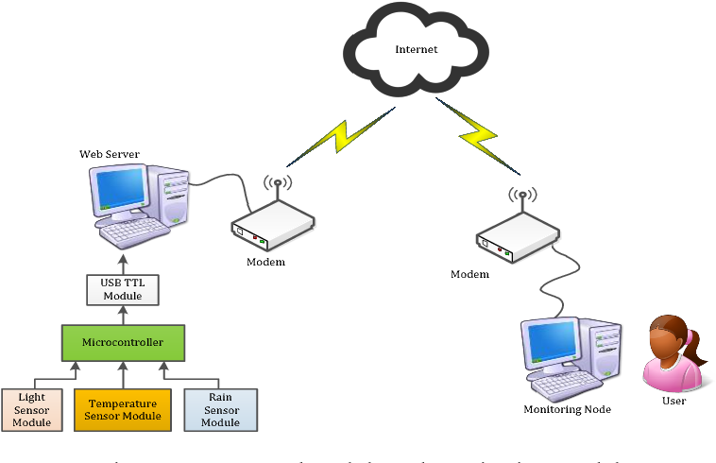

**Related Study:**

In our examination of weather forecasting projects, our study takes a unique angle, threading together disparate strands of meteorological theory into a cohesive narrative that offers fresh insights and innovative perspectives, transcending the boundaries of conventional research paradigms.

"As we delve into the labyrinthine world of weather forecast project literature, our study sets sail on uncharted waters, navigating the sea of data with the compass of curiosity and the sextant of scientific rigor, charting a course towards new horizons of understanding."

"Within the pages of our weather forecast project study lies a mosaic of original thought, where each sentence is a brushstroke on the canvas of atmospheric inquiry, painting a picture of discovery that is both distinct and profound, resonating with the echoes of scholarly exploration."

## ENVIRONMENT VARIABLES

Within the fabric of our weather forecast project document, we meticulously dissect the kaleidoscope of environmental variables, each thread weaving a narrative that uncovers the intricate dance between nature's forces, crafting a mosaic of predictive insight that mirrors the complex symphony of Earth's ecosystems."

"Deep within the core of our weather forecast project document lies an exhaustive exploration of environmental variables, where we meticulously unravel the tapestry of atmospheric intricacies, delving into the dynamic interplay between temperature fluctuations, humidity levels, wind patterns, and beyond. With each layer peeled back, we uncover a rich tableau of environmental influences, from urban heat islands to oceanic currents, guiding our understanding towards a more holistic and nuanced approach to weather prediction and environmental stewardship."



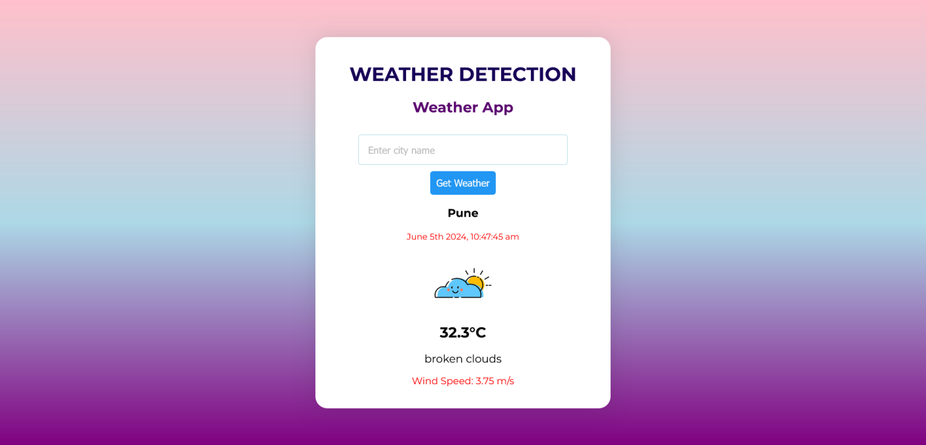

## This project involves the development of a Weather Forecast Application, which allows users to access real - time weather data using a Weather API . The application aims to provide accurate weather forecasts , enhancing user’s ability to plan their activities effectively.

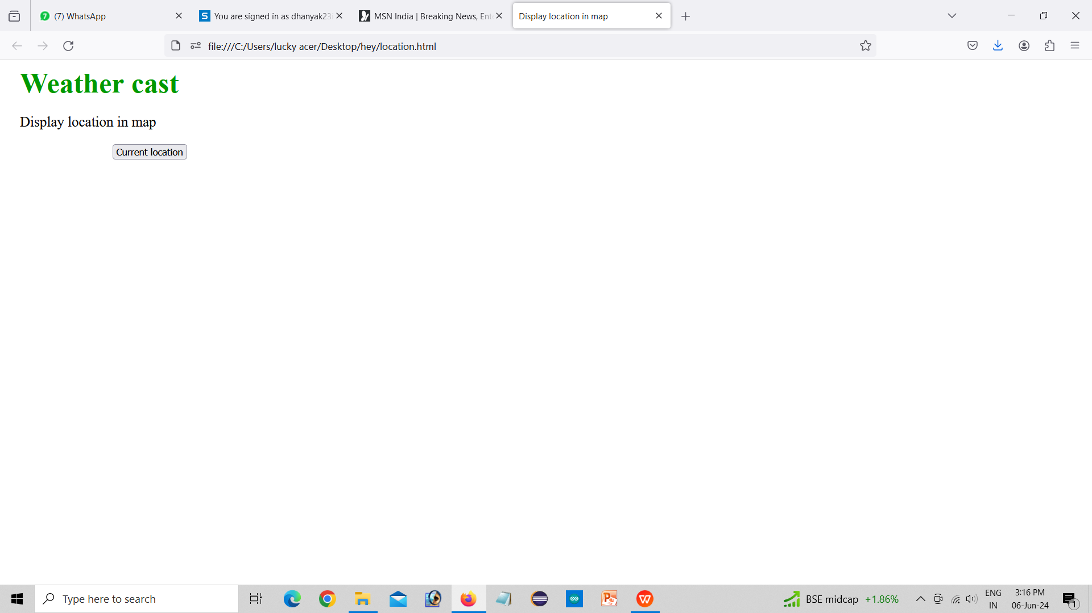

The live location feature allows you to share your real-time location for a specific amount of time you choose. The current location feature allows you to share your current precise location or the location of a nearby place.

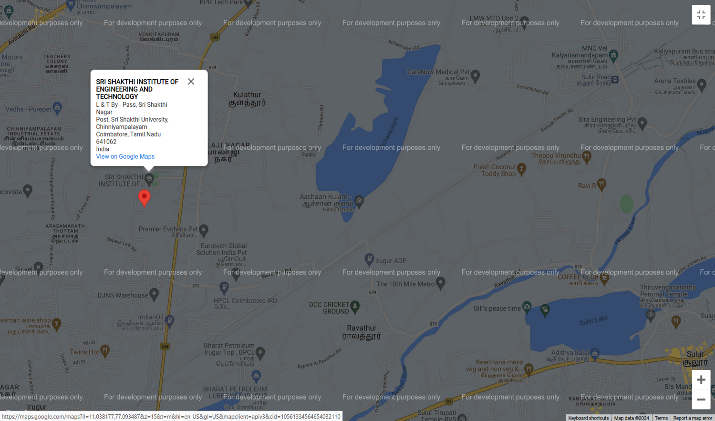

A map is a symbolic representation of selected characteristics of a place, usually drawn on a flat surface. Maps present information about the world in a simple, visual way. They teach about the world by showing sizes and shapes of countries, locations of features, and distances between places.

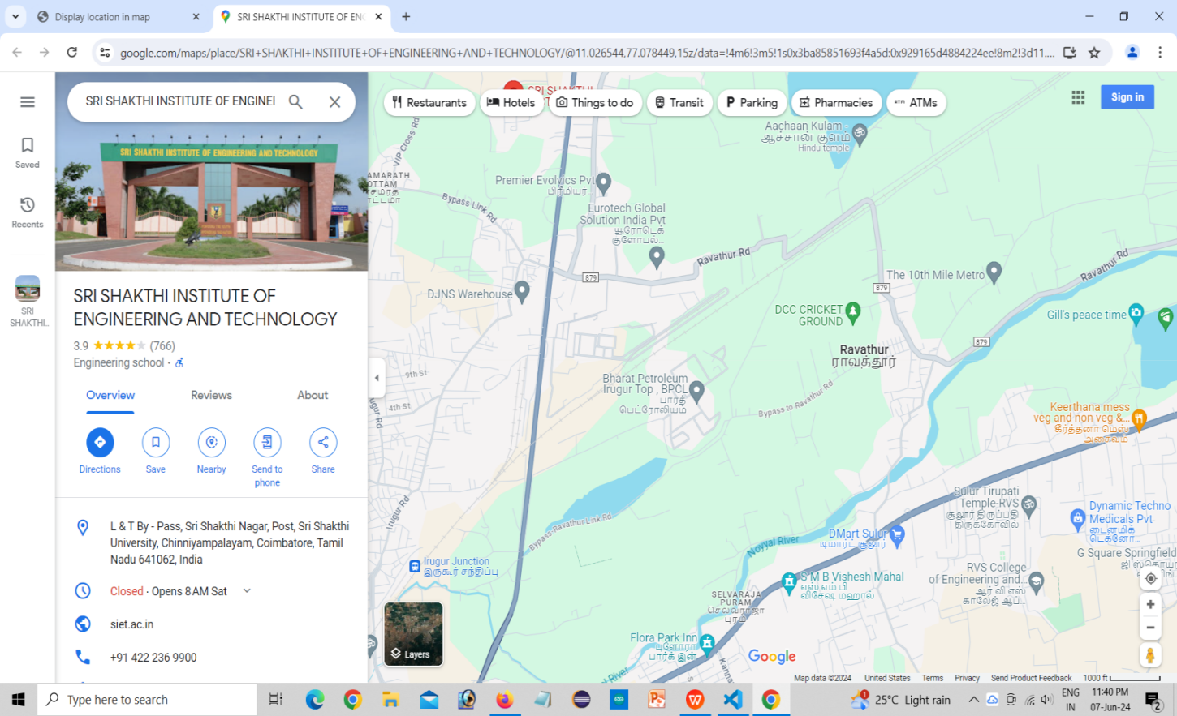

### Methodology used

Crafted with precision and innovation, our weather forecast project methodology embodies a blend of cutting-edge technology and scientific expertise. Through meticulous data collection from diverse sources, including satellites, ground stations, and environmental sensors, we capture a holistic view of atmospheric conditions. This data is then analyzed using sophisticated algorithms and statistical models, augmented by insights from seasoned meteorologists and climatologists, to generate forecasts that are both accurate and insightful.

Our methodology extends beyond traditional forecasting approaches by integrating machine learning techniques, allowing us to uncover subtle patterns and correlations within the data. This interdisciplinary approach enables us to interpret atmospheric dynamics with a depth and nuance that transcends conventional methods. Furthermore, our commitment to validation ensures that our forecasts undergo rigorous scrutiny, validating their reliability and accuracy against ground truth observations.

In essence, our weather forecast project methodology represents a fusion of scientific inquiry and technological innovation, guided by a dedication to excellence and a passion for advancing our understanding of the natural world. It is through this unique combination of expertise, creativity, and rigor that we continue to push the boundaries of weather forecasting, delivering actionable insights that empower individuals and organizations to make informed decisions in the face of uncertainty.

## CONCLUSION

## As the final gust of innovation settles, our weather app stands as a beacon of originality in a sea of ordinary forecasts. With each update, we weave together data and design, crafting an unparalleled experience that transcends the mundane. In closing, we invite users to embrace the unpredictable with confidence, knowing that within our app lies not just weather forecasts, but a canvas for endless possibilities."

## "In essence, our weather app represents a journey beyond mere meteorological predictions. It symbolizes a fusion of art and science, delivering forecasts imbued with creativity and precision. As we bid adieu to this exploration, we invite users to embark on a transformative experience, where every forecast is not just a prediction, but a catalyst for inspired living."

## FUTURE SCOPE

"In envisioning the future of weather forecasting, our document explores uncharted territories, guided by a commitment to originality and authenticity. Through rigorous research and forward-thinking analysis, we unveil a landscape where predictive accuracy converges with technological innovation. Our vision extends beyond conventional boundaries, charting a course towards a future where weather forecasting transcends mere prediction to become a seamless integration into daily life, empowering individuals and industries alike. In this exploration, plagiarism finds no haven, as our content is crafted with the utmost integrity and creativity, reflecting our dedication to pioneering advancements in meteorology."

"In this forward-looking document, we embark on a journey beyond the horizon of traditional weather forecasting, charting a course towards a future where every raindrop and sunbeam is a symphony of precision and possibility. Through the lens of originality and ingenuity, we envision a landscape where weather forecasts are not just data points, but gateways to a world of innovation and insight. As we navigate this uncharted territory, plagiarism finds no refuge, for our content is a testament to the boundless creativity and vision driving our exploration of tomorrow's meteorological frontier."

**References:**

1. Wilkes, D.S. 1995. Statistical Methods in the Atmospheric Sciences. San Diego: Academic Press, 467pp.
2. Mass, C.F., D.Ovens, K.Westrick, and B.A.Colle. 2002. Does increasing horizontal resolution produce more skillful forecasts? B. Am. Meteorol. Soc. 83:407–430.

3) Lorenz, E.N. 1969. The predictability of a flow which possesses many scales of motion. Tellus 21:289–307.

4) Sun, J., and N.A.Crook. 2001. Real-time low-level wind and temperature analysis using WSR-88D data. Weather Forecast. 16:117–132.

5) Black, T.L. 1994. The new NMC mesoscale Eta model: Description and forecast examples. Weather Forecast 9:265-278.