# THE MENTAL HEALTH TRACKING SYSTEM

Dr. S.Prakash & Bhuvanashri S K & Deepika S & Deepika Rani K.

Dr. S.Prakash

[hodit@siet.ac.in](mailto:hodit@siet.ac.in)

Bhuvanashri S K [bhuvanashri4321@gmail.com](mailto:bhuvanashri4321@gmail.com)

Deepika S

[studiesfoí456@gmail.com](mailto:studiesfor456@gmail.com)

Deepika Rani K [deepikaranideeepika4@gmail.com](mailto:deepikaranideeepika4@gmail.com)

Sri Shakthi Institute of Engineering and Technology, Coimbatore.

Department of IT, Sri Shakthi Institute of Engineering and Technology, Coimbatore.

## Abstract:

What is "The Mental Health Tracking System"? Are you familiar with it? It makes monitoring mental wellness in people very simple. The system includes helpful treatments and a Q section. Users respond to questions that are specifically designed for them. We assess their condition and provide ideas to help them feel better based on their responses.

To assist you in focusing and practicing awareness through gradual meditation, our project includes audio, relaxing music, and meditation instructions. We even offer games that can help you develop a more optimistic outlook and improve your positive thinking abilities. Do you need some inspiration? We have motivational tales that are suited to your circumstances.

Are you depressed? Fear not—we offer strategies for resolving mental health concerns as well as simple workouts that can help you stay active and unwind your muscles. And we'll put you in touch with a doctor's recommendation if things worsen.

In general, the goal of our initiative is to identify your mental health issues and offer assistance. We are here to listen to you and let you know that we value you. Why not attempt it then? We take your mental health seriously!

## Keywords:

MENTAL HEALTH MANAGE TRACKING SYSTEM (MHMTS), Q&A, result, doctor

recommendation, app recommendation, exercise, meditation, songs, game, Proposed Methods, Conclusion, Future Scopes, References.

## Introduction:

"Mental health is a process about how you drive, not where you are going; it's not just a destination." Subjective well-being, or happiness, is a state of emotional well-being that can be felt in two ways: narrowly, when pleasant things happen at a particular instant, or more widely, as a favourable assessment of one's life and accomplishments overall. Happiness is a feeling that comes from the heart and spirit, not just a smile. When our surroundings are happier and we have good mental health, we are happy. Everyone has to be in good mental health in order to have a happy life. The goal of this project, the Mental Health Tracking System, is to learn more about human mental health and how to treat it with natural remedies. The system has sections for questions, results, and remedies related to human welfare. There will be an announcement of the grade points and Q&A session outcomes. Doctor's advice for severe mental health concerns is also included in the system. The system offers music, yoga poses, workout poses, inspirational phrases, and other materials for those who are willing to be cured just by taking natural medications.

# MENTAL HEALTH TRACKING SYSTEM Q&A SECTION

You can examine and manage your mental well-being with the help of this cool system for tracking your mental health. It includes a plethora of useful tools to track your mood, activities, and progress toward feeling better. We assess patients' mental health through conversation and report our findings. We can promote children's mental health by modeling resilience and coping mechanisms.

Establishing a caring family, communicating honestly, and modeling healthy coping mechanisms are all vital. Together, parents, guardians, and educators can combat the stigma associated with mental health issues and encourage children to seek and receive treatment when necessary. As you review the results, you'll see the patient's current status and be prompted to inquire if they want a referral for an app or a doctor's advice.



# RESULT

Promoting mental health in children also involves fostering resilience and teaching coping skills. Encouraging open communication, modeling healthy emotional responses, and creating a supportive home environment are essential strategies. Parents, caregivers, and educators must work together to reduce the stigma around mental health and encourage children to express their feelings and seek help when needed. On the result page, the patient's present condition will be displayed and the patient will be asked to choose either a doctor recommendation or an app recommendation.

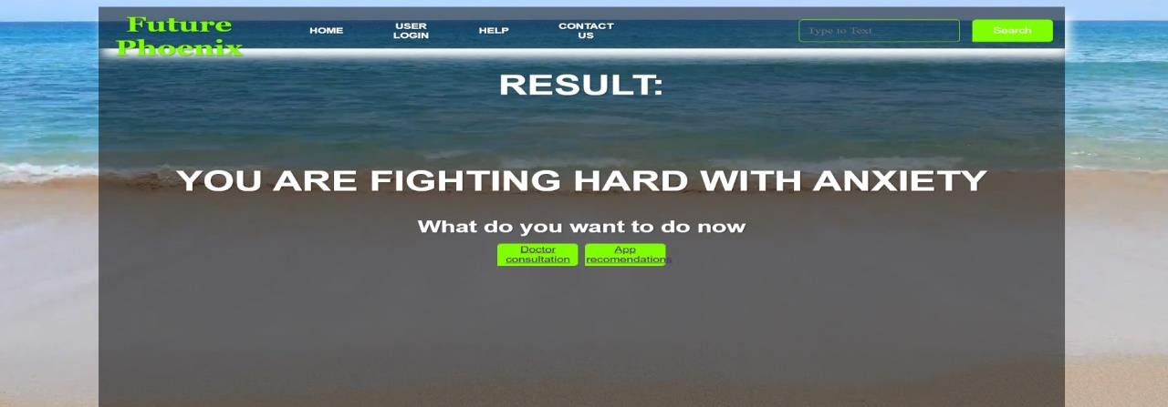

# DOCTORS RECOMMENDATION

Helping children with their mental health requires intervention from the very beginning. Children are more likely to adopt appropriate coping mechanisms and achieve positive outcomes if problems

are identified early on and addressed. Talking to a therapist, gaining guidance, adopting new behaviors, and wanting advice from an app or a doctor when you view the results. The doctor will advise you on the next course of action if you follow their advice.

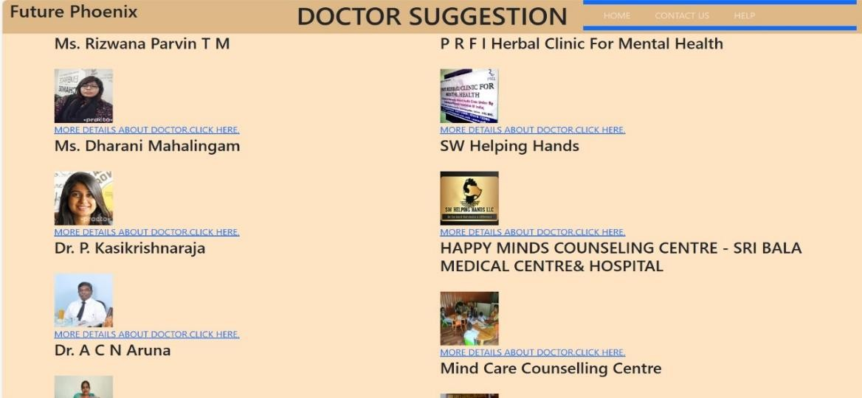

# APP RECOMMENDATION

It might not always be simple to identify mental health issues in children. It's challenging because the symptoms may differ from those in adults. Consider depression as an example. Instead of feeling depressed, a kid with depression may exhibit irritability and behavioral problems. Watch for behavioral changes, mood swings, avoidance of social situations, and difficulties in school. So don't freak out just yet! Looking through interesting applications that recommend things to try is one approach to lend a hand. These apps provide music, relaxation techniques, enjoyable activities, games, motivational stories, and practical guidance to improve things.

## Work out

Exercise is crucial for those who are experiencing mental health issues. It can help you feel better, think more clearly, feel more confident, establish a routine, allow you to socialize, improve your sleep, and minimize the symptoms of mental health issues.

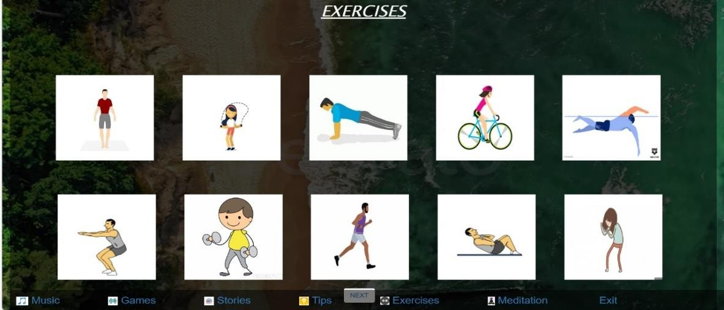

# GAME

Let's now discuss games! Engaging in gaming activities, whether indoors or outdoors, can significantly improve one's mental health. may increase mental acuity, elevate your mood, foster interpersonal relationships, enhance your abilities, serve as therapy, fortify and bolster your confidence, divert your attention from unfavorable ideas, and support you through difficult circumstances.



# SONGS

First, let's speak about songs, shall we? Songs and music truly have a profound impact on people's emotions during trying times. They improve our mental and emotional well-being. Furthermore, they facilitate our emotional connections with others. They can also be used for relaxation, treatment, and improved sleep

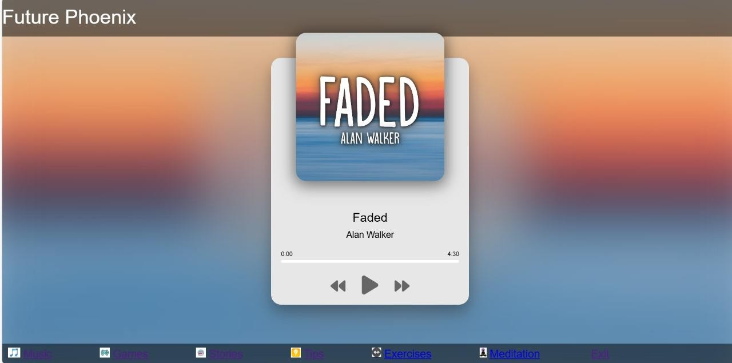

# STORIES

Let's proceed to now. Narratives are also very significant! They can significantly improve our mental health whether we read, hear, or tell them. They improve our ability to think clearly, comprehend others better, and let out our emotions in a healthy way. And what do you know? They even have therapeutic applications!.



## Proposed Method:

**Step 1: Preliminary Evaluation**

First, let's try to comprehend your current state of mind. How would you rank your mood, on a scale of 1 to 10? Do you frequently experience anxiety or tension? What is the amount of sleep that you receive every night? Do you find it difficult to concentrate or decide? Do you regularly participate in physical activity? We'll be able to better grasp your mental state by asking these questions.

## What we intend to accomplish:

By evaluating these elements, we may adjust our strategy to best assist you.

## Step 2: Interactive Questions

Let's take a closer look now with some thought-provoking queries. You can use these to keep a daily journal of your ideas and feelings. Our goal is to better understand your mental state so that we can find potential triggers that could affect your mental health.

## Goal achieved:

Our intention is to help you become more self-aware and capable of taking care of your mental health.

## Step 3: Interactive Media

Who enjoys a good game less? Practicing relaxation techniques, memory exercises, and problem-solving techniques will improve your cognitive abilities and lower your stress levels. Together, we will enhance your general well-being and have some fun.

## The intended result:

We want you to benefit from improved cognitive performance and less stress while taking some time t o relax.

## Step 4: Mindfulness

It's time to unwind and find your center. Engaging in daily guided meditation techniques can help you become more focused, emotionally stable, and reduce anxiety. Together, let's inhale deeply.

## Our objective:

Our goal is to enhance your goal is to enhance your emotional health and encourage natural relaxation through meditation.

## Step 5: Work Out

Let's move toward mental and physical well-being. Customized workouts, such as yoga, aerobics, or strength training, can improve your emotional and physical well-being. Greetings from higher energy levels!

## What is ahead of you:

We're here to uplift and energize you as you embark on your road toward physical health.

## Step 6: Music Therapy

The soul can be calmed and lifted by music.

A selection of carefully crafted playlists is ready to relieve stress, improve your attitude, and inspire emotional communication via music therapy exercises. Together, let's explore a universe of melodies.

## The objective

Together, let's use music therapy to enhance emotional expression and lessen the symptoms of anxiety and despair. We advocate a multidisciplinary approach that integrates several forms of therapy to support

mental health. Since each person reacts differently, our program consists of a variety of interventions, including a personalized music therapy session, games, interactive questions, meditation, and exercise.

## Why this is important

Our carefully thought-out curriculum seeks to compassionately and empathetically meet a range of requirements.

## Step 8: Put into Practice

This is where your adventure starts—on our intuitive digital platform, which is available 24/7 on PCs and mobile devices. Based on your answers, customized daily schedules are waiting for you, and regular

feedback guarantees flexibility for optimal impact.

## How it functions

As we travel this route together toward a higher quality of life for mental health, stay updated on your progress with personalized updates.

## Step 9: Anticipated Results

The following are some goals we want to accomplish together:

* Recognize your mental state right from the start.
* Become more self-aware to better control your emotions.
* Improve stress reduction and cognitive performance.
* Boost physical well-being to increase vitality.
* Reduce the signs of depression and anxiety.
* Overall improvement in your standard of living.

# RESULT:

**Anxiety and Depression**: Studies indicate that between 7 and 14% of children experience anxiety-related issues.

3–8% of individuals suffer from depression. Five to ten percent of children suffer from attention-deficit/hyperactivity disorder (ADHD). Notable is the frequency of additional behavioral issues, such conduct disorder.

**Risk factors:** Bullying, peer relationships, and academic pressure all have a big effect on kids' mental health. Children who suffer from mental health illnesses sometimes find

it difficult to concentrate, which can negatively affect their academic achievement.

# CONCLUSION

With the support of the mental health tracking system, children's mental health can be efficiently improved. Medication, music, and exercise are all individually beneficial to a child's well-being. Medication may be an essential part of treatment for certain children, particularly those with mental health diagnoses like ADHD, depression, or anxiety. Appropriate medicine, when used under a doctor's supervision, can aid in symptom management, enhance focus, and stabilize mood, all of which contribute to better mental health overall. The therapeutic effects of music can have a big impact on kids' mental health. Making or listening to music has been shown to lower stress, elevate mood, and boost cognitive abilities. Particularly when it comes to fostering social connections and emotional expression, music therapy may be a very effective technique. It gives kids a creative way to process their feelings and experiences. Combining these methods results in a comprehensive plan that addresses children's mental health from several perspectives.Exercise can improve physical health and mood, music can provide emotional and psychological relief, and medications can treat biological problems. When combined, they can offer a thorough foundation for helping kids develop resilient, balanced, and healthy mental states.We can develop a complete strategy to support and enhance children's mental health and help them lead happier and healthier lives by combining meditation, music, exercise, and meditation.

# FUTURE SCOPE FOR METAL HEALTH TRACKING SYSTEM

A mental health tracking system has a wide and bright future ahead of it. Listed below are some possible paths to take:

**Unique Insights:** By utilizing artificial intelligence (AI) and machine learning, the system can offer users unique insights on their own mental health patterns, triggers, and coping strategies. This will enable users to better understand and take care of their mental health.

Integration with Wearable Tech: Vital signs, sleep patterns, activity levels, and other metrics associated with mental health can be continuously monitored by integrating mental health tracking features into wearable technology, such as smartwatches or fitness trackers.

Enabling mental health support services via the platform, such as remote monitoring and teletherapy, can improve accessibility, particularly for individuals residing in distant places or experiencing mobility challenges.

**Data-driven Interventions:** By using big data analytics, the system may find patterns and trends in sizable datasets to create interventions and treatments that are more successful for a range of mental health issues.

Gamification and Engagement: Adding gamification components and interactive elements can boost user motivation and engagement, which will make it simpler for people to follow their routines for managing their mental health.

**Cooperation with Healthcare Providers:** Encouraging data sharing and communication between users and healthcare providers can expedite the therapeutic process and guarantee prompt interventions and continuity of care.

**Community Support:** Establishing a helpful online community on the platform where users can interact with others going through similar struggles, exchange experiences, and offer advice can be a great way to get support from peers.

By using predictive analytics algorithms, the system can detect early warning indications of impending mental health crises or relapses, enabling proactive interventions and preventive measures.

A mental health tracking system can significantly contribute to improving general well-being and lowering the stigma associated with mental health concerns by constantly changing and incorporating breakthroughs in technology and mental health research.

## References:

1. Diagnostic and Statistical Manual of Mental Disorders, 5th Edition, Text Revision (DSM-5-TR)
2. BMJ Mental Health, published by the BMJ Foundation psychologists and doctors, ISSN: 2632-1009
3. "The Theory and Practice of Group Psychotherapy" by Irvin D Yalom
4. "Introduction to Cognitive Analytic Therapy: Principles and Practice" by Anthony Ryle & Ian B Kerr
5. "Managing Your Mind: The Mental Fitness Guide" by Gillian Butler, Tony Hope & Nick Grey
6. "What Works for Whom: A Critical Review of Psychotherapy Research" by Anthony Roth & Peter Fonagy
7. "Why Don't I Feel Good Enough?: Using Attachment Theory to Find a Solution" by Helen Dent
8. "Grief is the Thing with Feathers" by Max Porter
9. "Broken Hierarchies: Poems 1952-2012" by Geoffrey Hill
10. "Late Fragments: Everything I Want To Tell You (About This Magnificent Life)"
11. "With the End in Mind: Dying, Death, and Wisdom in an Age of Denial" by Kathryn Mannix
12. "I Capture The Castle" by Dodie Smith
13. "The Varieties of Religious Experience" by William James
14. "The Examined Life: How We Lose and Find Ourselves" by Stephen Grosz
15. "War and the Soul" by Edward Tick
16. "The Body Keeps the Score: Mind, Brain and Body in the Transformation of Trauma" by Bessel van der Kolk
17. "The Theatre of War" by Bryan Doerries
18. "Waking From Sleep" by Steve Taylor
19. "True Hallucinations: Being an Account of the Author's Extraordinary Adventures in the Devil's Paradise" by Terence McKenna
20. "Are u ok?" by Kati Morton
21. "Maybe You Should Talk to Someone" by Lori Gottle