# **Implementation of Artificial Intelligence (AI) & Machine Learning (ML) in Changing Consumer Buying Behaviour**

**Niranjan Sushant Sawant1,** **Shweta Vikas Walawalkar2**

1,2Student, MCA, Hope Foundation’s Finolex Academy of Management & Technology, Ratnagiri, Maharashtra, India.

**Abstract**

In the information age, the world is awash in data. Unlocking its potential requires sophisticated tools, and Data Science (DS) and Machine Learning (ML) have emerged as powerful drivers of transformative change across diverse domains. This paper explores the revolutionary impact of DS and ML on the modern world, analysing their contributions to various sectors and highlighting their profound influence on individuals, societies, and economies. This research paper explores the positive impact of Artificial Intelligence (AI) on marketers' ability to analyse and understand customer behaviour. By examining online consumer actions, marketers can enhance the effectiveness of their marketing plans and strategies.

**Keywords:** Data Science, Machine Learning, Artificial Intelligence, Market Basket Analysis, Predictive Analytics, Innovation, Transformation, Consumer Behaviour Analysis.

1. **Introduction**

Artificial Intelligence (AI) refers to the simulation of human intelligence functions by machines, particularly computer systems. Various ways AI is used are speech recognition, machine learning, natural language processing, expert systems, and speech synthesis. A huge amount of labelled training data is usually acquired by AI systems, which examine the data for correlations and patterns before employing them to forecast future states. For example, by studying millions of instances, an image recognition tool can learn to recognize and describe objects in photographs, after seeing sample conversations chatbot can have realistic conversations with people

The study of consumers' actions to choose whether to buy a certain product which satisfies their needs is known as consumer buying behaviour. It is a study of consumer behaviour and what drives people to buy and utilise particular products. For marketers, understanding consumer purchase behaviour is crucial because it helps in comprehending what customers expect from them. To understand what makes the consumer decide whether a product is useful. Consumer buying behaviour examines a variety of situations, including what customers purchase, why they purchase it, when they purchase it, how frequently they purchase it, and many other factors.

In digital marketing, AI focuses on user retention and lead conversion. It steers users towards business objectives through tools like intuitive AI chatbots, smart email marketing, interactive web design, and other digital marketing services. The effectiveness of AI in digital marketing is influenced by various factors. Machine Learning (ML), a subset of AI, involves computer programs that independently learn from data. These programs gather information from social media, menus, online reviews, websites, and more. AI then processes this data to create and deliver content that resonates with the audience.

1. **Problem Definition**

The e-commerce landscape is booming, with countless websites offering a dizzying array of products from a multitude of brands. This vast selection caters to diverse categories, promising to fulfil every whim and desire. However, this very abundance can be overwhelming for consumers, creating issues such as(6):

**Information Overload:** Wading through a sea of product listings, each boasting unique features, technical specifications, and brand claims.

**The Paradox of Choice:** Decision paralysis sets in due to seemingly endless options, making it difficult to narrow down searches.

**Brand Blindness:** Overwhelmed by logos and key differentiators, consumers experience difficulty in making informed choices.

**Reviews Galore, but Not Trustworthy Enough:** Flooded review sections make it hard to discern genuine feedback from sponsored content or biased reviews.

## 

1. **Objective**

The objective of this research is to leverage the power of AI and ML to address the growing problem of consumer decision fatigue in the e-commerce landscape. By understanding the challenges faced by online shoppers, we aim to develop and evaluate potential solutions that can:

* Reduce Information Overload
* Mitigate the Paradox of Choice
* Enhance Consumer Confidence
* Streamline the Decision-Making Process
* Influence consumer buying behaviour through AI

Evaluate the overall performance of industries using AI

Ultimately, the goal is to create a framework for e-commerce businesses to leverage AI and ML, enhancing online shopping experiences, leading to increased customer satisfaction, loyalty, and conversion rates.

1. **Scope**

This research will explore how AI and ML can address challenges faced by consumers on e-commerce websites. We aim to identify and evaluate solutions that can streamline decision-making and increase consumer confidence.

1. **Focus Areas:**

**Information Filtering:** Utilising AI and ML algorithms to personalise product listings based on user demographics, purchase history, and browsing behaviour.

Smart Recommendations: Implementing recommendation engines powered by ML to suggest products tailored to individual user needs and preferences.

**Chatbots and Virtual Assistants:** (4)Integrating AI-powered chatbots and virtual assistants to provide real-time product information, answer queries, and guide consumers.

**Review Analysis:** Employing Natural Language Processing (NLP) techniques to analyse online reviews, identify trustworthy sources, and filter out biassed or irrelevant content.

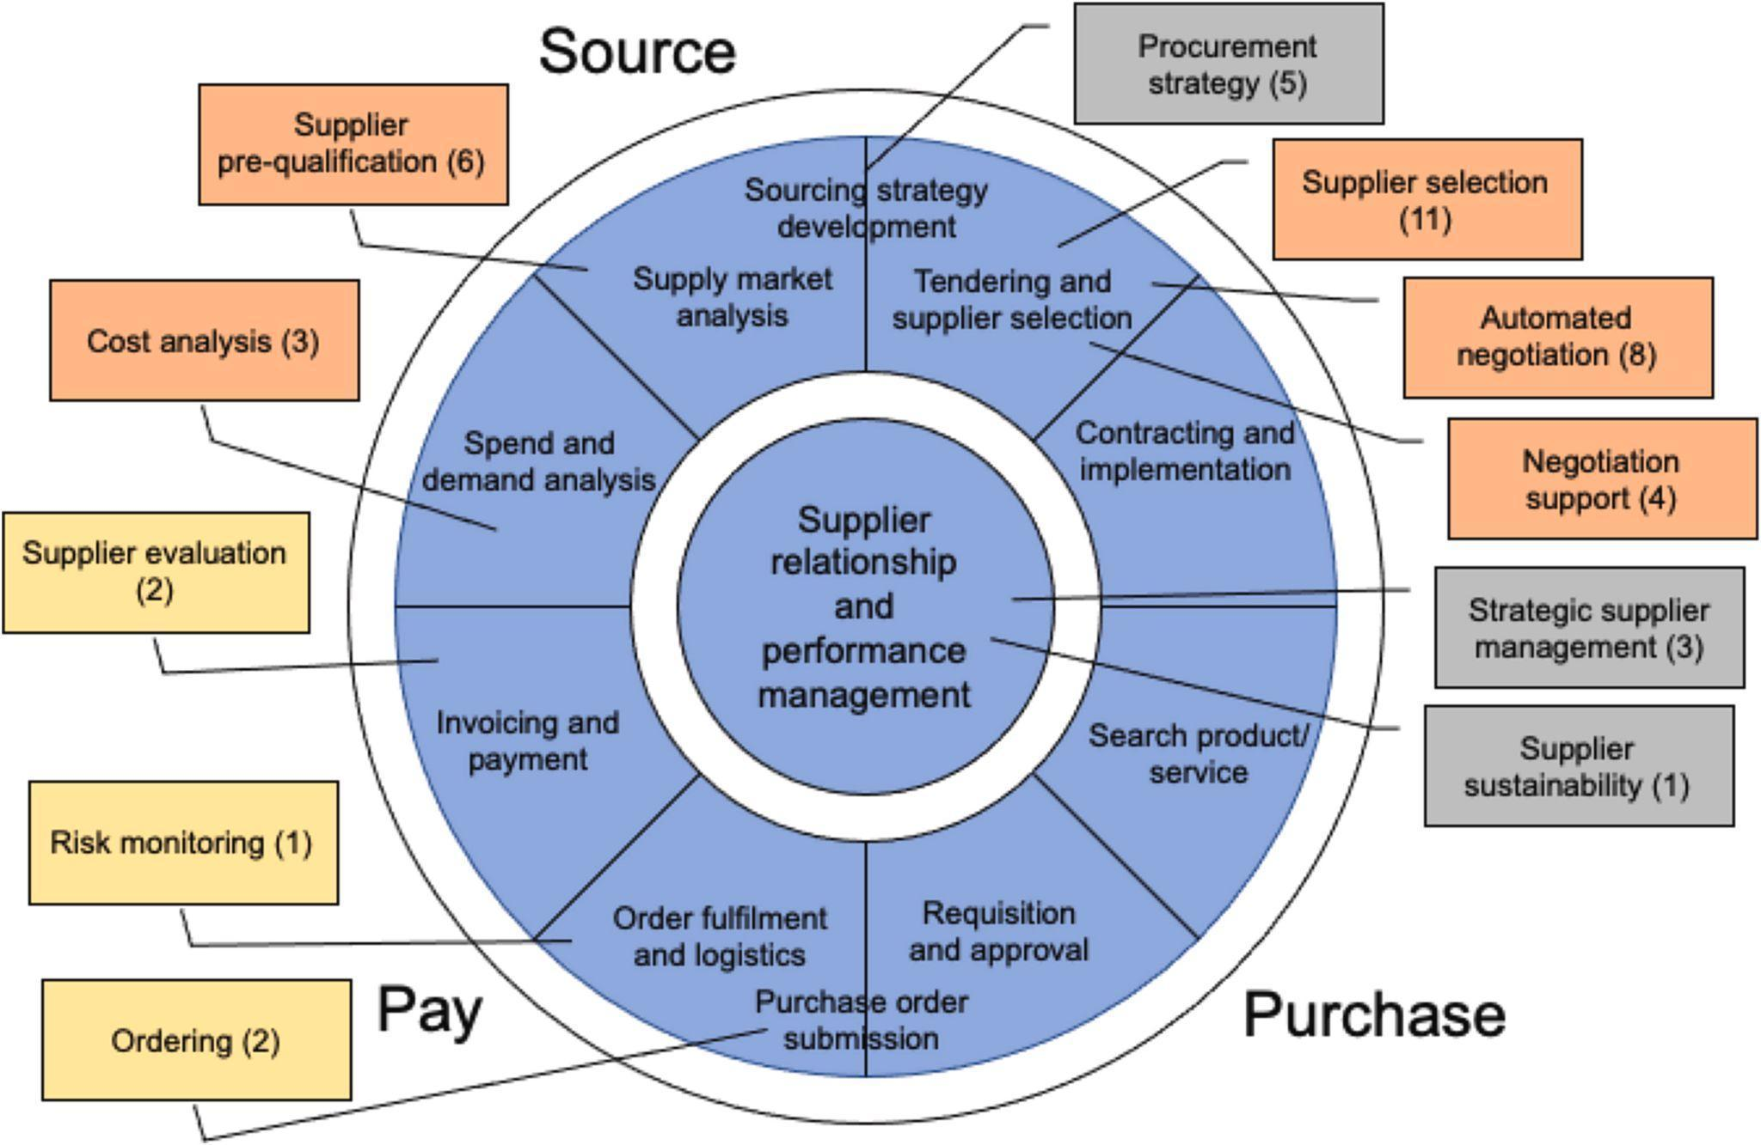

1. **Research Methodology**

This research utilised corporate cases from several industries, including banking, education, healthcare, online retail, and trading firms.(2) The data gathered was assessed in line with the study's objectives.

**Banking Industry Chatbots**

(3) AI is being used in customer support, such as HDFC Bank's OnChat and Eva, which handle millions of inquiries and transactions with high accuracy, enhancing customer interactions and efficiency. Developed in partnership with Niki.ai, this chatbot achieved a 160% month-over-month increase in transactions during its first year. By April 2018, HDFC Bank OnChat had engaged with over 300,000 users and handled transactions amounting to nearly Rs 2.5 crore. Another instance of AI in banking is HDFC Bank's virtual assistant, Eva, available on Google Assistant and Amazon Alexa. Eva boasts an accuracy rate exceeding 85% and has answered more than five million queries from around a million customers. Daily, Eva engages in over 20,000 conversations with clients globally.

**Online Retail Industry**

AI-driven platforms like Amazon utilise vast datasets to personalise shopping experiences, from product recommendations to automated customer support, making online shopping more efficient and personalised. These platforms provide online shoppers with personalised experiences through advanced reasoning and self-learning algorithms. Key features of AI-driven online shopping include instantaneous focus, visual search, voice-activated search, selection intelligence tools, and conversational commerce.

For businesses and marketers to remain competitive, it is crucial to understand how AI impacts consumers and how to interpret this data. A deeper knowledge of customer behaviour enables businesses to tailor their operations and marketing strategies to better meet consumer needs. Amazon, the largest online retailer in the USA, exemplifies successful AI integration in online retail. Amazon's extensive selection, rapid delivery, and competitive pricing are enhanced by a personalised shopping experience that includes location-specific pricing, destination-tailored messaging, and local currency payment options.

AI enhances the online shopping experience by enabling customer-centric search and a high level of personalization, leading to a more efficient sales process. New marketing strategies supported by AI technologies allow businesses to effectively reach target audiences and provide superior consumer experiences. Online retailers must understand consumer trust and perception regarding the use of AI in e-commerce, as well as how to use AI to improve shopping efficiency and frequency.

**Trading Industry**

(1) AI is crucial in trading, with technologies aiding brokers in safeguarding equities and tailoring marketplaces. Firms like Trading Technologies and Numerai use AI for stock trading and market prediction, revolutionising the industry.

**Logistics and Supply Chain Industry**

AI optimises logistics and supply chain management, (5)offering competitive advantages and cost reduction opportunities through predictive analytics, warehouse automation, and more efficient transportation planning.

1. **Analysis & Findings**

AI has significantly enhanced the online experience across various industries by:

Increasing customer satisfaction through quick response times and efficient issue resolution.

(14)Predicting future market trends and identifying existing trends based on customer preferences.

Personalising marketing campaigns and customer interactions, leading to higher engagement and loyalty.

Enhancing decision-making processes in e-commerce, banking, trading, and logistics by leveraging vast amounts of data.

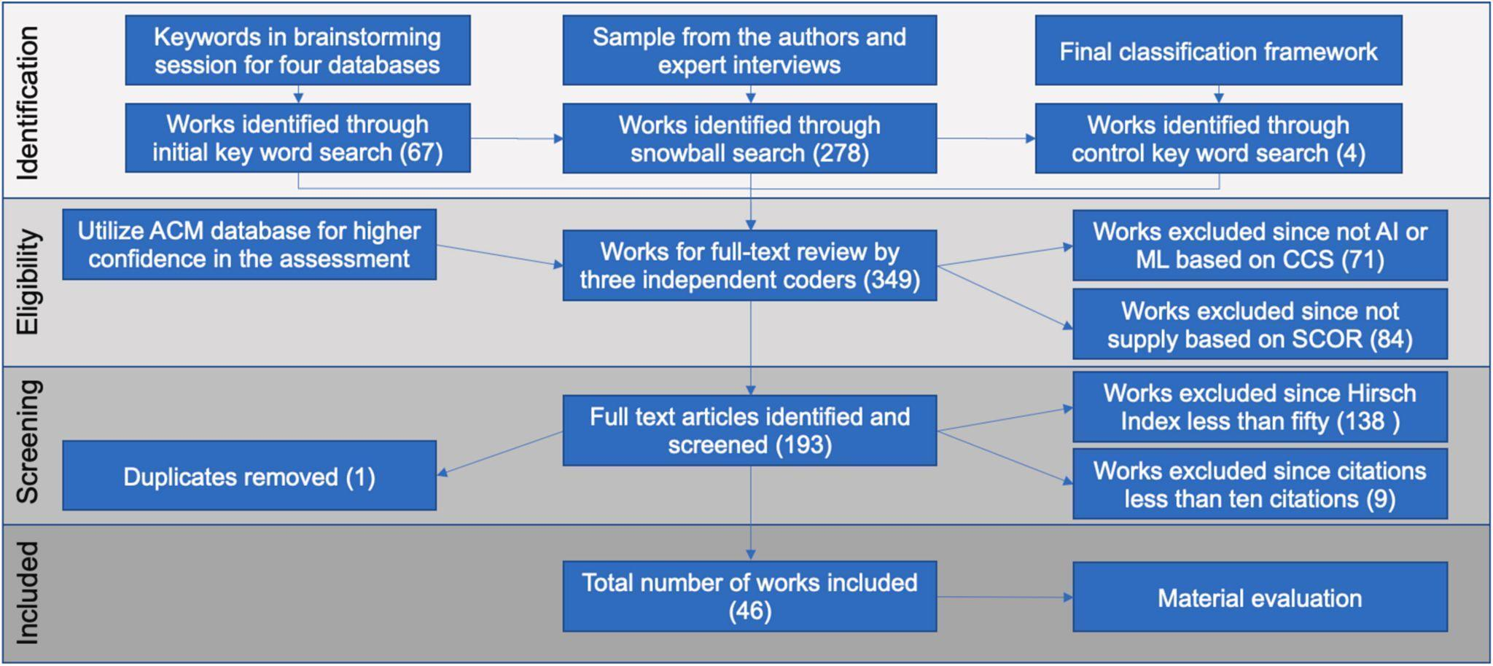

1. **References**
2. Powers, J. (2022). "How AI Trading Technology Is Making Stock Market Investors Smarter." Built In.
3. Suleman, A. (2018). "How A.I. Is Superseding Healthcare Customer Experience."
4. Singh, S. (2022). "AI in Banking – How Artificial Intelligence is Used in Banks."
5. Rathod, M. (2018). "How HDFC Bank is Banking Upon AI Across the Organization." Express Computer.
6. Davenport, T., Guha, A., Grewal, D., & Bressgott, T. (2019). "How Artificial Intelligence Will Change the Future of Marketing." SpringerLink.
7. Nancy, S. (2022). "How Artificial Intelligence Has Made Understanding Consumer Behaviour Easy in 2020."
8. Little, A. "The Impact of Artificial Intelligence on Consumer Behaviour: Topline Research Results."
9. Yoh BLOG. (2022). "Predicting Consumer Behaviour with AI."
10. Burns, E. (2022). "What is Artificial Intelligence (AI)?" TechTarget.
11. Rajdhar, P., & Brahme, M. (2020). "Artificial Intelligence Influence is Changing Consumer Buying Behaviour in Online Shopping." Neliti.
12. Singh, S. (2022). "Artificial Intelligence – Revamping User Experience in Mobile Banking Apps."
13. Niranjan, K., Surya Narayana K., & Narasimha Rao M.V.A.L. (2021). "Role of Artificial Intelligence in Logistics and Supply Chain." IEEE Conference Publication.
14. AndSoft Transportation & Logistics Software. (2022). "AI: This powerful technology offers to automate and simplify numerous processes."
15. Semeney, A. "How to Use Artificial Intelligence for Trading." DevTeam.Space.