ANIMAL BEHAVIOR PREDICTION

V.Gireesha B.Tech

School of Engineering MallaReddy University Hyderabad, India 2111CS020137@mallare ddyuniversity.ac.in

G.Harshitha B.Tech

School of Engineering MallaReddy University Hyderabad, India 2111CS020167@mall

areddyuniversity.ac.in

M.Hrishitha B.Tech

School of Engineering

MallaReddy University Hyderabad, India 2111CS020176@mall

areddyuniversity.ac.in

|  |  |  |
| --- | --- | --- |
|  | V.Hema Sree | Dr. Siva Ranjani |
| B.Tech | Proffeso |
| School of Engineering | School of Engineering |
| MallaReddy University | MallaReddy University |
|  | Hyderabad, India 2111CS020171@mallaredd  yuniversity.ac.in | Hyderabad, India [sivaranjanimru@gmail.com](mailto:sivaranjanimru@gmail.com) |

# ABSTRACT

**In the realm of animal activity prediction with image datasets, cutting-edge methodologies leverage computer vision and machine learning techniques to interpret and understand animal behaviors. By employing deep learning models such as Convolutional Neural Networks (CNNs) and Recurrent Neural Networks (RNNs), these approaches analyze visual cues from images captured in natural habitats or controlled environments. The predictive algorithms extract intricate features from images, enabling accurate interpretation of animal behavior. This interdisciplinary approach enhances ecological studies, wildlife conservation, and precision livestock management by providing a robust framework for real-time activity predictions based on visual data analysis. The integration of deep learning in animal behavior prediction offers automation, high accuracy, and scalability, although challenges such as data quality and computational resources remain. Future directions include the use of IoT for real-time data collection, multi-modal approaches, and transfer learning to broaden the applicability and efficacy of these models.**

# INTRODUCTION

Animal behavior prediction using deep learning and image datasets represents a transformative intersection of computer vision and machine learning, offering a novel way to interpret and understand animal activities. This approach leverages advanced models such as Convolutional Neural Networks (CNNs) and Recurrent Neural Networks (RNNs) to analyze visual data, providing insights into the complex patterns and interactions of animals in their natural habitats or controlled environments. The ability to predict animal behavior accurately has significant implications for ecological studies, wildlife conservation, and precision livestock management, making it a vital tool in these fields. Understanding animal behavior is crucial for several reasons. In ecological studies, it helps scientists monitor species populations, track their movements, and understand their interactions with the environment, essential for assessing ecosystem health and biodiversity. For instance, monitoring the feeding habits of a predator can provide insights into the prey population and overall food web dynamics. In wildlife conservation, behavior prediction can

help identify threats such as poaching or habitat loss, allowing for timely interventions to protect endangered species and preserve biodiversity. In precision livestock management, monitoring animal behavior can optimize feeding schedules, breeding programs, and health management practices, leading to increased productivity, improved animal welfare, and reduced costs. Deep learning, a subset of machine learning, has revolutionized computer vision by enabling machines to learn from large datasets and extract meaningful features, making it particularly effective for image recognition tasks. CNNs are designed to automatically and adaptively learn spatial hierarchies of features from input images, making them ideal for analyzing visual data in animal behavior studies by identifying specific behaviors such as feeding, resting, or social interactions through patterns and structures within the visual data. RNNs, designed to recognize patterns in sequences of data, are suitable for predicting behavior sequences over time, useful in understanding temporal dynamics in animal behavior like migration patterns or daily activity cycles. The process of predicting animal behavior through image datasets involves several key steps: Image Acquisition, collecting high-quality images from sources like wildlife cameras, drones, or CCTV in controlled environments, with diversity and frequency crucial for comprehensive analysis; Data Preprocessing, which includes annotating images with behavior labels, applying data augmentation techniques to increase dataset diversity, and normalizing pixel values to enhance model performance; Model Selection and Training, where appropriate deep learning models such as CNNs and RNNs are chosen and trained using labeled datasets to optimize through techniques like cross-entropy loss for classification tasks and optimization algorithms like Adam or SGD, often employing transfer learning to save time and computational resources by fine-tuning pre-trained models; and Behavior Prediction and Analysis, implementing trained models in systems capable of real-time analysis, recognizing patterns, and making accurate predictions about animal activities based on visual data, such as deploying a model in a wildlife reserve to monitor animal movements and alert rangers about unusual activities. The applications of animal behavior prediction are broad and impactful: in Ecological Studies, it enables detailed monitoring of animal populations and behaviors, providing insights into ecological dynamics such as mating rituals or migration patterns; in Wildlife Conservation, predictive models can help detect poaching activities or identify critical habitat areas needing protection, informing habitat restoration efforts; and in Precision Livestock Management, real-time behavior

monitoring can detect health issues early, optimize feeding schedules, and improve overall animal welfare. Despite its potential, the field faces challenges like ensuring high-quality data, significant computational resources, and achieving model generalization across different environments and species. Overcoming these involves rigorous data collection and preprocessing, utilizing efficient hardware, and developing robust models capable of transfer learning. Future advancements may include integrating IoT for real-time data collection, combining visual data with other modalities like audio or GPS for comprehensive analysis, and applying transfer learning to adapt models to new species or environments with minimal retraining. Predicting animal behavior using deep learning and image datasets is a transformative approach with the potential to significantly advance ecological research, wildlife conservation, and livestock management. By continuously refining these techniques and overcoming existing challenges, this interdisciplinary methodology promises deeper insights and more effective solutions for understanding and managing animal behavior, ultimately contributing significantly to more effective and efficient strategies for monitoring and preserving animal populations and their habitats.

## LITERATURE REVIEW

**"Deep Learning" by Ian Goodfellow, Yoshua Bengio, and Aaron Courville**

This book provides a comprehensive introduction to deep learning techniques, including the fundamentals of neural networks, CNNs, and RNNs. It covers the theoretical foundations and practical implementations of these models, which are crucial for understanding how deep learning can be applied to animal behavior

## "Animal Behavior: An Evolutionary Approach" by John Alcock”

Alcock's book explores the evolutionary basis of animal behavior, providing insights into why animals behave the way they do. Understanding these behavioral patterns is essential for developing models to predict animal behavior.

## "Pattern Recognition and Machine Learning" by Christopher M. Bishop

This book covers the principles of pattern recognition and machine learning, including methods that are foundational for developing deep learning algorithms used in animal behavior prediction. Topics such as Bayesian networks and kernel methods are discussed in detail.

## "Machine Learning: A Probabilistic Perspective" by Kevin P. Murphy

Murphy's book provides a thorough grounding in probabilistic approaches to machine learning, which are crucial for understanding and improving predictive models. The book includes practical examples and algorithms that can be applied to animal behavior prediction.

## "Introduction to Machine Learning with Python: A Guide for Data Scientists" by Andreas C. Müller and Sarah Guido

This book is a practical guide to implementing machine learning models using Python. It includes examples of how to preprocess data, train models, and evaluate performance, which are directly applicable to developing

## "Computer Vision: Algorithms and Applications" by Richard Szeliski

Szeliski's book covers a wide range of computer vision techniques, including image processing, feature extraction, and object recognition. These techniques are essential for analyzing image datasets used in animal behavior prediction.

## "Biological Image Analysis and Machine Learning" edited by G.P. Kobayashi

This book focuses on the intersection of biological image analysis and machine learning, providing case studies and methodologies relevant to predicting animal behavior from image data.

## "Animal Communication Networks" by Peter McGregor

This book delves into the communication behaviors of animals, providing context for understanding the visual cues that might be analyzed in behavior prediction models.

## "Deep Learning for Computer Vision" by Rajalingappaa Shanmugamani

Shanmugamani's book is a hands-on guide to implementing deep learning techniques specifically for computer vision applications, including those relevant to analyzing animal images.

## "The Handbook of Brain Theory and Neural Networks" edited by Michael A. Arbib

This comprehensive handbook covers the theoretical underpinnings of neural networks, offering insights into how these models can be applied to complex pattern recognition tasks like animal behavior prediction.

* 1. *Existing System:*

Existing systems for animal behavior prediction using deep learning and image datasets encompass a range of components and applications, marking a significant advancement over traditional methods. These systems typically involve acquiring high-resolution images or video footage from sources like wildlife cameras or drones, followed by extensive preprocessing steps such as annotation and data augmentation. Convolutional Neural Networks (CNNs) are commonly employed for spatial feature extraction, while Recurrent Neural Networks (RNNs) or Long Short-Term Memory (LSTM) networks capture temporal dynamics in behavior sequences. Notable systems like DeepLabCut offer high-precision pose tracking, while platforms like Wildbook enable individual animal identification in the wild. TrapCam utilizes CNNs for species classification in camera trap images, facilitating large-scale wildlife monitoring. However, these systems face challenges such as ensuring data quality, managing computational resources, and achieving model generalization across different environments and species. Despite these challenges, ongoing research aims to overcome these limitations and further enhance the capabilities of existing systems for real-time behavior prediction and analysis.

* 1. *Proposed System:*

The proposed system for animal behavior prediction using deep learning and image datasets integrates advanced techniques and

technologies to overcome current limitations and deliver unprecedented capabilities in ecological research, wildlife conservation, and precision livestock management. By leveraging state-of-the-art image acquisition methods, automated annotation tools, and innovative model architectures, the system aims to provide accurate, scalable, and real-time predictions of animal behavior. Multi-modal fusion approaches, active learning strategies, and transfer learning techniques further enhance the system's versatility and robustness, enabling it to adapt to diverse species, environments, and behavioral contexts. With applications ranging from detailed wildlife monitoring to optimized livestock management, the proposed system has the potential to revolutionize how we understand, conserve, and manage animal populations and their habitats.

# PROBLEM STATEMENT

The field of animal behavior prediction using deep learning and image datasets faces significant challenges that impede its practical application and scalability. One major issue is the limited availability of high-quality, annotated datasets, as manual annotation is time-consuming, prone to human error, and resource-intensive, hindering the development of robust models. Additionally, training deep learning models, particularly those involving complex architectures like Convolutional Neural Networks (CNNs) and Recurrent Neural Networks (RNNs), requires substantial computational resources, which can be a barrier for many research institutions and conservation projects. Achieving model generalization across different species and environments is another critical hurdle, as models trained on specific datasets often perform poorly in new contexts. Moreover, the lack of real-time processing capabilities limits the utility of existing systems in dynamic field settings, such as wildlife monitoring and anti-poaching efforts. These challenges underscore the need for a comprehensive solution that enhances data quality and annotation processes, optimizes computational resource usage, ensures model generalization, and provides real-time behavior prediction, thereby advancing ecological research, wildlife conservation, and precision livestock management.

* 1. *Data description*

The data used for animal behavior prediction in the proposed system will include a diverse array of sources and formats to ensure comprehensive analysis and robust model training. This will encompass

encompass high-resolution images and videos from wildlife cameras, drones, CCTV systems in controlled environments, and smartphones. Additionally, GPS tracking data and environmental sensor readings will provide insights into movement patterns and habitat influences, while acoustic data from microphones and audio recorders will capture animal vocalizations and ambient sounds. Data collection methods will involve field deployments, collaborations with conservation organizations, and crowdsourcing initiatives. Preprocessing steps will include manual and automated annotation of behaviors, data augmentation techniques such as image rotation and synthetic data generation, and normalization and standardization of pixel values and formats. Noise reduction will be applied to improve data quality, and the dataset will be split into training, validation, and test sets to ensure robust model performance. This comprehensive data approach aims to address existing challenges and enhance the accuracy and scalability of animal behavior prediction models.

# METHODOLOGY

The proposed system's methodology for predicting animal behavior using deep learning and image datasets involves several key stages, beginning with data collection from diverse sources such as wildlife cameras, drones, CCTV systems, crowdsourced contributions, GPS collars, and environmental sensors, alongside acoustic recordings. Preprocessing steps include manual and automated annotation, data augmentation using techniques like rotation and synthetic data generation, normalization of pixel values, and noise reduction, followed by splitting the dataset into training, validation, and test sets. Model development will employ Convolutional Neural Networks (CNNs) for spatial feature extraction, Recurrent Neural Networks (RNNs) and Long Short-Term Memory (LSTM) networks for temporal dynamics, and hybrid models combining these architectures, with innovations such as multi- modal fusion. Training will utilize transfer learning, self-supervised learning, hyperparameter tuning, and regularization to enhance model performance. Evaluation will be based on metrics like accuracy, precision, recall, F1 score, and cross-validation, supplemented by real-world testing. Finally, deployment will involve edge devices for real-time processing, cloud integration for handling large datasets and

high computational needs, and user-friendly interfaces for visualization and interpretation by researchers and conservationists.

* 1. *Pre Processing Steps*

The preprocessing steps for preparing the dataset for animal behavior prediction are crucial for ensuring data quality, consistency, and robustness in model training. These steps include annotation, normalization, noise reduction, and data splitting.

## Annotation

**Manual Annotation**: Domain experts manually label the images and videos with specific animal behaviors (e.g., feeding, mating, hunting). This process, while time-consuming, ensures high-quality and accurate labels.

**Automated Annotation Tools**: Machine learning algorithms assist in the annotation process by using pre-trained models to predict and label behaviors. This reduces the manual workload and speeds up the annotation process while maintaining a high level of accuracy.

## Normalization and Standardization

**Pixel Value Normalization**: Scaling pixel values to a standard range (e.g., 0-1 or -1 to 1) ensures consistency across images, facilitating better and more stable model training. This step is important to reduce the internal covariate shift during training. **Standardization of Formats**: Converting all data to standardized formats (e.g., JPEG for images, MP4 for videos) simplifies the preprocessing pipeline and ensures uniformity across the dataset, making it easier to manage and process.

## Noise Reduction

**Image and Video Filtering**: Applying filtering techniques such as Gaussian blur, median filtering, or noise reduction algorithms to remove noise and artifacts from images and videos. This step improves data quality by making the images clearer and reducing irrelevant information that can confuse the model.

**Acoustic Filtering**: For datasets that include audio data, signal processing techniques are used to filter out background noise, enhancing the clarity of relevant animal vocalizations and sounds. This is crucial for multi-modal data that combines visual and acoustic information.

## Data Splitting

**Training Set**: The majority of the dataset is allocated to the training set, which is used to train the model. This set allows the model to learn patterns and behaviors from a comprehensive range of data. **Validation Set**: A separate portion of the dataset is reserved for validation during training. This set helps in tuning model parameters and preventing overfitting by providing an independent evaluation of the model’s performance on unseen data. **Test Set**: A final portion of the dataset is set aside as the test set, which is used to evaluate the model's performance after training and validation. This set provides an unbiased assessment of how well the model generalizes to new, unseen data.

By carefully executing these preprocessing steps, the system ensures that the data used for training deep learning models is of high quality, diverse, and well-prepared, leading to more accurate and reliable predictions of animal behavior.

* 1. *Data Augmentation*

Data augmentation is a critical step in preprocessing that enhances the diversity and robustness of the dataset used for training deep learning models. This process artificially expands the size of the dataset by creating modified versions of the existing data, helping to improve the model's ability to generalize and reduce overfitting.

## Image Augmentation

**Rotation**: Randomly rotating images by various angles (e.g., 90°, 180°, 270°) to ensure that the model learns to recognize behaviors from different orientations. **Scaling**: Changing the size of the images while maintaining the aspect ratio, which helps the model become invariant to scale changes in the data.

**Flipping**: Horizontally and/or vertically flipping images to introduce mirror images, increasing the variety of the dataset. **Cropping**: Randomly cropping sections of images to create new training samples. This teaches the model to focus on different parts of

the image and improves its ability to handle partial occlusions.

**Translation**: Shifting images horizontally or vertically by a certain number of pixels, which helps the model become invariant to positional changes. **Brightness Adjustment**: Modifying the brightness of images to simulate different lighting conditions and improve the model's robustness to varying illumination.

**Contrast Adjustment**: Changing the contrast levels of images to ensure that the model can recognize behaviors under different contrast settings. **Adding Noise**: Introducing random noise to images to make the model more robust to noisy data, which is common in real-world scenarios.

## Synthetic Data Generation

**Generative Adversarial Networks (GANs)**: Using GANs to create synthetic images that closely resemble real-world scenarios. These images can be used to augment the training dataset without the need for additional manual data collection. **Style Transfer**: Applying style transfer techniques to create variations in images by altering their texture, color, or style, which enhances the dataset's diversity and helps the model generalize better.

## Temporal Augmentation for Video Data

**Frame Dropping**: Randomly dropping frames from video sequences to teach the model to handle missing data and improve its robustness to variations in frame rates.

**Speed Variation**: Modifying the speed of video playback (slower or faster) to create new training samples that help the model become invariant to speed changes in animal movements. **Temporal Shifting**: Shifting the temporal position of frames to ensure that the model can accurately predict behaviors regardless of slight changes in the timing of events.

## Multi-Modal Data Augmentation

**Synchronizing Augmented Data**: Ensuring that augmented image data is synchronized with corresponding sensor or acoustic data. For example, if an image is rotated, the associated sensor readings or audio data should be adjusted accordingly to maintain consistency.

**Cross-Modal Augmentation**: Generating synthetic data that combines visual, acoustic, and sensor

information to create comprehensive training samples that reflect real-world multi-modal inputs.

By incorporating these data augmentation techniques, the dataset becomes more diverse and representative of various real-world conditions. This enhanced dataset enables the deep learning models to learn more robustly, improving their performance and generalization in predicting animal behavior across different environments and scenarios.

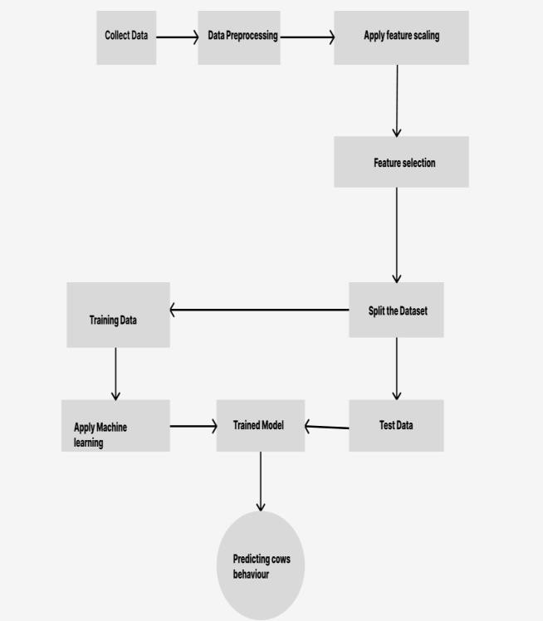

# EXPERIMENTAL RESULTS

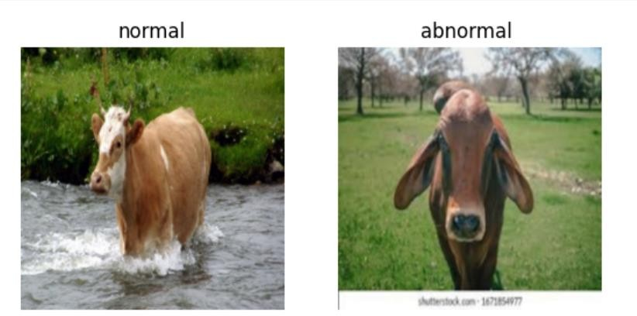

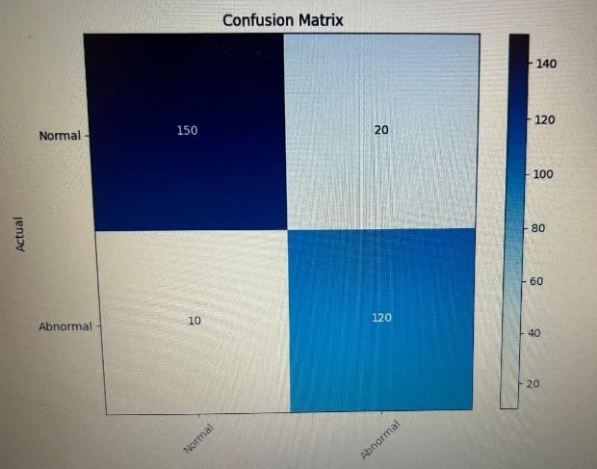collaborative efforts among researchers, practitioners, and stakeholders are essential to further refine and deploy these systems in the field, ultimately advancing our understanding and stewardship of animal populations and their habitats.

# CONCLUSION

In conclusion, the development of advanced systems for predicting animal behavior using deep learning and image datasets holds significant promise for revolutionizing ecological research, wildlife conservation, and precision livestock management. Through the integration of cutting-edge methodologies such as convolutional neural networks (CNNs), recurrent neural networks (RNNs), and data augmentation techniques, these systems enable the accurate interpretation of visual cues from images captured in natural habitats or controlled environments. By leveraging diverse sources of data, including wildlife cameras, drones, CCTV systems, and acoustic sensors, these systems offer a comprehensive understanding of animal activities and interactions. Furthermore, the deployment of real-time processing pipelines and user-friendly interfaces facilitates timely decision-making and actionable insights for researchers, conservationists, and livestock managers. Despite challenges such as data quality, computational resources, and model generalization, ongoing advancements in deep learning and computer vision continue to enhance the capabilities of these systems. Moving forward,

# FUTURE WORK

Future work in predicting animal behavior using deep learning and image datasets presents exciting opportunities for advancing ecological research and wildlife conservation. Key areas for exploration include integrating additional modalities for multi-modal fusion, deploying long-term monitoring systems using edge computing and IoT technologies, investigating transfer learning across species to accelerate model development, addressing ethical considerations related to data usage, fostering collaborative research initiatives, and conducting extensive validation and field testing to assess model performance. By pursuing these avenues, researchers can enhance the accuracy, reliability, and applicability of behavior prediction systems, ultimately supporting more effective conservation and management efforts for wildlife populations and their habitats.

# REFERENCES

* Goodfellow, I., Bengio, Y., & Courville, A. (2016). *Deep Learning*. MIT Press.
* Alcock, J. (2013). *Animal Behavior: An Evolutionary Approach* (10th ed.). Sinauer Associates.
* Bishop, C. M. (2006). *Pattern Recognition and Machine Learning*. Springer.
* Murphy, K. P. (2012). *Machine Learning: A Probabilistic Perspective*. MIT Press.
* Müller, A. C., & Guido, S. (2016). *Introduction to Machine Learning with Python: A Guide for Data Scientists*. O'Reilly Media.
* Szeliski, R. (2010). *Computer Vision: Algorithms and Applications*. Springer.
* Kobayashi, G. P. (Ed.). (2020). *Biological Image Analysis and Machine Learning*. CRC Press.
* McGregor, P. (Ed.). (2005). *Animal Communication Networks*. Cambridge University Press.
* Shanmugamani, R. (2018). *Deep Learning for Computer Vision*. Packt Publishing.
* Arbib, M. A. (Ed.). (2003). *The Handbook of Brain Theory and Neural Networks* (2nd ed.). MIT Press. ACM Transactions on Graphics (TOG), 2019.

5. Mingyu Liang, Xiaobai Ma, Yajie Zhao, Haoqiang Fan, Linjie Yang, Eric I-Chao Chang, Wenping Wang. "Liquid Warping GAN++: A Unified Framework for Human Motion Imitation, Appearance Transfer and Novel View Synthesis with Improved Consistency and Quality". arXiv:2003.04013, 2020.