ONLINE TIFFIN SERVICE

Surabhi Choubey

Student of Department Electrical &Electronics ,GGITS MP HOD - Professor Ruchi Pandey

Directed by - Professor Amit Gupta, Professor Ashok Soni

# ABSTRACT

This project provides a Webpage application through which people can order Dabba service online using the internet. Presently, ready-made food is available but homemade food and is taste have another matter. In our busy schedule fresh and homemade food preparation is difficult in early mornings. But it is made possible by our web application to add homemade food and deliver the same before our lunch time. This web application allows people to directly order a Dabba for online For 24hr. This application is built to be beneficial to customer as well as Homemade food maker. Our Project connect the tiffin services provider with customer to provide the quality food. This system is totally secure and safe after every user is provided with a user id and password so there is no chance of any unauthorized access. Ordering food is a entertaining. In today's world everyone loves to order meals from restaurants. However, during covid-pandamic, a lot of people had to order food compulsively from these restaurants. A typical family in India believes that ordering food from a restaurant can be harmful to health and bad for nutrition. Various items are available to the customer and they can select the desire item for lunch and dinner at a reasonable price. The customer can choice so we have generated a system that will provide meals to the customer like lunch and dinner. The purpose of this product is to create a platform for users to facilitate food search and booking experience.. This will result in a working application that will speed up the ordering process.

**Keywords:** Web Page Application, Secure And Safe System Application, Unauthorized Access, Ordering Process, Python, Django, Sqlite.

# INTRODUCTION

Online Tiffin system focus on providing food to the customers. Online food ordering is the process of ordering food through a web page from a local restaurant or food cooperative. Just as consumer goods are ordered online, many of these allow customers to have accounts with them to make it easier to order frequently. The customer will search for the favorite restaurant, usually filtered by type of recipe and select from the available items and select delivery or pick-up. The restaurant can pay the online food company by returning the percentage, wallet or cash. But the aspect that consumers are worried about Is Time. This application will enable customers to actively track Tiffin. This application is mainly for ordering home cooked food from available franchises. Customers of all tiffin services should contact their respective tiffin-sellers on a daily basis and inform them how much tiffin or how much food they need. Also tiffin-sellers find it very difficult to manage orders (Without worries of regular customer). Sometimes in case of special requests from the customers, the vendors may forget or get off-track while keeping those requests in mind. Customers are eager to know where the seller is now and what his status is. In this way, our system seeks to eliminate the hassle of providing hassle-free service to both customers and tiffin-sellers.

This project provides a Web page application through which people can order Dabba service online using the internet. In our busy schedule fresh and homemade food preparation is difficult in early mornings. But it is made possible by our web application to add homemade food and deliver the same before our lunch time. This web application allows people to directly order a dabba for their afternoon lunch online. This application is designed to be beneficial for consumers as well as home food makers. Online tiffin services uses HTML, CSSS as a front-end and Django, sql as the back-end. The online food menu is set by the proposed food ordering system and customers can easily place the order as per their wish. Also, customers can easily track their orders with

food mthe enu. Management improves food delivery services and protects customer databases. The motivation

for developing the system is from the restaurant management system. Users of the system provide various facilities to get the service efficiently. The tiffin service system for customers includes restaurants as well as mess facilities. Mess users are usually individuals who relocate to new cities / areas and this can be considered an inspiration for the Tiffin service system. Another motivation is considered as the increasing use of smart phones/ mobile by the customers, so that any users of this system use all facilities of the system. The system will be designed to avoid users doing fatal errors where users can change their own profile also where users can track their food items. through GPS and where users can provide feedback and recommendations to Restaurants / Mess service providers. The system is needed due to the lack of a complete application that can meet the needs of the customers by providing food to the customers through restaurant/mess services. For the students who studying in different cities, our system will be very helpful for these Students. Our system provides customers / users the flexibility to order from restaurants or messes. Recommendations are also given to customers by restaurant / mess owners which are updated daily. There will be no limit on how much the customer wants to order by ordering food from our system.

The main approach behind developing this project is the people of our country who are Depending on the mess The services are from different states and they have different food options. They need their special tiffin Destinations that need to be updated in real time if traveling to other parts of the city for a few days. Each customer has their own time at which he / she prefers to deliver the tiffin. In the case of paper-based The system, due to incorrect entry, is likely to exchange customer tiffins, and there it is. Loss of information due to loss / theft of pen-paper based data. To overcome all such problems The project has surveyed a number of confusions, identified problem areas as well as requirements and has System model developed.

# LITERATURE REVIEW

In [1] proposes an automated food ordering system Which will smartly track user orders. Basically, that Implemented food ordering system for different types Restaurant where the user will place an order or make a custom Food with just one click. By means of android application for Tablet PCs this system was implemented. The front end was Developed using JAVA, Android and backend MySQL Database was used.

In [2] the smartphone/mobile user is considered the basic assumption for the system. When a customer arrives at the restaurant, the saved order can be confirmed by touching the smartphone. A list of selected pre-ordered items will be displayed on the kitchen screen and once confirmed, an order slip will be printed for further order processing. The solution provides customers with an easy and convenient way to choose a pre-order transaction form.

In [3] attempts were made to design and implement digital dining in restaurants using Android technology. This system was a basic dynamic database utility system that retrieves all information from a centralized database. This application improved the accuracy and efficiency of restaurants as well as human errors. Previous errors in the automated food ordering system were eliminated One-time investment is required for systems and gadgets.

In [4] introducing the application of hotel management system integration through web service technology. Ordering System Kitchen Order Ticket (KOT), Billing System, Customer Relationship Management System (CRM) are organized jointly by Digital Hotel Management. Let's add and expand the solution to allow hotel software systems of any size in the hotel chain environment.

In [5] the purpose of the research work is to design and develop a wireless food ordering system in restaurants. The technical operations of Wireless Ordering System (WOS) including system architecture, functions, limitations and recommendations were presented in this system. By providing high quality customer service and minimizing human error to improve the management aspect for restaurants, the wide application of handheld devices such as PDAs will make it a valuable tool.

In [6] wireless food ordering system designed and implemented for restaurant with customer feedback. It enables restaurant owners to setup the system in wireless environment and update menu presentations easily. Smart phones have been integrated into customizable wireless food ordering systems with real-time customer feedback implementation to facilitate real-time communication between restaurant owners and customers.

In Paper [7], the purpose of this study was to examine the factors that affect the attitude of Internet users towards ordering food online in Turkey among university students. The Technology Acceptance Model (TAM) developed by Davis in 1986 was used to study the adoption of the web The environment for ordering food. Trust, Innovativeness and External Influences are added to the model as main factors along with TAM.

In Paper [8], the aim of the research work is to automate the process of ordering food in restaurants and to improve the dining experience of the customers. This paper discusses the design implementation of food ordering systems for restaurants. This system implements wireless data access to servers. The Android application on the user's mobile will have all the details of the menu. Kitchen and Cashier receive the order details wirelessly from the customer's mobile. the order details are updated in the central database. Restaurant owners can easily manage menu changes.

In Paper [9], this research focuses on the efforts made by restaurant owners to adopt information and communication technologies such as PDAs, wireless LANs, expensive multi-touch screens, etc. to enhance dining experience. This paper highlights some of the limitations of traditional paper-based and PDA-based food ordering systems and proposes a low-cost touch screen-based restaurant management system. Using an Android smartphone or tablet as a solution.

# PROPOSED SYSTEM

To overcome the regulations of above System, based totally on Internet an Online Tiffin Ordering System is proposed. Nowadays everyone has a busy schedule whether it is urban or rural. But specially when it comes into the urban areas and big cities, people there are so busy with their lives that they don't have enough time to prepare their meals. Nowadays women are no less than men in the field. in metropolitan citie's even other halves are working women, consequently usually the small families control to have their meals ordered from someplace, as they lack of time. It’s not the easiest, if you interact with the kids inside the modern technology, they like the best restaurant food or something outdoors. the tiffin ordering system these days has one of the fastest-growing markets, though being a new idea. In this project, We have developed some things like doing research and serving the country is more feasible. Nowadays, humans are extra everyday to dine-in at the restaurant for their food.

The online tiffin ordering machine caters to customers who are not special however regular humans inside the community. It overcomes the flaws of manual hotel or mess system and old style queue system. This system enhances the home-made foods for people. Therefore, this system enhances the speed of getting food in a person's tray and the quality and method of taking orders from the customer. It offers a very good communication platform. User info are stored the usage of electronic media. The online food ordering system provides an online menu and customers can place orders easily by simply clicking a mouse or touching a button on their smartphone. Also, with the online tiffin ordering system, people can easily track their orders and the administrator can maintain the customer's database and move on to the food delivery system. This tiffin ordering tool permits the user to pick out the preferred meals from the listing of menu objects to be had through the nearby motel or restaurant. Individuals can order their desired meal from the list. Customer make payment either online or cash-on-delivery in our system. User details are kept confidential because it maintains a separate account for each user. id and password are provided to every user.. And a number of server-side encryption techniques have also been used to protect card details. Therefore, it provides a more secure and secure ordering system.

# PROBLEM STATEMENT

Online food service is a growing industry in today's world. There are some bugs in the current system that work for this, such as Zomato, swiggy, which will be fixed by our proposed system. The current system does not have any facilities for home food services like mess and tiffin service. The proposed system will serve as a platform for such vendors and customers. The system will also keep analyzes using customer reviews and ratings so that the seller can view their sales and plan accordingly. Our proposed system will motivate consumers to find better and healthier food and also give sellers the publicity they need.

Nowadays, many restaurants use traditional restaurant ordering systems to serve customers. In the traditional restaurant ordering system, the restaurant staff write down the foods that the customer order. The paper will

then pass to the kitchen and the chef will start to cook. This has caused few inconveniences. the restaurant staff may make some mistakes when writing orders. Sometimes, when restaurant staff write in a hurry, handwriting is difficult to understand. restaurant staff may lose order paper and customers may also receive incorrect bills. This is a problem facing restaurants that use traditional ordering systems Consumers do not know when to make a meal. Some customers may have Next schedule after their lunch or dinner. They need to know the preparation of the time so that they They can cleverly schedule. Especially when there are plenty of customers, customers probably If their food hasn't been delivered in a long time, their order seems to have been forgotten. Will be It is better to have approximate time to prepare the food shown to the customer.

# SYSTEM ARCHITECTURE

The system implementation contains 3 main users: - Customer, Proprietor of Mess/Restaurant, and Worker of mess. When a person moved to new city he must find source for clean and superior food, so he/she will explore and select restaurant or mess, or tiffin service based on his category.

Figure 1. represents the simple system architecture Proposed system: -

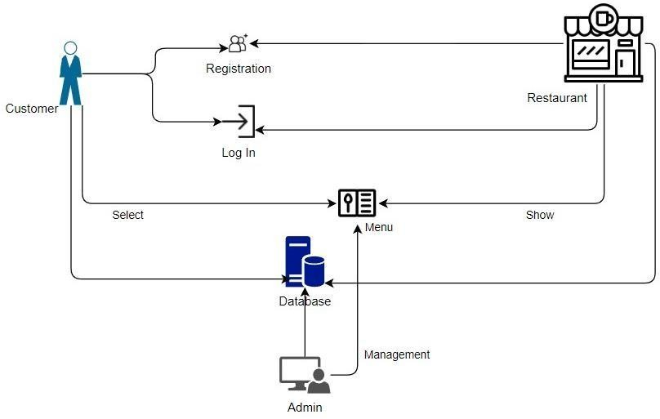

**Figure 1:** System Architecture

# SYSTEM DESIGN

Using the Staruml, we construct the application design workflow for restaurant, customer, the user experience design. use case diagram, class diagram, sequence diagram, activity diagram, class diagram, object diagram, dataflow diagram and database structure design are comprised in the Unified Modeling Language.

* **StarUML:** Designing the user interface is done by StarUML design which includes each interface description. staruml is a State-of-the-art software modeler aimed to support agile and concise modeling
* **Database structure design**: According to the results of the class diagram, the structure of the database is created. The training that want to be stored inside the database and its relationships are eliminated with the aid of this layout
* **Data Flow Diagrams:** A data flow diagram (DFD) is used to show a graphical representation of the flow of data through an information system, modelling its process aspects. A DFD is also used as a preliminary step to create an overview of the system, which can later be elaborated.

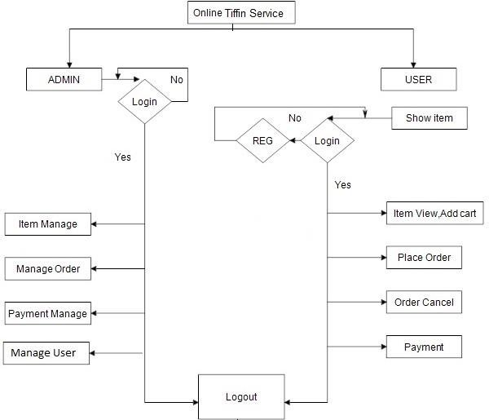

**Figure 2:** Data Flow Diagram.

* **UML Diagram:** Use case diagram is used for describe the function requirements of the system by using the use cases and the actors. In the Figure user and database are the actors into the system. Use cases involved into the system.

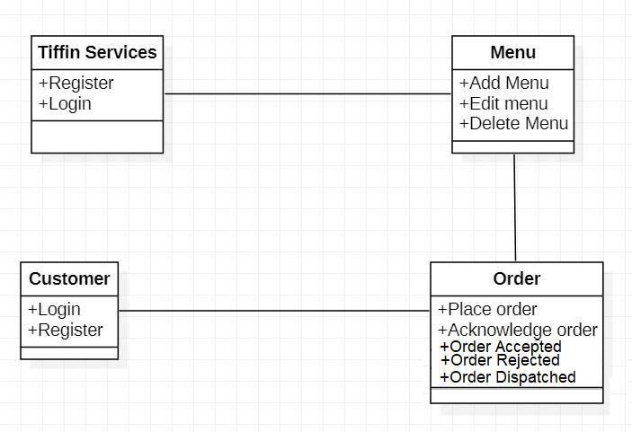

**Figure 3:** UML Diagram.

* **Activity diagram:** The basic purposes of activity diagram are similar to other four diagrams. It capture the dynamic conduct of the system. The other figures are used to represent the message flow from one object to another, but the activity diagram is used to represent the message flow from one activity to another.

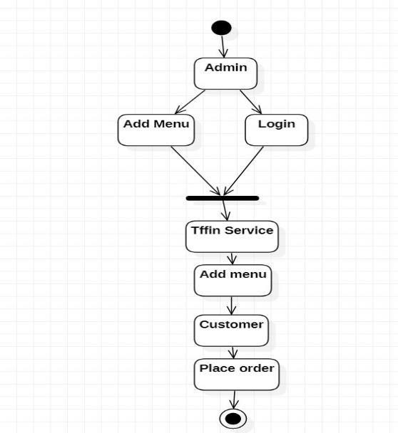

**Figure 4:** Activity Diagram.

# SYSTEM IMPLEMENTATION

The implementation of the system will be started after the end of the system design. The structure of the database will firstly build during development phase. Then, the server side and client side also built to allow the communication between customers and restaurant staff During the testing phase. The application is implemented in python, Django, HTML and the database used is sqllite database. We have developed a secure web application using HTML. We have developed a web-based application and based on it. The hardware required for our application includes Android Smart phone and a desktop or laptop with browser and internet connection. For the initial implementation of the system we have considered 2 restaurants/mess from 4 areas nearby in our database. The implementation of our system includes a real time feedback system where once you place an order, customers will be emailed about their order feedback.

# RESULTS

The result of our system application a Web-based application. Once a customer place an order for a restaurant / mess, he/she will get the order Id on the screen dynamically. The customer can check the status of the order through the Order Status interface provided in the GUI of the application. and customer can also get the order status on customer email id which is provided by customer. We have developed the system application in such a way that the customer can order the tiffin first and then enter the required credentials while checkout. our system also help to customer for track their order and status of customers order is sent to the customers email id.

**Home Page:**

# PROJECT SCREENSHORTS

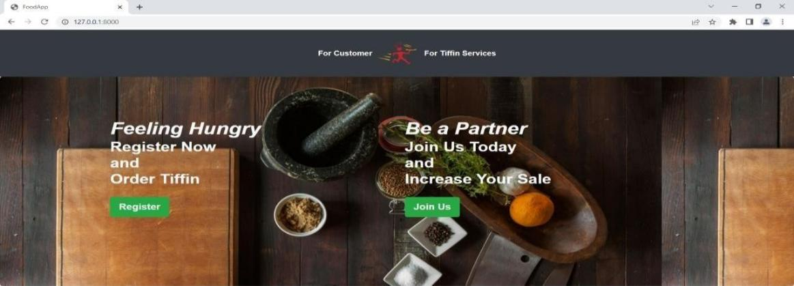

**Image-1:** Main Page

## Tiffin Service Provider:

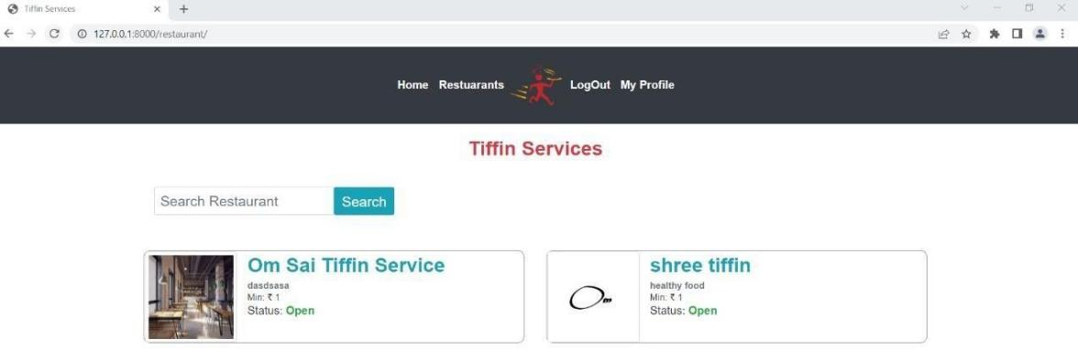

**Image-2:** Tiffin Services Provides.

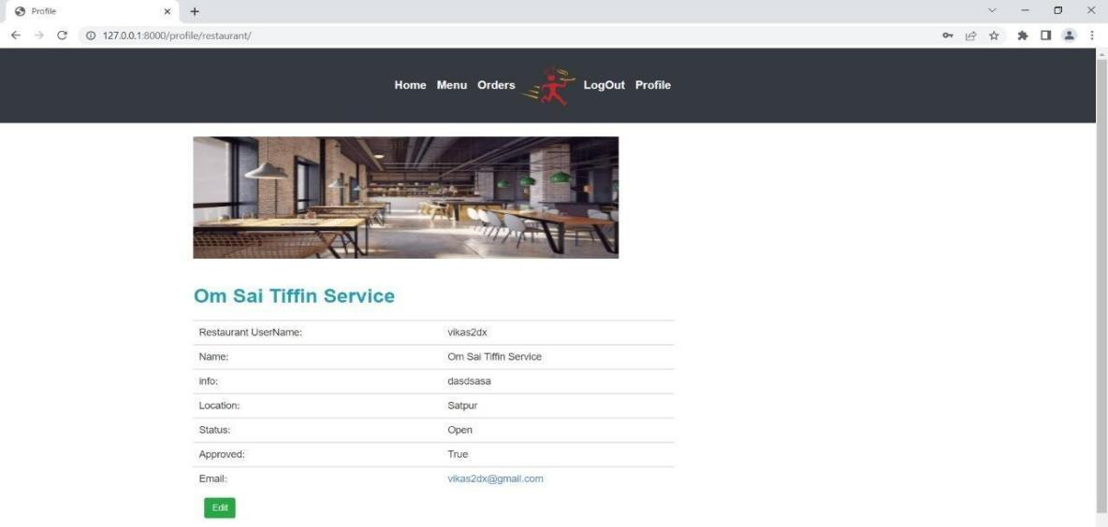

**Image-3:** Tiffin Service Provider Profile.

## Tiffin Service Menu:

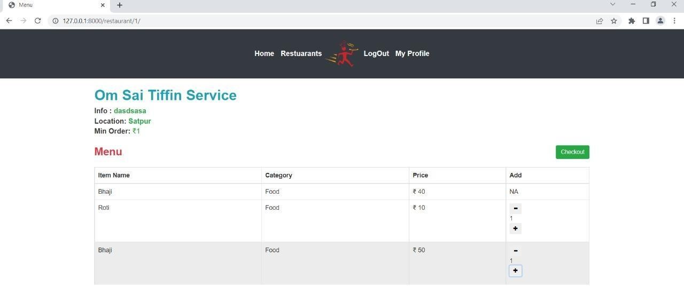

**Image-4:** Tiffin Service Menu

# CONCLUSION

With the help of online tiffin service we can easily connect customers with restaurant and mess services. And customer can easily order their tiffin just by following a few steps and easily tracking their order. The application is user based and user focused. All issues related to the all user which are included in this system are developed by this system. This system will solve various problems related to mess / tiffin service. An online

food ordering system is implemented to help people solve important problems. Based on the application it can be concluded: Orders are easily made through this system; The information required to create customers is provided by the system. Receiving orders and changing their data is possible through the application and it helps the administration to control all tiffin system.

In this project we have implemented a role-based mess tiffin management system which efficiently manages the entire functionality of restaurant/mess ownerand customer. The owner can manage customer records and preferences easily whereas the customer can register and enjoy tiffin service based on personal preferences. It also handles mess bill payments according to the tiffin the customer eats. Food waste is minimized as the customer orders only the food that he / she prefers to order from the range of available menu items. The mess owner can prepare less food in case the customer decides to skip make food for a particular day. This will help to reduce food wastage and save the owner‟s money. Delivery of tiffins can be done properly at the given address.