A Study On Effectiveness Of Training And Development

Sheri Vigneshwar Reddy
Roll No: 212122672127, Department of Management Studies
Aristotle PG College,Chilkur, Moinabad, Ranga Reddy District, Telangana.

Ms. G. Swetha
Assistant Professor
Aristotle PG College, Chilkur, Moinabad, Ranga Reddy District, Telangana.
swetha.golla1@gmail.com

Abstract:
Training and development plays a completely critical role in each organization. it's an fundamental characteristic of human resource development. it's thought to be means of accomplishing the very best level of efficiency from the personnel through imparting them necessary abilities wished for the activity
Training often is taken into account for brand spanking new employees only. this is often an error because ongoing training for existing employees helps them in adjusting to rapidly changing job requirements. The difference between the training methods lies mainly in terms of the non-public involvement or participation of trainees within the process of learning. the necessity for training and development
Training and development arises right from the initial stages of recruitment. The organization recruits new talents to figure in their organization. they're to be trained properly so they will get a practical experience of their work. the necessity for development arises when the already trained employees are required to shine their skills so they'll be made suitable to serve the organization in a very multi-dimension way.
Keywords: Training and development training methods, employee skills.

INTRODUCTION:
DEFINITION :
"Training is the act of developing the skills of a worker for doing a specific venture”
Edwin Flippo
TRAINING AND DEVELOPMENT
Employee training is awesome from control improvement or govt development. While the previous refers to training given to employees within the regions of operations, technical and allied place, the later refers to developing of a worker in the areas of concepts and techniques of control, management, business enterprise and allied place.
DEFINITION:
Training is concerned with teaching unique and right now useable skills. Training gives well-known statistics used to increase know-how for future long-term application. Training is a part of mastering technique whereby humans acquire talents, concepts, attitudes or knowledge to useful resource inside the achievement of goals. Training is the act of increasing the information and talent of an employee for doing a selected

GOAL OF TRAINING
Training has positive purpose, in which the main intention is to teach the employees with the high-quality of the understanding available in order that overall performance is performed to the maximum and as well it leads to better process pleasure. The questions on this phase are designed to education implements for the personnel.Help the proprietor- manager define the goal or intention to be finished via a schooling program. Whether the goal is to conduct initial schooling, to offer for upgrading personnel, or to retrain for converting activity assignments, the purpose must be spelled out earlier than developing the plan for the education program.
TRAINING METHODS

ON-THE-JOB METHODS:
• Job rotation .
• Coaching.
• Job instruction.
• Committee Assignments.

OFF-THE-JOB METHODS:
• vestibule training
• Role playing
• Lecture Methods
• Conferences or discussions programmed.

REVIEW OF LITERATURE:
Evaluation of training and development programs: A review of the literature
Shakila P
This paper aims to provide a synthetic review of the literature on the training and development. Review of literature justifies the reason for our research. It demonstrates the topic. It narrates a brief elaboration of prior studies. Prior research will help us to ensure that we have included all of our major relevant constructs in our study. It talks about the knowledge of our field which allows us to identify the gap which our research could fill and also strength’s the topic that we chosen for our research. The literature review will help us to find and select appropriate measurement instruments. The literature review is needed because it is a necessary skill both for researchers and for practitioners of a profession which claims to be founded on acknowledge base and also to locate and summarize the findings of research on a given topic not uncritically but assessing the evidence and for argument to sustain the conclusions. It is also useful to obviate the need for fresh research or to replicate the study. Polit and Hungler in the year (2001) stated that the term “Literature Review” is often used to cover both the process of searching for relevant literature and the critical reporting of the literature. Cormack in the year (1991) stated that “Literature Review” means to systematically read, critically appraise, and then synthesize the material into a coherent, structured, and logical review of the literature.
Muhammad Zahid Iqbal et. Al in the year (2011) has done their research in the topic
“An Empirical Analysis Ofthe Relationship Between Characteristics And Formative Evaluation Of Training”
Their analysis is about the relationship between characteristics and formative evaluation of Training. This paper attempted to signify the use of formative training evaluation. The authors have carried out a study at three public-sector training institutions to empirically test the predicted relationship between the training characteristics and formative training evaluation under the Kirkpatrick model(reaction and learning) . This study explains the causal linkage between components of formative training evaluation, the mediating role of reaction in the relationships between training characteristics and learning was also investigated. The principal finding revealed that a set of seven training characteristics explained 59% and 61% variance in reaction and learning respectively. All training characteristics were found to have a positive impact on reaction and learning except training contents.
Eugen Rotarescu in the year (2010) has reviewed on the topic
“Alternative Selection Under Riskconditions In Human Resources Training And Development Through The Application Ofthe Estimated Monetary Value And Decision Tree Analysis”.
The topic in this article is the presentation in a succinct and applicative manner of several decision making processes and the methods applied to human resources training and development in environments with risk factors. The decisions have been optimized by the human resources training and development, the decision makers have readily available with two methods of analysis they are: (1) the decision matrix and (2) the decision tree method. Both methods compute the alternatives based on the estimated monetary value (EMV). Finally the decision matrix and the decision tree analyses represent two viable, scalable and easily applicable framework analyses for selecting the optimum course of action regarding the training and development of human resources. Both analyses generate the same solution and rely on the accuracy of the expected monetary value (EMV) method calculated for each course alternative action. Of these two methods, the selected decision method depends on the circumstances, the complexity of the situation and preference of the decision makers.
.RESEARCH GAP:

The project Training and development activities in which employees had participated bring new potentials of employees in performing task and resulted in employee effectiveness.
OBJECTIVES:
- To review the worker perception on educational program and methods obtained by SRI DEVI HONDA Showroom.
- To check the Training and Development techniques practiced by SRI DEVI HONDA showroom.
- To study the effectiveness of coaching program and whether fulfill the training needs.
- To find out the satisfaction level of the workers towards the educational program.
- To save you obsolescence.
- To impart the new entrants the essential know-how and skill they need for an wise overall performance of precise job.

RESEARCH METHODOLOGY:
Need For The Study
Training and Development in HONDA has been studied previously by means of the many college students from other institutions. But there are some missing links because the information provided by means of them isn't accurate. So to refill those gaps and to produce the management with correct and up thus far statistics I even have selected the topic Training and Development.
Scope Of The Study:

Conducting a examine on the schooling and improvement of employees of an company will provide the whole scenario of the personnel department’s efforts closer to building up of numerous abilities of their employees in numerous areas in their work.

The examine covers numerous elements like worker details, work nature, activity specification, knowledge, character improvement of employees of the company. It also covers activity nature of technical, behavioral, focus and numerous components of training Programs performed by using the employees branch.
Methodology
There are two types of facts to assemble information relating the worried topic
- Primary data
- Secondary data
PRIMARY DATA:
The first records is amassed through the interview each based and unstructured with the assist of a questionnaire for the Training and improvement survey inside the branch.
SECONDARY DATA:
It become accrued from various books, web sites, journals, magazines and then forth, literature was accrued approximately the agency
RESEARCH DESIGN:
RESEARCH METHODOLOGY:
Data was gathered the utilization of survey technique
RESEARCH INSTRUMENT:
To reap the goals of the survey distinctive questionnaire were designed to amass information approximately the opinion of personnel concerning Training and Development.
SAMPLING TECHNIQUE:
Because the study relies on most wanted data, a questionnaire changed into framed and therefore the survey is restrained to the staff (SAMPLE SIZE 100 in number)
TOOLS FOR DATA PRESENTATION: Tables and bar diagrams , Pie charts.
DATA ANALYSIS & INTERPRETATION:
1.Do you understand by training program is useful for employee learning, sharing information, Enhancement ?
Opinion | Respondents | % respondent  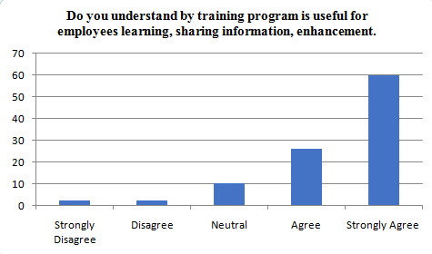
Strongly disagree | 2 | 2%
Disagree | 2 | 2%
Neutral | 10 | 10%
Agree | 26 | 26%
Strongly agree | 60 | 60%
Total | 100 | 100%

INTERPRETATION: Mean : 4.4 ,S.D :3.969886648
From the analysis : It is observed that 60% of respondents strongly agree that training program is useful for employees learning, sharing information, enhancement, 26% of respondents agree that training program is useful for employees learning, sharing information, enhancement, 10% of respondents Neutral that training program is useful for employees learning, sharing information, enhancement, 2% of respondents disagree and 2% of respondents strongly disagree training program is useful for employees learning, sharing information, enhancement.

2. Do you agree with training is must for enhancing productivity and performance?

Opinion | Respondents | % respondent  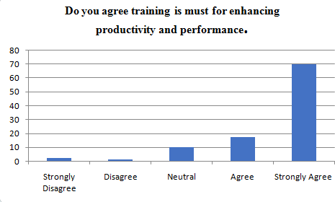
Strongly disagree | 2 | 2%
Disagree | 1 | 1%
Neutral | 10 | 10%
Agree | 17 | 17%
Strongly agree | 70 | 70%
Total | 100 | 100%
INTERPRETATION: Mean:4.12,S.D:3.93192065
From the analysis : It is observed that 70% of respondents strongly agree that training is must for enhancing productivity and performance, 17% of respondents agreed that training is must for enhancing productivity and performance, 10% of resstood on natural, 1% of respondents disagree and 2% of respondents strongly disagree the training is must for enhancing productivity and performance.
3. Do you agree with training helps to increase the motivation level of employee?
Opinion | Respondents | % respondent  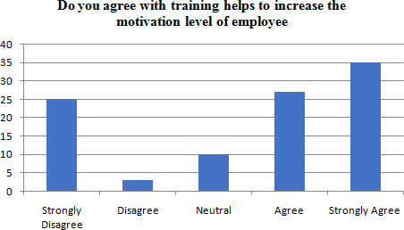
Strongly disagree | 25 | 25%
Disagree | 3 | 3%
Neutral | 10 | 10%
Agree | 27 | 27%
Strongly agree | 35 | 35%
Total | 100 | 100 %
INTERPRETATION: Mean : 3.44 , S.D: 3.301514804
From the analysis: It is observed that respondents 27% agreed that the training helps to increase the motivation level of employee, of respondents 35% strongly agreed that the training helps to increase the motivation level of employee, 10% of respondents stood on neutral, 3% of respondents disagree and 25% of respondents strongly disagree that the training helps to increase the motivation level of employee.
4. Do you agree with trainee following the different methodology in the training program?
Opinion | Respondents | % respondent  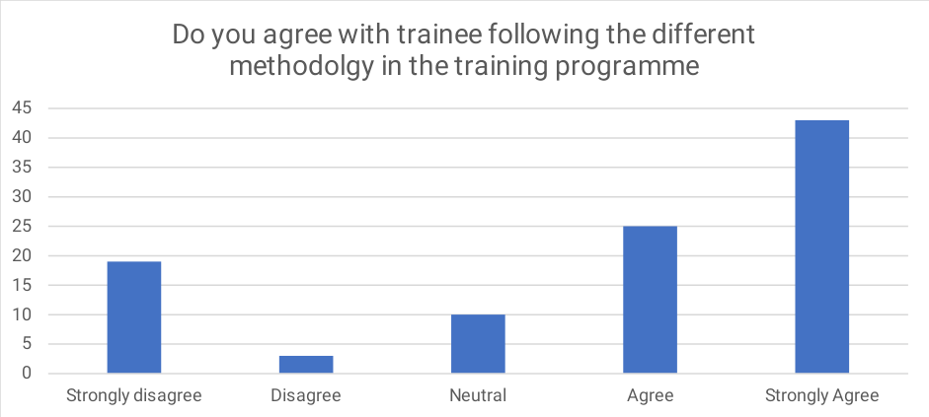
Strongly disagree | 19 | 19%
Disagree | 3 | 3%
Neutral | 10 | 10%
Agree | 25 | 25%
Strongly agree | 43 | 43%
Total | 100 | 100%
INTERPRETATION: Mean : 3.7,S.D: 3.50142828
Finding analysis : It is observed that respondents 43 % employees strongly agree that trainee following different methodology in training programs ,and 25% respondents agree that trainee following the different methodology in the training program , 10 % respondents are Neutral and 3% Disagree and 19% respondents strongly disagree the trainee following the different methodology in the training program.
5. Do you agree pre - training and post - training test influence the Employee to learn ?
Opinion | Respondents | % respondent  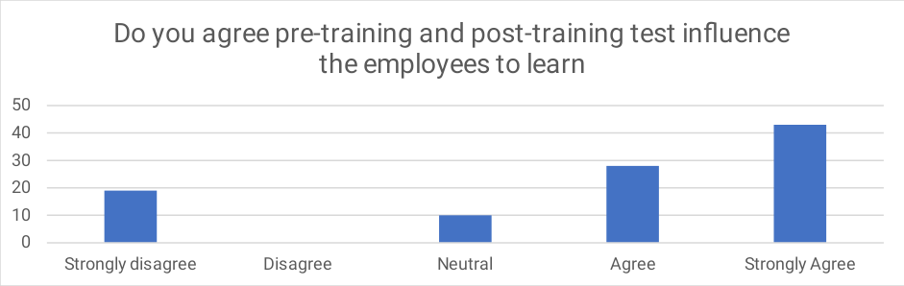
Strongly disagree | 19 | 19%
Disagree | 0 | 0%
Neutral | 10 | 10%
Agree | 28 | 28%
Strongly agree | 43 | 43%
Total | 100 | 100%

INTERPRETATION: Mean : 36,S.D: 3.475629439
Finding analysis: It is observed that 43 % respondents strongly agree that post training and pre training influence the employee to learn ,28% agree and 10% neutral respondents that pre training and post training influence the employee to learn and 0% Disagree and 19 % strongly disagree the post training and pre training influence the employee to learn .

CONCLUSION

The employee in every company work for the betterment of the corporate and therefore the employees of "Sri Devi Honda showroom" Hyderabad" to form work effectively the concerned department should organize training and development programs.
From the study it had been concluded that the staff benefit by attending effective training programs within the HONDA Showroom . They perceived their training and Development practices during a positive manner. the workers in "Sri Devi Honda showroom" jagannadhapuram ,Kakinada" are satisfied with their job and responsibilities given to them. It also helped to know the motivation and morale driven up by the training programmes among the workers and their interests to attend the programmes for personality development.
i've got discovered that thanks to the training employees are more able to perform their work very effectively by imparting suitable training to employees the corporate achieves the target of low cost, prime quality, timely service, reliability, value of cash, customer satisfaction.
REFERENCES
www.wikipedia.com
www.traininganddevelopment
www.wikipedia.com dreams.honda.com world.honda.com
www.hondacarsindia.com
www.scribd.com

